# STRING QUESTIONS

Q1.write code c# for taking input string firstname and lastname.

Q2.find the length of the firstname and lastname and if the length is same then give the . . boolean output true or false,and find the value by index no

Q3.Use compare to operation and perform some task.

4. create a console application that finds number of digits and alphabet in a given string

5.create a console application that accept a string and increments each character in the string by 1 and toggle all characters in the new string to UPPER CASE or LOWER CASE.

INTEGER

6. Create a Console Application to accept the side of a square and print the area of the square

7. implement the arithmetic operation.

8. .Write a simple program that accepts two numbers num1 and num2.

Assign num1 to num2 in two scenario:

i)Assign num1 to num2 by pre-incrementing num1 and observe the output

ii)Assign num1 to num2 by post-incrementing num1 and observe the output

iii) Swap both value

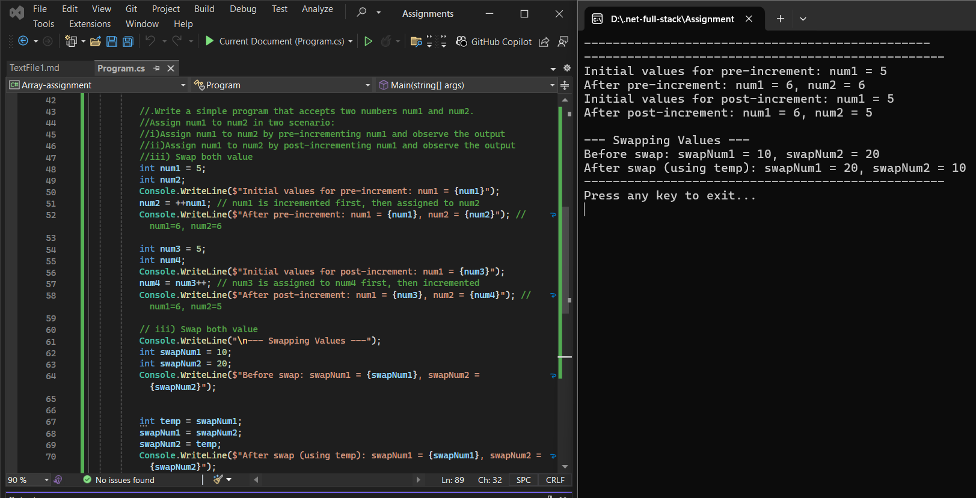

9. Use switch statement and perform some task.

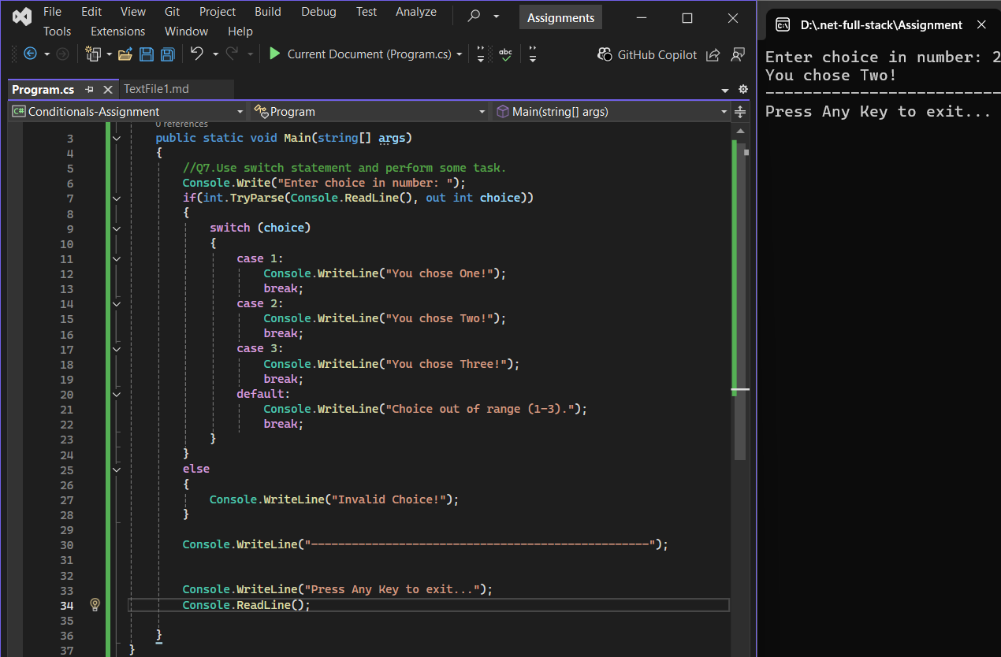

10. write a program to accept a number N and print whether it is positive , negative or zero.

11. Write a program to accept two number and print greater value of two

12. write a program to accept a number N and print whether the number is Even or Odd

13. Return last digit of the given number.

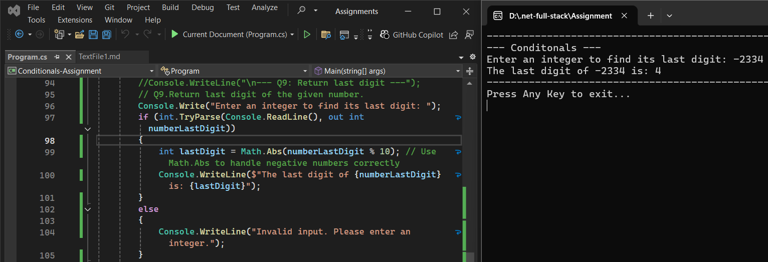

14. Return second last digit of the given number.

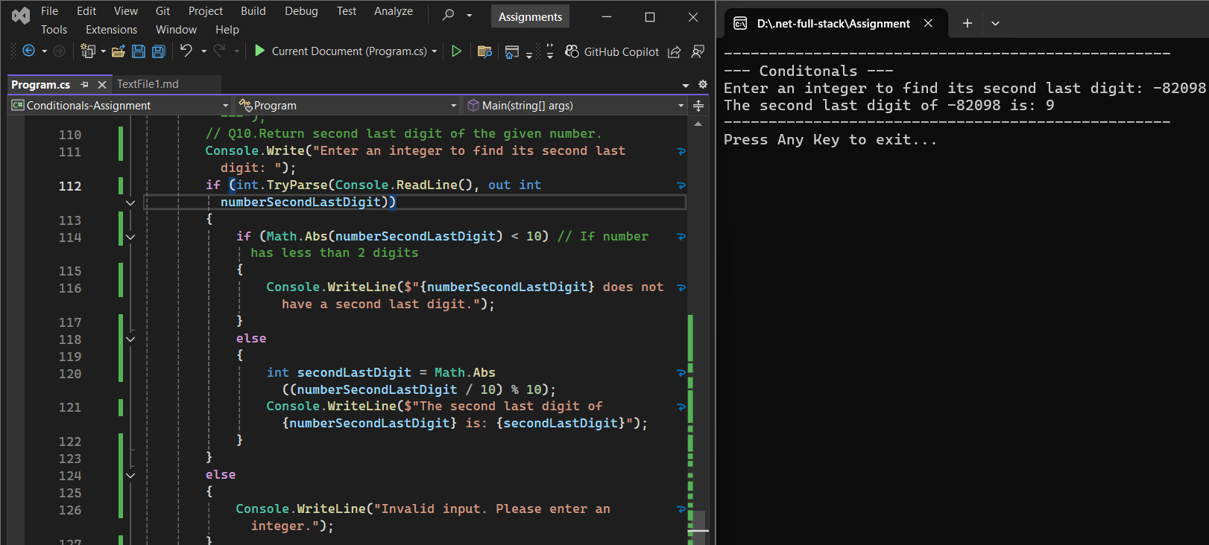

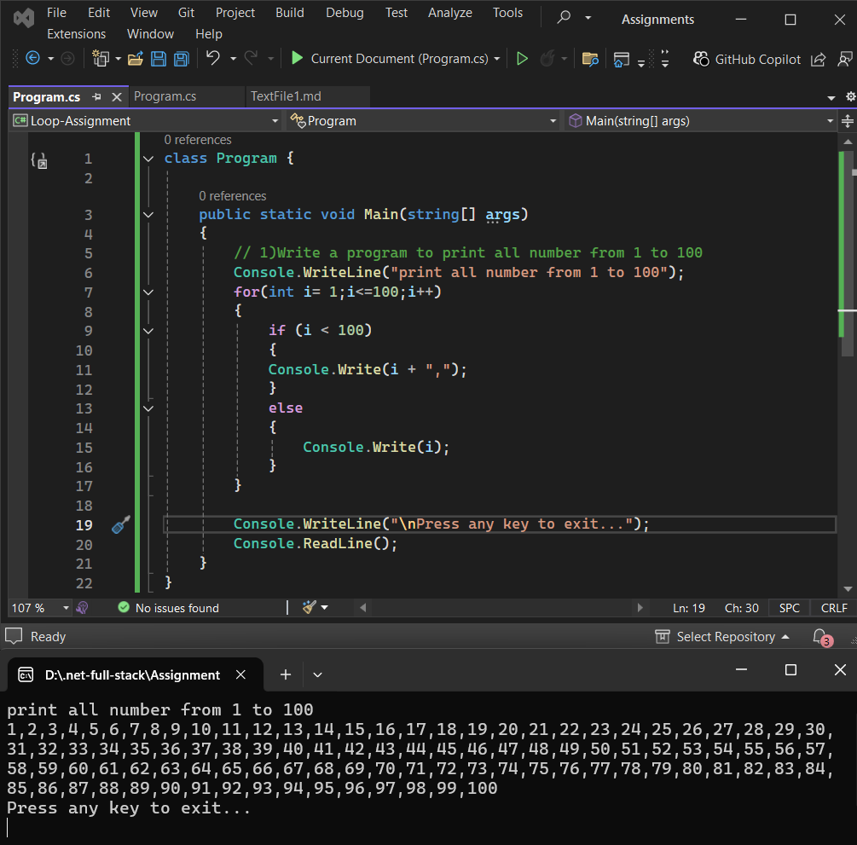

15. Write a program to print all number from 1 to 100

16. Write a program to print alternate number from 1 to 99

17. Write a program to print all numbers backward from 100 to 1 i.e.100,99,98....

18. Write a program to print all numbers backward from 100 to 1 by skipping 2 number i.e.100,97,94....

Array ArrayList

19. create an array and take input from user

20. Write a program that finds a number of element in an array with out using built in function.

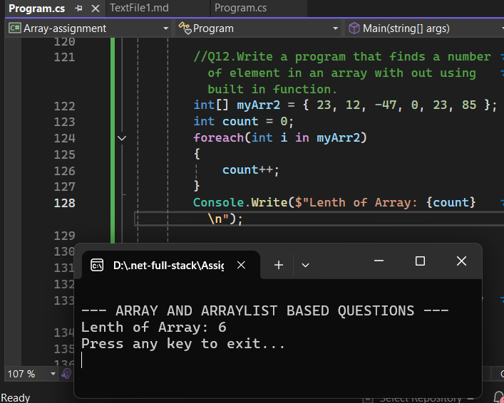

Q13.Write a program to accept 10 integers to an array and perform the below action:

1) print the element in descending order

2)find the min value, max value entered

