1. Design an algorithm to accept 10 integer elements for an array and then rearrange the elements in the array in reverse order. The reversed array must be displayed as output.

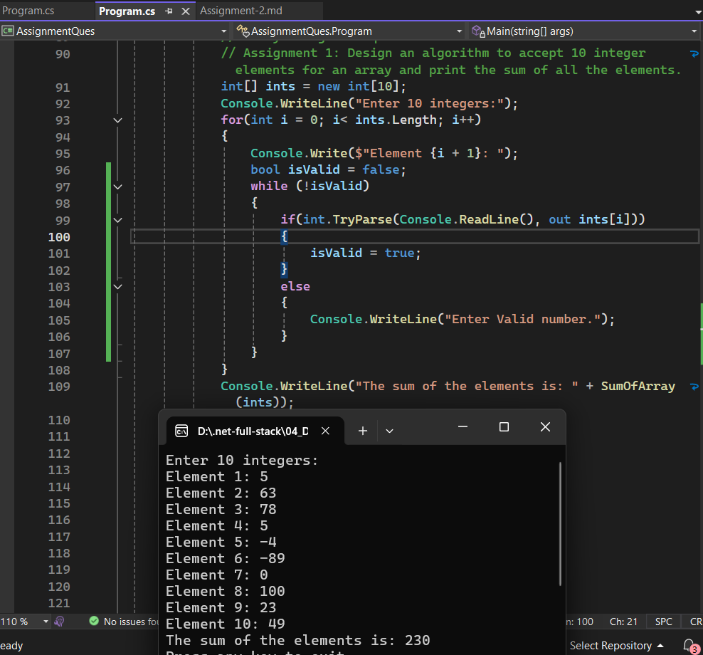

1. Design an algorithm which accepts a set of N (consider N to be 30) student's examination marks (in the range of O to 100). Then make a count of the number of students that obtain each possible mark

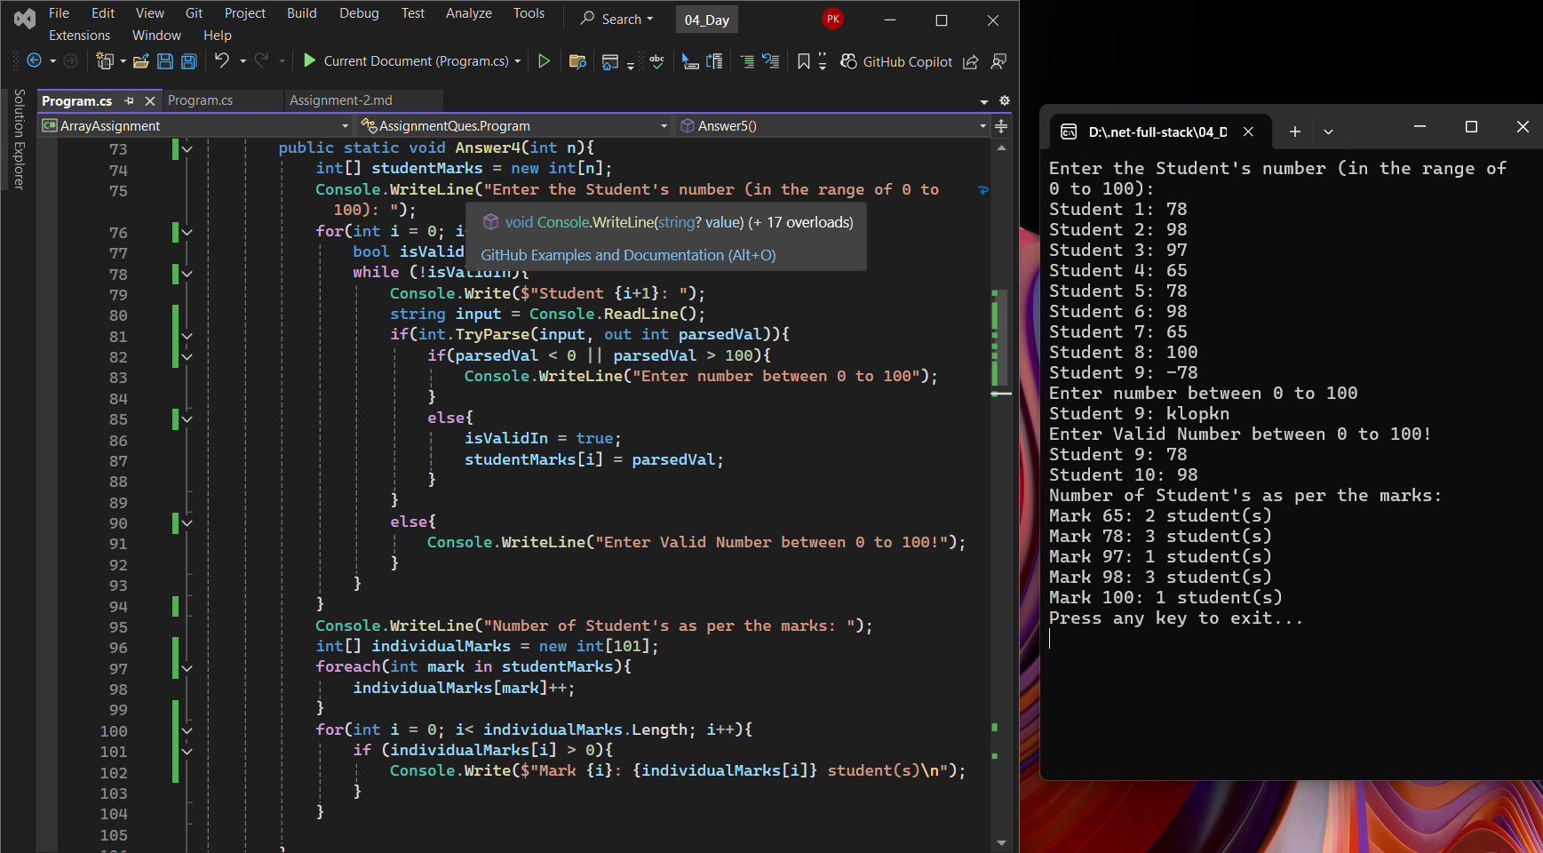

1. Design an algorithm which accepts a set of N (consider N to be 30) student's examination marks (in the range of O to 100). Then make a count of the number of students that obtain each possible mark (i.e.; count of how many students scored O, count of how many students scored 1, till count of how many students scored 100) Activity 5: Modify the algorithm written in Activity 4 in order to get count of students in a specific range of marks as defined below. Range of marks: O to 1096 91% to 100%

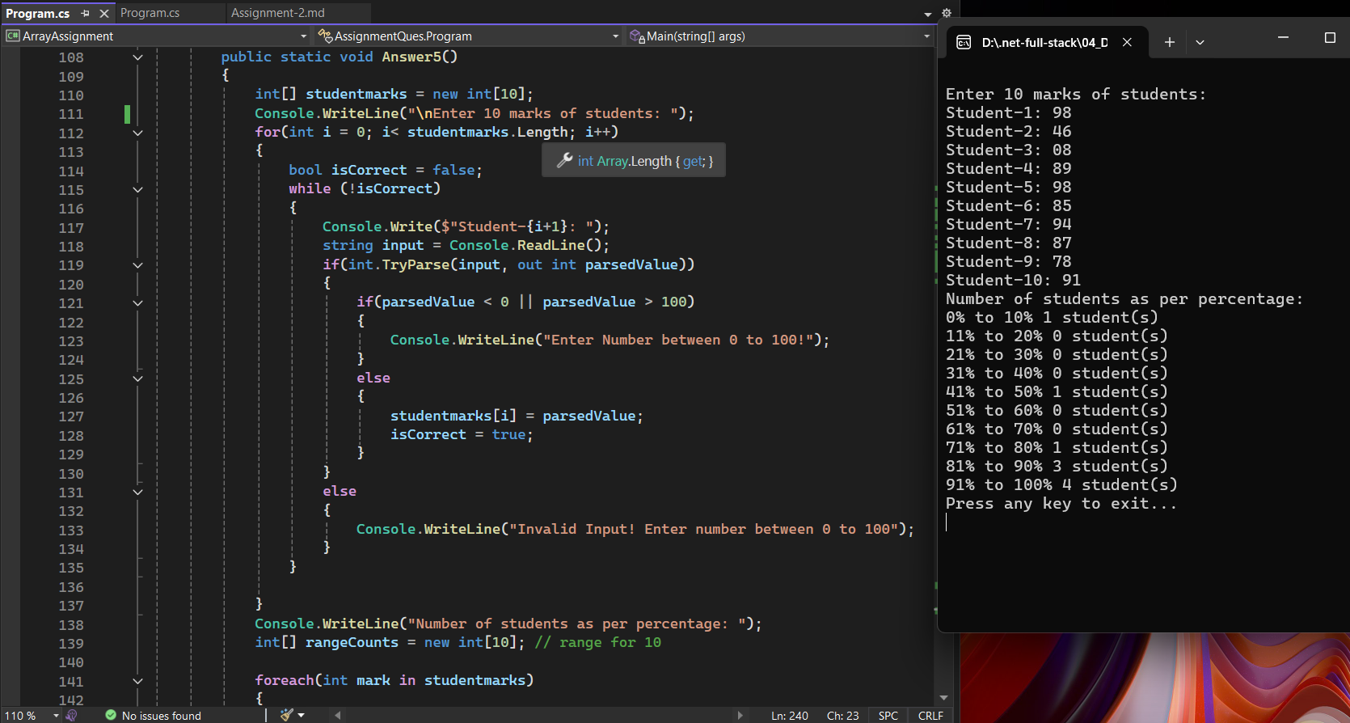

1. Get 3 max and min elements of the array
2. Write a Program to Implement the Compile time polymorphism using Function Overloading approach.

Calculate the area of circle, triangle and rectangle using function overloading

Write a Program to Implement the Compile Time Polymorphism

a. Write a user defined Math class that implements the overloaded method to implement the mathematical functions.

Return Type Method

Int Add(inta, int b)

Int Add(inta, int b, int c)

b. Similarly implement the method overloading for Multiply, divide and subtract functionalities.

