1. Write a program in C to store elements in an array and print them.

#include <stdio.h>

int main()

{

int myArray[5];

myArray[0] = 10;

myArray[1] = 20;

myArray[2] = 30;

myArray[3] = 40;

myArray[4] = 50;

printf("Elements in the array:\n");

for (int i = 0; i < 5; i++)

{

printf("%d ", myArray[i]);

}

return 0;

}

OUTPUT:-

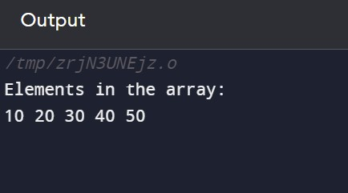

2. Write a program in C to read n number of values in an array and display

them in reverse order.

#include <stdio.h>

int main() {

int n;

printf("Enter the number of values: ");

scanf("%d", &n);

int myArray[n];

printf("Enter %d values:\n", n);

for (int i = 0; i < n; i++)

{

scanf("%d", &myArray[i]);

}

printf("Values in reverse order:\n");

for (int i = n - 1; i >= 0; i--) {

printf("%d ", myArray[i]);

}

return 0;

}

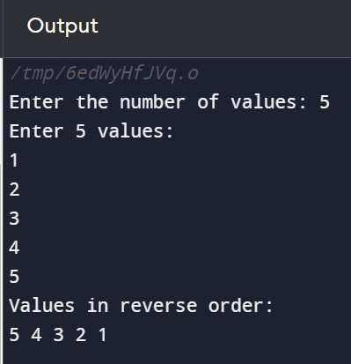

1. Write a program in C to find the sum of all elements of the array.

#include <stdio.h>

int main() {

int n, sum = 0;

printf("Enter the number of elements in the array: ");

scanf("%d", &n);

int myArray[n];

printf("Enter %d elements:\n", n);

for (int i = 0; i < n; i++) {

scanf("%d", &myArray[i]);

sum += myArray[i];

}

printf("The sum of all elements in the array is: %d\n", sum);

return 0;

}

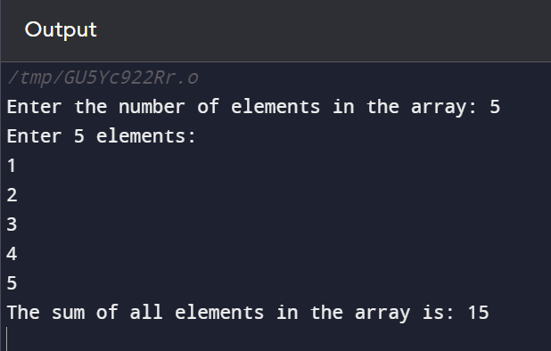

4. Write a program in C to count the total number of duplicate elements in

an array.

#include <stdio.h>

int main() {

int n, count = 0;

printf("Enter the number of elements in the array: ");

scanf("%d", &n);

int myArray[n];

printf("Enter %d elements:\n", n);

for (int i = 0; i < n; i++) {

scanf("%d", &myArray[i]);

}

for (int i = 0; i < n - 1; i++) {

for (int j = i + 1; j < n; j++) {

if (myArray[i] == myArray[j]) {

count++;

break;

}

}

}

printf("Total number of duplicate elements in the array: %d\n", count);

return 0;

}

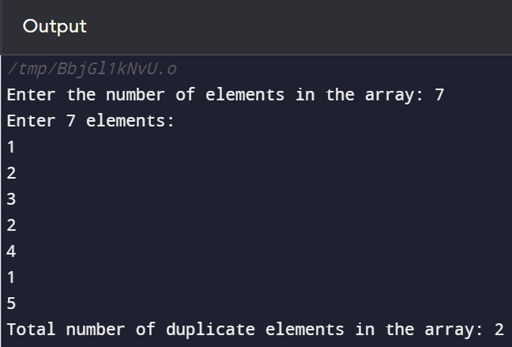

1. Write a program in C to print all unique elements in an array.

#include <stdio.h>

int main() {

int n;

printf("Enter the number of elements in the array: ");

scanf("%d", &n);

int myArray[n];

int isUnique;

printf("Enter %d elements:\n", n);

for (int i = 0; i < n; i++) {

scanf("%d", &myArray[i]);

}

printf("Unique elements in the array:\n");

for (int i = 0; i < n; i++) {

isUnique = 1;

for (int j = 0; j < i; j++) {

if (myArray[i] == myArray[j]) {

isUnique = 0;

break;

}

}

if (isUnique) {

printf("%d ", myArray[i]);

}

}

return 0;

}

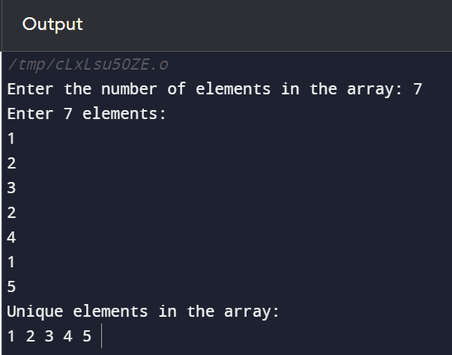

6. Write a program in C to insert an element into an array at a specified

position.

#include <stdio.h>

int main() {

int n, pos, newValue;

printf("Enter the number of elements in the array: ");

scanf("%d", &n);

int myArray[n+1];

printf("Enter %d elements:\n", n);

for (int i = 0; i < n; i++) {

scanf("%d", &myArray[i]);

}

printf("Enter the position to insert the new element (0-indexed): ");

scanf("%d", &pos);

printf("Enter the value of the new element: ");

scanf("%d", &newValue);

for (int i = n; i > pos; i--) {

myArray[i] = myArray[i - 1];

}

myArray[pos] = newValue;

n++;

printf("Array after insertion:\n");

for (int i = 0; i < n; i++) {

printf("%d ", myArray[i]);

}

return 0;

}

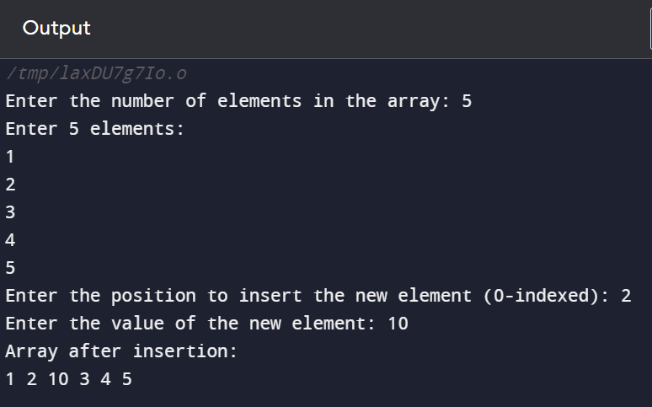

1. Write a program in C to delete the element at the given index.

#include <stdio.h>

int main() {

int n, index;

printf("Enter the number of elements in the array: ");

scanf("%d", &n);

int myArray[n];

printf("Enter %d elements:\n", n);

for (int i = 0; i < n; i++) {

scanf("%d", &myArray[i]);

}

printf("Enter the index of the element to delete (0-indexed): ");

scanf("%d", &index);

if (index < 0 || index >= n) {

printf("Invalid index!\n");

return 1;

}

for (int i = index; i < n - 1; i++) {

myArray[i] = myArray[i + 1];

}

n--;

printf("Array after deletion:\n");

for (int i = 0; i < n; i++) {

printf("%d ", myArray[i]);

}

return 0;

}

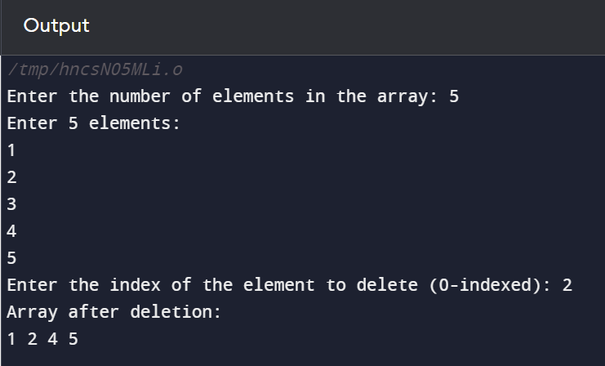

THE END