1. Implement Linear Search

#include <stdio.h>

int linear_search(int arr[], int n, int target) {

for (int i = 0; i < n; i++) {

if (arr[i] == target) {

return i;

}

}

return -1;

}

int main() {

int my_array[] = {5, 2, 9, 1, 7, 6};

int array_size = sizeof(my_array) / sizeof(my_array[0]);

int target_element = 7;

int result = linear_search(my_array, array_size, target_element);

if (result != -1) {

printf("Element %d found at index %d.\n", target_element, result);

} else {

printf("Element %d not found in the array.\n", target_element);

}

return 0;

}

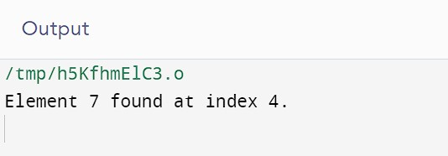

1. Implement Binary Search

#include <stdio.h>

int binary_search(int arr[], int n, int target) {

int low = 0, high = n - 1;

while (low <= high) {

int mid = (low + high) / 2;

if (arr[mid] == target) {

return mid;

} else if (arr[mid] < target) {

low = mid + 1;

} else {

high = mid - 1;

}

}

return -1;

}

int main() {

int sorted_array[] = {1, 2, 3, 4, 5, 6, 7, 8, 9, 10};

int array_size = sizeof(sorted_array) / sizeof(sorted_array[0]);

int target_element = 7;

int result = binary_search(sorted_array, array_size, target_element);

if (result != -1) {

printf("Element %d found at index %d\n", target_element, result);

} else {

printf("Element %d not found in the array\n", target_element);

}

return 0;

}

