Ecommerce-API-Testing-Project

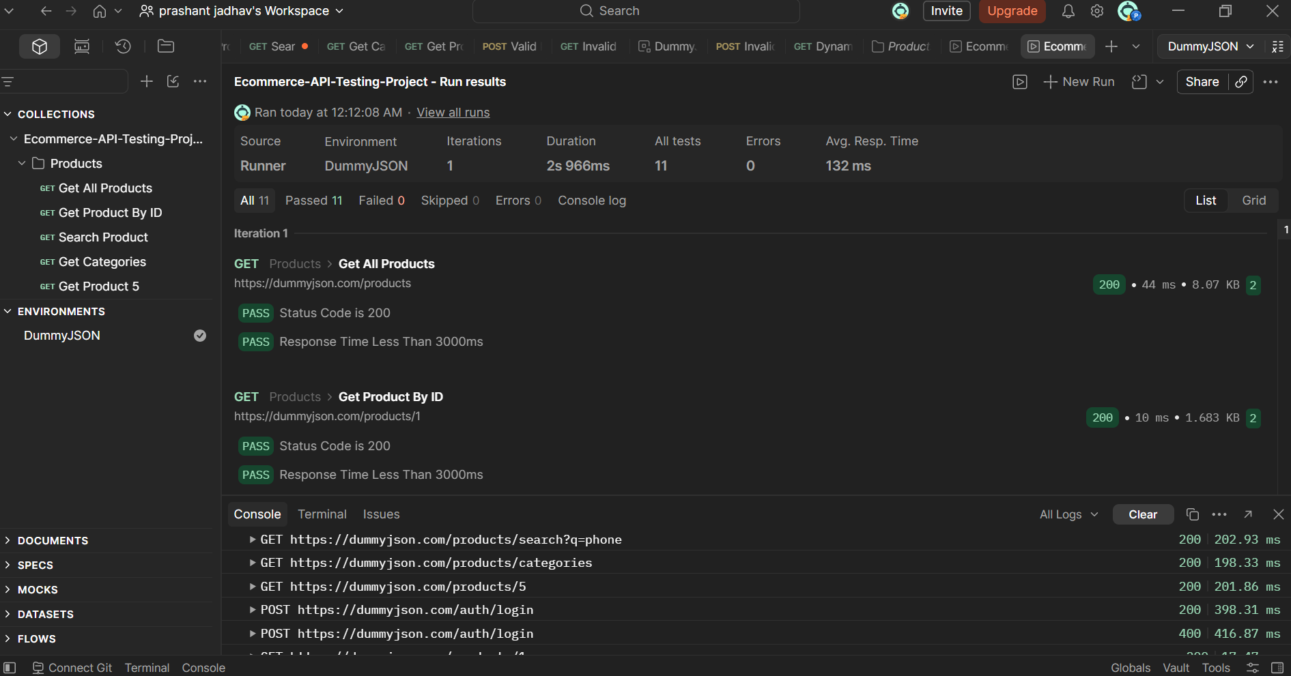

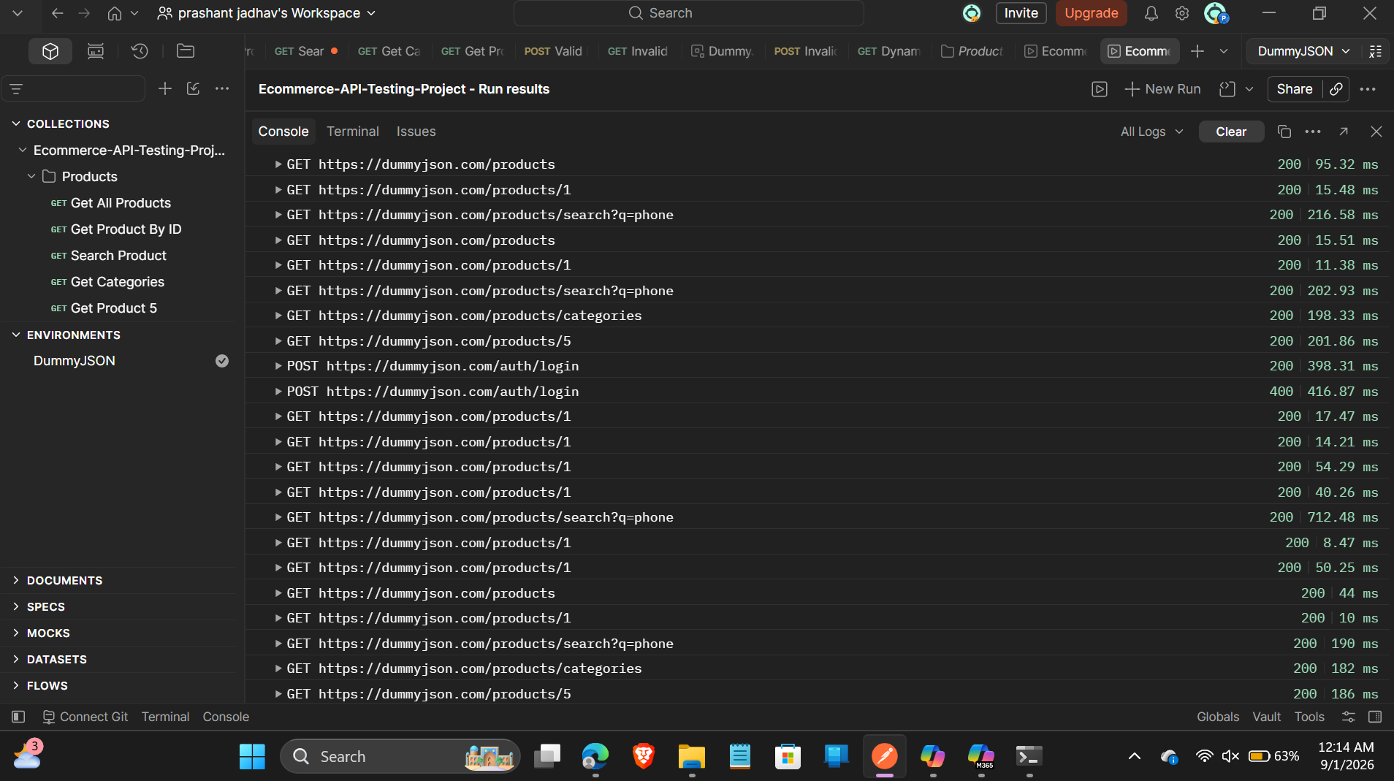

□ Products
└ Get All Products
GET /products [errored]
Invalid URI "http:///products"
2. Status Code is 200
3. Response Time Less Than 3000ms
4⠄ JSONError in test-script

└ Get Product By ID
GET /products/ [errored]
Invalid URI "http:///products/"
6. Status Code is 200
7. Response Time Less Than 3000ms

└ Search Product
GET /products/search?q=phone [errored]
Invalid URI "http:///products/search?q=phone"
9. Status Code is 200
10. Response Time Less Than 3000ms

└ Get Categories
GET /products/categories [errored]
Invalid URI "http:///products/categories"
12. Status Code is 200
13. Response Time Less Than 3000ms

└ Get Product 5
GET /products/5 [errored]
Invalid URI "http:///products/5"
15. Status Code is 200
16. Response Time Less Than 3000ms

└ Valid Login
POST /auth/login [errored]
Invalid URI "http:///auth/login"
18. Status 200

└ Invalid Login
POST /auth/login [errored]
Invalid URI "http:///auth/login"

└ Dynamic Product
GET /products/ [errored]
Invalid URI "http:///products/"

┌─────────────────────────┬──────────┬──────────┐
│ │ executed │ failed │
├─────────────────────────┼──────────┼──────────┤
│ iterations │ 1 │ 0 │
├─────────────────────────┼──────────┼──────────┤
│ requests │ 8 │ 8 │
├─────────────────────────┼──────────┼──────────┤
│ test-scripts │ 7 │ 1 │
├─────────────────────────┼──────────┼──────────┤
│ prerequest-scripts │ 0 │ 0 │
├─────────────────────────┼──────────┼──────────┤
│ assertions │ 11 │ 11 │
├─────────────────────────┴──────────┴──────────┤
│ total run duration: 780ms │
├───────────────────────────────────────────────┤
│ total data received: 0B (approx) │
└───────────────────────────────────────────────┘

# failure detail

01. Error Invalid URI "http:///products"
at request
inside ""

02. AssertionError Status Code is 200
expected PostmanResponse{ …(5) } to have property 'code'
at assertion:0 in test-script
inside "Products / Get All Products"

03. AssertionError Response Time Less Than 3000ms
expected undefined to be a number or a date
at assertion:1 in test-script
inside "Products / Get All Products"

04. JSONError "undefined" is not valid JSON
at test-script
inside "Products / Get All Products"

05. Error Invalid URI "http:///products/"
at request
inside ""

06. AssertionError Status Code is 200
expected PostmanResponse{ …(5) } to have property 'code'
at assertion:0 in test-script
inside "Products / Get Product By ID"

07. AssertionError Response Time Less Than 3000ms
expected undefined to be a number or a date
at assertion:1 in test-script
inside "Products / Get Product By ID"

08. Error Invalid URI "http:///products/search?q=phone"
at request
inside ""

09. AssertionError Status Code is 200
expected PostmanResponse{ …(5) } to have property 'code'
at assertion:0 in test-script
inside "Products / Search Product"

10. AssertionError Response Time Less Than 3000ms
expected undefined to be a number or a date
at assertion:1 in test-script
inside "Products / Search Product"

11. Error Invalid URI "http:///products/categories"
at request
inside ""

12. AssertionError Status Code is 200
expected PostmanResponse{ …(5) } to have property 'code'
at assertion:0 in test-script
inside "Products / Get Categories"

13. AssertionError Response Time Less Than 3000ms
expected undefined to be a number or a date
at assertion:1 in test-script
inside "Products / Get Categories"

14. Error Invalid URI "http:///products/5"
at request
inside ""

15. AssertionError Status Code is 200
expected PostmanResponse{ …(5) } to have property 'code'
at assertion:0 in test-script
inside "Products / Get Product 5"

16. AssertionError Response Time Less Than 3000ms
expected undefined to be a number or a date
at assertion:1 in test-script
inside "Products / Get Product 5"

17. Error Invalid URI "http:///auth/login"
at request
inside ""

18. AssertionError Status 200
expected PostmanResponse{ …(5) } to have property 'code'
at assertion:0 in test-script
inside "Products / Valid Login"

19. Error Invalid URI "http:///auth/login"
at request
inside ""

20. Error Invalid URI "http:///products/"
at request
inside ""

