Contentslistsavailableat

InternetofThings

journalhomepage:
Researcharticle  Blockchain-assistedattribute-basedmulti-keywordsearchfor | 
dynamicencrypteddataincloud-edge-IoT
HanleiCheng |  | a,Sio-LongLo |  | b,∗,JingLu |  | c,d
a CollegeofComputerScienceandCyberSecurity,ChengduUniversityofTechnology,Chengdu610059,China b SchoolofComputerScienceandEngineering,MacauUniversityofScienceandTechnology,Macau999078,China c CollegeofComputerScienceandArtificialIntelligence,HubeiUniversityofEducation,Wuhan430205,China d BlockchainandMetaverseLaboratory,YGSoftInc,Zhuhai519085,China
articleinfo | abstract
Keywords:  Attribute-basedkeywordsearch Datasharing  Blockchain  Searchverifiability  Revocationandtraceability | Keywordsearchisafundamentaltechniqueforretrievingdataoutsourcedtothecloud.Although encryptionpreservesdataconfidentiality,existingsearchableencryptionschemesoftenfailto efficientlysupportdynamicauthorizationandflexibleretrieval.Toaddresstheselimitations,we propose𝖡𝖠𝖬𝖪𝖲,ablockchain-assistedattribute-basedmulti-keywordsearchschemethatsupports secureandefficientsearchoverversion-awareencrypteddata.In𝖡𝖠𝖬𝖪𝖲,multipledataowners collaborativelygenerateversion-boundaccesstokensthatgrantauthorizedusersdecryptionpriv-
ilegesoverevolvingdata.Theschemefurtherenablesconjunctivekeywordsearchwithupdatable indexes.Toensuretheintegrityofsearchresults,userscanverifytheircorrectnessusinganag-gregatedSchnorr-basednon-interactivezero-knowledgeproof,whichisvalidatedbysmartcon-tracts.Inaddition,𝖡𝖠𝖬𝖪𝖲providesefficientattributeanduserrevocationwithoutre-encrypting thestoredciphertexts,andsupportsusertraceabilityforidentifyingmalicioususersfromleaked keys.Weformallyprovethat𝖡𝖠𝖬𝖪𝖲achievessecurityagainstchosen-plaintextattacks(IND-CPA) andchosen-keywordattacks(IND-CKA)undertheDecisionalBilinearDiffie-Hellman(DBDH)as-sumption.Performanceevaluationsshowthattheschemeachieveslightweightdecryptionand efficientmulti-keywordsearch,therebyreducingclient-sidecomputationandmakingitsuitable forresource-constrainedIoTenvironments.Thesefeaturesdemonstratethepracticalityof𝖡𝖠𝖬𝖪𝖲fordistributedcloud-edge-IoTstorageapplications.
1.Introduction
Withtheincreasingconvergenceofcloud-edgecomputingandtheInternetofThings(IoT),moreend-usersareoutsourcing personaldatafromtheirresource-constrainedIoTdevicestoscalable,pay-as-you-gocloudstorageproviders(CSPs).Thisoutsourcing processeffectivelyalleviatesthelocalstorageburden.EdgeserversactasabridgebetweenthecentralizedcloudanddistributedIoT devices.Theyareequippedwithcloud-likecomputingresources,enablingthemtocachedatatoserveIoTuserswithlowlatencyand highdataprocessingcapability.Thiscloud-edge-IoTparadigmfacilitatesdatasharingbetweenIoTend-usersandbusinessproviders whileintroducingvarioussecurityandprivacychallengesindataaccessandretrieval[1].Forinstance,patients’sensitiveelectronic healthcarerecords(EHRs)couldbeleakedtothesemi-trustedcloudoredgeservers[2].Tosolvethissecurityissue,itisconventional
∗Correspondingauthor.
E-mailaddresses:(H.Cheng),(S.-L.Lo),(J.Lu).
evisedform9November2025;Accepted29November2025
Available online 6 December 2025
2 by Elsevier B.V. This is an open access article under the CC BY-NC-ND license ( ).

H.Chengetal. InternetofThings36(2026)101838
toencrypttheowners’databeforeoutsourcingthemtothecloud[3].However,itisnecessarytoconsiderhowtosecurelysearch keywordstoretrievethetargetencryptedwhilepreservingtheconfidentialityofoutsourceddata.
Attribute-basedencryption(ABE)[4]andsearchableencryption(SE)[5]haveemergedasfoundationaltechniquesforattribute-basedkeywordsearch(ABKS)[6],whichservesasapromisingapporachthatauthorizeslegitimateuserstosearchencrypteddata usingspecifickeywords[7].InABKSschemes,inadditiontoencryptingthedatabasedontheABEalgorithm,eachkeywordinthe keyworddictionaryisencryptedunderanaccesspolicytogenerateacorrespondingindex.Incontrast,aquerykeywordisencrypted withauserattributesettoproduceatrapdoor.Accessisgrantedonlyiftheuser’sattributessatisfytheaccessstructure[8]andthe encryptedkeywordindextextuallymatchesthequerytrapdoor[9].
ExistingABKSschemes[10,11]mainlyfocusonkeywordsearchoverstaticdatasetsandlackeffectivemechanismsforhandling dynamicupdates.Infact,inmanyreal-worldapplications(e.g.,remoteemailservicesorelectronichealthrecord(EHR)systems), outsourceddocumentsevolvecontinuously,requiringsynchronousadjustmentstobothusers’decryptionprivilegesandtheassociated encryptedkeywordindexes.Insuchstreamingscenarios,continuousdataupdatesformadatastream,whichnecessitatesacontinuous accessandquerymechanism[12]toensuresecureandaccurateretrievalovertheevolvingciphertexts.
Furthermore,moststate-of-the-artABKSschemesenableone-to-many1datasharing[13].However,indistributedIoT-basedappli-cations,datausersoftenrequireaccesstodatafrommultiplesourcesincloudenvironments,leadingtomany-to-oneormany-to-many datasharingdemands[14].Inaddition,mostABKSschemesarelimitedtosingle-keywordsearches,whichnotonlyreducessearch accuracybutalsoleadstoinefficientuseofcomputationalresources.
1.1.Motivation
Theselimitationsrevealseveralkeychallengesthatmotivateourwork:
•Indynamicdatasharinginvolvingmultipledataowners,users’decryptionprivilegesneedtoevolveconsistentlywiththeongoing dataupdates.However,mostexistingABKSschemesdonotprovideanefficientmechanismforjointlyauthorizedkeymanagement.•Asoutsourceddatasetscontinuouslygrow,theirencryptedkeywordindexesareexpectedtosupportscalableconjunctivekeyword searchwhilepreventingleakageofsearchoraccesspatterns.
•Beyondsecureretrieval,usersshouldbeabletoverifythecorrectnessofreturnedsearchresultswithoutexposingsensitivequery orplaintext.
•CurrentABKSschemesgenerallyrelyonre-encryptingstoredciphertextsduringattributeoruserrevocation,whichincursaddi- tionalcomputationaloverheadandisimpracticalinresource-constrainedenvironments.
Toaddressthesechallenges,weconstructaBlockchain-assistedAttribute-basedMulti-KeywordSearch(𝖡𝖠𝖬𝖪𝖲)schemeover dynamicencrypteddata,whichsupportssecureandefficientdatasharing.
1.2.Contributions
Ourschememakesthefollowingmaincontributions:
•Efficientsharingofdynamicfilesinmulti-ownersettings.Wepropose𝖡𝖠𝖬𝖪𝖲,whichenablesdataownerstojointlygenerate version-boundaccesstokens.Thetokenisprotectedthroughahybridoff-chain/on-chainABEmechanism,providingefficientand decentralizedaccesscontrolfordynamicallyupdatedfiles.
•Secureconjunctivemulti-keywordsearchwithindexupdates.Ourschemeallowsuserstoconjunctivelyquerymultiplekey-wordswhencreatingasearchtrapdoor,therebyenablingefficientandsecureretrievaloftargetfiles.Inaddition,toenhance searchscalability,oursolutionsupportsupdatingthekeywordindexesofencryptedfiles.
•Anonymousandverifiablesearchresults.WeextendaSchnorr-basednon-interactivezero-knowledge(SNIZK)prooftocon-structanaggregatedSNIZKproofformatchedfiles.Thecorrectnessoftheretrievalresultsisverifiedbysmartcontractswithout revealingthequeriedkeywordsorfilecontents.
•Revocationandusertraceability.𝖡𝖠𝖬𝖪𝖲supportsbothattributeanduserrevocationwithoutrequiringthere-encryptionofall storedciphertexts.Moreover,abuilt-intraceabilitymechanismallowsidentifyingmisbehavingusersfromleakedkeys,ensuring accountabilityinpracticaldeployments.
Theremainderofthispaperisorganizedasfollows.Section2reviewstherelatedwork.Section3introducesthepreliminaries oftheproposed𝖡𝖠𝖬𝖪𝖲scheme.Section4definestheproblemformulations,andSection5presentsthedetailedconstructionof𝖡𝖠𝖬𝖪𝖲.ThecorrectnessandsecurityanalysisispresentedinSection6,andtheperformanceevaluationisgiveninSection7.Finally, Section8concludesthepaper.
1Inthecontextofdatasharing,“one-to-many”meansthatmultipleuserscanaccessdatafromasingleowner,providedthattheirattributes satisfytheaccesspolicy.
2

H.Chengetal. InternetofThings36(2026)101838
2.Relatedwork
2.1.ABKS
Attribute-basedkeywordsearch(ABKS)inheritsfromattribute-basedencryption(ABE)[4,15]andsearchableencryption(SE)[5]. Zhengetal.[6]werethefirsttoproposethecryptographicprimitiveofverifiableattribute-basedkeywordsearch(VABKS),which allowsuserswhosatisfytheaccessstructuretosearchoverencrypteddatawhileverifyingthecorrectnessofthesearchresults.
ABKShasattractedconsiderableattentioninbothacademiaandindustry.Varrietal.[16]developedFELT-ABKS,afog-enabled lightweightandtraceableABKSschemethatsupportsmulti-keywordsearchanddecryptionforauthorizedusers,whileenablingboth userandattributerevocation.Tofurthertraceuserswhomisusetheirdecryptionkeys,theauthorssubsequentlyproposedTL-ABKS, whichemployswhite-boxtraceabilitytoidentifymalicioususers[17].However,theseschemesprimarilyfocusonstaticdataaccess insingle-ownersettingsanddonotaddressdynamicauthorizationandretrievalovercontinuouslyevolvingdatasets.Shietal.[18] proposedanABKSschemeforinformationsharinginsocialapplications.Theirschemeallowsuserstosearchoverencrypteddata basedonattributepolicies;however,itonlysupportssingle-keywordqueries,limitingpracticalusability.Similarly,Yinetal.[19] introducedPH-ABKS-DS,apolicy-hidingABKSschemebasedonprimeordergroups.Whileitenhancesprivacybyhidingaccess policiesduringsearch,italsorestrictsqueriestoasinglekeyword.IntheSocialInternetofVehicles(SIoVs),Guetal.[20]designed atraceableABKSschemeinwhichdata-owningvehiclespartitionanduploadencrypteddatablockswithassociatedkeywords,while data-requestingvehiclesgeneratetrapdoorstoretrieverequireddata.Althoughthisapproachsupportstraceability,itstillrelieson single-keywordqueriesanddoesnotefficientlyhandlelargedatasets,oftenreturningmanyirrelevantresults[10].
Toimproveretrievalefficiencyandflexibility,severalworkshaveexploredmulti-keywordsearchtechniques.Zhangetal.[21] developedanABKSsystemthatsupportsconjunctivekeywordqueriesanddesignatesanindependentauditortoverifysearchresults. Liuetal.[22]proposedEMK-ABSE,inwhichthedataownerpartiallyencryptsbothdataandassociatedkeywordsonline,enabling edgenodestoperformthesearchprocessandthusimprovingsearchefficiency.Huangetal.[23]introducedABERKS,whichsupports expressiveBooleanqueriesusingAND,OR,andNOToperators,andranksmatchedfilesbasedonrelevance.Lietal.[24]proposed atree-basedstructureforconjunctivekeywordsearches,enhancingqueryefficiencyinmulti-keywordscenarios.Chenetal.[25] presentedPHP-ABMKSE-VR,apartiallyhidden-policyABKSsupportingmulti-keywordsearch,verification,andrevocation.Their schemealsoresistsattribute-valueguessingattacks.Despitetheseadvancements,theseschemesaremostlydesignedfordatasharing insingle-ownersettings,whichleadstoredundantauthorizationoverheadoncemultipledataownersareinvolved.
Motivatedbycollaborativedatasharing,recentstudieshaveproposedmulti-ownerABKSschemes.Wangetal.[26]introduced AESM2,supportingmulti-owner,multi-useraccesswithasingletrapdoorandefficientowner-levelrevocationwithoutupdating ciphertexts.Yinetal.[27]designedanABKSschemeforcloud-assistedIIoTenvironments,whereanovelmasterkeygenerationand privatekeyaggregationmechanismallowsalldataownerstocollaborativelygenerateauser’sprivatekeyusingonlytheirrespective masterkeys,simplifyingkeymanagement.IntheInternetofVehicles(IoV),Lietal.[28]proposedFAMI,afuzzyABKSscheme supportingmany-to-manyaccesscontrol.FAMIemploysanindistinguishableBloomfilter(IBF)andbigramkeywordconversionto improvetheaccuracyofsimilaritymatchingformulti-keywordsearches.
ThesestudiesadvanceABKS;however,theyprimarilyfocusonstaticdatasets.VeryfewABKSschemessimultaneouslysupport dynamicdatasharinginmulti-ownersettings,multi-keywordsearch,verifiableretrieval,efficientrevocation,andusertracing.
2.2.Blockchain-basedABKS
Benefitingfromtheintrinsicpropertiesofblockchain,suchasconsensus,transparency,tamperresistance,andnon-repudiation [29],blockchain-basedABKSschemeshavebeenextensivelyexplored[30,31].Existingworkstypicallyaddressoneorseveralspecific functionalities,suchasmulti-keywordretrieval,multi-authoritysettings,hiddenpolicies,malicioususertracing,oruserrevocation.
Forexample,XiangandZhao[32]developedablockchain-basedsearchableattribute-basedencryption(SABE)schemeforhealth-careapplications,whileSuetal.[33]introducedBA-RMKABSE,ablockchain-aidedrankedmulti-keywordsearchableencryption schemewithhiddenpolicies,wheresmartcontracts[34]areemployedtomatchtrapdoorswithkeywordindexesandverifysearch results.Zhangetal.[35]proposedaverifiableandfairattribute-basedconjunctivekeywordsearch(ABCKS)schemethatleverages blockchainasadecentralized,tamper-proofindexrepositorytoensuretrustworthyverification.Wangetal.[36]presentedanABSE-basedknowledgesharingarchitectureforintelligentIoT,whichintegratesapermissionedblockchainwithareputation-enhanced DelegatedProofofStake(DPoS)protocoltomaintaindecentralizedconsensusamongedgenodes.Zhangetal.[37]furtherproposed aBADSschemethatenablesDOstoencryptkeywordindexesusingananonymousCP-ABSEalgorithmandstoretheresultingcipher indexesonaconsortiumblockchain.
Tomitigatetherisksofmasterkeyabuse,Yinetal.[38]introducedaDCP-ABSEschemeinwhichboththesystemmasterkey andusersecretkeysarejointlygeneratedbyattributeauthoritiesactingasblockchainnodes.Shenetal.[39]proposedBMSE, whichappliesSimhash,K-means,andTF-IDFtoclusterelectronicmedicalrecords(EMRs)andreturnthetop-𝑘results.Yuetal. [40]developedBC-dPEKS,enablingmulti-keywordsearchwithtrapdoorgenerationviathePedersenProtocolonapermissioned blockchain.Alameretal.[9]developedthesecurityandprivacyblockchain-baseddatasharing(SPB-DS)system,inwhichrequesters createtrapdoorstomatchkeywordsontheblockchain,andapaymentmechanismisdesignedtoincentivizestakeholderparticipation. YanandZhang[41]proposedanABSEschemeforIoTthatemploysanattributeBloomfilterforaccesspolicyprotectionandquery prefiltering,whileutilizingblockchainforindexstorage,trapdoormanagement,andpreliminaryfiltering.Houetal.[42]designed
3

H.Chengetal. InternetofThings36(2026)101838
BC-RMABSEforIoV,whichcombinesthevectorspacemodelwithPedersen’s(𝑘, 𝑛)secretsharingprotocolonconsortiumblockchain tosupportrankedmulti-keywordsearchandaddressthesingle-point-of-failureissue.
Despitetheseadvancements,mostblockchain-basedABKSschemesprimarilyexploitblockchainasanimmutablestoragefor encrypteddataorkeywordindexes.Theyarelimitedtostaticdatascenariosthatdonotsupportdynamicupdates.Therefore,there remainsanurgentneedforblockchain-basedABKSschemesthatnotonlyenabledynamicdatasharinginmulti-ownersettings,but alsoprovidesecureandefficientkeywordsearchcapabilities.
3.Preliminaries
3.1.Blockchain
Blockchain,initiallypopularizedbyBitcoin[43],isadistributedledgertechnologythatmaintainstransactionsinachronologically append-onlyledgerreplicatedacrossanetworkofnodes.Eachblockcontainsasetoftransactionstogetherwiththecryptographic hashofthepreviousblock,therebyprovidingintegrityandtamper-resistancethroughprimitivessuchashashchaininganddigital signatures[44].Withitsdecentralizedandimmutablearchitecture,blockchainoffersatrustworthyfoundationforsecuredatasharing incloud-edge-IoTscenarios[45].Moreover,blockchainplatformssupportsmartcontracts,i.e.,self-executingprogramsdeployedon theledgerthatenforcepredefinedruleswithoutcentralizedauthority[46].Smartcontractsenabletransparentandautomateddecryp-tionprivilegeverificationandaccesspolicyenforcement[47].Whencombinedwithaccesscontrolmodels(e.g.,ABAC),blockchain canrecordauthorizationactivitiesandoperationlogson-chain,therebyaddressingtraceabilityandaccountabilitylimitationsin traditionalcentralizedsystems.Thesehybridapproachesprovideconsistent,auditable,anddecentralizedaccesscontrol[48].
3.2.Accessstructure
Anaccessstructure𝔸overanattributeuniverseisafamilyofnon-emptysubsets,i.e.,𝔸⊆2⧵∅.Subsetsin𝔸areauthorized, whilethosenotin𝔸areunauthorized.Anaccessstructureismonotoneifforany𝑌, 𝑍⊆,𝑌∈𝔸and𝑌⊆𝑍imply𝑍∈𝔸[49].
3.3.Linearsecretsharingscheme(LSSS)
AnLSSSschemeΠisdefinedbyan𝓁× 𝑛share-generatingmatrix𝕄∈ℤ𝓁×𝑛𝑝 togetherwithanaccesspolicy(𝕄, 𝜌),where𝜌isa functionmappingeachrowindex𝑖of𝕄toanattribute.Let⃗𝑣= (𝑠, 𝑣2, … , 𝑣𝑛)⊤∈ℤ𝑛𝑝,where𝑠∈ℤ𝑝isthesecretand𝑣2, … , 𝑣𝑛∈ℤ𝑝are randomlychosenvalues.Thesharevector⃗𝜆= 𝕄⃗𝑣defines𝓁sharesof𝑠.Auserholdinganattributesetcanreconstructthesecret𝑠ifandonlyifthereexistconstants{𝜔𝑖∈ℤ𝑝}𝑖∈,where= {𝑖∶𝜌(𝑖) ∈},suchthat∑𝑖∈𝜔𝑖𝜆𝑖= 𝑠[49].
3.4.Bilinearpairing
Let𝔾and𝔾𝑇bemultiplicativecyclicgroupsofprimeorder𝑝,andlet𝑔beageneratorof𝔾.Abilinearmap̂𝑒∶𝔾× 𝔾→𝔾𝑇satisfiesthefollowingproperties[50]:
•Bilinearity:forall𝑔1, 𝑔2∈𝔾and𝜚1, 𝜚2∈ℤ∗𝑝,̂𝑒(𝑔𝜚1 1, 𝑔𝜚2 2) =̂ 𝑒(𝑔1, 𝑔2)𝜚1𝜚2.
•Non-degeneracy:thereexist𝑔1, 𝑔2∈𝔾suchthat̂𝑒(𝑔1, 𝑔2) ≠1.
•Computability:forall𝑔1, 𝑔2∈𝔾,̂𝑒(𝑔1, 𝑔2)canbeefficientlycomputedinpolynomialtime.
3.5.DecisionalbilinearDiffie-Hellman(DBDH)assumption
Let(𝔾, 𝔾𝑇,̂ 𝑒, 𝑔)bebilinearmapparameters,and𝑎1, 𝑎2, 𝑎3 $←←←←←ℤ𝑝berandomelementsofℤ𝑝.WesaythattheDBDHassumption holdsifnoprobabilisticpolynomial-time(PPT)adversarycandistinguish(𝑔𝑎1, 𝑔𝑎2, 𝑔𝑎3,̂ 𝑒(𝑔, 𝑔)𝑎1𝑎2𝑎3)from(𝑔𝑎1, 𝑔𝑎2, 𝑔𝑎3, )withnon-negligibleadvantage[4],whereisrandomlyselectedfrom𝔾𝑇,i.e.,
𝐴𝑑𝑣DBDH =||| Pr[(𝑔𝑎1, 𝑔𝑎2, 𝑔𝑎3,̂ 𝑒(𝑔, 𝑔)𝑎1𝑎2𝑎3) = 1]−Pr[(𝑔𝑎1, 𝑔𝑎2, 𝑔𝑎3, ) = 1]|||
Definition1.TheDBDHassumptionholdsifnoPPTadversarycansolvetheDBDHproblemwithnon-negligibleadvantage.
3.6.Schnorrnon-interactivezero-knowledge(SNIZK)
TheSNIZKproofprotocol[51]allowsaprovertodemonstrateknowledgeofasecretvaluetoaverifierwithoutrevealingthe
secretitself.Let(𝔾, 𝑔, 𝑝, 𝐻)bethepublicparameters,where𝐻isacryptographichashfunction.Theproverholdsasecret𝜎andpublishesapublickey𝑦= 𝑔𝜎. | $←←←←←ℤ∗𝑝
•Prover:Choose𝑐$←←←←←ℤ∗𝑝,compute= 𝑔𝑐,ℎ= 𝐻(, 𝑦),and𝜋= 𝑐+ 𝜎ℎ.SendtheSNIZKproof(, 𝜋)totheverifier.
•Verifier:Computeℎ= 𝐻(, 𝑦)andacceptif= 𝑔𝜋𝑦−ℎ.
•Correctness:𝑔𝜋𝑦−ℎ= 𝑔𝑐+𝜎𝐻(,𝑦)𝑔−𝜎𝐻(,𝑦)= 𝑔𝑐= .
•Security:Intherandomoraclemodel,theprovermustcommittobeforelearningℎ,preventingadaptivebiasofthechallenge andthusrulingoutforgery.
4

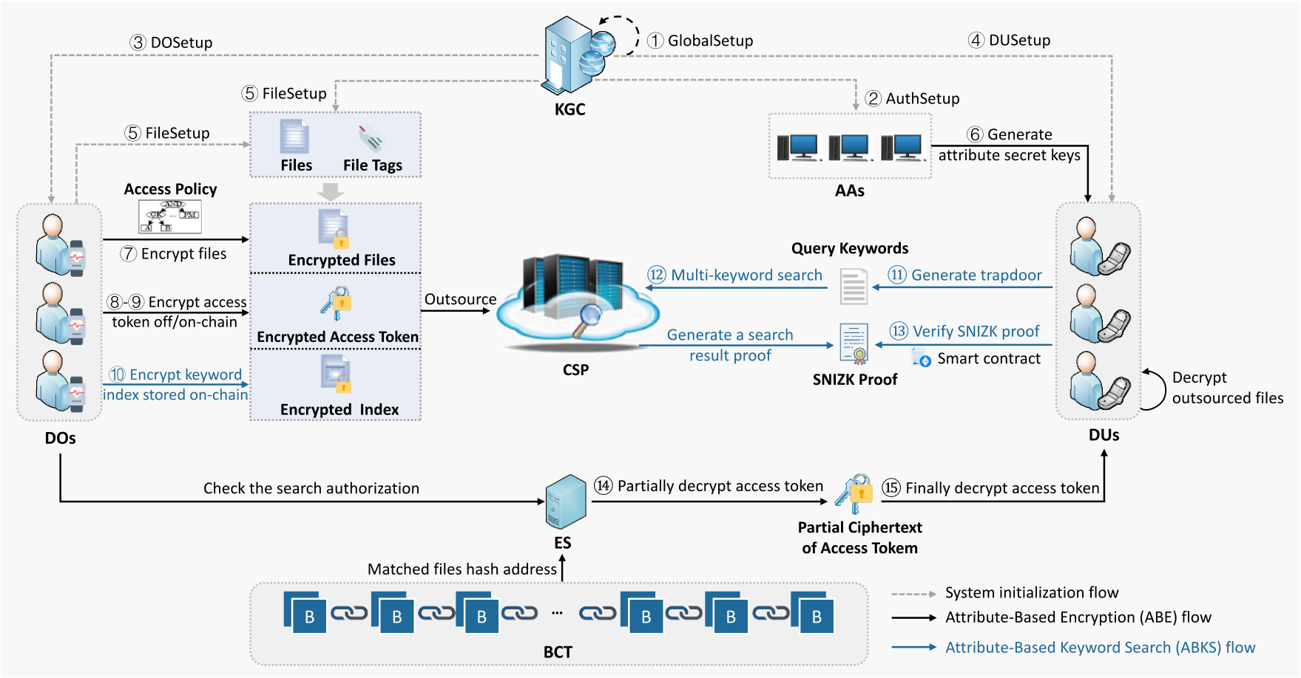
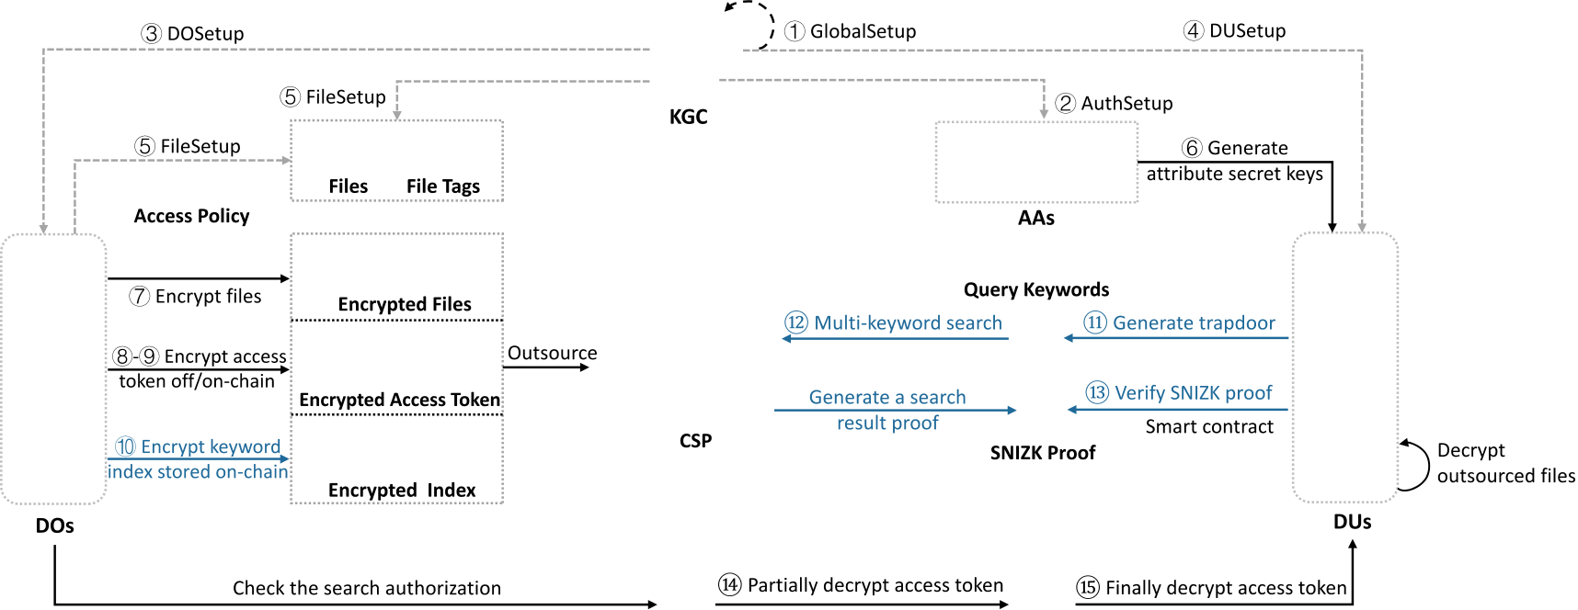
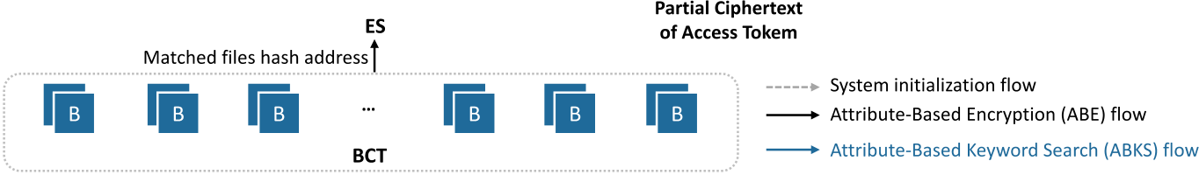
H.Chengetal. InternetofThings36(2026)101838
4.Problemformulations
Inthissection,wepresentthesystemmodel,formaldefinition,notation,threatmodel,securitymodel,anddesigngoals.
4.1.Systemmodel
Theproposedsysteminvolvesthefollowingeightentities.
•KeyGenerationCenter(KGC):TheKGCinitializesthesystembygeneratingtheglobalparameters(GP)andcoordinating blockchainvalidatornodestoexecuteadistributedkeygeneration(DKG)protocolthatjointlyderivesthesystemmastersecret
key(MSK).Inaddition,theKGCissuespublic-privatekeypairstousersandmaintainsversion-controlledfiles.
•AttributeAuthorities(AAs):EachAAmanagesasubsetofattributes,generatesthecorrespondingkeypairs,andderivesattribute secretkeys𝑆𝐾𝑢𝑖𝑑basedontheuser’sattributeset𝑢𝑖𝑑.
•DataOwners(DOs):DOsdefineaccesspolicies,symmetricallyencryptdatafiles,encryptaccesstokensusingABEinahybrid on-chain/off-chainmanner,andconstructsearchableencryptedkeywordindexes.Theencryptedfilesareoutsourcedtothecloud
storageprovider(CSP),whiletheencryptedaccesstokensandkeywordindexesarestoredintheblockchainledger.
•DataUsers(DUs):DUsgeneratetrapdoorscorrespondingtotheirkeywordsofinterestandsubmitthemtotheblockchain.Upon receivingthesearchresultsandanaggregatedSNIZKprooffromtheCSP,theDUinvokesasmartcontracttoverifytheproof.
TheDUthendecryptsthepartiallyencryptedaccesstokenfromtheedgeserver(ES),derivesthefileencryptionkey,andfinally
performssymmetricdecryptiontorecoverthetargetfiles.
•CloudStorageProvider(CSP):Leveragingitscomputationalcapability,theCSPexecutessmartcontractstoretrievemulti-keywordsearchresultsusingtheencryptedindexesandtrapdoorsstoredon-chain,andreturnsanaggregatedSNIZKprooffor
verification.
•EdgeServer(ES):TheEScheckswhethertheDU’sattributessatisfytheDO’saccesspolicy.Ifso,itpartiallydecryptstheaccess token’sciphertextandreturnstheresultstotheDUforfinaldecryption.
•BlockchainPlatform(BCT):TheBCTfunctionsasatamper-resistantdistributedledger[52]thatimmutablyrecordingfilehash addresses,encryptedkeywordindexes,andtrapdoors,anddeployssmartcontracts.
•RevocationandTracingAuthority(RTA):TheRTAmaintainsauserregistrationlist(RegList)andausertracinglist (TraceList),whichsupportuserrevocationandthetracingofmisbehavinguserswhosesecretkeysareleakedormisused.
Theworkflowoftheproposed𝖡𝖠𝖬𝖪𝖲systemisillustratedinFig.1andproceedsasfollows.First,theKGCpublishestheglobal parametersGPandcollaborateswithblockchainvalidatornodestoderivethesystemmastersecretkeyMSKusingDKG(step1⃝). EachAAthenemploysGPtogenerateitspublic-privatekeypairsfortheattributesunderitscontrol(step2⃝).Subsequently,the KGCdistributesthemulti-ownergroupmasterkeytotheDOs(step3⃝)andissuespublic-privatekeypairstotheDUs(step4⃝). Meanwhile,theRTAmaintainstwostatelists:auserregistrationlist(RegList)thatrecordsalllegitimateDUsandassignsthema sharedmembershipcontrolfactor,andausertracinglist(TraceList)thatlaterstorestracecredentialsgeneratedduringsecretkey
Fig.1.Systemmodel.
5

H.Chengetal. InternetofThings36(2026)101838
Table1
Notationsanddescriptions.
Notation | Description | Notation | Description
𝜄 | Securityparameter. | 𝑣𝑒𝑟 | Filesetwithaspecificversion{𝑓1,𝑣𝑒𝑟, 𝑓2,𝑣𝑒𝑟, … , 𝑓𝐿,𝑣𝑒𝑟}.
GP | Globalpublicparameters. | VMK𝑣𝑒𝑟 | Versionmasterkeysforthefileset,consistingof{𝛿𝑣𝑒𝑟, dsk𝑣𝑒𝑟}.
MSK | Mastersecretkeyofthesystem. | VPK𝑣𝑒𝑟 | Versionpublickeysofthefileset,consistingof{𝑔𝛿𝑣𝑒𝑟, dpk𝑣𝑒𝑟}.
𝐻(⋅) | Hashfunctionmappingto𝔾,𝐻∶{0, 1}∗→𝔾. | 𝛿𝑣𝑒𝑟 | Version-specificmasterkeyofthefileset𝑣𝑒𝑟.
𝐻1(⋅) | Hashfunctionmappingtoℤ∗𝑝,𝐻1∶{0, 1}∗→ℤ∗𝑝. | (dpk𝑣𝑒𝑟, dsk𝑣𝑒𝑟) | Public/secretkeypairfortheversionedfileset𝑣𝑒𝑟.
,Θ | Attribute/authorityuniverse. | (𝜎𝜅, 𝑦𝜅) | Public/secrettagpairofdocument𝜅inafileset.
(𝑝𝑘𝐴𝐴𝜃, 𝑠𝑘𝐴𝐴𝜃) | Public/secretkeypairofauthority𝐴𝐴𝜃. | (𝕄, 𝜌) | Accessstructurewithmatrix𝕄andmappingfunction𝜌.
(𝑢𝑝𝑘, 𝑢𝑠𝑘) | Public/secretkeypairofauser. |  | Attributesetusedinanaccesspolicy.
 | Setofdataowners{𝑂𝑟}𝑁𝑟=1.  Membershipcontrolfactor. | 𝑢𝑖𝑑 | Attributesetofuser𝑢𝑖𝑑,{𝖺𝗍𝗍1, 𝖺𝗍𝗍2, … , 𝖺𝗍𝗍𝑥}.
ℏ𝜛 | Setofdataowners{𝑂𝑟}𝑁𝑟=1.  Membershipcontrolfactor. |  | Attributesetusedfordecryption,⊆.
𝜀 | Multi-ownergroupmasterkey. | 𝐶𝑇ver | Ciphertextoffilesetver.
Φ | Accesstoken. | 𝐼𝐶𝑇Φ∕𝐶𝑇Φ | Intermediate/completeciphertextofaccesstokenΦ.
 | Keyworddictionary{𝑤1, 𝑤2, … , 𝑤𝑚}. | 𝐼𝐶𝑇Φ∕𝐶𝑇Φ | Outsourceddecryptionpublic/secretkeypair.
 | Keyworddictionary{𝑤1, 𝑤2, … , 𝑤𝑚}. | (𝑡𝑝𝑘, 𝑡𝑠𝑘) | Outsourceddecryptionpublic/secretkeypair.
 | Querykeywordset{̃𝑤1,̃ 𝑤2, … ,̃ 𝑤𝑚∗}. | PCTΦ | PartiallydecryptedciphertextofaccesstokenΦ.
𝐈𝐧𝐝𝐞𝐱 | Encryptedkeywordindexof. | RegList, TraceList | Userregistration/tracinglist.
𝐈𝐧𝐝𝐞𝐱 | Trapdoorforquerykeywordset̃. | RegList, TraceList | AggregatedSNIZKproof.
𝐓𝐫𝐚𝐩̃ | Trapdoorforquerykeywordset̃. | 𝜋 | AggregatedSNIZKproof.
issuance.Afterwards,theKGC,togetherwiththeDOs,initializestheversion-controlledfileset(step5⃝).WithintheABEframework,
AAsgenerateattributesecretkeysbasedontheuser’sattributes(step6⃝).DOsthensymmetricallyencryptthedatafiles(step7⃝)and
protectthecorrespondingaccesstokensviaahybridon-chain/off-chainABEencryptionprocess(steps8⃝-9⃝).Additionally,keywords
areencryptedtogeneratesearchableindexes(step10⃝).TheencryptedfilesareoutsourcedtotheCSP,whiletheencryptedaccess
tokensandkeywordindexesarestoredontheBCT.Fordataretrieval,aDUgeneratesatrapdoorfortheinterestedkeywords(step
⃝)andsubmitsittotheES.TheESfirstverifiestheDU’sauthorizationagainsttheDO’spredefinedaccesspolicy.Uponsuccessful
verification,theESforwardsthetrapdoortotheCSP,whichretrievestheencryptedindexesfromtheBCTandperformsthesearch
computationbymatchingtheuser’strapdooragainstthem(step12⃝).ThesearchresultsareaccompaniedbyanaggregatedSNIZK
proof,whichtheCSPsendstotheDU.TheDUcanthenverifythecompletenessoftheresultsbyexecutingtheResultVerification
SmartContract(RVSC)(step13⃝).Onceverificationsucceeds,theESpartiallydecryptstheaccesstoken’sciphertext(step14⃝)and
sendsthepartiallydecryptedresulttotheDU.TheDUthencompletesthefinaldecryptionoftheaccesstoken(step15⃝),derives
thecorrespondingsymmetrickey,andrecoverstheplaintextfiles.Inadditiontoindexupdatingforversion-controlledfiles,𝖡𝖠𝖬𝖪𝖲
alsosupportsattributerevocation,userrevocation,andusertraceabilityduringdynamicupdates.Thesedynamiccontrolcapabilities
arerealizedthroughthe𝖪𝖾𝗒𝖴𝗉𝖽𝖺𝗍𝖾(⋅),𝖢𝖳𝖴𝗉𝖽𝖺𝗍𝖾(⋅),and𝖳𝗋𝖺𝖼𝖾(⋅)algorithms(seeSections5.8and5.9),andaretriggeredonlywhen
needed;therefore,theyarenotexplicitlyshowninFig.1forsimplicity.
4.2.Notation
Table1presentsthemainnotationsalongwiththeirdescriptions.
4.3.Formaldefinition
Theproposed𝖡𝖠𝖬𝖪𝖲schemeconsistsofthefollowingalgorithms:
(1)𝖦𝗅𝗈𝖻𝖺𝗅𝖲𝖾𝗍𝗎𝗉(1𝜄) →(GP, MSK):Oninputofasecurityparameter𝜄,theKGCruns𝖦𝗅𝗈𝖻𝖺𝗅𝖲𝖾𝗍𝗎𝗉(⋅)togeneratetheglobalpublicparameters
GPandcoordinatesacommitteeofblockchainvalidatornodestojointlyderivethesystemmastersecretkeyMSKviaadistributed
keygeneration(DKG)protocol.TheGParepublishedon-chain,whiletheMSKsharesarekeptsecretbythevalidatornodes.
(2)𝖠𝗎𝗍𝗁𝖲𝖾𝗍𝗎𝗉(GP, Θ, 𝜃) →(𝑝𝑘𝐴𝐴𝜃, 𝑠𝑘𝐴𝐴𝜃):GivenGPandtheattributeuniverseΘ,eachattributeauthority𝐴𝐴𝜃executes𝖠𝗎𝗍𝗁𝖲𝖾𝗍𝗎𝗉(⋅) togenerateapublic-privatekeypair(𝑝𝑘𝐴𝐴𝜃, 𝑠𝑘𝐴𝐴𝜃)fortheattributesunderitscontrol.
(3)𝖣𝖮𝖲𝖾𝗍𝗎𝗉(GP, ) →(𝜀, Φ):GivenGPandthesetofdataowners,theKGCexecutes𝖣𝖮𝖲𝖾𝗍𝗎𝗉(⋅)togenerateamulti-ownergroup
masterkey𝜀andtheaccesstokenΦ.
(4)𝖣𝖴𝖲𝖾𝗍𝗎𝗉(GP, 𝑢𝑖𝑑) →((𝑢𝑝𝑘, 𝑢𝑠𝑘), ℏ𝜛, RegList)GivenGPandauseridentifier𝑢𝑖𝑑,theKGCruns𝖣𝖴𝖲𝖾𝗍𝗎𝗉(⋅)togeneratetheuser’s
public-privatekeypair(𝑢𝑝𝑘, 𝑢𝑠𝑘).Meanwhile,theRTAissuesamembershipcontrolfactorℏ𝜛sharedbyallnon-revokedusers
recordedintheuserregistrationlistRegList.
(5)𝖥𝗂𝗅𝖾𝖲𝖾𝗍𝗎𝗉(GP, 𝑣𝑒𝑟, 𝜀) →((VPK𝑣𝑒𝑟, VMK𝑣𝑒𝑟), {(𝜎𝜅, 𝑦𝜅)}):GivenGP,aversionedfileset𝑣𝑒𝑟,andthemulti-ownergroupkey𝜀,theDOs
run𝖥𝗂𝗅𝖾𝖲𝖾𝗍𝗎𝗉(⋅)tocreatetheversionpublic/secretkeypair(VPK𝑣𝑒𝑟, VMK𝑣𝑒𝑟)andapublic/secrettagpair(𝜎𝜅, 𝑦𝜅)foreachfile.
(6)𝖪𝖾𝗒𝖦𝖾𝗇(GP, 𝑢𝑖𝑑, 𝑢𝑖𝑑, {𝑠𝑘𝐴𝐴𝜃}, dpk𝑣𝑒𝑟, ℏ𝜛) →𝑆𝐾𝑢𝑖𝑑:GivenGP,auseridentifier𝑢𝑖𝑑,theuser’sattributeset𝑢𝑖𝑑,thecorresponding privatekeysofrelevantAAs{𝑠𝑘𝐴𝐴𝜃},thepublickeyofthefilesetdpk𝑣𝑒𝑟,andthesharedmembershipcontrolfactorℏ𝜛,theAAs collaborativelyexecute𝖪𝖾𝗒𝖦𝖾𝗇(⋅)toderivetheuser’sattributesecretkey𝑆𝐾𝑢𝑖𝑑.
(7)𝖥𝗂𝗅𝖾𝖤𝗇𝖼(𝑣𝑒𝑟, , Φ, VPK𝑣𝑒𝑟) →𝐶𝑇𝑣𝑒𝑟:Given𝑣𝑒𝑟,thesymmetricencryptionkey,theaccesstokenΦ,andVPK𝑣𝑒𝑟,theDOsexecute 𝖥𝗂𝗅𝖾𝖤𝗇𝖼(⋅)toobtaintheciphertextset𝐶𝑇𝑣𝑒𝑟.
(8)𝖳𝗈𝗄𝖾𝗇𝖤𝗇𝖼𝑜𝑓𝑓-𝑐ℎ𝑎𝑖𝑛(GP, {𝑝𝑘𝐴𝐴𝜃}, dsk𝑣𝑒𝑟, ℏ𝜛) →𝐼𝐶𝑇Φ:GivenGP,{𝑝𝑘𝐴𝐴𝜃},dsk𝑣𝑒𝑟,andℏ𝜛,theDOsexecute𝖳𝗈𝗄𝖾𝗇𝖤𝗇𝖼𝑜𝑓𝑓-𝑐ℎ𝑎𝑖𝑛(⋅)topro- ducetheintermediateciphertext𝐼𝐶𝑇ΦoftheaccesstokenΦ.
6

H.Chengetal. InternetofThings36(2026)101838
(9)𝖳𝗈𝗄𝖾𝗇𝖤𝗇𝖼𝑜𝑛-𝑐ℎ𝑎𝑖𝑛(GP, (𝕄, 𝜌), Φ, 𝐼𝐶𝑇Φ) →𝐶𝑇Φ:GivenGP,anaccessstructure(𝕄, 𝜌),thetokenΦ,andtheintermediateciphertext 𝐼𝐶𝑇Φ,theDOsinvoke𝖳𝗈𝗄𝖾𝗇𝖤𝗇𝖼𝑜𝑛-𝑐ℎ𝑎𝑖𝑛(⋅)toobtainthefinalciphertext𝐶𝑇Φ.
(10)𝖨𝗇𝖽𝖾𝗑𝖦𝖾𝗇(GP, , ) →𝐈𝐧𝐝𝐞𝐱:GivenGP,thekeywordsetextractedfrom𝑣𝑒𝑟,andthedataownergroup,theDOsexecute 𝖨𝗇𝖽𝖾𝗑𝖦𝖾𝗇(⋅)togeneratetheencryptedkeywordindex𝐈𝐧𝐝𝐞𝐱,whichisthenstoredontheBCT.
(11)𝖳𝗋𝖺𝗉𝖦𝖾𝗇(GP,̃ , 𝑢𝑠𝑘) →𝐓𝐫𝐚𝐩̃:GivenGP,aquerykeywordset̃,andtheuser’sprivatekey𝑢𝑠𝑘,theDUexecutes𝖳𝗋𝖺𝗉𝖦𝖾𝗇(⋅)to generateasearchtrapdoor𝐓𝐫𝐚𝐩̃.
(12)𝖲𝖾𝖺𝗋𝖼𝗁(GP, 𝐶0, 𝐈𝐧𝐝𝐞𝐱, 𝐓𝐫𝐚𝐩̃) →{𝚂𝚁𝙻, ⟂}:GivenGP,𝐶0∈𝐶𝑇Φ,𝐈𝐧𝐝𝐞𝐱,and𝐓𝐫𝐚𝐩̃,theCSPexecutes𝖲𝖾𝖺𝗋𝖼𝗁(⋅)tocheckforthe matchingentries,outputtingasearchresultlist𝚂𝚁𝙻consistingoftheindicesofthematchedciphertexts,or⟂ifnomatchisfound. (13)𝖯𝗋𝗈𝗈𝖿𝖵𝖾𝗋𝗂𝖿𝗒(GP, 𝚂𝚁𝙻, {𝑦𝜅∗}) →{✓∕⟂}:GivenGP,𝚂𝚁𝙻,andthecorrespondingfiletags{𝑦𝜅∗},theCSPfirstgeneratesanaggregated SNIZKproof̂𝜋.TheDUsubsequentlyinvokestheResultVerificationSmartContract(RVSC)toverifŷ𝜋byexecuting𝖯𝗋𝗈𝗈𝖿𝖵𝖾𝗋𝗂𝖿𝗒(⋅), whichoutputs✓ifthesearchresultsarecorrectandcomplete,and⟂otherwise.
(14)𝖯𝖺𝗋𝗍𝗂𝖺𝗅𝖣𝖾𝖼𝗋𝗒𝗉𝗍(GP, 𝐶𝑇Φ, 𝑆𝐾𝑢𝑖𝑑) →𝑃𝐶𝑇Φ:GivenGP,theDUlocallygeneratesanoutsourceddecryptionkeypair(𝑡𝑝𝑘, 𝑡𝑠𝑘).Then, using𝐶𝑇Φ,𝑆𝐾𝑢𝑖𝑑,and𝑡𝑝𝑘,theESruns𝖯𝖺𝗋𝗍𝗂𝖺𝗅𝖣𝖾𝖼𝗋𝗒𝗉𝗍(⋅)toproducethepartiallydecryptedaccesstoken𝑃𝐶𝑇Φ.
(15)𝖥𝗂𝗇𝖺𝗅𝖣𝖾𝖼𝗋𝗒𝗉𝗍(GP, 𝑃𝐶𝑇Φ, 𝑉𝑃𝐾𝑣𝑒𝑟, 𝑡𝑠𝑘, 𝐶𝑇∗𝑣𝑒𝑟) →∗𝑣𝑒𝑟:GivenGP,𝑃𝐶𝑇Φ,VPK𝑣𝑒𝑟,𝑡𝑠𝑘,andtheciphertextsofthematchedfiles𝐶𝑇∗𝑣𝑒𝑟, theDUexecutes𝖥𝗂𝗇𝖺𝗅𝖣𝖾𝖼𝗋𝗒𝗉𝗍(⋅)torecoverΦ,derivethesymmetrickey𝑣𝑒𝑟,andfinallydecryptthematchedfileset∗𝑣𝑒𝑟. (16)𝖪𝖾𝗒𝖴𝗉𝖽𝖺𝗍𝖾(GP, 𝑆𝐾𝑢𝑖𝑑, Γ𝑢𝑝𝑑) →𝑆𝐾𝑢𝑖𝑑:GivenGP,𝑆𝐾𝑢𝑖𝑑,andanupdatefactorΓ𝑢𝑝𝑑,theauthoritycomputestherefreshedsecretkey 𝑆𝐾𝑢𝑖𝑑.(ThespecificformofΓ𝑢𝑝𝑑dependsonwhetheritcorrespondstoattributeoruserrevocation;seeSection5.8.) (17)𝖢𝖳𝖴𝗉𝖽𝖺𝗍𝖾(GP, 𝐶𝑇Φ, Γ𝑢𝑝𝑑) →𝐶𝑇Φ:GivenGP,𝐶𝑇Φ,andthecorrespondingΓ𝑢𝑝𝑑,theDOrefreshestheciphertextto𝐶𝑇Φ,ensuring thatrevokedattributesoruserscannotdecryptupdatedciphertexts.
(18)𝖪𝖾𝗒𝖲𝖺𝗇𝗂𝗍𝗒𝖢𝗁𝖾𝖼𝗄(̃𝑆𝐾𝑢𝑖𝑑) →{0, 1}:Givenasuspectedleakedkeỹ𝑆𝐾𝑢𝑖𝑑,theRTAverifieswhetherthekeyisstructurallyvalid. (19)𝖳𝗋𝖺𝖼𝖾(̃𝑆𝐾𝑢𝑖𝑑) →𝑢𝑖𝑑:If𝖪𝖾𝗒𝖲𝖺𝗇𝗂𝗍𝗒𝖢𝗁𝖾𝖼𝗄(̃𝑆𝐾𝑢𝑖𝑑) = 1,theRTAidentifiesthemisbehavinguserbymatchingthecorrespondingtrace credentialinthetracinglistTraceListandtriggersuserrevocation.
(20)𝖨𝗇𝖽𝖾𝗑𝖴𝗉𝖽𝖺𝗍𝖾(GP, 𝐈𝐧𝐝𝐞𝐱) →𝐈𝐧𝐝𝐞𝐱′:GivenGPand𝐈𝐧𝐝𝐞𝐱,theDOexecutes𝖨𝗇𝖽𝖾𝗑𝖴𝗉𝖽𝖺𝗍𝖾(⋅)toupdatetheencryptedindex,produc- ing𝐈𝐧𝐝𝐞𝐱′usingthelatestfileversionmasterkeys𝛿′𝑣𝑒𝑟and𝜉′𝑣𝑒𝑟.
4.4.Threatmodel
Oursystemisbasedonthefollowingthreatmodel,whichspecifiesthetrustassumptionsforeachentityasfollows.
•KGC,DOs,BCT,andRTAareassumedtobefullytrusted.Theyareexpectedtohonestlyandaccuratelyadheretoallprotocols throughouttheentiresystem.
•Ratherthanassumingapurelysemi-trustedCSP,wemodelitasarationaladversary.Itissemi-honestwithrespecttodataprivacy, namelythatitstoresencryptedfilescorrectlywhileattemptingtoinferinformationfromtheobserveddata.Nonetheless,itmay actmaliciouslyregardingresultintegrity.Motivatedbysavingcomputationresources,theCSPmayexecuteonlyafractionofthe searchoperationsorevenfabricateresults,suchasreturninganincompletesetoffilesthatmatchtheuser’squery.
•AAs,ES,andDUsarehonest-but-curious.Specifically,AAhonestlyissuesattributesecretkeystousers,butiscuriousaboutthe databeingaccessedusingtheattributestheymanage.EShonestlyexecutesthepartialdecryptionprotocolonaccesstokens,butis curiousabouttheirunderlyingcontent.DUsgenuinelygenerateandsubmittrapdoorsfortheirqueries,butmayattempttoglean additionalinformationfromthesearchresultsbeyondtheirauthorizedaccessprivileges.
4.5.Securitymodel
The𝖡𝖠𝖬𝖪𝖲isrequiredtoresistthechosen-plaintextattacks(CPA)andchosenkeywordattacks(CKA).
4.5.1.IND-CPA
TheCPAsecuritygame,playedbetweenaprobabilisticpolynomial-time(PPT)adversaryandachallenger,isdefinedas follows.ThegoalistoachieveIND-CPAsecurityfor𝐶𝑇Φunderatargetaccessstructure𝔸∗.
•Initialization:maycorruptasubsetofAAsandobtaintheirsecretkeys{𝑠𝑘𝐴𝐴𝜃},whiletheremainingAAsremainhonestunder ’scontrol.thensubmitsachallengeaccessstructure𝔸∗= (𝕄∗𝓁∗×𝑛∗, 𝜌∗)to.
•Setup:runs𝖦𝗅𝗈𝖻𝖺𝗅𝖲𝖾𝗍𝗎𝗉(1𝜄)togenerateGPandMSK.ThepublicparametersGParegivento,whileMSKiskeptsecret.•QueryPhase1:adaptivelysubmitsasequenceofuserattributesets{𝑢𝑖𝑑}subjecttotherestrictionthat𝑢𝑖𝑑̸⊧𝔸∗.Foreach query,respondsbyexecuting𝖪𝖾𝗒𝖦𝖾𝗇(⋅)andreturnsthecorrespondingsecretkey𝑆𝐾𝑢𝑖𝑑to.
•Challenge:selectstwoequal-lengthmessages𝑚0and𝑚1.choosesarandombit𝜏∈{0, 1}andrunsthe𝖤𝗇𝖼𝗋𝗒𝗉𝗍(⋅)algorithm (coveringboth𝖳𝗈𝗄𝖾𝗇𝖤𝗇𝖼𝑜𝑓𝑓-𝑐ℎ𝑎𝑖𝑛and𝖳𝗈𝗄𝖾𝗇𝖤𝗇𝖼𝑜𝑛-𝑐ℎ𝑎𝑖𝑛)under𝔸∗toproducethechallengeciphertext𝐶𝑇∗,whichisreturnedto.
•QueryPhase2:continuestoqueryadditionalattributesecretkeysforsets𝑢𝑖𝑑thatdonotsatisfy𝔸∗,asinQueryPhase1.•Guess:givesaguess𝜏′∈{0, 1}andwinsthegameifandonlyif𝜏′= 𝜏.Theadvantageofinthissecuritygameisdefinedas 𝐴𝑑𝑣CPA =||| Pr[𝜏′= 𝜏] −1 |||.
Definition2.The𝖡𝖠𝖬𝖪𝖲schemeachievesIND-CPAsecurityifnoPPTadversarycanwintheabovegamewithnon-negligible advantage𝜖undertheDBDHassumption.
7

H.Chengetal. InternetofThings36(2026)101838
4.5.2.IND-CKA
TheCKAsecuritygame,playedbetweenaPPTadversaryandachallenger,isdefinedasfollows.Thegoalistoachieve
IND-CKAsecurityforthekeywordsearchfunctionality.
•Setup:runs𝖦𝗅𝗈𝖻𝖺𝗅𝖲𝖾𝗍𝗎𝗉(1𝜄)togenerateGPandMSK.ThepublicparametersGPisgivento,whileMSKiskeptsecret.•QueryPhase1:adaptivelysubmitsaseriesofquerykeywordsets{̃}ofitschoice.Foreachquery,executes𝖳𝗋𝖺𝗉𝖦𝖾𝗇(⋅)and returnsthecorrespondingtrapdoor𝐓𝐫𝐚𝐩̃to.
•Challenge:submitstwochallengekeyworddictionaries0and1,bothofequallengthandcontainingthesamenumberof keywords,neitherofwhichwereusedinQueryPhase1.picksarandombit𝜏∈{0, 1}andruns𝖨𝗇𝖽𝖾𝗑𝖦𝖾𝗇(⋅)togeneratethe encryptedindex𝐈𝐧𝐝𝐞𝐱𝜏,whichisthenreturnedto.
•QueryPhase2:maycontinuetoissuequeriesforadditionalkeywordsets,asinQueryPhase1,withtherestrictionthat0 and1cannotbequeriedagain.
•Guess:outputsaguess𝜏′∈{0, 1}andwinsthegameifandonlyif𝜏′= 𝜏.Itsadvantageisdefinedas𝐴𝑑𝑣CKA =||| Pr[𝜏′= 𝜏] −1 |||. Definition3.The𝖡𝖠𝖬𝖪𝖲achievesIND-CKAsecurityifnoPPTadversarycanwintheabovegamewithnon-negligibleadvantage𝜖undertheDBDHassumption.
4.6.Designgoals
𝖡𝖠𝖬𝖪𝖲enablessecureandflexibleencrypteddataaccessincloud–edge–IoTenvironmentswiththefollowingobjectives:
•DynamicandFine-GrainedAccessControl:Enablemultipledataownerstosecurelysharedynamicallyevolvingdatawhile ensuringthatonlyuserswhoseattributessatisfythespecifiedaccesspolicycanobtaindecryptionprivileges.Accessrightscanbe
updatedovertimewithoutreissuingkeystoallusers.
•EfficientConjunctiveMulti-KeywordSearch:Supportexpressiveandaccuratekeyword-basedretrievaloverencryptedfilesvia conjunctivesearch,whileensuringthatneitherkeywordqueriesnorindexcontentsarerevealedtotheserver.
•Privacy-PreservingResultVerification:Allowuserstoverifythecorrectnessandcompletenessofreturnedsearchresultsby employingzero-knowledgeproofs,withoutdisclosingplaintextcontentorsearchqueries.
•LightweightRevocationandUserTraceability:Supportattributeanduserrevocationbyupdatingonlysmallkeyandciphertext components,withoutreconstructingsecretkeysorre-encryptingexistingfiles,therebyachievingforwardsecurityatminimalcost.
Moreover,identifymalicioususersassociatedwithleakeddecryptionkeys,enablingaccountableaccesscontrol.
5.Detailedconstruction
5.1.Systeminitialization
(1)𝖦𝗅𝗈𝖻𝖺𝗅𝖲𝖾𝗍𝗎𝗉(1𝜄) →(GP, MSK)
Let𝔾and𝔾𝑇bemultiplicativecyclicgroupsofprimeorder𝑝,andlet̂𝑒∶𝔾× 𝔾→𝔾𝑇beabilinearmapwithgenerator𝑔∈𝔾. Thebilinearmapparametersare𝑝𝑝= (𝑝, 𝑔,̂ 𝑒, 𝔾, 𝔾𝑇,̂ 𝑒(𝑔, 𝑔)).Definetwocryptographicallysecurehashfunctions𝐻∶{0, 1}∗→𝔾and𝐻1∶{0, 1}∗→ℤ∗𝑝.Toeliminateanysingle-point-of-failure,thesystemadoptsadistributedkeygeneration(DKG)protocolexecuted
byasetofblockchainvalidatornodesunderthecoordinationoftheKGC.Eachnode𝗇∈independentlysamples𝜇𝗇, 𝛾𝗇$←←←←←ℤ∗𝑝andpublishesthecommitments𝖢𝗈𝗆𝜇,𝗇= 𝑔𝜇𝗇and𝖢𝗈𝗆𝛾,𝗇= 𝑔𝛾𝗇on-chain.Basedonthesecommitments,theaccumulatedpublic valuesaredefinedas𝑔𝜇=∏𝗇∈𝖢𝗈𝗆𝜇,𝗇,𝑔𝛾= ∏𝗇∈𝖢𝗈𝗆𝛾,𝗇,̂𝑒(𝑔𝜇, 𝑔) =̂ 𝑒(𝑔, 𝑔)𝜇.Thesystemmastersecretkeyisimplicitlycomputedas𝜇=∑
𝗇∈𝜇𝗇mod 𝑝,𝛾= ∑𝗇∈𝛾𝗇mod 𝑝,sothatnosinglenodecanreconstructit.Thesmartcontractstores(𝑔𝜇, 𝑔𝛾,̂ 𝑒(𝑔, 𝑔)𝜇)on-chain, enablingauditabilityofthesysteminitializationprocess.Meanwhile,eachvalidatornodeholdsonlyitsownsecretkeyshares(𝜇𝗇, 𝛾𝗇), ensuringthatnopartylearnstheentireMSK.Consequently,
𝐺𝑃={𝑝𝑝, 𝐻, 𝐻1,̂ 𝑒(𝑔, 𝑔)𝜇, 𝑔𝜇, 𝑔𝛾}, (1) 𝑀𝑆𝐾= {𝜇, 𝛾}.
Remark1.UnlikecentralizedschemesthatrelyonafullytrustedKGCtogeneratethesystemmastersecretkeyMSK,𝖡𝖠𝖬𝖪𝖲adopts aDKGprotocolexecutedbyblockchainvalidatornodes.Asaresult,MSK(i.e.,𝜇and𝛾)cannotbereconstructedbyanyindividual node,sinceeachvalidatoronlyretainsitsownkeyshare.Thisdecentralizedinitializationavoidsasingle-point-of-failureandprevents
anyindividualpartyfromcompromisingthesystem.
(2)𝖠𝗎𝗍𝗁𝖲𝖾𝗍𝗎𝗉(GP, Θ, 𝜃) →(𝑝𝑘𝐴𝐴𝜃, 𝑠𝑘𝐴𝐴𝜃)
Forthesetofattributesmanagedbyanauthority𝐴𝐴𝜃∈Θ,theauthoritysamplesrandomvalues𝛼𝜃, 𝛽𝜃keyas𝑠𝑘𝐴𝐴𝜃= {𝛼𝜃, 𝛽𝜃}andcomputesthecorrespondingpublickeyas𝑝𝑘𝐴𝐴𝜃= {̂𝑒(𝑔, 𝑔)𝛼𝜃, 𝑔𝛽𝜃}. | $←←←←←ℤ∗𝑝.Itsetsthesecret
(3)𝖣𝖮𝖲𝖾𝗍𝗎𝗉(GP, ) →(𝜀, Φ)
GiventhesetofDOs= {𝑂1, 𝑂2, … , 𝑂𝑁},theKGCexecutes𝖣𝖮𝖲𝖾𝗍𝗎𝗉(⋅)tochooseamulti-ownergroupmasterkey𝜀 |  | $←←←←←ℤ∗𝑝.For
each𝑂𝑟∈,theKGCfurtherselectsarandom𝜑𝑟 | $←←←←←ℤ∗𝑝,andcomputestheaccesstokenasΦ = ∑𝑁𝑟=1𝜑𝑟. | $←←←←←ℤ∗𝑝.For
8

H.Chengetal. InternetofThings36(2026)101838
(4)𝖣𝖴𝖲𝖾𝗍𝗎𝗉(GP, 𝑢𝑖𝑑) →((𝑢𝑝𝑘, 𝑢𝑠𝑘), ℏ𝜛, RegList, TraceList)
ForeachDUwithidentifier𝑢𝑖𝑑,theKGCselectstworandoms𝜒, 𝑧$←←←←←ℤ∗𝑝andderivestheuser’spublic-privatekeypairas𝑢𝑝𝑘= {𝑔𝜒, 𝑔𝑧}and𝑢𝑠𝑘= {𝜒, 𝑧}.TheKGCthensecurelydelivers𝑢𝑠𝑘tothecorrespondinguser.Meanwhile,theRTAmaintainsauser
registrationlist(RegList)thatrecordscurrentlylegitimateusersandassignsaglobalmembershipcontrolfactorℏ𝜛= 𝐻1(𝜛),where𝜛←ℤ∗𝑝.Thisfactorissharedamongallnon-revokedusersandisrefreshedwheneverthemembershipofRegListchanges.TheRTA alsomaintainsausertracinglist(TraceList),whichwilllaterstoretracecredentials𝑢𝑖𝑑generatedduringtheKeyGeneration phase(seeSection5.2).Finally,theRTAappends(𝑢𝑖𝑑, 𝑢𝑝𝑘, ℏ𝜛)toRegListandinitializesthecorrespondingentryinTraceListfor laterrecordingoftracecredentials.
(5)𝖥𝗂𝗅𝖾𝖲𝖾𝗍𝗎𝗉(GP, 𝑣𝑒𝑟, 𝜀) →((VPK𝑣𝑒𝑟, VMK𝑣𝑒𝑟), {(𝜎𝜅, 𝑦𝜅)})
Givenaversionedfileset𝑣𝑒𝑟= {𝑓1,𝑣𝑒𝑟, … , 𝑓𝐿,𝑣𝑒𝑟}contributedbymultipleDOs,theKGCexecutes𝖥𝗂𝗅𝖾𝖲𝖾𝗍𝗎𝗉(⋅)toderiveparameters:
•Foreachversion𝑣𝑒𝑟∈[1, 𝑉]ofthefileset,itderivestheversionmasterkeyVMK𝑣𝑒𝑟= {𝛿𝑣𝑒𝑟, dsk𝑣𝑒𝑟}andtheversionpublickey
VPK𝑣𝑒𝑟= {𝑔𝛿𝑣𝑒𝑟, dpk𝑣𝑒𝑟},where𝛿𝑣𝑒𝑟$←←←←←ℤ∗𝑝istheversion-specificmasterkey,𝑔𝛿𝑣𝑒𝑟servesasthefilesetidentifier,dsk𝑣𝑒𝑟= 𝛿𝑣𝑒𝑟∕𝜀is thefilesetsecretkey,anddpk𝑣𝑒𝑟= 𝑔𝛿𝑣𝑒𝑟∕𝜀isthecorrespondingpublickey.
•Foreachdocument𝑓𝜅,𝑣𝑒𝑟∈𝑣𝑒𝑟,theassociatedDOrandomlychooses𝜎𝜅$←←←←←ℤ∗𝑝andcomputes𝑦𝜅= 𝑔𝜎𝜅.Theresultingpublic-secret tagpair(𝜎𝜅, 𝑦𝜅)willbeusedtoverifythecorrectnessofsearchresultsduringtheResultVerificationphase(seeSection5.6).
5.2.Keygeneration
(6)𝖪𝖾𝗒𝖦𝖾𝗇(GP, 𝑢𝑖𝑑, 𝑢𝑖𝑑, {𝑠𝑘𝐴𝐴𝜃}, dpk𝑣𝑒𝑟, ℏ𝜛) →𝑆𝐾𝑢𝑖𝑑
Thealgorithmpicksarandom𝑡$←←←←←ℤ∗𝑝.Foreachattribute𝖺𝗍𝗍𝑖∈𝑢𝑖𝑑managedbyauthority𝐴𝐴𝜃withsecretkey𝑠𝑘𝐴𝐴𝜃= (𝛼𝜃, 𝛽𝜃), thefollowinguserattributesecretkeysarecomputed:
𝐾1= 𝐻(𝑢𝑖𝑑)−𝑡
𝐾2,𝑖= 𝐻(𝑢𝑖𝑑)𝑡𝛽𝑖dpk𝑣𝑒𝑟 |  | 𝛼𝑖= 𝐻(𝑢𝑖𝑑)𝑡𝛽𝑖𝑔 |  | 𝛿𝑣𝑒𝑟𝛼𝑖 | (2)
 |  |  |  | 𝜀 | (2)
𝐾3= ℏ𝜛  𝑆𝐾𝑢𝑖𝑑= (𝐾1,{𝐾2,𝑖 | }  𝑖∈𝑢𝑖𝑑, 𝐾3 |  | )  . | 𝜀 | (2)
Remark2.(i)Revocation.ℏ𝜛isamembershipcontrolfactorrecordedintheuserregistrationlist(RegList).Itisusedduring outsourceddecryptiontoconfirmthatarequestinguserremainsvalid(i.e.,non-revoked).WhenauserisremovedfromRegList,ℏ𝜛isrefreshedandservesastheupdatefactorforefficientlyrekeyingusersecretkeysandrefreshingciphertexts.
(ii)Traceability.Toenableaccountability,theRTAcomputesatracingcredentialforeachuser,𝑢𝑖𝑑=̂ 𝑒(𝐾−1 1, 𝑔) =̂ 𝑒(𝐻(𝑢𝑖𝑑), 𝑔)𝑡∈𝔾𝑇, andrecordsitinthetracinglist(TraceList).
5.3.Ciphertextsuploading
(7)𝖥𝗂𝗅𝖾𝖤𝗇𝖼(𝑣𝑒𝑟, , Φ, VPK𝑣𝑒𝑟) →𝐶𝑇𝑣𝑒𝑟
EachDOemploysasymmetrickey(e.g.,AES)toencryptthefileset𝑣𝑒𝑟= {𝑓𝜅,𝑣𝑒𝑟∣𝜅∈[1, 𝐿]}.Tosupportbothdynamic ownershipandversioncontrol,theDOsderiveare-encryptionkey:
′𝑣𝑒𝑟= KDF(Φ ∥𝐻1(𝑔𝛿𝑣𝑒𝑟)), (3)
whereΦ =∑𝑁𝑟=1𝜑𝑟(hereinafterreferredtoastheaccesstoken)isgeneratedduringthe𝖣𝖮𝖲𝖾𝗍𝗎𝗉phase,and𝑔𝛿𝑣𝑒𝑟∈VPK𝑣𝑒𝑟isthe version-specificidentifier.Thederivedkey′𝑣𝑒𝑟isusedtowrapthefileencryptionkey,thusyieldingtheciphertext:
𝐶𝑇𝑣𝑒𝑟= 𝐹𝑖𝑙𝑒𝐸𝑛𝑐(𝑣𝑒𝑟, , Φ, VPK𝑣𝑒𝑟). (4)
Remark3.Thefileset𝑣𝑒𝑟isencryptedonlyonceunder,whileaccesstoismediatedbytheaccesstokenΦandtheversion identifier𝑔𝛿𝑣𝑒𝑟.Thisdesignprovidestwolayersofprotection:(i)whenthesetofdataownerschanges,onlyΦneedstobeupdated,
withoutre-encryptingstoredfiles;(ii)whenanewfileversionisreleased,thederivedkey′𝑣𝑒𝑟changesdueto𝑔𝛿𝑣𝑒𝑟,ensuringthat outdatedkeyscannotdecryptnewerversions.Thus,theschemenaturallysupportsdynamicownershipandfine-grainedversion
controlwithminimalrekeyingoverhead.
(8)𝖳𝗈𝗄𝖾𝗇𝖤𝗇𝖼𝑜𝑓𝑓-𝑐ℎ𝑎𝑖𝑛 | (  GP, {𝑝𝑘𝐴𝐴𝜃}, dsk𝑣𝑒𝑟, ℏ𝜛 |  |  |  |  | ) | →𝐼𝐶𝑇Φ
TheaccesstokenΦisprotectedviaahybridon-chain/off-chainABEencryptionmechanism.Beforedefiningtheaccesspolicy,
DOsperformtheoff-chainencryptionstep.Given{𝑝𝑘𝐴𝐴𝜃},dsk𝑣𝑒𝑟,andℏ𝜛,thealgorithmselectsarandomvalue𝑟𝑥row𝑥oftheaccessmatrix𝕄andcomputestheintermediateciphertextofΦasfollows. |  |  |  |  |  |  |  |  | $←←←←←ℤ∗𝑝foreach
𝐶1,𝑥= 𝑔𝛽𝜌(𝑥)𝑟𝑥, |  |  | 𝐶2,𝑥= 𝑔𝑟𝑥,
𝐶3,𝑥=̂ 𝑒(𝑔, 𝑔) |  | 𝛼𝜌(𝑥)𝑟𝑥⋅dsk𝑣𝑒𝑟 |  |  | 𝛼𝜌(𝑥)𝑟𝑥𝛿𝑣𝑒𝑟 |  |  |  | (5)
 |  | ℏ𝜛 |  | =̂ 𝑒(𝑔, 𝑔) | 𝜀ℏ𝜛 |  |  | , | (5)
𝐼𝐶𝑇Φ= {𝐶1,𝑥, 𝐶2,𝑥, 𝐶3,𝑥}𝑥∈[1,𝓁].
9

H.Chengetal. InternetofThings36(2026)101838
(9)𝖳𝗈𝗄𝖾𝗇𝖤𝗇𝖼𝑜𝑛-𝑐ℎ𝑎𝑖𝑛(GP, (𝕄, 𝜌), Φ, 𝐼𝐶𝑇Φ)
TheDOsdefineanLSSSaccesspolicy(𝕄, 𝜌)[49],where𝕄isan𝓁× 𝑛matrixand𝜌(⋅)mapseachrow𝕄𝑥toitsassociatedattribute [53].TheaccesstokenΦisencryptedon-chainasfollows:selectarandom𝑠←ℤ∗𝑝and𝑛−1randomvalues𝑣2, … , 𝑣𝑛∈ℤ∗𝑝toform𝑣= (𝑠, 𝑣2, … , 𝑣𝑛)⊤,andcompute𝜆𝑥= 𝕄𝑥⋅⃗𝑣foreachrow𝕄𝑥of𝕄.
Finally,compute𝐶,𝐶0and𝐶4,𝑥toobtainthefinalciphertext𝐶𝑇Φ:
𝐶= Φ ⋅̂ 𝑒(𝑔, 𝑔)𝜇𝑠, 𝐶0= 𝑔𝑠, 𝐶4,𝑥= 𝑔𝜇𝜆𝑥
𝐶𝑇Φ= (𝐶, 𝐶0,{𝐶1,𝑥, 𝐶2,𝑥, 𝐶3,𝑥, 𝐶4,𝑥}
𝑥∈[1,𝓁] .
) (6)
Remark4.(i)Mostcomputationallyintensiveencryptionareperformedoff-chain,whereasonlylightweightcomputationsare
executedon-chain.(ii)Theintermediateciphertext𝐼𝐶𝑇Φneedstobegeneratedonlyonceandcanbereusedformultipleon-chain encryptions,substantiallyreducingtheoverallABEcost.
(10)𝖨𝗇𝖽𝖾𝗑𝖦𝖾𝗇(GP, , ) →𝐈𝐧𝐝𝐞𝐱
𝜂𝑟 | Givenakeyworddictionary= {𝑤1, … , 𝑤𝑚}withversion𝑣𝑒𝑟,let𝜉𝑣𝑒𝑟denotethedictionarymasterkey.EachDOselectsarandom $←←←←←ℤ∗𝑝,andtheaggregatevalue𝜂= ∑𝑁𝑟=1𝜂𝑟iscomputedforthemulti-ownergroup.Ifthekeyword𝑤𝑗∈iscontainedinfile
𝑓𝜅,𝑣𝑒𝑟,then𝐼𝜅,𝑗= 𝑔𝜂𝐻1(𝑤𝑗);otherwise𝐼𝜅,𝑗= 1.Thekeywordindexisconstructedas:
𝐼1= 𝑔𝜂+𝑠,
𝐼2,𝑟= 𝑔𝛾𝜂𝑟,  𝐈𝐧𝐝𝐞𝐱= (𝐼1,{𝐼2,𝑟 | }𝑟∈[1,𝑁], {𝐼𝜅,𝑗 | } | )  . | (7)
𝐼2,𝑟= 𝑔𝛾𝜂𝑟,  𝐈𝐧𝐝𝐞𝐱= (𝐼1,{𝐼2,𝑟 | }𝑟∈[1,𝑁], {𝐼𝜅,𝑗 | 𝜅∈[1,𝐿],𝑗∈[1,𝑚] | )  . | (7)
5.4.Trapgeneration
(11)𝖳𝗋𝖺𝗉𝖦𝖾𝗇(GP,̃ , 𝑢𝑠𝑘) →𝐓𝐫𝐚𝐩̃
Givenakeywordqueryset̃= {̃𝑤1, … ,̃ 𝑤𝑚∗} ⊆,theDUruns𝖳𝗋𝖺𝗉𝖦𝖾𝗇(⋅)togeneratethetrapdoor𝐓𝐫𝐚𝐩̃.Toachievetrapdoor
unlinkability(i.e.,identicalqueriesproducedifferenttrapdoors),theDUselectsarandom𝜙$←←←←←ℤ∗𝑝andcomputes:
𝑇1= 𝑔𝛾𝜙,
𝑇2= 𝑔𝜙+ 𝜒𝑧, |  | (8)
𝑇3= (𝑔𝛾) | 𝜒  𝑧⋅∑𝑚∗𝑗=1𝐻1(̃𝑤𝑗) | (8)
𝐓𝐫𝐚𝐩̃= {𝑇1, 𝑇2, 𝑇3}.
TheDUthensendstheresulting𝐓𝐫𝐚𝐩̃totheES.
5.5.Keywordsretrieval
(12)𝖲𝖾𝖺𝗋𝖼𝗁(GP, 𝐶0, 𝐈𝐧𝐝𝐞𝐱, 𝐓𝐫𝐚𝐩̃) →{𝚂𝚁𝙻, ⟂}
UponreceivingaqueryrequestfromtheDU,thenearestESfirstverifieswhethertheuser’sattributesetsatisfiestheaccesspolicy
oftherequestedfilesandchecksiftheDUhasavalidℏ𝜛associatedwiththecurrent𝚁𝚎𝚐𝙻𝚒𝚜𝚝.Ifauthorized,theESforwardsthe trapdoortotheCSP.TheCSPthenexecutesthe𝖲𝖾𝖺𝗋𝖼𝗁(⋅)algorithmtoperformaconjunctivemulti-keywordsearch,whichmatches
thetrapdoor𝐓𝐫𝐚𝐩̃againstthekeywordindexes𝐈𝐧𝐝𝐞𝐱,i.e.,byverifyingwhetherthefollowingequationholds: |  |  |  |  | (9)
𝑒(∏𝑁  𝑟=1𝐼2,𝑟, 𝑇2  𝑒(𝐼1∕𝐶0, 𝑇1 ) | ) | (𝑚∗?=̂ 𝑒 ∏ | 𝐼𝜅,𝑗∗, 𝑇3 | ) | (9)
𝑒(∏𝑁  𝑟=1𝐼2,𝑟, 𝑇2  𝑒(𝐼1∕𝐶0, 𝑇1 ) | ) | 𝑗∗=1 | 𝐼𝜅,𝑗∗, 𝑇3 | ) | (9)
Iftheequationholds,thealgorithmoutputsasearchresultlist𝚂𝚁𝙻containingtheindicesofthefilesthatmatchthequery.
Otherwise,itoutputs⟂.
5.6.Resultsverification
(13)𝖯𝗋𝗈𝗈𝖿𝖵𝖾𝗋𝗂𝖿𝗒(GP, 𝚂𝚁𝙻, {𝑦𝜅∗}) →{✓∕⟂}
SincetheCSPissemi-trusted,itisessentialtoallowtheDUtoverifytheintegrityandcorrectnessofthesearchresultset { }
∗𝑣𝑒𝑟= 𝑓𝜅∗,𝑣𝑒𝑟||𝜅∗∈[1,𝐿∗] ,withoutrevealinganyunderlyingfilecontent.Tothisend,weconstructanaggregatedSchnorr-based
non-interactivezero-knowledge(SNIZK)proof[51],whichenablesefficientbatchverificationofmatchedfileswhilepreservingdata
privacy.Specifically,let{𝜅∗}1≤𝜅∗≤𝐿∗denotethesetofmatchedfileindicesreturnedinthesearchresultlist𝚂𝚁𝙻.Foreach𝜅∗inthis set,theCSPretrievesthepublictag𝑦𝜅∗= 𝑔𝜎𝜅∗associatedwiththecorrespondingfile𝑓𝜅∗,𝑣𝑒𝑟.The𝖯𝗋𝗈𝗈𝖿𝖵𝖾𝗋𝗂𝖿𝗒(⋅)procedureisexecuted bytheResultVerificationSmartContract(RVSC)(seeAlgorithm1)andisdescribedindetailbelow.
10

H.Chengetal. InternetofThings36(2026)101838
(a)CSP(Prover):
•Selectarandom𝑐𝜅∗$←←←←←ℤ∗𝑝foreachmatchedfile.
∑𝐿∗
•Compute= 𝑔 𝜅∗=1𝑐𝜅∗.
•Foreachfile,computeℎ𝜅∗= 𝐻1(𝑔‖ 𝑦𝜅∗‖ ) ∈ℤ∗𝑝.
•ComputetheindividualSNIZKproof𝜋𝜅∗= 𝑐𝜅∗+ ℎ𝜅∗𝜎𝜅∗.
•Aggregateallproofsintoasingleshortproof̂𝜋=∑𝐿∗𝜅∗=1𝜋𝜅∗.
•Outputtheaggregatedproofpair(,̂ 𝜋)andsendittotheDU.
(b)DU(Verifier):
•Foreach𝜅∗,computeℎ′𝜅∗= 𝐻1(𝑔‖ 𝑦𝜅∗‖ ).
•Accepttheproofifandonlyifthefollowingequationholds:
 | ?= 𝑔̂𝜋⋅ | 𝐿∗  ∏ | 𝑦  −ℎ′  𝜅∗  𝜅∗ | (10)
 | ?= 𝑔̂𝜋⋅ | 𝜅∗=1 | 𝑦  −ℎ′  𝜅∗  𝜅∗ | (10)
Ifverificationsucceeds(i.e.,outputs✓),theDUconfirmsthattheCSPhasreturnedacorrectandcompletesetofmatchedfiles; otherwise,itoutputs⟂.Thisguaranteesresultintegrityandcompletenessevenunderasemi-trustedCSP.
5.7.Outsourceddecryption
(14)𝖯𝖺𝗋𝗍𝗂𝖺𝗅𝖣𝖾𝖼𝗋𝗒𝗉𝗍(GP, 𝐶𝑇Φ, 𝑆𝐾𝑢𝑖𝑑) →{(𝑡𝑝𝑘, 𝑡𝑠𝑘), 𝑃𝐶𝑇Φ}
TheDUsamples𝜗$←←←←←ℤ∗𝑝andsetstheoutsourceddecryptionkeypairas𝑡𝑠𝑘= 𝜗,𝑡𝑝𝑘= 𝑔𝜗.TheESthenperformspartialdecryption
andcomputesanintermediatecomponentasfollows,returningthepartiallydecryptedciphertext𝑃𝐶𝑇Φ= {, 𝐶}totheDU:
= | ∏ | ⎛⎜ 𝐶𝐾3 3,𝑥⋅̂ 𝑒(𝐶4,𝑥, 𝑡𝑝𝑘) |  | 𝜔𝑥  ⎞  ⎟
 | 𝑥∈ | ⎜⎝𝑒(𝐶1,𝑥, 𝐾1 ) ⋅̂ 𝑒(𝐶2,𝑥, 𝐾2,𝑥  (̂𝑒(𝑔, 𝑔)𝜇𝜆𝑥𝜗)𝜔𝑥 | ) | ⎟⎠ | (11)
= | ∏
𝑥∈
=̂ 𝑒(𝑔, 𝑔)𝜇𝜗𝑠
Algorithm1RVSC
Require:GlobalpublicparametersGP,searchresultlist𝚂𝚁𝙻,matchedfiles’signatures{𝜎𝜅∗} Ensure:Verificationoutput(✓or⟂).

1:{𝜅∗}1≤𝜅∗≤𝐿∗←𝚂𝚁𝙻
2:CSP(Prover):

⊳Indicesofmatchedfilesfrom𝖲𝖾𝖺𝗋𝖼𝗁

3:Initialize←1,̂𝜋←0
4:for𝜅∗←1to𝐿∗do
5: 𝑐𝜅∗$←←←←←ℤ∗𝑝
6: ←⋅𝑔𝑐𝜅∗

7: 𝑦𝜅∗←𝑔𝜎𝜅∗
8: ℎ𝜅∗←𝐻1(𝑔‖ 𝑦𝜅∗‖ )
9: 𝜋𝜅∗←𝑐𝜅∗+ ℎ𝜅∗𝜎𝜅∗
10: 𝜋←̂ 𝜋+ 𝜋𝜅∗
11:endfor
12:DU(Verifier):

⊳Aggregateallproofintoasingleone

13:𝐿𝐻𝑆← ⊳Eq.(10),left-handside 14:𝑅𝐻𝑆←𝑔̂𝜋 ⊳Eq.(10),right-handside 15:for𝜅∗←1to𝐿∗do
16: 𝑦𝜅∗←𝑔𝜎𝜅∗
17: ℎ′𝜅∗←𝐻1(𝑔‖ 𝑦𝜅∗‖ )
18: 𝑅𝐻𝑆←𝑅𝐻𝑆⋅𝑦 −ℎ′ 𝜅∗ 𝜅∗
19:endfor
20:if𝐿𝐻𝑆= 𝑅𝐻𝑆then
21: | return✓ | ⊳Aggregatedproofisvalid
22:else
23: return⟂
24:endif
11

H.Chengetal. InternetofThings36(2026)101838
(15)𝖥𝗂𝗇𝖺𝗅𝖣𝖾𝖼𝗋𝗒𝗉𝗍(GP, 𝑃𝐶𝑇Φ, VPK𝑣𝑒𝑟, 𝑡𝑠𝑘, 𝐶𝑇∗𝑣𝑒𝑟) →∗𝑣𝑒𝑟
Uponreceiving𝑃𝐶𝑇Φ,theDUemploystheoutsourceddecryptionsecretkey𝑡𝑠𝑘torecovertheaccesstokenΦ:
1∕𝑡𝑠𝑘=Φ ⋅̂ 𝑒(𝑔, 𝑔)𝜇𝑠[̂𝑒(𝑔, 𝑔)𝜇𝜗𝑠]1 | = Φ. | (12)
WithΦathand,theDUderivesthere-encryptionkeyas′𝑣𝑒𝑟= KDF(Φ ∥𝐻1(𝑔𝛿𝑣𝑒𝑟)),where𝑔𝛿𝑣𝑒𝑟∈VPK𝑣𝑒𝑟ispubliclyavailable.The resulting′𝑣𝑒𝑟isusedtodecryptthefilekey,whichinturndecryptstheciphertext𝐶𝑇∗𝑣𝑒𝑟torecoverthetargetfiles∗𝑣𝑒𝑟.
5.8.Revocationmechanism
Toenhancethepracticalityof𝖡𝖠𝖬𝖪𝖲,weintroducearevocationmechanismsupportingbothattributerevocationanduserre-vocation.Thisensuresthatcompromisedattributesorrevokeduserscannotdecrypteitherexistingandfutureciphertextswithout re-encryptingalreadystoredciphertexts.
5.8.1.Attributerevocation
(16a)𝖪𝖾𝗒𝖴𝗉𝖽𝖺𝗍𝖾(GP, 𝑆𝐾𝑢𝑖𝑑, Γ𝑢𝑝𝑑) →𝑆𝐾𝑢𝑖𝑑
UponreceivinganattributerevocationmessagefromtheKGC,theresponsibleauthority𝐴𝐴𝜃selectsarandom̄𝛼𝜃 |  |  |  |  | $←←←←←ℤ∗𝑝suchthat
𝛼𝜃≠𝛼𝜃,andderivestheupdatefactorΓ𝑢𝑝𝑑=̄𝛼𝜃𝛼𝜃.Foreachattribute𝖺𝗍𝗍𝑖under𝐴𝐴𝜃,theuserkeycomponentisupdatedas:
Γ𝑢𝑝𝑑𝐾2,𝑖= 𝐾2,𝑖 | = 𝐻(𝑢𝑖𝑑)𝑡𝛽𝑖⋅dpk𝑣𝑒𝑟̄ | 𝛼𝑖 | (13)
Therefreshedusersecretkeybecomes:𝑆𝐾𝑢𝑖𝑑= |  |  | (  𝐾1, {𝐾2,𝑖}𝑖∈𝑢𝑖𝑑, 𝐾3 | )  .
(17a)𝖢𝖳𝖴𝗉𝖽𝖺𝗍𝖾(GP, 𝐶𝑇Φ, Γ𝑢𝑝𝑑) →𝐶𝑇Φ
Tomaintainforwardsecurity,theciphertextcomponentcorrespondingtotherevokedattributeissynchronouslyupdated:
 |  | 𝛼𝜌(𝑥)𝑟𝑥⋅dsk𝑣𝑒𝑟
Γ𝑢𝑝𝑑𝐶3,𝑥= 𝐶3,𝑥 | =̂ 𝑒(𝑔, 𝑔) | ℏ𝜛 | . | (14)
Theupdatedciphertextbecomes:𝐶𝑇Φ= (𝐶, 𝐶0, {𝐶1,𝑥, 𝐶2,𝑥, 𝐶3,𝑥, 𝐶4,𝑥}𝑥∈[1,𝓁]).
5.8.2.Userrevocation
(16b)𝖪𝖾𝗒𝖴𝗉𝖽𝖺𝗍𝖾(GP, 𝑆𝐾𝑢𝑖𝑑, Γ𝑢𝑝𝑑) →𝑆𝐾𝑢𝑖𝑑
WhenaDUisrevoked,theRTAupdatestheuserregistrationlisttoRegList′andrefreshesthemembershipcontrolfactoras
ℏ𝜛′= 𝐻1(𝜛′),where𝜛′$←←←←←ℤ∗𝑝and𝜛′≠𝜛.Theresultingupdatefactorisdefinedas:Γ𝑢𝑝𝑑=ℏ𝜛ℏ𝜛′.Eachnon-revokeduserlocally
updatesitskeycomponentas:
𝐾3= 𝐾3∕Γ𝑢𝑝𝑑= ℏ𝜛′.
𝐾3= 𝐾3∕Γ𝑢𝑝𝑑= ℏ𝜛′. | (15)
Thus,therefreshedusersecretkeybecomes:𝑆𝐾𝑢𝑖𝑑= (𝐾1, {𝐾2,𝑖}𝑖∈𝑢𝑖𝑑, 𝐾3).
(17b)𝖢𝖳𝖴𝗉𝖽𝖺𝗍𝖾(GP, 𝐶𝑇Φ, Γ𝑢𝑝𝑑) →𝐶𝑇Φ
GivenΓ𝑢𝑝𝑑,theciphertextcomponentisupdatedas:
 |  | 𝛼𝜌(𝑥)𝑟𝑥⋅dsk𝑣𝑒𝑟
Γ𝑢𝑝𝑑𝐶3,𝑥= 𝐶3,𝑥 | =̂ 𝑒(𝑔, 𝑔) | ℏ𝜛′ | . | (16)
Thus,𝐶𝑇Φ= (𝐶, 𝐶0, {𝐶1,𝑥, 𝐶2,𝑥, 𝐶3,𝑥, 𝐶4,𝑥}𝑥∈[1,𝓁]).
Remark5.Neitherrevocationprocedurerequiresafullre-encryptionofΦ.Only𝐶3,𝑥isrefreshed,while𝐶,𝐶0,𝐶1,𝑥,𝐶2,𝑥,and𝐶4,𝑥remainunchanged.Thisensuresefficientciphertextrefreshandforwardsecurity,sincerevokedusersorattributescannotdecrypt
updatedciphertexts.
5.9.Usertraceability
IfaDU’sdecryptionkeyisleakedormisused,thesystemmustfirstidentifythemisbehavinguserpriortorevocation.Sinceeach
keyin𝖪𝖾𝗒𝖦𝖾𝗇(⋅)isboundtoatracecredential𝑢𝑖𝑑storedinTraceList,theRTAproceedsasfollows.
(18)𝖪𝖾𝗒𝖲𝖺𝗇𝗂𝗍𝗒𝖢𝗁𝖾𝖼𝗄(̃𝑆𝐾𝑢𝑖𝑑) →{0, 1}
Givenasuspectedleakedkeỹ𝑆𝐾𝑢𝑖𝑑,theRTAcomputes̃=̂ 𝑒((̃𝐾1)−1, 𝑔)andcheckswhether̃appearsinTraceList.Ifso,output 1(validkey);otherwiseoutput0.
12

H.Chengetal. InternetofThings36(2026)101838
(19)𝖳𝗋𝖺𝖼𝖾(̃𝑆𝐾𝑢𝑖𝑑) →𝑢𝑖𝑑
If𝖪𝖾𝗒𝖲𝖺𝗇𝗂𝗍𝗒𝖢𝗁𝖾𝖼𝗄(̃𝑆𝐾𝑢𝑖𝑑) = 1,theRTAidentifiesthemisbehavinguserby𝑢𝑖𝑑= TraceList[̃].Theidentified𝑢𝑖𝑑istheninserted intoRegList,andthecorresponding𝖪𝖾𝗒𝖴𝗉𝖽𝖺𝗍𝖾(⋅)and𝖢𝖳𝖴𝗉𝖽𝖺𝗍𝖾(⋅)proceduresaretriggered.
Remark6.Thistraceabilitymechanismisnon-invasive:itdoesnotalterthestructureofuserkeysandciphertexts.Itguarantees thatanyDUwholeaksormisusesitskeyscanbenon-repudiablyidentifiedandrevoked.
5.10.Indexupdating
(20)𝖨𝗇𝖽𝖾𝗑𝖴𝗉𝖽𝖺𝗍𝖾(GP, 𝐈𝐧𝐝𝐞𝐱) →𝐈𝐧𝐝𝐞𝐱′
Tosupportdynamicfileandkeywordevolution,thesystemallowsrefreshingtheencryptedindexwithoutre-encryptingdata
files.Giventheupdatedfile-setmasterkey𝛿′𝑣𝑒𝑟andkeyword-setmasterkey𝜉′𝑣𝑒𝑟,theDOcomputestheindexupdatefactor:𝑋𝑢𝑝𝑑= 𝑔Δ, whereΔ = (𝛿′𝑣𝑒𝑟−𝛿𝑣𝑒𝑟)∕(𝜉′𝑣𝑒𝑟−𝜉𝑣𝑒𝑟) ∈ℤ∗𝑝.
Eachindexcomponentisthenupdatedas:
𝐼′1= 𝑔𝜂+𝑠⋅𝑋𝑢𝑝𝑑,
𝐼′2,𝑟= 𝑔𝛾𝜂𝑟⋅𝑋𝑢𝑝𝑑,
(17)𝐼′𝜅,𝑗= 𝑔𝜂𝐻1(𝑤𝑗) ⋅𝑋𝑢𝑝𝑑,
(
)𝐈𝐧𝐝𝐞𝐱′= 𝐼′1, {𝐼′2,𝑟}𝑟∈[1,𝑁], {𝐼′𝜅,𝑗}𝜅∈[1,𝐿′],𝑗∈[1,𝑚′] .
Avalidsearchrequiresthetrapdoorandindextobelongtothesameversionidentifier𝑣𝑒𝑟(implicitlycarriedin𝑔𝛿𝑣𝑒𝑟).Afteran updateto𝑣𝑒𝑟′,theexponentoffsetΔbreakscross-versioncompatibility,sotrapdoorsgeneratedunder𝑣𝑒𝑟willfailon𝐈𝐧𝐝𝐞𝐱′by design.Hence,DUsonlyneedtore-generatetrapdoorsforthecurrentversion;the𝖲𝖾𝖺𝗋𝖼𝗁(⋅)algorithmremainsunchanged.
Remark7.Theindexupdatemechanismprovablyensuresbothforwardandbackwardsearchsecurity:atrapdoorgeneratedunder version𝑣𝑒𝑟cannotmatchanindexfromversion𝑣𝑒𝑟′,andviceversa,exceptwithnegligibleprobability.Thisfollowsfromthehardness ofthediscretelogarithmproblemin𝔾andtherandomoracleassumptionon𝐻1.
6.Correctnessandsecurityanalysis
6.1.Correctnessproof
6.1.1.Computationalcorrectnessofthekeywordsearch
𝑒(∏𝑁  𝑟=1𝐼2,𝑟, 𝑇2  𝑒(𝐼1∕𝐶0, 𝑇1 ) |  | ) | = | 𝑒(∏𝑁𝑟=1𝑔𝛾𝜂𝑟, 𝑔𝜙+𝜒𝑍  )  (𝑔𝜂+𝑠 )  𝑒 𝑔𝑠, 𝑔𝛾𝜙  𝑒(𝑔𝛾∑𝑁𝑟𝜂𝑟, 𝑔𝜙)⋅̂ 𝑒(𝑔𝛾∑𝑁𝑟𝜂𝑟, 𝑔 |  |  |  | 𝜒 | )
(𝑚∗  ∏  𝑒 |  |  |  |  |  |  |  | 𝑧 |  | (18)
(𝑚∗  ∏  𝑒 |  |  | = |  | 𝑒(𝑔𝜂, 𝑔𝛾𝜙) |  |  |  |  | (18)
(𝑚∗  ∏  𝑒 |  |  | =̂𝑒(𝑔, 𝑔)𝜂𝜙𝛾⋅̂ 𝑒(𝑔, 𝑔) 𝑒(𝑔, 𝑔)𝜂𝜙𝛾 |  |  | 𝜂𝜒𝛾 |  |  |  | (18)
(𝑚∗  ∏  𝑒 |  |  |  |  |  | 𝑧
(𝑚∗  ∏  𝑒 |  |  | 𝜂𝜒𝛾
(𝑚∗  ∏  𝑒 | 𝐼𝜅,𝑗∗, 𝑇3 | ) | =̂ 𝑒(𝑔, 𝑔) |  | 𝑧 |  |  |  |  | (19)
(𝑚∗  ∏  𝑒 | 𝐼𝜅,𝑗∗, 𝑇3 | ) | =̂ 𝑒  ⎛  ⎜∏  𝑚∗  𝑔𝜂𝐻1 (̃𝑤𝑗∗)  , (𝑔𝛾)  ⎜⎝𝑗∗=1  =̂ 𝑒  (  𝑔𝜂∑𝑚∗𝑗∗=1𝐻1 (̃𝑤𝑗∗)  , 𝑔 |  |  |  | 𝜒  𝑧∑𝑚∗𝑗∗=1𝐻1(̃𝑤𝑗∗) ⎞⎟  ⎟⎠  𝑧∑𝑚∗𝑗∗=1𝐻1𝜒𝛾(𝑤𝑗∗)) |  |  | (19)
𝑗∗=1 |  |  |  |  |  |  |  |  |  | (19)
 |  |  | 𝜂𝜒𝛾 |  |  |  |  |  |  | (19)
 |  |  | =̂ 𝑒(𝑔, 𝑔) |  | 𝑧
Iftheunderlyingindexkeywords̃in𝐈𝐧𝐝𝐞𝐱isidenticaltothequerykeywords̃in𝐓𝐫𝐚𝐩̃,then
𝑒(∏𝑁  𝑟=1𝐼2,𝑟, 𝑇2  𝑒(𝐼1∕𝐶0, 𝑇1 ) | ) | (𝑚∗  ∏  =̂ 𝑒 | 𝐼𝜅,𝑗∗, 𝑇3 | ) | (20)
𝑒(∏𝑁  𝑟=1𝐼2,𝑟, 𝑇2  𝑒(𝐼1∕𝐶0, 𝑇1 ) | ) | 𝑗∗=1 | 𝐼𝜅,𝑗∗, 𝑇3 | ) | (20)
13

H.Chengetal. InternetofThings36(2026)101838
6.1.2.Computationalcorrectnessoftheresultverification
′= 𝑔̂𝜋⋅ | 𝐿∗  ∏ | (  −ℎ′𝜅∗𝑦𝜅 | )
𝜅∗=1
= 𝑔 | ∑𝐿∗  𝜅∗=1 | (𝑐𝜅∗+ℎ𝜅∗𝜎𝜅∗ |  | ) | ⋅ | 𝐿∗  ∏ | 𝑔 | 𝜎𝜅∗ | (  −ℎ′𝜅∗ | ) | ) | (21)
= 𝑔 | ∑𝐿∗  𝜅∗=1𝑐𝜅∗⋅𝑔 |  | 𝜅∗=1 |  |  |  |  | (−∑𝐿∗𝜅=1𝜎𝜅∗ℎ′𝜅∗ |  |  | ) | (21)
= 𝑔 |  |  | ∑𝐿∗  𝜅=1ℎ𝜅∗𝜎𝜅∗⋅𝑔 |  |  |  |  |  |  |  | ) | (21)
= 𝑔 | ∑𝐿∗  𝜅∗=1𝑐𝜅∗ |  |  |  |  |  |  |  |  |  | ) | (21)
= 
6.1.3.Computationalcorrectnessofthepartialdecryption
′= | 𝐶𝐾3 3,𝑥⋅̂ 𝑒(𝐶4,𝑥, 𝑡𝑝𝑘)  𝑒(𝐶1,𝑥, 𝐾1 ) ⋅̂ 𝑒(𝐶2,𝑥, 𝐾2,𝑥 |  | )
′= | 𝛼𝜌(𝑥)𝑟𝑥𝛿𝑣𝑒𝑟  𝑒(𝑔, 𝑔) 𝜀ℏ𝜛 ⋅ℏ𝜛̂ 𝑒(𝑔𝜇𝜆𝑥, 𝑔𝜗) (  𝑒(𝑔𝛽𝜌(𝑥)𝑟𝑥, 𝐻(𝑢𝑖𝑑)−𝑡)̂𝑒 𝑔𝑟𝑥, 𝐻(𝑢𝑖𝑑)𝑡𝛽𝜌(𝑥)𝑔 |  |  |  | 𝛿𝑣𝑒𝑟𝛼𝜌(𝑥) |  | )
= |  |  |  |  |  |  | )
 |  |  |  |  | 𝜀 |  | ) | (22)
 | 𝑒(𝑔, 𝑔) | 𝛼𝜌(𝑥)𝑟𝑥𝛿𝑣𝑒𝑟 |  | 𝑒(𝑔, 𝑔)𝜇𝜆𝑥𝜗 |  |  |  | (22)
= | 𝑒(𝑔, 𝑔) | 𝜀
 | 𝑒(𝑔, 𝐻(𝑢𝑖𝑑))−𝑡𝛽𝜌(𝑥)𝑟𝑥̂𝑒(𝑔, 𝐻(𝑢𝑖𝑑))𝑡𝛽𝜌(𝑥)𝑟𝑥̂𝑒(𝑔, 𝑔) |  |  |  |  | 𝛼𝜌(𝑥)𝑟𝑥𝛿𝑣𝑒𝑟
 |  |  |  |  |  | 𝜀
=̂ 𝑒(𝑔, 𝑔)𝜇𝜆𝑥𝜗
Sinceasetofconstants{𝜔𝑥}𝑥∈𝑆satisfying∑𝑥𝜆𝑥𝜔𝑥= 𝑠,wegetthefollowingsimplified:  =∏(̂𝑒(𝑔, 𝑔)𝜇𝜆𝑥𝜗)𝜔𝑥=̂ 𝑒(𝑔, 𝑔)𝜇𝜗∑𝑥𝜆𝑥𝜔𝑥=̂ 𝑒(𝑔, 𝑔)𝜇𝜗𝑠 | (23)
𝑥∈
6.2.Securityproof
Inthissection,wepresentacomprehensivesecurityanalysisof𝖡𝖠𝖬𝖪𝖲,coveringciphertextconfidentiality(IND-CPA;seeSec-tion6.2.1),keywordsearchprivacy(IND-CKA;seeSection6.2.2),decryptionsecurity(seeSection6.2.3),andsearchresultverification
(seeSection6.2.4).OurproofsproceedundertheDecisionalBilinearDiffie-Hellman(DBDH)anddiscrete-logarithm(DLP)assump-
tions,assumingthatthehashfunctionsaremodeledasrandomoracles.
6.2.1.IND-CPAsecurityproof
Theorem1.IfaPPTadversarybreakstheIND-CPAsecurityof𝖡𝖠𝖬𝖪𝖲withnon-negligibleadvantage𝜖> 0,thenthereexistsaPPT simulatorthatdistinguishesaDBDHtuplefromrandomwithadvantageatleast𝜖∕2.
Proof.Considerasecuritygamebetweenanadversaryandachallenger.WeconstructaPPTsimulatorthatusestosolve theDBDHproblemwithadvantageatleast𝜖∕2.Let(𝑝, 𝑔,̂ 𝑒, 𝔾, 𝔾𝑇)bebilinearparametersgeneratedbytheDBDHchallenger.The
challengerrandomlyselects𝑎1, 𝑎2, 𝑎3 $←←←←←ℤ∗𝑝andflipsacoin𝑏∈{0, 1},andgivestothechallengetuple(𝑔𝑎1, 𝑔𝑎2, 𝑔𝑎3, ),where
=̂ 𝑒(𝑔, 𝑔)𝑎1𝑎2𝑎3if𝑏= 0;and$←←←←←𝔾𝑇if𝑏= 1.Thetaskofistodeterminewhether̂𝑒(𝑔, 𝑔)𝑎1𝑎2𝑎3?= ,giventhat𝑎1, 𝑎2, 𝑎3andremainunknownto.Thesimulatortheninteractswithasthechallengerinthefollowinggame.
•Initialization:corruptsasubsetofauthoritiesΘ⊆Θ(leavingatleasttwohonest),revealsΘto,andsubmitsachallenge accessstructure𝔸∗= (𝕄∗𝓁∗×𝑛∗, 𝜌∗)to,whereattributesmaybecorrespondtobothcorruptedandhonestauthorities.•Setup:GiventheDBDHchallenge(𝑔𝑎1, 𝑔𝑎2, 𝑔𝑎3, ),simulatestheoutputoftheDKGwithoutactuallyexecutingtheprotocol:
–Set𝑔𝜇= 𝑔𝑎1.Randomlyselectaglobalmask𝜈$←←←←←ℤ∗𝑝andset̂𝑒(𝑔, 𝑔)𝜇=̂ 𝑒(𝑔𝑎1, 𝑔𝑎2) ⋅̂ 𝑒(𝑔, 𝑔)𝜈=̂ 𝑒(𝑔, 𝑔)𝑎1𝑎2⋅̂ 𝑒(𝑔, 𝑔)𝜈.Randomlychoose
𝛾$←←←←←ℤ∗𝑝(consistentwithDKGoutput).Theglobalparametersarethenpublishedas𝐺𝑃= {𝑝, 𝑔,̂ 𝑒, 𝔾, 𝔾𝑇, 𝐻, 𝐻1,𝑔𝜇,𝑔𝛾,̂𝑒(𝑔, 𝑔)𝜇}.

–Foreachhonestauthority𝐴𝐴𝜃,run𝖠𝗎𝗍𝗁𝖲𝖾𝗍𝗎𝗉(⋅)torandomlyselect𝛼𝜃, 𝛽𝜃 {̂𝑒(𝑔, 𝑔)𝛼𝜃, 𝑔𝛽𝜃}.

$←←←←←ℤ∗𝑝,set𝑠𝑘𝐴𝐴𝜃= {𝛼𝜃, 𝛽𝜃},andpublish𝑝𝑘𝐴𝐴𝜃=

–Run𝖣𝖴𝖲𝖾𝗍𝗎𝗉(⋅)toselect𝜛$←←←←←ℤ∗𝑝andsetℏ𝜛= 𝐻1(𝜛).Thisfactorisfixedforallnon-revokedusersduringthegame.
–Run𝖥𝗂𝗅𝖾𝖲𝖾𝗍𝗎𝗉(⋅)tochoose𝛿𝑣𝑒𝑟, 𝜀$←←←←←ℤ∗𝑝andpublishVPK𝑣𝑒𝑟= {𝑔𝛿𝑣𝑒𝑟, dpk𝑣𝑒𝑟= 𝑔𝛿𝑣𝑒𝑟∕𝜀},whilekeepingVMK𝑣𝑒𝑟= {𝛿𝑣𝑒𝑟, 𝜀}secret.
14

H.Chengetal. InternetofThings36(2026)101838
•QueryPhase1:adaptivelyrequestusersecretkeysfor(𝑢𝑖𝑑, 𝑢𝑖𝑑)underthestandardrestriction𝑢𝑖𝑑∪corr̸⊧𝔸∗,wherecorr
collectsattributesmanagedbycorruptedauthorities.Foreachvalidquery,executes𝖪𝖾𝗒𝖦𝖾𝗇(⋅)asfollows:choose𝑡$←←←←←ℤ∗𝑝,set𝐾1=𝐻(𝑢𝑖𝑑)−𝑡,andforeveryattribute𝖺𝗍𝗍𝑖∈𝑢𝑖𝑑managedby𝐴𝐴𝜃set𝐾2,𝑖= 𝐻(𝑢𝑖𝑑)𝑡𝛽𝜃⋅dpk𝛼𝜃𝑣𝑒𝑟= 𝐻(𝑢𝑖𝑑)𝑡𝛽𝜃⋅𝑔𝛿𝑣𝑒𝑟𝛼𝜃∕𝜀.Return𝑆𝐾𝑢𝑖𝑑= (𝐾1, {𝐾2,𝑖}𝑖∈𝑢𝑖𝑑, 𝐾3),where𝐾3∶= ℏ𝜛.Notethat𝜇doesnotappearin𝖪𝖾𝗒𝖦𝖾𝗇(⋅),andℏ𝜛israndomlyselectedindependentlyof theDBDHinstance;hence,thedistributionisidenticaltotherealsystem.
•Challenge:submitstwoequal-lengthmessages(𝑚0, 𝑚1)forthechallengepolicy𝔸∗.flipsacoin𝜏∈{0, 1}andformsachallenge ciphertextfollowingtherealencryption,exceptforthemessagecomponent.
–Set𝑠= 𝑎3(thus𝐶0= 𝑔𝑠= 𝑔𝑎3)andselects⃗𝑣= (𝑠, 𝑣2, … , 𝑣𝑛)⊤tocomputeLSSSshares𝜆𝑥= 𝕄∗𝑥⋅⃗𝑣.
–Foreachrow𝑥,randomlyselect𝑟𝑥 | $←←←←←ℤ∗𝑝andrun𝖳𝗈𝗄𝖾𝗇𝖤𝗇𝖼𝑜𝑓𝑓-𝑐ℎ𝑎𝑖𝑛(⋅)and𝖳𝗈𝗄𝖾𝗇𝖤𝗇𝖼𝑜𝑛-𝑐ℎ𝑎𝑖𝑛(⋅)tocompute𝐶1,𝑥= 𝑔𝛽𝜌(𝑥)𝑟𝑥,𝐶2,𝑥=
𝛼𝜌(𝑥)𝑟𝑥𝛿𝑣𝑒𝑟
𝑔𝑟𝑥,𝐶3,𝑥=̂ 𝑒(𝑔, 𝑔) 𝜀ℏ𝜛,and𝐶4,𝑥= (𝑔𝜇)𝜆𝑥= (𝑔𝑎1)𝜆𝑥.
–Definetheaccesstokencomponent𝐶= 𝑚𝜏⋅⋅̂ 𝑒(𝑔, 𝑔)𝜈𝑠,andoutput𝐶𝑇∗Φ= ((𝕄∗, 𝜌∗),𝐶,𝐶0,{𝐶1,𝑥, 𝐶2,𝑥, 𝐶3,𝑥, 𝐶4,𝑥}𝑥).
–If𝑏= 0,then𝐶= 𝑚𝜏⋅̂ 𝑒(𝑔, 𝑔)𝑎1𝑎2𝑎3⋅̂ 𝑒(𝑔, 𝑔)𝜈𝑠= 𝑚𝜏⋅̂ 𝑒(𝑔, 𝑔)(𝑎1𝑎2+𝜈)𝑠= 𝑚𝜏⋅̂ 𝑒(𝑔, 𝑔)𝜇𝑠,so𝐶𝑇∗Φisidenticallydistributedtoarealci- phertext.
–If𝑏= 1,then𝐶= 𝑚𝜏⋅⋅𝑒(𝑔, 𝑔)𝜈𝑠with |  | $←←←←←𝔾𝑇,whereactsasamultiplicativeone-timepadin𝔾𝑇,therebyperfectlyhiding
𝑚𝜏fromanyCPAadversary.
•QueryPhase2:SameasPhase1underthesamerestriction¬(𝑢𝑖𝑑⊧𝔸∗).•Guess:outputs𝜏′.setsitsDBDHguess𝑏′= 0if𝜏′= 𝜏,and𝑏′= 1otherwise.
Let𝑝0= Pr[𝜏′= 𝜏∣𝑏= 0]and𝑝1= Pr[𝜏′= 𝜏∣𝑏= 1].Fromtheabove,𝑝0=1 2+ 𝜖and𝑝1=1 2.Hence,
Pr[𝑏′= 𝑏] =1 2𝑝0 +1 2𝑝1=1 2+𝜖2, and 𝐴𝑑𝑣DBDH =||| Pr[𝑏′= 𝑏] −1 ||| =𝜖2.
ThereforeanyPPTadversarythatbreakstheIND-CPAsecurityof𝖡𝖠𝖬𝖪𝖲withadvantage𝜖yieldsaPPTdistinguisherforDBDH withadvantageatleast𝜖∕2.
Inconclusion,’sadvantagetowintheabovesecuritygameis,where$←←←←←𝔾𝑇:  𝐴𝑑𝑣() =1 ( Pr[(𝑔, 𝑔𝑎1, 𝑔𝑎2, 𝑔𝑎3,̂ 𝑒(𝑔, 𝑔)𝑎1𝑎2𝑎3) = 0]+ Pr[(𝑔, 𝑔𝑎1, 𝑔𝑎2, 𝑔𝑎3, ) ])  2 | −1 2=𝜖2.
6.2.2.IND-CKAsecurityproof
Theorem2.IfaPPTadversarybreakstheIND-CKAsecurityof𝖡𝖠𝖬𝖪𝖲withnon-negligibleadvantage𝜖> 0,thenthereexistsaPPT simulatorthatdistinguishesaDBDHtuplefromrandomwithadvantageatleast𝜖∕2.
Proof.SimilartothesecuritygameinTheorem1,weconstructasimulatorthatsolvestheDBDHproblemifanadversarycan breaktheCKAgame.Let(𝑝, 𝑔,̂ 𝑒, 𝔾, 𝔾𝑇)bebilinearparameters.TheDBDHchallengerrandomlyselects𝑎1, 𝑎2, 𝑎3∈ℤ∗𝑝andflipacoin
𝑏∈{0, 1},andhandstothetuple(𝑔𝑎1, 𝑔𝑎2, 𝑔𝑎3, ),where=̂ 𝑒(𝑔, 𝑔)𝑎1𝑎2𝑎3if𝑏= 0and$←←←←←𝔾𝑇if𝑏= 1.ActingastheCKAchallenger,interactswithandattemptstodistinguishthesetwocasesinthefollowingsecuritygame:
•Setup:GiventheDBDHchallenge(𝑔𝑎1, 𝑔𝑎2, 𝑔𝑎3, ),programsthepublicparameterssimilarlytoTheorem1:
–Set𝑔𝜇= 𝑔𝑎1.Let𝜈$←←←←←ℤ∗𝑝bearandommask,andpublisĥ𝑒(𝑔, 𝑔)𝜇=̂ 𝑒(𝑔𝑎1, 𝑔𝑎2) ⋅̂ 𝑒(𝑔, 𝑔)𝜈=̂ 𝑒(𝑔, 𝑔)𝑎1𝑎2+𝜈.Thenrun𝖦𝗅𝗈𝖻𝖺𝗅𝖲𝖾𝗍𝗎𝗉(⋅)to
randomlyselect𝛾$←←←←←ℤ∗𝑝andobtain𝑔𝛾.Generatetheauthoritykeypairs(𝑝𝑘𝐴𝐴𝜃, 𝑠𝑘𝐴𝐴𝜃)andthefileversionkeys(VPK𝑣𝑒𝑟, VMK𝑣𝑒𝑟), andincorporatethemintheglobalparametersGP.
–Run𝖴𝗌𝖾𝗋𝖲𝖾𝗍𝗎𝗉(⋅)torandomlyselect𝜒, 𝑧$←←←←←ℤ∗𝑝andset𝑢𝑠𝑘= {𝜒, 𝑧},𝑢𝑝𝑘= {𝑔𝜒, 𝑔𝑧}.
•QueryPhase1:adaptivelyissuestrapdoorqueriesfortheuser-chosenkeywords̃.Foreachvalidquery,runs𝖳𝗋𝖺𝗉𝖦𝖾𝗇(⋅):
randomlyselect𝜙$←←←←←ℤ∗𝑝andcompute𝑇1= 𝑔𝛾𝜙,𝑇2= 𝑔𝜙+𝜒∕𝑧,𝑇3= (𝑔𝛾)𝜒∕(𝑧∑𝑗𝐻1(̃𝑤𝑗)),where{̃𝑤𝑗} ⊆̃ .Thus,outputthetapdoor𝐓𝐫𝐚𝐩̃= {𝑇1, 𝑇2, 𝑇3}.WeimposethestandardCKArestrictionthatnooraclequerymayenableatrivialtestagainstthechallenge index.
•Challenge:submitstwokeyworddictionaries0, 1ofequalsizethatwerenotpreviouslyqueried.flipsacoin𝜏∈{0, 1} andmustreturnanencryptedindex𝐈𝐧𝐝𝐞𝐱𝜏togetherwiththeon-chainciphertext𝐶0.Specifically,actsasfollows: –Set𝜂= 𝑎2andchooserandomshares{𝜂𝑟}summingto𝜂;run𝖳𝗈𝗄𝖾𝗇𝖤𝗇𝖼𝑜𝑛-𝑐ℎ𝑎𝑖𝑛(⋅)toset𝑠= 𝑎3(so𝐶0= 𝑔𝑠= 𝑔𝑎3).
–Run𝖨𝗇𝖽𝖾𝗑𝖦𝖾𝗇(⋅)tocomputetheindexcomponents:𝐼1= 𝑔𝜂+𝑠= 𝑔𝑎2⋅𝑔𝑎3, 𝐼2,𝑟= (𝑔𝛾)𝜂𝑟, 𝐼𝜅,𝑗= (𝑔𝜂)𝐻1(𝑤𝑗)= (𝑔𝑎2)𝐻1(𝑤𝑗).If𝑏= 0 (realDBDH),outputtheindex𝐈𝐧𝐝𝐞𝐱𝜏builtwiththeabove(𝐼1, 𝐼2,𝑟, 𝐼𝜅,𝑗)and𝐶0= 𝑔𝑎3.If𝑏= 1(randomDBDH),outputa
shape-identicalbutrandomindex:resample𝐼1 $←←←←←𝔾,𝐼2,𝑟$←←←←←𝔾forall𝑟,and𝐼𝜅,𝑗$←←←←←𝔾forall𝜅, 𝑗,keeping𝐶0= 𝑔𝑎3.
•QueryPhase2.IdenticaltoPhase1underthesameadmissibilityrestriction;keepsanswering𝖳𝗋𝖺𝗉𝖦𝖾𝗇(⋅)querieshonestly.•Guess.outputsabit𝜏′.setsitsDBDHguess𝑏′= 0if𝜏′= 𝜏and𝑏′= 1otherwise.
When𝑏= 0,thechallengeindexandalloracleanswersaredistributedexactlyasintherealsystem,andthusPr[𝜏′= 𝜏∣𝑏= 0] = 2+ 𝜖.When𝑏= 1,thechallengeindexisindependentof𝜏,andbyadmissibilitycannotinvoke𝖲𝖾𝖺𝗋𝖼𝗁(⋅)onthechallengeindex;
15

H.Chengetal. InternetofThings36(2026)101838
Table2
Functionalitycomparison.
Scheme | 𝐹1 | 𝐹2 | 𝐹3 | 𝐹4 | 𝐹5 | 𝐹6
BLUMA[8] | × | ✓ | × | × | × | ×
MKSV-ABE[21]
MKSV-ABE[21] | × | × | ✓ | ✓ | ✓ | ×
EMK-ABSE[22]
EMK-ABSE[22] | × | × | × | ✓ | × | ×
BA-RMKABSE[33]
BA-RMKABSE[33] | × | ✓ | × | ✓ | ✓ | ×
BC-dPEKS[40]
BC-dPEKS[40] | × | ✓ | × | ✓ | × | ×
VMSE[54] | × | × | × | ✓ | ✓ | ×
Ours
Ours | ✓ | ✓ | ✓ | ✓ | ✓ | ✓
Note:𝐹1:dynamicdatasharing,𝐹2:blockchain,𝐹3:
multi-owner,𝐹4:multi-keywordsearch,𝐹5:resultsver-
ification,𝐹6:revocation&traceability;“✓”meanssup-
port;“×”meansnotsupported.
Table3
TheoreticalcomparisonofcomputationalcostinABE.
Scheme | KeyGen | Encrypt | Decrypt
 |  |  | Outsourced | DU
BLUMA[8] | (4|| + 1)𝐸+ ||𝑀(2|| + 4)𝐸+ 𝑀  (2|| + 8)𝐸+ 2𝑀(2|| + 2)𝐸+ ||𝑀(2|| + 1)𝐸 | (|𝓁| + 1)𝐸𝑇+ 5|𝓁|𝐸+ 𝑀 | 4||𝑃+ ||𝐸𝑇+ 4||𝑀  (|| + 2)𝑃+ ||𝐸𝑇+ |𝑁|𝐸+ 2||𝑀(2|| + 1)𝑃+ ||𝐸𝑇+ 2||𝑀  3||𝑃+ (|| + 1)𝐸𝑇+ 2||𝑀  3||𝑃+ (|| + 1)𝐸𝑇+ 4||𝑀 | 𝐸𝑇+ 𝑀
MKSV-ABE[21] |  | 𝐸𝑇+ (1 + |𝓁| + |𝑁|)𝐸+ (|𝓁| + 1)𝑀 |  | 𝑀
EMK-ABSE[22] |  | 𝐸𝑇+ (3|𝓁| + 1)𝐸+ (|𝓁| + 1)𝑀 |  | 𝑃+ 2𝐸𝑇+ 𝑀
BA-RMKABSE[33] |  | 𝐸𝑇+ (4|𝓁| + 2)𝐸+ (|𝓁| + 1)𝑀 |  | 𝐸𝑇
Ours |  | (|𝓁| + 1)𝐸𝑇+ (3|𝓁| + 1)𝐸 |  | 𝐸𝑇
Note:||:attributenumberwithinusersecretkeys;|𝓁|:attributenumberwithinaccessstructure;𝑃:bilinearpairingoperation on𝔾;𝐸𝑇,𝐸:exponentiationoperationon𝔾𝑇and𝔾;𝑀:multiplicationoperationon𝔾𝑇and𝔾.
Table4
TheoreticalcomparisonofcomputationalcostinABKS.
Scheme | IndexGen | TrapGen | Search
EMK-ABSE[22] | (|𝑚| + 3)𝐸 | (|𝑚∗| + 2)𝐸+ |𝑚∗|𝑀 | 4𝑃+ (|𝑚∗| + 2)𝑀
BA-RMKABSE[33] | (|𝑚| + 3)𝐸 | 3𝐸 | 3𝑃+ (|𝑚∗| + 2)𝑀
BC-dPEKS[40] | (|𝑚| + 1)𝑃+ 3𝐸+ |𝑚|𝑀 | (|𝑚∗| + 2)𝐸+ (|𝑚∗| + 1)𝑀 | 2𝑃+ 2𝐸+ (2|𝑚∗| + 1)𝑀
VMSE[54] | (|𝑚| + 1)𝐸 | (|𝑚∗| + 2)𝐸+ |𝑚∗|𝑀 | 3𝑃+ (|𝑚∗| + 2)𝑀
Ours | (|𝑚| + |𝑁| + 1)𝐸 | 3𝐸 | 3𝑃+ (|𝑚∗| + |𝑁|)𝑀
Note:||:numberofattributesinsystemattributeuniverses;|𝑁|:numberofdataowners;|𝑚|: numberofkeywordsinthekeyworddictionary;|𝑚∗|:numberofkeywordsinthequerykeyword set.
hencePr[𝜏′= 𝜏∣𝑏= 1] =1 2.Therefore,
Pr[𝑏′= 𝑏] =1 2( 1 2+ 𝜖) +1 2⋅1 2=1 2+𝜖2, | and | 𝐴𝑑𝑣DBDH | =||| Pr[𝑏′= 𝑏] −1 | ||| =𝜖2. | (24)
Hence,anyPPTadversarythatbreaksIND-CKAfor𝖡𝖠𝖬𝖪𝖲withadvantage𝜖yieldsaPPTdistinguisherforDBDHwithadvantage atleast𝜖∕2.
Remark8.AsinstandardadaptiveCKAsecuritymodels,trapdoorqueriesinPhases1and2arerestrictedsothattheadversary cannotissueaquerythatwouldcause𝖲𝖾𝖺𝗋𝖼𝗁(GP, 𝐶0, 𝐈𝐧𝐝𝐞𝐱𝜏, 𝐓𝐫𝐚𝐩̃)toacceptonthechallengeindex(e.g.,exactmatch,subsetor superset),whichpreventstrivialwinswhilepreservinggeneralqueryingcapability.
6.2.3.Decryptionsecurityproof
Theorem3.AssumeDLPishardin𝔾, 𝔾𝑇,𝐻, 𝐻1arerandomoracles,theKDFisaPRF,andthesymmetricencryptionisIND-CPAsecure. ThenforanyPPTadversary:(i)AnyuserwhoseattributesdonotsatisfytheaccesspolicycannotrecovertheaccesstokenΦ(andhence
cannotdecrypt),evenifcolludingwithcorruptedauthorities.(ii)Asemi-trustedESperformingpartialdecryptionlearnsnothingaboutΦor thefileencryptionkey;moreover,thefileciphertextisindistinguishablefromrandomtoanypartythatcannotreconstructΦ.
Proof.
(i)Unauthorizeduserdecryptionresistance.
BytheLSSSproperty,iftheuser’sattributesdonotsatisfythepolicy,thenthereexistnoweights{𝜔𝑥}thatreconstruct∑𝑥𝜔𝑥𝜆𝑥= 𝑠. Consequently,theESaggregate(cf.Eq.(11))cannotequalthetarget̂𝑒(𝑔, 𝑔)𝜇𝜗𝑠.Hence,evenaftertheDUremoves𝜗using𝑡𝑠𝑘(i.e.,
16

H.Chengetal. InternetofThings36(2026)101838
Table5
Theoreticalcomparisonofstorageoverhead.
Scheme | KeySZ | CipherSZ | IndexSZ | TrapSZ
BLUMA[8] | (3|| + 1)|𝔾| + |ℤ𝑝| (2|| + 3)|𝔾| + |ℤ∗𝑝| | (|𝓁| + 1)|𝔾𝑇| + 5|𝓁||𝔾| | – | –
MKSV-ABE[21] | (3|| + 1)|𝔾| + |ℤ𝑝| (2|| + 3)|𝔾| + |ℤ∗𝑝| | |𝔾𝑇| + (|𝓁| + 1)|𝔾| | – | –
EMK-ABSE[22] | (|| + 6)|𝔾| + |ℤ∗𝑝| | |𝔾𝑇| + (2|𝓁| + 1)|𝔾| | (|𝑚| + 3)|𝔾| | 4|𝔾|
BA-RMKABSE[33] | (2|| + 1)|𝔾|– | |𝔾𝑇| + (3|𝓁| + 2)|𝔾|– | (|𝑚| + 3)|𝔾| | 3|𝔾|
BC-dPEKS[40] | (2|| + 1)|𝔾|– | |𝔾𝑇| + (3|𝓁| + 2)|𝔾|– | |𝑚||𝔾𝑇| + |𝔾| | 2|𝔾|
VMSE[54] | – | – | (|𝑚| + 1)|𝔾| | 3|𝔾|
Ours | (|𝑆| + 1)|𝔾| + |ℤ∗𝑝| | (|𝓁| + 1)|𝔾𝑇| + (3|𝓁| + 1)|𝔾| | (|𝑚| + |𝑁| + 1)|𝔾| | 3|𝔾|
Note:KeySZ:sizeofusersecretkeys,CipherSZ:sizeofon-andoff-chainciphertextofaccesstoken, IndexSZ:sizeofindex,TrapSZ:sizeoftrapdoor.||:attributenumbersintheuserattributeset; |𝔾𝑇|,|𝔾|:sizeofaelementingroups𝔾𝑇and𝔾,|𝔾𝑇| = |𝔾|=72bytes;|ℤ∗𝑝|:sizeofaelementinℤ∗𝑝,|ℤ∗𝑝|=56bytes;“-”meanswithoutthecorrespondingparameter.

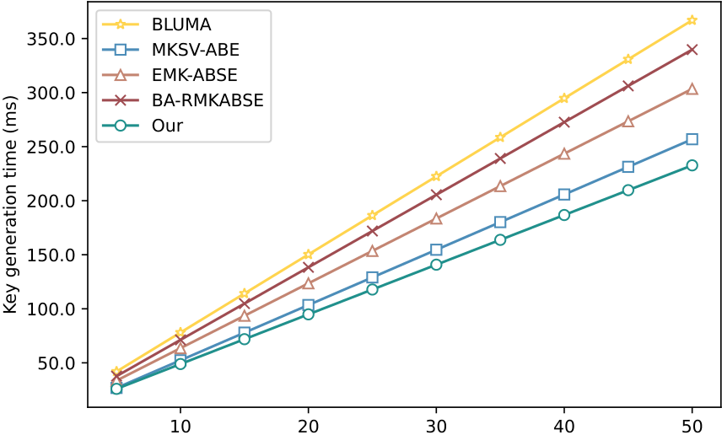

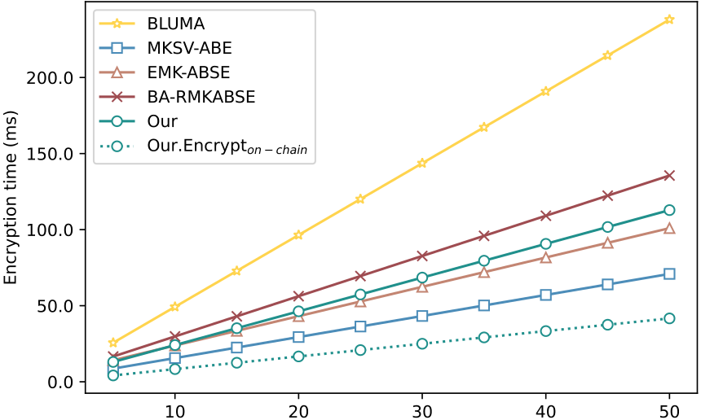

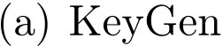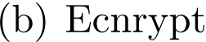
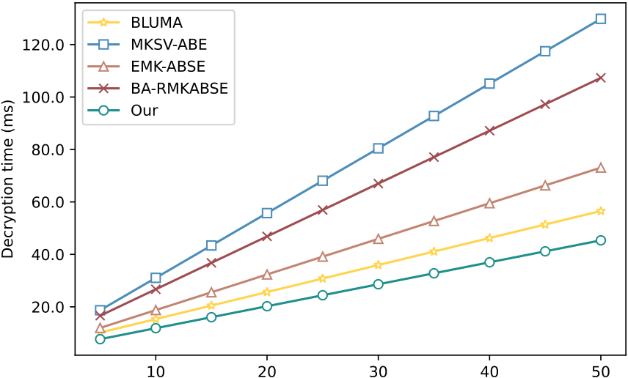
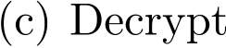
Fig.2.Comparisonofcomputationaloverheadin𝖪𝖾𝗒𝖦𝖾𝗇,𝖤𝗇𝖼𝗋𝗒𝗉𝗍and𝖣𝖾𝖼𝗋𝗒𝗉𝗍algorithms(|𝑚| = 100, |𝑚∗| = 3).
computes1∕𝑡𝑠𝑘),theresultdoesnotyieldΦ;rather,itisΦmultipliedbyauniformelementin𝔾𝑇,whichinformation-theoretically hidesΦ.Therefore,nounauthorizedkeymaterialenablesdecryption,evenundercollusion.
(ii)Outsourceddecryptionconfidentiality.
AccesstokenprivacyagainsttheES.TheESlearnsonly𝑡𝑝𝑘= 𝑔𝜗and= 𝜇𝜗𝑠,where=̂ 𝑒(𝑔, 𝑔).Fromtheseitcanform𝜗=̂ 𝑒(𝑔, 𝑡𝑝𝑘), soitsviewisthepair(𝜗, (𝜗)𝜇𝑠).Recovering𝜇𝑠fromthispairrequirescomputinga𝜗-throotin𝔾𝑇(i.e.,raisingto𝜗−1(mod𝑝)), whichamountstoinvertingthemap𝑥↦𝑥𝜗inaprime-ordergroupandisDLP-hard.Hence,underDLP,(, 𝑡𝑝𝑘)revealsno informationabout𝜇𝑠andthusnothingaboutΦ.
Confidentialityof.AfteranauthorizedDUrecoversΦ,itderives′𝑣𝑒𝑟= KDF(Φ ∥𝐻1(𝑔𝛿𝑣𝑒𝑟)).UnderthePRFassumptionforKDF andtheROmodelfor𝐻1,′𝑣𝑒𝑟ispseudorandomtoanypartylackingΦ.Encapsulatingunder′𝑣𝑒𝑟withanIND-CPAsymmetric
17

H.Chengetal. InternetofThings36(2026)101838

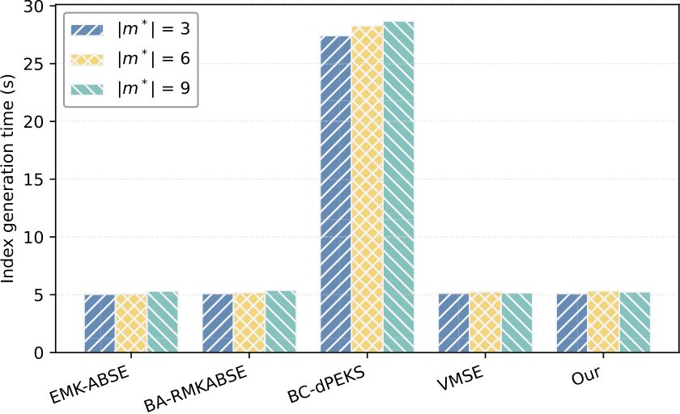

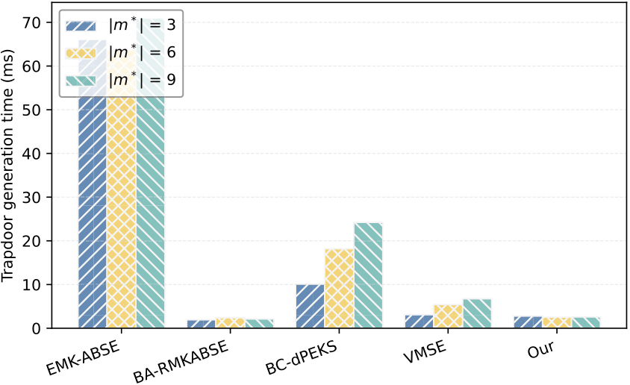

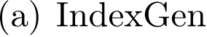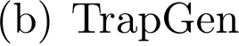
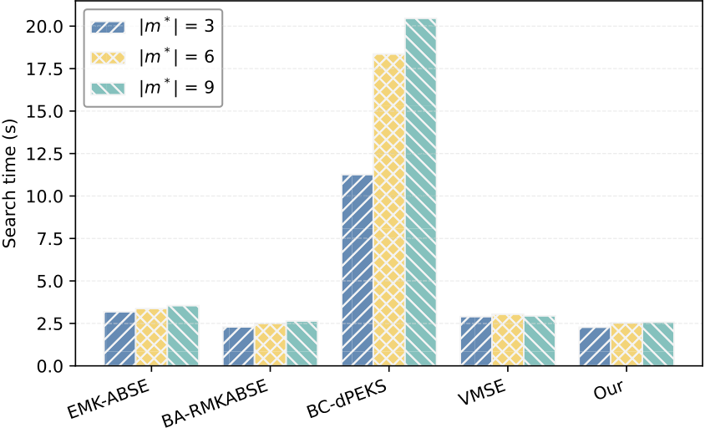
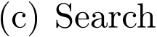
Fig.3.Comparisonofcomputationaloverheadin𝖨𝗇𝖽𝖾𝗑𝖦𝖾𝗇,𝖳𝗋𝖺𝗉𝖦𝖾𝗇,𝖲𝖾𝖺𝗋𝖼𝗁algorithms(|𝑚| = 100, |𝑚∗| ∈{3, 6, 9}).
schememakestheadversary’sviewindependentofunlessΦisknown;hencethefileciphertextisindistinguishablefromrandom
toanypartythatcannotreconstructΦ.
Thus,𝖡𝖠𝖬𝖪𝖲ensuresconfidentiality:onlyaDUholding𝑡𝑠𝑘andvalidattributekeyscanrecoverΦ,derive,anddecryptthe
files;whereastheESlearnsnothingaboutΦor.
6.2.4.SNIZKsecurityproof
Theorem4.AssumingthatDLPishardin𝔾and𝐻1ismodeledasarandomoracle,theaggregatedSNIZKproofusedin𝖯𝗋𝗈𝗈𝖿𝖵𝖾𝗋𝗂𝖿𝗒(⋅)
satisfies:(i)completeness:allhonestly-generatedproofsverify;and(ii)soundness:anyPPTprover(e.g.,theCSP)thatconvincestheverifier
withnon-negligibleprobabilitymustknowwitnesses{𝜎𝜅∗}suchthat𝑦𝜅∗= 𝑔𝜎𝜅∗.Hence,producinganacceptingproofwithoutvalidwitnesses
wouldsolveDLP.
∑𝐿∗
Proof.Let𝑦𝜅∗= 𝑔𝜎𝜅∗bethetagsofthematchedfiles.Theproverrandomlyselects𝑐𝜅∗$←←←←←ℤ∗𝑝,sets= 𝑔𝜅∗=1𝑐𝜅∗,deriveschallenges
ℎ𝜅∗= 𝐻1(𝑔∥𝑦𝜅∗∥),andoutputstheaggregatedresponsê𝜋=∑𝐿∗𝜅∗=1(𝑐𝜅∗+ ℎ𝜅∗𝜎𝜅∗).TheverifieracceptsifEq.(10)holds.
(i)Completeness.If𝑦𝜅∗= 𝑔𝜎𝜅∗and̂𝜋=∑𝐿∗𝜅∗=1(𝑐𝜅∗+ ℎ𝜅∗𝜎𝜅∗),then𝑔̂𝜋= 𝑔∑𝑐𝜅∗⋅∏(𝑔𝜎𝜅∗)ℎ𝜅∗= ⋅∏𝑦ℎ𝜅∗𝜅∗,soEq.(10)holds.
(i)Soundness.Model𝐻1asarandomoracle.SupposeaPPTCSPconvincestheverifierwithnon-negligibleprobability𝜖.Fixthe
prover’sinternalrandomnesssothat= 𝑔∑𝑐𝜅∗isdetermined.Runtheproveroncewiththerandomoracleandobtainanaccepting
transcript(,̂ 𝜋,{ℎ𝜅∗}).Thenreplaytheproverusingthesameinternalrandomnessandoracleanswers,exceptthatforatleast
onequery(𝑔‖‖𝑦𝜅∗‖‖)theoracleoutputsanindependentvalueℎ′𝜅∗≠ℎ𝜅∗.Bythegeneralizedforkinglemma,withprobability
𝜖= Ω(𝜖2∕poly(𝑞𝐻, 𝐿∗)thissecondrunalsosucceeds,yieldingtwoacceptingtranscriptsforthesame:𝑔̂𝜋= ⋅∏𝑦ℎ𝜅∗𝜅∗and
𝑔̂𝜋′= ⋅∏𝑦𝜅∗.Subtractingthetwoexponentsyieldŝ𝜋−̂ 𝜋′= ∑𝐿∗𝜅∗=1(ℎ𝜅∗−ℎ′𝜅∗) 𝜎𝜅∗fromwhichatleastonewitness𝜎𝜅∗canbe
extracted.Hence,anysuccessfulforgerywouldsolveDLPin𝔾.Therefore,𝖯𝗋𝗈𝗈𝖿𝖵𝖾𝗋𝗂𝖿𝗒(⋅)issoundintherandom-oraclemodel.
18

H.Chengetal. InternetofThings36(2026)101838
7.Performanceanalysis
7.1.Functionalitycomparison
AsshowninTable2,wecompareourschemewithstate-of-the-artABKSschemesalongsixdimensions:dynamicdatasharing, blockchain,multi-ownersetting,multi-keywordsearch,resultverification,andrevocation&traceability.Mostpriorschemesprovide onlypartialfeatures,whereas𝖡𝖠𝖬𝖪𝖲supportsallsixsimultaneously,makingitmoresuitableforreal-worldapplications.
7.2.Theoreticalperformance
Weperformatheoreticalanalysisofcomputationalandstorageoverheadofourschemeincomparisonwithcloselyrelated schemes,includingBLUMA[8],MKSV-ABE[21],EMK-ABSE[22],BA-RMKABSE[33],BC-dPEKS[40],andVMSE[54].
Table3showsthatBLUMA[8]incursthehighestcomputationaloverheadingeneratingdecryptionkeys.Thisismainlybecause itmapseachattributetoafixed-lengthhashvaluevia𝐻(𝖺𝗍𝗍𝑖)𝑖∈𝑢𝑖𝑑.AlthoughBLUMAsupportslarge-universeattributes,thisbenefit comesataconsiderableoverhead.Amongcomparableschemes,ourschemeachievesthelowestcomputationalcostfor𝖪𝖾𝗒𝖦𝖾𝗇(⋅). Fornotationalsimplicity,weuse𝖤𝗇𝖼𝗋𝗒𝗉𝗍(⋅)todenotethecompleteABE-basedaccesstokenencryptionprocedure,comprisingboth𝖳𝗈𝗄𝖾𝗇𝖤𝗇𝖼𝑜𝑓𝑓-𝑐ℎ𝑎𝑖𝑛and𝖳𝗈𝗄𝖾𝗇𝖤𝗇𝖼𝑜𝑛-𝑐ℎ𝑎𝑖𝑛,hereafter.Thecomputationalcostof𝖤𝗇𝖼𝗋𝗒𝗉𝗍(⋅)in𝖡𝖠𝖬𝖪𝖲ishigherthanthatinMKSV-ABE[21] andEMK-ABSE[22].However,sinceweemployahybridoff-andon-chainencryptionmechanism,theoutputof𝖳𝗈𝗄𝖾𝗇𝖤𝗇𝖼𝑜𝑓𝑓-𝑐ℎ𝑎𝑖𝑛(i.e.,𝐼𝐶𝑇Φ)remainsreusableevenwhentheaccesspolicyisupdated.Consequently,onlytheon-chainciphertextassociatedwith thepolicyrequiresre-computation,significantlyreducingtheencryptionoverhead.𝖡𝖠𝖬𝖪𝖲minimizesthetotaldecryptioncostby outsourcingcomputationallyintensiveoperationstotheES,leavingonlylightweightfinalcomputations(i.e.,𝐸𝑇)fortheDU.
Table4showsthatthetimeoverheadof𝖨𝗇𝖽𝖾𝗑𝖦𝖾𝗇(⋅)growswiththenumberofkeywordsinthedictionary(i.e.,|𝑚|).Ourscheme andMKSV-ABE[21]aretheonlytwothatsupportamulti-ownersetting.However,MKSV-ABEincurssubstantiallyhigherkeyword encryptiontimebecauseits𝖨𝗇𝖽𝖾𝗑𝖦𝖾𝗇(⋅)performsper-attributecomputationsovertheaccesspolicy,sothecostincreaseswiththe numberofpolicyattributes(i.e.,|𝓁|).Bycontrast,in𝖡𝖠𝖬𝖪𝖲thecostof𝖨𝗇𝖽𝖾𝗑𝖦𝖾𝗇(⋅)scalesmainlywiththenumberofkeywords,largely independentofthepolicysize,resultinginlowercomputationaloverhead.Allschemessupportmulti-keywordsearchbygeneratinga singletrapdoor.However,in[21]and[22],thetrapdoorcomputationisbasedontheuser’sattributesecretkeys,resultinginlinearly increasing𝖳𝗋𝖺𝗉𝖦𝖾𝗇(⋅)timeasthenumberofattributesgrows.Incontrast,ourschemeaggregatesthequerykeywordsbeforegenerating𝐓𝐫𝐚𝐩̃,whichkeepsthecomputationaloverheadof𝖳𝗋𝖺𝗉𝖦𝖾𝗇(⋅)lowerandmorestable.Regarding𝖲𝖾𝖺𝗋𝖼𝗁(⋅)time,ourschemeachieves thelowestcomputationalcostamongallcomparedschemes:itiscomparabletoBA-RMKABSE[33],significantlylowerthan[21], andconsistentlymoreefficientthanotherrepresentativeschemes[22,40,54].
Table5showsthatthestorageoverheadsforusersecretkeysandciphertextsincreasewiththenumberofattributes.Ourtheoretical analysisindicatesthat,amongthecomparedschemes,oursyieldstheloweststoragecostforattributesecretkeys.Althoughthe ciphertextsizeinourschemeiscomparativelylarge,weadoptahybridencryptionarchitectureinwhichpartoftheencryptionis performedoff-chainandtheremainderon-chain.Theimmutableciphertext𝐼𝐶𝑇Φisstoredonlyoncewithsize2|𝓁||𝔾| + |𝓁||𝔾𝑇|, whileeachpolicyupdatestoresonlyanewon-chainciphertextofsize((|𝓁| + 1)|𝔾| + |𝔾|𝑇),whichissmallerthanthosereportedin [8],[22],and[33].Inaddition,ourschemeisspace-efficientinstoringtheindexandtrapdoors,whosesizesareindependentofthe attributes.Thesizeoftheindex𝐈𝐧𝐝𝐞𝐱scaleswiththekeyworddictionarysize|𝑚|andthenumberofDOs|𝑁|.Intermsoftrapdoor size,ourschemeincursslightlyhigheroverheadthan[33],whileremainingloweroverheadthan[22].
7.3.Experimentalperformance
7.3.1.Simulationenvironment
WeimplementedallsimulationsinPython3.7usingtheCharm-Crypto0.50andweb3onUbuntuLinux22.04equippedwith anAppleM1Pro-chipand16GBRAM.AllschemesemploytheSS512pairinggroupandEthereumastheblockchainplatform. ExperimentsareconductedontheEnronEmaildataset(2015)2,whichcontainsover500,000emails.Wemeasurethecostsof𝖪𝖾𝗒𝖦𝖾𝗇(⋅),𝖤𝗇𝖼𝗋𝗒𝗉𝗍(⋅),and𝖣𝖾𝖼𝗋𝗒𝗉𝗍(⋅)byvaryingthenumberofsystemattributesfrom10to50.Furthermore,𝖨𝗇𝖽𝖾𝗑𝖦𝖾𝗇(⋅)and𝖳𝗋𝖺𝗉𝖦𝖾𝗇(⋅) areevaluatedonasubsetof2000randomlyselectedemailswithakeyworddictionaryof100keywords(|𝑚| = 100)under50attributes, wherethenumberofquerykeywordsissetto|𝑚∗| ∈{3, 6, 9}.Toenablefaircomparisonofcomputationalandstorageoverhead,all blockchain-relatedcostsareexcludedinthefollowingevaluation.
7.3.2.Experimentalcomputationoverheadcomparison
In𝖪𝖾𝗒𝖦𝖾𝗇,Fig.2(a)showsthattherunningtimeofallschemesgrowswiththenumberofattributes,whilethegrowthrateofour schemeisconsiderablylower.When||is50,thetimeofgeneratingusersecretkeysis233.20msforourscheme,and365.47ms, 260.64ms,302.38ms,and335.91msforBLUMA[8],MKSV-ABE[21],EMK-ABSE[22],andBA-RMKABSE[33],respectively.
In𝖤𝗇𝖼𝗋𝗒𝗉𝗍,Fig.2(b)illustratesthatthetimecostincreasesroughlylinearlywiththenumberofpolicyattributes|𝓁|.Inourscheme, hashoperationsdominatetheruntime,outweighingexponentiationsin𝔾and𝔾𝑇.When|𝓁| = 50,thetotalencryptiontimeofour schemeis119.98ms,whichishigherthanthatof[21](68.26ms)and[22](101.49ms).Nevertheless,the𝐸𝑛𝑐𝑟𝑦𝑝𝑡𝑜𝑛-𝑐ℎ𝑎𝑖𝑛time requiresonly42.06ms,indicatingasignificantlylowercostthatisbothacceptableandpracticalforIoTapplications.
2Availableat
19

H.Chengetal. InternetofThings36(2026)101838

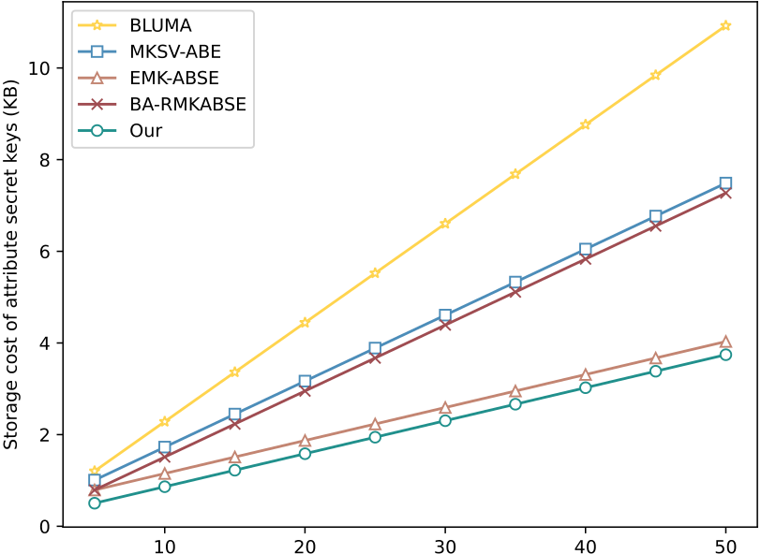

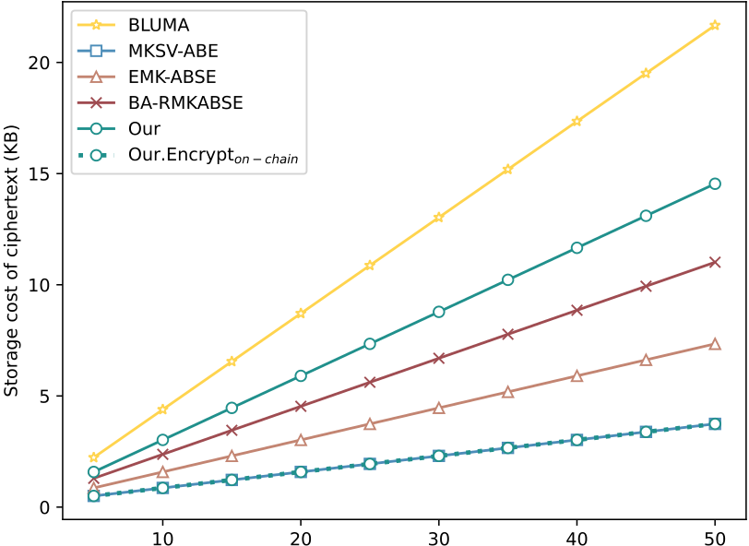

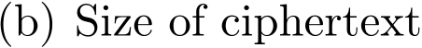
Fig.4.Comparisonstorageoverheadinusersecretkeysandciphertext(|𝑚| = 100,|𝑚∗| = 3).

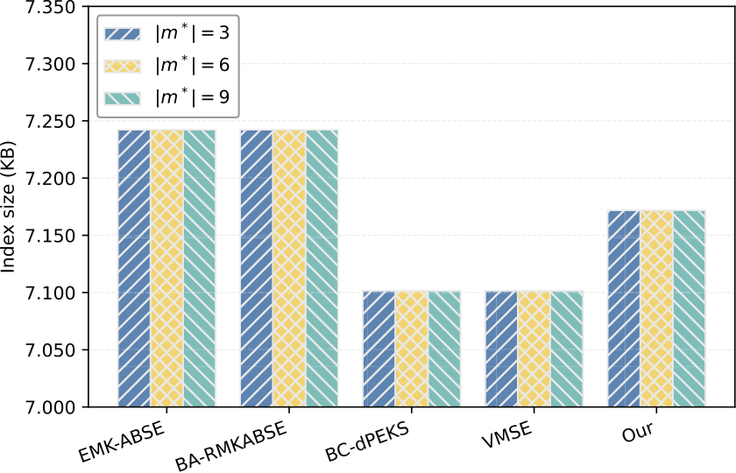
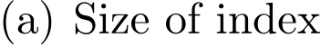

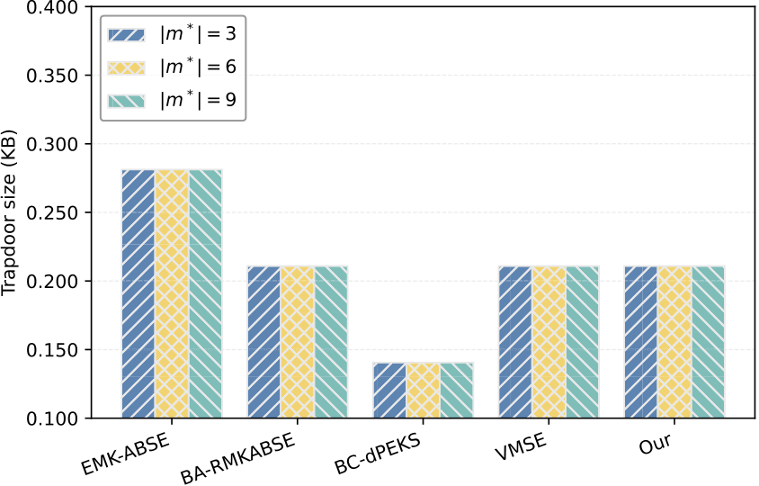
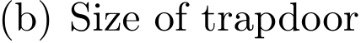

Fig.5.Comparisonstorageoverheadinindexandtrapdoor(|𝑚| = 100,|𝑚∗| ∈{3, 6, 9}).
In𝖣𝖾𝖼𝗋𝗒𝗉𝗍,Fig.2(c)showsthatourschemeachievesthemostefficientdecryption,requiringonly48.43ms.Incomparison,BLUMA [8],MKSV-ABE[21],EMK-ABSE[22],andBA-RMKABSE[33]incur60.27ms,136.73ms,74.02ms,and108.96ms,respectively.
In𝖨𝗇𝖽𝖾𝗑𝖦𝖾𝗇,Fig.3(a)showsthattheexecutiontimeof𝖨𝗇𝖽𝖾𝗑𝖦𝖾𝗇(⋅)remainsnearlyconstantwithrespecttothenumberofqueried keywords|𝑚∗|.When|| = 50and|𝑚∗| = 3,ourschemerequiresonly5.11s,whichiscomparableto[22],[33],and[54],butis substantiallyfasterthan[40],whichincurs27.42sduetoitsmoreexpensivepairingandmultiplicationoperations.
In𝖳𝗋𝖺𝗉𝖦𝖾𝗇,Fig.3(b)indicatesthattrapdoorgenerationcostincreasesmodestlywith|𝑚∗|.When|𝑚∗| = 3,[22]and[40]incur considerablyhighercosts,averaging66.11msand10.10ms,respectively.Incontrast,ourschememaintainsconsistentlylowoverhead (2.52ms),whichiscloseto[33](1.95ms)and[54](3.12ms).Thisdemonstratestheefficiencyofourtrapdoorconstruction.
In𝖲𝖾𝖺𝗋𝖼𝗁,Fig.3(c)showsthat|𝑚|isnotacriticalfactorindeterminingsearchtime.When|𝑚∗| = 3,ourschemeattainscompetitive performance(2.28s),comparableto[33](2.29s)and[54](2.91s),whilesignificantlyoutperforming[22](3.19s)andespecially [40](11.27s).Theseresultsconfirmthatourschemeachievesbothefficiencyandscalabilitybysustainingstablesearchperformance irrespectiveofthenumberofattributesorqueriedkeywords.
7.3.3.Experimentalstorageoverheadcomparison
Weevaluatestorageforusersecretkeys,ciphertexts,indexes,andtrapdoors.Fig.4(a)showsthatourschemerequiresonly 3.656 KBforusersecretkeys,thesmallestamongthemeasuredcomparisons.Fig.4(b)showsthatourschemeinitiallyappearsto havethelargestciphertextstoragerequirementatapproximately14.203 KB,whereastheon-chainciphertextstorageisremarkably lowatabout3.656 KB.AsshowninFig.5(a)-(b),ourschemerequiresonly7.127 KBtostoretheencryptedkeywordindexwhen |𝑁| = 1and|𝑚∗| = 3,andtheindexsizeremainsconstantasthenumberofattributes|𝓁|increases,therebydemonstratingscalability.
20

H.Chengetal. InternetofThings36(2026)101838

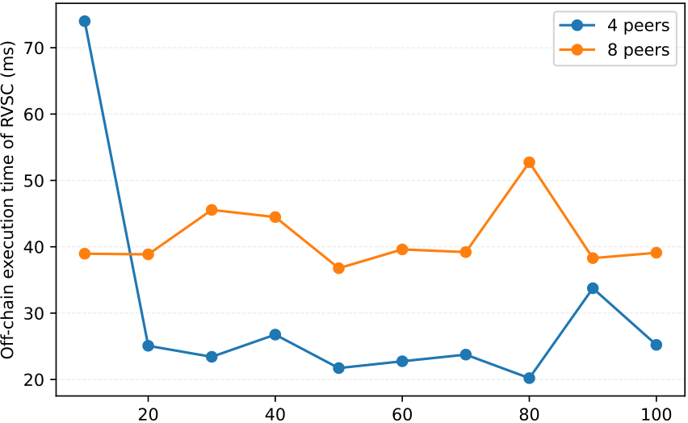

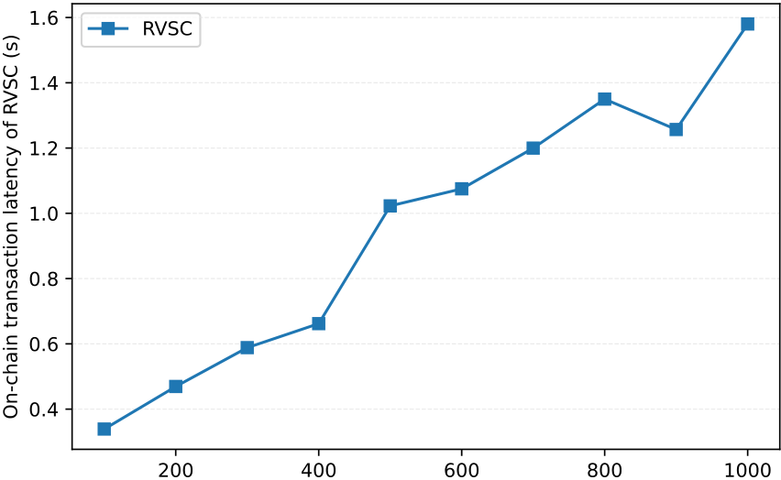

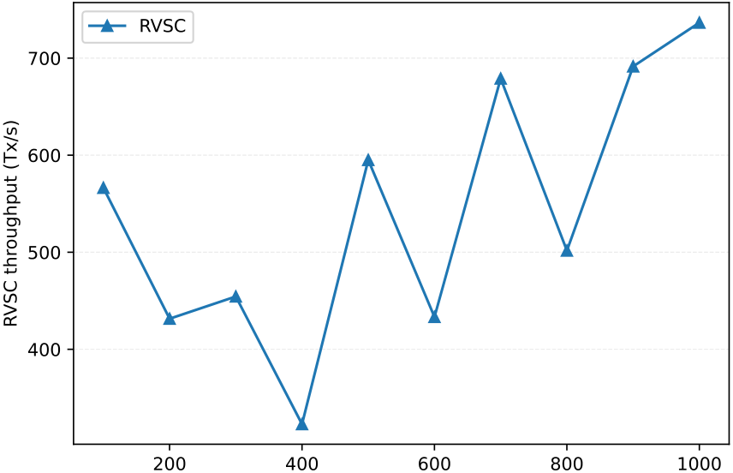
Fig.6.Smartcontractoverhead.
Inaddition,thetrapdoorsizeismaintainedatjust0.211 KB.Bothvaluesaresmallerthanthosereportedinpriorworks,wherethe encryptedindexreaches7.242 KBin[22,33]andthetrapdoorsizeis0.281KBin[22].
7.3.4.Experimentalblockchainoverheadanalysis
Inthissection,weevaluatetheperformanceoftheResultVerificationSmartContract(RVSC).Tobalancesecurityandefficiency, thesystemadoptsahybridon-chain/off-chainarchitecture,wheretheSNIZKproofisgeneratedandpartiallyverifiedoff-chainto reducecomputationaloverhead,whilethesmartcontractperformsthefinalcorrectnessvalidationandrecordstheverificationresult on-chain,therebyensuringintegrityandnon-repudiation.
TheRVSCwasinstantiatedonaprivateEthereumusingGeth,requiring145,448gasfordeploymentandexecutedwitha20 % safetybuffer(gaslimit=174,537,gasprice=8Gwei).Afterdeployment,eachproofverificationtransactionincurredagasfee (≈21,000gas),asthecontractenforcesthefinalcorrectnessvalidationandanchorstheresulton-chain.Inaddition,approximately 10.78 KBofdata(3.656 KBofpartialciphertextand7.127 KBofkeywordindex)isstoredon-chainfortamper-proofauditing.
Fig.6(a)presentstheoff-chainverificationcostundertwosettingswith4and8peernodes.Theexperimentvariesthekey-worddictionarysize|𝑚|from10to100,whilethequerysize(|𝑚∗| = 3)anddataset(2000emails)arefixed.Sincethenumber ofmatchedfilesremainsunchanged,theproofsizeandtheverificationworkloadremainstableacrossdictionarysizes,indicat-ingthattheverificationcostisdeterminedbythequerycomplexityratherthanthedictionarysize,therebydemonstratingstrong scalability.When|𝑚| = 100,theaverageverificationtimeisapproximately25.22mswith4peersand39.10mswith8peers. Themoderateincreaseisattributedtotheoverheadassociatedwithmanagingadditionalparallelthreadsinthelocalsimulation environment.
Fig.6(b)showsthetransactionlatencyfortheon-chainproofverification,measuredastheend-to-enddurationfromtransac-tionsubmissiontoconfirmation.TheexperimentwasconductedonaprivateblockchainnetworkusingaProof-of-Authority(PoA) consensusprotocolwithimmediateblockfinality,enablingconsistentlatencymeasurements.Theresultsshowthattheaveragela-tencyincreasesfrom0.34sfor100concurrenttransactionsto1.58sfor1000transactions.Theincreaseresultsfromqueuingatthe validator,wherealargertransactionpooldelaysblockinclusion.
21

H.Chengetal. InternetofThings36(2026)101838
Fig.6(c)illustratesthesystem’sthroughputfortheon-chainproofverificationprocess,measuredintransactionspersecond(TPS). Theresultsindicatethatthethroughputimprovesasthetransactionbatchsizeincreases,risingfrom566.42TPSforabatchof100 transactionsto736.54TPSforabatchof1000transactions.
Insummary,althoughblockchaininevitablyintroducesadditionaloverhead,theresultingtamper-resistanceandauditablever-ificationsignificantlyenhancethetrustworthinessof𝖡𝖠𝖬𝖪𝖲,makingitsuitablefordeploymentincloud-edge-IoTenvironments. Furthermore,𝖡𝖠𝖬𝖪𝖲supportsflexibleandpracticalfunctionalitiesrequiredinreal-worldapplications.
8.Conclusion
Thispaperpresentsablockchain-assisted,attribute-basedmulti-keywordsearchschemefordynamicencrypteddata,termed𝖡𝖠𝖬𝖪𝖲.Theschemeenablesmultipledataownerstocollaborativelygenerateatokenfordataaccess,ensuringthatauthorized userscanretrievetheversion-specificfiles.Moreover,itsupportsverifiablemulti-keywordsearchviaanaggregatedSNIZKproof, whileprovidingattributeanduserrevocationaswellasusertraceability.Experimentalevaluationsdemonstratetheefficiencyand practicalityofthescheme.Inaddition,𝖡𝖠𝖬𝖪𝖲isprovenIND-CPAandIND-CKAsecureundertheDBDHassumption,whileoutsourced decryptionandproofverificationareshownsecureundertheDLPassumption.Comparedwithexistingworks,ourschemeachieves strongersecurityguaranteeswithacceptablecomputationalandcommunicationoverheads.Tothebestofourknowledge,thisisthe firstworktosimultaneouslysatisfyalltheseproperties,makingitparticularlysuitableforsecureandefficientcloud-edge-IoTdata storage.Inthefuture,weplantoextend𝖡𝖠𝖬𝖪𝖲tosupporttime-sensitivedatasharingwithadding,deleting,andinsertingoperations.
CRediTauthorshipcontributionstatement
HanleiCheng:Writing–originaldraft,Visualization,Validation,Software,Methodology,Investigation,Formalanalysis,Con-ceptualization;Sio-LongLo:Writing–review&editing,Supervision,Projectadministration,Methodology,Conceptualization;Jing Lu:Writing–review&editing,Validation,Methodology,Investigation.
Dataavailability
Datawillbemadeavailableonrequest.
Declarationofinterests
Theauthorsdeclarethattheyhavenoknowncompetingfinancialinterestsorpersonalrelationshipsthatcouldhaveappearedto influencetheworkreportedinthispaper.
References
[1]
[2]
[3]
[4]
[5]
[6]
[7]
[8]
[9][10]
[11]
[12]
[13]
[14]
[15]
[16]
22

H.Chengetal. InternetofThings36(2026)101838
[17]
[18]
[19]
[20]
[21]
[22]
[23]
[24]
[25]
[26]
[27]
[28][29]
[30]
[31][32]
[33]
[34]
[35]
[36]
[37]
[38]
[39]
[40]
[41]
[42]
[43]
[44]
[45]
[46][47]
[48][49]
[50]
[51]
[52]
[53]
[54]
23

