Title of the invention: Driver Drowsiness Detection System Using Machine Learning
Abstract
Driver drowsiness is a significant factor contributing to road accidents worldwide. Early detection of drowsiness can save lives by preventing accidents caused by reduced reaction times and inattentiveness. This paper proposes a driver drowsiness detection system leveraging machine learning algorithms to monitor and analyze driver behavior. The system utilizes computer vision and physiological signals to identify signs of fatigue, such as prolonged eye closure, yawning frequency, and head posture. By integrating these features into a machine learning model, the system achieves high accuracy in real-time detection and alerts the driver promptly to avoid accidents.

PROPOSED METHODOLOGY
- Data Acquisition:
  - Visual Data: Utilize a camera to capture video of the driver's face in real time. The video frames are preprocessed to detect key facial landmarks such as eyes, mouth, and head position.
- Feature Extraction:
  - Facial Features: Use computer vision techniques such as Haar cascades or Dlib’s facial landmark detector to extract eye aspect ratio (EAR).
- Preprocessing:
  - Normalize and filter the data to reduce noise and ensure consistency across diverse lighting conditions and camera angles.
  - Implement techniques such as histogram equalization for video frames.
- System Integration:
  - Deploy the trained model on an embedded system or edge device to facilitate real-time drowsiness detection.
  - Integrate with an alert mechanism, such as audio alarms or seat vibrations, to immediately notify the driver when drowsiness is detected.

- Performance Evaluation:
  - Validate the system’s accuracy using metrics such as precision, recall, and F1-score.
  - Conduct real-world testing under varying environmental conditions to ensure reliability.
- Improvement and Scalability:
  - Introduce adaptive learning mechanisms to personalize the system for individual drivers based on their unique behavior patterns.
  - Explore cloud-based solutions for processing and improving scalability, enabling fleet-wide deployment.
This methodology emphasizes the use of computer vision techniques focusing solely on face detection, along with robust machine learning techniques, to develop a highly accurate and real-time driver drowsiness detection system.
Flowchart:
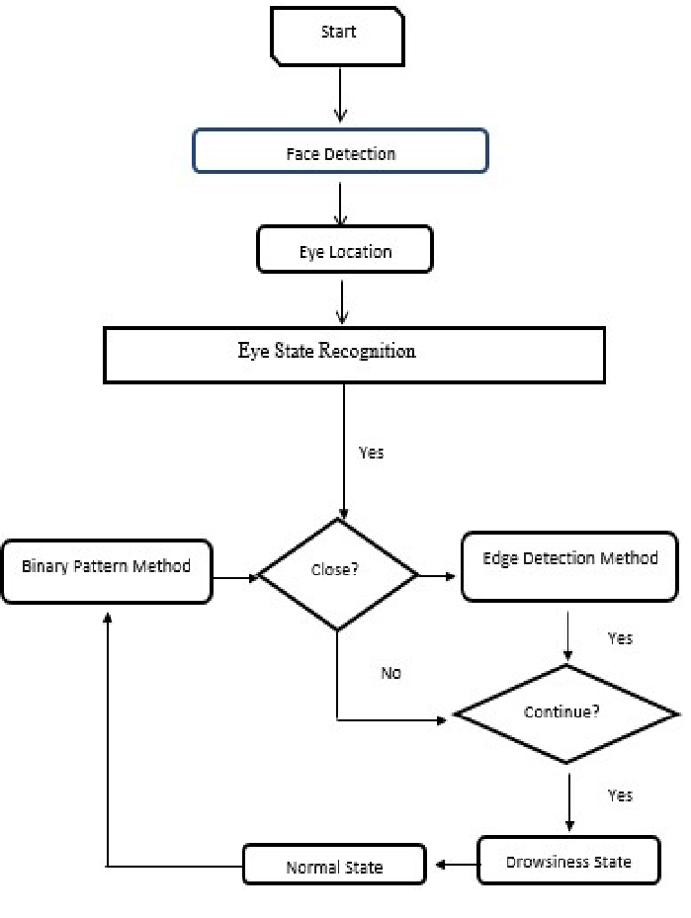

Name of Applicant:
- Prof. (Dr.) Umashankar Sharma
Address of Applicant: Professor, Department of CSE (AI&ML), Greater Noida Institute of Technology (Engineering Institute), Greater Noida, Uttar Pradesh-201310-------------
- MS. Nikita
Address of Applicant: Assistant Professor, Department of CSE (AI&ML), Greater Noida Institute of Technology (Engineering Institute), Greater Noida, Uttar Pradesh-201310-------------
- Prashant Kumar Mishra
Address of Applicant: Student, Department of CSE (AI&ML), Greater Noida Institute of Technology (Engineering Institute), Greater Noida, Uttar Pradesh-201310-------------
- Sameer Khan
Address of Applicant: Student, Department of CSE (AI&ML), Greater Noida Institute of Technology (Engineering Institute), Greater Noida, Uttar Pradesh-201310-------------
- Mohd Azam Khan
Address of Applicant: Student, Department of CSE (AI&ML), Greater Noida Institute of Technology (Engineering Institute), Greater Noida, Uttar Pradesh-201310--------------

Name of Inventor:
- Prof. (Dr.) Umashankar Sharma
Address of Applicant: Professor, Department of CSE (AI&ML), Greater Noida Institute of Technology (Engineering Institute), Greater Noida, Uttar Pradesh-201310-------------
- MS. Nikita
Address of Applicant: Assistant Professor, Department of CSE (AI&ML), Greater Noida Institute of Technology (Engineering Institute), Greater Noida, Uttar Pradesh-201310-------------
- Prashant Kumar Mishra
Address of Applicant: Student, Department of CSE (AI&ML), Greater Noida Institute of Technology (Engineering Institute), Greater Noida, Uttar Pradesh-201310-------------
- Sameer Khan
Address of Applicant: Student, Department of CSE (AI&ML), Greater Noida Institute of Technology (Engineering Institute), Greater Noida, Uttar Pradesh-201310-------------
- Mohd Azam Khan
Address of Applicant: Student, Department of CSE (AI&ML), Greater Noida Institute of Technology (Engineering Institute), Greater Noida, Uttar Pradesh-201310--------------

