Student
1. Registration & Login
- Sign up with name, email, phone, password
- Login with email and password
- JWT token stored, auto-login on refresh
- Protected routes — can't access dashboard without login
2. Dashboard
- Sees real name, email, phone, role
- Sees payment status — Paid or Unpaid
- Sees exam status — Pending or Attempted
- Sees best score, rank after attempting
- Pay Now button if unpaid
- Start Exam button if paid and not attempted
- List of all attempts with scores and View Result button
3. Payment
- Clicks Pay Now → goes to payment page
- Sees order summary — amount, GST, total
- Clicks Pay → payment initiated in DB → transaction ID generated → marked as PAID
- Sees confirmation screen with transaction ID
- Goes to exam from payment success screen
4. Exam
- Sees instruction page — total questions, time, sections, rules
- Clicks Start → attempt created in backend
- 50 questions across 5 sections — Quantitative, Reasoning, English, GK, Technical
- 60 minute countdown timer — turns amber at 10 min, red at 5 min
- Click any option to select answer
- Mark for Review — marks question in amber
- Question navigation panel — shows answered, unanswered, review, current
- Prev / Next navigation
- Tab switch detected and warned on screen
- Manual Submit button with confirmation
- Auto-submit when timer hits zero
5. Result
- Score — e.g. 38/50
- Percentage
- Rank — among all students who attempted
- Percentile
- Time taken
- Section-wise performance with progress bars — each of 5 sections
- Full question review — every question, your answer, correct answer, explanation
- Export CSV — downloads full result as spreadsheet
6. Leaderboard
- Top 3 shown as podium
- Full table — rank, name, score, percentage, percentile, time
- Sorted by highest score, then lowest time as tie-breaker
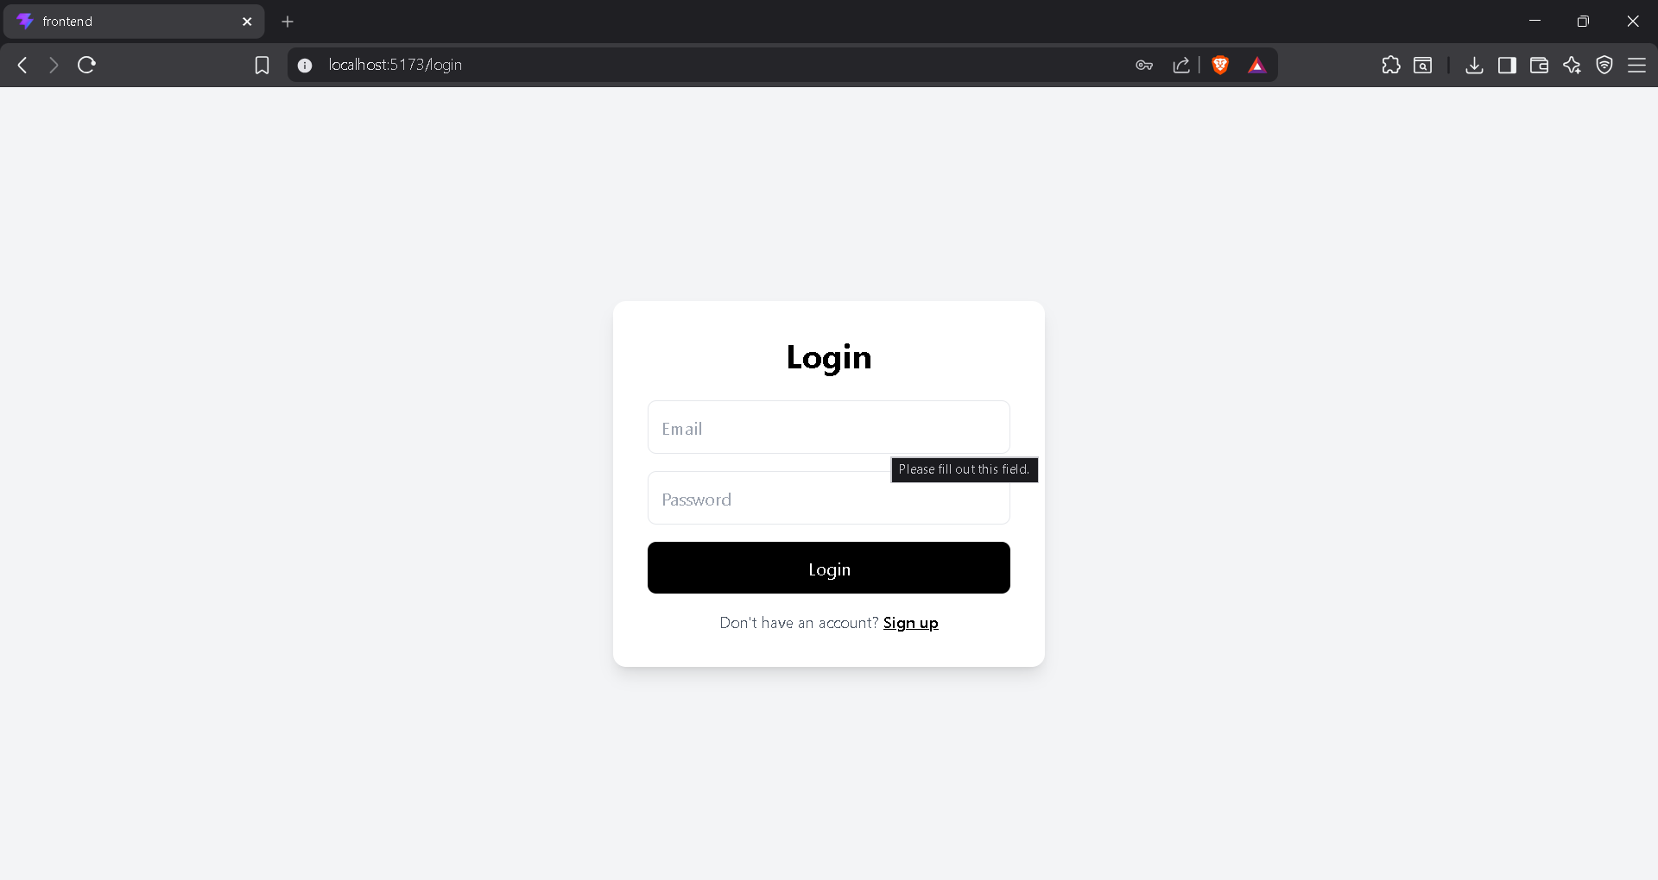
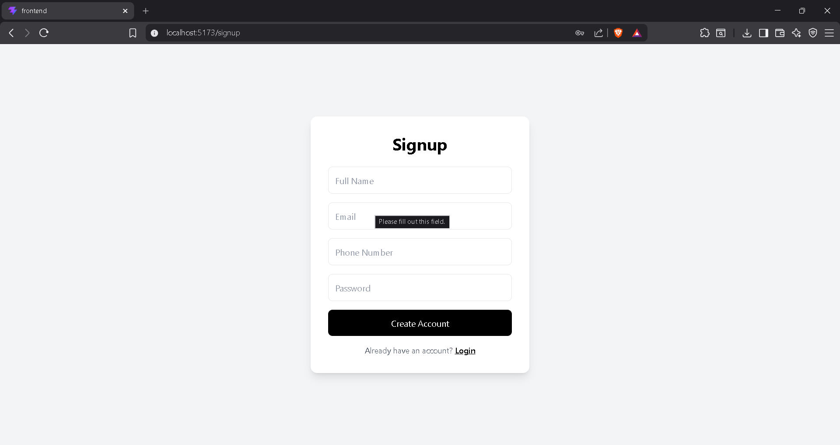
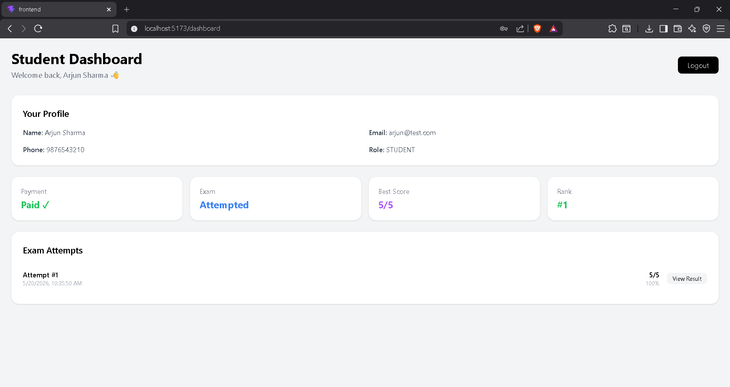
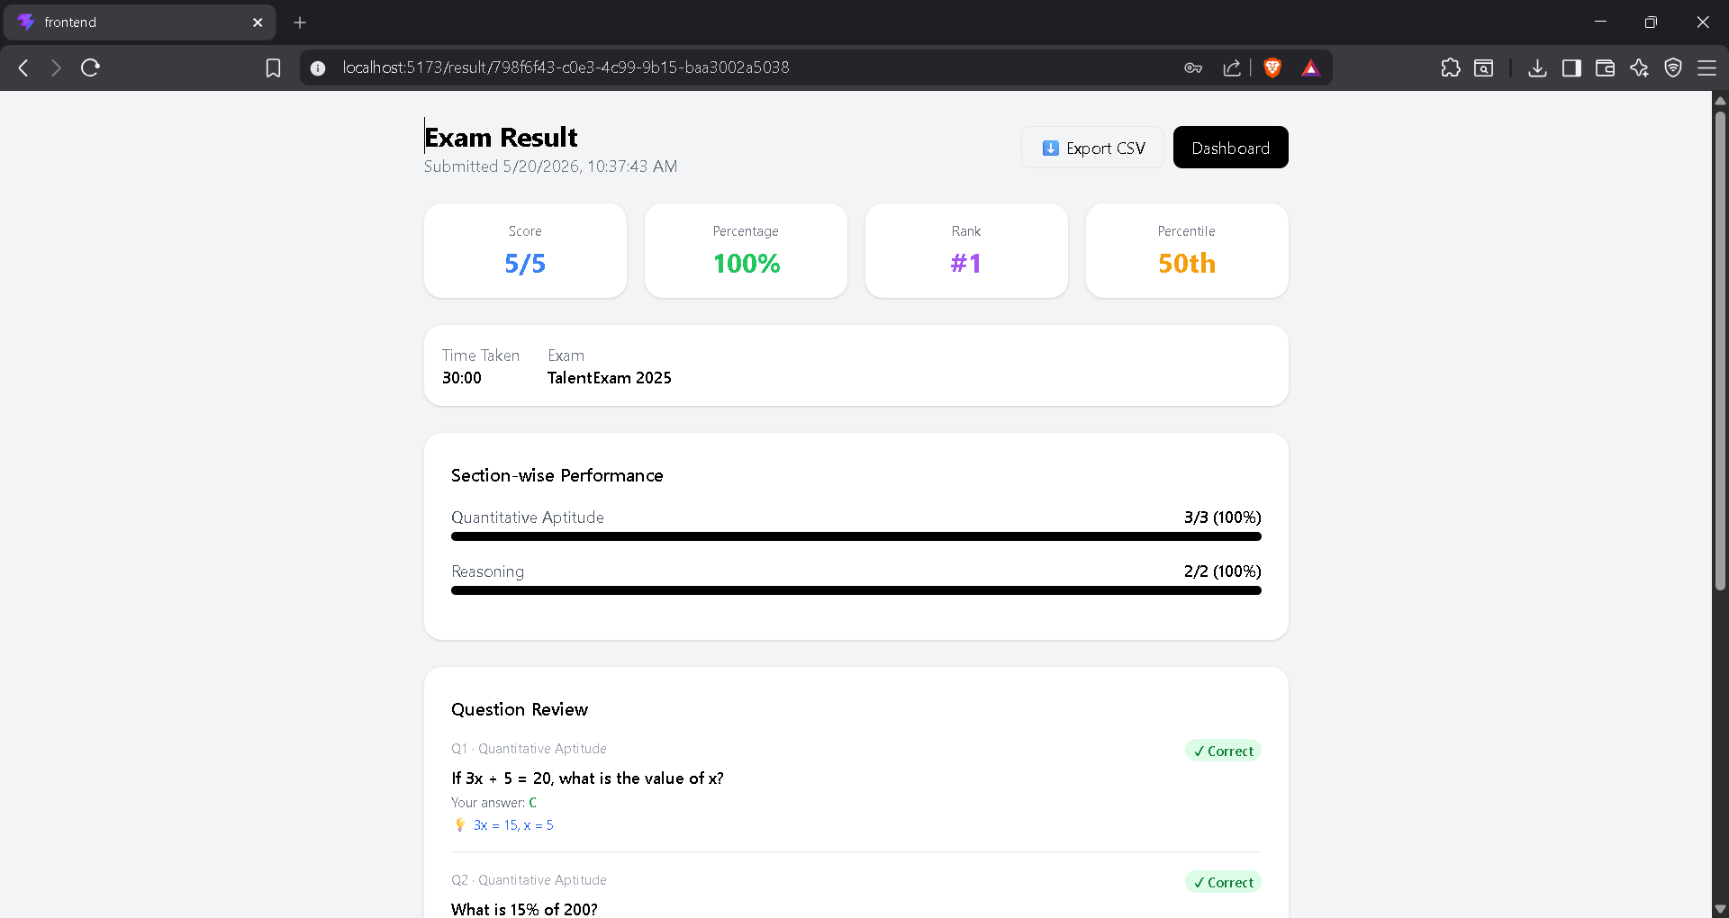

Admin
1. Login
- Separate admin account
- Redirects to admin panel after login
- Students can't access /admin
2. Overview Tab
- Total students registered
- Total paid students
- Total exam submissions
- Exam enabled or disabled status
- Recent submissions with name, score, timestamp
3. Students Tab
- List of all registered students
- Name, email, phone
- Payment status — Paid or Unpaid
- Exam status — Done or Pending
4. Payments Tab
- All payment records
- Student name and email
- Amount, transaction ID, status, date
5. Results Tab
- Full leaderboard with ranks
- Name, email, score, percentage, percentile, time
- Export CSV — downloads all results as spreadsheet
6. Questions Tab
- Add new questions to any section
- Choose section from dropdown
- Write question text
- Fill 4 options — A, B, C, D
- Select correct answer via radio button
- Optional explanation
- Question gets added to DB instantly
7. Settings Tab
- Enable or disable exam — students can't start if disabled
- Allow or block reattempt — if enabled, students can retake
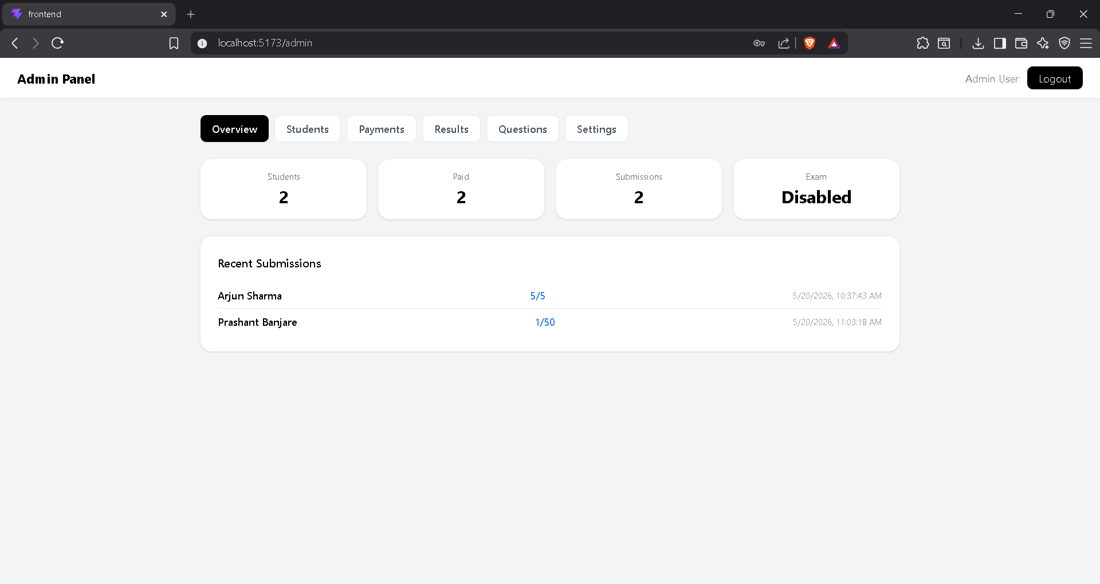
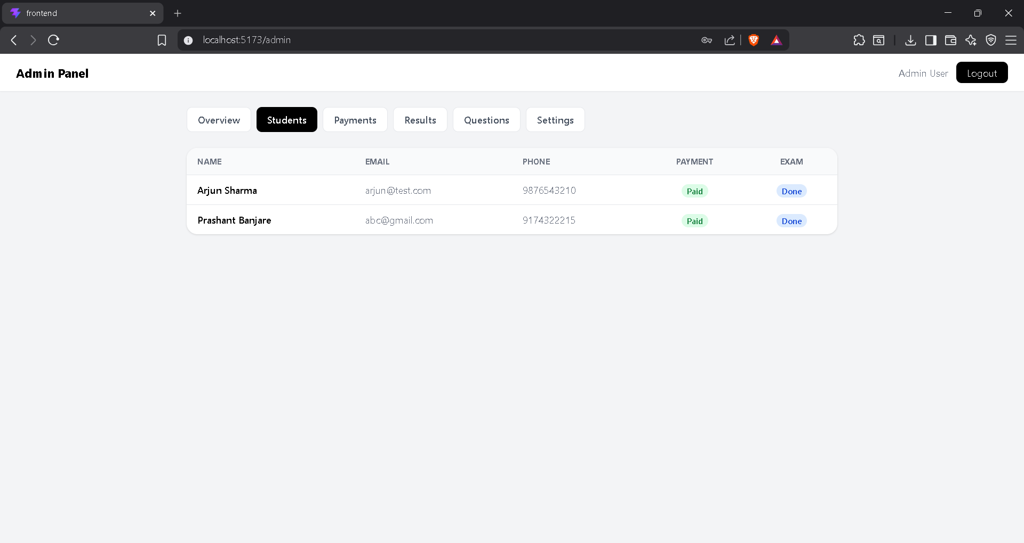
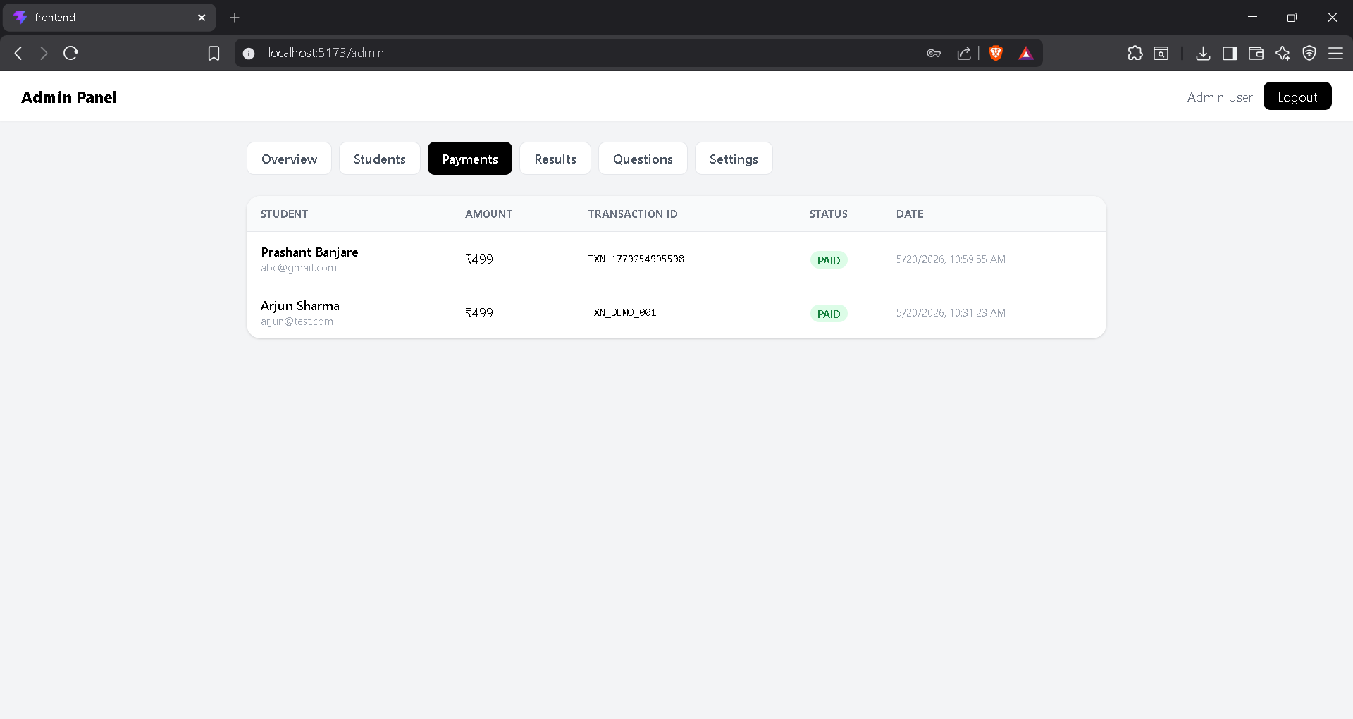
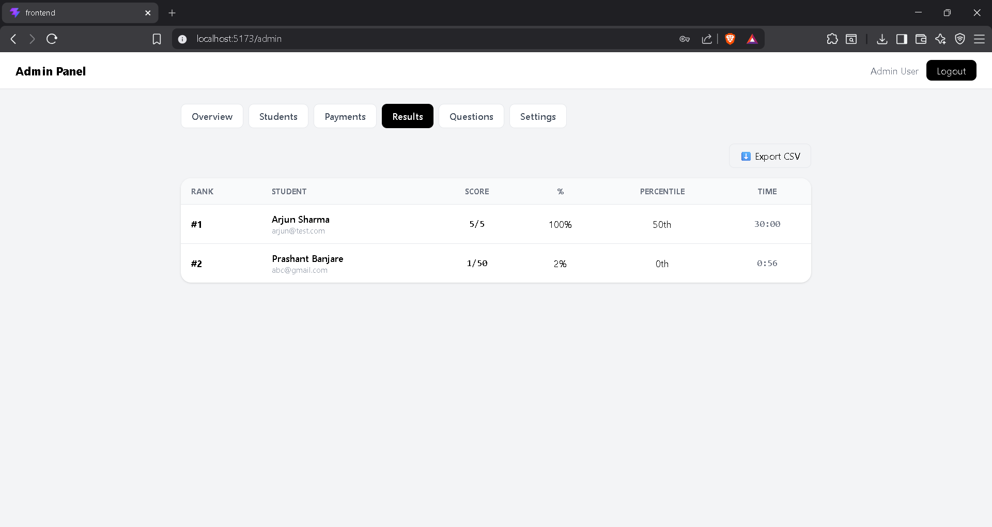
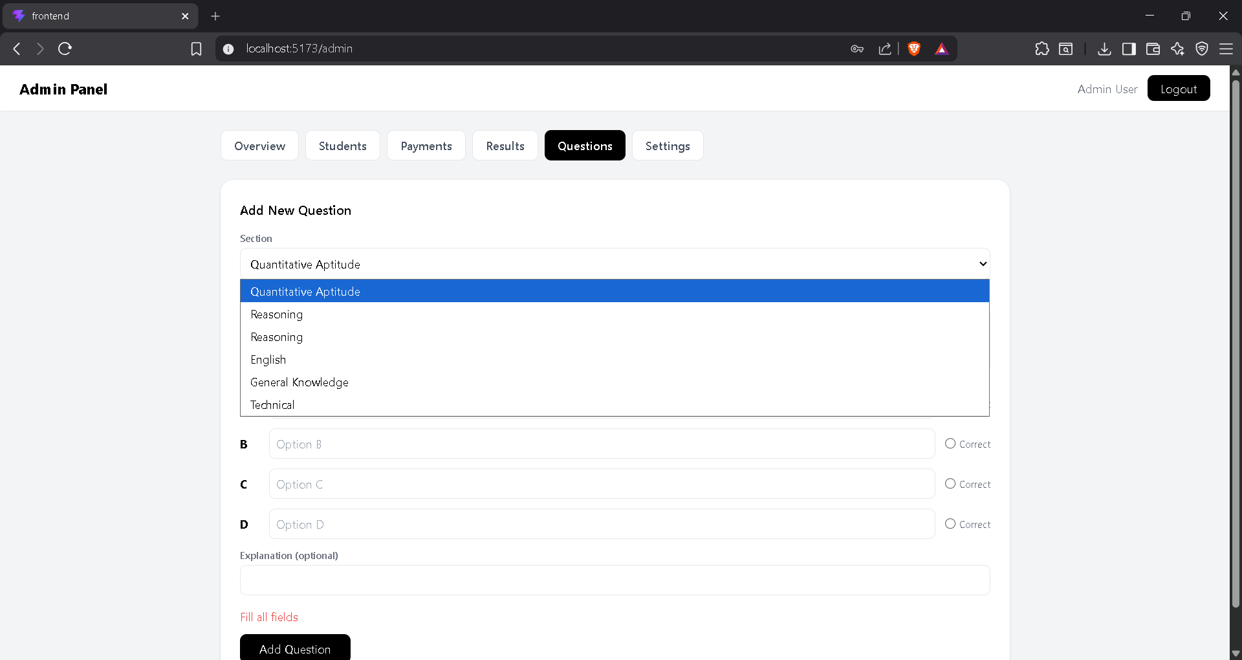
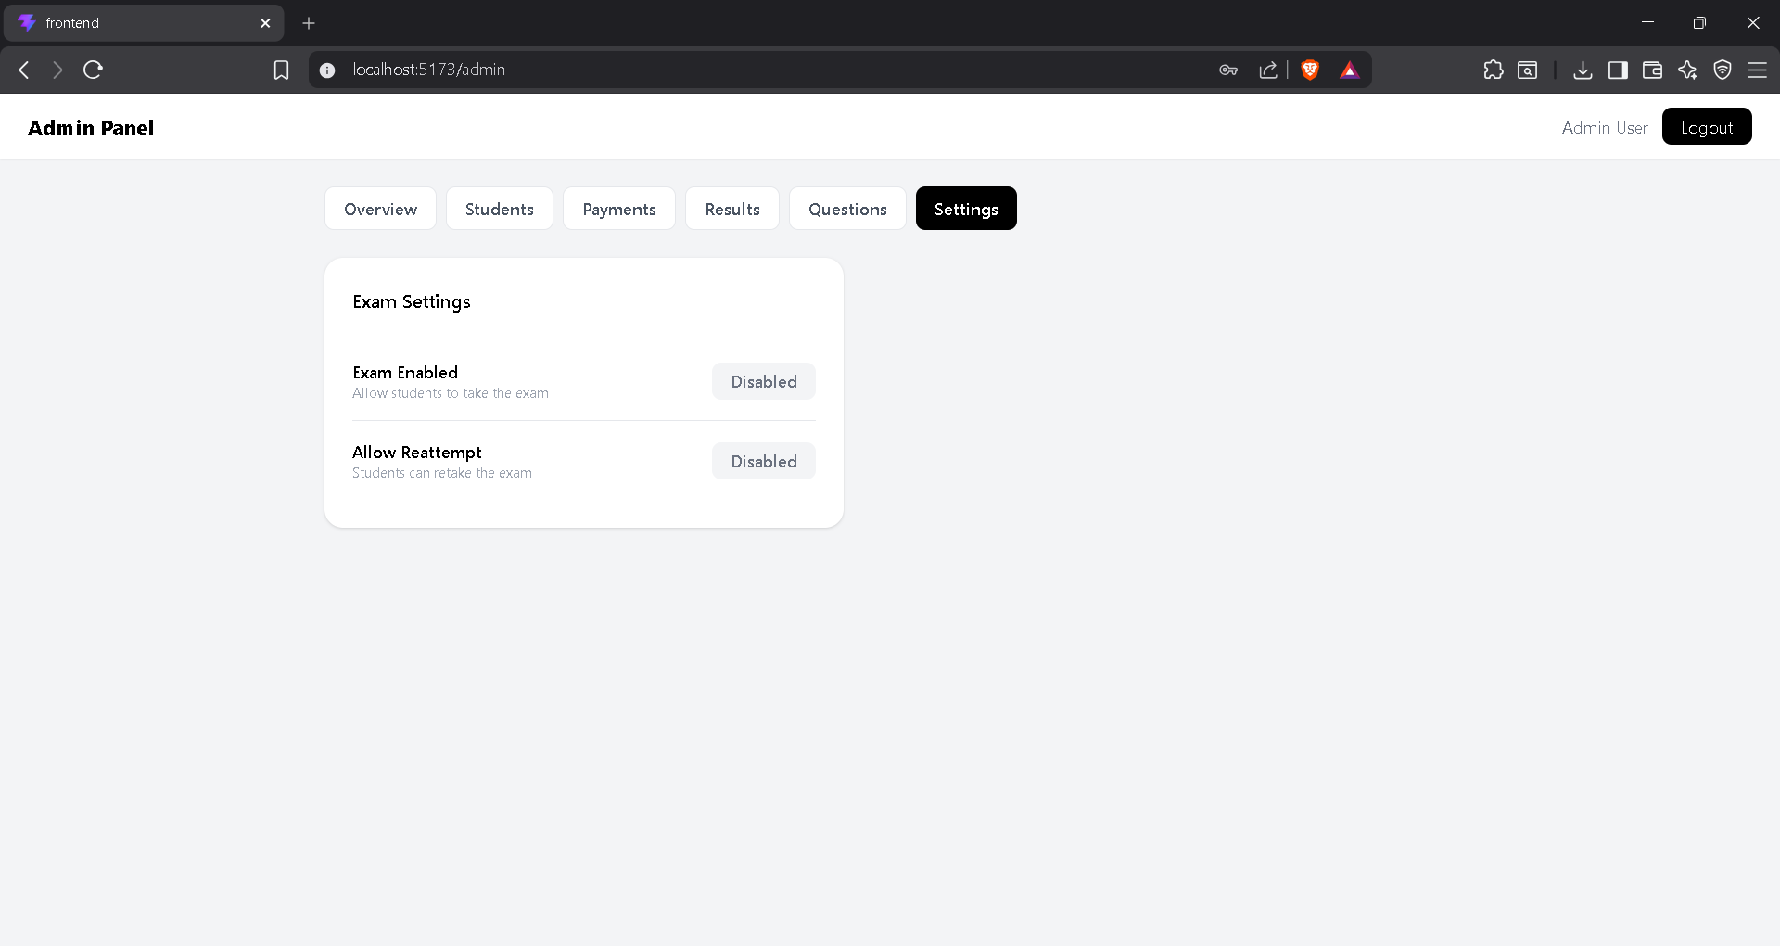

What's NOT built yet

Feature | Status
Forgot password | No
Email notifications | No
Real Razorpay integration | No (simulated)
Admin delete questions | No
Admin allow reattempt per student | No
Profile edit page | No
Socket.IO real-time | No
AI proctoring / webcam | No
Deployment | No

