 

INSTITUTE FOR ADVANCED COMPUTING AND SOFTWARE DEVELOPMENT AKURDI, PUNE

Documentation On

**“Highway Help”**

PG-DAC March 2022

*Submitted By:*

**Group No: 63**

Mr.Chaitanya N. Walke Roll No. 140 Mr.Prashant P. Chede Roll No. 183

**Mrs. Rohit Puronit Mrs. Manjiri Deshpande**

**Centre Coordinator Project Guide**

**Table of Contents**

1. Introduction 4

Document Purpose 4

Problem Statement 4

Product Scope 5

Aim & Objectives 5

1. Overall Description 6

Product Perspective 7

Benefits of Highway Help 7

User and Characteristics 7

Operating Environment 7

Design and Implementation Constraints 8

1. Requirements Specification 9

External Interface Requirements 9

Non-Functional Requirements 10

1. System Diagram 11

Activity Diagram 11

Data Flow Diagram 13

Class Diagram 15

Use Case Diagram 16

ER Diagram 18

1. Table Structure 19

users_tbl 19

payment_cards 19

categories 19

products 20

carts 20

cart_items 20

1. Conclusion 21

Future Scope 21

1. References 21

**List of Figures**

Figure 1 Admin Activity Diagram 11

Figure 2 Customer Activity Diagram 12

Figure 3 Level 0 Data Flow Diagram 13

Figure 4 Level 1 Data Flow Diagram 13

Figure 5 Level 2 Data Flow Diagram for Admin 14

Figure 6 Level 2 Data Flow Diagram for Customer 14

Figure 7 Class Diagram 15

Figure 8 Customer Use Case Diagram 16

Figure 9 Admin Use Case Diagram 17

Figure 10 ER Diagram 18

# Introduction

The Highway-Help project is a collaborative effort to create a secure online platform to provide the helpful services to the users or customers which are in trouble or needy when they are travelling on the highway.Becuase nowadays we are seeing that in our country amount of night or highway accidents are increasing very rapidly.And if the accident place is far from city or village then it is difficult for peoples to get the help immediately.The Highway-Help project will allow service providers to list their services on an online application and to accept the payment directly from the users or customers. This will help the users/customers to get benefit of the services which are available on the application.

## Document Purpose

The Highway-Help project is initiative to create an online platform for any user to consume the services which are available on the application. So that they will get secure, gauranted and immediate service/help on time.

The advancement in Information Technology and internet penetration has greatly enhanced various business processes and communication between society owners and their customers who are purchasing the flats. This Society Management System is developed to provide the following services:

Enhance Business Processes:

To be able to use internet technology to project to the global world instead of limiting their services to their local domain alone, thus increase their return on investment (ROI).

Online Service Providing:

A tool through which admin can register a services and provide many functionalities to them. The admin also receives some set of functionalities which help in managing the services.

Online Service Booking:

A tool through which customer can use a services whenever he wants. This will increase safety when he travels on highway.

## Problem Statement

Nowadays we are seeing that in our country amount of highway accidents are increasing very rapidly.And if the accident place is far from city or village then it is difficult for peoples to get the help immediately. And peoples also fear to help because of police case and other things so it is difficult to get help on highway immediately. Also if someone face car related issue then also he doesn’t get the car services easily.

## Product Scope

The scope of Highway-Help project would include designing and developing a digital platform that allows customers/users and service providers can track the actual location on the map and also we can extend this to the area which we want or for the whole country and world wide also.

This project traverses a lot of areas ranging from business concept and providing help to computing field, and required to perform several researches to be able to achieve the project objectives. The area covers include:

* J2EE Technology used for the development of the application.
* Service provide­­­­­­­­ will be able to use the system effectively.
* Web-platform means that the system will be available for access 24/7 except when there is a temporary server issue which is expected to be minimal.

**Aims & Objectives**

Specific goals are: -

* To produce a web-based system that allow the admin to add Services Details and provide functionalities to its role.
* To ease Service providers by providing different functionalities to it.
* To ease customers to help him if he is in trouble or want help on highway.

# Overall Description

## Product Perspective:

Nowadays we are seeing that in our country amount of highway accidents are increasing very rapidly.And if the accident place is far from city or village then it is difficult for peoples to get the help immediately. And peoples also fear to help because of police case and other things so it is difficult to get help on highway immediately. Also if someone face car related issue then also he doesn’t get the car services easily. So this project will easily provide the services which customer or user need while travelling on highway.

* **PROPOSED SYSTEM**
  + Access Website (Admin, Service providers and General Users):

User should be able to access web-application through either an application browser or similar service on the mobile phone or computer

* + Registration (Service providers and General Users):

Given that user and service providers has accessed web-application, then both should be able to register through the web-application. The user must provide first name, last name, email, contact number, username and password.

* + Admin Module :

Admin can login/logout. Admin can delete the Service providers, and users profile. Admin can display list of service providers, services and their locations.

* + View Profile (Admin, Service providers and General Users):

In which all can see their current profile status.

* + View Service Details ( Service providers and General Users):

Service providers and General Users can see the ervice details by login to the web application. e.g., service category, Service providers location and price etc.

* + User log-in (Admin, Service providers and General Users):

Given that the user has registered, then the user should be able to login to the web-application. The login information will be stored on the database for future use.

* + Search services in service list:

Specific service can be viewed in the service list. Users and can search services by using service category.

* + Update services in service list:

Service providers can update their services as well as add new services. Also service providers can give discount and Offers to the services. Specific services can be viewed in the service list.

## Benefits of Highway Help :

* This online highway help solution is fully functional and flexible.
* It is very easy to use.
* This online Highway Help system helps users to avail services which are available on this platform.
* It saves a lot of time,and important one safety.
* The application acts as an office that is open 24/7.
* It increases the efficiency of the management at offering quality services to the customers.
* It provides custom features development and support with the application.

**Users and Characteristic****s:**

*Admin*:

* + Admin can login to the system.
  + Add a Services to system.
  + Add Service Details.
  + View Serivce Details.
  + Update Service Details.

*Customer:*

* + Customer can login to the system.
  + Customer can register.
  + Customer can update his/her details.
  + Customer can view available Services.
  + Customer can book Service.

## Operating Environment:

Server Side:

**Processor:** Intel® Xeon® processor 3500 series

**HDD:** Minimum 500GB Disk Space

**RAM:** Minimum 4GB **OS:** Windows 10, Linux 6 **Database:** Mysql

Client Side (minimum requirement):

**Processor:** Intel Dual Core

**HDD:** Minimum 80GB Disk Space

**RAM:** Minimum 1GB

**OS:** Windows 8 and above, Linux

## Design and Implementation Constraints:

* + The application will use Axios, JavaScript, HTML and css as main web technologies.
  + HTTP and FTP protocols are used as communication protocols. FTP is used to upload the web application in live domain and the client can access it via HTTP protocol.
  + Several types of validations make this web application a secured one.
  + Since Highway Help system is a web-based application, internet connection must be established.
  + The Highway Help System will be used on PCs and will function via internet or intranet in any web browser.
  1. **Specific Requirement**

## External Interface Requirements:

User Interfaces:

* + - All the users will see the same page when they enter in this website. This page asks the users a username i.e email and a password.
    - After being authenticated by correct username and password, user will be redirect to their corresponding profile where they can do various activities.
    - The user interface will be simple and consistence, using terminology commonly understood by intended users of the system. The system will have simple interface, consistence with standard interface, to eliminate need for user training of infrequent users.

Hardware Interfaces:

* + - No extra hardware interfaces are needed.
    - The system will use the standard hardware and data communication resources.
    - This includes, but not limited to, general network connection at the server/hosting site, network server and network management tools.

Application Interfaces:

**OS:** Windows 10, Linux

**Web Browser:**

The system is a web-based application; clients need a modern web browser such as Mozilla Firebox, Internet Explorer, Opera, and Chrome. The computer must have an Internet connection in order to be able to access the system.

Communications Interfaces:

* + - This system uses communication resources which includes but not limited to, HTTP protocol for communication with the web browser and web server and TCP/IP network protocol with HTTP protocol.
    - This application will communicate with the database that holds all the booking information. Users can contact with server side through HTTP protocol by means of a function that is called HTTP Service. This function allows the application to use the data retrieved by server to fulfil the request fired by the user.

## Non Functional Requirements:

1. Security

The system’s back-end servers shall only be accessible to authenticated administrators. Sensitive data will be encrypted before being sent over insecure connections like the internet.

1. Availability

The system should be available at all times, meaning the user can access it using a web browser, only restricted by the downtime of the server on which the system runs. In case of an of a hardware failure or database corruption, a replacement page will be shown. Also, in case of a hardware failure or database corruption, backups of the database should be retrieved from the server and saved by the administrator. Then the service will be restarted. It means 24 X 7 availability.

1. Reliability

The reliability of the overall program depends on the reliability of the separate components. The main pillar of the reliability of the system is the backup of the database which is continuously maintained and updated to reflect the most recent changes. Thus, the overall stability of the system depends on the stability of container and its underlying operating system.

1. Maintainability

A commercial database is used for maintaining the database and the application server takes care of the site. In case of a failure, a re-initialization of the program will be done. Also, the software design is being done with modularity in mind so that maintainability can be done efficiently.

1. Accessibility

The system will be a web-based application it is going to be accessible on the web browser.

1. Back up

We will take a backup in our system database. In order to enable the administrator and the user to access the data from our system.

1. Performance

The product shall be based on web and has to be run from a web server. The product shall take initial load time depending on internet connection strength which also depends on the media from which the product is run. The performance shall depend upon hardware components of the client/customer.

8. Supportability

The source code developed for this system shall be maintained in configuration management tool.

**4 Activity Diagram**

**Figure 1: Admin Activity Diagram**

Login

Check

V

alid

**System Show**

**Login Page**

**Again**

Invalid

add services

update services

Logout

Login

Check

V

alid

**System Show**

**Login Page**

**Again**

Invalid

view services

book services

Logout

Login

Check

V

alid

**System Show**

**Login Page**

**Again**

Invalid

**Registeration**

Check

Successfull

Not Successfull

**Figure 2: Customer Activity Diagram**

## Data Flow Diagram

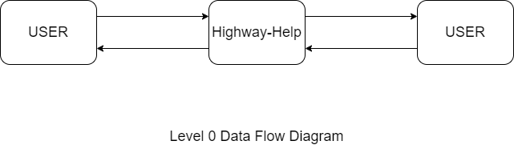

**Figure 3: Level 0 Data Flow Diagram**

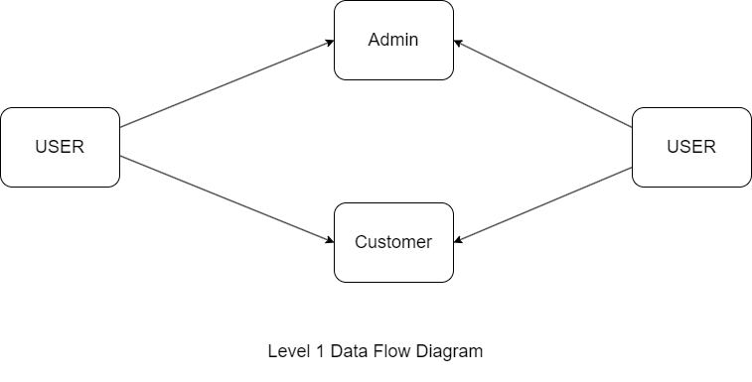

**Figure 4: Level 1 Data Flow Diagram**

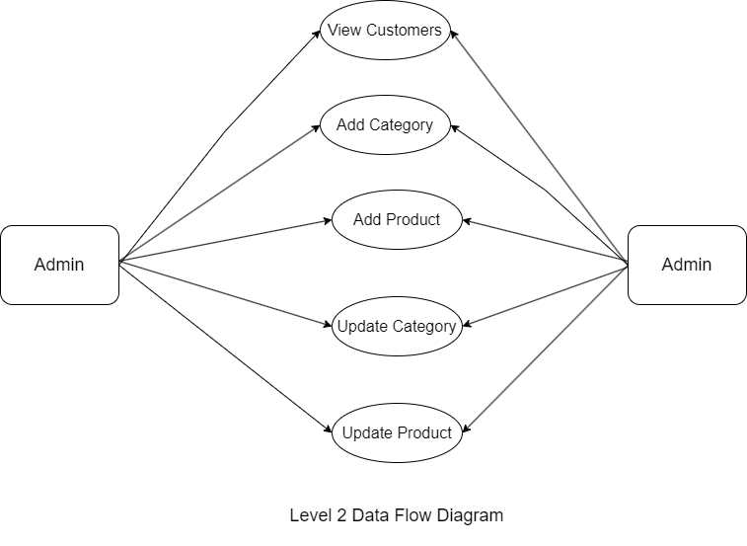

**Figure 5: Level 2 Data Flow Diagram for Admin**

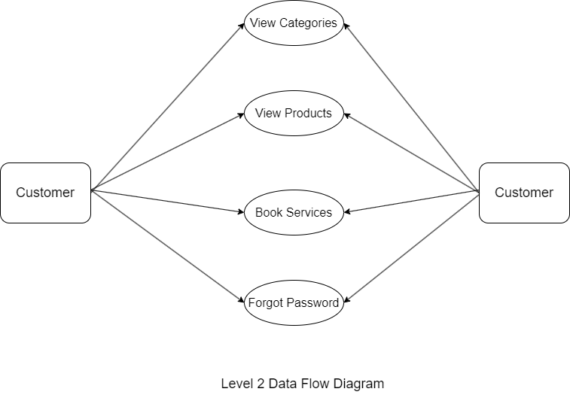

**Figure 6 Level 2 Data Flow Diagram for Customer**

## Class Diagram

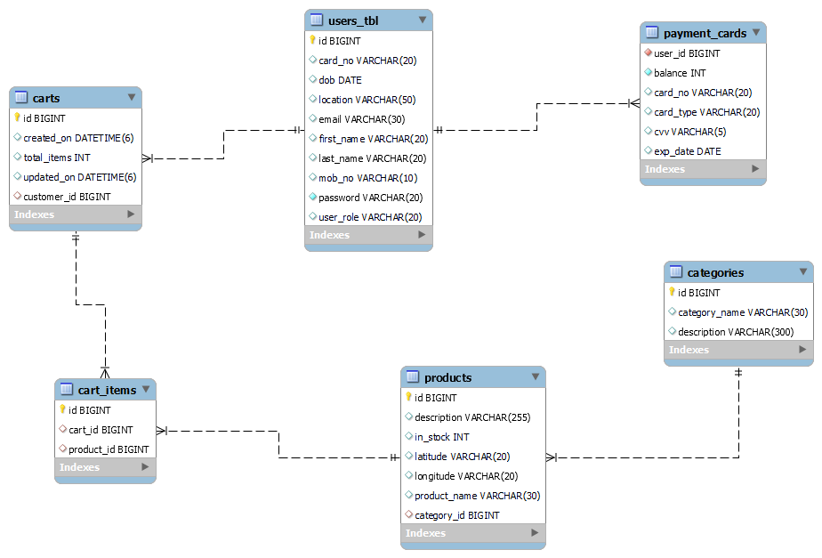

**Figure 7: Class Diagram**

## Use Case Diagram

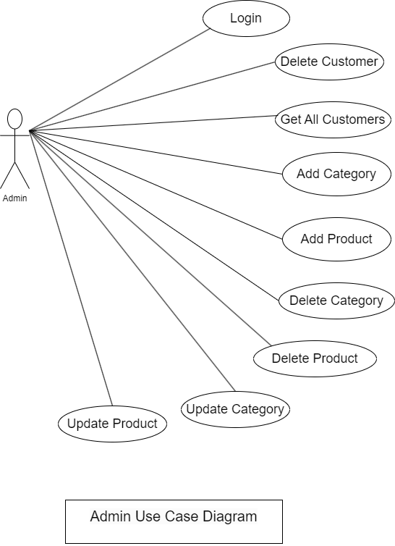

**Figure 9: Admin Use Case Diagram**

## 

**Figure 9: Customer Use Case Diagram**

## ER Diagram:

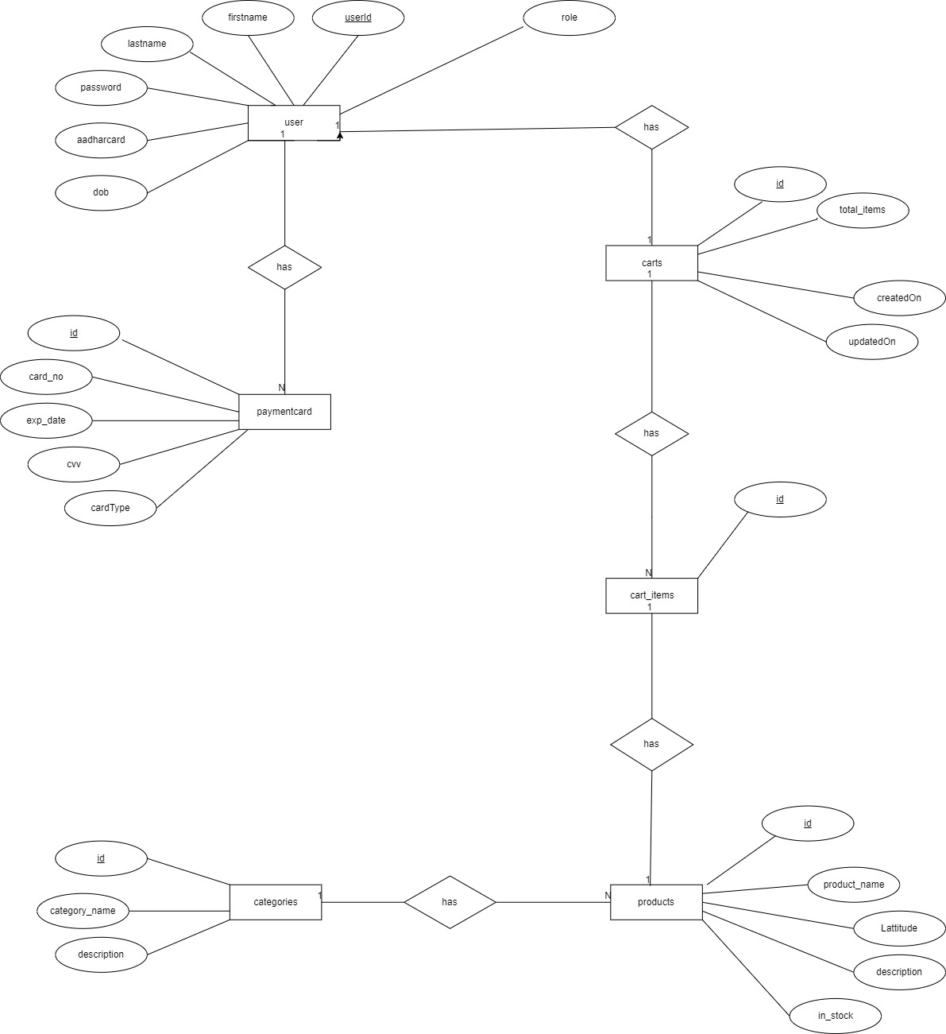

**Figure 10: ER Diagram**

# Table Structure

**users_tbl :**

|  |  |  |
| --- | --- | --- |
| **Name** | **Type** | **Extra** |
| id | bigint | Primary & Auto-increments |
| aadharcard_no | varchar(20) | Unique |
| dob | date |  |
| location | varchar(30) |  |
| email | varchar(30) |  |
| first_name | varchar(20) |  |
| last_name | varchar(20) |  |
| mob_no | varchar(10) |  |
| password | varchar(20) |  |
| user_role | varchar(20) |  |

**payment_cards:**

|  |  |  |  |
| --- | --- | --- | --- |
|  | **Name** | **Type** | **Extra** |
| user_id | bigint | Foreign Key |
| card_no | varchar(20) | Unique |
| card_type | varchar(20) |  |
| cvv | varchar(3) |  |
| exp_date | date |  |
|
|

**categories:**

|  |  |  |
| --- | --- | --- |
| **Name** | **Type** | **Extra** |
| id | bigint | Primary & Auto-increments |
| category_name | varchar(30) | Unique |
| description | Varchar(300) |  |

**products:**

|  |  |  |
| --- | --- | --- |
| **Name** | **Type** | **Extra** |
| id | bigint | Primary & Auto-increment |
| description | varchar(255) |  |
| in_stock | int |  |
| latitude | varchar(20) |  |
| longitude | varchar(20) |  |
| product_name | varchar(30) | Unique |
| category_id | bigint | Foreign Key |

**carts :**

|  |  |  |
| --- | --- | --- |
| **Name** | **Type** | **Extra** |
| id | bigint | Primary & Auto-increment |
| created_on | datetime(6) |  |
| total_items | int |  |
| updated_on | datetime(6) |  |
| customer_id | bigint | Foreign Key |

**carts_items:**

|  |  |  |
| --- | --- | --- |
| **Name** | **Type** | **Extra** |
| id | bigint | Primary & Auto-increment |
| cart_id | bigint | Foreign Key |
| product_id | bigint | Foreign Key |

# Conclusion

The Highway-Help project is initiative to create an online platform for any user to consume the services which are available on the application. So that they will get secure, gauranted and immediate service/help on time. And also these services will be secure and easily available to any user.

**Future Scope**

This project can be enhanced further by adding more fascilities like nearby ho tels and their fascilities and also other services. Also we can extend this service providing fascility over wide area network . In this project we have just used geo-location like latitude and longitude but in future we can use real Google map so that user and service providers can track their respective locations. We have tried our best to present this user–friendly website to all users.

**7.0 References**

1. <https://docs.oracle.com/en/java/>

[2] <https://docs.spring.io/spring-boot/docs/current/reference/htmlsingle/>

[3] <https://dev.mysql.com/doc/>

[4] <https://reactjs.org/>

[5] <https://ihmcl.co.in/24x7-national-highways-helpline-1033/>