**Question 3**

Write a brief intro on available data types in Javascript.

Introduction

 There are different types of data types in JavaScript.

Definition

The data type is a basic type of data that can be used in a program. JavaScript provides different data types to hold different types of values. In JavaScript, there is no need to specify the type of variable because it is dynamically used by JavaScript Engine. The different types of data types in JavaScript are shown in the flowchart below:

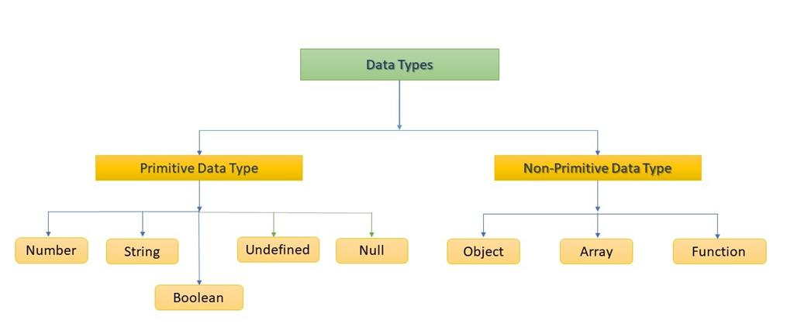

There are two major data types in JavaScript,

* Primitive Data Types
* Non-primitive Data Types/ composite data type
* Primitive Data Types
* **Number-**It represents numeric Value
* **String-** is a sequence of Characters
* **Boolean-**represent Boolean value either True or False
* **Undefined-** it represents an undefined value
* **Null-** represents no value

Number

The number is representing the numeric value, the number type represents integer, float, decimal. You need to use var here to specify the datatype. It can hold any type of value.

### String

The string is a sequence of characters, the character must be representing single or double quotations.

**E.g.**“Hello World”, ‘Hello World’

### Boolean

Boolean can only have two values, True or False. Boolean is used in conditional testing.

### Undefined and Null datatype

Variable does not have any value but it will have later on.

* Non-Primitive Data Type

1. **Object–**Key Value pair
2. **Array–** group of similar values