Lab 2: Hostel Maintenance & Issue Ticketing System

Project Name: Hostel Maintenance & Issue Ticketing System
Student Name: PRASHANT
SRN: PES1UG24CS597
Section: J

Epics and User Stories Table
Epic Name | User Story Summary | User Story Description (As a... I want to... So that...) | Priority | Story  Points
Epic 1: Maintenance  Issue Reporting | Story 1.1: Report  Maintenance Issue | As a resident, I want to report a maintenance issue, so that it  can be resolved by the hostel management. | High | 5
 | Story 1.2: Upload Issue  Evidence | As a resident, I want to upload images of the issue, so that  the maintenance staff can better understand the problem. | Medium | 3
Epic 2: Ticket  Management & Staff Assignment | Story 2.1: View Reported Tickets | As an administrator, I want to view all reported maintenance tickets, so that I can manage them efficiently. | High | 3
 | Story 2.2: Assign Staff to Ticket | As an administrator, I want to assign maintenance staff to a ticket, so that the issue can be resolved. | High | 5
Epic 3: Ticket Status  Tracking | Story 3.1: View Ticket  Status | As a resident, I want to view the status of my maintenance  ticket, so that I know the progress of my request. | High | 3
 | Story 3.2: Update Work Status | As a maintenance staff member, I want to update the ticket status, so that residents and administrators know the  progress of the work. | High | 5
Epic 4: SLA Monitoring & Escalation | Story 4.1: Monitor SLA Deadline | As an administrator, I want the system to monitor ticket  deadlines, so that issues are resolved within the required time. | High | 8
 | Story 4.2: Escalate Overdue Tickets | As an administrator, I want overdue tickets to be escalated automatically, so that serious delays are addressed quickly. | High | 8
Epic 5: Work Completion & Resident  Verification | Story 5.1: Mark Work as Completed | As a maintenance staff member, I want to mark a ticket as completed after fixing the issue, so that the resident can  verify the work. | High | 3
 | Story 5.2: Verify Completed Work | As a resident, I want to verify the completed maintenance  work, so that I can confirm whether my issue has been resolved. | High | 5

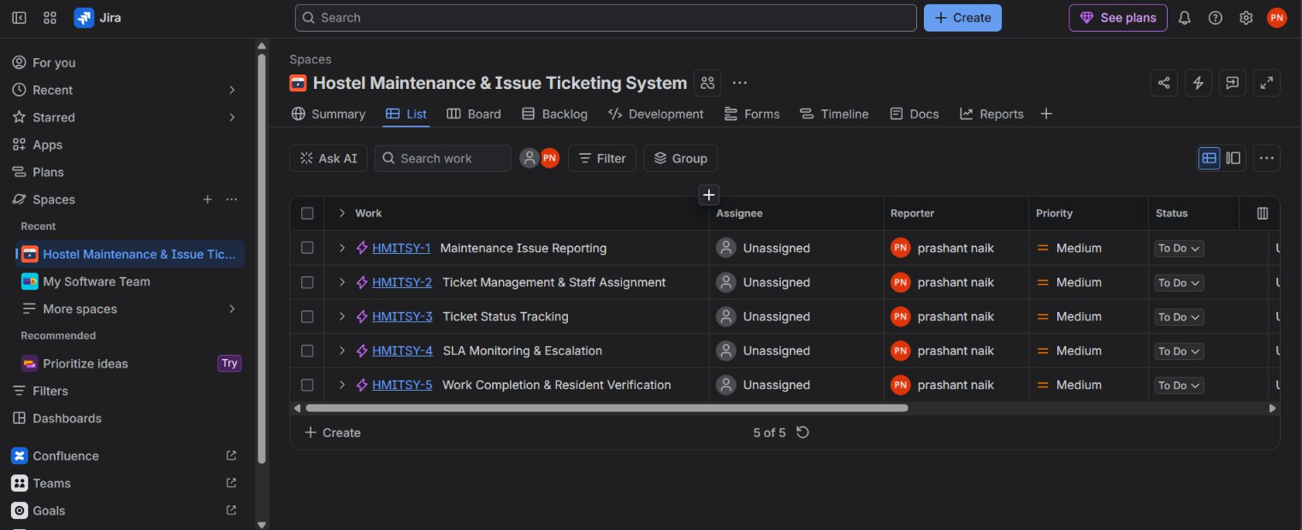
Jira Evidence: The following screenshot shows the five epics created for the project.
SCREENSHOT 1: Jira List Showing the 5 Project Epics

Story Point Estimation & Planning Poker Write-up
  - Planning Poker & Story Points: Story points are used to estimate the overall effort, complexity, and uncertainty involved in implementing each user story rather than measuring the work in raw hours. The stories in this project were estimated comparatively using Planning Poker principles so that the backlog could be planned consistently.
  - Fibonacci Scale: The Fibonacci-based values 1, 2, 3, 5, 8, and 13 are suitable for Agile estimation because larger values represent increasing complexity and uncertainty. For this project, simple viewing and completion activities were estimated around 3 points, standard reporting and assignment activities around 5 points, and more complex SLA monitoring and automatic escalation activities at 8 points.

Prioritization & Ranked Backlog
The product backlog was prioritized according to business value and the importance of each function to the core hostel maintenance workflow. High-priority stories include reporting maintenance issues, viewing tickets, assigning staff, tracking status, monitoring SLA deadlines, escalating overdue tickets, and verifying completed work. These stories support the main end-to-end workflow of the Minimum Viable Product (MVP). The issue-evidence upload story was given Medium priority because the core ticket can still be created without an image.
Suggested ranked backlog:

Rank | User Story | Priority | Story Points
1 | Report Maintenance Issue | High | 5
2 | Assign Staff to Ticket | High | 5
3 | View Reported Tickets | High | 3
4 | View Ticket Status | High | 3
5 | Update Work Status | High | 5
6 | Monitor SLA Deadline | High | 8
7 | Escalate Overdue Tickets | High | 8
8 | Mark Work as Completed | High | 3
9 | Verify Completed Work | High | 5
10 | Upload Issue Evidence | Medium | 3

Sprint Simulation & Burndown Chart
  - Sprint Execution: The project backlog was organized into three mock sprints in Jira. Each sprint was used to group related user stories and simulate Scrum execution through the To Do, In Progress, In Review, and Done workflow states.
Sprint Distribution:

Sprint | User Stories | Total Story Points
HMITSY Sprint 1 | Report Maintenance Issue; Upload Issue Evidence; View Reported Tickets; Assign  Staff to Ticket | 16
HMITSY Sprint 2 | View Ticket Status; Update Work Status;  Monitor SLA Deadline | 16
HMITSY Sprint 3 | Escalate Overdue Tickets; Mark Work as  Completed; Verify Completed Work | 16
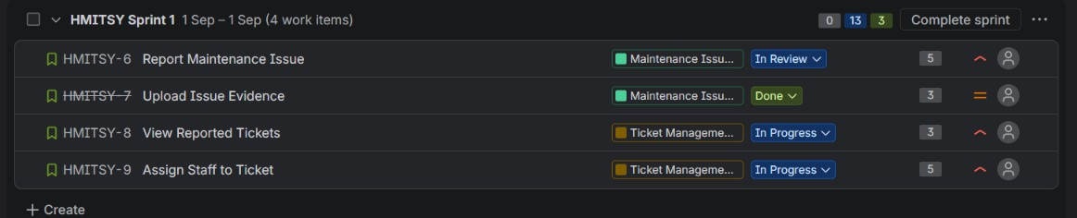
SCREENSHOT 2: HMITSY Sprint 1 with 4 Work Items
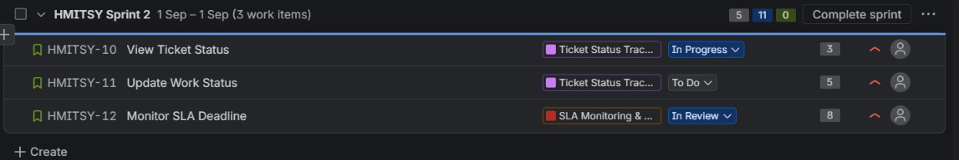
SCREENSHOT 3: HMITSY Sprint 2 with 3 Work Items
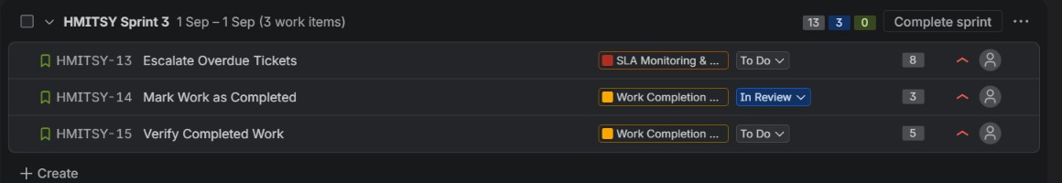
SCREENSHOT 4: HMITSY Sprint 3 with 3 Work Items
  - Burndown Analysis: The Burndown Chart tracks the remaining Story Points on the vertical axis against the sprint timeline on the horizontal axis. The Jira reports for the three mock sprints show the remaining work decreasing to zero, demonstrating completion of the committed work items during the simulation.

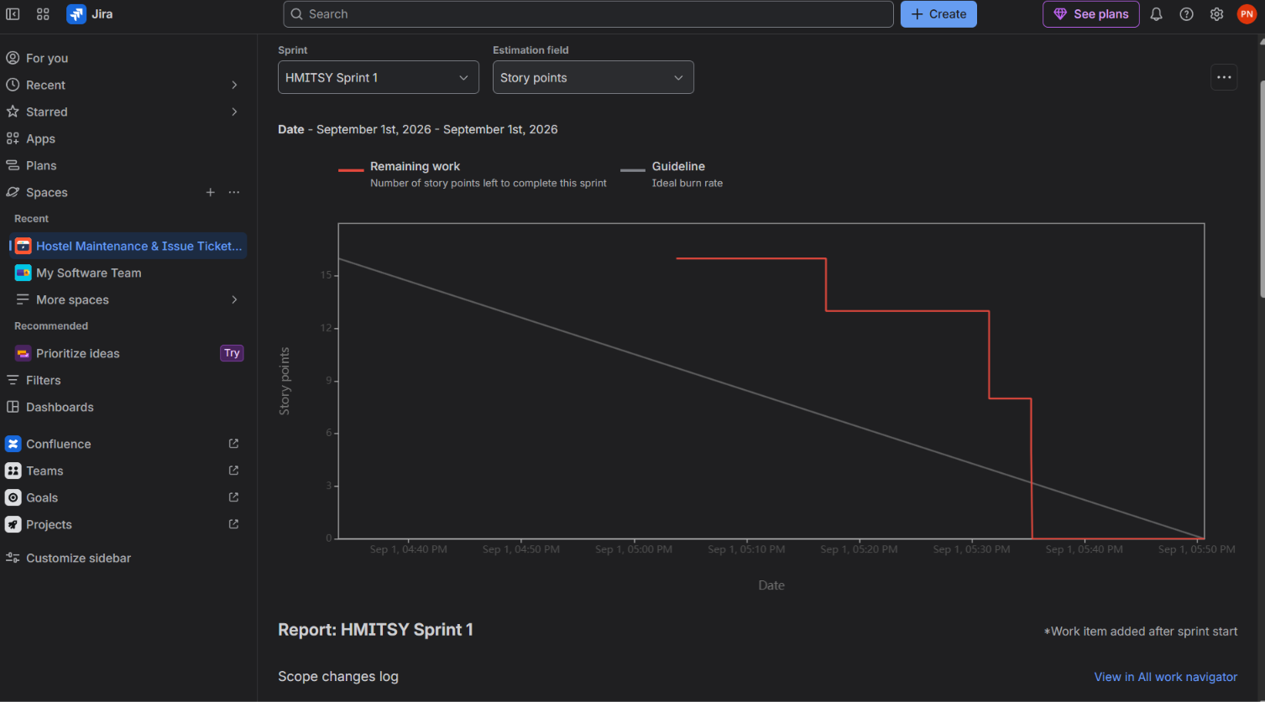
SCREENSHOT 5: Burndown Chart – HMITSY Sprint 1
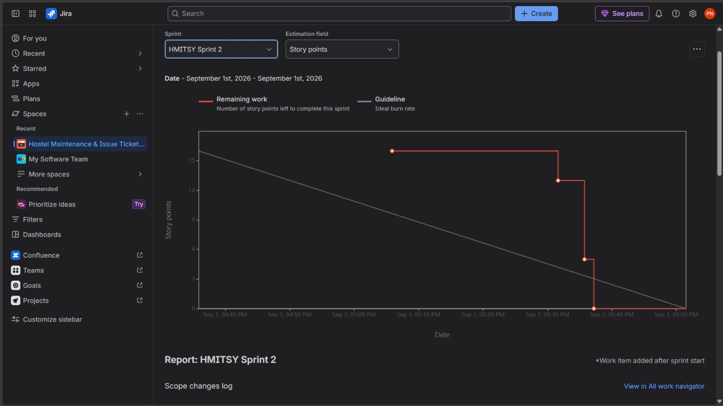

SCREENSHOT 6: Burndown Chart – HMITSY Sprint 2

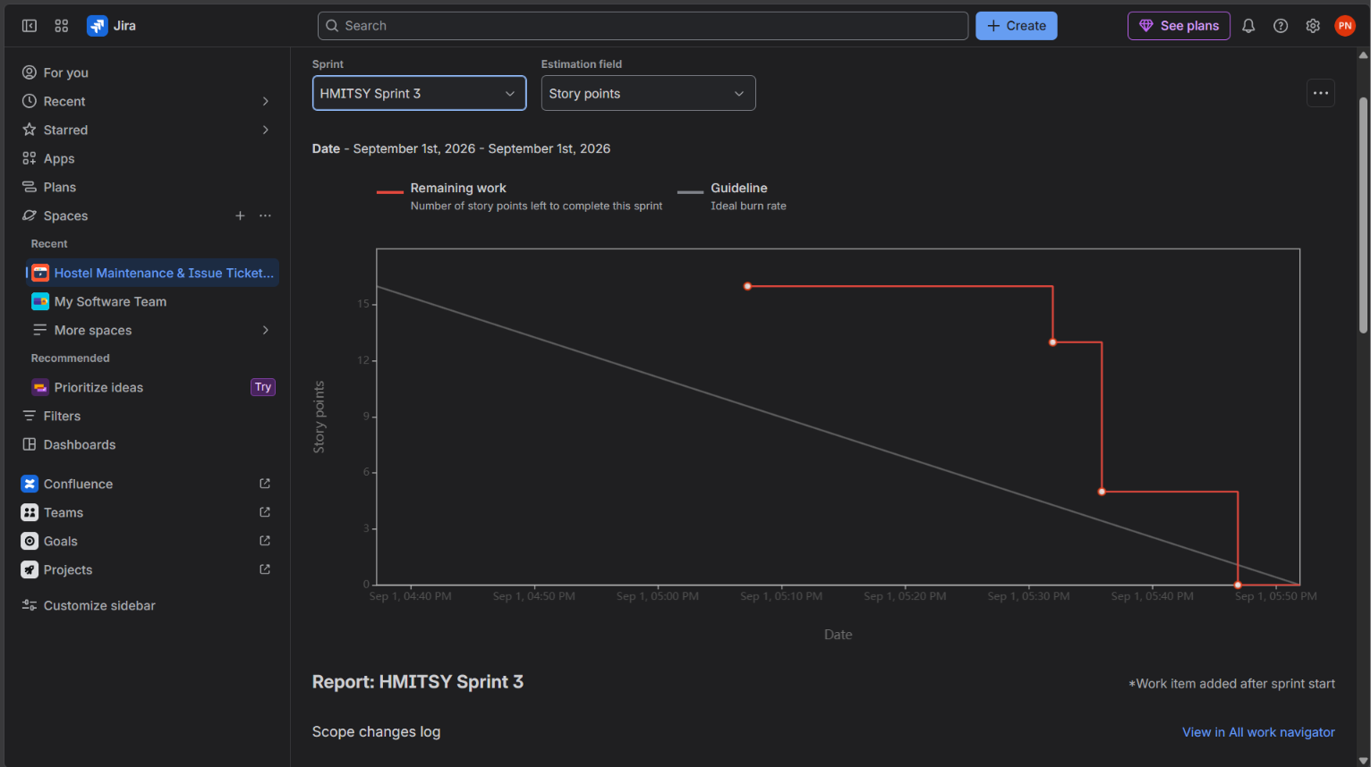

SCREENSHOT 7: Burndown Chart – HMITSY Sprint 3

Jira Summary Dashboard
The Jira Summary dashboard provides an overview of the project work items, completion status, recent activity, priority distribution, work types, team workload, and epic progress. In this project, the dashboard reflects the created epics and user stories and provides visual evidence of the simulated Agile workflow.

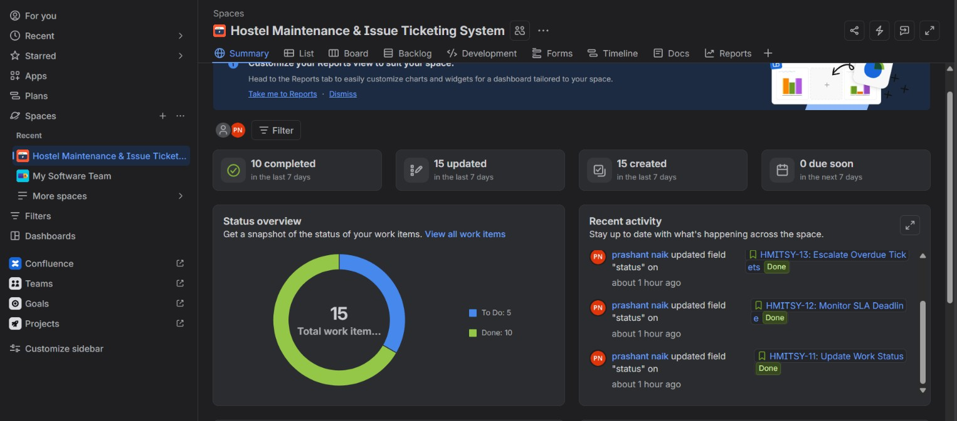

SCREENSHOT 8: Jira Summary – Status Overview and Recent Activity
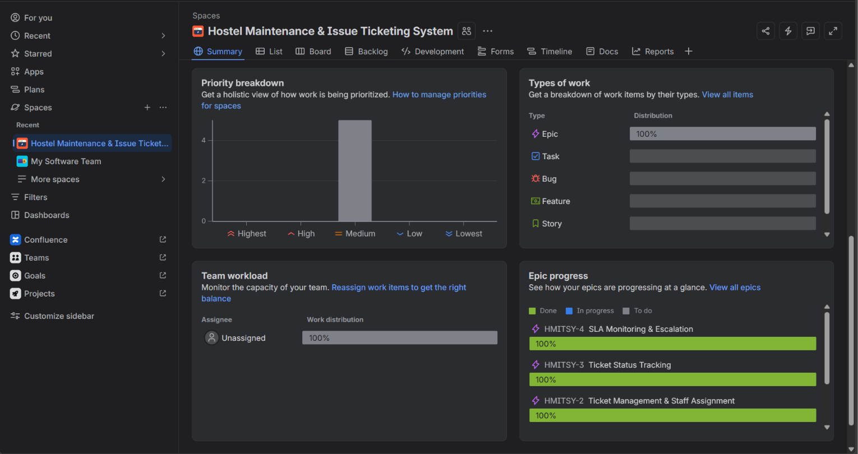

SCREENSHOT 9: Jira Summary – Priority Breakdown and Epic Progress

Reflection & Analysis
This sprint simulation demonstrated the practical use of Agile Scrum methodologies in Jira for the Hostel Maintenance & Issue Ticketing System. Breaking the project into five Epics and ten User Stories made the system requirements easier to understand, prioritize, and manage. Assigning priorities and Fibonacci-based story points helped estimate relative effort and identify the most important functionality for early implementation.
Organizing the backlog into three sprints demonstrated how work can be delivered incrementally. The Scrum workflow states and Burndown Charts provided visual feedback on progress and remaining effort. Overall, the activity showed how Jira supports backlog management, sprint planning, prioritization, estimation, progress tracking, and iterative delivery in an Agile software project.

