

Bluestock Mutual Fund Analytics Capstone Project

Final Project Report
Department of Data Analytics
Mutual Fund Analytics using Python, SQL & Power BI
Submitted By
Prashant Nikhare

Technologies Used
- Python
- Pandas
- NumPy
- SQLite
- SQL
- Power BI
- Matplotlib

Project
Bluestock Mutual Fund Analytics Capstone

Submission Date
14 August, 2026

Internship
Bluestock

Executive Summary
The objective of this project was to analyse mutual fund data and develop a complete analytics solution using Python, SQL, SQLite, and Power BI.
The project started with collecting and cleaning multiple mutual fund datasets such as fund master, NAV history, AUM details, SIP inflows, investor transactions, portfolio holdings, and benchmark data. After cleaning the datasets, they were stored in a SQLite database for easy querying and analysis.
Exploratory Data Analysis (EDA) was performed to understand industry trends, investor behaviour, and scheme performance. Financial performance metrics such as CAGR, Sharpe Ratio, Alpha, Beta, Tracking Error, and Maximum Drawdown were calculated to evaluate different mutual fund schemes.
An interactive Power BI dashboard was created with four analytical pages to visualize industry performance, fund performance, investor behaviour, and SIP market trends.
Advanced analytics including Historical VaR, Conditional VaR (CVaR), Rolling Sharpe Ratio, Investor Cohort Analysis, SIP Continuity Analysis, Sector HHI Concentration, and a Mutual Fund Recommendation System were also implemented.
The project demonstrates practical knowledge of data cleaning, database management, financial analytics, dashboard development, and business intelligence techniques using real-world mutual fund data.

1. Introduction
Mutual funds are one of the most popular investment options because they allow investors to invest in different financial assets with the help of professional fund managers. Every day, a large amount of data is generated, such as NAV prices, SIP investments, fund performance, and investor transactions. This data can be analysed to understand market trends and fund performance.
The main purpose of this project is to build a complete Mutual Fund Analytics solution using Python, SQL, SQLite, and Power BI. The project starts with collecting and cleaning raw datasets, storing them in a database, analysing the data using different financial metrics, and finally creating an interactive dashboard for better visualization.
During this project, different datasets such as Fund Master, NAV History, AUM Details, Monthly SIP Inflows, Investor Transactions, Portfolio Holdings, and Benchmark Indices were used. These datasets were cleaned and processed before analysis.
The project also includes advanced analytics such as Historical Value at Risk (VaR), Conditional Value at Risk (CVaR), Rolling Sharpe Ratio, Investor Cohort Analysis, SIP Continuity Analysis, and Sector HHI Concentration. These analyses help in understanding fund risk, investor behaviour, and portfolio diversification.
Finally, an interactive Power BI dashboard was developed to present important business insights in a simple and user-friendly way.

2. Project Objectives
The main objective of this project is to analyse mutual fund data and create a complete business intelligence solution that helps investors understand fund performance, investment trends, and portfolio risk.
The specific objectives of this project are:
- Collect and organise multiple mutual fund datasets.
- Clean and validate raw datasets before analysis.
- Store cleaned datasets in a SQLite database.
- Perform Exploratory Data Analysis (EDA) to understand market trends.
- Calculate financial performance metrics such as CAGR, Sharpe Ratio, Alpha, Beta, Tracking Error, and Maximum Drawdown.
- Develop an interactive Power BI dashboard with multiple analytical pages.
- Perform advanced analytics including Historical VaR, CVaR, Rolling Sharpe Ratio, Investor Cohort Analysis, SIP Continuity Analysis, Sector HHI Concentration, and Fund Recommendation.
- Generate useful business insights that support better investment decisions.

3. Data Sources
The project uses multiple datasets collected from different mutual fund-related sources. Each dataset represents a different part of the mutual fund ecosystem and helps in performing complete financial analysis.
The following datasets were used in this project:
Dataset | Description
Fund Master | Basic information about all mutual fund schemes
NAV History | Daily Net Asset Value (NAV) of schemes
AUM by Fund House | Assets Under Management for different fund houses
Monthly SIP Inflows | Monthly SIP investment data
Category Inflows | Net inflows by mutual fund category
Industry Folio Count | Total investor folios in the industry
Scheme Performance | Returns and performance of mutual funds
Investor Transactions | SIP, Lumpsum and Redemption transactions
Portfolio Holdings | Stocks and sector allocation of each fund
Benchmark Indices | Benchmark performance used for comparison

4. Technology Stack
Different tools and technologies were used during the development of this project.
Technology |  |  |  |  |  |  |  |  |  |  |  |  |  |  |  |  |  |  |  | Purpose
Python |  |  |  |  |  |  |  |  |  |  |  |  |  |  |  |  |  |  |  | Data Processing and Analysis
Pandas |  |  |  |  |  |  |  |  |  |  |  |  |  |  |  |  |  |  |  | Data Cleaning and Transformation
NumPy |  |  |  |  |  |  |  |  |  |  |  |  |  |  |  |  |  |  |  | Numerical Calculations
SQLite |  |  |  |  |  |  |  |  |  |  |  |  |  |  |  |  |  |  |  | Database Management
SQL |  |  |  |  |  |  |  |  |  |  |  |  |  |  |  |  |  |  |  | Data Querying
Matplotlib |  |  |  |  |  |  |  |  |  |  |  |  |  |  |  |  |  |  |  | Charts and Visualization
Power BI |  |  |  |  |  |  |  |  |  |  |  |  |  |  |  |  |  |  |  | Interactive Dashboard
Jupyter Notebook |  |  |  |  |  |  |  |  |  |  |  |  |  |  |  |  |  |  |  | Data Analysis
VS Code |  |  |  |  |  |  |  |  |  |  |  |  |  |  |  |  | Python Development

5. ETL (Extract, Transform, Load) Design
The ETL process is one of the most important parts of this project. It was used to collect raw data, clean the data, and store it in a structured format for analysis.
The ETL pipeline was divided into three main stages:

5.1 Extract
In the first stage, all raw datasets were collected and loaded into Python using the Pandas library. The project contains multiple datasets such as Fund Master, NAV History, AUM Details, SIP Inflows, Investor Transactions, Portfolio Holdings, and Benchmark Indices.
The data was read from CSV files and checked for missing values, incorrect data types, and duplicate records before processing.
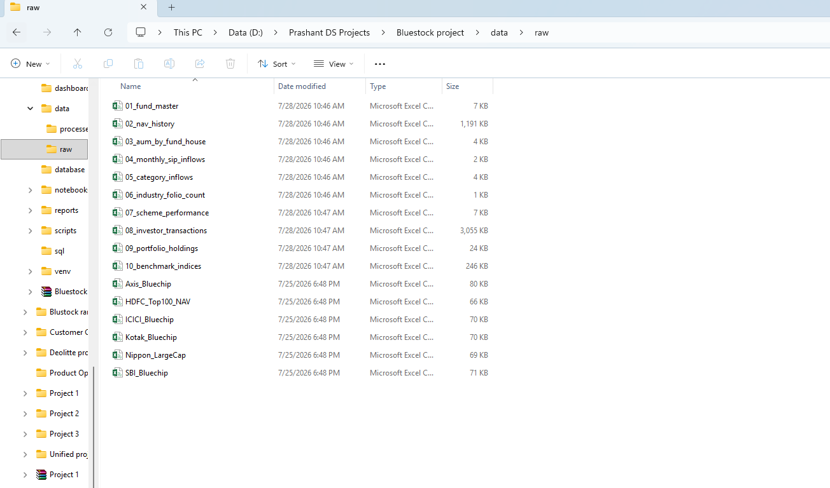
Figure 1: Raw mutual fund datasets stored in the data/raw folder before the ETL process.

5.2 Transform
After loading the data, different data cleaning and transformation techniques were applied.
The following operations were performed:
- Removed duplicate records.
- Converted date columns into proper datetime format.
- Renamed column names for consistency.
- Corrected incorrect data types.
- Removed unwanted spaces from text columns.
- Checked for missing values.
- Standardized numerical columns.
- Generated cleaned datasets for further analysis.
The cleaned files were saved inside the processed folder.

5.3 Load
After cleaning the datasets, all processed data was loaded into a SQLite database.
SQLite was used because it is lightweight, easy to use, and suitable for analytical projects.
The database contains separate tables for each cleaned dataset, allowing SQL queries to be executed efficiently.
The database was later used for validation and analytical queries.

ETL Workflow
Raw CSV Files
│
▼
Data Ingestion
│
▼
Data Cleaning
│
▼
Processed CSV Files
│
▼
SQLite Database
│
▼
EDA & Performance Analytics
│
▼
Power BI Dashboard
6. Data Cleaning
Data cleaning was performed to improve the quality of the datasets before analysis.
The following activities were completed during the cleaning process:
- Removed duplicate records from datasets.
- Checked and handled missing values.
- Converted date columns into datetime format.
- Standardized text values.
- Corrected data types.
- Removed unnecessary spaces.
- Validated numerical columns.
- Created cleaned datasets for analysis.
The cleaned datasets were stored separately to preserve the original raw data.
The project maintains two different folders:
- Raw Data
- Processed Data
This approach helps in maintaining data integrity and allows the ETL process to be repeated whenever new data becomes available.
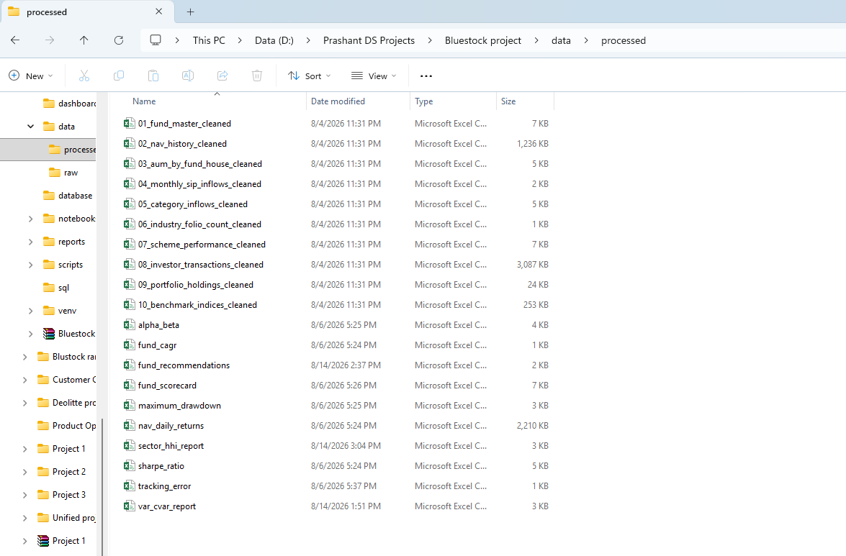

Data Validation
During the cleaning process, the following validation checks were performed:
- Duplicate record validation
- Missing value validation
- Data type validation
- Date validation
- Numerical value validation
- Column consistency validation
These validation steps ensured that the datasets were accurate before performing financial analysis.

7. Database Design
SQLite was used as the central database for this project.
Each cleaned dataset was loaded into a separate database table.
The database provides faster querying and better organization of data compared to working directly with CSV files.

Database Tables
Table Name | Description
fund_master | Mutual Fund Information
nav_history | Daily NAV Data
aum_by_fund_house | AUM Details
monthly_sip_inflows | Monthly SIP Data
category_inflows | Category-wise Inflows
industry_folio_count | Industry Folio Details
scheme_performance | Scheme Returns
investor_transactions | Investor Transaction Data
portfolio_holdings | Portfolio Allocation
benchmark_indices | Benchmark Performance
The SQLite database was also used to verify the correctness of the ETL pipeline using SQL queries.
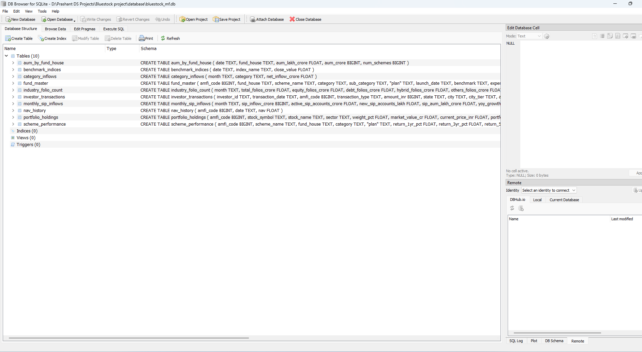

8. Exploratory Data Analysis (EDA)

8.1 Overview
Exploratory Data Analysis (EDA) was performed to understand the overall characteristics of the mutual fund datasets before calculating financial metrics. Different charts and visualizations were created using Python to identify trends, distributions, and patterns in the data.
The analysis focused on understanding fund categories, asset allocation, investor demographics, NAV behaviour, and industry growth.

8.2 Mutual Fund Category Distribution
Figure 3: Mutual Fund Category Distribution
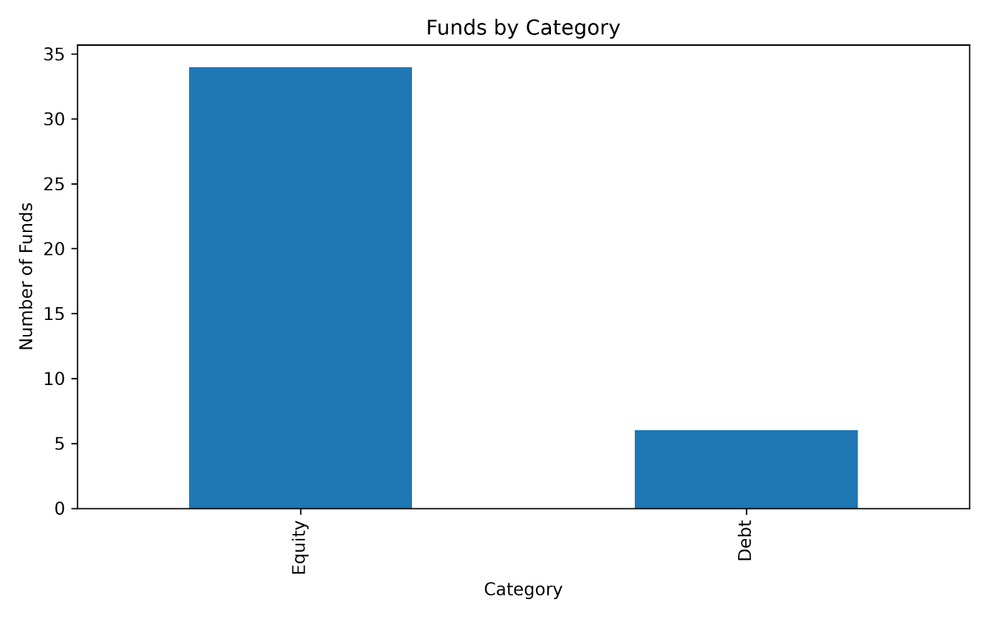Observation
The chart shows the distribution of mutual fund schemes across different categories. Equity funds represent the largest share of the dataset, followed by debt and hybrid funds. This indicates that equity schemes are more widely available and actively managed.

8.3 Risk Category Distribution
Figure 4: Risk Category Distribution
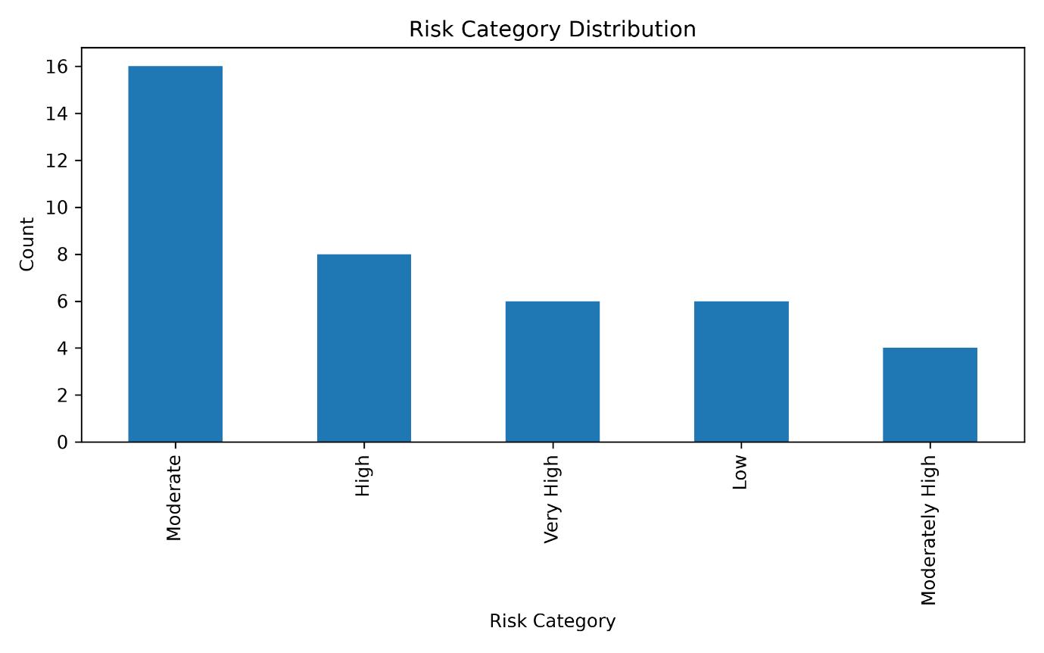Observation
Most mutual fund schemes fall under the Moderate, Moderately High, and High risk categories. Only a limited number of schemes belong to the Low risk category, showing that investors have a wider range of medium and high-risk investment options.

8.4 Plan Distribution
Figure 5: Plan Distribution
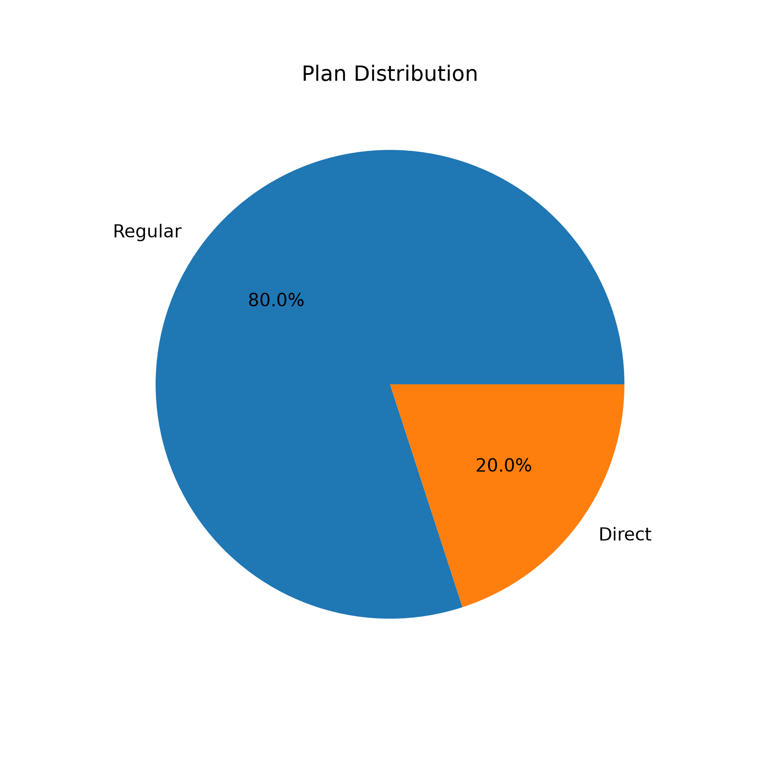Observation
The dataset contains both Regular and Direct plans. Regular plans are more common, while Direct plans are comparatively fewer. This reflects the availability of different investment options for investors.

8.5 Fund House Analysis
Figure 6: Top Fund Houses
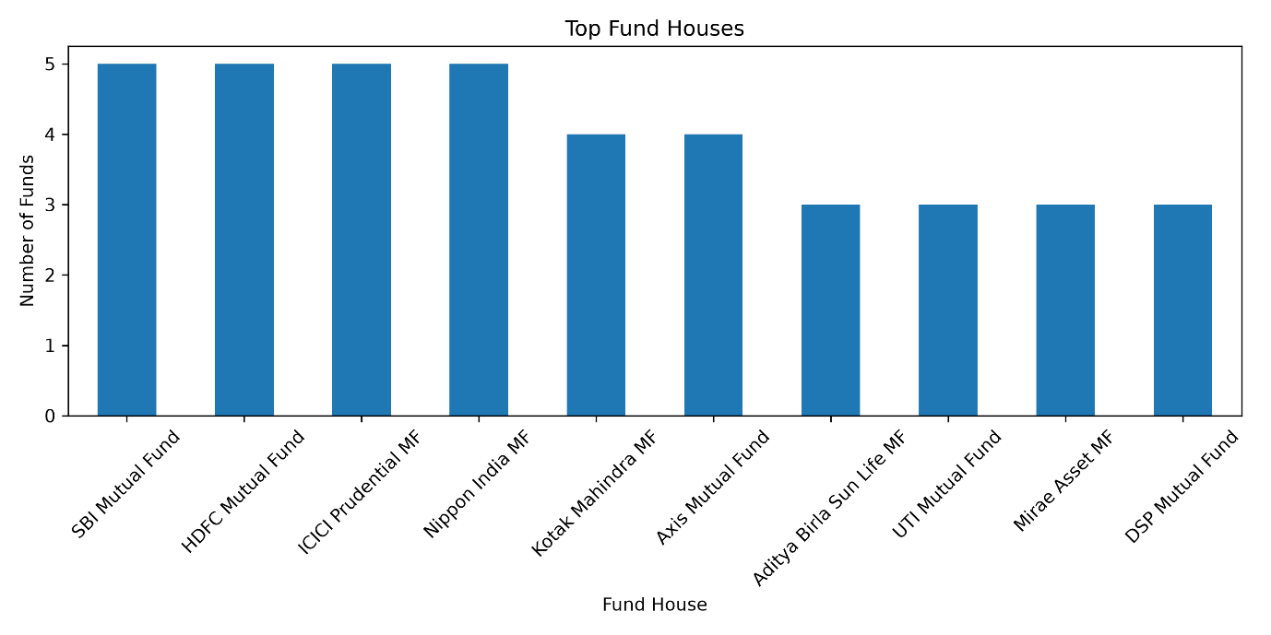Observation
The analysis shows that a few fund houses manage a large number of schemes compared to others. This indicates that the mutual fund industry is dominated by well-established asset management companies.

8.6 Investor Demographics
Figure 7: Age Group Distribution
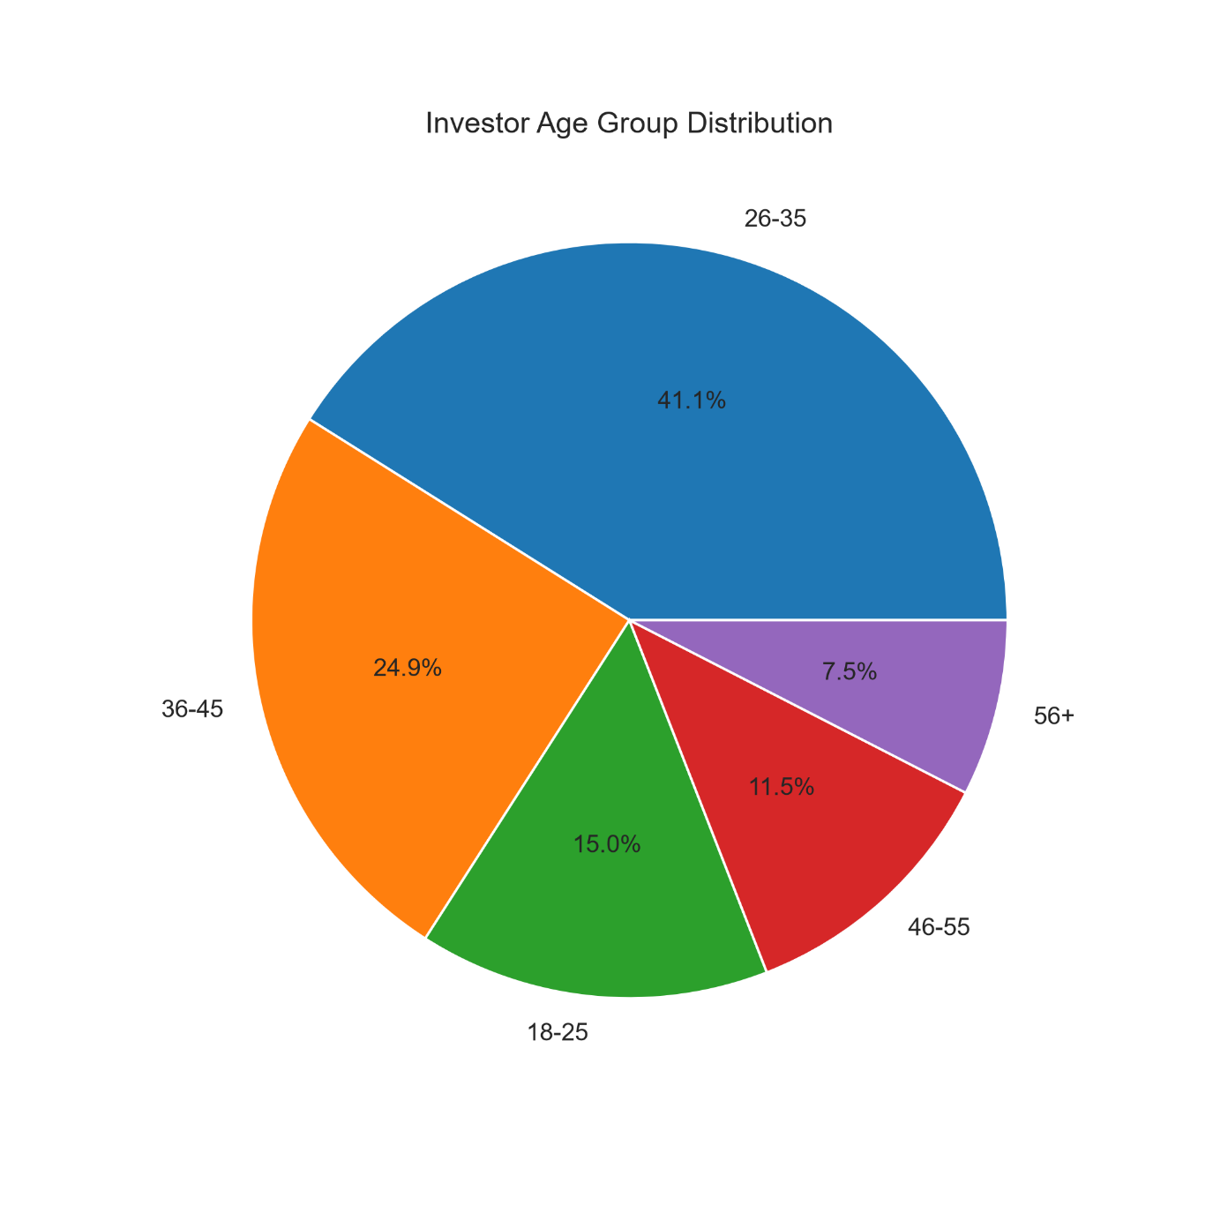
Observation
The majority of investors belong to the working-age population. Young and middle-aged investors contribute the highest number of investment transactions, indicating strong participation from active earning groups.

8.7 NAV Distribution
Figure 8: NAV Distribution
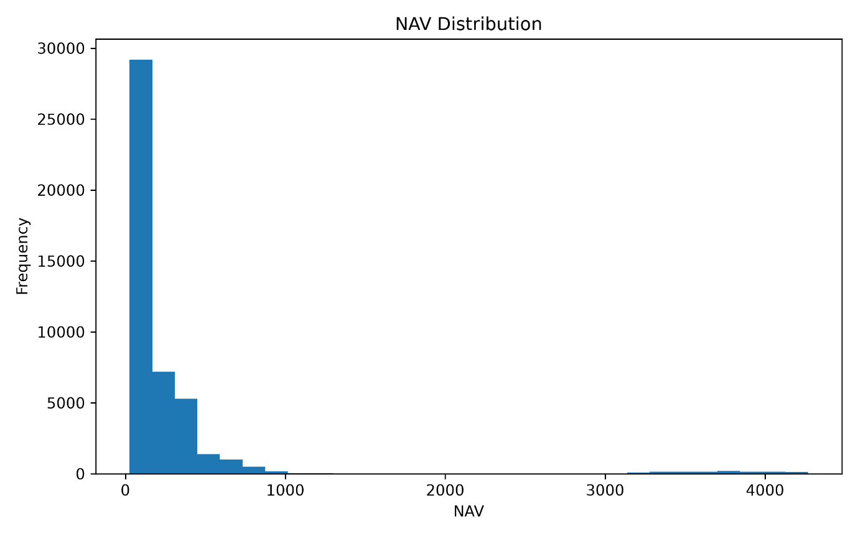Observation
The NAV values are spread across different ranges. While many schemes have moderate NAV values, a few schemes have significantly higher NAVs, showing variation in fund pricing.

8.8 Sector Allocation
Figure 9: Sector Allocation
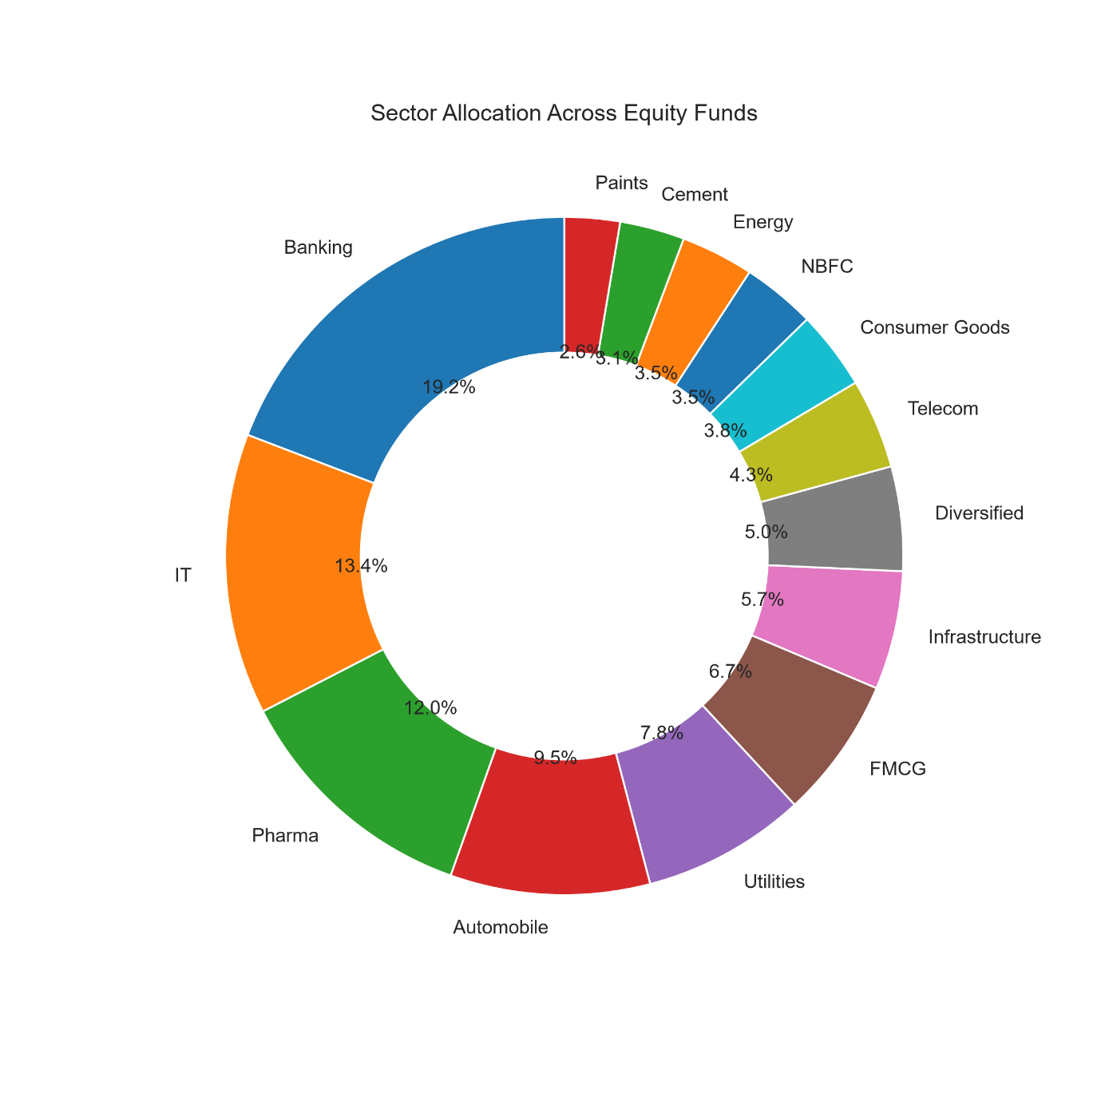Observation
The portfolio holdings are diversified across multiple sectors such as Banking, IT, Pharma, FMCG, and Financial Services. Banking and Financial Services contribute a significant share of the overall portfolio allocation.

Figure Caption
Figures 3–9: Exploratory Data Analysis performed using Python and Matplotlib to understand the structure of the mutual fund datasets.

9. Performance Analytics

9.1 Overview
Performance Analytics was performed to evaluate the historical performance and risk of different mutual fund schemes. Several financial metrics were calculated using Python to compare the performance of funds from different categories.
The analysis helps investors understand the return potential, volatility, and risk-adjusted performance of each scheme.
The following financial metrics were calculated during this project:
- CAGR (Compound Annual Growth Rate)
- Sharpe Ratio
- Alpha
- Beta
- Maximum Drawdown
- Tracking Error

9.2 Compound Annual Growth Rate (CAGR)
Observation
CAGR measures the annual growth rate of a mutual fund over a specific investment period. Funds with higher CAGR values delivered better long-term returns compared to other schemes.

9.3 Sharpe Ratio
Observation
Sharpe Ratio measures the return generated for every unit of risk taken by an investor. Funds with higher Sharpe Ratios provided better risk-adjusted returns and are generally considered more efficient.

9.4 Alpha
📷 Figure 10: Alpha Comparison
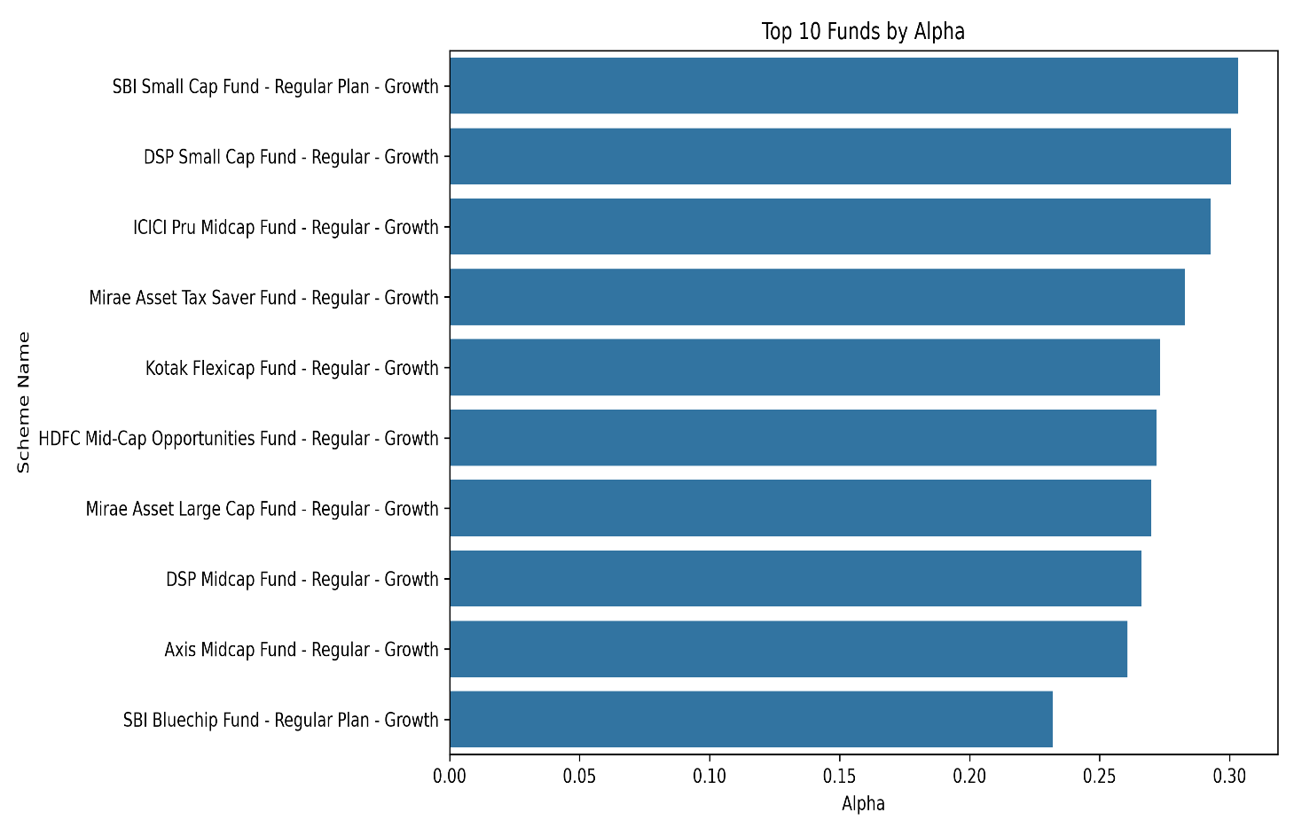Observation
Alpha represents the excess return generated by a fund compared to its benchmark index. Positive Alpha indicates that the fund outperformed its benchmark during the selected period.

9.5 Beta
📷 Figure 11: Beta Comparison
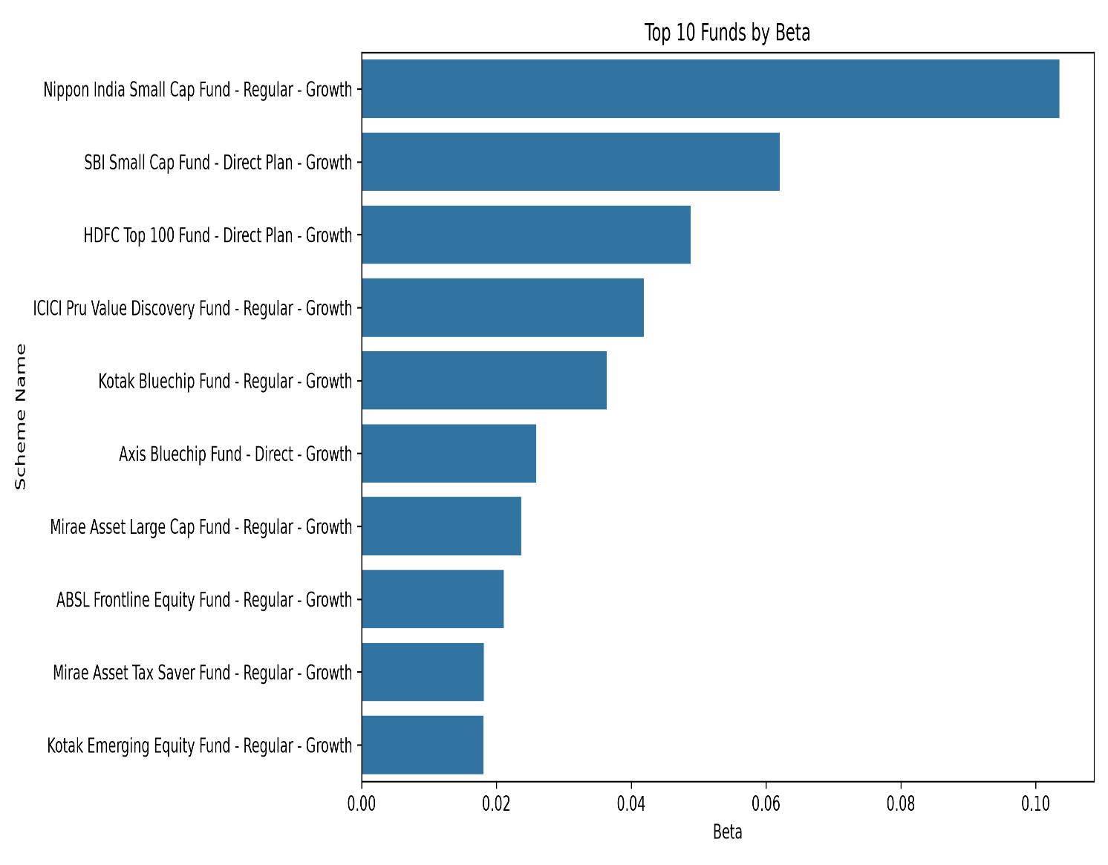Observation
Beta measures the sensitivity of a fund compared to the overall market. A Beta value close to 1 indicates that the fund moves similarly to the benchmark, while higher values indicate greater market volatility.

9.6 Maximum Drawdown
📷 Figure 12: Maximum Drawdown
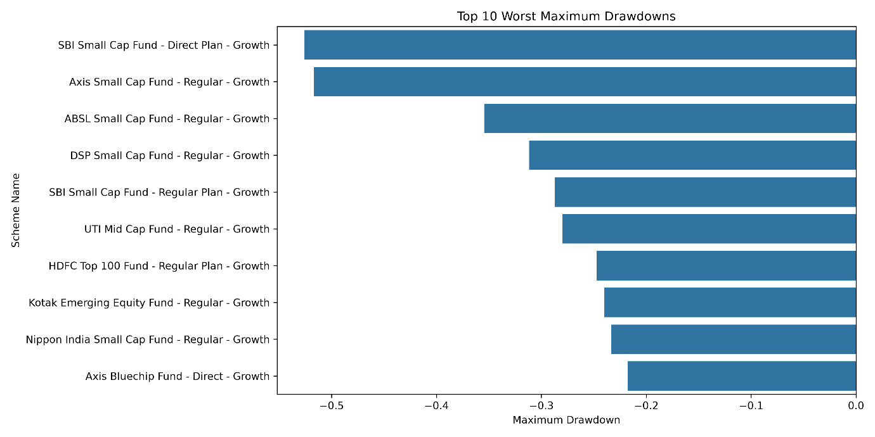Observation
Maximum Drawdown represents the largest decline in a fund's value from its highest point to its lowest point during the analysis period. Lower drawdown values indicate better downside protection.

9.7 Tracking Error
Tracking Error was calculated to measure how closely a mutual fund follows its benchmark index.
Lower Tracking Error indicates that the fund performance closely matches the benchmark, while higher values indicate larger deviations.
The calculated Tracking Error values were stored in a separate CSV file for further analysis and comparison.

Performance Summary
The performance analysis showed that different funds performed differently across all financial metrics. Some schemes generated higher long-term returns, while others provided better risk-adjusted performance with lower volatility.
Using multiple financial metrics together provides a more balanced evaluation of fund performance than relying on returns alone.

10. Power BI Dashboard
An interactive Power BI dashboard was developed to present the analysed mutual fund data in a simple and user-friendly format. The dashboard allows users to explore different aspects of the mutual fund industry through interactive charts, KPIs, and slicers.
The dashboard is divided into four pages, where each page focuses on a different business area.

10.1 Industry Overview
📷 Figure 13: Industry Overview Dashboard
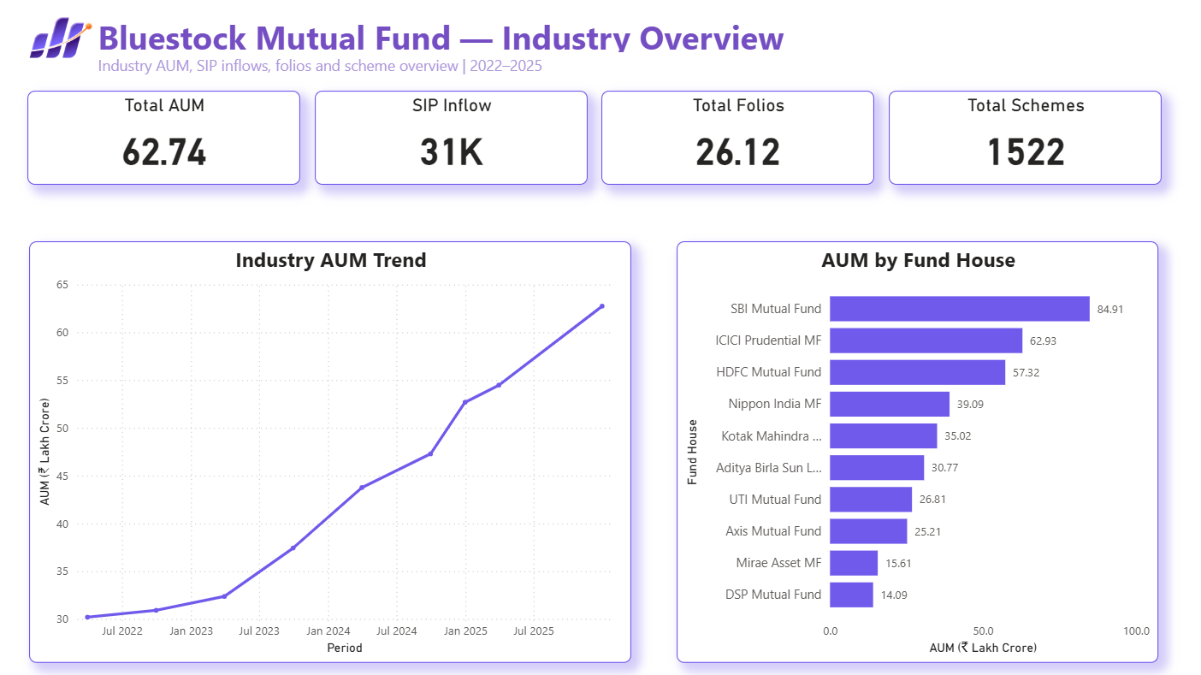Description
This dashboard page provides an overview of the mutual fund industry. It highlights important KPIs such as total schemes, AUM, SIP inflows, and category-wise distribution. Interactive slicers allow users to filter the data based on different fund categories.

10.2 Fund Performance
📷 Figure 14: Fund Performance Dashboard
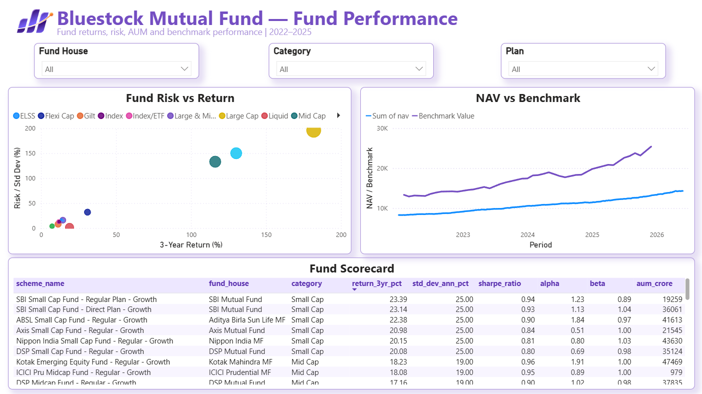Description
This page focuses on fund performance using different financial metrics. It helps compare mutual funds based on returns, risk, and performance indicators. Investors can easily identify better-performing schemes through interactive visualizations.

10.3 Investor Analytics
📷 Figure 15: Investor Analytics Dashboard
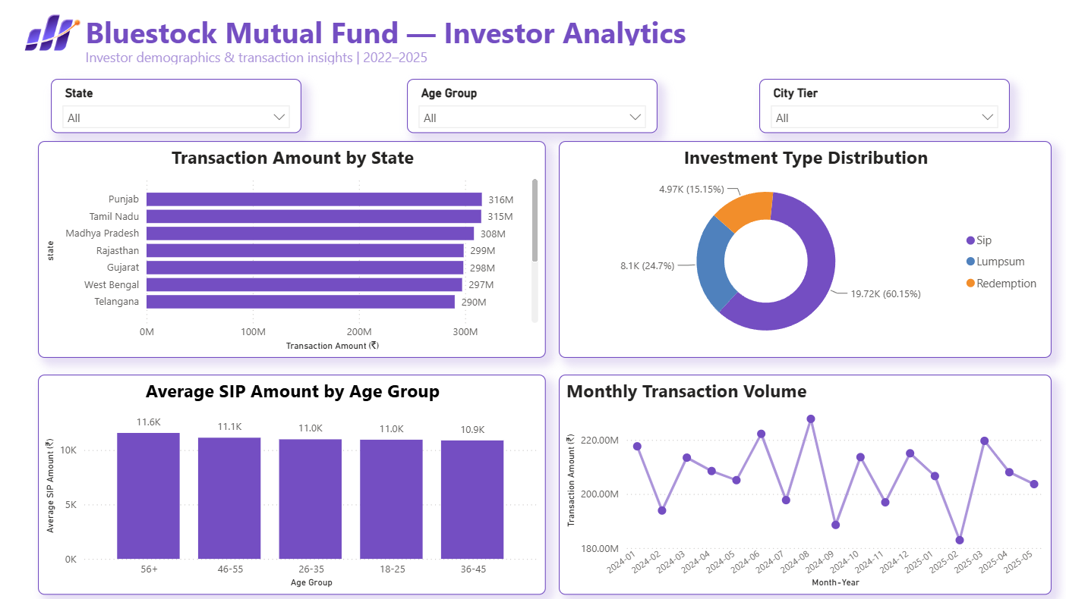
Description
This dashboard analyses investor behaviour using demographic information such as age group, gender, state, and city tier. It provides useful insights into investment patterns across different investor groups.

10.4 SIP & Market Trends
📷 Figure 16: SIP & Market Trends Dashboard
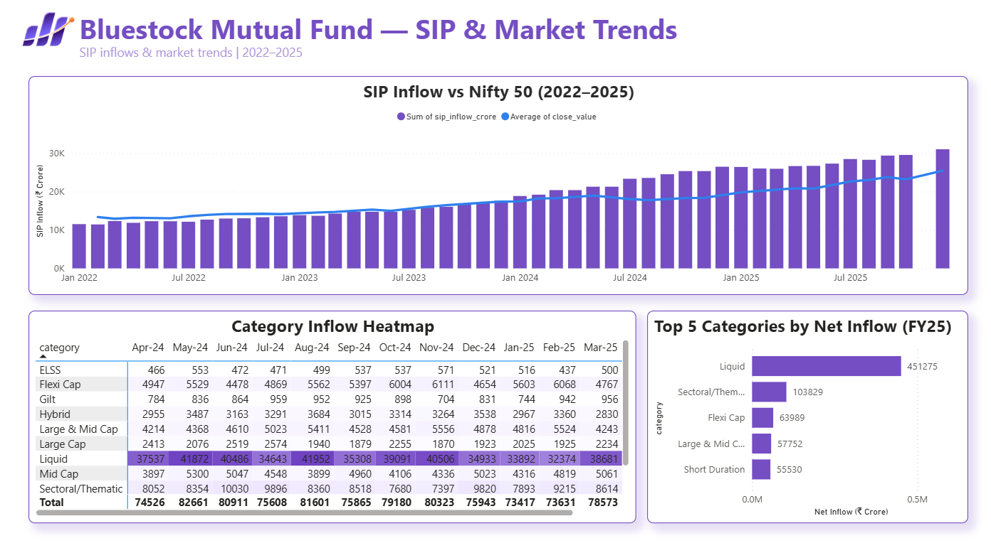Description
The final dashboard page presents SIP growth trends, market movement, and investment behaviour over time. Users can analyse monthly SIP inflows and compare changes across different periods.

Dashboard Summary
The Power BI dashboard converts complex financial data into interactive visualizations, making it easier for users to understand fund performance and investment trends.

11. Advanced Analytics
Advanced analytical techniques were implemented to provide deeper insights into mutual fund performance, portfolio risk, and investor behaviour.

11.1 Historical VaR & CVaR
Historical Value at Risk (VaR) was calculated using the 5th percentile of daily returns for each mutual fund scheme. Conditional Value at Risk (CVaR) was calculated as the average return below the VaR threshold.
These metrics help estimate the potential downside risk under normal market conditions.

11.2 Rolling 90-Day Sharpe Ratio
A rolling 90-day Sharpe Ratio was calculated to monitor changes in risk-adjusted performance over time.
📷 Figure 17: Rolling 90-Day Sharpe Ratio
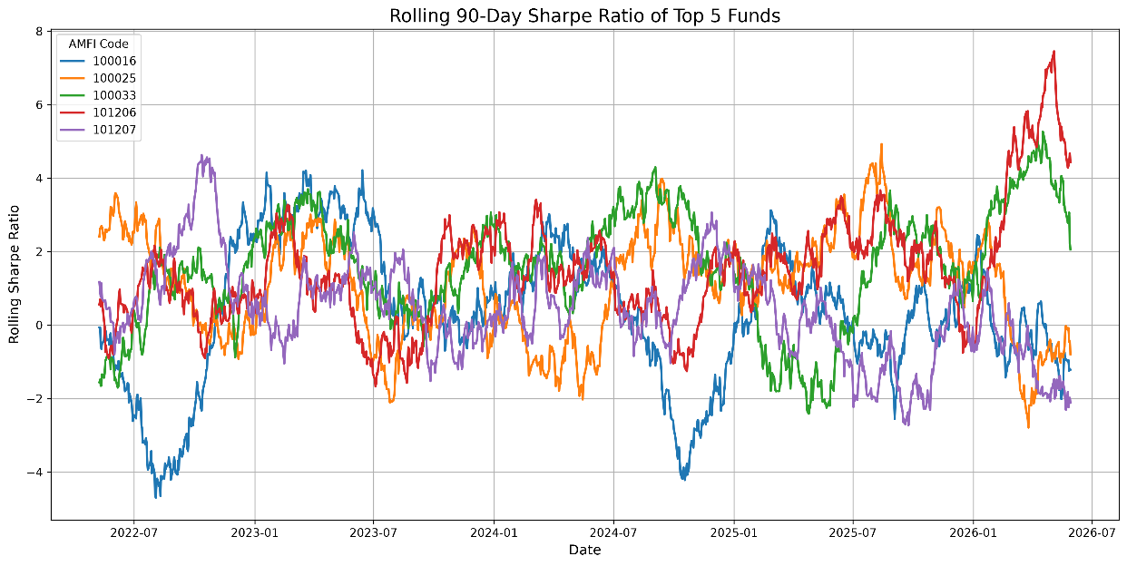The rolling analysis helps identify periods where fund performance improved or declined.

11.3 Investor Cohort Analysis
Investor Cohort Analysis grouped investors based on their first investment year.
The analysis calculated:
- Average SIP Amount
- Total Investment
- Most Preferred Mutual Fund
This helped identify differences in investment behaviour across investor groups.

11.4 SIP Continuity Analysis
Investors with six or more SIP transactions were analysed to measure the average gap between SIP payments.
Investors whose average gap exceeded 35 days were identified as At-Risk Investors, indicating irregular investment behaviour.

11.5 Mutual Fund Recommendation System
A simple recommendation system was developed using Sharpe Ratio and Risk Category.
Based on the selected risk appetite (Low, Moderate, or High), the system recommends the Top 3 mutual funds with the highest Sharpe Ratio within the matching risk category.

11.6 Sector HHI Concentration
The Herfindahl-Hirschman Index (HHI) was calculated using portfolio holding weights.
HHI helps measure portfolio concentration:
- Higher HHI → More concentrated portfolio
- Lower HHI → Better diversification
The analysis compared HHI values across all equity mutual funds.

Advanced Analytics Summary
These advanced analytical techniques provide additional insights beyond traditional financial metrics. They improve fund evaluation by combining risk analysis, investor behaviour, portfolio diversification, and recommendation logic.

Figure Caption
Figure 17: Rolling 90-Day Sharpe Ratio calculated for selected mutual fund schemes.

12. Key Findings
The project generated several useful insights from the mutual fund datasets through exploratory data analysis, financial performance evaluation, and advanced analytics.
The major findings of this project are:

1. Equity Funds Dominated the Dataset
The analysis showed that equity mutual funds represented the largest category in the dataset, indicating higher participation and availability compared to other fund categories.

2. Risk-Adjusted Performance Varied Across Funds
Sharpe Ratio analysis revealed that some funds generated better returns without taking significantly higher risk, making them more attractive for long-term investors.

3. Portfolio Diversification Differed Across Schemes
Sector HHI analysis showed that some mutual funds maintained diversified portfolios, while others had higher concentration in a few sectors such as Banking and Financial Services.

4. Investor Behaviour Changed Across Cohorts
Investor Cohort Analysis highlighted differences in SIP amounts and investment preferences between investors who entered the market in different years.

5. SIP Continuity Can Be Used for Risk Identification
SIP Continuity Analysis identified investors whose average investment gap exceeded 35 days. These investors can be considered potential churn risks and may require engagement from fund houses.

6. Rolling Sharpe Ratio Helped Track Performance Changes
Rolling 90-Day Sharpe Ratio demonstrated that fund performance is dynamic and changes over time based on market conditions.

7. Recommendation System Simplified Fund Selection
The rule-based recommendation system successfully suggested suitable mutual funds according to different investor risk profiles using Sharpe Ratio and Risk Category.

13. Limitations and Recommendations

13.1 Limitations
Although the project achieved its objectives, a few limitations were observed during development.
- The analysis was limited to the available datasets.
- Historical market conditions may not represent future performance.
- Some advanced portfolio-level information was not available for every scheme.
- The recommendation system is rule-based and does not use machine learning models.
- Live market data was not integrated into the dashboard.

13.2 Recommendations
The project can be further improved by implementing the following enhancements:
- Integrate live NAV updates using APIs.
- Develop a machine learning–based recommendation engine.
- Add portfolio optimization using Modern Portfolio Theory.
- Deploy the dashboard as a web application using Streamlit.
- Automate the ETL process using scheduled jobs.
- Expand the dashboard with additional investor and market insights.
These improvements can make the system more interactive and useful for investors and financial analysts.

14. Conclusion
This project successfully developed a complete Mutual Fund Analytics solution using Python, SQLite, SQL, and Power BI.
The project covered the complete analytics workflow, starting from raw data collection and cleaning to database creation, exploratory data analysis, financial performance evaluation, advanced analytics, and dashboard development.
Several financial metrics, including CAGR, Sharpe Ratio, Alpha, Beta, Tracking Error, Maximum Drawdown, Historical VaR, and CVaR, were calculated to evaluate fund performance from different perspectives.
The interactive Power BI dashboard provides an easy-to-understand interface for analysing mutual fund performance, investor behaviour, and market trends.
Overall, this project demonstrates practical knowledge of data analytics, financial analysis, database management, business intelligence, and dashboard development. The solution can be further extended by integrating real-time data, predictive analytics, and machine learning models.

15. References
The following tools, technologies, and datasets were used during the development of this project.

Software
- Python 3.12
- Jupyter Notebook
- Visual Studio Code
- SQLite
- DB Browser for SQLite
- Power BI Desktop

Python Libraries
- Pandas
- NumPy
- Matplotlib
- SQLite3
- Pathlib

Project Datasets
- Fund Master
- NAV History
- AUM by Fund House
- Monthly SIP Inflows
- Category Inflows
- Industry Folio Count
- Scheme Performance
- Investor Transactions
- Portfolio Holdings
- Benchmark Indices

Project Repository
GitHub Repository: https://github.com/PrashantNikhare/Bluestock-Internship

