**Name : Prashant Raghuwanshi**

**Roll No : A4_B2_34**

**Competitive Coding Link:**  
<https://www.geeksforgeeks.org/problems/m-coloring-problem-1587115620/1>

**Code :**

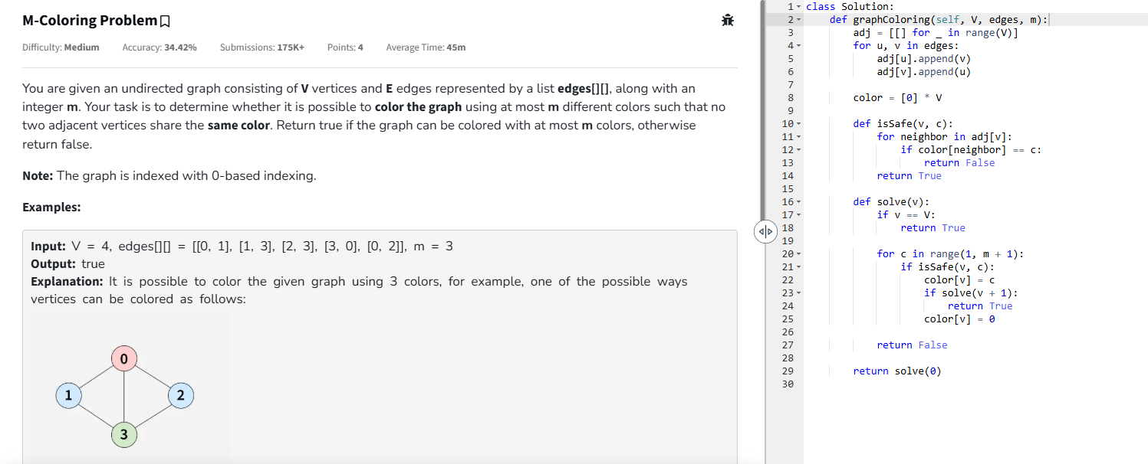

**Output :**

