7.2 Exercises Probabilities Scenarios

Prashant Raghuwanshi

DSC, Bellevue University

[DSC500-T301 Introduction to Data Science (2215-1)](https://cyberactive.bellevue.edu/webapps/blackboard/execute/courseMain?course_id=_500210_1)

 Professor [Catherine](mailto:Catherine.williams@bellevue.edu) Williams

05/01/2021

ABSTRACT:

This exercise 7.2 aims to practice probability calculations for the given scenarios.

Calculate Probabilities for below given Scenarios

==============================================================

Formula to Calculate Probability

The formula of the probability of an event is:

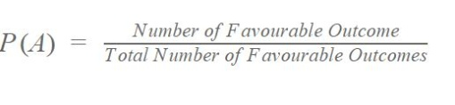

Probability Formula

Or,

|  |
| --- |
| * **P(A) = n(A)/n(S)** |

Where,

P(A) is the probability of an event “A”

n(A) is the number of favourable outcomes

n(S) is the total number of events in the sample space

* Rolling a die and having a number greater than 5
* Assuming a standard six-sided die, the only number greater than 5 is 6, resulting in a probability of 1/6 = 0.167 or 16.7 percent
* Rolling a die and return a 6
* Assuming a standard six-sided die, the only face is 6, resulting in a probability of 1/6 = 0.167 or 16.7 percent
* Selecting a card from a standard pack of cards that is Red
* In a standard  pack of 52 cards, half of them are red (hearts and diamonds) and the other half are black (clubs and spades). Which makes the odds of picking a red card  at random is 50%
* Selecting a card from a standard pack of cards that is an Ace
* There are 4 suits in the pack, being Hearts, Diamonds, Spades and Clubs.

Each suit has 13 cards in it, being Ace, 2, 3, 4, 5, 6, 7, 8, 9, 10, Jack, Queen and King.

There are 4 Aces in the pack, one for each suit.

P(Ace) = ( 4/52 ) = ( 1/13 ) = 0.0769 = 7.69%

* Flipping a coin and getting heads
* Assuming we have single coin , so number of outcome is 2

Probability is = ½ = 0.5 = 50%

**References**

Web references:

<https://www.khanacademy.org/math/statistics-probability/probability-library/basic-theoretical-probability/a/probability-the-basics>