* 1. Assignment: PyCharm

Screen print showing newly installed Python 3.9 version configured @ Pycharm 2020 version.

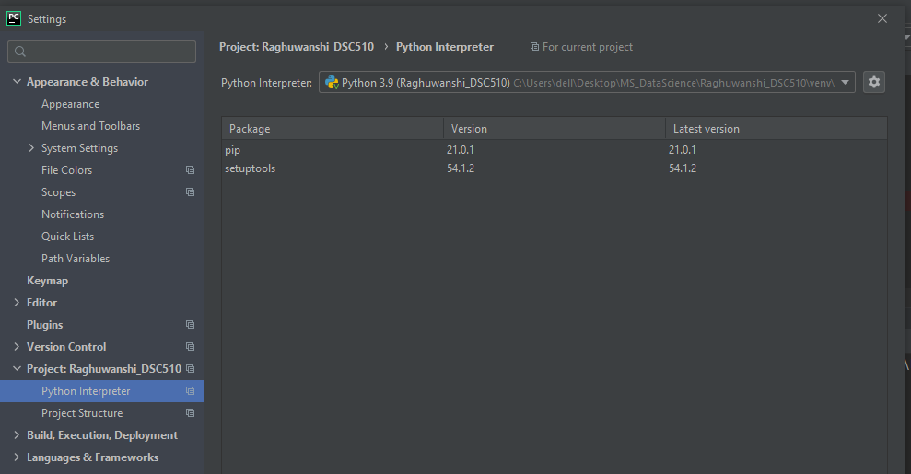

Screen print showing helloworld program and console output showing Hello World

