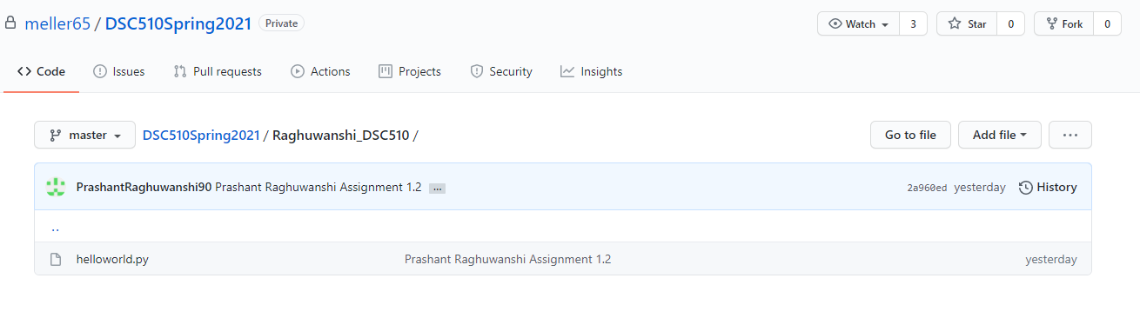

Screenprint showing “raghuwanshi_DSC510” code was commited and pushed successfully to DSC510Spring2021 repo.