Please find below screen print showing terminal output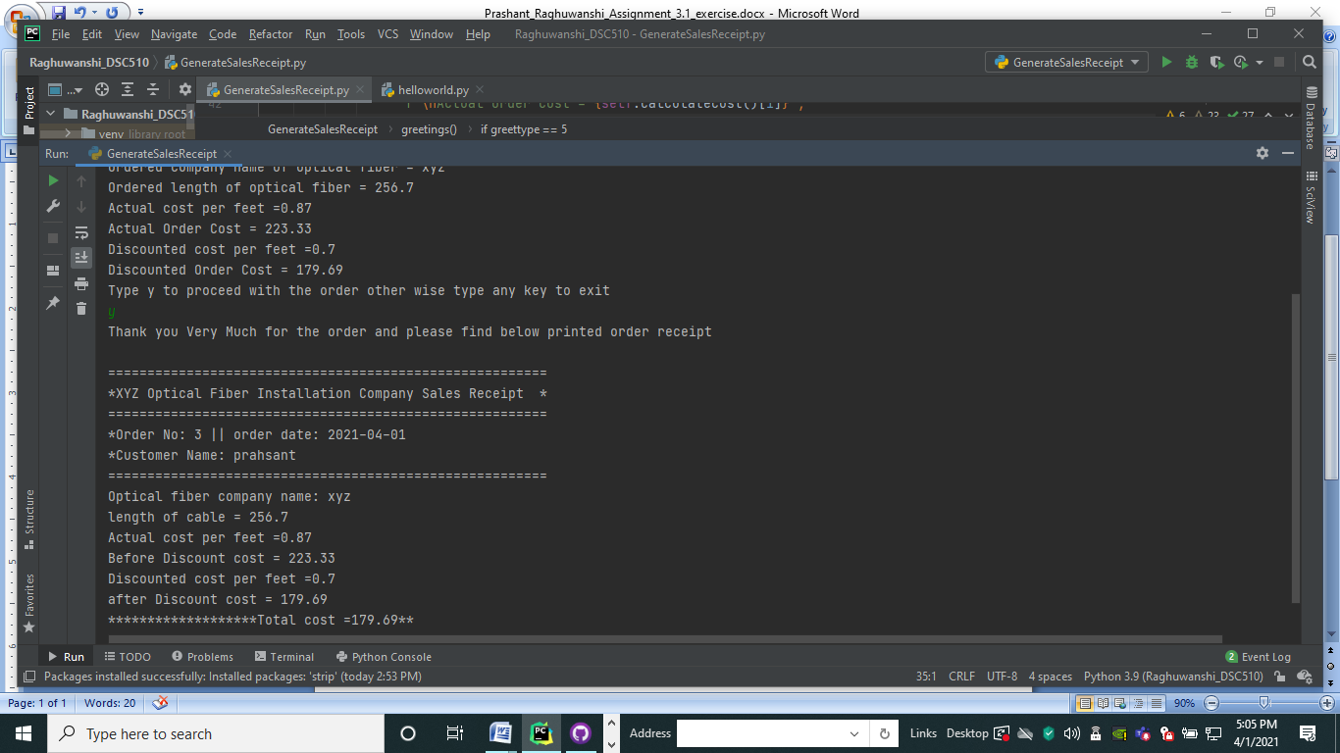tput:

C:\Users\dell\Desktop\MS_DataScience\Raghuwanshi_DSC510\venv\Scripts\python.exe C:/Users/dell/Desktop/MS_DataScience/Raghuwanshi_DSC510/assignment3_1.py

Welcome to the Optical fiber installation order terminal

Please enter customer Full Name :uu

Please enter the required Optical Fiber Company Name :yu

Please enter the required length of optical cable in feats :100

Please Verify below order details before generating the sales receipt

Ordered Company name of optical fiber = yu

Ordered length of optical fiber = 100.0 ft

Actual cost per feet = $0.87

Actual Order Cost = $87.0

Discounted cost per feet =$0/ft

Discounted Order Cost = $87.0

Type y to proceed with the order other wise type any key to exit :y

Thank you Very Much for the order and please find below printed order receipt

========================================================

*XYZ Optical Fiber Installation Company Sales Receipt *

========================================================

*Order No: 3 || order date: 2021-04-18

*Customer Name: uu

========================================================

Optical fiber company name: yu

length of cable = 100.0 ft

Actual cost per feet =$0.87/ft

Before Discount cost = $87.0

Discounted cost per feet =$0/ft

after Discount cost = $87.0

*******************Total cost =$87.0**

Process finished with exit code 0