Please find below screen print showing pushed assignment code to git hub:

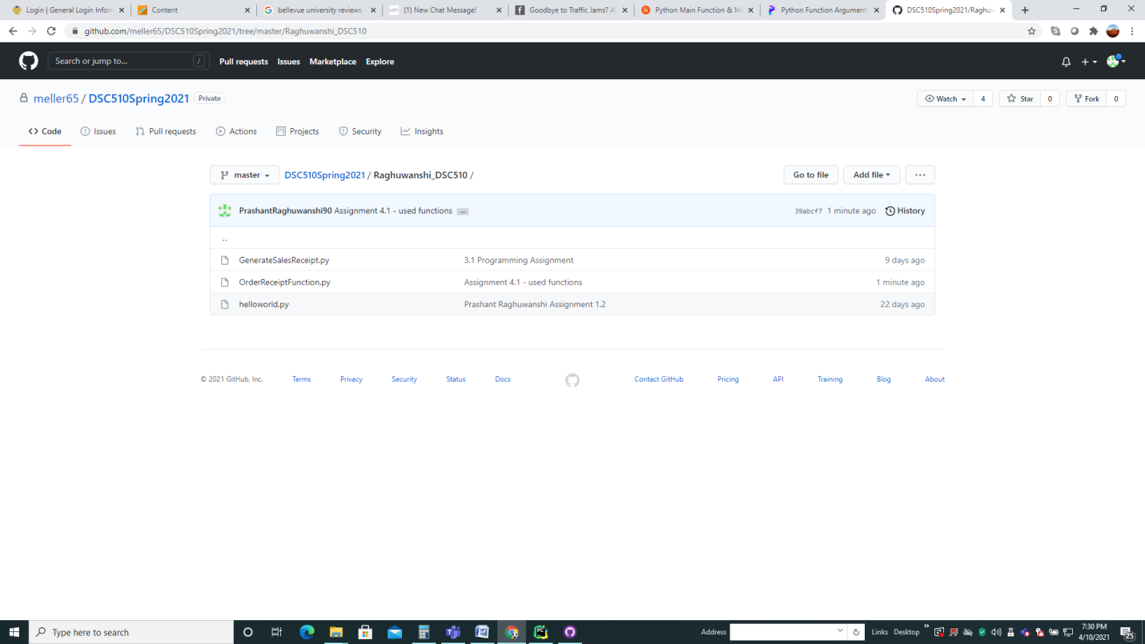

Please find below screen print showing terminal output:

C:\Users\dell\Desktop\MS_DataScience\Raghuwanshi_DSC510\venv\Scripts\python.exe C:/Users/dell/Desktop/MS_DataScience/Raghuwanshi_DSC510/OrderReceiptFunction.py

Welcome to the Optical fiber installation order terminal

Please enter your Full Name

prash

Please enter the required Optical fiber company name

erd

Please enter the required length of optical cable in feets

378.56

Optical fiber company name = erd

Ordered length of optical fiber = 378.56 ft

Actual cost per feet = $0.87

Actual Order Cost = $329.35

Special Discount only apply if ordered fiber length is equal or greater than 100 ft

Discounted cost per feet = $0.7

Discounted Order Cost = $264.99

Type y to proceed with the order other wise type any key to exit

y

Thank you Very Much for the order and please find below printed order receipt

========================================================

*XYZ Optical Fiber Installation Company Sales Receipt *

========================================================

*Order No: 3 || order date: 2021-04-18

*Customer Name: prash

========================================================

Optical fiber company name: erd

length of cable = 378.56 ft

cost per feet = $0.87

Actual pOrder Cost = $329.35

Discounted cost per feet = $0.7

after Discount cost = $264.99

*******************Total Paid Amount = $264.99**

Process finished with exit code 0