1. Group the items and categories and identify if there are misspellings or errors. This would most easily be done by creating a pivot table – (see [Excel Pivot Tables](https://www.excel-easy.com/data-analysis/pivot-tables.html) for help)

Please find below misspelling errors:

At Catergory :

Beverages = Beerages, Beverags

Candy = Cand

Frozen Treats = Frozen Treat

Hot Food = Hot Fod

At Item level:

Gummy Bears = Gumy Bears

Licorice Rope = Licorce Rope

Popsicle = Popsile

Hamburger = Hmburger

Pizza = Pizzaa

Popcorn= Popcrn

Data value fix at price columns:

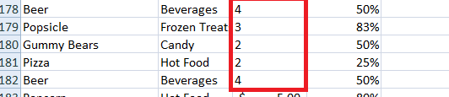

Fixed values

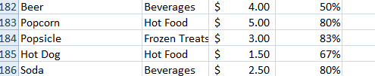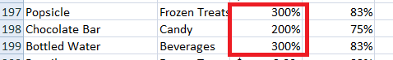

Fixed values

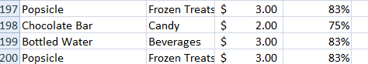

1. Are there duplicates of the groups and are they valid?

Yes we had duplicated of group and all of them got fixed after fixing the spelling issue (refer below screen print shaowing fixed group)

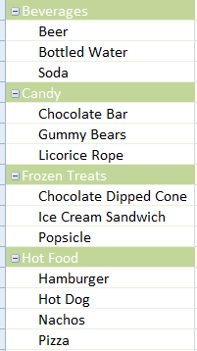

1. Identify data with the wrong data type.

Fixed the price of soda from 25 to 2.5 , beer from 3 to 4, Licorice Rope from 20 to 2

Data value fix at price columns:



Fixed values



Fixed values



1. Calculate the actual profit based on the profit %.

Please refer attached excel sheet -- Basketball Game Sales tab

1. Complete a Vlookup to see what the calories for each item are by using the Calories tab (see [Vlookup: When and How to Use it](https://support.office.com/en-us/article/video-vlookup-when-and-how-to-use-it-9a86157a-5542-4148-a536-724823014785" \t "_blank) for help)

Please refer attached excel sheet -- Basketball Game Sales tab