Term End Project Milestone-1

Prashant Raghuwanshi

DSC, Bellevue University

[DSC500-T301 Introduction to Data Science (2215-1)](https://cyberactive.bellevue.edu/webapps/blackboard/execute/courseMain?course_id=_500210_1)

 Professor [Catherine](mailto:Catherine.williams@bellevue.edu) Williams

04/04/2021

ABSTRACT:

This term-end project aims to evaluate the use of techniques like Google trend Analysis, Google searches, and open-source historical graphs in conjunction with the management model CRISP-DM. It helps understand the data science concepts and enables Data science learners to frame the appropriate questions for the given requirement and accordingly pull out the relevant data from the web or google.

Term End project Milestone -1

1. **INTRODUCTION**

Please find the questions/theories that I will analyze as per the requirement for the term-end project.

* Does Weather forecasting information helps in reducing the road accidents
* Do parents want to send their kinder garden kid to in-person classes?
* Before registering for covid vaccination appointments, do peoples are considering vaccine manufacturers too.
* Which is the preferred pet in the USA (Cat or Dog)
* Dose an economic downturn had an impact on the peoples night dream

I am using the Visualization results to find answers to my questions. I will implement this study by utilizing a data mining management model called CRISP-DM.

Please find the list of question to ourself under business understandi8ng section and gather corresponding raw data under understanding data and preparation section.

**CRISP-DM**

The Cross-Industry Standard Process for Data-Mining – CRISP-DM is a model of a data mining process used to solve problems by experts. The model identifies the different stages in implementing a data mining project, as described bellow

The model proposes the following steps:

* Business Understanding – to understand the rules and business objectives of the company.
* Understanding Data – to collect and describe data.
* Data Preparation – to prepare data for import into the software.
* Modeling – to select the modeling technique to be used.
* Evaluation – Evaluate the process to see if the technique solves modeling and creating rules.
* Deployment – to deploy the system and train its users

2.1. Business Understanding

The first phase of the CRISP-DM is the Business Understanding. This phase is aimed at defining the business objectives of our research. The proposed goal is to ask questions from businesses or ourselves before starting data gathering and analysis.

Please find below-related questions under each topic and initial data collection details to get the possible answers.

1. Does Weather forecasting information help in reducing road accidents?

* Do we have related blogs or articles in google for initial information?
* How does the people's search sentiments fluctuate during extreme weather periods in a year(like a cold week, hot week, rainy week)
* Way to identify the extreme weather periods in a year
* Search the public reported road accident records of specific area or city by months
* Zoom out accident data by vehicle
* Find the interrelations on the search for emergency care with accident data
* Trends search on media reports related to extreme weather and its impact

1. Do parents want to send their kinder garden kid to in-person classes?

* What is the trending sentiment for the kinder garden during the covid period
* How trending sentiments look for covid search during that period
* How trending sentiments look for handling kids or engage kids during the covid period
* How trending sentiments look for kids online hobby classes
* How trending sentiments look for kinder garden assignments
* Trending sentiment for keywords like safe schools, a vaccine for kids
* Trending search for pets near me

1. Before registering for covid vaccination appointments, do peoples are considering vaccine manufacturers too.

* Trends for covid vaccine registration search for a state
* Trends for covid new cases search for a state
* Trends for Pfizer, Moderna
* Search for state government vaccine days for Pfizer and Moderna
* Comparing Pfizerve vs. Moderna sentiments
* Trends for traveling search for a state

1. Which is the preferred pet in the USA (Cat or Dog)

* How trending sentiments look for cat keyword
* How trending sentiments look dog trend
* How trending sentiments look new pets
* How trending sentiments look car food
* How trending sentiments look dog food
* How trending sentiments look vet hospitals
* How trending sentiments look for cat training and dog training
* How trending sentiments look for cat breeds vs. dog breeds

1. Dose an economic downturn impact peoples questions for a night dream

* Find trends for dream search in united state
* Find dow, Nasdaq, coronavirus cases, job data graph for a YTD.
* Find trends for good dreams graph for a YTD
* Find for trends for bad dreams graph for a YTD
* Find correlation between graphs
* Find trends for Psychiatrists or Psychologists
* Find the trends for a search like not getting sleep
* Find articles related to sleep and dream
  1. Data Understanding & Data Preparation

Please refer to the collected raw data visualization from google trend and google search related to the business understanding sections' questions.

* **Does Weather forecasting information help in reducing road accidents? (Chicago area)**
* **Data Collected from google search**:

<https://www.vaisala.com/en/case/using-weather-information-reduce-accidents-and-improve-traffic-flow>

<https://weatherspark.com/y/14091/Average-Weather-in-Chicago-Illinois-United-States-Year-Round>

* **Data collected from google trends**

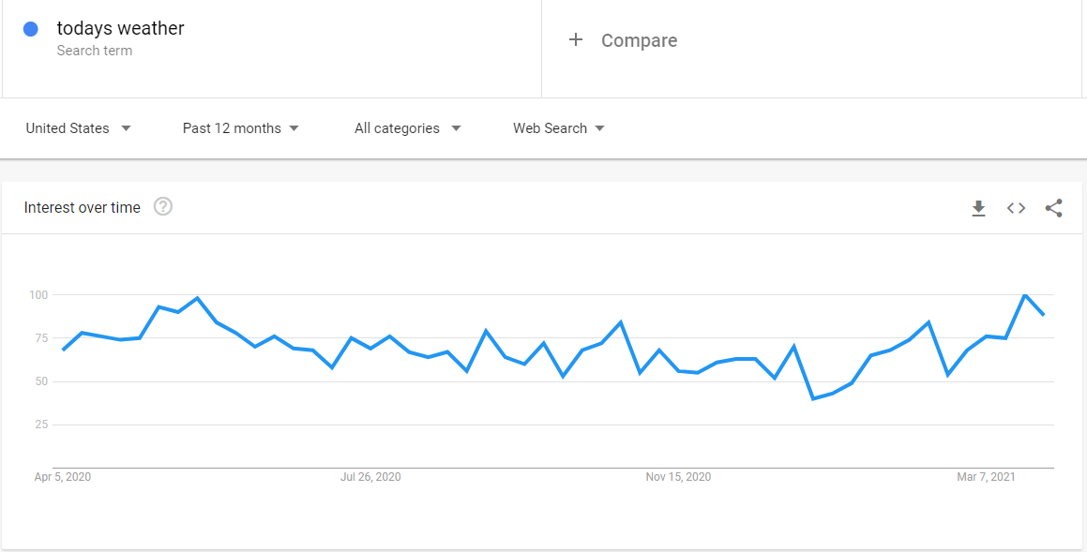

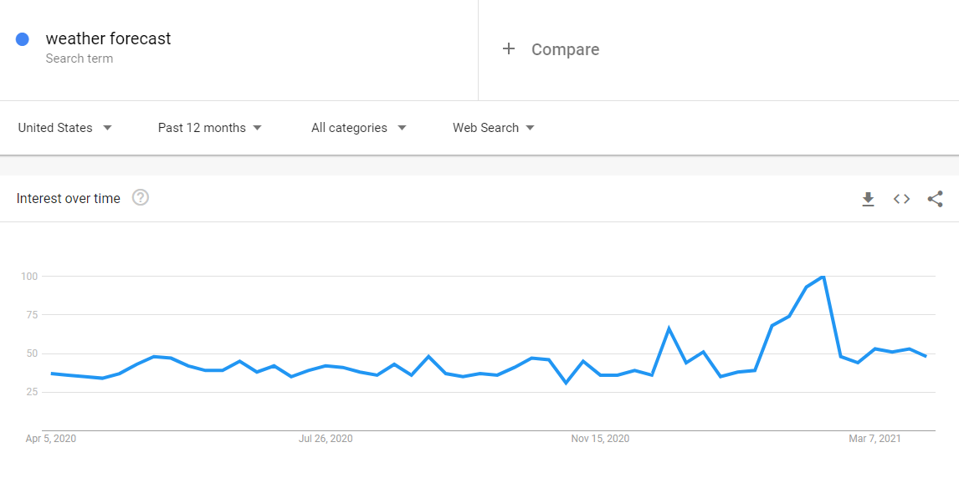

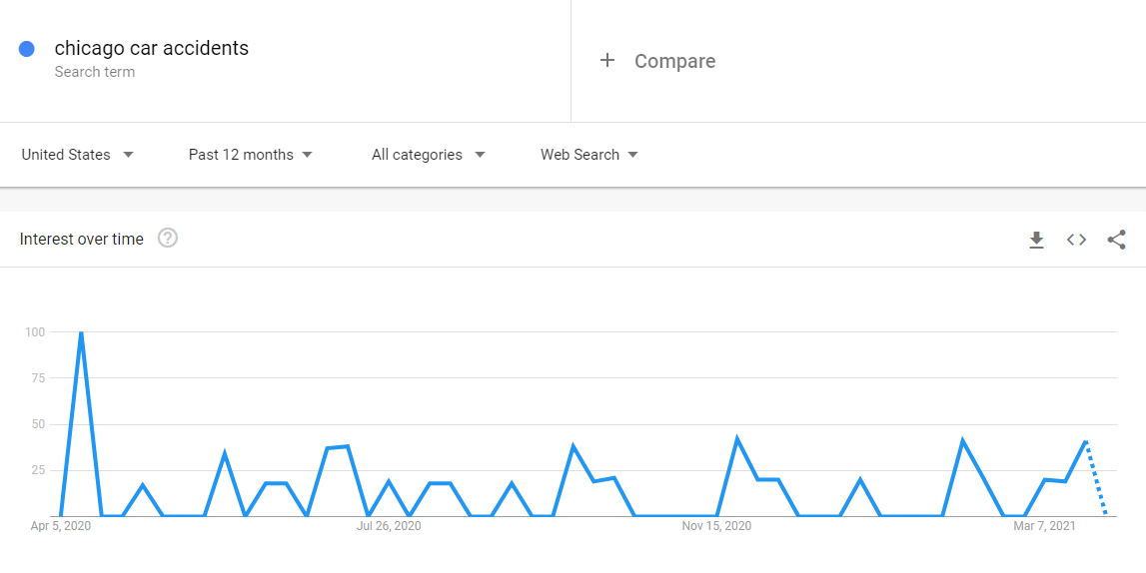

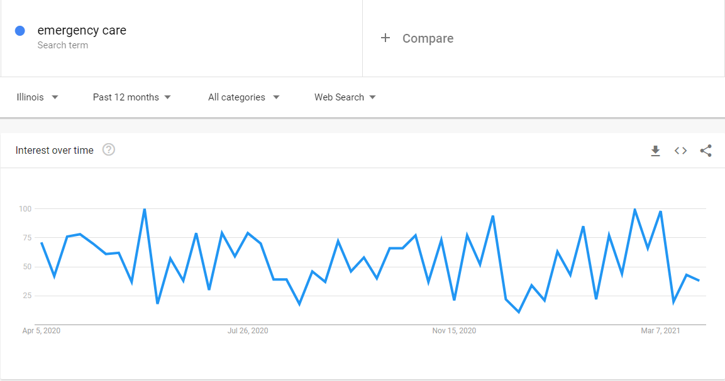

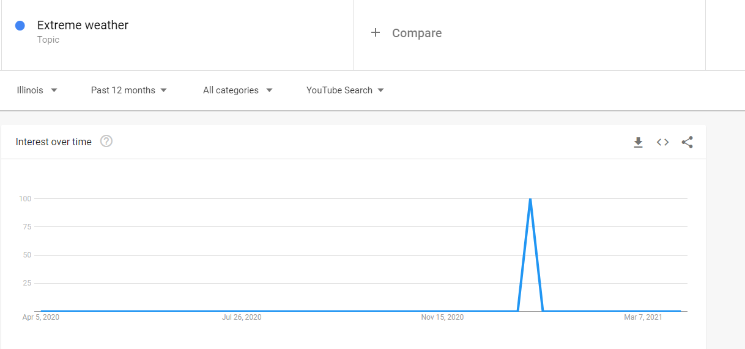

* **Do parents want to send their kinder garden kid to in-person classes?**
  + **Data Collected from google search**:

<https://wamu.org/story/21/02/04/how-five-families-decided-to-send-their-children-back-for-in-person-learning-or-not/>

<https://washingtonstatewire.com/poll-2-3rds-of-parents-likely-to-send-their-children-to-school-if-schools-re-open-for-in-class-learning/>

<https://labblog.uofmhealth.org/rounds/13-of-parents-3-states-may-not-send-children-to-school-because-of-covid-19>

<https://kidshealth.org/en/parents/coronavirus-school.html>

google trends:

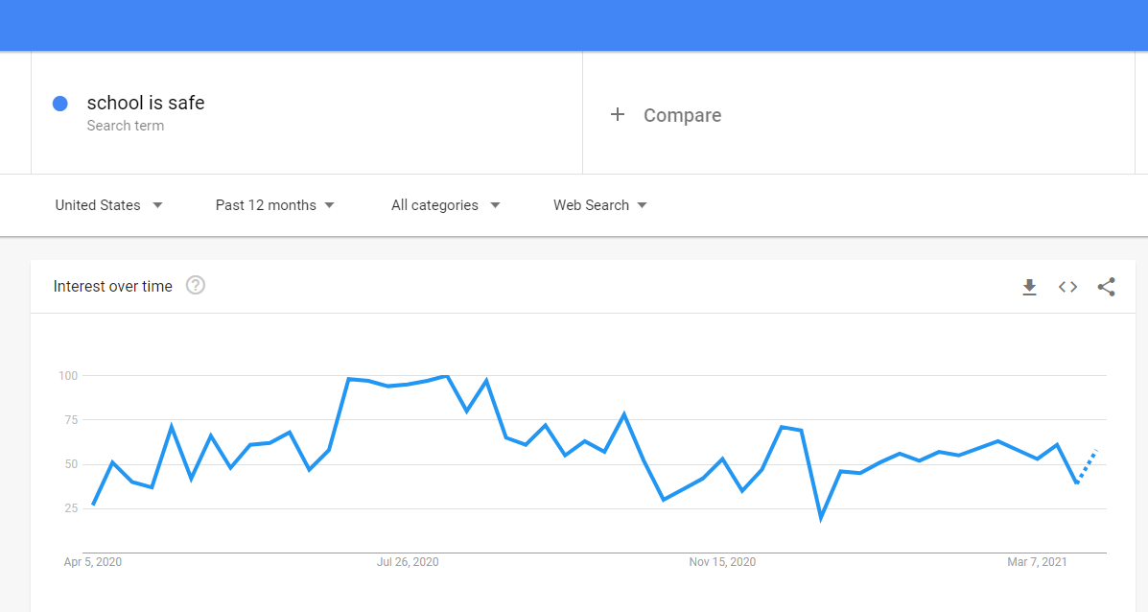

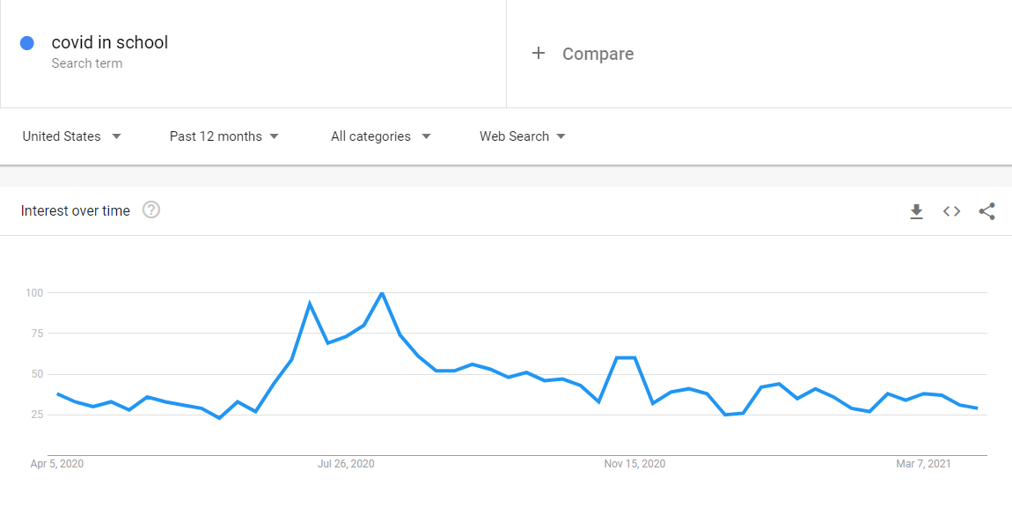

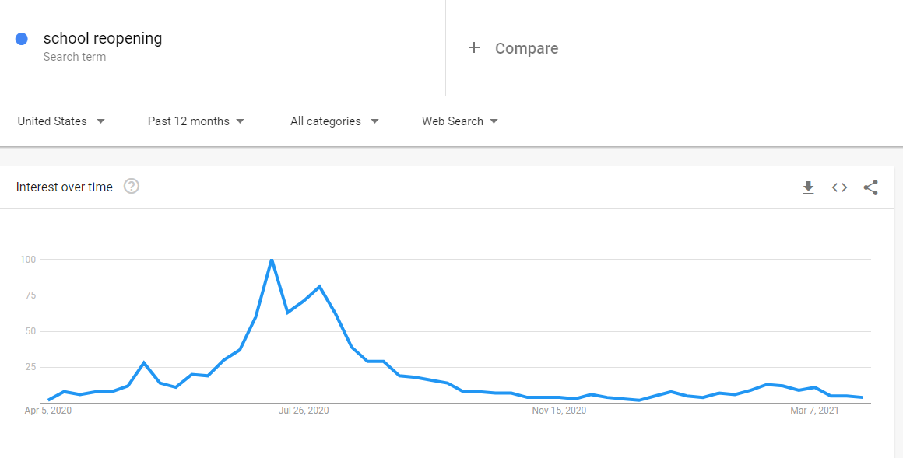

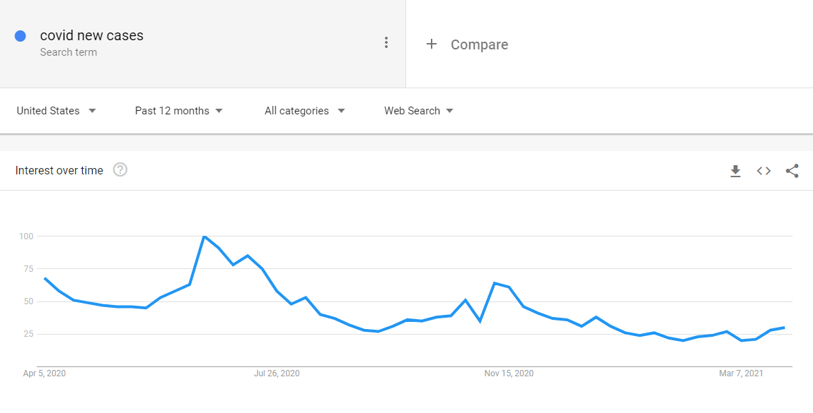

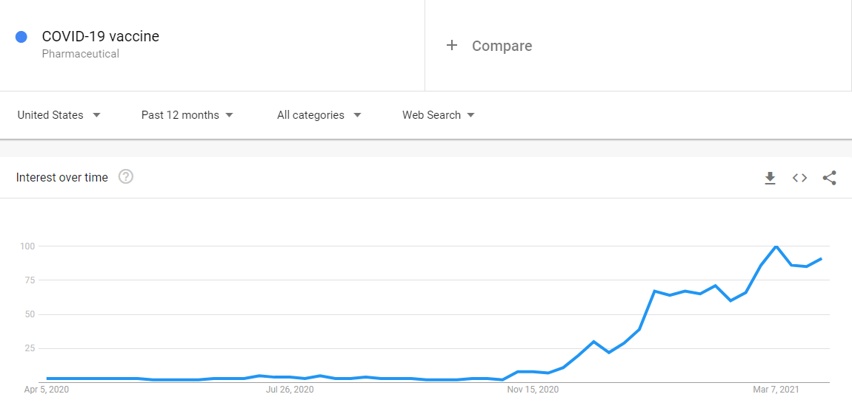

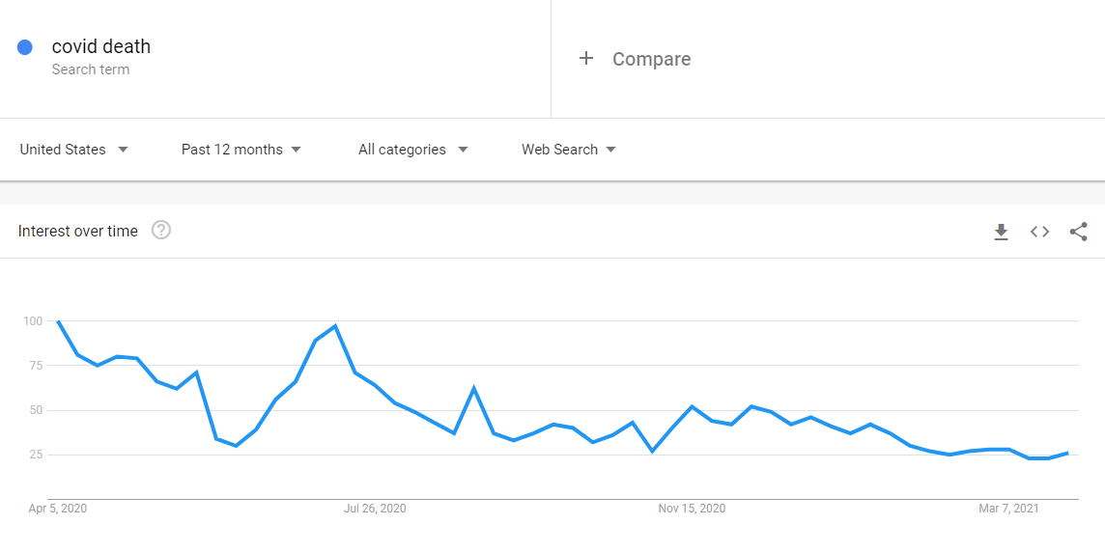

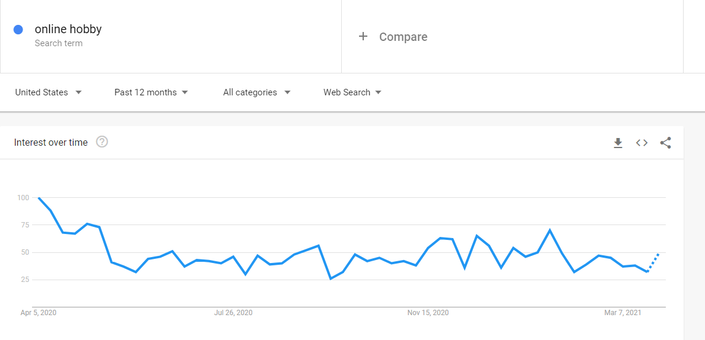

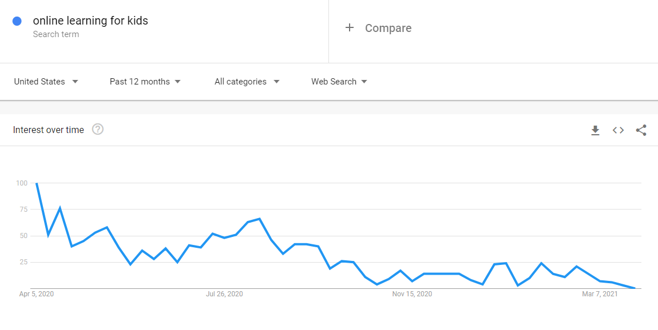

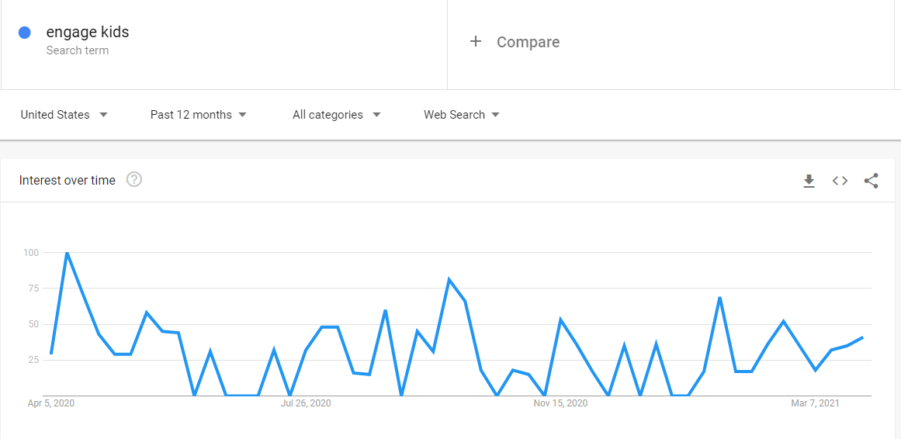

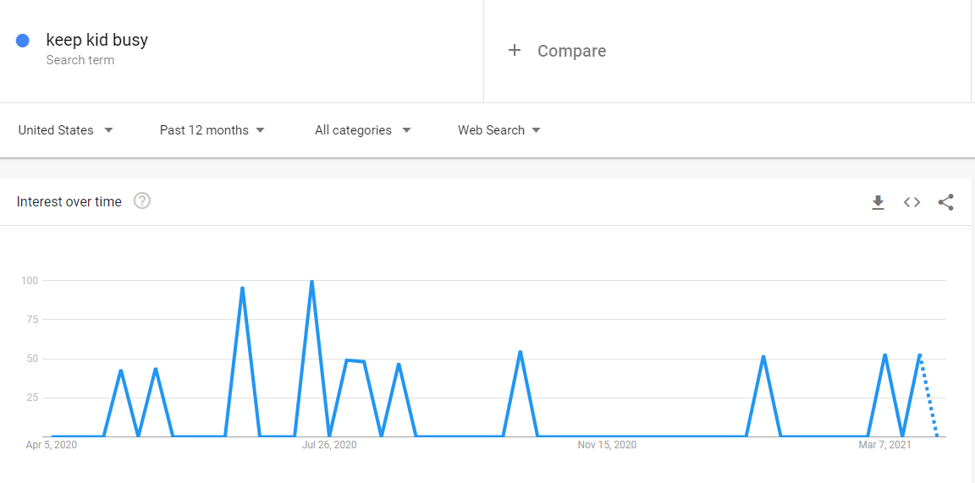

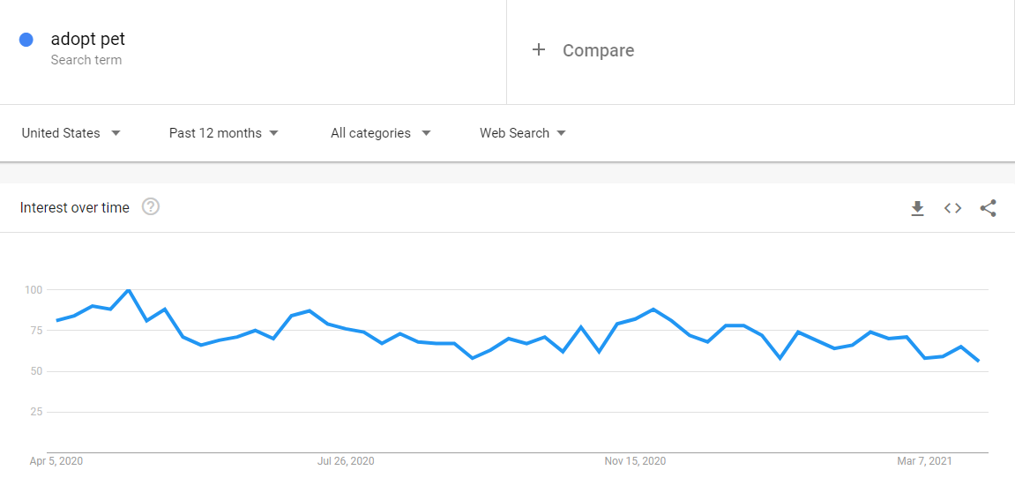

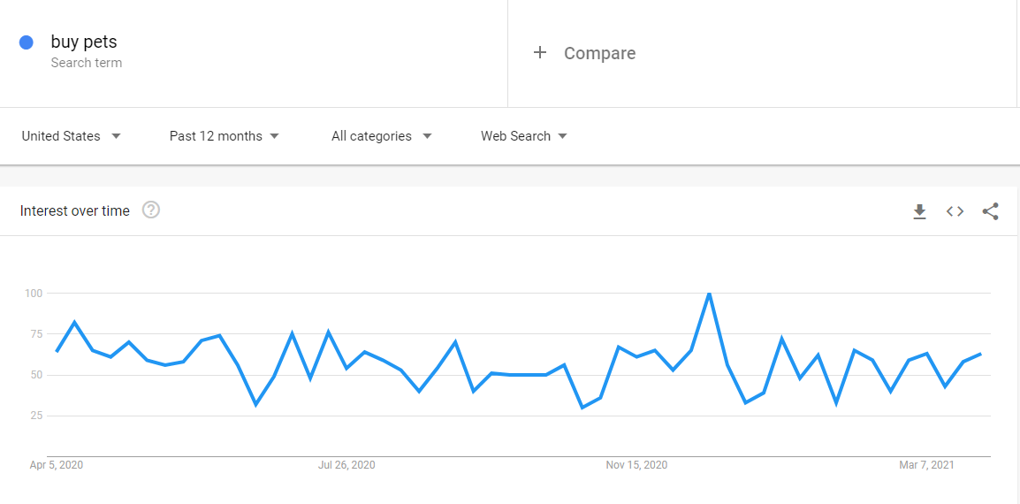

* **Before registering for covid vaccination appointments, do peoples are considering vaccine manufacturers too.**
  + **Data Collected from google search**:

<https://www.yalemedicine.org/news/covid-19-vaccine-safety>

<https://www.statnews.com/2021/02/02/comparing-the-covid-19-vaccines-developed-by-pfizer-moderna-and-johnson-johnson/>

<https://www.vox.com/22362894/which-covid-vaccine-is-better-moderna-vs-pfizer-video>

<https://www.dph.illinois.gov/covid19/vaccinedata?county=Illinois#InventoryReporting>

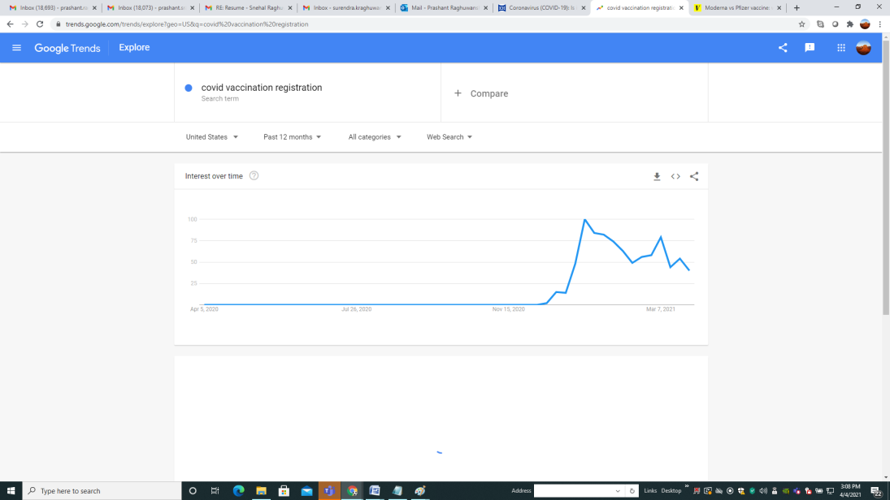

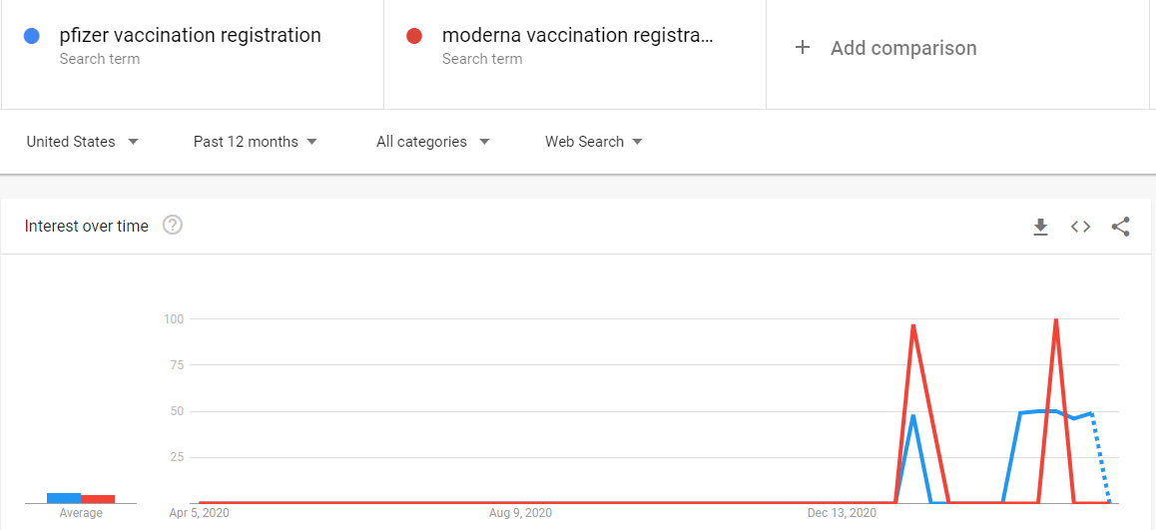

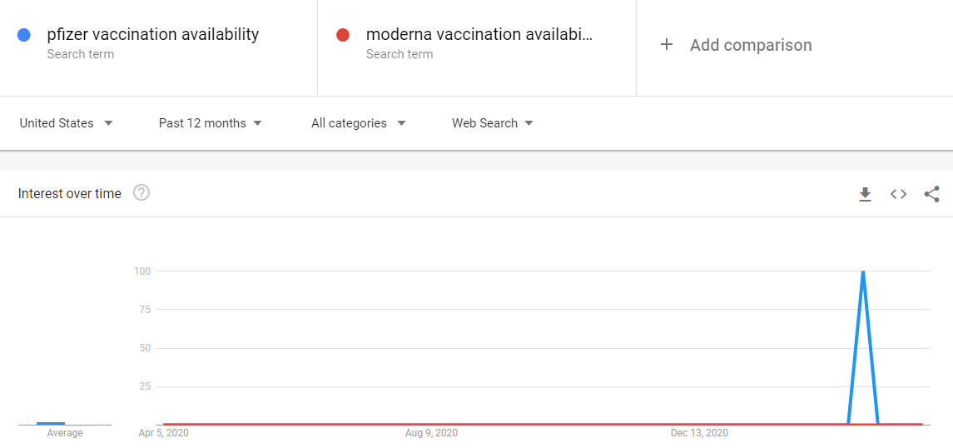

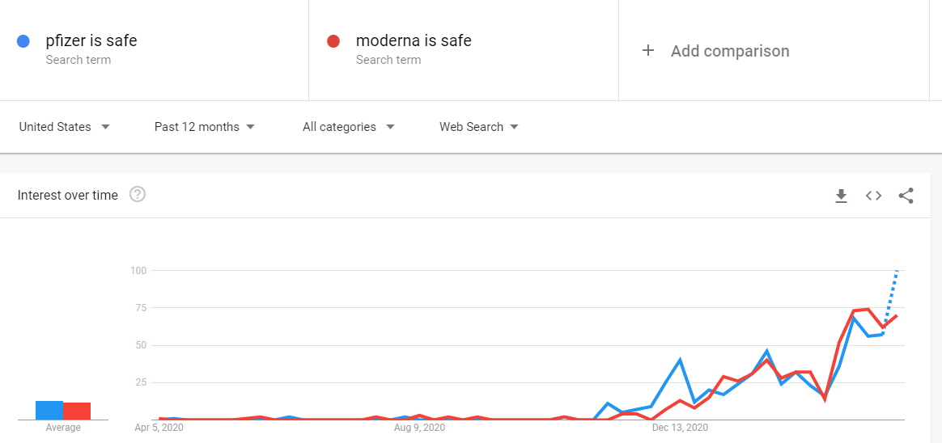

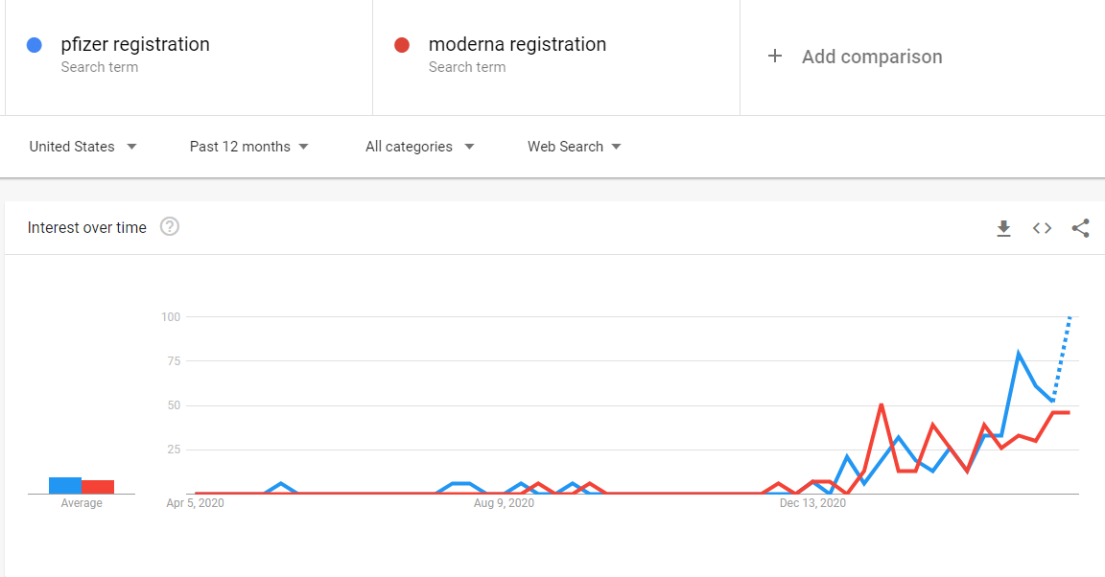

* **Which is the preferred pet in the USA (Cat or Dog)**

**Data collected from google search**

<https://easypetfence.com/pages/do-people-like-dogs-or-cats-better>

<https://www.petsecure.com.au/pet-care/a-guide-to-worldwide-pet-ownership/>

<https://www.usatoday.com/story/tech/reviewedcom/2020/05/04/15-most-popular-pet-products-you-can-get-petco/111649590/>

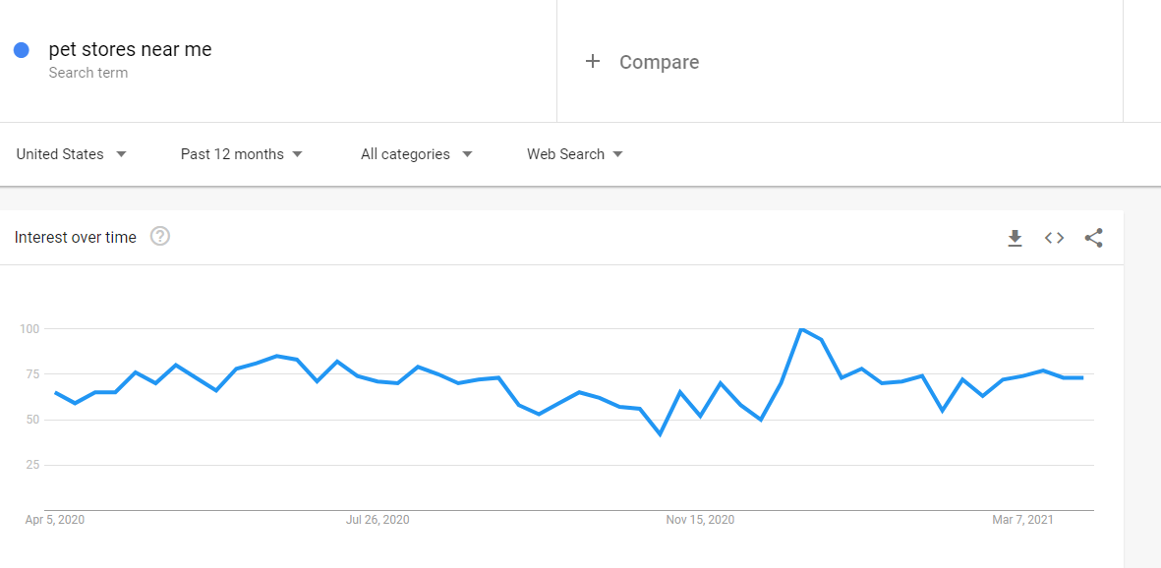

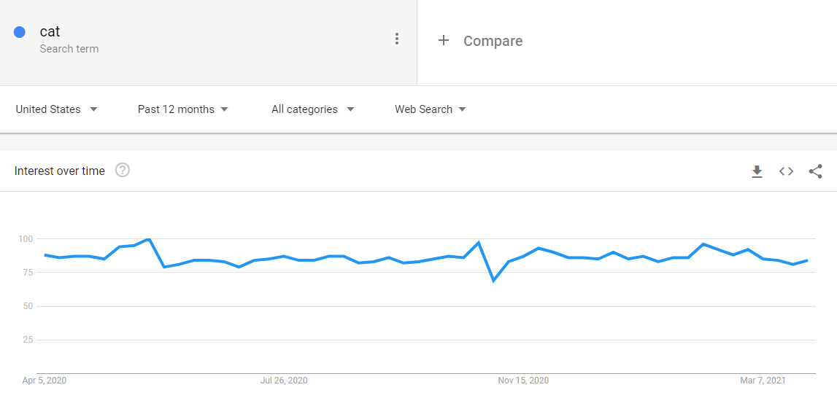

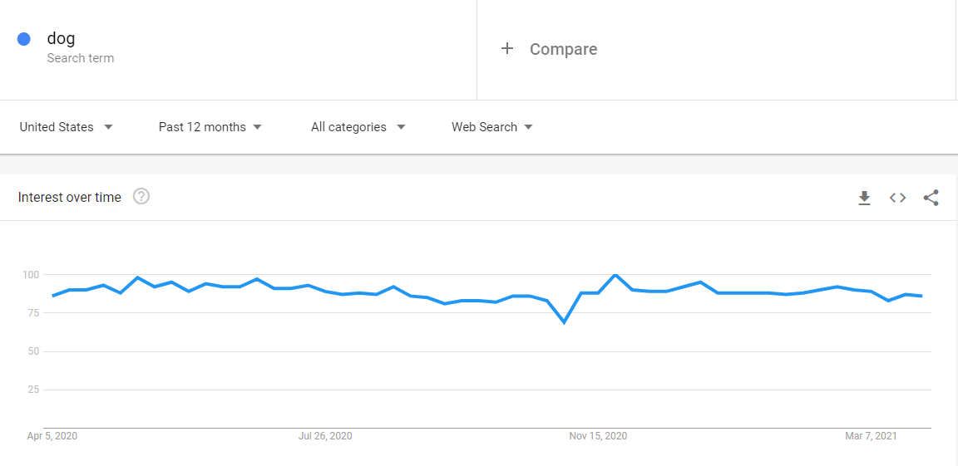

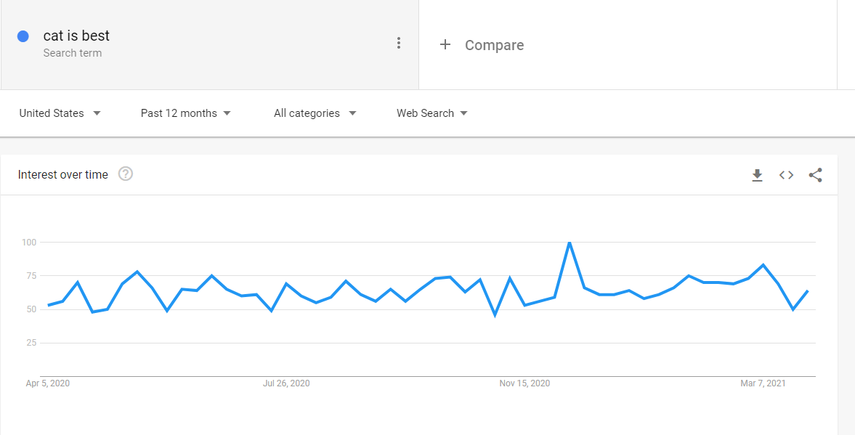

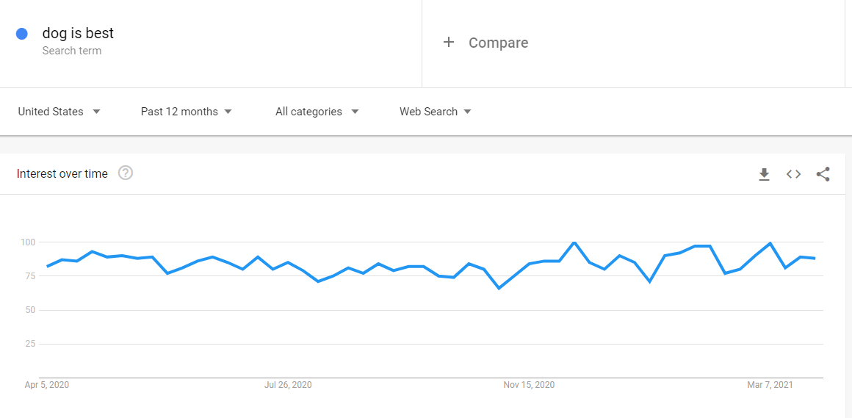

* **Dose an economic downturn impact peoples questions for a night dream**
* <https://www.bea.gov/news/2021/gross-domestic-product-4th-quarter-and-year-2020-advance-estimate#:~:text=Real%20GDP%20decreased%203.5%20percent,in%202019%20(table%201)>.
* <https://www.investing.com/>

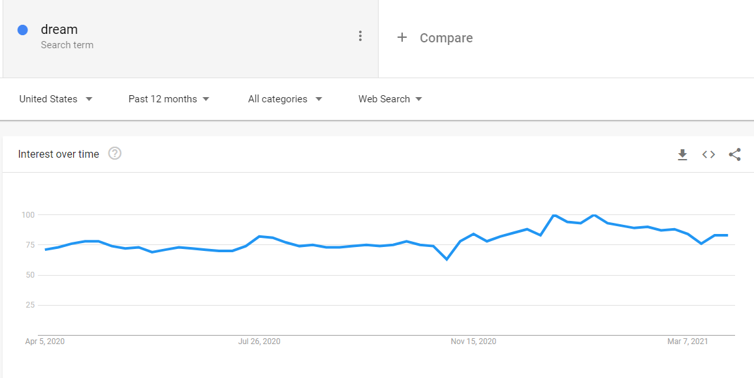

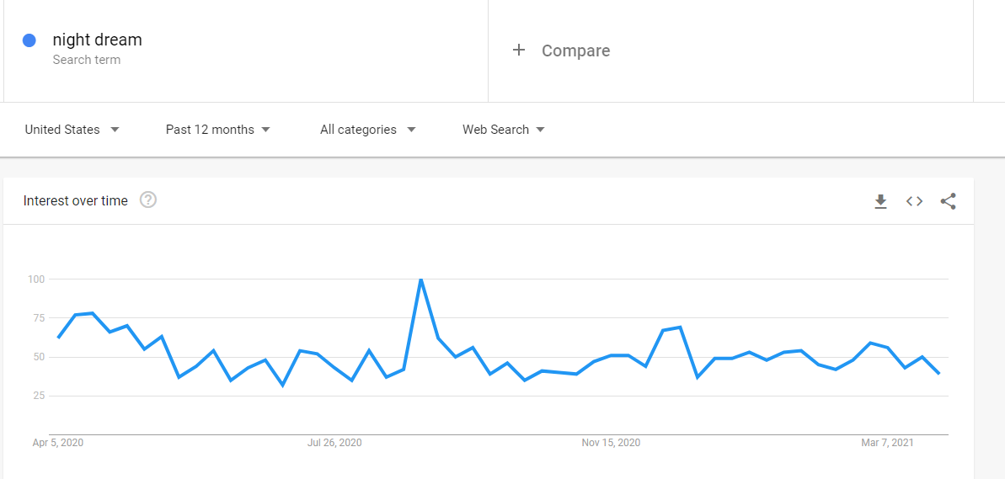

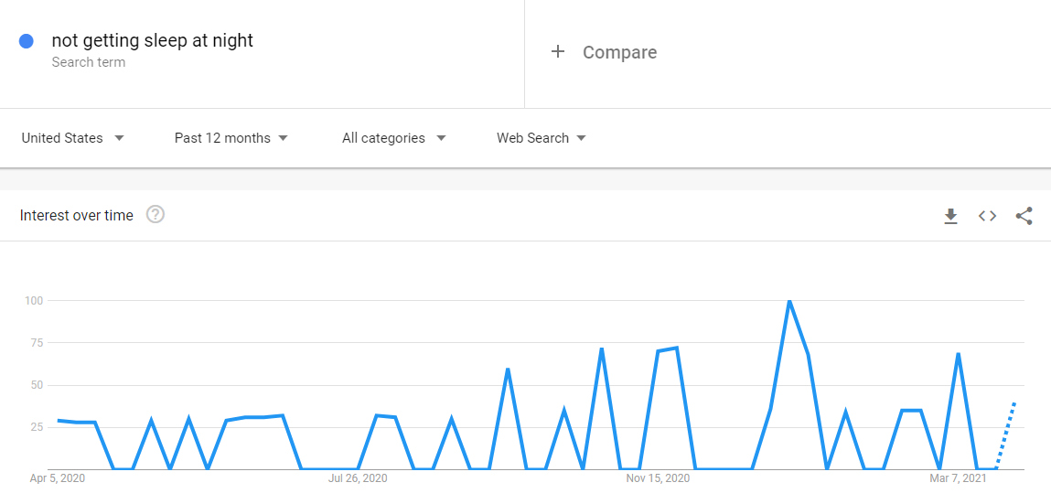

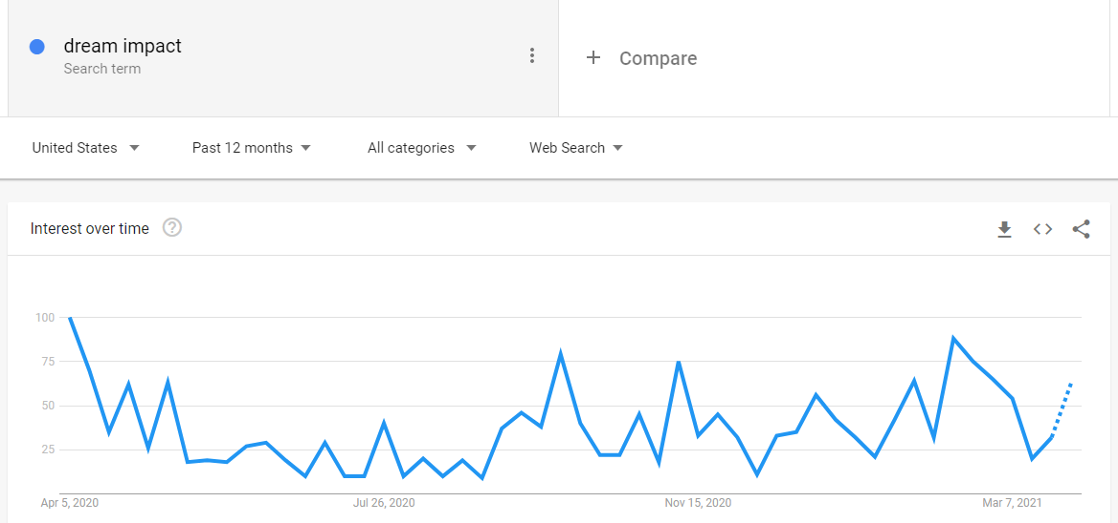

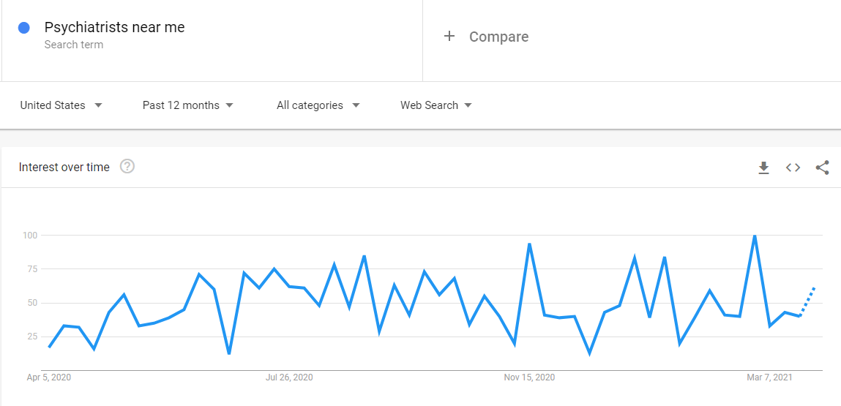

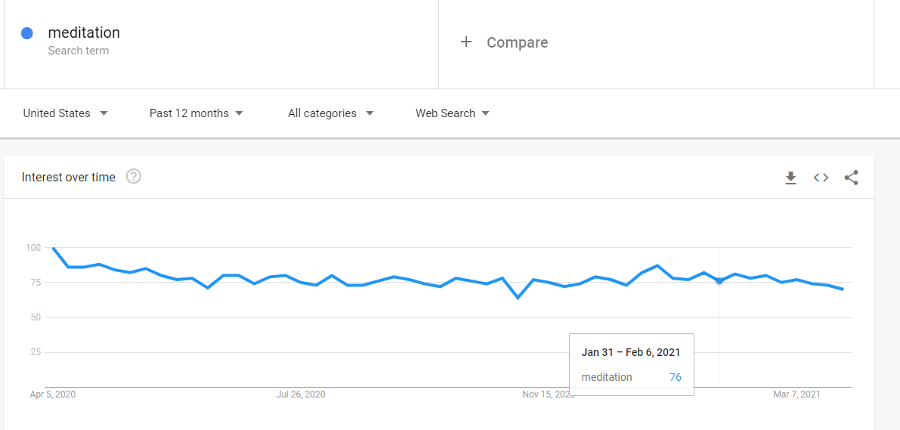

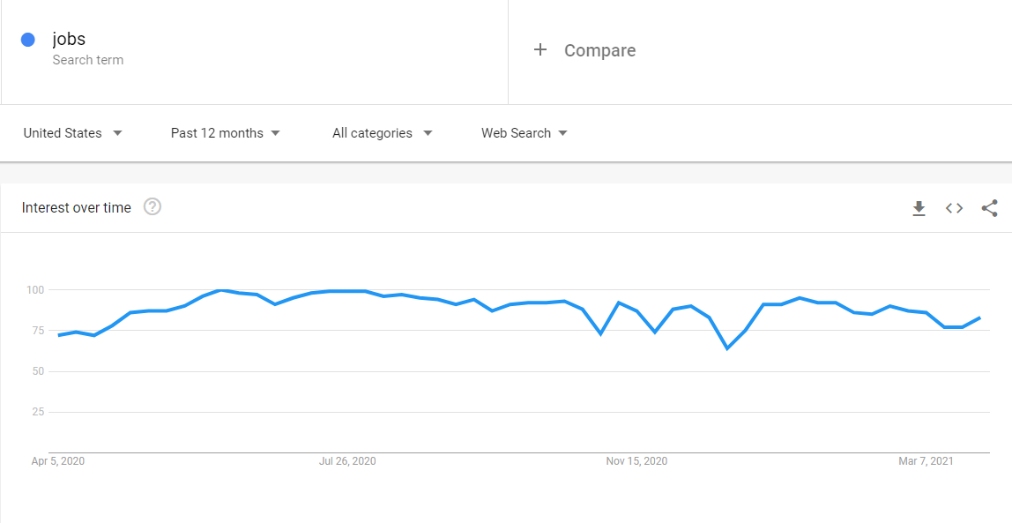

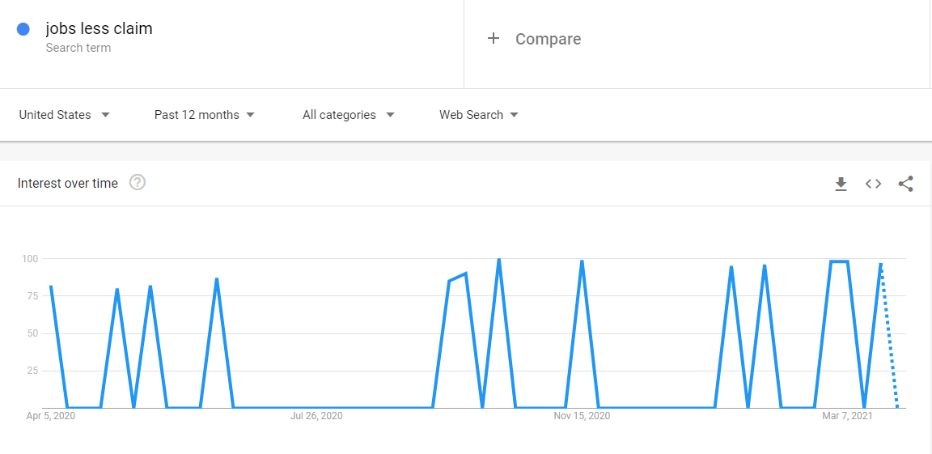

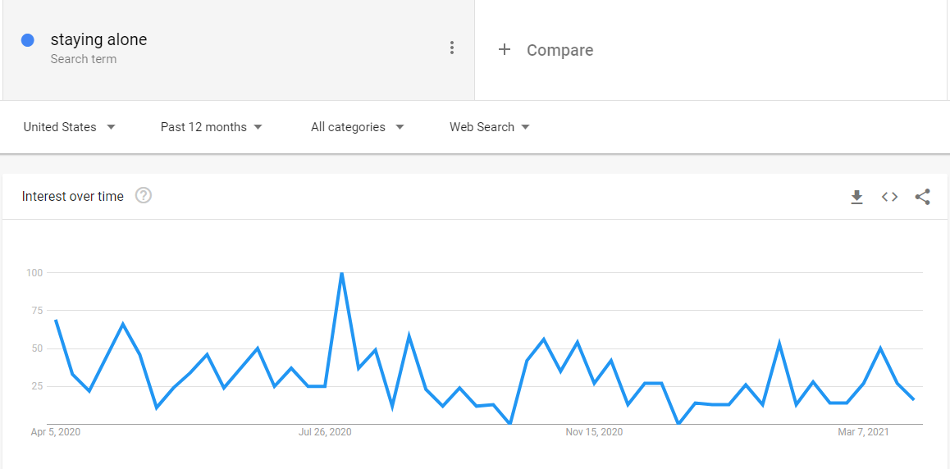

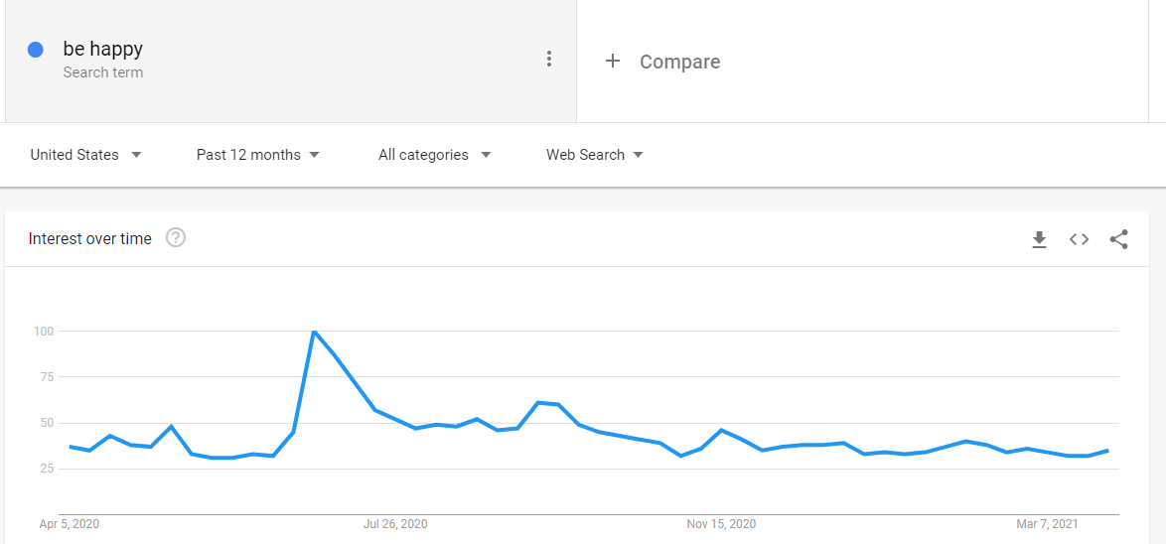

**References**

Seth Stephens (2017). *Everybody Lies*. DEY ST.

Web references:

<https://trends.google.com/trends/yis/2011/US/>