Assignment Task3:

What is the level of measurement of the following variables?

1. The number of downloads of different band’s songs on iTunes: Discrete measure, we can download whole complete song
2. The names of the bands downloaded: nominal variable, because we can have multiple names of the bands
3. The position in the iTunes download chart: Ordinal variable. Here the bands names and positions are arranged in ordered way.
4. The money earned by the bands from the downloads: continuous variables it is continuous because money can be broken down into very small amounts
5. The weight of drugs bought by the band with their royalties: continuous and ratio.
6. The type of drugs bought by the band with their royalties: Nominal variable: bands have different type of drugs
7. The phone numbers that the bands obtained because of their fame: Nominal variable: multiple phone numbers and order is meaningless
8. The gender of the people giving the bands their phone numbers: Binary variable, gender is male or female
9. The instruments played by the band members: Nominal variable : different types of instruments
10. The time, they had spent learning to play their instruments: ratio variable.

Assignment Task4:

Say I own 857 CDs. My friend has written a computer program that uses a webcam to scan my shelves in my house where I keep my CDs and measure how many I have. His program says that I have 863 CDs. Define measurement error. What is the measurement error in my friends CD counting device?

Measurement error : the discrepancy between the numbers we use to represent the things we are measuring and the true value of the thing which we measured. In this example, the measurement error is 6 CDs.

Assignment Task 6:

Sketch the shape of a normal distribution, a positively skewed distribution and a negatively skewed distribution.

Normal:

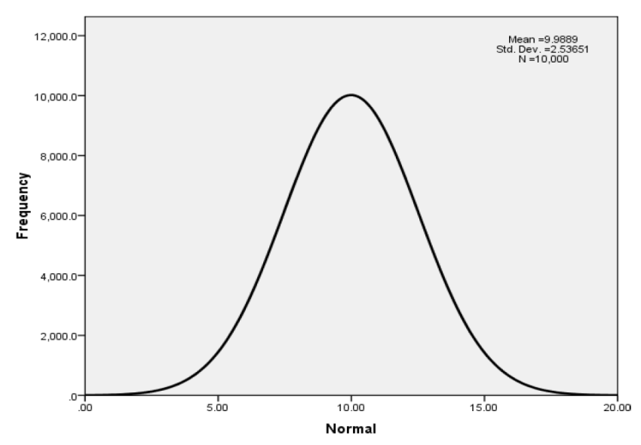

Positive & Negative Skewed:

