Assignment: 3.2 Exercise: Graph Analysis

Name: Prashant Raghuwanshi

Date: 9/18/2021

Course: DSC550-T301 Data Mining (2221-1)

***Write a 300-word paper justifying your ranking:***

As per the used sample data, which contains only two columns i.e year and the corresponding count of the world population, I have ranked the plotted three graphs in the below-mentioned order

## 1) Bar Chart

## 2) Line Chart

## 3) Pie Chart

Reason Behind ranking Bar Chart as first :

Here the Bar chart is precisely answering the below two questions:

1. Population over each year for last five decades
2. Showing population change over time in the last five decades (if we connect the midpoints of each bar by using line).

Bar Graphs Usage in general: To show a comparison between different categories, we can use a Bar Graph. It consists of two or more parallel vertical (or horizontal) bars (rectangles).e.g. between two grades, two companies, etc.

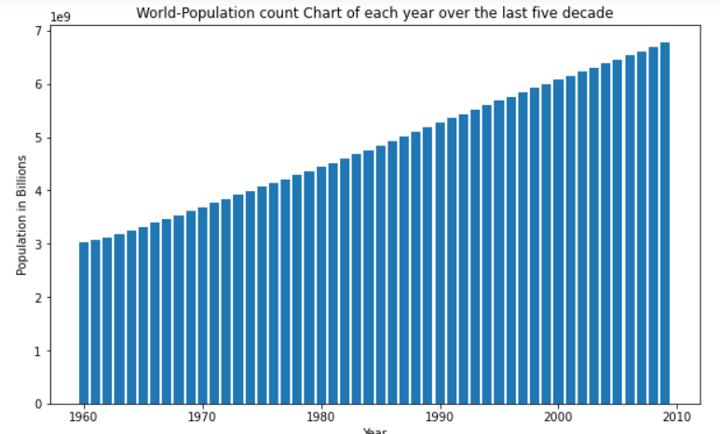

Reason Behind ranking line Chart as Second :

Here the Bar chart is precisely answering the below questions:

1. Showing population change over time in the last five decades.
2. However, it can use to view the population of each year but need more effort to determine the exact population count

Line Graphs Usage in general: A line graph compares two variables through visual representation, shown on the x- and y-axis. It shows the information through a continuous line drawn between all the points on a grid

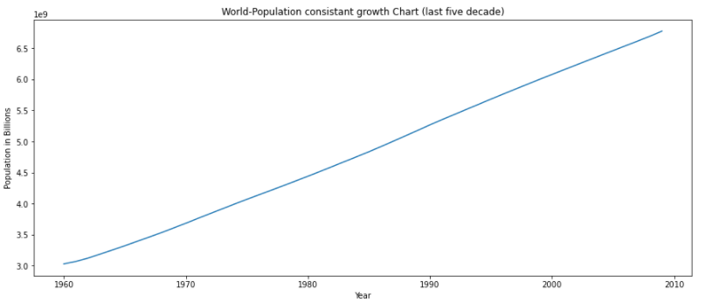

Reason Behind ranking Pie Chart as Third:

Here the Pie chart is answering the below questions:

1. Showing population grow pie over each year in the last five decades.
2. Since my population value is populating by each year, and have around 40 pies in my chart

Making understanding of population growth contribution of each year very difficult

1. Pie chart is usually used to show the compositions of current populations growth, however here in the pie chart we getting an incorrect population growth information

Pie Graphs Usage in general: Pie charts are circular charts divided into sectors according to the value they represent. The arc length of each sector is proportional to the quantity it represents.

We generally use pie charts to show percentage or proportional data. Usually, the percentage represented by each category is provided next to the corresponding sector of the circle. In a pie chart, the angle of each sector represents the fraction, out of 360 degrees, of that data value. We should always label them, either directly on the pie chart or by using a color-coded key.

