Term End Project Task-2_3

Prashant Raghuwanshi

DSC, Bellevue University

[DSC640-T301 Data Presentation & Visualization (2223-1)](https://cyberactive.bellevue.edu/webapps/blackboard/execute/courseMain?course_id=_506364_1)

 Professor Catie Williams

1/06/2022

Summary of DashBoard -1

**The scenario/Business Problem:**

Due to some recent airline crashes media is stating in public that Airtravel is no longer safer. So An a Visualization expert in the airline data science team, I have been asked to present the travel fatality fact to the internal organization team and its impact on Revenue along with the current situation to the business team.

I have created the dashboard with two different sections to address the given problem. Please find details for each graph and its corresponding datasets.

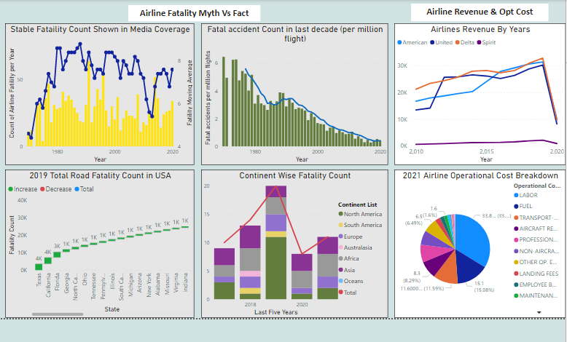

Used Datasets list in Dashboard:

* Accidents and fatalities per year
  + <https://docs.google.com/spreadsheets/d/1SDp7p1y6m7N5xD5_fpOkYOrJvd68V7iy6etXy2cetb8/edit#gid=1448957446>
* Summary 2017-21
  + <https://docs.google.com/spreadsheets/d/1SDp7p1y6m7N5xD5_fpOkYOrJvd68V7iy6etXy2cetb8/edit#gid=1733053069>
* Vehical_accident_2019.CSV
  + <https://www.nhtsa.gov/data>
* airline_revenue

power web scraping :

* + <http://web.mit.edu/airlinedata/www/2020%2012%20Month%20Documents/Traffic%20and%20Capacity/System%20Total/Passenger%20Revenue%20--%20Total%20System%20Operations.htm>")
  + [Economic Impact of Commercial Aviation By State](http://airlines.org/data/), Airlines for America
  + <https://www.nhtsa.gov/data>
* airline_op_cost

power web scraping :

* + https://www.airlines.org/dataset/a4a-quarterly-passenger-airline-cost-index-u-s-passenger-airlines/
  + <https://www.airlines.org/impact/>

QUESTION & ANSWERS:

1. IS Airlines Travel is really Safe, What Media is showing in its published coverage ?

Media is showing the facility counts per year for the last two decades, which is looking constant with a spike in a regular interval. This biased graph “Stable Fatality Count” shows Airlines are not following quality procedures properly that’s the reason in the last two decades the moving average of crash frequency is not decreased and it seems to be constant.

**Graph details :**

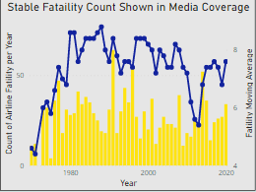

**Dataset used :**

* Accidents and fatalities per year
  + <https://docs.google.com/spreadsheets/d/1SDp7p1y6m7N5xD5_fpOkYOrJvd68V7iy6etXy2cetb8/edit#gid=1448957446>

**Used Visualization:** Power Bi Line & clustered bar Chart.

**The reason behind the use of this chart.**

* + Want to show the continuous fatality count yearly data for the last two decades
  + Here I am showing the data for 2 decades, might be the audience is not able to clearly view the increase or decrease in fatality counts of each bar, I have embedded moving average line in the same chart

1. IS Airlines Travel is really Safe, What is the fact?

Media coverage is Biased and does not present the fact correctly, please refer to the below graph which is showing the same type of Airline Fatatility count, but this count was the scale on fatality that happened per million airline flights. So from last decades in each year the seat count & flight counts are increasing, depending on the flight frequency in millions of flight the overall Fatatility is constantly decreasing

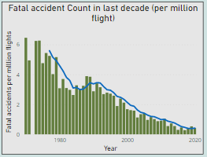

**Dataset used :**

* + Accidents and fatalities per year
    - <https://docs.google.com/spreadsheets/d/1SDp7p1y6m7N5xD5_fpOkYOrJvd68V7iy6etXy2cetb8/edit#gid=1448957446>

**Used Visualization:** Power Bi Line & clustered bar Chart.

**The reason behind the use of this chart.**

* + Want to show the continuous fatality count yearly data for the last two decades
  + Here I am showing the data for 2 decades, might be the audience is not able to clearly view the increase or decrease in fatality counts of each bar, I have embedded the moving average line in the same chart.

1. Do we have any constant increase in fatal crashes on particular geographical continents during the recent five years.

After looking below Stack-line bar chart, during the last 5 years fatality count is not increasing constantly for any continents. So it is a myth that some continents are more prone to accidents.

**Dataset used :**

* + 1. Summary 2017-21

<https://docs.google.com/spreadsheets/d/1SDp7p1y6m7N5xD5_fpOkYOrJvd68V7iy6etXy2cetb8/edit#gid=1733053069>

**Used Visualization:** Power Bi Line & stacked bar Chart.

**The reason behind the use of this chart.**

* 1. Want to show the yearly fatality count by continents for the 5 years
  2. Apart from showing the continent counts, I want to focus on total counts per year too that’s the reason I have embedded the total fatality count line in the same chart.

1. Do Airline fatality count is really more than the ground transport fatality count.

Please find below the 2019 total road fatality counts per state in USA, which is way more than the sum of fatality of all Airlines to date.

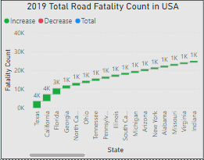

**Dataset used :**

Vehical_accident_2019

Vehical_accident_2019.CSV

<https://www.nhtsa.gov/data>

**Used Visualization:** Power Bi waterfall chart.

**The reason behind the use of this chart.**

* 1. Want to show the total road fatality count by all states in USA

1. Do fatalities will we have any impact on airline yearly revenues?

No below graph shows the listed airlines revenues are constantly increasing from past 5 years and we had some slump in revenue @ 2020 due to travel restrictions.

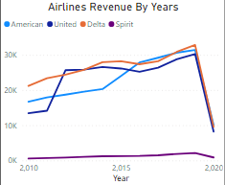

**Dataset used :**

airline_revenue

* power web scraping :

<http://web.mit.edu/airlinedata/www/2020%2012%20Month%20Documents/Traffic%20and%20Capacity/System%20Total/Passenger%20Revenue%20--%20Total%20System%20Operations.htm>")

[Economic Impact of Commercial Aviation By State](http://airlines.org/data/), Airlines for America

<https://www.nhtsa.gov/data>

**Used Visualization:** Power Bi multi line chart.

**The reason behind the use of this chart.**

* 1. Want to show the continuous yearly revenue growth of multiple airlines

1. Do airlines are facing any economic challenges in current year.

Yes, due to high demand and rise in inflation cost is impacting the airlines operating cost.

Please find below break up of operating cost components.

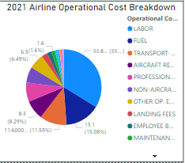

**Dataset used :**

* airline_op_cost
* power web scraping :

https://www.airlines.org/dataset/a4a-quarterly-passenger-airline-cost-index-u-s-passenger-airlines/

<https://www.airlines.org/impact/>

**Used Visualization:** Power Bi Pie chart.

**The reason behind the use of this chart.**

* 1. Want to show the percentage contribution of each operation cost componnets for recent 2021 year.