Term End Milestone-1 (Project -2)

Recognizing Images -Deep Learning

Proposal & Data Selection

DSC, Bellevue University

Prashant Raghuwanshi

DSC680-T301 Applied Data Science (2225-1)

 Professor Catie Williams

15/04/2022

Recognizing Images by using Deep Learning:

The current state-of-the-art Computer Vision (CV) and Machine Learning (ML) allow the detection and tracking of single objects classes (such as faces, pedestrians, or cars) in an unconstrained setting at a level that allows the realization of smart cameras that recognize smiling persons, driver assistance (pedestrian detection), surveillance applications and image-based web search.

Here I am going to build an image-driven application that leverages computer vision to classify or categorize an image file based on its visual content. In essence, these applications pull valuable information and insights out of visual content.

**Business Problem :**

The use cases for image classification are virtually unlimited. Across a wide range of industries, organizations can put these AI-driven capabilities to work to streamline business processes, automate tedious manual tasks and gain insights in real-time.

Please find below a few of the listed use cases for image classification :

* A social media company might use video classification to categorize and annotate content.
* With the right applications in place, a bank might use image identification to recognize its customers as they walk through the door.
* A retailer might use image classification to enable a checkout-free store.

The list of potential applications of image classification goes on and on.

A commonality these applications share is deep learning, one of the key building blocks for AI solutions.

### Requirements, assumptions:

Requirements: This Project is trying to make use of Deep learning techniques to automatically identify the category of a given Image. Here I am planning to feed the image to the ML model and the ML model will classify the group of images.

Assumption: Here I am assuming the use of sample images is sufficient to train the model and the model can deduct the selected image classification by using deep learning algorithms.

**Costs and benefits:**

Costs:

* The primary cost associated with this project is the time of the people working on it.
* Computing resources for modeling
* Data collection and processing computing costs

Benefits:

* Image recognition techniques can be used to count objects such as cars or people in images. This capability can be used in traffic management and sizing crowds.
* Grocers can now use computer vision capabilities to inspect and grade the quality and freshness of meats, seafood, produce, and bakery goods.
* Manufacturing company might train an image and video classification system to inspect manufactured products and components for signs of defects.
* A shipping company, in turn, might train a model to recognize signs of damaged boxes on a conveyor belt that is moving finished products to outbound trucks. This could be accomplished by feeding thousands of images of undamaged boxes and damaged boxes into a deep-learning algorithm

**What Questions Are We Trying To Answer?** :

* Which Deep learning Model is going to fit our use case?
* Which is the best target variable for our model?
* What is the accuracy of the model?
* Do we got any other interesting facts from datasets? Like correlations etc
* Is it possible, that the ML technique can identify the multiple objects correctly?

**Datasets:**

The CIFAR-10 are labeled subsets of the 80 million tiny images dataset. It is a freely available dataset on the web and can be used for education and learning purposes.

They were collected by Alex Krizhevsky, Vinod Nair, and Geoffrey Hinton.

The CIFAR-10 dataset consists of 60000 32x32 color images in 10 classes, with 6000 images per class. There are 50000 training images and 10000 test images.

The dataset is divided into five training batches and one test batch, each with 10000 images. The test batch contains exactly 1000 randomly-selected images from each class.

The training batches contain the remaining images in random order, but some training batches may contain more images from one class than another.

Between them, the training batches contain exactly 5000 images from each class.

Link: <https://www.cs.toronto.edu/~kriz/cifar-10-python.tar.gz>

**Describe Data**.

Here are the classes in the dataset, as well as 10 random images from each:

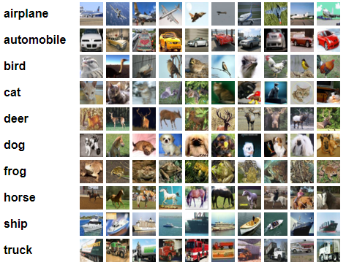

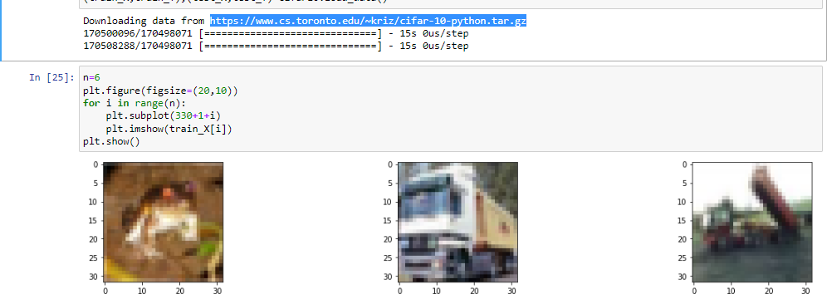

**Methods:**

**Convolutional Neural Networks** are used to extract features from images (and videos), employing convolutions as their primary operator.

The goal of recognizing faces and other images is well performed with the help of a special type of neural network called convolutional neural networks (CNNs).

Convolutional Neural Networks are a type of Deep Learning Algorithm that take the image as an input and learn the various features of the image through filters.

This allows them to learn the important objects present in the image, allowing them to discern one image from the other

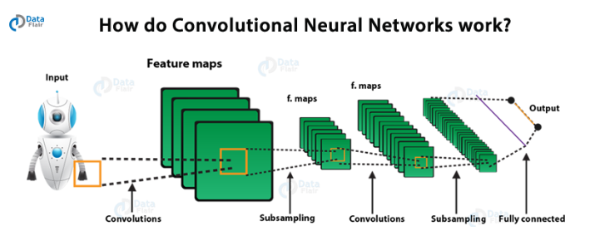

**Ethical Considerations:**

* This Data contains processed physical images information related to multiple verities of rice and does not contains any PII-related information.
* Datasets and information on data were extracted from the public websites’ machine learning repositories.
* This data research is not going to harm any privacy.

**Challenges/Issues :**

The process of training deep learning models is both compute- and data-intensive. Deep learning applications require massive amounts of data, fast computing, and equally fast storage, along with a lot of memory and high bandwidth networking. This is the fuel that propels AI applications forward.

References :

<https://data-flair.training/blogs/convolutional-neural-networks-tutorial/>

<https://www.cs.toronto.edu/~kriz/cifar.html>

<https://www.delltechnologies.com/asset/en-us/products/ready-solutions/industry-market/ai-driven-image-video-classification-white-paper.pdf>

<https://blog.keras.io/building-powerful-image-classification-models-using-very-little-data.html>

Deep Learning with Python 1st Edition

Andrej Karpathy, The Unreasonable Electiveness of Recurrent Neural Networks