Download jar present in jar folder inside this project

Steps to run this project

Linux:

1. Create bash file using VM. Command : **vim pm**
2. Add script in bash file (**pm**) as shown below:

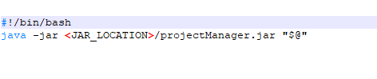

1. chmod 777 pm
2. If executable runs properly you can use “pm [options] SUBCMD [NAME]”

Windows:

1. Create batch file(**pm.batch**) as shown below

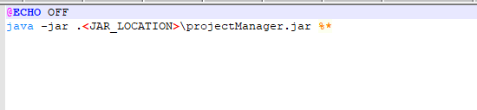

2. Open command prompt at batch file location and run commands “pm [options] SUBCMD [NAME]”