

**Name：Prashant Regmi**

**Roll No: 21053305**

**Section: 4**

**Subject: DAA Lab**

**Lab Day: 1**

**QUESTIONS**

**Aim of the Experiment 1**: To store random numbers into an array of N integers and then find out the smallest and largest number stored in it. N is the user input.

#include <stdio.h>

 int main(){

    int max;

    int min;

    int n;

    printf("Enter the number of elements : ");

    scanf("%d",&n);

    int arr_3305[n];

    printf("Enter the number in the array : ");

    for(int i=0;i<n;i++){

        scanf("%d",&arr_3305[i]);

    }

    max=arr_3305[0];

    min=arr_3305[0];

    for(int i=0;i<n;i++){

        if(arr_3305[i] < min){

            min=arr_3305[i];

        }

        if(arr_3305[i] > max){

            max=arr_3305[i];

        }

    }

    // display

    printf("The arrray is ");

    for(int i=0;i<n;i++){

        printf("%d ",arr_3305[i]);

    }

    printf("\n");

    printf("The maximum element in the array is : %d\n",max);

    printf("The minimum element in the array is : %d\n",min);

    return 0;

    }

Output

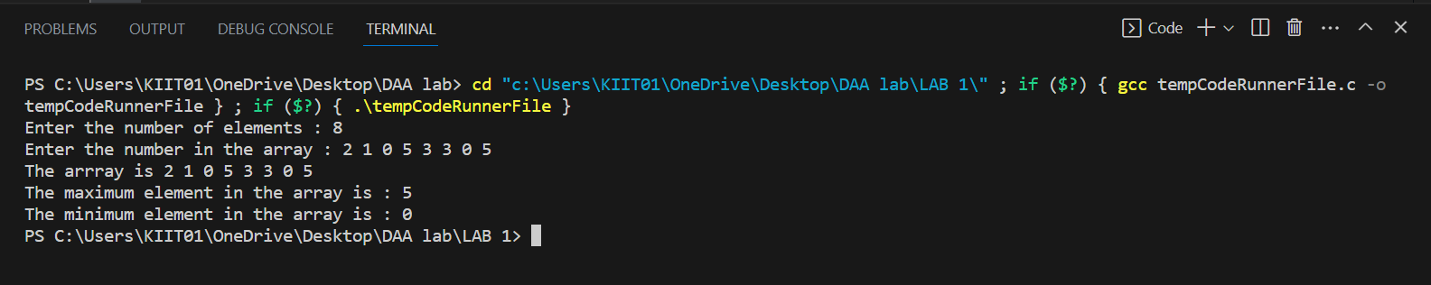

**Aim of the Experiment 2**: To store random numbers into an array of N integers, where the array must contains some duplicates and then do the following:

a) Find out the total number of duplicate elements.

b) Find out the most repeating element in the array.

 #include <stdio.h>

 int main(){

    int n;

    printf("Enter the number of elements : ");

    scanf("%d",&n);

    int arr_3305[n];

    printf("Enter the number in the array : ");

    for(int i=0;i<n;i++){

        scanf("%d",&arr_3305[i]);

    }

    //to dispaly the array

    printf("The arrray is ");

    for(int i=0;i<n;i++){

        printf("%d ",arr_3305[i]);

    }

    printf("\n");

    //a) Find out the total number of duplicate elements.

    int count=0;

    for(int i=0;i<n;i++){

        for(int j=i+1;j<n;j++){

            if(arr_3305[i]==arr_3305[j]){

                count++;

            }

        }

    }

    printf("The total number of duplicate elements is : %d\n",count);

    //b) Find out the most repeating element in the array.

    int max=0;

    int max_count=0;

    for(int i=0;i<n;i++){

        int count=0;

        for(int j=i+1;j<n;j++){

            if(arr_3305[i]==arr_3305[j]){

                count++;

            }

        }

        if(count>max_count){

            max_count=count;

            max=arr_3305[i];

        }

    }

    printf("The most repeating element in the array is : %d\n",max);

 }

Output

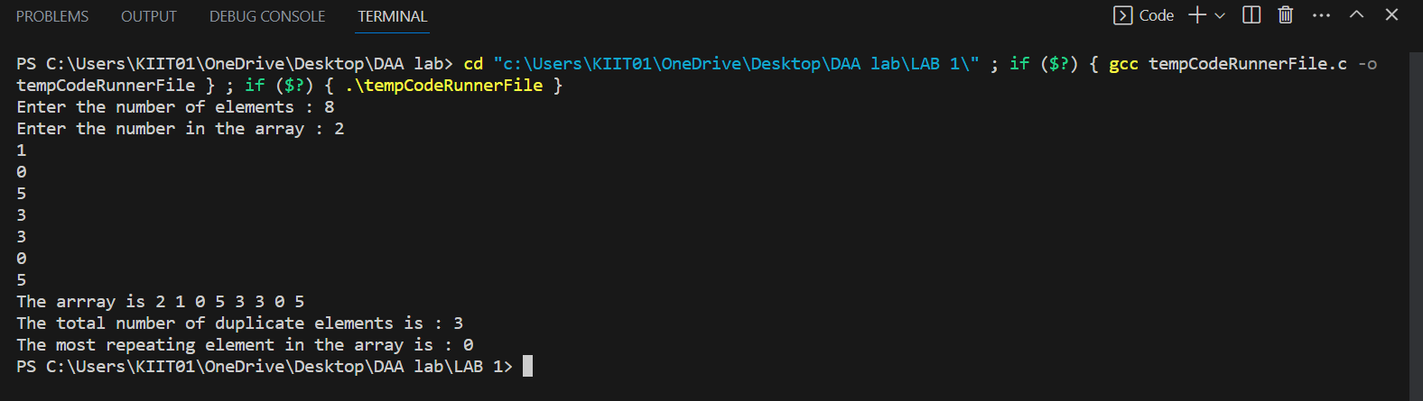

**Aim of the Experiment 3**: To rearrange the elements of an array of N integers such that all even numbers are followed by all odd numbers

#include <stdio.h>

int main()

{

    int n, i, j, temp;

    printf("Enter the number of elements in the array: ");

    scanf("%d", &n);

    int arr_3305[n];

    printf("Enter the elements of the array: ");

    for (i = 0; i < n; i++)

        scanf("%d", &arr_3305[i]);

    for (i = 0; i < n; i++){

        if (arr_3305[i]%2!= 0)

        {

            for (j=i+1; j<n; j++)

            {

                if (arr_3305[j] % 2 == 0)

                {

                    temp = arr_3305[i];

                    arr_3305[i] = arr_3305[j];

                    arr_3305[j] = temp;

                    break;

              }

            }

        }

    }

    printf("The rearranged array is: ");

    for (i = 0; i < n; i++)

        printf("%d ", arr_3305[i]);

    return 0;

}

Output

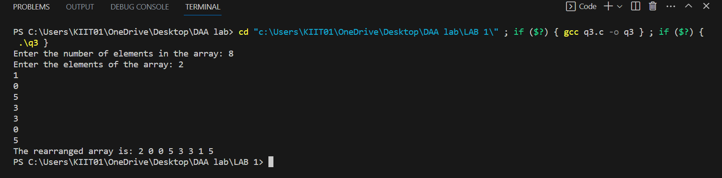

**Aim of the Experiment 4**: To take three variable (a, b, c) as separate parameters and swapvalues stored so that value a goes to b, b to c and c to a by using a SWAP(x,y) function that swaps/exchanges the numbers x and y.

#include <stdio.h>

void swap(int *a,int *b)

{

    int temp_3305=*a;

    *a=*b;

    *b=temp_3305;

}

int main()

{

    int a_3305,b_3305,c_3305;

    printf("Enter the values of a, b and c: ");

    scanf("%d%d%d",&a_3305,&b_3305,&c_3305);

    swap(&a_3305,&b_3305);

    swap(&b_3305,&c_3305);

    printf("The values of a, b and c after swapping are %d, %d and %d respectively\n",a_3305,b_3305,c_3305);

    return 0;

}

Output

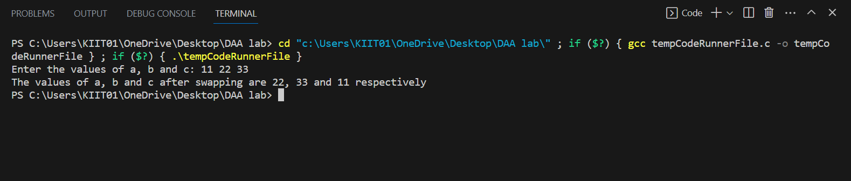

**Aim of the Experiment 5**: To take A an n*n square matrix array as an input and then WAP by using appropriate user defined functions for the following:

a) Find the number of nonzero elements in A

b) Find the sum of the elements above the leading diagonal.

c) Display the elements below the minor diagonal.

d) Find the product of the diagonal elements.

 #include <stdio.h>

 int main(){

    int n;

    printf(" Enter the matrix row/column: ");

    scanf("%d",&n);

    int arr_3305[n][n];

    printf("Enter the elements in the array : ");

    for(int i=0;i<n;i++){

        for(int j=0;j<n;j++){

            scanf("%d",&arr_3305[i][j]);

        }

    }

    //to display the array

    printf("The array is \n");

    for(int i=0;i<n;i++){

        for(int j=0;j<n;j++){

            printf("%d ",arr_3305[i][j]);

        }

        printf("\n");

    }

    // nonzero elements in A

    int count=0;

    for(int i=0;i<n;i++){

        for(int j=0;j<n;j++){

            if(arr_3305[i][j]!=0){

                count++;

            }

        }

    }

    printf("The number of nonzero elements in the array is : %d\n",count);

    // sum of the elements above the leading diagonal.

    int sum=0;

    for(int i=0;i<n;i++){

        for(int j=i+1;j<n;j++){

            sum+=arr_3305[i][j];

        }

    }

    printf("The sum of the elements above the leading diagonal is : %d\n",sum);

    // display the elements below the minor diagonal.

    printf("The elements below the minor diagonal are : ");

    for(int i=0;i<n;i++){

        for(int j=0;j<i;j++){

            printf("%d ",arr_3305[i][j]);

        }

    }

    printf("\n");

    //product of the diagonal elements.

int product=1;

    for(int i=0;i<n;i++){

        for(int j=0;j<n;j++){

            if(i==j){

                product*=arr_3305[i][j];

            }

        }

    }

    printf("The product of the diagonal elements is : %d\n",product);

}

Output

