Rakt

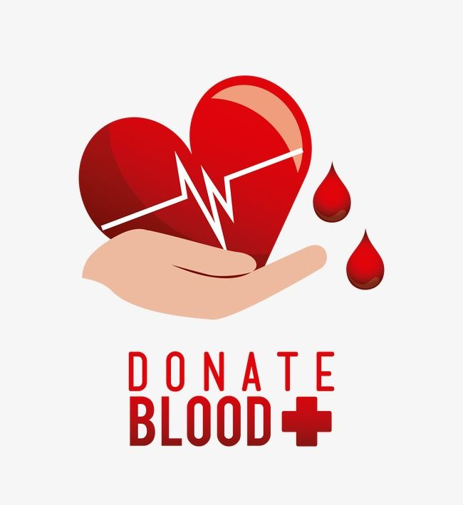AN ONLNE BLOOD MANAGEMENT SYSTEM

AGILE SYSTEMS

05-March-2020

*By :- Life Cycle Thugs*

|  |  |  |
| --- | --- | --- |
| GROUP MEMBERS | ROLL NO. | SAP ID |
| Prashant Ruhela | R174218036 | 500071255 |
| Samarth Panwar | R174218047 | 500069716 |
| Utsav Chaudhary | R174218085 | 500071649 |

TABLE OF CONTENTS

DECLARATION 4

MANIFESTO 5

PRINCIPLES 6

ABSTRACT 7

INTRODUCTION 8

SCOPE 9

ENTITY RELATIONSHIP DIAGRAM 10

DATA FLOW DIAGRAM 11

# DECLARATION

I thus announce that the project work entitled by under the direction and Supervision of Dr Durgansh Sharma at University of Petroleum & Energy Studies, Dehradun.

The Started Time of the Project,

* 16-Jan-2020

The Ending Time of the Project,

* End of Semester

# MANIFESTO

We are uncovering better ways of developing software by doing it and helping others do it. Through this work we have come to value:

* **Individuals & interactions** over processes and tools.
* **Working software** over comprehensive documentation.
* **Customer collaboration** over contract negotiation.
* **Responding to change** over following a plan.

That is while there is value in the items on the right, we value the items on the left more.

Kent Beck James Grenning Robert C. Martin

Mike Beedle Jim Highsmith Steve Mellor

Arie van Bennekum Andrew Hunt Ken Schwaber

Alistair Cockburn Ron Jeffries Jeff Sutherland

Ward Cunninghum Jon Kern Dave Thomas

Martin Fowler Brain Marick

# PRINCIPLES

We follow these principles:

* Our highest priority is to satisfy the customer through early & continuous delivery of valuable software.
* Welcome changing requirements, even late in development. Agile processes harness change for the customer’s competitive advantage.
* Deliver working software frequently, from a couple of weeks to couple of months, with preference to the shorter timescale.
* Business people and developers must work together daily throughout the project.
* Build projects around motivated individuals. Give them the environment and support they need and trust them to get the job done.
* The most efficient & effective method of conveying information to & within a development team is face-to-face conversation.
* Working software is the primary measure of progress.
* Agile processes promote sustainable development. The sponsors, developers & users should be able to maintain a constant pace indefinitely.
* Continuous attention to technical excellence & good design enhances agility.
* Simplicity-the art of maximizing the amount of work not done is essential.
* The best architectures, requirements, and designs emerge from self-organizing teams.
* At regular intervals, the team reflects on how to become more effective then tunes and adjusts its behavior accordingly.

# ABSTRACT

Blood Donor Information System is to make a Computerized Information about the giver and Hospitals that are identified with giving the blood. Through this System any individual who is keen on giving the blood can enroll himself similarly, if any clinics needs to enlist itself with this System that can likewise enlist. What's more, the motivation behind my System is enrolling blood givers, and keep up their subtleties. Not just had those things, utilizing my framework effectively contact the contributors in a basic or crisis circumstance. Since this framework giving more highlights to the customers or the clinics or the blood camp gatherings.

Automated frameworks when contrasted with Paper record Systems are time consuming, laborious, and expensive. This paper presents the audit of the fundamental highlights, benefits and faults gave by the current Computer-Based Information System for Blood Banks. This study shows the correlation of different existing framework and giving some more thought regarding the automated framework.

# INTRODUCTION

Blood is all around perceived as the most valuable component that supports life. It spares endless lives over the world in an assortment of conditions. A blood donation center is a spot structured particularly for the capacity of blood and blood items. The expression "blood bank "typically alludes to a division of an emergency clinic research center where the capacity of blood item happens and where appropriate testing is performed to decrease the danger of transfusion related occasions. Huge coolers hold these items at a consistent temperature and they are accessible immediately. The blood benefactor data framework offers functionalities to snappy access to enroll the giver, and gathered contributor subtleties from different pieces of the Provinces. It empowers observing of the outcomes and execution of the blood gift action with the end goal that important and quantifiable targets of the association can be checked. In my framework I'm giving the proficient hunt who needs the blood in their own city, name, and blood bunches as quick as would be prudent.

Blood donation center or the Hospital acknowledge the gave blood, just if giver fulfill the entirety of the following conditions :-

* If the donor’s are between age group of 18 – 60 years.
* If the donor’s weight is 45 Kg or more.
* If the donor’s haemoglobin is 12.5 gm% minimum.
* If the donor’s last blood donation was 6 months earlier & etc.

# SCOPE

This framework isn't just for business reason. This can take for social administrations, in such a case that we are utilizing this framework for a medical clinic, it will be make simple to enlist the givers and contact the benefactors in a crisis circumstance.

This framework is independent application, this framework utilizing neighborhood Database to store contributor's subtleties utilizing GUI (Graphical User Interface). This framework interface will have many capacity to control no problem at all

# ENTITY RELATIONSHIP DIAGRAM



# DATA FLOW DIAGRAM

