Authentication

http://localhost:7001/auth/authenticate

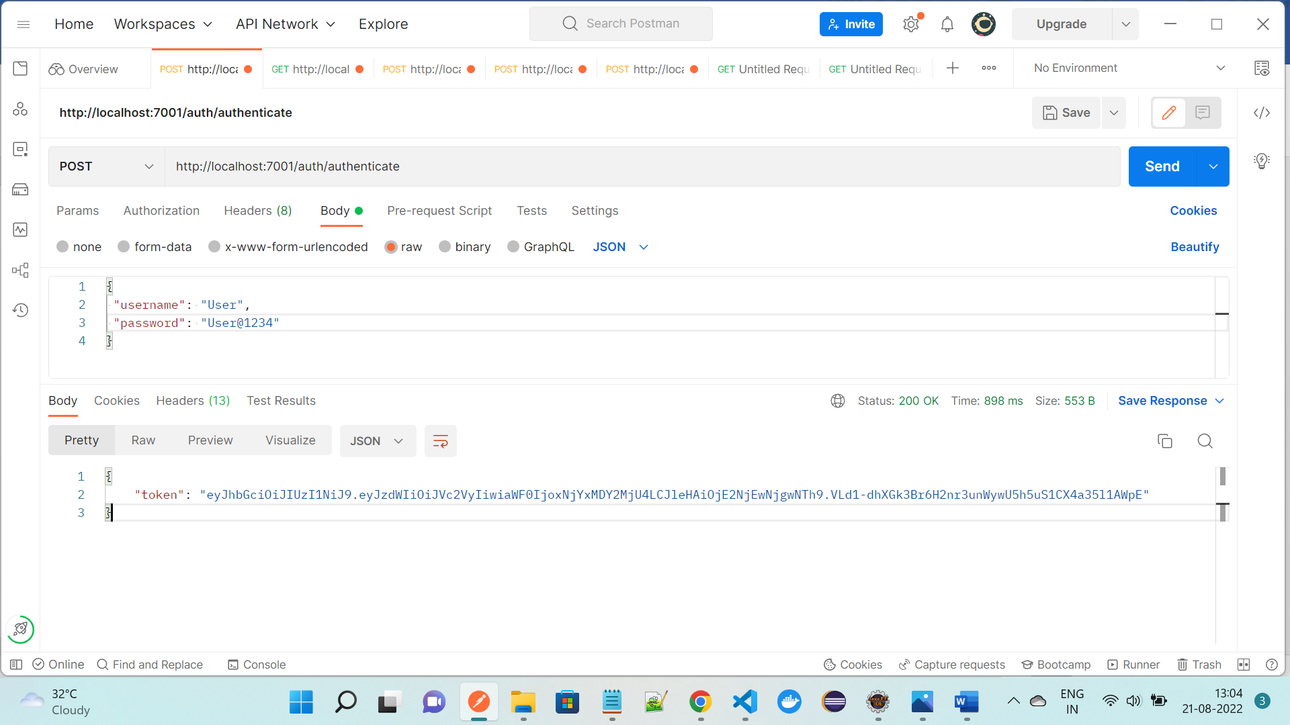

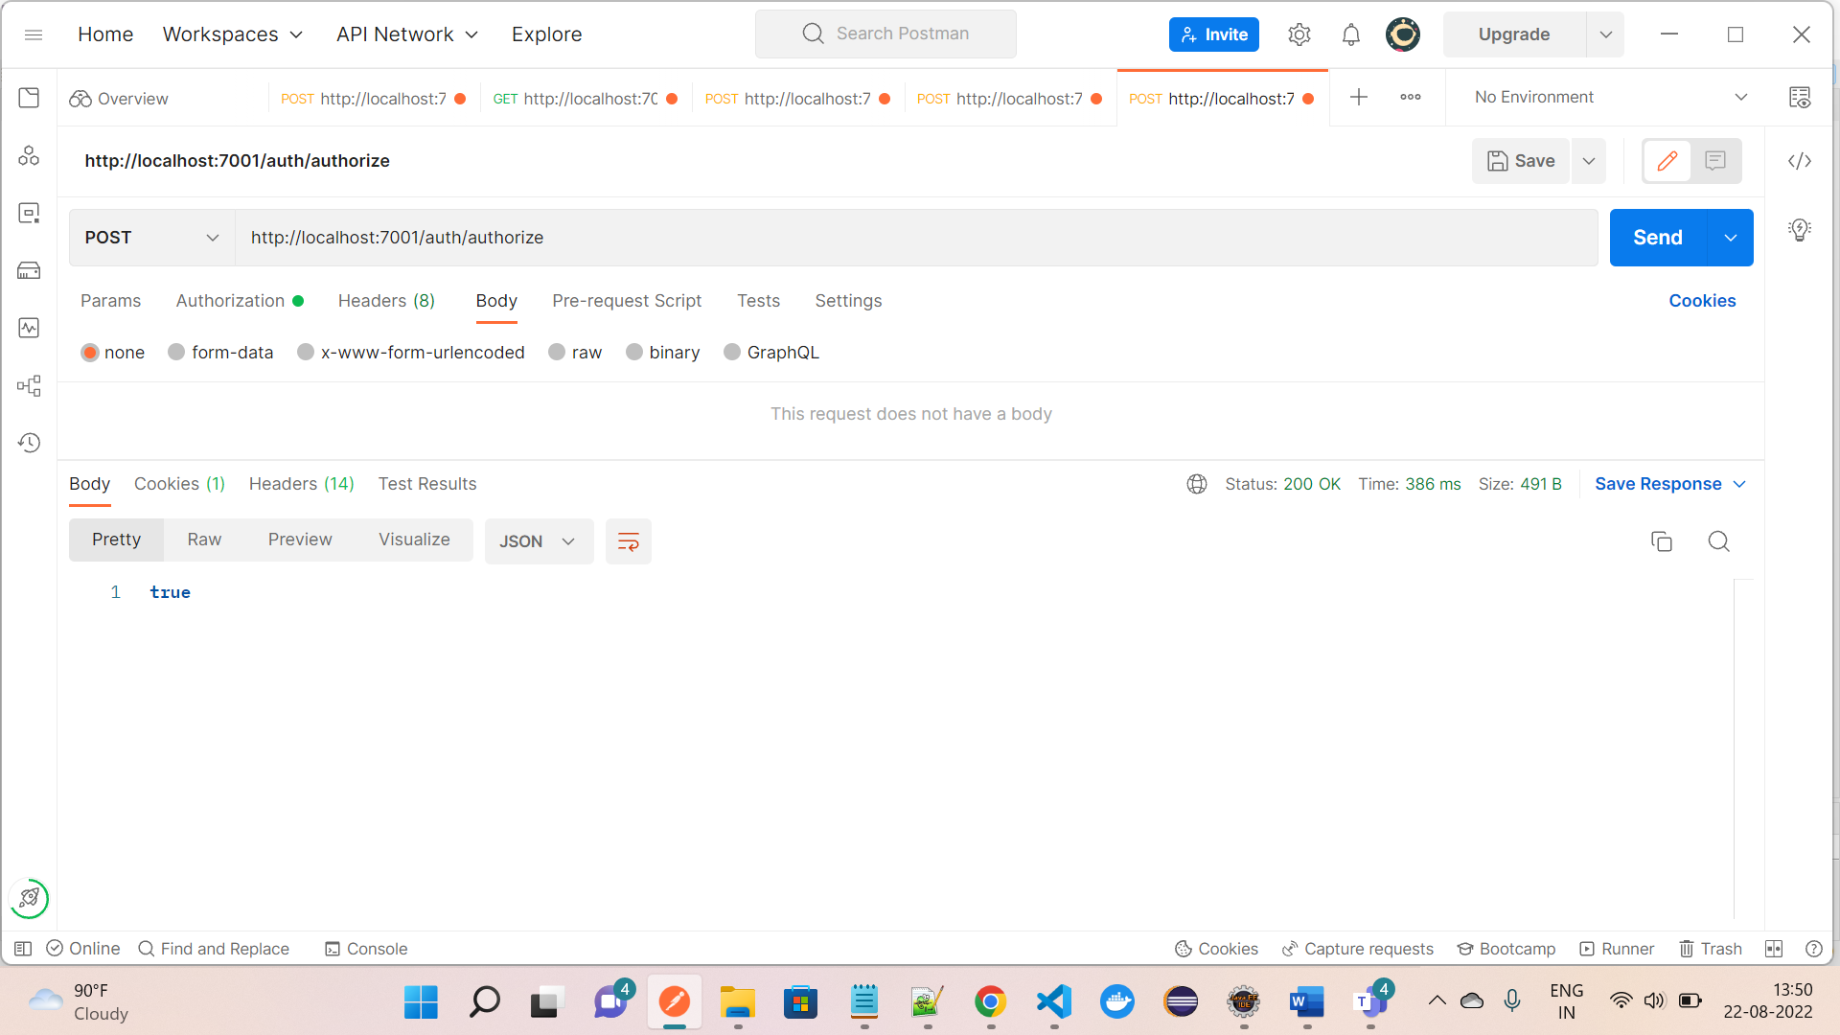

Process pension to Pension Details

<http://localhost:7004/process/PensionDetail>

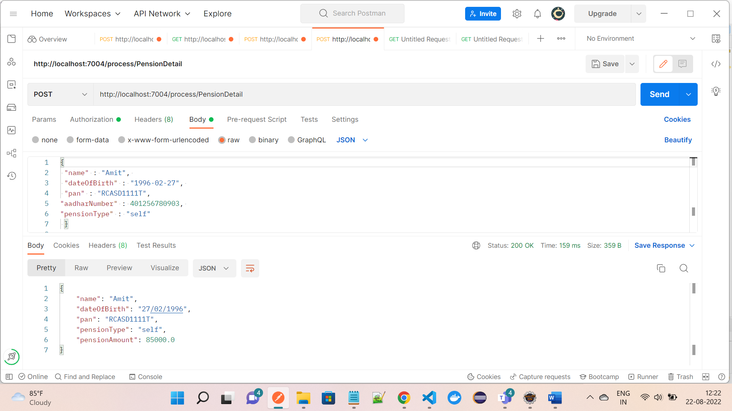

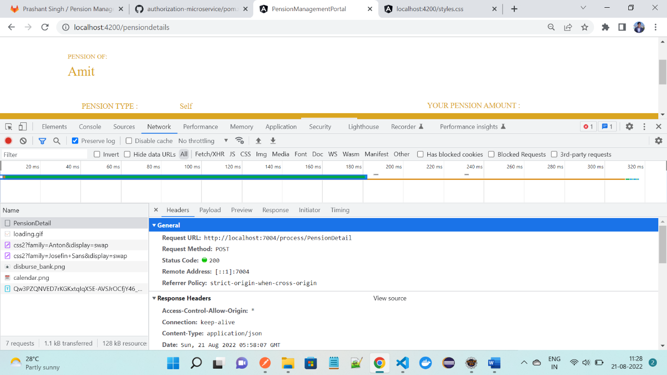

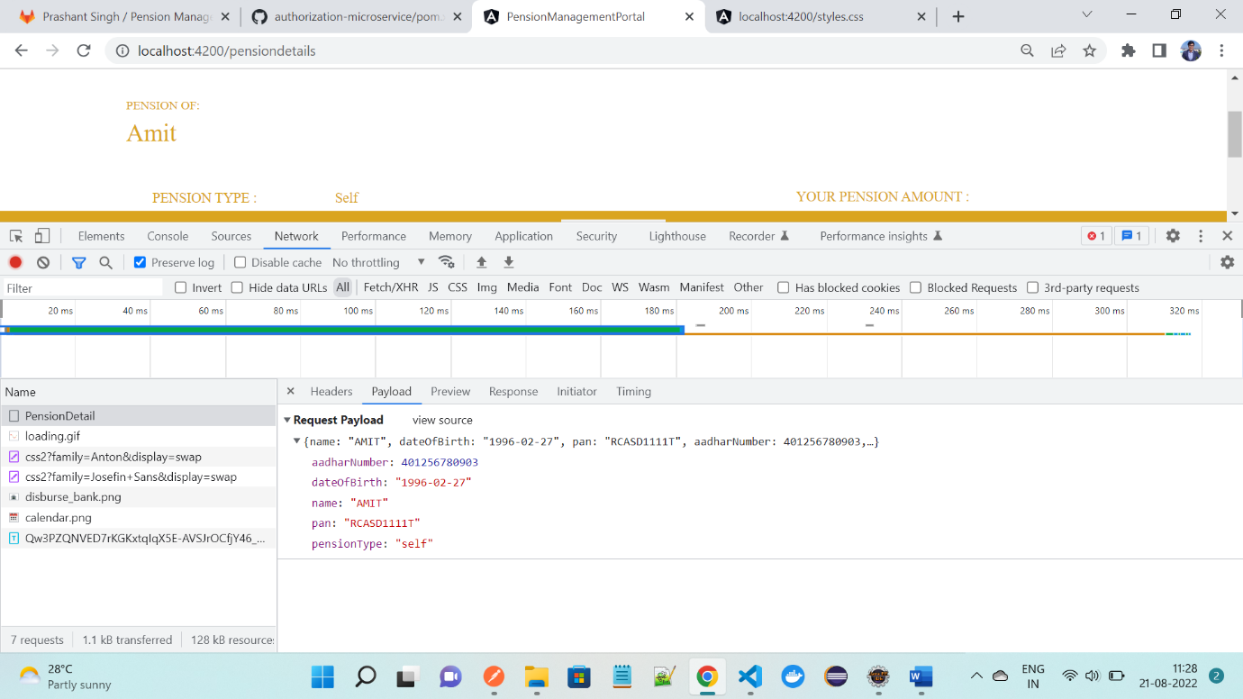

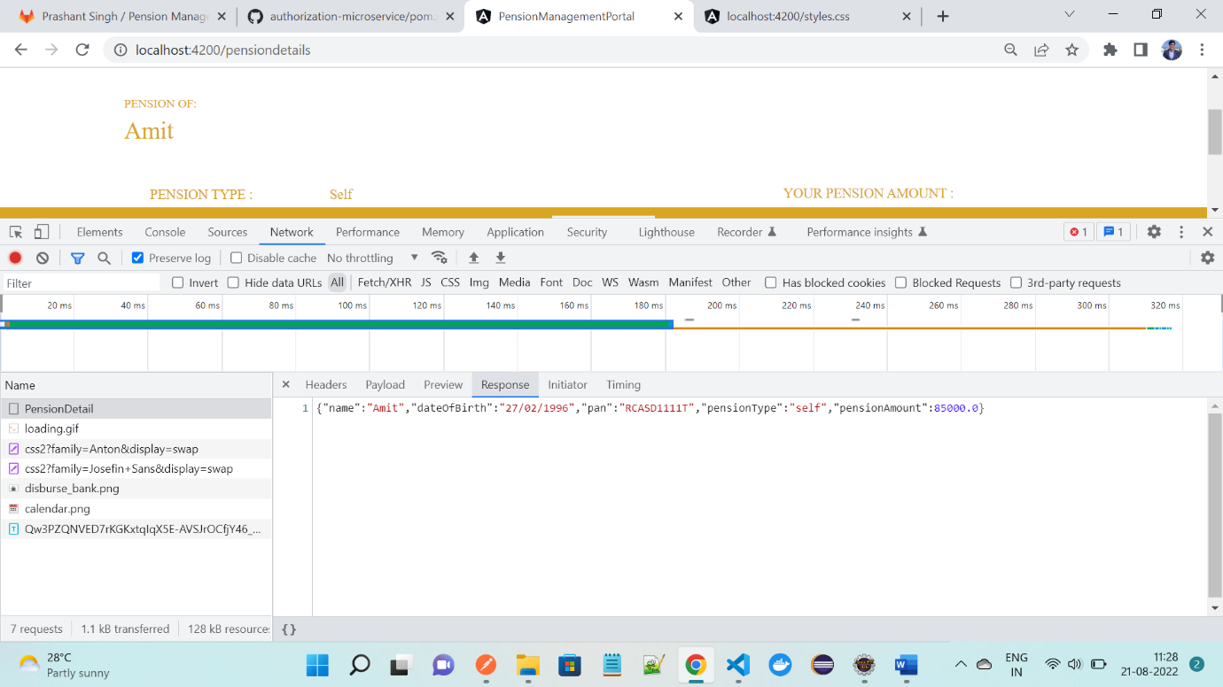

PENSION DETAILS

[http://localhost:7002/details/pensionerDetailByAadhaar/aadhaarNumber?aadhaarNumber=401256780903](http://localhost:7002/details/pensionerDetailByAadhaar/aadhaarNumber?aadhaarNumber=102233445566)

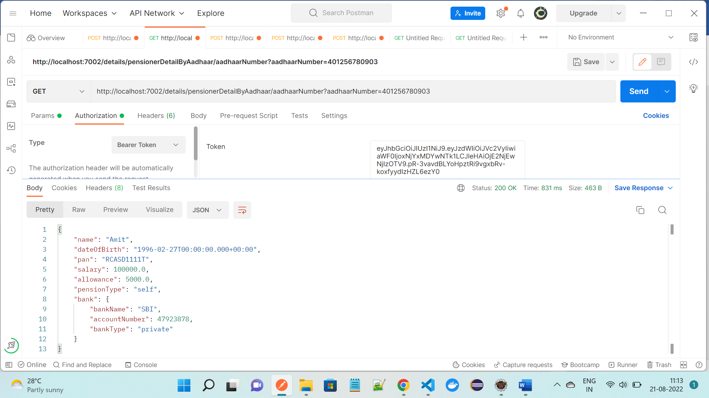

PROCESS TO DISBURSE FOR VALIDATION OF DETAILS

<http://localhost:7004/process/ProcessPension>

