**COVID-19 Normal & Pneumonia_CT_Images Using CNN**

**Techniques:-** By Using CNN Model

**Submitted By:-**

Prashant Sirohi 11709395 KM039 B46

Ayush Kumar Srivastava 11709497 KM039 B47

**Abstract-:**

Coronavirus Disease (COVID19) is a fast-spreading infectious disease that is currently creating a global healthcare crisis around the world. Due to the current limitations of the reverse transcription-polymerase chain reaction (RT-PCR) based tests for detecting COVID19, recently radiology imaging based ideas have been proposed by various works. In this work, various Deep CNN based approaches are explored for detecting the presence of COVID19 from chest CT images. A decision fusion based approach is also proposed, which combines predictions from multiple individual models, to produce a final prediction. Experimental results show that the proposed decision fusion based approach is able to achieve above 86% results across all the performance metrics under consideration, with average AUROC and F1-Score being 0.883 and 0.867, respectively. The experimental observations suggest the potential applicability of such Deep CNN based approach in real diagnostic scenarios, which could be of very high utility in terms of achieving fast testing for COVID19.

**Introduction-:**

The infection of COVID-19 (coronavirus disease 2019) that began in December 2019 in Wuhan, China is widespread throughout the world. COVID-19 causes severe respiratory symptoms and is associated with higher ICU admission and death. Along with an increasing number of cases, test kits are produced by diagnostic detectors. But according to Hematology Fellow Atilla Uslu from Ankara University School of Medicine, “They began to have cases where coronavirus tests were twice as negative, but lung tomography appeared to be coronavirus-related. How samples are taken from the mouth and nose affects the results. If not taken seriously, these tests could lead to negative consequences ”26 March 2020, Tweet. Also, it has been reported that the sensitivity of test kits may not be high enough to detect and treat high-risk patients. Therefore, CT scan images of the lungs play a major role in detecting COVID-19 early.

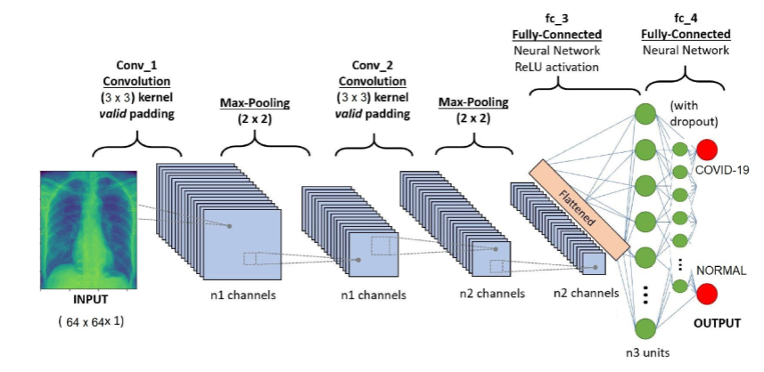

**Purpose of Study:-**

This study aims to design and develop a deep learning model for early detection of the COVID-19 by using chest x-ray images.

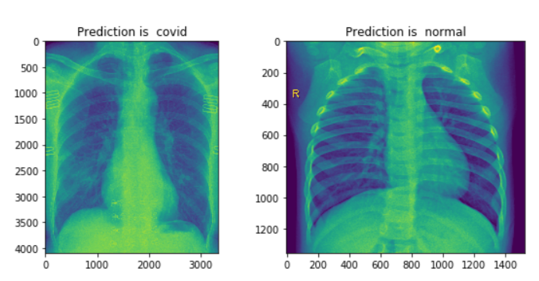

**Data Collection:-**

The data that will be used to train the model is open - a data source called COVID-19 is a platform data collection on the Github platform. According to the database, “The 2019 novel coronavirus (COVID-19) features a number of unique features. While the diagnosis is mixed using polymerasechainaction (PCR), patients with pneumoniamay infection present on chest X-ray and computed tomography (CT) images with a pattern limited to the human eye Ng, 2020 ”(Cohen J. Moorrison P. Dao L. , 2020). This study was limited to the details of 130 patients training for a spy model.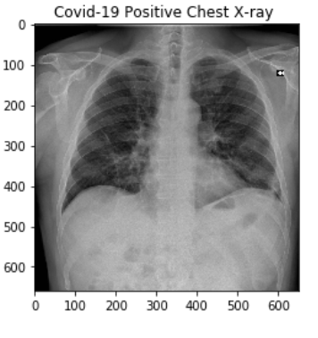

**Conclusion:-**

The final accuracy level of the deep learning model was recorded as 0.98 and the loss was recorded as 0.04. We can also see the exact values ​​— losses from Figure 1.2. The in-depth study model responds to approximately 0.98 chest x-ray images of patients well as well, distinguishing between infected and non-infected lungs which is the first region of the human body.

**Results:-**

These are the final test results for each COVIDNet-CT model on the COVIDx-CT dataset.

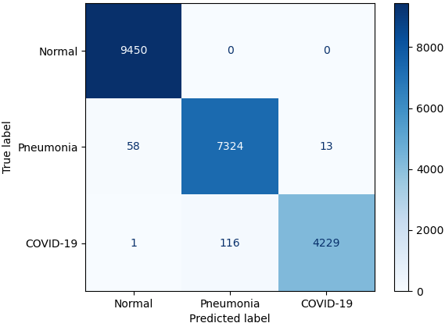

Confusion matrix for COVIDNet-CT-A on the COVIDx-CT test dataset.

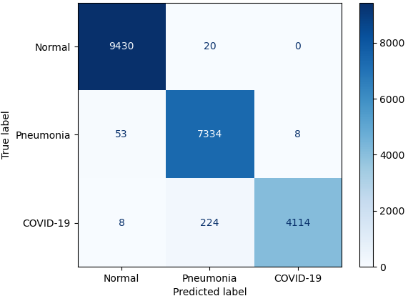

|  |  |  |
| --- | --- | --- |
|  |  |  |

Future Works:-

As a future work, the number of data which is used to train the CNN model can be increased and the general structure of convolutional neural network can be restructures so that it will be able to analyze images in more detail.