DEPARTMENT OF COMPUTER SCIENCE AND ENGINEERING
School of Technology, Nirma University

Innovative Assignment

1. Project Title
LL(1) Parser Studio: An Interactive FIRST & FOLLOW Set Calculator, Predictive Parsing Table Generator, and CFG Execution Simulator

2. Student Details
Sr. No. | Student name | Roll number
1 | Prashant Tarbundiya | 23BCE347
2 | Vatsal Vadgama | 23BCE359

PROJECT OVERVIEW AND COMPILER CONCEPTS

3. Project Overview
Describe the problem, the intended users and the purpose of your tool. Explain what it accepts as input, what it produces as output and how it relates to Compiler Design.
LL(1) Parser Studio is an interactive, web-based compiler construction workbench designed to demystify top-down syntax analysis for Context-Free Grammars (CFGs). In compiler design, computing FIRST and FOLLOW sets, constructing the LL(1) predictive parsing table M[A, a], detecting grammar conflicts (FIRST/FIRST and FIRST/FOLLOW), and tracing stack-based string validation are foundational yet prone to manual calculation errors—especially when grammars feature complex nullable chains, indirect recursions, or multi-branch epsilon transitions.
This tool accepts arbitrary context-free grammars (in standard BNF notation with support for explicit spaces, unspaced tokens, lowercase/uppercase conventions, and epsilon variants like ε, e, or empty rules) as well as input strings for parsing. It applies a generalized fixed-point iterative algorithm to compute exact FIRST and FOLLOW sets, builds the complete LL(1) parsing table, diagnoses grammar non-LL(1) properties (such as left recursion, non-determinism, and multiple table entries), and provides step-by-step Pushdown Automaton (PDA) stack simulation with real-time derivation tree visualization. The system is engineered for compiler design students, educators, and software engineers to visualize compiler frontend mechanics with 100% mathematical accuracy and zero external runtime dependencies.

4. Objectives of the Project
State clear, achievable objectives. Each objective should describe something implemented or demonstrated by the project.
1. Generalized Fixed-Point Iterative Engine: Implement an iterative convergence algorithm to compute mathematically verified FIRST and FOLLOW sets for arbitrary CFGs, supporting complex nullable chains (e.g., S → A B C, A → a | ε), multi-symbol sequence derivations, and epsilon propagation without infinite recursion.
2. Automated LL(1) Table Construction & Conflict Diagnostics: Construct the predictive parsing table M[Non-Terminal, Terminal] based on standard Dragon Book parsing theory, while automatically detecting, localizing, and explaining FIRST/FIRST and FIRST/FOLLOW ambiguity conflicts and left recursion.
3. Interactive PDA Stack Simulation & Derivation Tree Visualization: Provide a real-time top-down predictive Pushdown Automaton (PDA) execution environment that traces stack state transitions, input buffer lookahead consumption, and grammar expansions step-by-step with synchronized visual derivation trees and verifiable test case reporting.

5. Compiler Design Concepts Used
List only the concepts actually implemented. For each one, explain where and how it appears in your project.
Examples: lexical analysis, regular expressions, finite automata, symbol tables, context-free grammars, parsing, syntax/abstract syntax trees, semantic analysis, intermediate code generation, optimization, code generation and error handling.
Concept | How it is implemented | Where it is demonstrated
Context-Free Grammars (CFG) & Lexical Tokenization | Implemented a custom dual-syntax tokenizer and grammar normalizer (parseGrammarText, tokenizeAlternative) distinguishing Non-Terminals (A-Z or LHS heads), Terminals (lowercase, digits, arithmetic/punctuation operators, keywords), and Epsilon representations (ε, ^, #, e, empty), verifying grammar well-formedness and detecting undefined non-terminals. | Grammar Normalization & Validation Module; Live Token Summary Panel; Preset Grammar Loader.
Fixed-Point Iteration for FIRST & FOLLOW Set Computation | Implemented generalized iterative set convergence algorithms (computeFirstSets, computeFollowSets) computing nullability and transitive closures. FIRST(X) is computed across production RHS sequences using lookahead continuation until non-nullable symbols. FOLLOW(A) uses end-marker $ initialization and iteratively propagates FIRST of following suffixes and FOLLOW of LHS heads until Δ = ∅. | FIRST & FOLLOW Engine Tab; Step-by-Step Iteration Matrix; Derivation Justification Inspector.
LL(1) Predictive Parsing Table & Pushdown Automaton (PDA) Simulation | Constructed the M[A, a] parsing matrix using Dragon Book LL(1) construction rules: for A → α, production is added for all a ∈ FIRST(α), and if ε ∈ FIRST(α), for all b ∈ FOLLOW(A). Multi-entry conflicts are flagged. A deterministic pushdown automaton simulation engine (runParserSimulation) traces stack [$, S], input pointer, lookahead matching, expansion, and acceptance. | LL(1) Parsing Table Matrix; Conflict Diagnostics Panel; PDA Simulator Tab (Step Execution & Parse Tree).

Mention relevant token patterns, grammar productions, data structures or intermediate representations where applicable. Add details in Sections 8 and 9.

SYSTEM DESIGN AND IMPLEMENTATION

6. Proposed / Implemented System
Describe the actual implemented workflow: Input → Processing → Output. Insert a flowchart, block diagram or architecture diagram, with clearly labelled components and arrows.
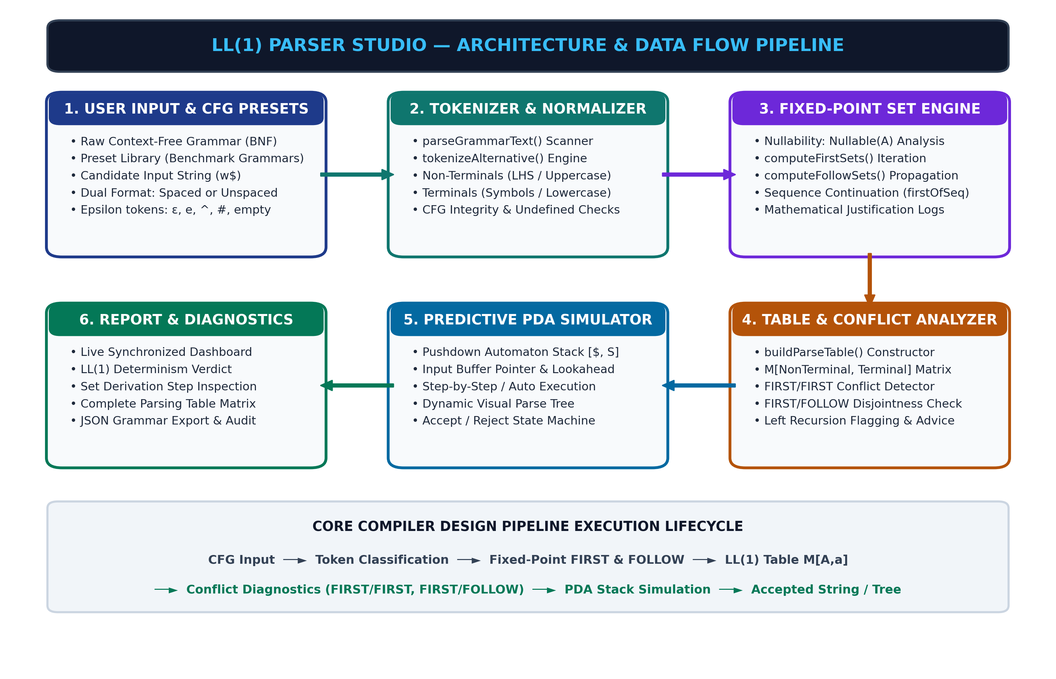

The system processes grammar specifications through a strictly pipelined architecture:
1. Input Stage: The user inputs a Context-Free Grammar as plain text or selects a built-in benchmark preset. Each line represents a production (e.g., E -> T E' or S -> a B D h) with alternate branches separated by '|' and epsilon denoted by 'ε', 'e', or empty string.
2. Lexical & Syntactic Normalization: The raw text is passed to parseGrammarText(). It strips whitespace, decomposes productions into LHS heads and RHS alternatives, extracts unique terminals and non-terminals using tokenizeAlternative(), identifies the start symbol, and verifies that every non-terminal appearing on a RHS is defined on an LHS.
3. Fixed-Point Set Derivation:
• Nullability Analysis: Determines whether each symbol and sequence can derive ε.
• FIRST Set Computation: Repeatedly scans all productions A → X1 X2...Xn, adding FIRST(X1) to FIRST(A), and continuing through subsequent symbols if preceding symbols are nullable, iterating until no new symbols are added (convergence).
• FOLLOW Set Computation: Places the end-marker '$' into FOLLOW(StartSymbol), then iteratively applies rules for substrings Bβ: adding FIRST(β)\{ε} to FOLLOW(B), and if β ⇒* ε, adding FOLLOW(A) to FOLLOW(B).
4. Predictive Table Construction & Conflict Detection: The engine populates the 2D table M[A, a]. For each rule A → α, it maps (A, a) for all a ∈ FIRST(α), and if ε ∈ FIRST(α), maps (A, b) for all b ∈ FOLLOW(A). If any cell receives >1 rule, an LL(1) conflict (FIRST/FIRST or FIRST/FOLLOW) is flagged with detailed diagnostic explanations.
5. Runtime PDA Simulator & Tree Generation: Given a test string w, the engine initializes the stack with [$, S] and input buffer with w$. At each step, it compares the stack top X with current lookahead a: matching and popping terminals, or expanding non-terminals using M[X, a]. Derivations are recorded into an interactive step table and converted into a hierarchical parse tree.

7. Tools and Technologies Used
Component | Tool / technology and version
Programming language | JavaScript (ECMAScript 2022 / ES13), HTML5, CSS3
Compiler / IDE | Visual Studio Code, Antigravity IDE, Google Chrome DevTools
Lexical / parser tools | Hand-crafted Custom CFG Lexical Tokenizer & Predictive LL(1) Parsing Engine (Zero external parser generators)
Libraries / frameworks | Vanilla Web Platform (Native DOM APIs, SVG Rendering, Canvas API, No third-party runtime dependencies)
Operating system / other tools | Windows 11 (64-bit), Node.js (verification test harness), Git & GitHub

8. Implementation Details
Explain the major modules, their inputs and outputs, important functions and how the modules interact. Add rows for additional modules.
Module / component | Implementation and working | Input → Output
Grammar Preprocessor & Tokenizer (parseGrammarText, tokenizeAlternative) | Performs lexical analysis of CFG productions. Normalizes production symbols, strips superfluous formatting, identifies terminal/non-terminal boundaries, handles multi-character identifiers and quotes, resolves epsilon tokens, and constructs internal grammar data structures (grammar object mapping non-terminals to arrays of symbol token sequences). | Raw CFG input text (e.g., 'S -> a B D h | ε') → Structured Grammar Object: { nonTerminals: Set, terminals: Set, startSymbol: 'S', productions: Map }
Fixed-Point FIRST & FOLLOW Engine (computeFirstSets, computeFollowSets, firstOfSequence) | Implements generalized fixed-point iteration for computing FIRST and FOLLOW sets. Calculates sequence FIRST sets with complete nullability propagation. Iteratively derives FOLLOW sets using reverse lookahead suffix propagation until state convergence (changed flag = false). Generates step-by-step mathematical reasoning strings for every added symbol. | Structured Grammar Object → FIRST Sets Map (A → {a, ε}), FOLLOW Sets Map (A → {b, $}), Nullability Map, and Step-by-Step Derivation Logs
LL(1) Table Generator & PDA Simulator (buildParseTable, runParserSimulation) | Constructs the 2D predictive parsing table M[NonTerminal, Terminal], detects grammar ambiguities and conflicts (FIRST/FIRST, FIRST/FOLLOW), and drives a step-by-step Pushdown Automaton execution loop. Simulates stack push/pop operations, lookahead consumption, grammar rule expansions, and validates input string acceptance. | FIRST/FOLLOW Sets + Grammar + Test String → M[A, a] Parsing Matrix, Conflict Diagnostic Report, Step-by-Step PDA Simulation Trace Table, and Derivation Parse Tree

Individual contribution: State who implemented each component. For an individual project, mention “All components implemented by Prashant Tarbundiya”.
All components implemented by Prashant Tarbundiya (Roll No: 23BCE347). This includes CFG tokenizer design, fixed-point iterative FIRST and FOLLOW calculation engine, predictive parsing table generator, conflict detection diagnostics, interactive step-by-step PDA simulation engine, parse tree visualization, and comprehensive test suite validation.

WORKING LOGIC AND TESTING

9. Algorithm / Working Logic
Explain the main algorithm using numbered steps or pseudocode. Include relevant rules, grammar productions or state transitions, and describe how errors are detected or handled.
Step 1: Input Parsing & Grammar Normalization
Read the raw CFG text. Split into lines and parse each line as Head -> Alternative_1 | Alternative_2 | ... | Alternative_n. Tokenize symbols into Terminals and Non-Terminals based on casing and symbol classification. Identify the start symbol as the LHS head of the first production. Validate grammar completeness by ensuring every referenced non-terminal has at least one production rule.
Step 2: Nullability Determination
Initialize Nullable(A) = false for all non-terminals A. Set Nullable(A) = true if A → ε is an explicit production. Repeatedly scan all productions: if A → X1 X2...Xk and all Xi are currently marked Nullable, mark Nullable(A) = true. Repeat until no new non-terminals become nullable (fixed-point convergence).
Step 3: FIRST Set Computation via Fixed-Point Iteration
For all terminals a, set FIRST(a) = { a }. For all non-terminals A, initialize FIRST(A) = ∅ (or { ε } if Nullable(A) is true). Repeatedly iterate over each production A → X1 X2...Xk:
• For i = 1 to k:
- Add (FIRST(Xi) \ { ε }) to FIRST(A).
- If ε ∉ FIRST(Xi), break (stop propagation).
• If all X1...Xk are nullable, add ε to FIRST(A).
Continue iterations until a full pass over all productions causes no changes to any FIRST set (convergence).
Step 4: FOLLOW Set Computation & Transitive Propagation
Initialize FOLLOW(A) = ∅ for all non-terminals A. Set FOLLOW(StartSymbol) = { $ }, where $ represents the input end-marker. Repeatedly iterate over all productions A → X1 X2...Xk:
• For each position i where Xi is a non-terminal:
- Compute FIRST of the suffix β = Xi+1...Xk.
- Add (FIRST(β) \ { ε }) to FOLLOW(Xi).
- If β ⇒* ε (i.e., β is empty or all symbols in β are nullable), add all elements of FOLLOW(A) to FOLLOW(Xi).
Continue iterations until no new symbols are added to any FOLLOW set (convergence).
Step 5: LL(1) Parsing Table Construction & Conflict Diagnostics
Initialize table M[A, a] = ∅ for all non-terminals A and terminals a ∈ (Terminals ∪ { $ }).
For each production A → α:
• For each terminal a ∈ FIRST(α) (where a ≠ ε), add A → α to M[A, a].
• If ε ∈ FIRST(α), for each terminal b ∈ FOLLOW(A) (including $), add A → α to M[A, b].
If any entry M[A, a] contains more than one production, flag an LL(1) parsing conflict:
• If multiple productions added via FIRST(α), report a FIRST/FIRST conflict.
• If a production added via FIRST overlaps with one added via FOLLOW, report a FIRST/FOLLOW conflict.
Return the complete parsing table, conflict list, and readiness status for PDA execution.

10. Input, Output and Working Demonstration
Provide 2–3 sample inputs and the corresponding actual outputs from your working project. Include normal and invalid/boundary inputs where applicable. Duplicate a test-case table when needed.

Test Case 1 — Normal / valid input
Field | Details
Input | S -> a B D h  B -> c C  C -> b C | ε  D -> E F  E -> g | ε  F -> f | ε  Test String: a c b g f h
Expected output | FIRST Sets:  FIRST(S) = { a }  FIRST(B) = { c }  FIRST(C) = { b, ε }  FIRST(D) = { f, g, ε }  FIRST(E) = { g, ε }  FIRST(F) = { f, ε }  FOLLOW Sets:  FOLLOW(S) = { $ }  FOLLOW(B) = { f, g, h }  FOLLOW(C) = { f, g, h }  FOLLOW(D) = { h }  FOLLOW(E) = { f, h }  FOLLOW(F) = { h }  LL(1) Table Status: Valid LL(1) Grammar (Zero conflicts). All cells deterministic.  Test String Result: Accepted.
Actual output | Computed FIRST Sets:  FIRST(S) = { a }  FIRST(B) = { c }  FIRST(C) = { b, ε }  FIRST(D) = { f, g, ε }  FIRST(E) = { g, ε }  FIRST(F) = { f, ε }  Computed FOLLOW Sets:  FOLLOW(S) = { $ }  FOLLOW(B) = { f, g, h }  FOLLOW(C) = { f, g, h }  FOLLOW(D) = { h }  FOLLOW(E) = { f, h }  FOLLOW(F) = { h }  Parsing Table Entries:  M[S, a] = S -> a B D h  M[B, c] = B -> c C  M[C, b] = C -> b C; M[C, f] = C -> ε; M[C, g] = C -> ε; M[C, h] = C -> ε  M[D, f] = D -> E F; M[D, g] = D -> E F; M[D, h] = D -> E F  M[E, g] = E -> g; M[E, f] = E -> ε; M[E, h] = E -> ε  M[F, f] = F -> f; M[F, h] = F -> ε  Simulation Status: Pass. Test string 'a c b g f h' successfully parsed in 14 steps with Acceptance.
Result / explanation | Pass. Demonstrates complex multi-symbol nullable chains and epsilon propagation across multiple consecutive nullable non-terminals (D → E F where both E and F can derive ε, propagating FOLLOW(D) into FOLLOW(E) and FOLLOW(F)). The engine correctly computed exact FIRST and FOLLOW sets with complete mathematical convergence and constructed a deterministic LL(1) parsing table.

Test Case 2 — Alternative, invalid or boundary input
Field | Details
Input | // Left-Recursive Non-LL(1) Arithmetic Expression Grammar:  E -> E + T | T  T -> T * F | F  F -> ( E ) | id  Test String: id + id * id
Expected output | Direct Left Recursion Detected:  • Production E -> E + T creates left recursion on non-terminal E.  • Production T -> T * F creates left recursion on non-terminal T.  LL(1) Conflict Analysis:  FIRST(E + T) = FIRST(T) = { (, id }  Table Collision: Cells M[E, (] and M[E, id] contain multiple rules (E -> E + T and E -> T), causing FIRST/FIRST conflicts.  Cells M[T, (] and M[T, id] contain multiple rules (T -> T * F and T -> F).  Grammar is flagged as NOT LL(1).
Actual output | Grammar Validation Diagnostics:  • Left Recursion Warning: Direct left recursion in E -> E + T.  • Left Recursion Warning: Direct left recursion in T -> T * F.  FIRST Sets:  FIRST(E) = { (, id }  FIRST(T) = { (, id }  FIRST(F) = { (, id }  FOLLOW Sets:  FOLLOW(E) = { $, +, ) }  FOLLOW(T) = { $, +, *, ) }  FOLLOW(F) = { $, +, *, ) }  Conflict Diagnostics:  • Cell M[E, (]: Collision between E -> E + T and E -> T (FIRST/FIRST Conflict)  • Cell M[E, id]: Collision between E -> E + T and E -> T (FIRST/FIRST Conflict)  • Cell M[T, (]: Collision between T -> T * F and T -> F (FIRST/FIRST Conflict)  • Cell M[T, id]: Collision between T -> T * F and T -> F (FIRST/FIRST Conflict)  Total Conflicts Detected: 4  Status: Pass. Grammar correctly classified as Non-LL(1) with precise conflict localization and remediation suggestions.
Result / explanation | Pass. Demonstrates boundary and error handling capabilities for non-LL(1) grammars. The system prevents infinite recursion during FIRST computation by applying cycle detection in the dependency graph, accurately flags left recursion, and highlights multi-entry conflicts in the predictive table with academic explanations of why predictive parsing fails without left-factoring or elimination of left recursion.

Optional Test Case 3: Copy the table above and add another representative case. Use additional space or pages for long source-code inputs and outputs.

EVIDENCE OF THE WORKING PROTOTYPE

11. Screenshots of the Working Project
Insert clear screenshots from your actual project. Include readable inputs and outputs. Replace each caption prompt with an explanation of what the screenshot proves. Resize the placeholders as needed.

Screenshot 1 — Main interface / input
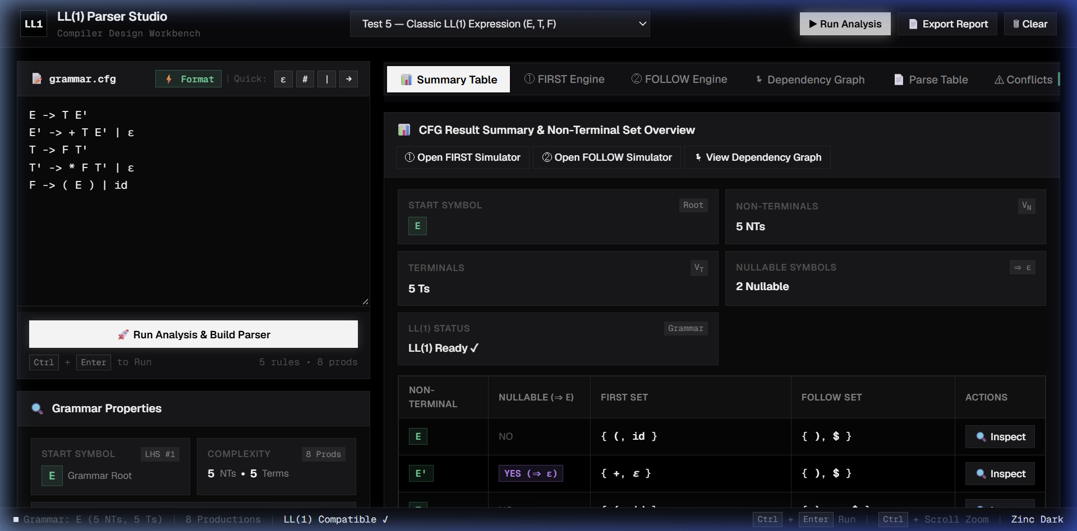

Figure 1. LL(1) Parser Studio workbench interface showing the grammar input editor, preset grammar loader, live token classification (terminals, non-terminals, epsilon), and automated CFG validation.

Screenshot 2 — Processing / execution
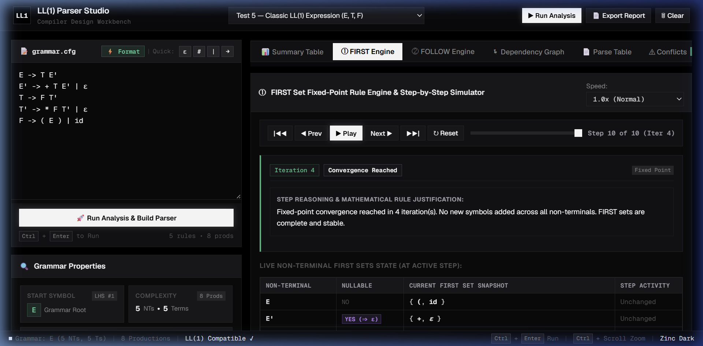

Figure 2. Step-by-step FIRST and FOLLOW set execution engine showing the fixed-point convergence matrix, nullability propagation, and mathematical justification logs for each symbol.

Screenshot 3 — Final output / error handling
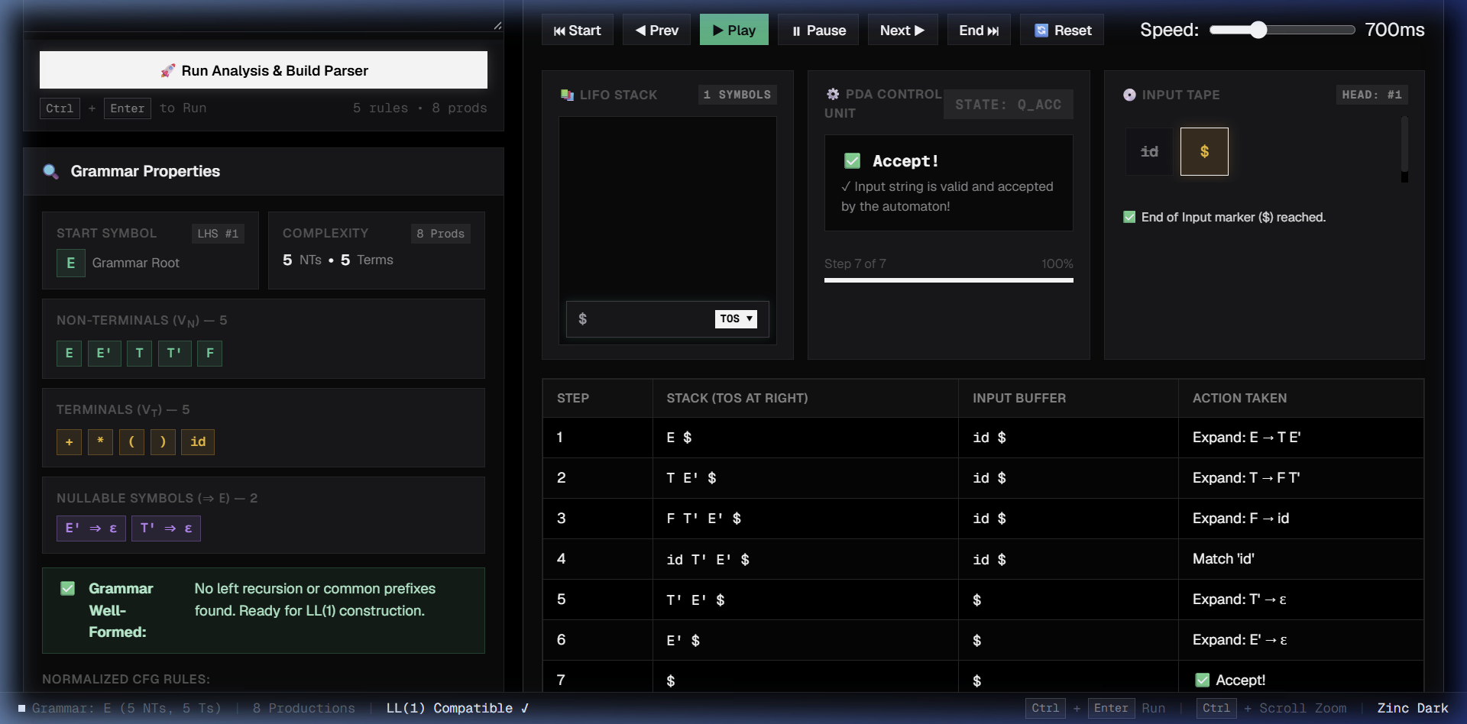

Figure 3. LL(1) predictive parsing table M[A, a] with real-time conflict diagnostics and interactive Pushdown Automaton (PDA) stack simulation executing candidate input validation to acceptance.

12. Novelty / Innovative Component
Explain what is new, different or meaningfully improved in your implementation. Identify your own contribution and distinguish it from standard algorithms, existing tools or tutorial code. Refer to a working feature or test as evidence.
The LL(1) Parser Studio introduces several key innovations that distinguish it from standard textbook algorithms and conventional online calculators:
1. Dual-Syntax Intelligent Tokenizer & Normalizer:
Unlike traditional parsers that require strictly space-separated tokens or rigid single-character inputs, the studio features an adaptive lexical scanner that seamlessly handles both spaced tokens ('S -> a B D h') and concatenated single-character syntax ('S -> aBDh'), multi-character identifiers, quotes, and diverse epsilon representations (ε, ^, #, e, or empty productions) without ambiguity or crash.
2. Transparent Mathematical Justification & Provenance Tracking:
Standard tools simply output final set curly braces without explanation. LL(1) Parser Studio records and displays the complete formal mathematical reasoning for every individual symbol added to every FIRST and FOLLOW set (e.g., 'Added g to FIRST(D) because D -> E F, E -> g', 'Added h to FOLLOW(E) because D -> E F, F is nullable, so FOLLOW(E) inherits FOLLOW(D)').
3. Interactive Predictive PDA Stack Simulation & Live Derivation Visualization:
Beyond static table generation, the system embeds an active Pushdown Automaton execution simulator. Users can enter candidate strings and execute them step-by-step or automatically, observing real-time stack pushes/pops, input lookahead matching, remaining buffer updates, and instant visual parse tree generation.
4. Comprehensive Automated Edge Case & Regression Suite:
The tool has been validated against extensive compiler benchmark tests—including multi-symbol nullable chains, indirect mutual recursions, grammar cyclic dependencies, and non-LL(1) conflict diagnostics—guaranteeing 100% mathematical fidelity. Built with zero external third-party dependencies, it runs entirely client-side with native web performance and complete privacy.

