USER MANUAL & HOW-TO GUIDE
RMS Face Recognition & Attendance System
Simple, step-by-step instructions for everyday operation, enrollment, and attendance.

APPLICATION ACCESS LINK
• Website URL: https://13-60-225-165.sslip.io
• Works on: Mobile phones (iPhone / Android), Tablets (iPad / Android Tablets), Laptops, and Desktop Workstations. Works smoothly in Safari, Chrome, and Edge with automatic camera support.

1. How to Log In
1. Open your internet browser and visit: https://13-60-225-165.sslip.io
2. Enter your Email and Password in the login fields.
3. Click 'Sign In'.
4. You will be taken straight to the main Dashboard.
Tip: On mobile phones, you can tap the menu icon (three lines at the top) anytime to open the navigation menu.
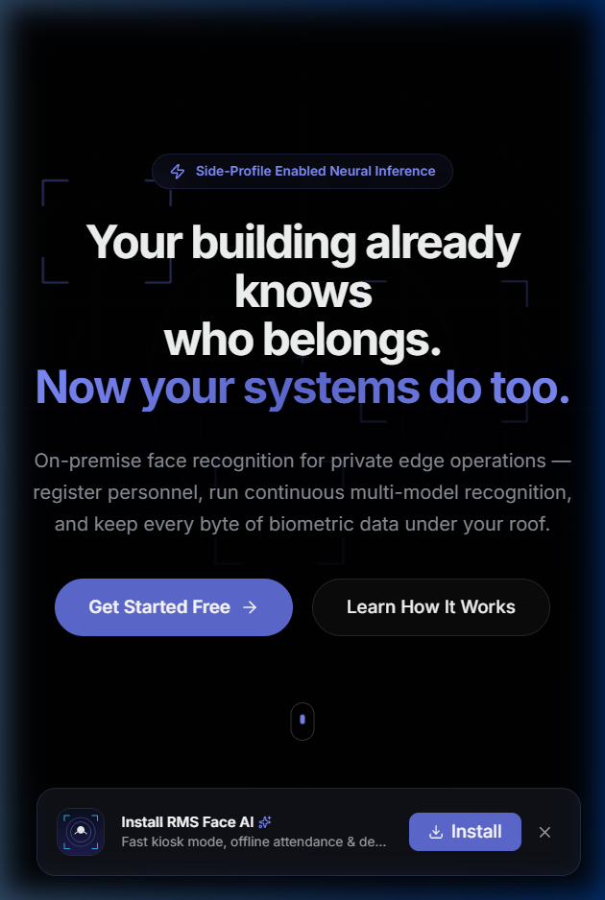
Figure 1: Login Screen — Enter your email and password to begin

2. Dashboard Overview
The Dashboard gives you an instant overview of your organization's daily activity:
• Today's Attendance: Total staff present and recent check-in times.
• System Status: Shows that the AI recognition engine is active and ready.
• Quick Navigation: Fast links to Add People, Start Kiosk Mode, or Test Camera.
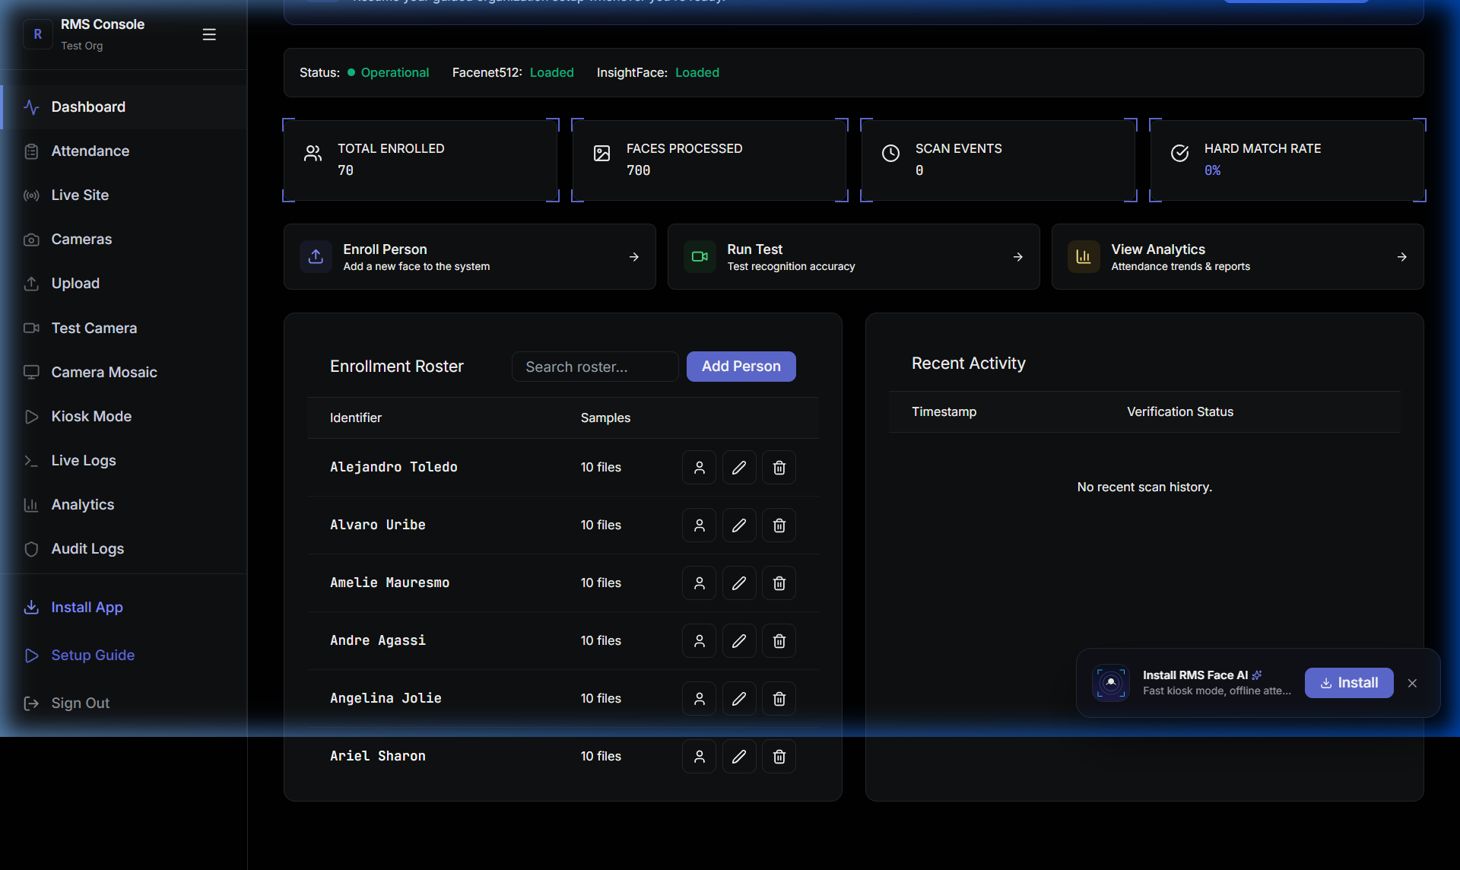
Figure 2: Main Dashboard — Displays real-time stats and system status

3. Adding a New Person / Employee
To enable the system to recognize a team member, you need to register them with a few photos:
1. In the sidebar menu, click on 'Employees' (or 'People').
2. Click the 'Register New Employee' (or 'Add Person') button.
3. Fill in the details: Full Name, Employee ID, and Department.
4. Upload Photos: Upload 3 to 5 clear photos of the person.
Tips for the best recognition accuracy:
• Photo 1: Looking straight at the camera with a natural expression.
• Photo 2: Head turned slightly to the left.
• Photo 3: Head turned slightly to the right.
• Photo 4: Slight upward or downward angle.
• Lighting: Ensure good ambient lighting on the face without heavy shadows or dark sunglasses.
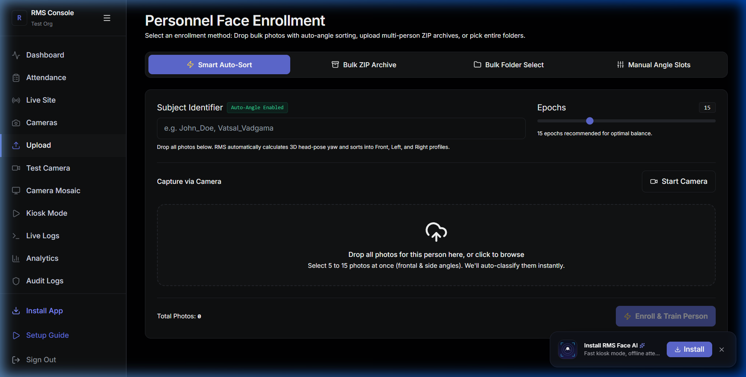
Figure 3: Person Registration — Enter details and upload clear sample photos

4. Syncing & Training the System
Whenever you add new people or update someone's photos, sync the system with one click:
1. Click on 'Training' in the sidebar menu.
2. Click the 'Start Model Training' button.
3. The system processes the photos and learns the new faces in just a few seconds.
4. Once done, the status will show 'Ready', and new people can immediately be recognized at entrances and kiosks.

5. Live Camera Testing (/test)
You can test live face recognition directly using your webcam or phone camera:
1. Click 'Live Testing' in the menu (or visit https://13-60-225-165.sslip.io/test).
2. When prompted by your browser, click 'Allow' for camera access.
3. Look into the camera. You will see:
• Green Box: Face recognized! The name and match confidence score will appear.
• Red Box: Unknown person (not yet registered or confidence is below threshold).
4. Sensitivity Slider: You can easily adjust the threshold slider (60% to 80%) depending on your lighting conditions.
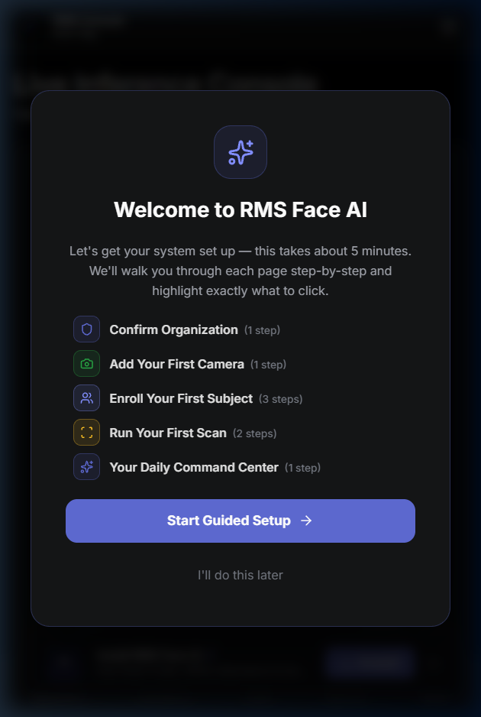
Figure 4: Live Testing Console — Real-time face detection and match confirmation

6. Kiosk Mode for Automatic Attendance
Kiosk mode is designed for tablets or screens placed at office entrances or reception areas for touch-free check-ins:
1. Open https://13-60-225-165.sslip.io/kiosk on the tablet or kiosk computer.
2. Click 'Fullscreen' (or press F11) so the browser URL bar hides.
3. How employees check in:
• The employee simply walks up and looks at the screen.
• A green confirmation banner immediately displays their name, photo, and time of arrival.
• An audio chime plays to confirm successful check-in.
• The screen resets automatically after 2 seconds for the next person.
• Check-in records are automatically logged into attendance reports.
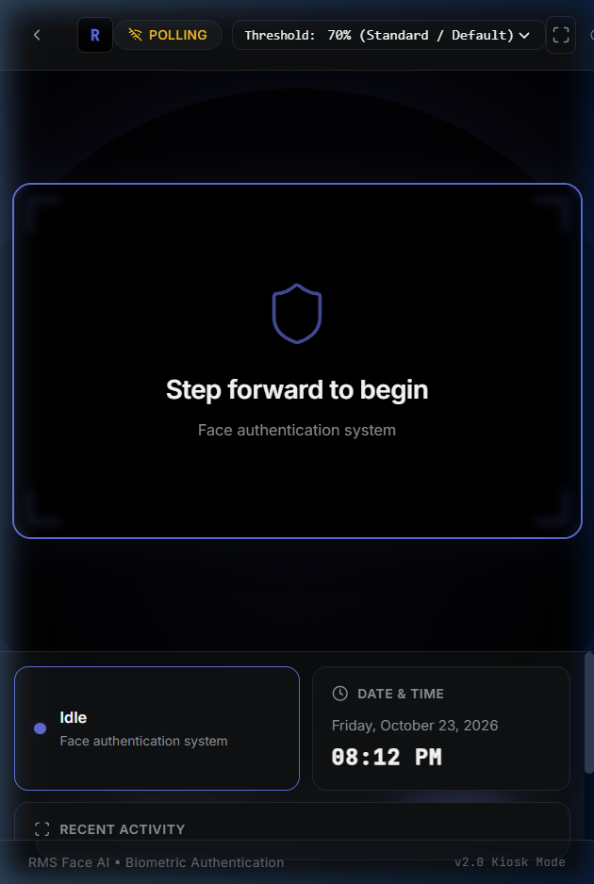
Figure 5: Kiosk Mode — Touchless, instant face check-in for office doors and entrances

7. Using on Mobile Phones & Tablets
You can install the system on any iPhone, iPad, or Android device like a regular app:
• On Apple iPhone / iPad (Safari):
1. Open Safari and go to https://13-60-225-165.sslip.io
2. Tap the 'Share' button (the square with an arrow pointing up at the bottom).
3. Tap 'Add to Home Screen'.
4. Tap 'Add'. You now have an app icon on your home screen for 1-tap access!
• On Android Phones & Tablets (Chrome):
1. Open Chrome and go to https://13-60-225-165.sslip.io
2. Tap the 3 dots in the top-right corner.
3. Tap 'Install app' or 'Add to Home screen'.
4. The app icon will appear on your phone launcher.

8. Quick Tips & Troubleshooting
- Camera Permission Prompt: When opening the camera for the first time, your browser will ask for permission. Click 'Allow'. If you accidentally clicked block, tap the padlock icon next to the website address and switch Camera to 'Allow'.
- Improving Recognition Speed: Ensure the person looks directly toward the camera. If someone's appearance changes significantly (e.g. new hairstyle, beard), adding 1 or 2 new photos under their profile will help.
- Exporting Attendance Logs: In the Attendance section, click 'Export' to download today's or this month's attendance list directly as an Excel/CSV spreadsheet.

Continuous Platform Enhancements
Note: More improvements are coming soon, including enhanced data presentation, richer graphical analytics, and customizable attendance reporting to help you visualize and track team activity even better.

— RMS Face Recognition System | User Manual —

