*Context*

When the 1st smartphone was invented, it completely changed our lives. Smartphones brought people closer like never before and enabled the users to have a better control of their lives through very simple and intuitive actions. People had developed a new pattern of living based on their usage of smartphones. And new jobs and new occupations were born with the birth of smartphones. Smartphones have also changed the world.

As time went by, we have seen so many revolutions and evolutions in the category that kept bringing us surprises and excitement. Nowadays people’s lives have been seamlessly connected with smartphones, and many of us cannot live without them. Instead of waiting for the big brands or telecom tycoons to decide what the next invention will be, why don't you show us your vision for the future of smartphones?

Imagine that a leading smartphone manufacturer with more than 200 million users around the globe, boasting a number of innovation that have improved smartphones over the last decades is looking forward to the next 5 years, they want to imagine how the technology and hardware will evolve. I need your creativity to envision people’s needs and how smartphones will address them. Can you help?

*Creative Challenge*

**Show us your vision of a future smartphone in 2025 through a refreshingly creative, forward-looking and groundbreaking product idea that brings revolutionary changes in our lives.**

The challenge is to imagine how smartphone can evolve within the next 5 years. We want to understand how it will look like from a hardware perspective and what functionalities it will offer to people.

If you look 20 years backward, you realise how much changes mobile phones have been through both in terms of technology than hardware. There have now applications to ease each and every steps of daily life, which make people carry their phone with them almost 24-7. Think about how the different smartphone evolution have changed our lives, we are expecting the same kind of idea and the same kind of impact.

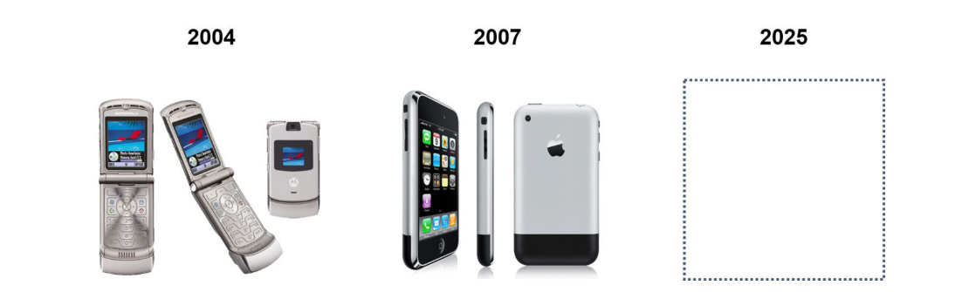

*Smartphone innovation has traditionally been monopolized by the giant brand names of the technology industry. But over the last decade this company has made waves within the industry creating products that are not only stylish but also embody ground-breaking technologies*

Please present your idea **with a high quality illustrations (up to 2) and text description,** so that we understand what your concept is and how people will use it.

To help us understand your idea, please answer the following questions:

* Name your idea
* Give a very brief description
* What are the main benefit your concept offers?
* What make your concept different from what it is on the market in 2020?

**Notes**

1. There are already lots of new features for smartphones: please make sure your concept idea doesn’t already exists.
2. It is important your concept remains realistic as we are looking at concept that could be launched within 5 years, which is not far from us.
3. You can start thinking about what will your life be like in 2025 and how could a smartphone change it. Or start considering the ups and downs in your experience with your smartphone and how you can make the experience more ideal and better by leveraging on some future technology. Or firstly identify who are the target users of your new smartphone and think about how it can change their lives.

**Deadline: 28 April, 2020**