***BORDER PATROLLING MULTIFUNCTIONAL***

***ROBOT***

**ABSTRACT**

The ordinary control border patrol system suffers from intensive human involvement, Recently unmanned border patrol system consist of high tech device, like unmanned aerial vehicles, unattended ground sensors and surveillance tower equipped with wireless camera However, any single technique encounter inextricable problem, such a high false alarm rate and line of sight constraints. These various technologies to improve the system accuracy. In these project general idea of border, security robot, wireless sensor network architecture for border patrol system is introduced. Border security robot utilize a PIR sensor for human detection ,a metal detector the presence of explosive and a wireless camera for monitoring the scenario continuously as well as capable of object detection at the remote station. The mechanical control of robotic vehicle is done from the remote station and reducing the risk of human lives. This robot has GPS system that will help to mark the suspicious locations and also and will help in keeping the track of robot. The bot is robust enough to survive harsh climatic and explosives and capable of obstacle avoidance, can be maneuver easily.

**INTRODUCTION**

The robot is basically electro-mechanical machine or device that is controlled either by computer program or with electronic circuit to perform variety of physical tasks. In the today life robot are becoming indispensable part of human life. The robot technology also provides automation & this technology also used in defense forces, entertainment, security systems and many dangerous mission execution. As the terror is always remains India’s first enemy so, the robot are going to use for saving human life. Countries like India are still facing and confronting with regular threats from terrors in borders.

**FEASIBILITY STUDY**

The ordinary border patrol system suffers from intensive human involvement. The border is a very dangerous place, citing the threat of Improvised Explosive Devices (IEDs), snipers, anti-tank missiles and terrorist tunnels, many of our soldiers are martyred by Terrorist Group and violation of seize fire. Sending unmanned Robots to do these patrols means that troops lives are not at risk. If anyone is going to get hurt, it better be that robot. Army helps us in various natural and manned hazards rescue mission, there are several areas where humans can't reach out so there is a need of bot that can detect alive humans in trouble like earthquake, nuclear reactors, boilers etc. This robotic vehicle has ability to substitute the solider at border areas to provide surveillance. The robotic vehicle works as manually controlled vehicle using internet as communication medium. This multisensory robot used to detect human, bombs, harmful gases and fire at remote and war field area.

**METHOD OR PLANNING OF WORK**

Unmanned border patrolling bot consist of high tech unattended ground services is equipped with wireless camera, sensors like PIR sensor for human detection, a metal detector to detect the presence of explosives and a web camera for monitoring the scenario continuously as well as capable of object detection from the remote station. Ultrasonic sensors uses SONAR to detect the distance to an object. Other sensors are used for keeping check on temperature and humidity. It consist of a modem assembled together with power supply circuit and communications interface. Border scenario can be monitored by using wireless camera. In robotic side continuously checking the output of PIR sensor. If the PIR sensor output is high means “an intruder found”, controller send this information to remote station through wifi interface. This bot is also robust enough to survive in harsh climatic and explosives and capable of obstacle avoidance also. By this way human involvement is reduced with the help of these bot.

**Architecture of Border Patrolling Multifunctional Robot**

It is a 6-wheel drive robot vehicle that can overcome the obstacle in its path. It is designed to maneuver in all terrains without difficulty. This robot is controlled remotely by remote station through a web interface. This interface is user friendly and user can control the bot and can receive the data from the sensors directly to the screen. The communication end points in this project are sensors to raspberry, Raspberry to cloud, cloud to user via web interface. single, discrete communication message exchanged between a robot and infrastructure.

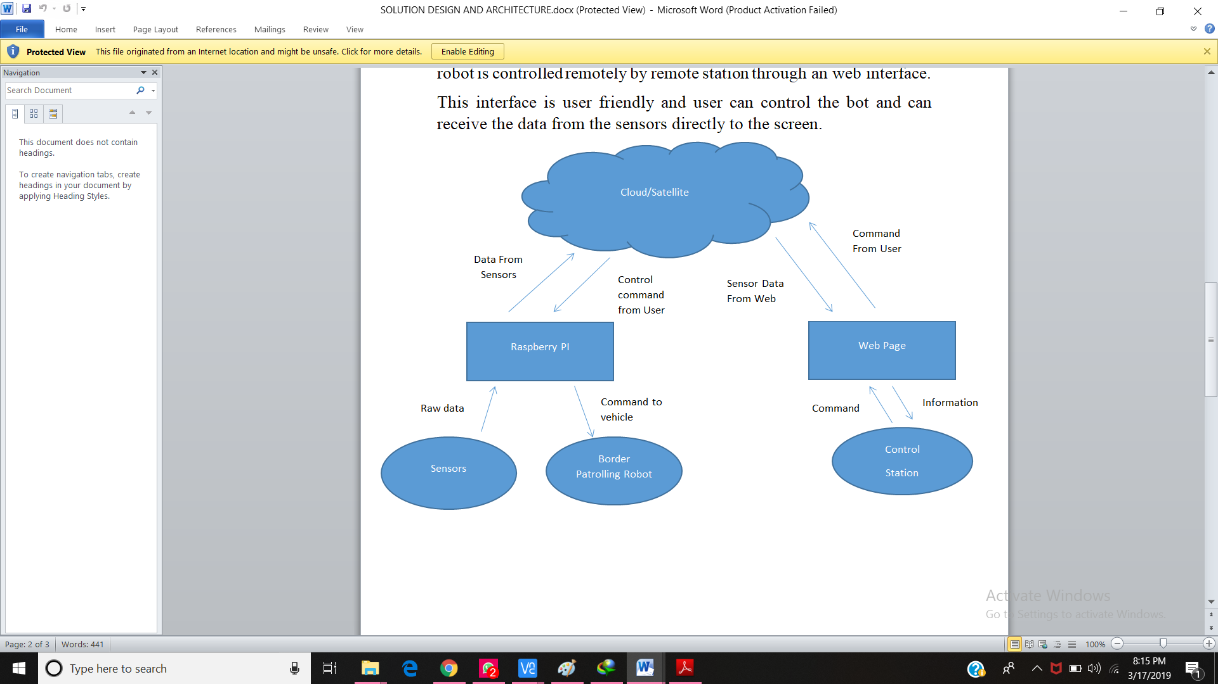

**Design and development of Robot**

The multifunctional robot is designed completely to be operable with cloud web server. The robot can be controlled with remote station. This is platform independent project can be implemented anywhere in any system. The user friendly interface is designed to avoid complexity in controlling the bot. Raspberry pi is connected to laptop wirelessly. Raspberry pi is controller of the robot. It controls the sensors and DC motors and logical activity of its component.

Raspberry then sends the data to the cloud and user access the data from cloud through web server. Web server is developed using **flask framework** of python and backend code is written in python 3.

There is a web app on laptop which displays video stream and reports control data that is live streaming of video and control arrows to control its movement according to our need. Through web server we can send control data to raspberry pi and receive data from it. It also sends and receive data through various sensors in our model there are various sensors used to make our bot multifunctional. There is a web cam to continuously stream the situation at the border. Through GPS sensor we get to know latitude and longitude of our bot where it is moving at what position. Temperature sensors are used to get climatic situations, humidity etc. Motor drivers are used to drive bot. Raspberry-pi uses 5v of battery and also motor uses 12v of power to drive wheels.

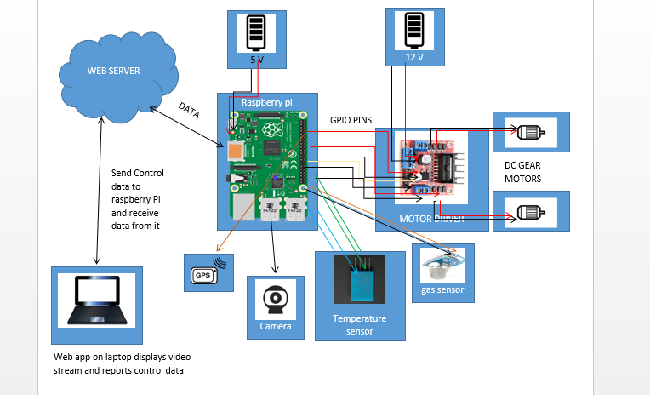

**FLOW CHART FOR MULTIFUNCTIONAL BORDERPATROLLING ROBOT.**

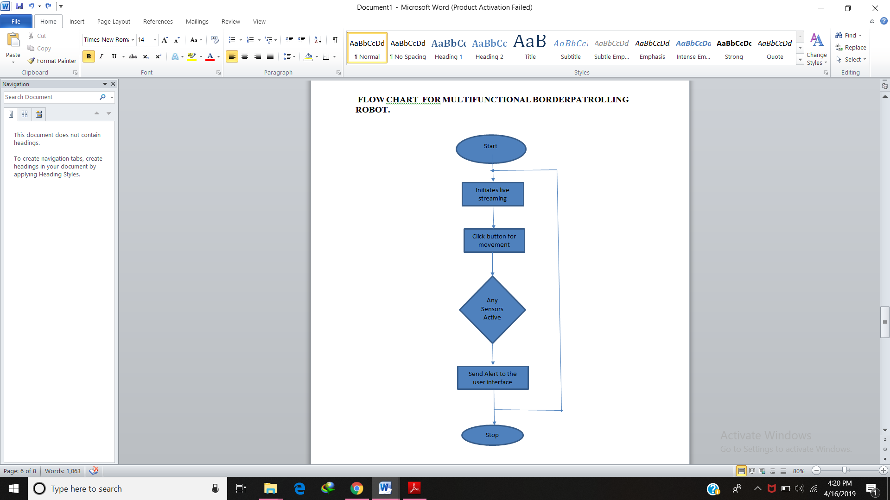

**SPECIFICATION REQUIRED**

*Software required*: Python, Flask framework , HTML, CSS, JSP.

*Hardware required*: Raspberry Pi 3B+, Motor Drivers, MQ138 Sensors, Temperature and Humidity Sensors, PIR sensors, Webcam, Ultrasonic sensors, GPS and GSM Modules, MODEM.

**Team Members:**

1.Prashant Kesarwani (<kesarwaniprashant0909@gmail.com>)

2.Neha Mishra (neham7925@gmail.com)