MessageMesh
Admin End-to-End Flow Documentation
Administration & Moderation • Application URL: http://localhost:5173/

This document walks through the complete administrator journey of the MessageMesh real-time chat application. Starting from an admin sign-in, it covers the admin navigation, the dashboard with its twelve live platform-analytics tiles, and full user management — searching and filtering by role and status, adjustable page sizes, creating accounts, viewing a user's details, forcing logout, resetting passwords, promoting/demoting, and bulk activate/deactivate/delete. It then covers conversation oversight and moderation (filtering, message-level moderation, deletion and restore), the audit log with date-range filtering and CSV export, and theme switching. Each step includes a screenshot captured from the running application and an explanation of the screen and the underlying functionality. All admin routes are protected server-side and client-side so that only accounts with the ADMIN role can reach them.

Step 1: Admin Sign In
Route: http://localhost:5173/login
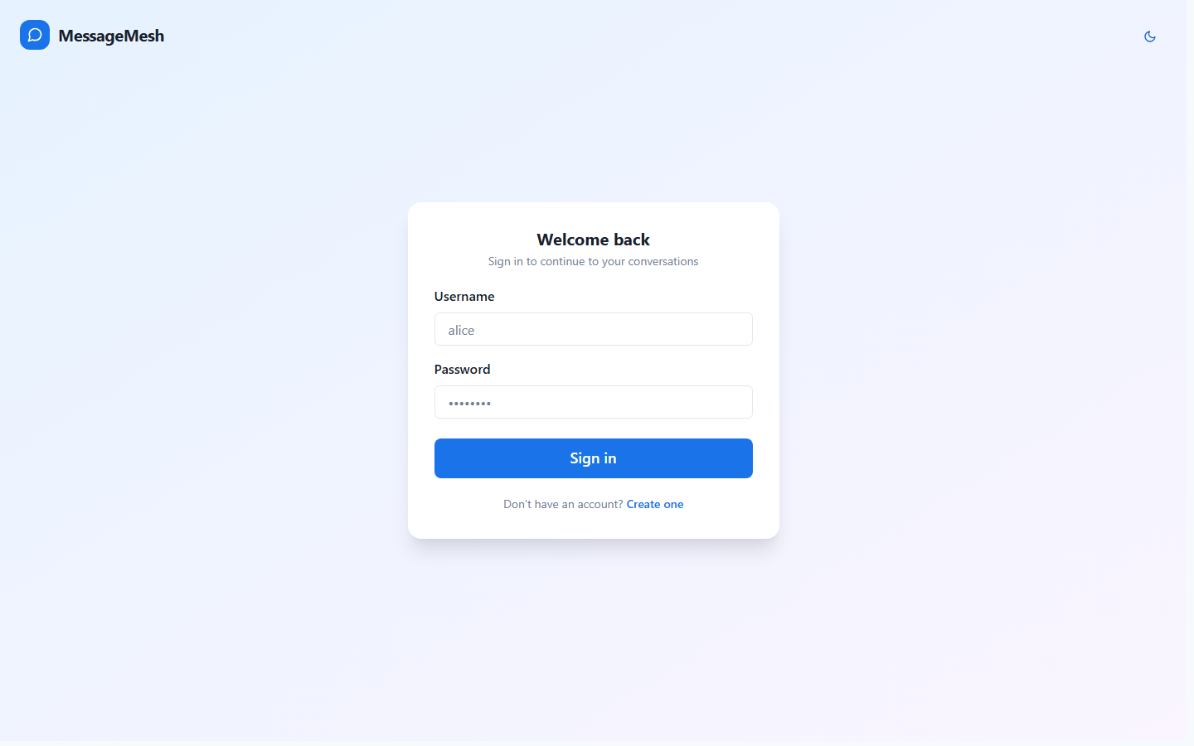
The admin journey begins at the standard sign-in screen. The administrator authenticates with the privileged account (username "admin"). Authentication is JWT-based; the returned token carries the ADMIN role claim, which unlocks the admin-only navigation and routes. All admin API calls and the WebSocket connection reuse this token for authorization.

Step 2: Admin Navigation Menu
Route: http://localhost:5173/chats
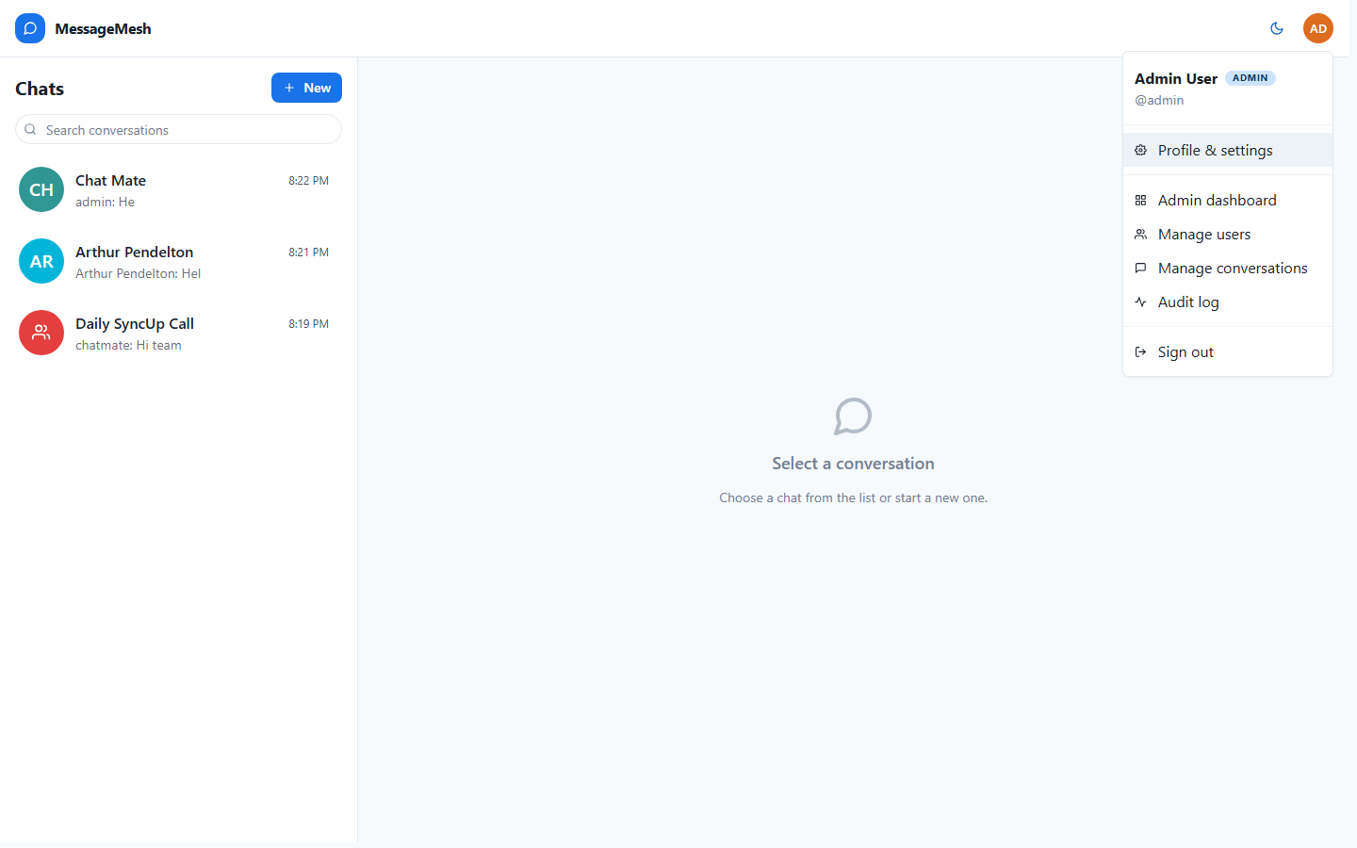
After signing in, the admin lands on the chat workspace like any user, but the profile menu (opened from the avatar) reveals privileged entries. An "Admin" badge next to the display name confirms the elevated role, and a dedicated section links directly to the Admin dashboard, Manage users, Manage conversations, and the Audit log, alongside Profile & settings and Sign out. These options are rendered only when the current user has the ADMIN role.

Step 3: Admin Dashboard & Platform Analytics
Route: http://localhost:5173/admin
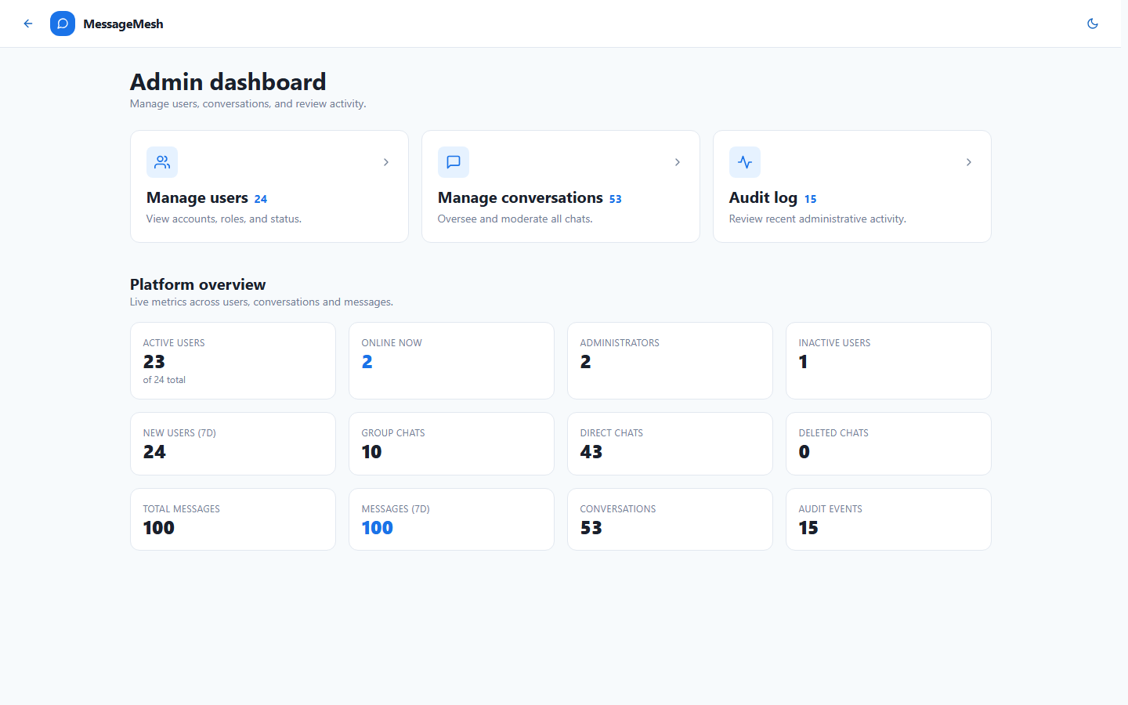
The Admin dashboard is the control center. Three shortcut cards summarize the platform and jump into each management area — registered users, conversations and recorded audit events, all fetched live from the backend. Below them, a "Platform overview" section renders twelve real-time metric tiles powered by the /api/admin/stats endpoint: active users (of total), online now, administrators, inactive users, new users in the last 7 days, group chats, direct chats, deleted chats, total messages, messages in the last 7 days, total conversations and audit events. The route is protected by a RequireAdmin guard, so non-admin users are redirected away.

Step 4: Manage Users
Route: http://localhost:5173/admin/users
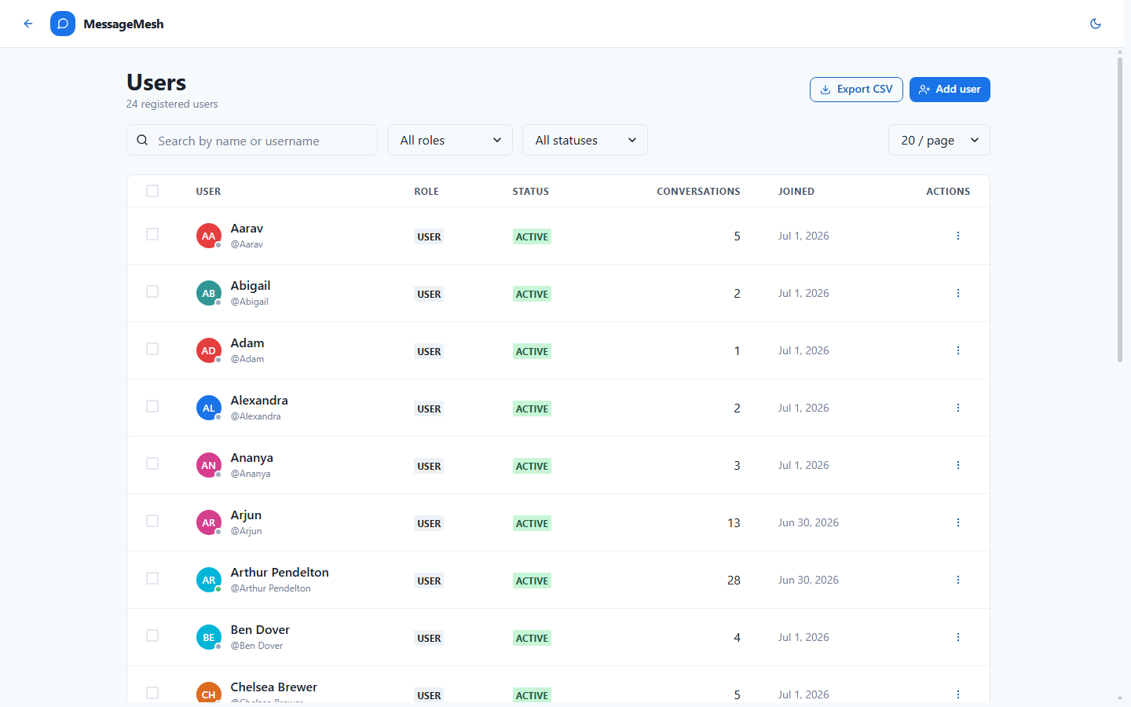
The Users page lists every registered account in a table showing a selection checkbox, avatar, display name, handle, role, active/inactive status, conversation count and join date. A debounced search box filters by name or username, and it is paired with a Role filter (All / Admins / Users), a Status filter (All / Active / Inactive) and a page-size selector (10 / 20 / 50 / 100 per page). The toolbar also offers "Add user" to create an account and "Export CSV" to download the current directory. Presence dots indicate who is currently online.

Step 5: User Actions
Route: http://localhost:5173/admin/users
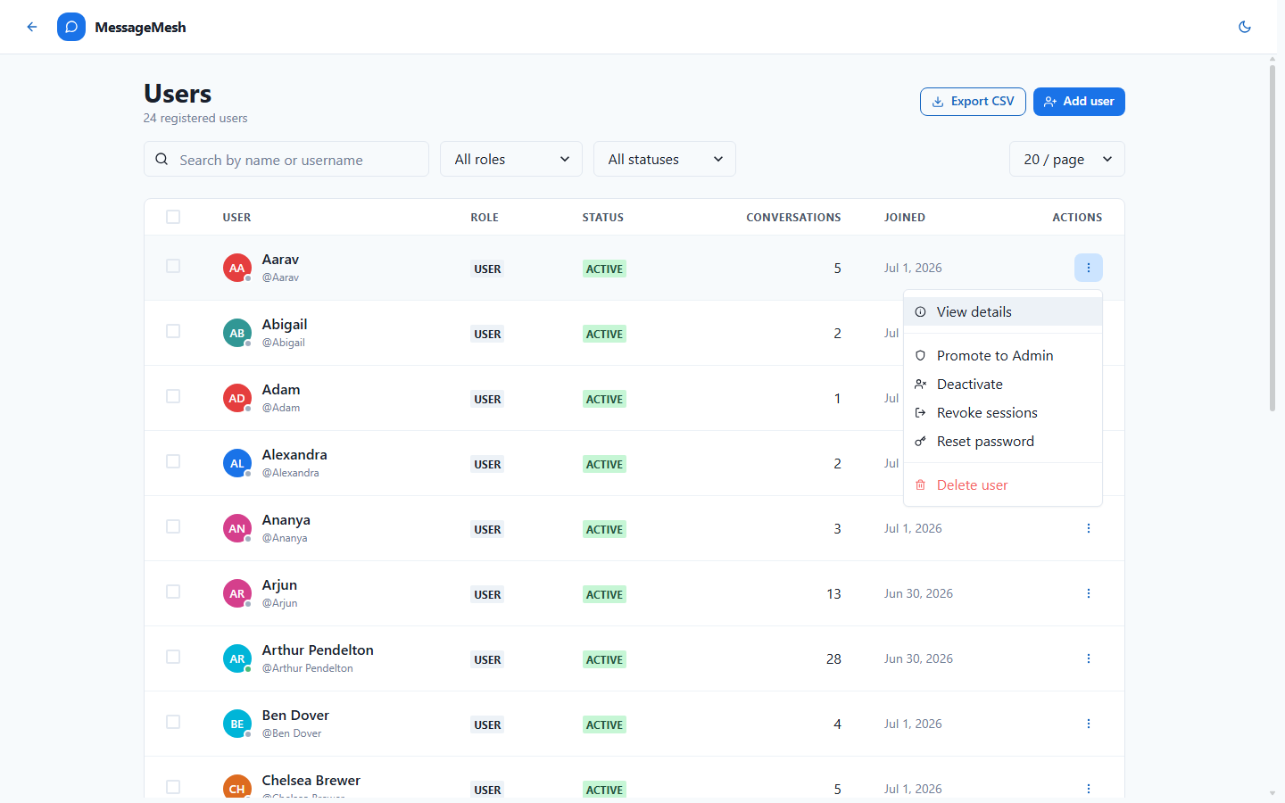
Each user row exposes an actions menu with the full set of moderation controls: View details (opens the profile drawer), promote to Admin or demote to User (role management), activate or deactivate the account (access control), Revoke sessions to force the user to log out everywhere, Reset password, and permanently Delete user. Destructive and role-changing actions open a confirmation dialog, and guard rails prevent unsafe self-actions (e.g. demoting or deleting your own account). Every action shows a success/error toast.

Step 6: Create a New User
Route: http://localhost:5173/admin/users
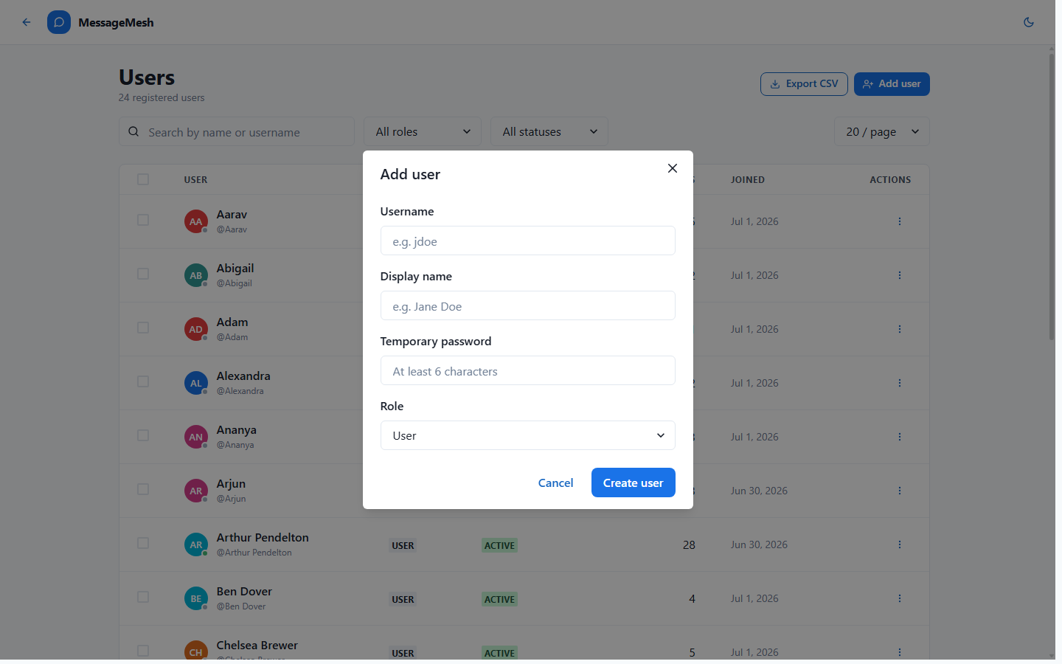
The "Add user" button opens a modal for provisioning an account directly from the admin console. The admin supplies a username, a display name, a temporary password and the initial role (User or Admin). On submit, the backend creates the account and the users table refreshes to include it. This lets administrators onboard people without requiring them to self-register.

Step 7: User Details & Force Logout
Route: http://localhost:5173/admin/users
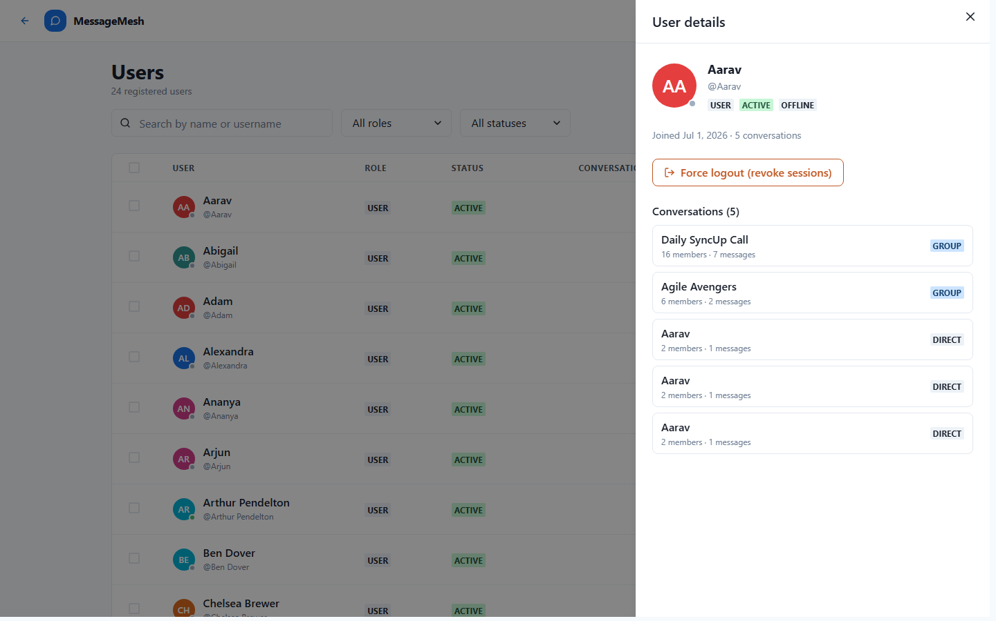
Selecting "View details" slides out a drawer with a full profile: avatar, display name, handle, and role / status / presence badges, plus the join date and total conversation count. A "Force logout (revoke sessions)" button immediately invalidates the user's active sessions. The drawer also lists the conversations the user belongs to, each with its type and member / message counts, giving the admin quick context on the account's activity.

Step 8: Bulk User Actions
Route: http://localhost:5173/admin/users
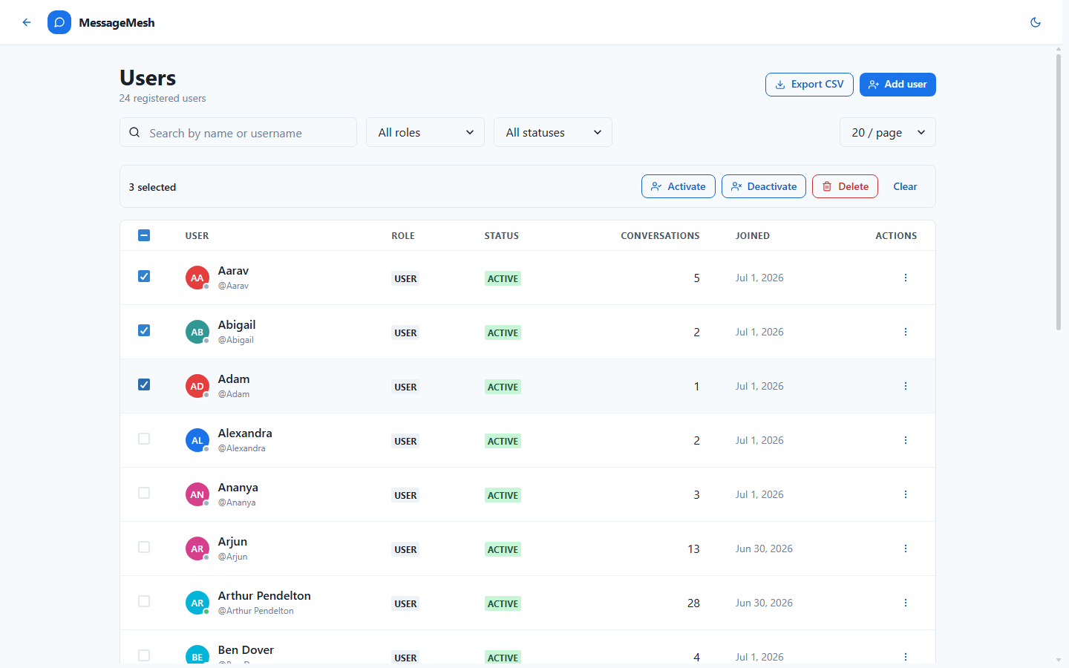
The header checkbox selects every visible user and per-row checkboxes select individual accounts. As soon as one or more rows are selected, a bulk-action bar appears showing the selection count ("3 selected") with Activate, Deactivate and Delete operations that apply to the whole selection at once, plus a Clear button to reset it. This makes large-scale account maintenance far faster than acting on users one by one.

Step 9: Manage Conversations
Route: http://localhost:5173/admin/conversations
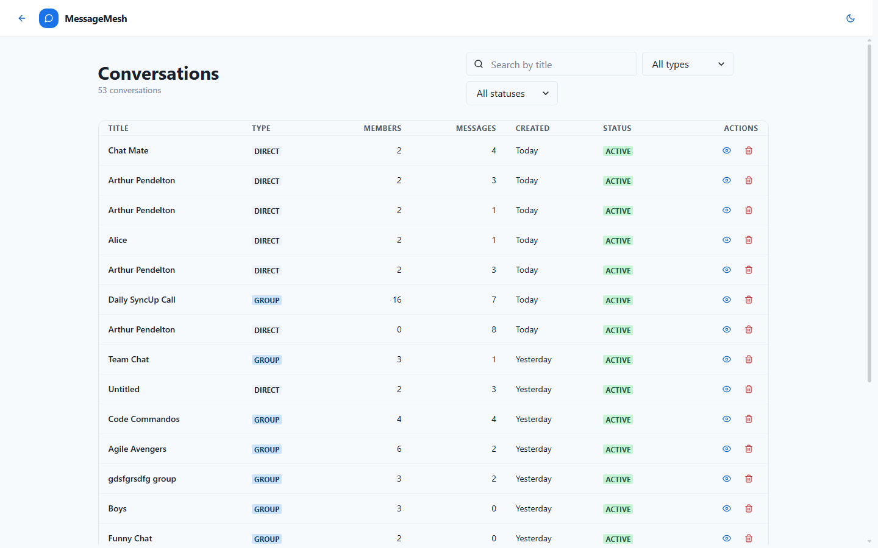
The Conversations page provides oversight of every chat on the platform. The table lists the title, type (Group or Direct), member count, message count, creation date and status (Active/Deleted). Admins search by title and narrow results with a Type filter (Group / Direct) and a Status filter (Active / Deleted). Each row offers "View messages" for moderation and "Delete conversation"; conversations already soft-deleted expose a "Restore" action so a removed chat can be brought back.

Step 10: Message Moderation
Route: http://localhost:5173/admin/conversations
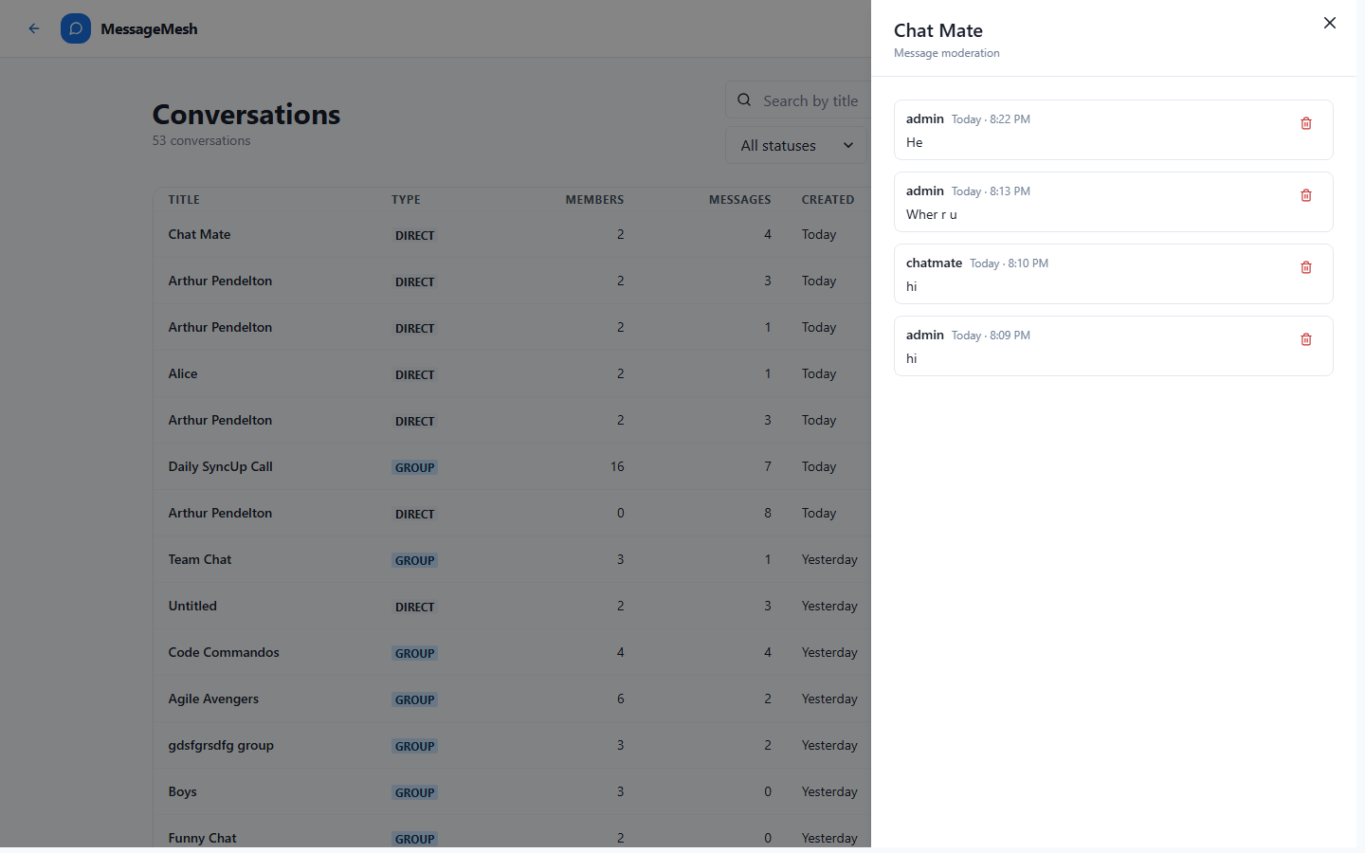
Choosing "View messages" opens a moderation drawer that streams the full message history of the selected conversation — each entry showing the sender, timestamp and content. From here an admin can delete an individual message rather than the entire conversation, enabling fine-grained moderation of specific inappropriate content while leaving the rest of the chat intact.

Step 11: Audit Log
Route: http://localhost:5173/admin/audit
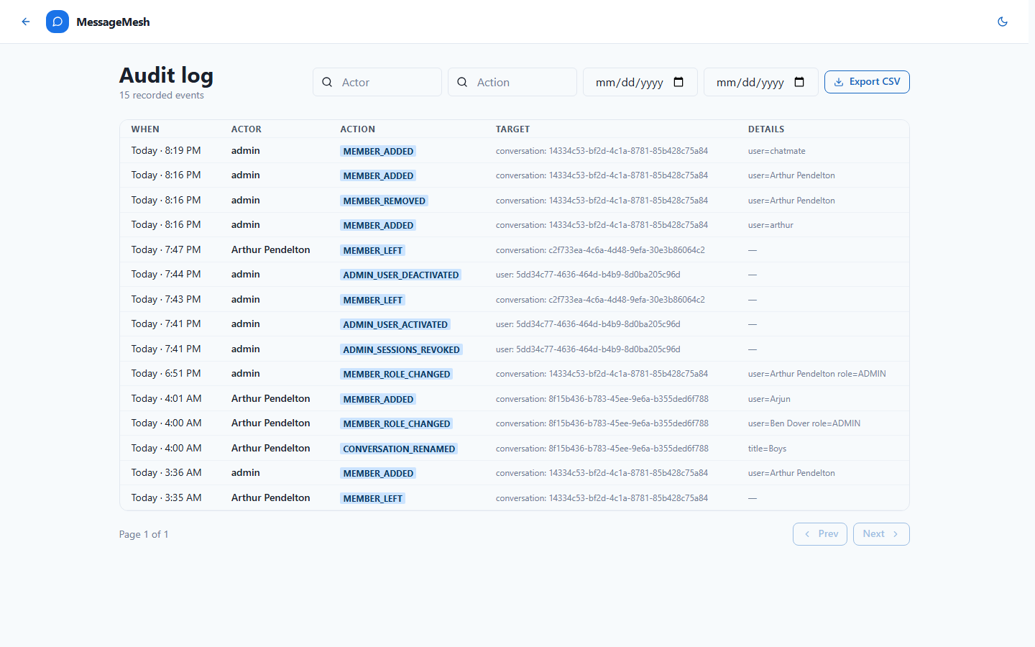
The Audit log records administrative and membership activity across the platform for accountability and compliance. Each event captures when it happened, the actor, the action (e.g. MEMBER_ROLE_CHANGED, MEMBER_ADDED, CONVERSATION_RENAMED, MEMBER_LEFT), the target entity and additional details. Admins can filter by actor, by action and by a from/to date range to investigate specific activity, and export the filtered results to CSV for offline review or reporting.

Step 12: Dark Mode
Route: http://localhost:5173/admin
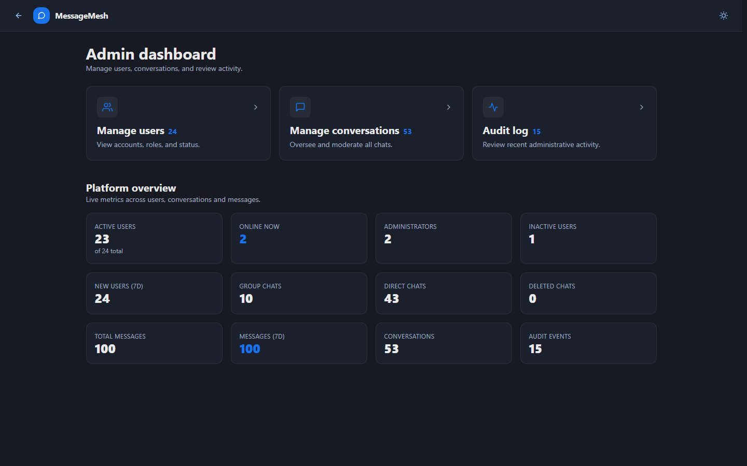
The color-mode toggle in the admin header switches the entire admin area between light and dark themes. All admin surfaces — the dashboard cards and metric tiles, tables, filters, drawers, menus and dialogs — re-style consistently while preserving layout and readability, which is useful for long moderation sessions in low-light environments.

