MessageMesh
End-to-End UI Flow Documentation
Real-Time Chat Application • Application URL: http://localhost:5173/

This document walks through the complete user journey of the MessageMesh real-time chat application, from the public landing page through authentication, browsing conversations, sending messages in real time, viewing group details, starting new conversations, switching themes and finally signing out. Each step includes a screenshot captured from the running application and an explanation of the screen.

Step 1: Welcome / Landing Page
Route: http://localhost:5173/
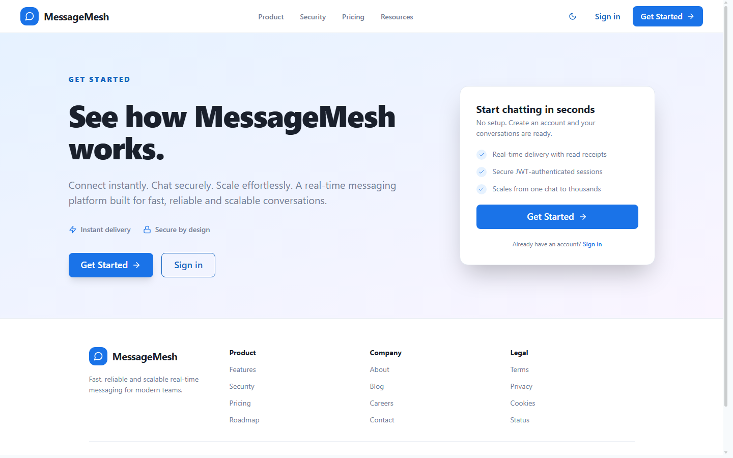
The public landing page is the entry point of MessageMesh. It presents the product value proposition ("See how MessageMesh works"), highlights key features such as instant delivery and secure-by-design messaging, and offers two primary calls to action: "Get Started" (registration) and "Sign in". A color-mode toggle and marketing navigation (Product, Security, Pricing, Resources) are available in the header.

Step 2: Sign In Page
Route: http://localhost:5173/login
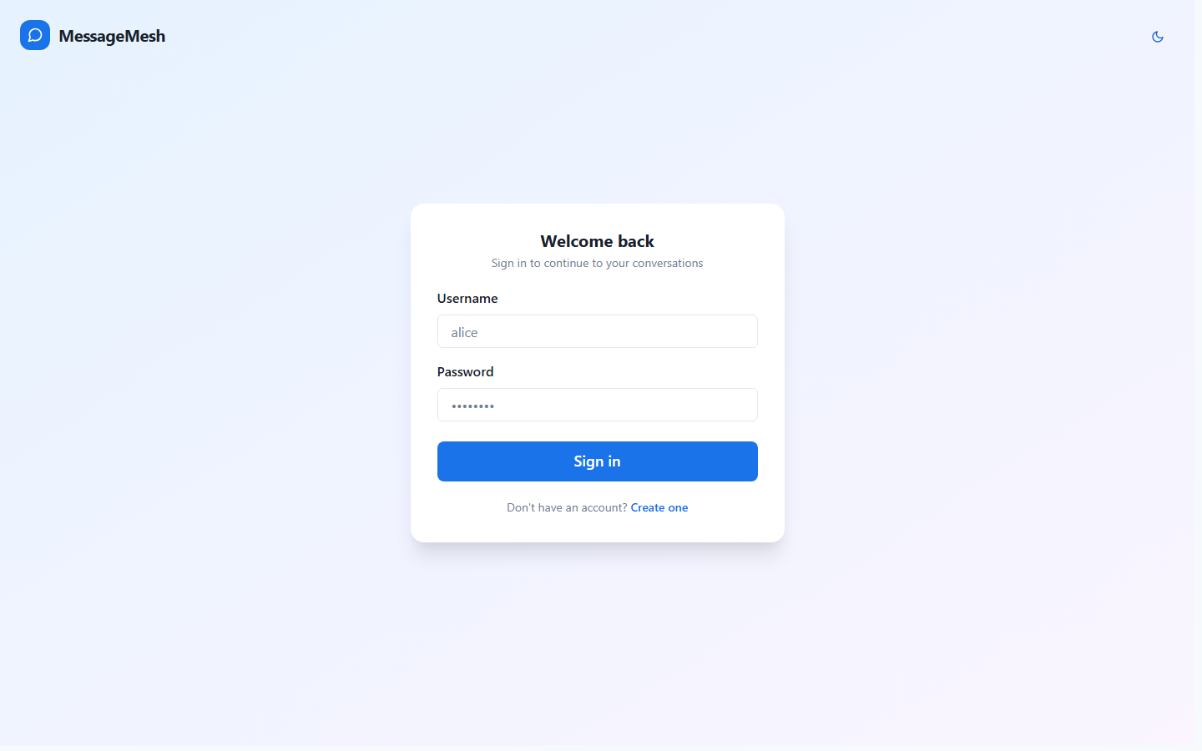
Clicking "Sign in" routes the user to the login screen. It provides a clean form with Username and Password fields, a primary "Sign in" button, and a link to create a new account. Authentication is JWT-based; on success a token is stored and used for all subsequent API and WebSocket requests.

Step 3: Entering Credentials
Route: http://localhost:5173/login
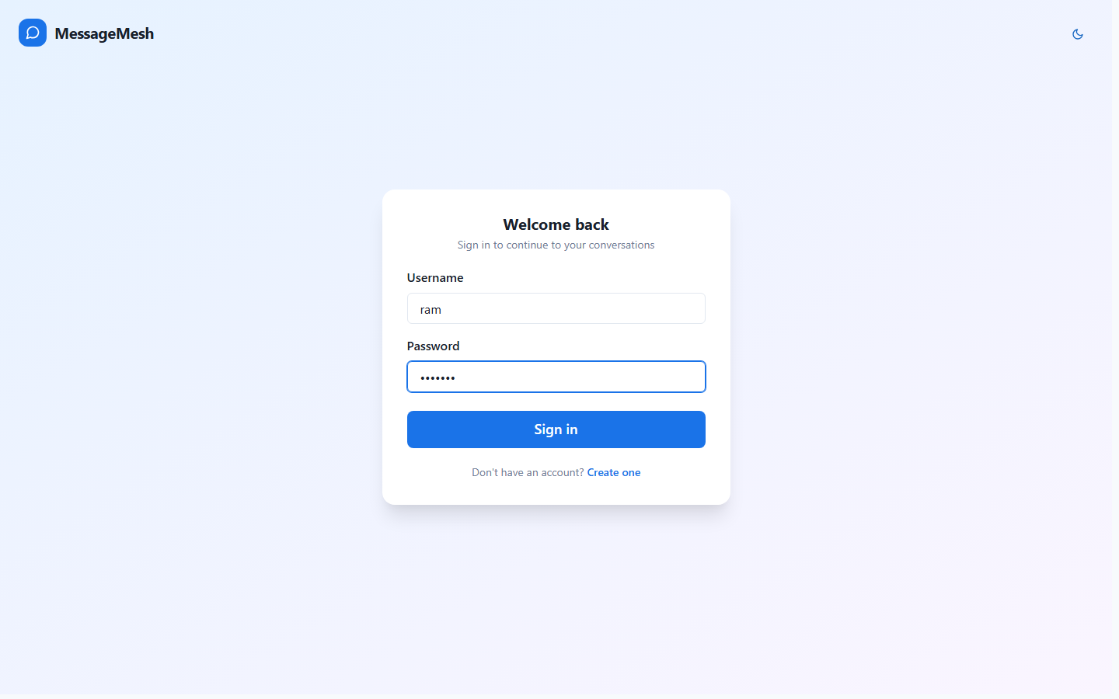
The user enters their credentials — username "ram" and the account password. The password field is masked for security. The "Sign in" button submits the credentials to the backend authentication endpoint, which returns a JWT for the standard (non-admin) user account.

Step 4: Chats Home / Conversation List
Route: http://localhost:5173/chats
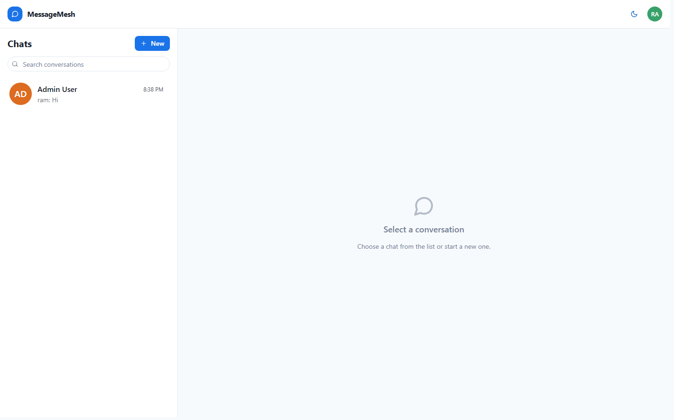
After a successful login the signed-in user ("Ram H") lands on the main chat workspace. The left sidebar lists the user's conversations with avatars, the latest message preview and a timestamp — here a direct message with "Admin User". A search box allows filtering conversations, and the "New" button starts a new chat. The right pane shows an empty state prompting the user to select or start a conversation.

Step 5: Opening a Conversation
Route: http://localhost:5173/chats/{id}
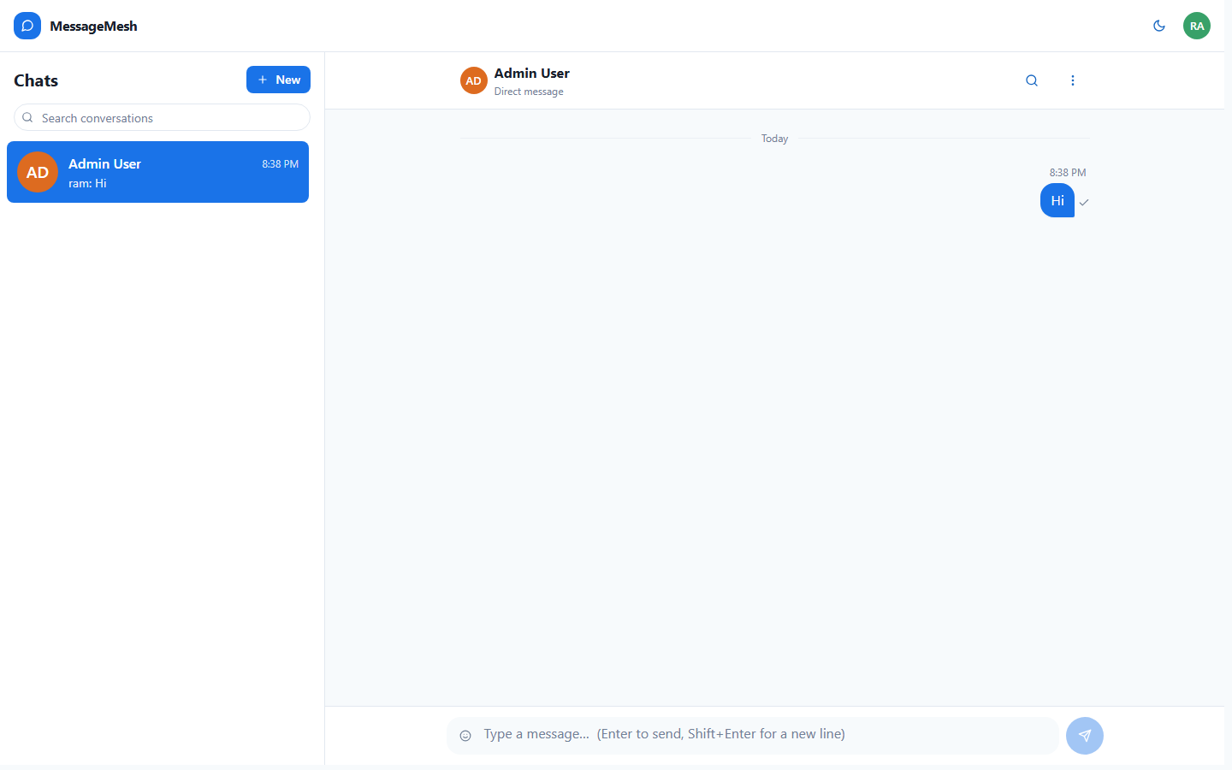
Selecting a conversation (here the direct message with "Admin User") opens the message panel. The header shows the conversation name and type (Direct message), along with actions to search messages and open conversation options. Messages are grouped by day ("Today"), display the time, and the message composer is docked at the bottom.

Step 6: Composing a Message
Route: http://localhost:5173/chats/{id}
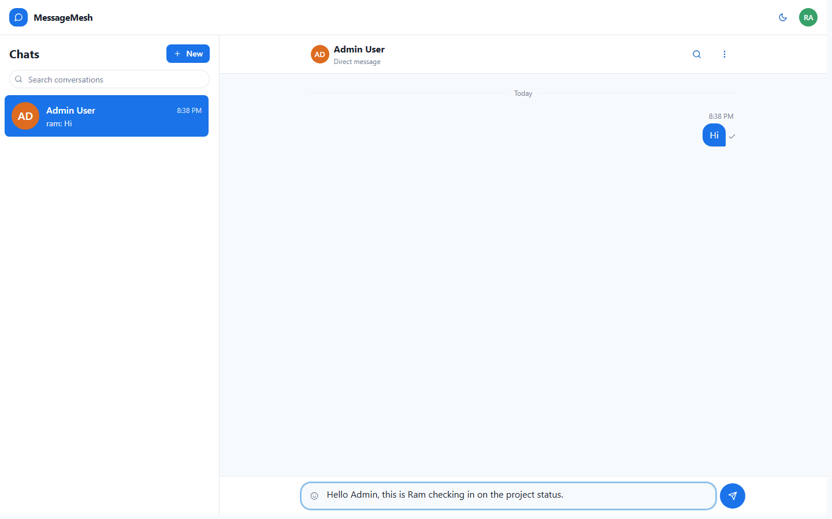
The user types a message into the composer. The input supports Enter to send and Shift+Enter for a new line. Once text is entered, the "Send" button becomes enabled.

Step 7: Message Sent (Real-Time Delivery)
Route: http://localhost:5173/chats/{id}
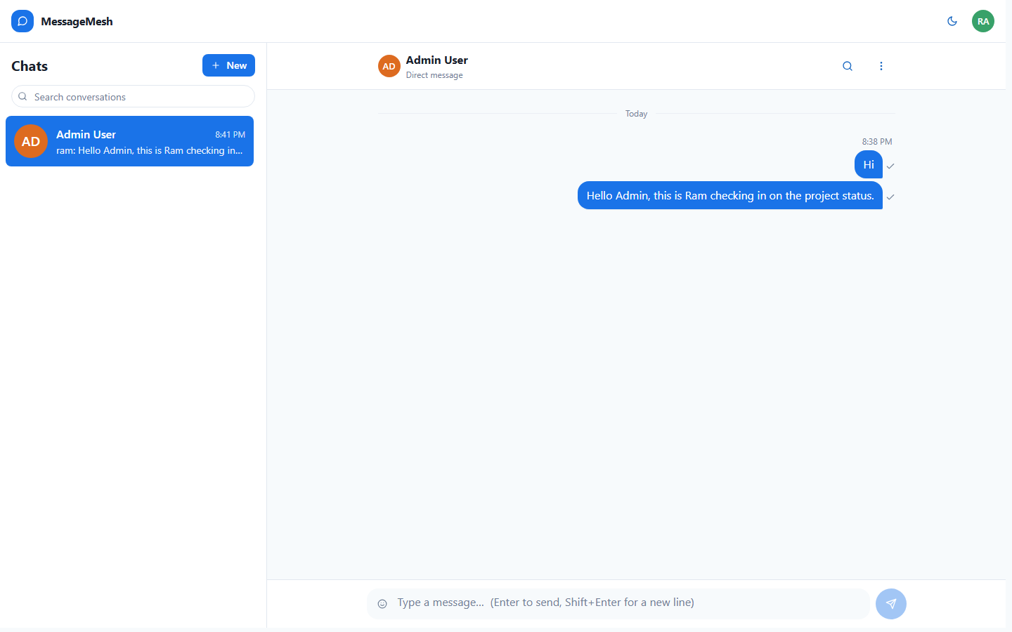
After sending, the message appears immediately in the thread aligned to the right (the current user's messages). A delivery status indicator transitions from "Sending" to "Sent". The message is delivered in real time over the WebSocket (STOMP) connection and the conversation's preview and timestamp in the sidebar update accordingly.

Step 8: Conversation Options
Route: http://localhost:5173/chats/{id}
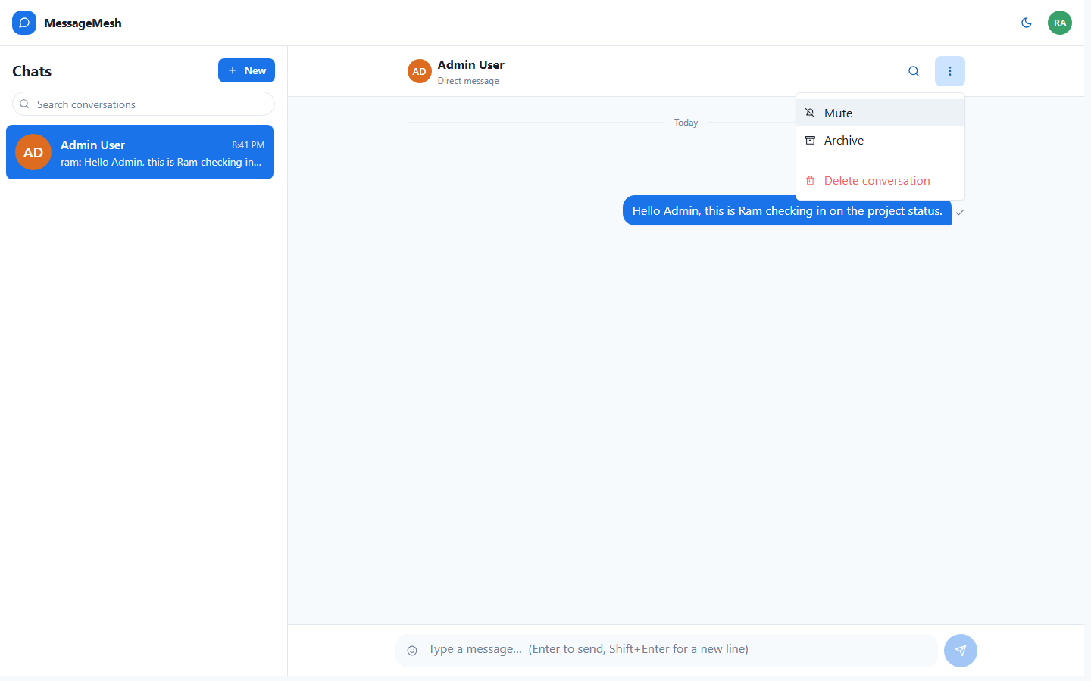
Opening the conversation options menu (the "⋯" control in the conversation header) reveals per-conversation actions available to the user: Mute to silence notifications, Archive to move the chat out of the active list, and Delete conversation to remove it. This lets the user manage and declutter their own conversations.

Step 9: New Conversation Modal
Route: http://localhost:5173/chats
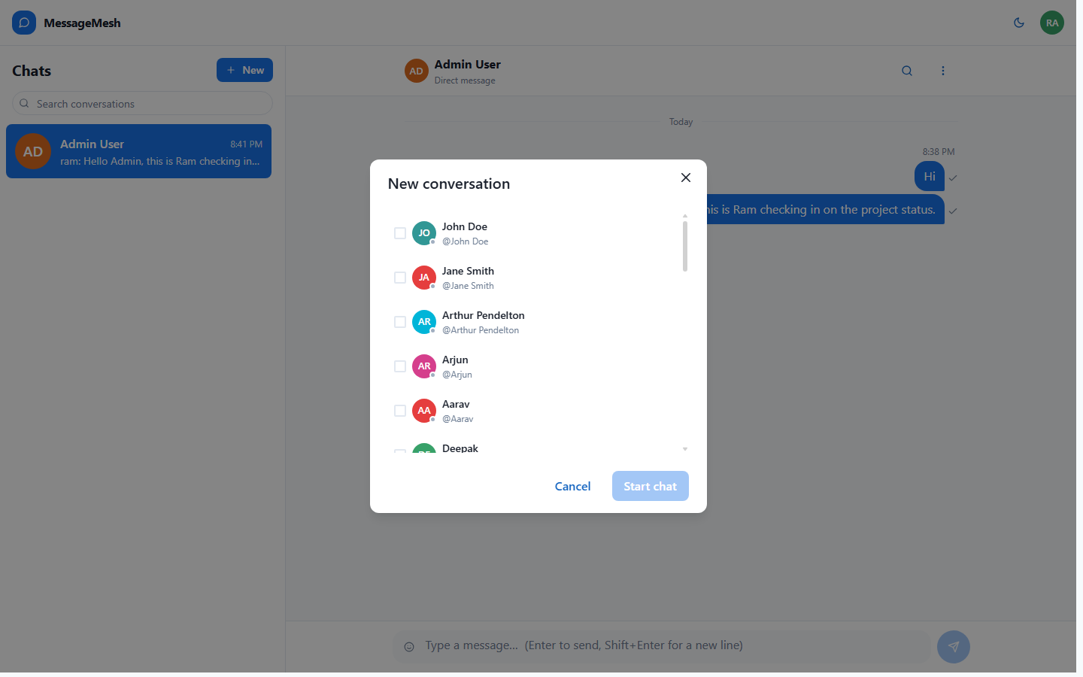
The "New" button opens the New Conversation modal. Users can select one or more people (via checkboxes) to start a one-to-one chat or create a group. Each contact is shown with an avatar, display name and handle.

Step 10: Dark Mode
Route: http://localhost:5173/chats/{id}
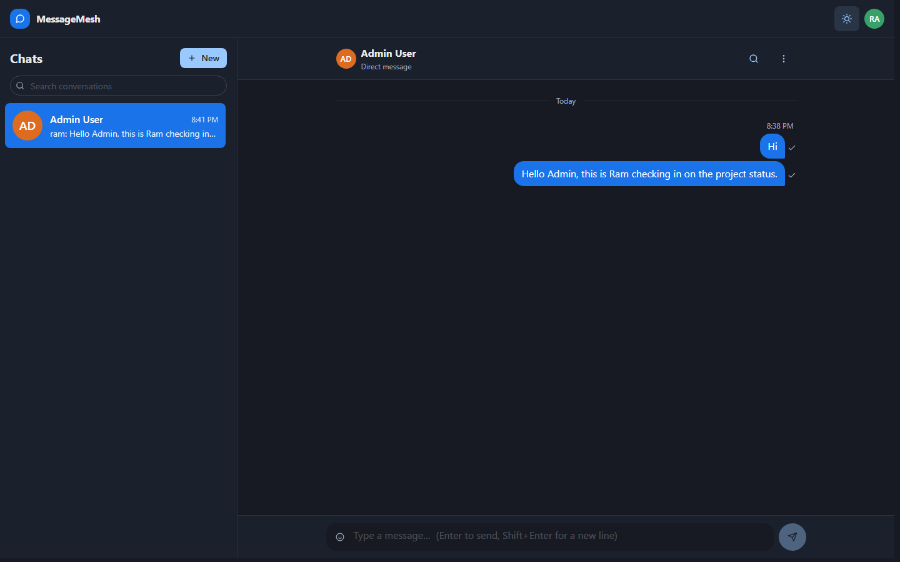
The color-mode toggle switches the entire application between light and dark themes. The dark theme re-styles the header, sidebar, message bubbles and composer while preserving layout and readability — useful for low-light environments.

Step 11: User Profile Menu / Sign Out
Route: http://localhost:5173/chats/{id}
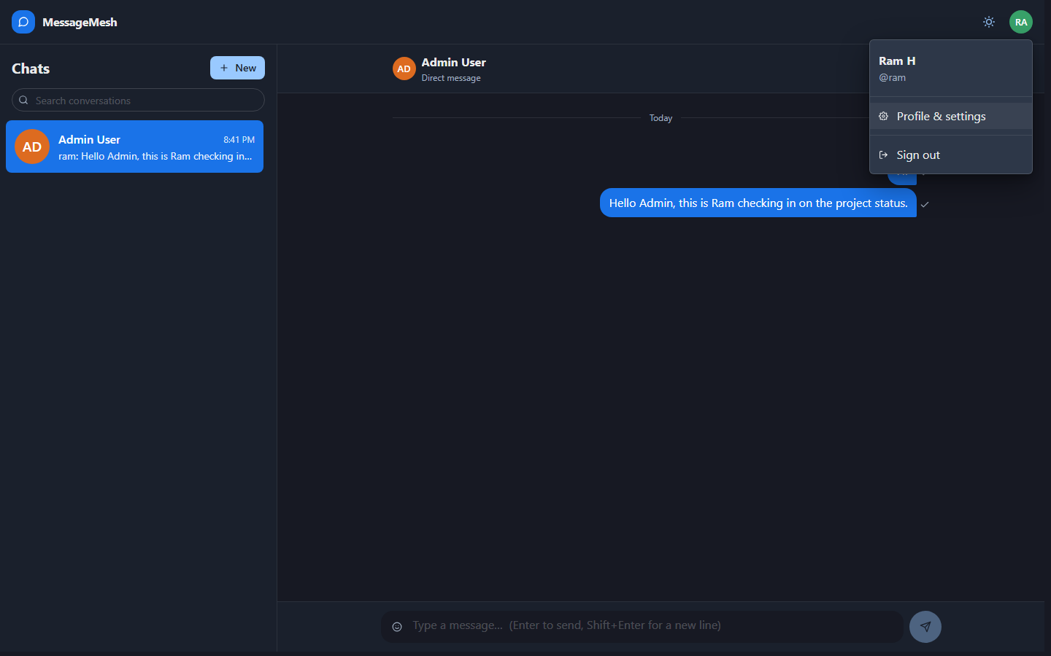
Clicking the user avatar in the top-right opens the profile menu, showing the signed-in user's name and handle along with a "Sign out" action. Signing out clears the JWT session and returns the user to the public landing/login flow, completing the end-to-end journey.

