**PROJECT Report**

**On**

**“GYM MANAGEMENT SYSTEM”**

**Submitted in the partial Fulfilment of Masters**

**in Computer Application**

**To**

**UTTARANCHAL UNIVERSITY**



**Under The Supervision Of Submitted By**

Mrs. Pratibha Pandey PRASHANT BHATT

Vaibhav Dalakoti

MCA(2020-22)

**TABLE OF CONTENT**

|  |  |  |
| --- | --- | --- |
| S.No. | Content | Page No. |
| 1. | Acknowledgement | I |
| 2. | Declaration | ii |
| 3. | Certificate of Originality | iii |
| 4. | Introduction | 7 |
| 5. | Objectives | 8 |
| 6. | Hardware and Software used | 9 |
| 7. | System Analysis   * Problem Statement * Feasibility Study * Technical feasiablity * Economical feasibility * Operational feasibility | 10-11 |
| 8. | Project Planning: Gantt Chart | 12 |
| 9. | System Design   * Use case diagram * ER diagram * Screenshots * admin * add member * Member Information * Fanatical details * DataBase * Pert Chart * Flowchart | 13-18 |
| 10. | Testing | 19-20 |
| 11. | System Security measures | 21 |
| 12. | Reports | 22 |
| 13. | Future scope and further enhancement of the Project | 23 |
| 14. | Appendices | 24 |
| 15. | Coding | 24-45 |
| 16. | Bibliography | 46 |

ACKNOWLEDGEMENT

The success and final outcome of this project required a lot of guidance and assistance from many people and I am extremely fortunate to have got this all along the completion of my project work. Whatever I have done is only due to such guidance and assistance and I would not forget to thank them.

I am very thankful to the director of UIM, Dr. Pradeep Suri and our H .O. D, Dept. of Computer Application, Dr. Sonal Sharma for her valuable suggestions & guidance.

I owe my profound gratitude to our project guide Miss. Pratibha Pandey who took keen interest on our project work and guided us all along, till the completion of our project work by providing all the necessary information for developing a good system.

I am thankful to and fortunate enough to get constant encouragement, support and guidance from all Teaching staffs of Department of computer science which helped us in successfully completing our project work.

DECLARATION

I hereby declare that the project work entitled “Gym Management System” submitted to the UIM, is a record of an original work done by me under the guidance of Ms. Pratibha Pandey, this project is submitted in the partial fulfilment of the requirements for the award of the degree of Master of Computer Application.

(Prashant Bhatt)

(Vaibhav Dalakoti)

**CERTIFICATE**

**untitled.png**

This is to certify that the project entitled “Gym Management System” submitted by “Prashant Bhatt and Vaibhav Dalakoti“ in partial fulfilment of the requirements for the award of “Master of computer application” at the “UIM” is an authentic work carried out by him under my supervision and guidance.

To the best of my knowledge, the matter embodied in the project has not been submitted to any other university/institute for the award of any degree or diploma.

Under the guidance of:

Ms. Pratibha Pandey

Dept. of computer application

Uttaranchal University, Dehradun

1. INTRODUCTION

“GYM MANAGEMENT SYSTEM” project is designed to facilitate a gymming and fitness center to automate its operations of keeping records and store them in form of a large and user friendly database further facilitating easy access to the personnel.

Owner can keep records of members, their payment. Our system provides a lots of functions such data entry of customer, keeping records of all the things about customer’s dees, plan and physical fitness which help to provide good quality of services to customer from Gym owners

The main purpose of this project is to automate gym or a fitness centre. It is a user-friendly application. That helps the Gym Owner to maintain the track of various things like,

* Add Member
* Update member
* Delete member
* Fee information

1. **OBJECTIVES**

* The main objective of this project is to develop software that facilitates the data storage, data maintenance and its retrieval for the gym in an igneous way.
* To store the record of the customers, the staff that has privileges to access, modify, delete any record and finally the service, gym provides to its customers.
* Also, only the staff has the privilege to access any database and make the required changes, if necessary.
* To develop easy-to-use software which handles the customer-staff relationship in an effective manner.
* To develop a user-friendly system that requires minimal user training. Most of the features and function are similar to those on any windows platform.

1. **SYSTEM ANALYSIS**

## Existing System

The existing system was a manual system. This manual system had piles of the paper work to be maintained to track the record of cash. Due to this a lot of the time and energy was been utilized and this led to wastage of important resources.

* Time consuming.
* Processing speed of the software is not so much good to operate fast.
* Sometimes the system hangs when work load is more.
* Limited space for storing the information
* Processing speed of the software is not so much good to operate fast.

## Proposed System

“GYM MANAGEMENT SYSTEM” is the software that stores all records of members. It is a user friendly and fast working software. All the data is stored in database and will be only accessible by admin.

* Error reduction.
* Improve reporting.
* Flexibility.
* Improve resource user.
* Reduction in man power.
* Administrator controls the entire system.

**3.1 Identification of need:**

There are many health advantages of going to the gym, yoga poses as well as meditation. But keeping records of all members is not an easy task.

Thus there we need a user-friendly and secured software to keep track of all members of the gym and their details.

**3.2 Preliminary Study:**

1. **Convenience.** Convenience is the biggest perk. And when it comes about storing a lot of data than it is good to have a software like this.
2. **More secured.** Many times, people don’t care for their personal details whom the are sharing with but this software gives a secured environment to store personal details of the member

**3.3 FEASIBILITY STUDY**

By the investigation, I have identified the need, problems and requirements. So my next step was to determine exactly what the proposed system is to do by defining its expected performance. This kind of work can be carried out in the Feasibility Study.

In the conduct of the feasibility study, I have gone through followings distinct, but inter-related types of feasibility. These are:

### **Technical feasibility**

This software will be developed using java and SQL Server. As we require some time to learn all these technologies, All these technologies are easy to learn and can develop system very rapidly. After developing and deploying the system, student can easily use it.

### **Economic feasibility**

As existing system is manual, where it is expensive to maintain, up to date, and available on time. But proposed system will be computerized, so we can overcome all limitations of existing system. Also with this new system insertion, deletion, and modification of various data will be easier to handle.

This website will reduce the paperwork. And quality of data will be improved.

So keeping all above mentioned benefits and comparing with various expenditures of resources, we conclude that proposed system is economical feasible.

## 3.4 PROJECT PLANNING:-

* Firstly we analyzed all possible sectors that are in the GYM MANAGEMENT SYSTEM software.
* Then we understand the needs and requirement for the development of such a system that could make this process faster, and easier to manage.
* According to the needs of the system, we chose the language or platform for the development of this system which we found out that java, My SQL Server is suitable for such project
* Then we decided the modules and sub-modules required for our system and the work to be accomplished by each module.
* We designed the database, tables and its attributes and designed back-end of the system in MY SQL Server.

## 3.5 PROJECT SCHEDULING

### **3.5.1. Pert chart:-**

Analysis

Requirement and Specification

Feasibility Study

13

Detail

Implementation

Unit

System

Design

Testing

Coding

Sys*t*em Design

Normal Path (Black Line)

Critical Path (Red Line)

Figure – 3.5.1

### **3.5.2. Gantt chart:-**

We estimated the number of days for each task as follows:

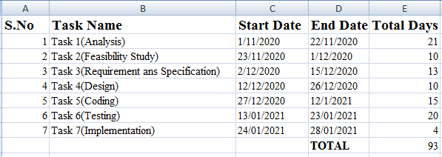**Table:-**

Fig – 3.5.2(i)

**3.5.3. Pivot Chart:-**

### 

Fig – 3.5.3(ii)

**3.6** **SOFTWARE REQUIREMENTS SPECIFICATION**

**Introduction**

The following subsections of the SRS document provide an overview of three tire SRS.

1. **Purpose**

The purpose of the project is to provide facility to the admin to help in managing tasks conveniently and faster.

**B. Scope**

This software will be used by admin as well as Member can view their record easily from the software.

**C. Benefits**

This application reduces the complexity, increase efficiency, increases accessibility and saving time.

### **3.6.1 Functional Requirement: -**

For this project we need the following functional requirement to be fulfilled:

* Login form that will allow the authorized user to access the software.
* Add user details to store members details in database.
* A payment information that will show who has paid and who doesn’t.

### **3.6.2 Non-Functional Requirement**

* The software needs to be user friendly and easy to access so that the end user can easily use this software.
* The software needs to be secure by implementing login using user ID and Password.
* The software needs to be portable so that it can be run on any system.

## Software Engineering Paradigm applied: -

* The software engineering paradigm applied in the system is the Iterative waterfall model.
* Firstly, the requirement of the system was analyzed, what was needed to build the proposed system, what were the initial requirements of the system was determined.
* Like, we need software that can be accessed easily on any system.
* All the requirements were already clearly specified what all functionalities needed to be provided like manage product and billing for an event.
* Using Iterative waterfall model a schedule can be set with deadlines for each stage of development like Information Gathering, Analysis, system design, coding, etc. and a system can proceed through the development process model phases one by one. So, this would help in the development of the system in the scheduled time.
* Then the system was designed on the basis of the requirement determined in the analysis phase.
* The design includes the different menus and options that will be displayed to the admin for performing different tasks.
* The Admin section of the project needs to provide the facility to show the record of user and payment.
* Then we designed the database and the front end.

**TOOLS/PLATFORM USED**

## Hardware being used:

* **RAM**: 4 GB RAM
* **PROCESSOR**: Intel Core i3
* **HARD DISK**: 1TB Hard Disk

## Software being used:

* **OPERATING SYSTEM**: WINDOWS 8/10
* **FRONT END**: JAVA
* **BACK END/ DATABASE**: MY SQL

## Hardware minimum requirement:

* **RAM**: 4 GB RAM
* **PROCESSOR**: Intel® Pentium ® Dual CPU E2180
* **HARD DISK**: 160GB Hard Disk

## Software minimum requirement:

* **OPERATING SYSTEM**: WINDOWS 10 Ultimate
* **Software : - NETBEANS 8.2**.

### **3.8. Data Models**

**3.8.1. UML**

### **Use Case Diagram: -**

### 

Figure – 3.8(i)

**4. SYSTEM DESIGN**

* 1. **Modularization details:**

**4.1.1. Admin:** -

* Login
* Overview
* Get Member Info.
* Fanatical Detail.
* Update Member
* Delete Member
* **Admin login page: -**

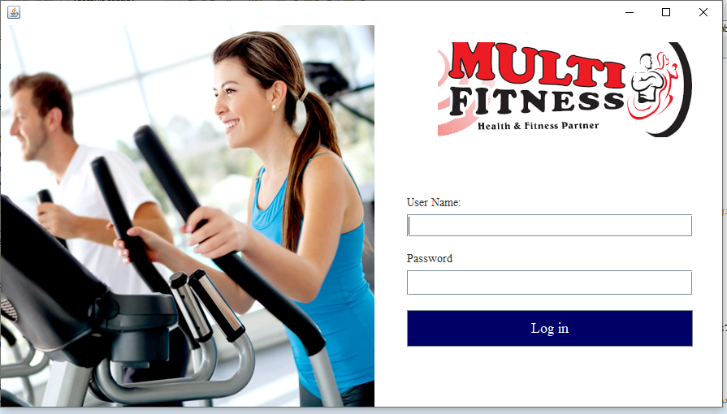

* **Home page: -**

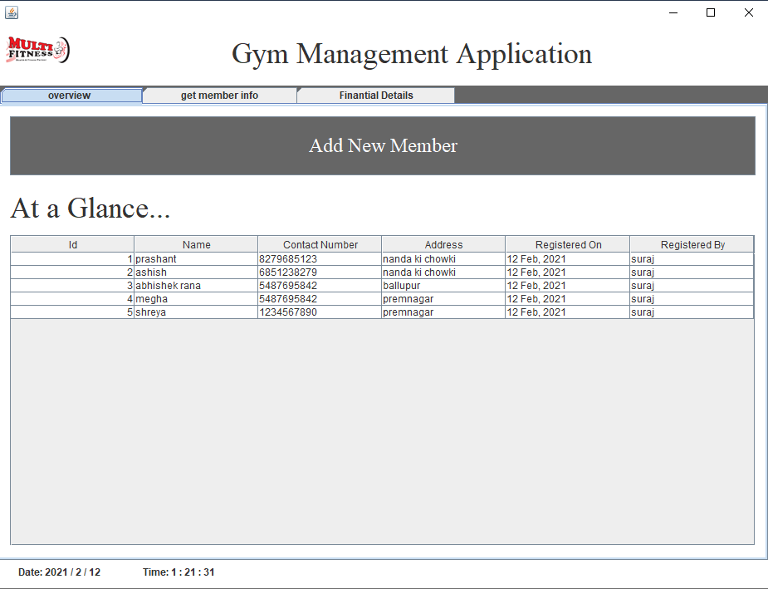

* **Add new member page: -**

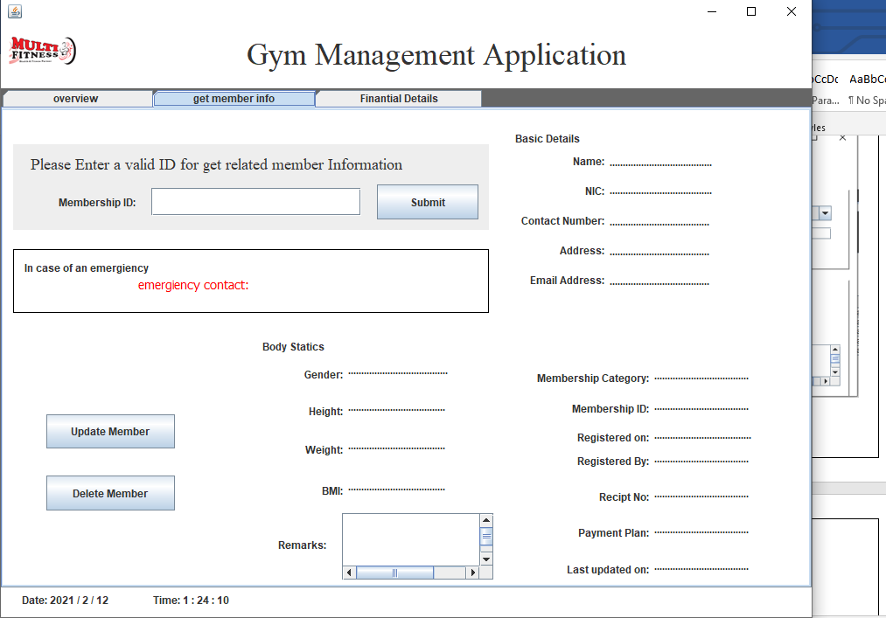

* **Get member info page: -**

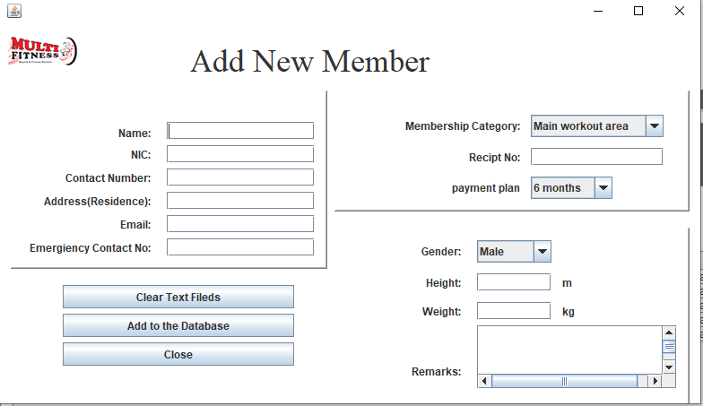

* 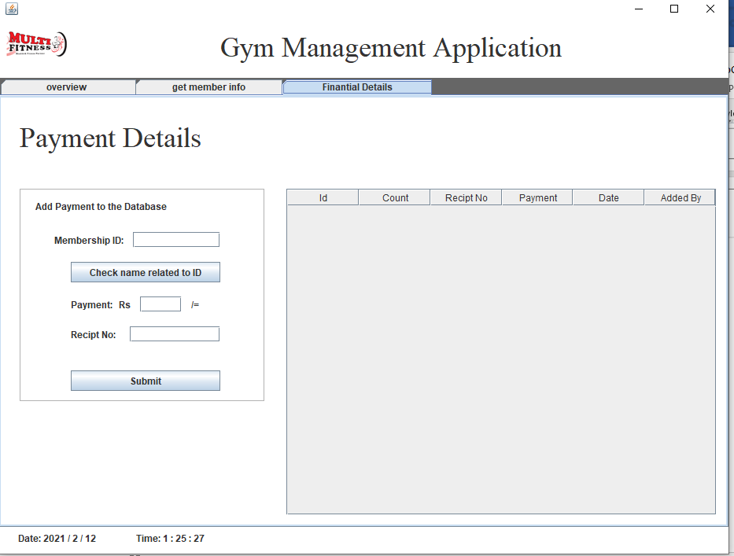**Payment page:**
* **Update Member Detail**

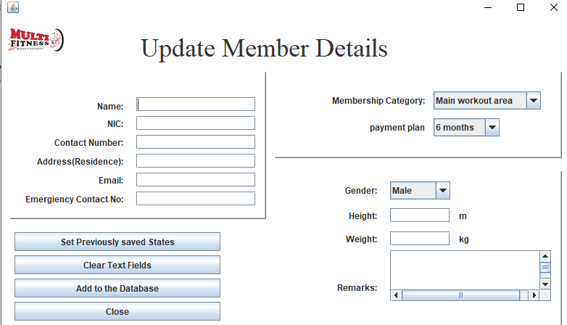

* **Delete Member Detail**

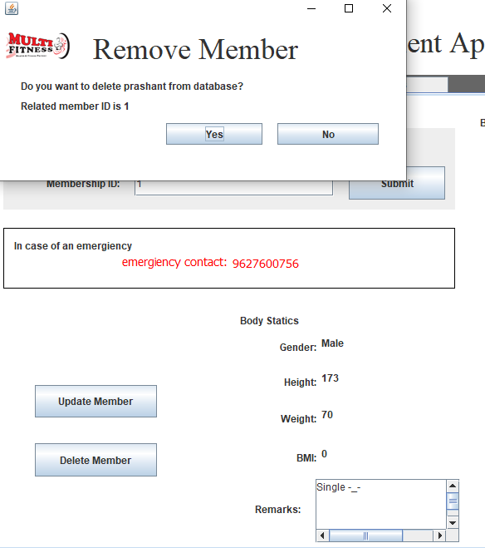

**4.1.3. Database:**

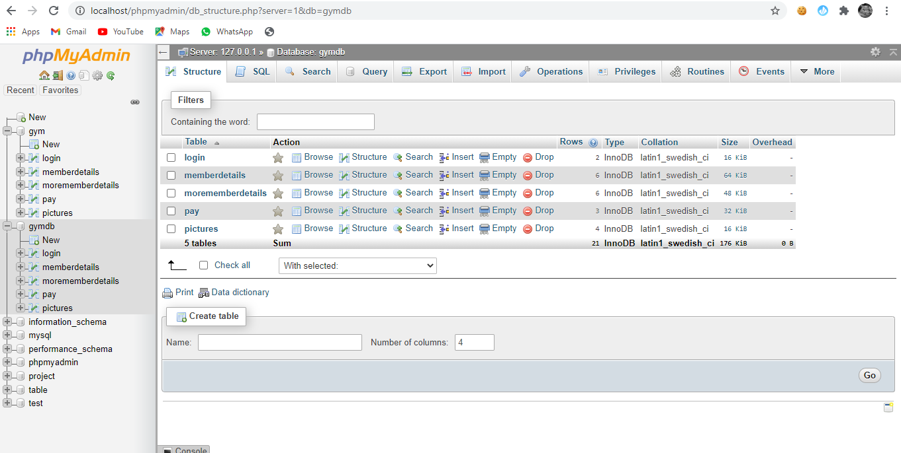

* Admin Login

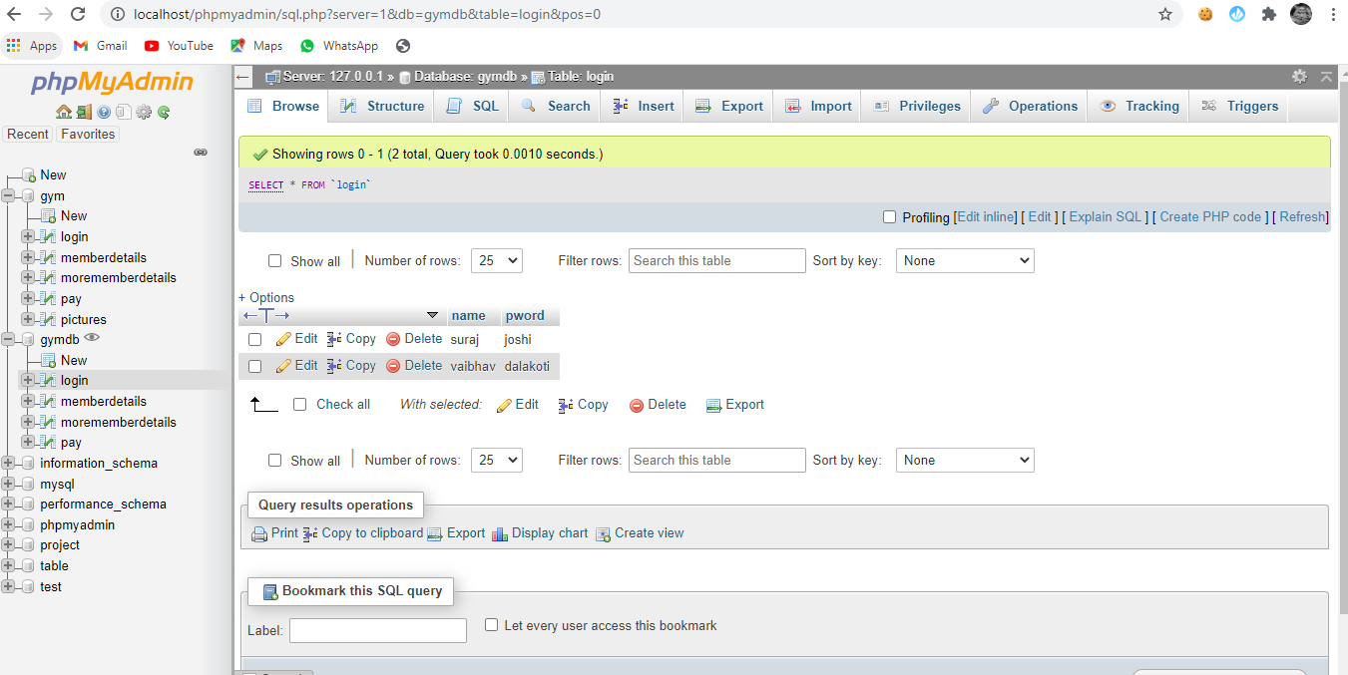

* Member Details

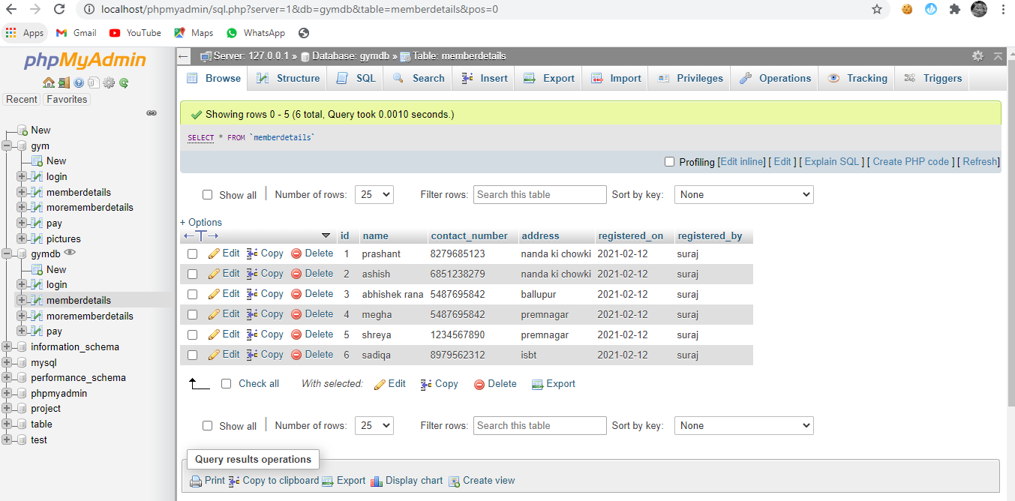

* More Member Details

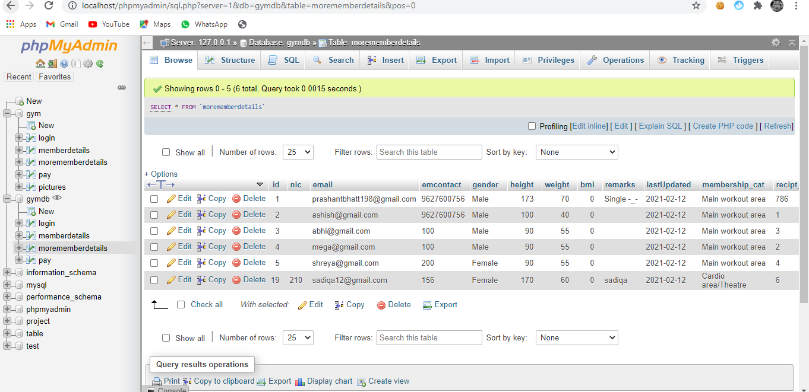

* Pay

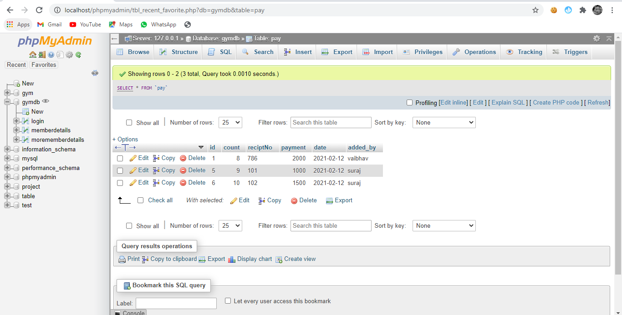

**ER diagram**

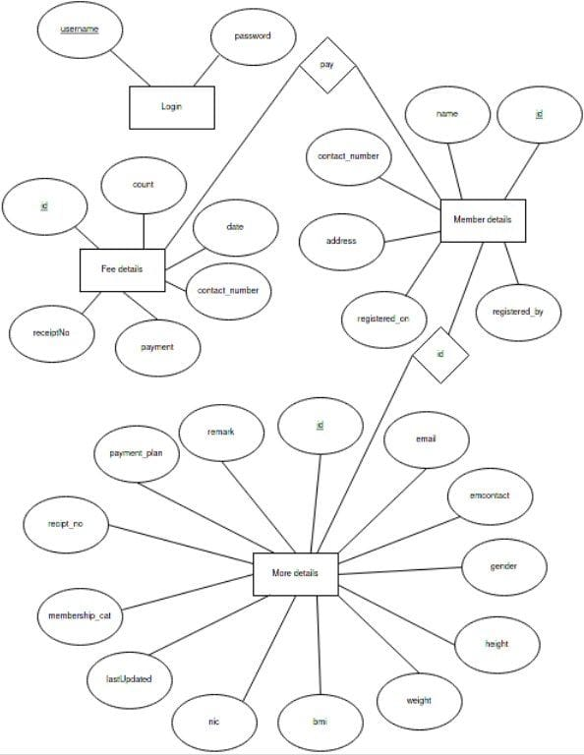

**Testing**

1. **Test case:1**

When admin forgets his/her username and password

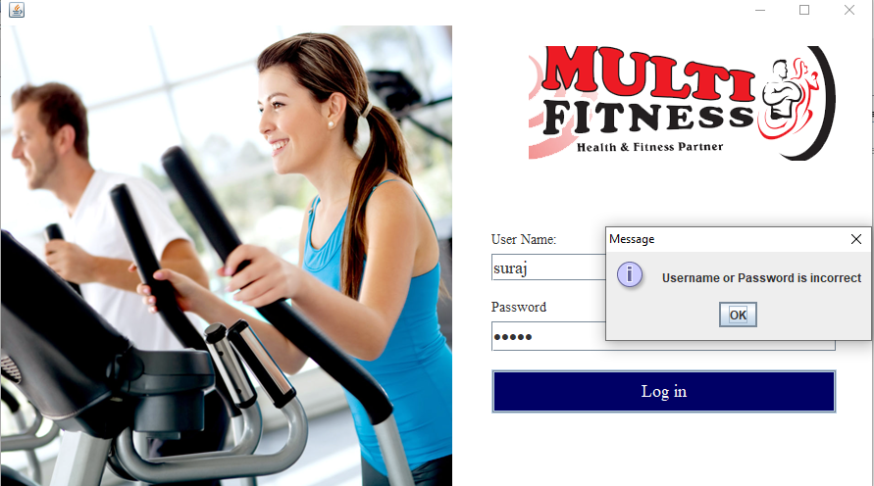

When username and password is correct

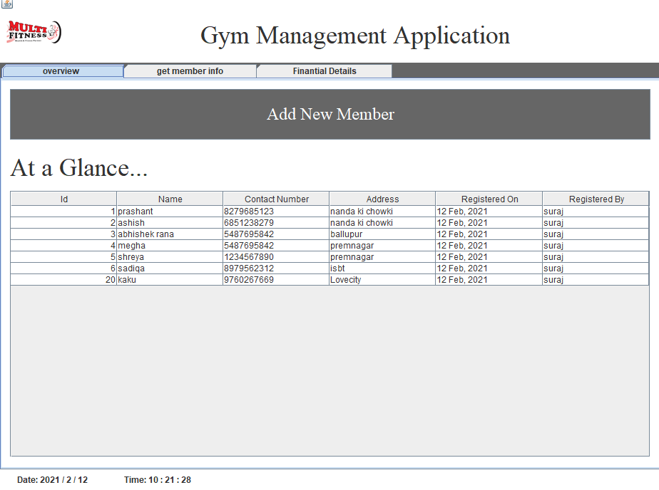

**Test case: 2**

When Membership id is incorrect

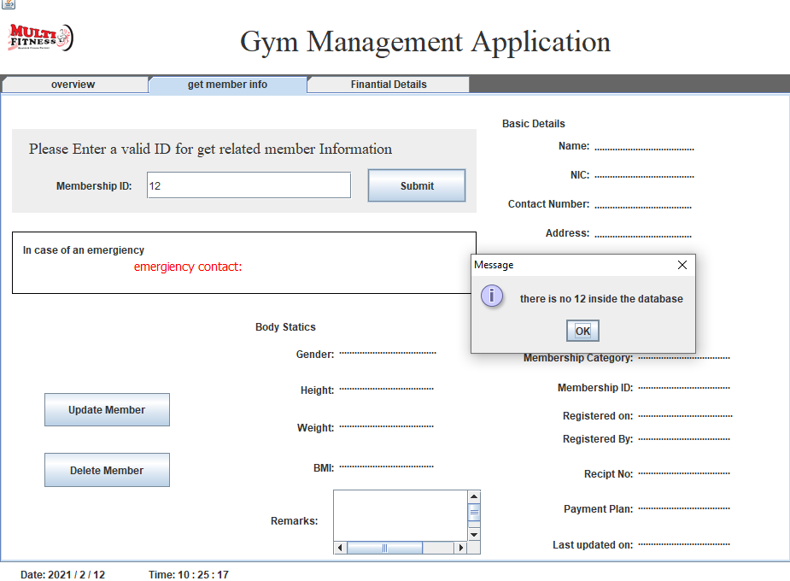

When membership id is correct

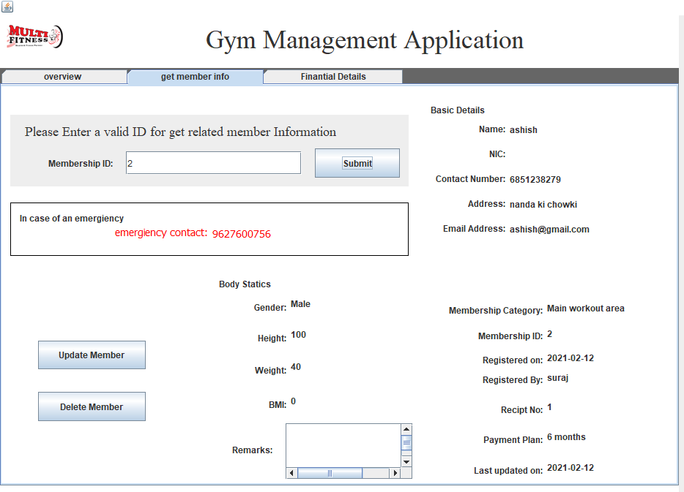

**Future scope**

This system provides user the facility to make all the data saving process easy. Update, Add, Delete etc. This system provides to add information or any kind of details from file. System avoid mistakes & error in maintaining the details of members.

The main aim of our system is to provide a paper-less working of the hospital up to 90 %. It also aims at providing low cost, reliable, automation of exiting system i.e. manual system. The system also provides a security of data at every level of user system interaction.

All the details of suppliers and maintenance details of the equipment are secured stored in database as we have used MS Access to store our data. It has a Login form by which the authority to access the system will be provide only to the user no other person can access the system till the password and username is known to him/her

**COST ESTIMATION MODEL**

In Cocomo model two attributes are required:

1. Effort
2. Tdev(time development) First of all we calculate the Effort.

In our project we have estimated 5 KLOC(kilobyte line of code), two students are working on the project so our estimated cost would be

Effort (E) = a*(KLOC)*a2(where the value of a1 and a2 are constant i.e. 2.4 and 1.05) E=2.4*(5)*1.05

E=12.6

Now we have to calculate Tdev

Tdev(t) = b1*(E)*b2(where the value of b1 is 2.5 and b2 is 0.38) T=2.5*(12.6)*0.38

T=11.97

Now finally we calculate the estimated cost i.e. T * Cost of one employee Estimated Cost = T * Cost of one employee

= 11.97 * 1000

= =11,970

**APPENDICES:-**

**Coding-**

package gym;

import static com.sun.javafx.tk.Toolkit.getToolkit;

import java.awt.HeadlessException;

import java.awt.Image;

import static java.lang.Integer.parseInt;

import static java.lang.Thread.sleep;

import java.sql.Connection;

import java.sql.PreparedStatement;

import java.sql.ResultSet;

import java.sql.SQLException;

import java.sql.Statement;

import java.util.Calendar;

import java.util.GregorianCalendar;

import java.util.logging.Level;

import java.util.logging.Logger;

import javax.swing.ImageIcon;

import javax.swing.JOptionPane;

public class Home extends javax.swing.JFrame {

/**

* Creates new form Home

*/

public Home() {

initComponents();

CurrentDate();

}

static String SearchKey;

static boolean yes;

static String[] results = new String[18];

public void CurrentDate(){

Thread c = new Thread(){

public void run(){

for(;;){

Calendar cal = new GregorianCalendar();

int month = cal.get(Calendar.MONTH);

int year = cal.get(Calendar.YEAR);

int day =cal.get(Calendar.DAY_OF_MONTH);

String date = ("Date: "+year+" / "+(month+1)+" / "+day);

showDate.setText(date);

int s = cal.get(Calendar.SECOND);

int m = cal.get(Calendar.MINUTE);

int h = cal.get(Calendar.HOUR);

String time = ("Time: "+h+" : "+m+" : "+s);

showTime.setText(time);

try {

sleep(1000);

} catch (InterruptedException ex) {

Logger.getLogger(Gym.class.getName()).log(Level.SEVERE, null, ex);

}

}

}

};

c.start();

}

@SuppressWarnings("unchecked")

// <editor-fold defaultstate="collapsed" desc="Generated Code">

private void initComponents() {

bindingGroup = new org.jdesktop.beansbinding.BindingGroup();

entityManager = java.beans.Beans.isDesignTime() ? null : javax.persistence.Persistence.createEntityManagerFactory("gymdb?zeroDateTimeBehavior=convertToNullPU").createEntityManager();

memberdetailsQuery = java.beans.Beans.isDesignTime() ? null : entityManager.createQuery("SELECT m FROM Memberdetails m");

memberdetailsList = java.beans.Beans.isDesignTime() ? java.util.Collections.emptyList() : memberdetailsQuery.getResultList();

memberdetailsQuery1 = java.beans.Beans.isDesignTime() ? null : entityManager.createQuery("SELECT m FROM Memberdetails m");

memberdetailsList1 = java.beans.Beans.isDesignTime() ? java.util.Collections.emptyList() : memberdetailsQuery1.getResultList();

payQuery = java.beans.Beans.isDesignTime() ? null : entityManager.createQuery("SELECT p FROM Pay p");

payList = java.beans.Beans.isDesignTime() ? java.util.Collections.emptyList() : payQuery.getResultList();

jPanel1 = new javax.swing.JPanel();

jPanel2 = new javax.swing.JPanel();

jLabel18 = new javax.swing.JLabel();

jLabel33 = new javax.swing.JLabel();

jPanel4 = new javax.swing.JPanel();

jTabbedPane1 = new javax.swing.JTabbedPane();

jPanel5 = new javax.swing.JPanel();

jScrollPane1 = new javax.swing.JScrollPane();

jTable2 = new javax.swing.JTable();

addMemBtn = new javax.swing.JButton();

jLabel35 = new javax.swing.JLabel();

jPanel6 = new javax.swing.JPanel();

jPanel7 = new javax.swing.JPanel();

jLabel2 = new javax.swing.JLabel();

idS = new javax.swing.JTextField();

submitS = new javax.swing.JButton();

jLabel34 = new javax.swing.JLabel();

jPanel8 = new javax.swing.JPanel();

jLabel1 = new javax.swing.JLabel();

jLabel3 = new javax.swing.JLabel();

jLabel4 = new javax.swing.JLabel();

jLabel5 = new javax.swing.JLabel();

jLabel6 = new javax.swing.JLabel();

lname = new javax.swing.JLabel();

lnic = new javax.swing.JLabel();

lcon = new javax.swing.JLabel();

ladd = new javax.swing.JLabel();

lemail = new javax.swing.JLabel();

jLabel7 = new javax.swing.JLabel();

jPanel10 = new javax.swing.JPanel();

jLabel8 = new javax.swing.JLabel();

jLabel9 = new javax.swing.JLabel();

jLabel10 = new javax.swing.JLabel();

em = new javax.swing.JLabel();

jPanel11 = new javax.swing.JPanel();

jLabel11 = new javax.swing.JLabel();

jLabel12 = new javax.swing.JLabel();

jLabel13 = new javax.swing.JLabel();

jLabel14 = new javax.swing.JLabel();

jLabel15 = new javax.swing.JLabel();

jLabel16 = new javax.swing.JLabel();

jScrollPane2 = new javax.swing.JScrollPane();

remarks = new javax.swing.JTextArea();

h = new javax.swing.JLabel();

gen = new javax.swing.JLabel();

w = new javax.swing.JLabel();

bmi = new javax.swing.JLabel();

jPanel12 = new javax.swing.JPanel();

jLabel17 = new javax.swing.JLabel();

memcat = new javax.swing.JLabel();

jLabel19 = new javax.swing.JLabel();

id = new javax.swing.JLabel();

jLabel21 = new javax.swing.JLabel();

regOn = new javax.swing.JLabel();

jLabel23 = new javax.swing.JLabel();

regBy = new javax.swing.JLabel();

jLabel25 = new javax.swing.JLabel();

reciptNo = new javax.swing.JLabel();

jLabel27 = new javax.swing.JLabel();

paymentPlan = new javax.swing.JLabel();

jLabel29 = new javax.swing.JLabel();

lastUpdated = new javax.swing.JLabel();

btnDelete = new javax.swing.JButton();

btnUpdate = new javax.swing.JButton();

jPanel9 = new javax.swing.JPanel();

jPanel13 = new javax.swing.JPanel();

jPanel14 = new javax.swing.JPanel();

jLabel20 = new javax.swing.JLabel();

jLabel22 = new javax.swing.JLabel();

ida = new javax.swing.JTextField();

jLabel24 = new javax.swing.JLabel();

jButton1 = new javax.swing.JButton();

paymenta = new javax.swing.JTextField();

jLabel26 = new javax.swing.JLabel();

jLabel28 = new javax.swing.JLabel();

jLabel30 = new javax.swing.JLabel();

recipta = new javax.swing.JTextField();

jButton2 = new javax.swing.JButton();

jScrollPane3 = new javax.swing.JScrollPane();

jTable1 = new javax.swing.JTable();

jLabel31 = new javax.swing.JLabel();

jLabel32 = new javax.swing.JLabel();

jPanel3 = new javax.swing.JPanel();

showDate = new javax.swing.JLabel();

showTime = new javax.swing.JLabel();

setDefaultCloseOperation(javax.swing.WindowConstants.EXIT_ON_CLOSE);

jPanel1.setBackground(new java.awt.Color(255, 255, 255));

jPanel2.setBackground(new java.awt.Color(255, 255, 255));

jLabel18.setIcon(new javax.swing.ImageIcon(getClass().getResource("/gym/logoSmall.png"))); // NOI18N

jLabel33.setFont(new java.awt.Font("Times New Roman", 0, 36)); // NOI18N

jLabel33.setText("Gym Management Application");

javax.swing.GroupLayout jPanel2Layout = new javax.swing.GroupLayout(jPanel2);

jPanel2.setLayout(jPanel2Layout);

jPanel2Layout.setHorizontalGroup(

jPanel2Layout.createParallelGroup(javax.swing.GroupLayout.Alignment.LEADING)

.addGroup(jPanel2Layout.createSequentialGroup()

.addComponent(jLabel18, javax.swing.GroupLayout.PREFERRED_SIZE, 108, javax.swing.GroupLayout.PREFERRED_SIZE)

.addGap(173, 173, 173)

.addComponent(jLabel33)

.addContainerGap(212, Short.MAX_VALUE))

);

jPanel2Layout.setVerticalGroup(

jPanel2Layout.createParallelGroup(javax.swing.GroupLayout.Alignment.LEADING)

.addGroup(jPanel2Layout.createSequentialGroup()

.addComponent(jLabel18, javax.swing.GroupLayout.PREFERRED_SIZE, 61, javax.swing.GroupLayout.PREFERRED_SIZE)

.addGap(0, 0, Short.MAX_VALUE))

.addGroup(jPanel2Layout.createSequentialGroup()

.addContainerGap()

.addComponent(jLabel33)

.addContainerGap(javax.swing.GroupLayout.DEFAULT_SIZE, Short.MAX_VALUE))

);

jPanel4.setBackground(new java.awt.Color(102, 102, 102));

jPanel5.setBackground(new java.awt.Color(255, 255, 255));

org.jdesktop.swingbinding.JTableBinding jTableBinding = org.jdesktop.swingbinding.SwingBindings.createJTableBinding(org.jdesktop.beansbinding.AutoBinding.UpdateStrategy.READ_WRITE, memberdetailsList1, jTable2);

org.jdesktop.swingbinding.JTableBinding.ColumnBinding columnBinding = jTableBinding.addColumnBinding(org.jdesktop.beansbinding.ELProperty.create("${id}"));

columnBinding.setColumnName("Id");

columnBinding.setColumnClass(Integer.class);

columnBinding = jTableBinding.addColumnBinding(org.jdesktop.beansbinding.ELProperty.create("${name}"));

columnBinding.setColumnName("Name");

columnBinding.setColumnClass(String.class);

columnBinding = jTableBinding.addColumnBinding(org.jdesktop.beansbinding.ELProperty.create("${contactNumber}"));

columnBinding.setColumnName("Contact Number");

columnBinding.setColumnClass(String.class);

columnBinding = jTableBinding.addColumnBinding(org.jdesktop.beansbinding.ELProperty.create("${address}"));

columnBinding.setColumnName("Address");

columnBinding.setColumnClass(String.class);

columnBinding = jTableBinding.addColumnBinding(org.jdesktop.beansbinding.ELProperty.create("${registeredOn}"));

columnBinding.setColumnName("Registered On");

columnBinding.setColumnClass(java.util.Date.class);

columnBinding = jTableBinding.addColumnBinding(org.jdesktop.beansbinding.ELProperty.create("${registeredBy}"));

columnBinding.setColumnName("Registered By");

columnBinding.setColumnClass(String.class);

bindingGroup.addBinding(jTableBinding);

jScrollPane1.setViewportView(jTable2);

addMemBtn.setBackground(new java.awt.Color(102, 102, 102));

addMemBtn.setFont(new java.awt.Font("Times New Roman", 0, 24)); // NOI18N

addMemBtn.setForeground(new java.awt.Color(255, 255, 255));

addMemBtn.setText("Add New Member");

addMemBtn.addActionListener(new java.awt.event.ActionListener() {

public void actionPerformed(java.awt.event.ActionEvent evt) {

addMemBtnActionPerformed(evt);

}

});

jLabel35.setFont(new java.awt.Font("Times New Roman", 0, 36)); // NOI18N

jLabel35.setText("At a Glance...");

javax.swing.GroupLayout jPanel5Layout = new javax.swing.GroupLayout(jPanel5);

jPanel5.setLayout(jPanel5Layout);

jPanel5Layout.setHorizontalGroup(

jPanel5Layout.createParallelGroup(javax.swing.GroupLayout.Alignment.LEADING)

.addGroup(jPanel5Layout.createSequentialGroup()

.addContainerGap()

.addGroup(jPanel5Layout.createParallelGroup(javax.swing.GroupLayout.Alignment.LEADING)

.addComponent(addMemBtn, javax.swing.GroupLayout.DEFAULT_SIZE, javax.swing.GroupLayout.DEFAULT_SIZE, Short.MAX_VALUE)

.addComponent(jScrollPane1, javax.swing.GroupLayout.Alignment.TRAILING, javax.swing.GroupLayout.DEFAULT_SIZE, 902, Short.MAX_VALUE)

.addGroup(jPanel5Layout.createSequentialGroup()

.addComponent(jLabel35)

.addGap(0, 0, Short.MAX_VALUE)))

.addContainerGap())

);

jPanel5Layout.setVerticalGroup(

jPanel5Layout.createParallelGroup(javax.swing.GroupLayout.Alignment.LEADING)

.addGroup(javax.swing.GroupLayout.Alignment.TRAILING, jPanel5Layout.createSequentialGroup()

.addContainerGap()

.addComponent(addMemBtn, javax.swing.GroupLayout.PREFERRED_SIZE, 71, javax.swing.GroupLayout.PREFERRED_SIZE)

.addGap(18, 18, 18)

.addComponent(jLabel35)

.addPreferredGap(javax.swing.LayoutStyle.ComponentPlacement.UNRELATED)

.addComponent(jScrollPane1, javax.swing.GroupLayout.PREFERRED_SIZE, 374, javax.swing.GroupLayout.PREFERRED_SIZE)

.addContainerGap(16, Short.MAX_VALUE))

);

jTabbedPane1.addTab(" overview ", jPanel5);

jPanel6.setBackground(new java.awt.Color(255, 255, 255));

jLabel2.setText("Membership ID:");

idS.addActionListener(new java.awt.event.ActionListener() {

public void actionPerformed(java.awt.event.ActionEvent evt) {

idSActionPerformed(evt);

}

});

submitS.setText("Submit");

submitS.addActionListener(new java.awt.event.ActionListener() {

public void actionPerformed(java.awt.event.ActionEvent evt) {

submitSActionPerformed(evt);

}

});

jLabel34.setFont(new java.awt.Font("Times New Roman", 0, 18)); // NOI18N

jLabel34.setText("Please Enter a valid ID for get related member Information");

javax.swing.GroupLayout jPanel7Layout = new javax.swing.GroupLayout(jPanel7);

jPanel7.setLayout(jPanel7Layout);

jPanel7Layout.setHorizontalGroup(

jPanel7Layout.createParallelGroup(javax.swing.GroupLayout.Alignment.LEADING)

.addGroup(javax.swing.GroupLayout.Alignment.TRAILING, jPanel7Layout.createSequentialGroup()

.addContainerGap(javax.swing.GroupLayout.DEFAULT_SIZE, Short.MAX_VALUE)

.addComponent(jLabel2)

.addGap(18, 18, 18)

.addComponent(idS, javax.swing.GroupLayout.PREFERRED_SIZE, 240, javax.swing.GroupLayout.PREFERRED_SIZE)

.addGap(18, 18, 18)

.addComponent(submitS, javax.swing.GroupLayout.PREFERRED_SIZE, 116, javax.swing.GroupLayout.PREFERRED_SIZE)

.addContainerGap())

.addGroup(jPanel7Layout.createSequentialGroup()

.addGap(20, 20, 20)

.addComponent(jLabel34)

.addContainerGap(javax.swing.GroupLayout.DEFAULT_SIZE, Short.MAX_VALUE))

);

jPanel7Layout.setVerticalGroup(

jPanel7Layout.createParallelGroup(javax.swing.GroupLayout.Alignment.LEADING)

.addGroup(jPanel7Layout.createSequentialGroup()

.addContainerGap(javax.swing.GroupLayout.DEFAULT_SIZE, Short.MAX_VALUE)

.addComponent(jLabel34)

.addPreferredGap(javax.swing.LayoutStyle.ComponentPlacement.UNRELATED)

.addGroup(jPanel7Layout.createParallelGroup(javax.swing.GroupLayout.Alignment.BASELINE)

.addComponent(submitS, javax.swing.GroupLayout.PREFERRED_SIZE, 40, javax.swing.GroupLayout.PREFERRED_SIZE)

.addComponent(idS, javax.swing.GroupLayout.PREFERRED_SIZE, 32, javax.swing.GroupLayout.PREFERRED_SIZE)

.addComponent(jLabel2))

.addContainerGap())

);

jPanel8.setBackground(new java.awt.Color(255, 255, 255));

jLabel1.setText("Name:");

jLabel3.setText("NIC:");

jLabel4.setText("Contact Number:");

jLabel5.setText("Address:");

jLabel6.setText("Email Address:");

lname.setText(".......................................");

lnic.setText(".......................................");

lcon.setText("......................................");

ladd.setText("......................................");

lemail.setText("......................................");

jLabel7.setText("Basic Details");

javax.swing.GroupLayout jPanel8Layout = new javax.swing.GroupLayout(jPanel8);

jPanel8.setLayout(jPanel8Layout);

jPanel8Layout.setHorizontalGroup(

jPanel8Layout.createParallelGroup(javax.swing.GroupLayout.Alignment.LEADING)

.addGroup(jPanel8Layout.createSequentialGroup()

.addGap(19, 19, 19)

.addGroup(jPanel8Layout.createParallelGroup(javax.swing.GroupLayout.Alignment.TRAILING)

.addComponent(jLabel6)

.addComponent(jLabel5)

.addComponent(jLabel4)

.addComponent(jLabel1)

.addComponent(jLabel3))

.addPreferredGap(javax.swing.LayoutStyle.ComponentPlacement.RELATED)

.addGroup(jPanel8Layout.createParallelGroup(javax.swing.GroupLayout.Alignment.LEADING)

.addComponent(lname, javax.swing.GroupLayout.PREFERRED_SIZE, 240, javax.swing.GroupLayout.PREFERRED_SIZE)

.addComponent(lnic, javax.swing.GroupLayout.PREFERRED_SIZE, 240, javax.swing.GroupLayout.PREFERRED_SIZE)

.addComponent(lcon, javax.swing.GroupLayout.PREFERRED_SIZE, 240, javax.swing.GroupLayout.PREFERRED_SIZE)

.addComponent(ladd, javax.swing.GroupLayout.PREFERRED_SIZE, 240, javax.swing.GroupLayout.PREFERRED_SIZE)

.addComponent(lemail, javax.swing.GroupLayout.PREFERRED_SIZE, 240, javax.swing.GroupLayout.PREFERRED_SIZE)))

.addGroup(jPanel8Layout.createSequentialGroup()

.addContainerGap()

.addComponent(jLabel7))

);

jPanel8Layout.setVerticalGroup(

jPanel8Layout.createParallelGroup(javax.swing.GroupLayout.Alignment.LEADING)

.addGroup(jPanel8Layout.createSequentialGroup()

.addContainerGap()

.addComponent(jLabel7)

.addPreferredGap(javax.swing.LayoutStyle.ComponentPlacement.RELATED, 10, Short.MAX_VALUE)

.addGroup(jPanel8Layout.createParallelGroup(javax.swing.GroupLayout.Alignment.LEADING)

.addGroup(javax.swing.GroupLayout.Alignment.TRAILING, jPanel8Layout.createSequentialGroup()

.addGroup(jPanel8Layout.createParallelGroup(javax.swing.GroupLayout.Alignment.LEADING)

.addGroup(javax.swing.GroupLayout.Alignment.TRAILING, jPanel8Layout.createSequentialGroup()

.addGroup(jPanel8Layout.createParallelGroup(javax.swing.GroupLayout.Alignment.LEADING)

.addComponent(lname, javax.swing.GroupLayout.Alignment.TRAILING, javax.swing.GroupLayout.PREFERRED_SIZE, 14, javax.swing.GroupLayout.PREFERRED_SIZE)

.addComponent(jLabel1))

.addGap(18, 18, 18)

.addGroup(jPanel8Layout.createParallelGroup(javax.swing.GroupLayout.Alignment.LEADING)

.addComponent(jLabel3)

.addComponent(lnic, javax.swing.GroupLayout.PREFERRED_SIZE, 14, javax.swing.GroupLayout.PREFERRED_SIZE))

.addGap(18, 18, 18)

.addComponent(jLabel4))

.addComponent(lcon, javax.swing.GroupLayout.Alignment.TRAILING, javax.swing.GroupLayout.PREFERRED_SIZE, 14, javax.swing.GroupLayout.PREFERRED_SIZE))

.addGap(18, 18, 18)

.addComponent(jLabel5))

.addComponent(ladd, javax.swing.GroupLayout.Alignment.TRAILING, javax.swing.GroupLayout.PREFERRED_SIZE, 14, javax.swing.GroupLayout.PREFERRED_SIZE))

.addGap(18, 18, 18)

.addGroup(jPanel8Layout.createParallelGroup(javax.swing.GroupLayout.Alignment.TRAILING)

.addComponent(jLabel6)

.addComponent(lemail, javax.swing.GroupLayout.PREFERRED_SIZE, 14, javax.swing.GroupLayout.PREFERRED_SIZE))

.addContainerGap(30, Short.MAX_VALUE))

);

jPanel10.setBackground(new java.awt.Color(255, 255, 255));

jPanel10.setBorder(javax.swing.BorderFactory.createLineBorder(new java.awt.Color(0, 0, 0)));

jLabel8.setText("In case of an emergiency");

jLabel9.setFont(new java.awt.Font("Tahoma", 0, 14)); // NOI18N

jLabel9.setForeground(new java.awt.Color(255, 0, 0));

jLabel9.setText("emergiency contact:");

em.setFont(new java.awt.Font("Tahoma", 0, 14)); // NOI18N

em.setForeground(new java.awt.Color(255, 0, 0));

javax.swing.GroupLayout jPanel10Layout = new javax.swing.GroupLayout(jPanel10);

jPanel10.setLayout(jPanel10Layout);

jPanel10Layout.setHorizontalGroup(

jPanel10Layout.createParallelGroup(javax.swing.GroupLayout.Alignment.LEADING)

.addGroup(jPanel10Layout.createSequentialGroup()

.addContainerGap()

.addComponent(jLabel8))

.addGroup(jPanel10Layout.createSequentialGroup()

.addGap(142, 142, 142)

.addComponent(jLabel9)

.addPreferredGap(javax.swing.LayoutStyle.ComponentPlacement.RELATED)

.addComponent(em, javax.swing.GroupLayout.PREFERRED_SIZE, 172, javax.swing.GroupLayout.PREFERRED_SIZE)

.addGap(18, 18, 18)

.addComponent(jLabel10, javax.swing.GroupLayout.PREFERRED_SIZE, 240, javax.swing.GroupLayout.PREFERRED_SIZE))

);

jPanel10Layout.setVerticalGroup(

jPanel10Layout.createParallelGroup(javax.swing.GroupLayout.Alignment.LEADING)

.addGroup(jPanel10Layout.createSequentialGroup()

.addContainerGap()

.addComponent(jLabel8)

.addGroup(jPanel10Layout.createParallelGroup(javax.swing.GroupLayout.Alignment.LEADING)

.addGroup(jPanel10Layout.createParallelGroup(javax.swing.GroupLayout.Alignment.TRAILING)

.addComponent(jLabel10, javax.swing.GroupLayout.PREFERRED_SIZE, 20, javax.swing.GroupLayout.PREFERRED_SIZE)

.addComponent(jLabel9))

.addGroup(jPanel10Layout.createSequentialGroup()

.addGap(6, 6, 6)

.addComponent(em, javax.swing.GroupLayout.PREFERRED_SIZE, 15, javax.swing.GroupLayout.PREFERRED_SIZE)))

.addGap(22, 22, 22))

);

jPanel11.setBackground(new java.awt.Color(255, 255, 255));

jLabel11.setText("Body Statics");

jLabel12.setText("Gender:");

jLabel13.setText("Height:");

jLabel14.setText("Weight:");

jLabel15.setText("BMI:");

jLabel16.setText("Remarks:");

remarks.setColumns(20);

remarks.setRows(5);

jScrollPane2.setViewportView(remarks);

h.setText(".....................................");

gen.setText("......................................");

w.setText(".....................................");

bmi.setText(".....................................");

javax.swing.GroupLayout jPanel11Layout = new javax.swing.GroupLayout(jPanel11);

jPanel11.setLayout(jPanel11Layout);

jPanel11Layout.setHorizontalGroup(

jPanel11Layout.createParallelGroup(javax.swing.GroupLayout.Alignment.LEADING)

.addGroup(jPanel11Layout.createSequentialGroup()

.addGroup(jPanel11Layout.createParallelGroup(javax.swing.GroupLayout.Alignment.LEADING)

.addGroup(javax.swing.GroupLayout.Alignment.TRAILING, jPanel11Layout.createSequentialGroup()

.addComponent(jLabel16)

.addPreferredGap(javax.swing.LayoutStyle.ComponentPlacement.UNRELATED)

.addComponent(jScrollPane2, javax.swing.GroupLayout.PREFERRED_SIZE, 174, javax.swing.GroupLayout.PREFERRED_SIZE))

.addGroup(jPanel11Layout.createSequentialGroup()

.addContainerGap()

.addComponent(jLabel11)

.addGap(0, 0, Short.MAX_VALUE))

.addGroup(jPanel11Layout.createSequentialGroup()

.addGap(60, 60, 60)

.addGroup(jPanel11Layout.createParallelGroup(javax.swing.GroupLayout.Alignment.TRAILING)

.addComponent(jLabel13)

.addComponent(jLabel12)

.addComponent(jLabel14)

.addComponent(jLabel15))

.addPreferredGap(javax.swing.LayoutStyle.ComponentPlacement.RELATED)

.addGroup(jPanel11Layout.createParallelGroup(javax.swing.GroupLayout.Alignment.LEADING)

.addComponent(gen, javax.swing.GroupLayout.DEFAULT_SIZE, 167, Short.MAX_VALUE)

.addComponent(h, javax.swing.GroupLayout.DEFAULT_SIZE, javax.swing.GroupLayout.DEFAULT_SIZE, Short.MAX_VALUE)

.addComponent(w, javax.swing.GroupLayout.DEFAULT_SIZE, javax.swing.GroupLayout.DEFAULT_SIZE, Short.MAX_VALUE)

.addComponent(bmi, javax.swing.GroupLayout.DEFAULT_SIZE, javax.swing.GroupLayout.DEFAULT_SIZE, Short.MAX_VALUE))))

.addContainerGap())

);

jPanel11Layout.setVerticalGroup(

jPanel11Layout.createParallelGroup(javax.swing.GroupLayout.Alignment.LEADING)

.addGroup(jPanel11Layout.createSequentialGroup()

.addContainerGap()

.addComponent(jLabel11)

.addPreferredGap(javax.swing.LayoutStyle.ComponentPlacement.RELATED)

.addGroup(jPanel11Layout.createParallelGroup(javax.swing.GroupLayout.Alignment.TRAILING)

.addGroup(jPanel11Layout.createSequentialGroup()

.addGroup(jPanel11Layout.createParallelGroup(javax.swing.GroupLayout.Alignment.TRAILING)

.addComponent(jLabel12)

.addComponent(gen, javax.swing.GroupLayout.PREFERRED_SIZE, 26, javax.swing.GroupLayout.PREFERRED_SIZE))

.addGap(16, 16, 16)

.addGroup(jPanel11Layout.createParallelGroup(javax.swing.GroupLayout.Alignment.TRAILING)

.addComponent(h, javax.swing.GroupLayout.PREFERRED_SIZE, 26, javax.swing.GroupLayout.PREFERRED_SIZE)

.addComponent(jLabel13))

.addGap(18, 18, 18)

.addGroup(jPanel11Layout.createParallelGroup(javax.swing.GroupLayout.Alignment.TRAILING)

.addComponent(w, javax.swing.GroupLayout.PREFERRED_SIZE, 26, javax.swing.GroupLayout.PREFERRED_SIZE)

.addComponent(jLabel14))

.addGap(31, 31, 31)

.addComponent(jLabel15))

.addComponent(bmi, javax.swing.GroupLayout.PREFERRED_SIZE, 26, javax.swing.GroupLayout.PREFERRED_SIZE))

.addGroup(jPanel11Layout.createParallelGroup(javax.swing.GroupLayout.Alignment.LEADING)

.addGroup(jPanel11Layout.createSequentialGroup()

.addGap(18, 18, 18)

.addComponent(jScrollPane2, javax.swing.GroupLayout.PREFERRED_SIZE, 77, javax.swing.GroupLayout.PREFERRED_SIZE))

.addGroup(jPanel11Layout.createSequentialGroup()

.addGap(46, 46, 46)

.addComponent(jLabel16)))

.addGap(25, 25, 25))

);

jPanel12.setBackground(new java.awt.Color(255, 255, 255));

jLabel17.setText("Membership Category:");

memcat.setText("....................................");

jLabel19.setText("Membership ID:");

id.setText("....................................");

jLabel21.setText("Registered on:");

regOn.setText(".....................................");

jLabel23.setText("Registered By:");

regBy.setText("....................................");

jLabel25.setText("Recipt No:");

reciptNo.setText("....................................");

jLabel27.setText("Payment Plan:");

paymentPlan.setText("....................................");

jLabel29.setText("Last updated on:");

lastUpdated.setText("....................................");

javax.swing.GroupLayout jPanel12Layout = new javax.swing.GroupLayout(jPanel12);

jPanel12.setLayout(jPanel12Layout);

jPanel12Layout.setHorizontalGroup(

jPanel12Layout.createParallelGroup(javax.swing.GroupLayout.Alignment.LEADING)

.addGroup(jPanel12Layout.createSequentialGroup()

.addGap(25, 25, 25)

.addGroup(jPanel12Layout.createParallelGroup(javax.swing.GroupLayout.Alignment.TRAILING)

.addComponent(jLabel29)

.addComponent(jLabel27)

.addComponent(jLabel25)

.addComponent(jLabel23)

.addComponent(jLabel21)

.addComponent(jLabel19)

.addComponent(jLabel17))

.addPreferredGap(javax.swing.LayoutStyle.ComponentPlacement.RELATED)

.addGroup(jPanel12Layout.createParallelGroup(javax.swing.GroupLayout.Alignment.LEADING)

.addComponent(id, javax.swing.GroupLayout.DEFAULT_SIZE, javax.swing.GroupLayout.DEFAULT_SIZE, Short.MAX_VALUE)

.addComponent(regOn, javax.swing.GroupLayout.DEFAULT_SIZE, javax.swing.GroupLayout.DEFAULT_SIZE, Short.MAX_VALUE)

.addComponent(memcat, javax.swing.GroupLayout.DEFAULT_SIZE, javax.swing.GroupLayout.DEFAULT_SIZE, Short.MAX_VALUE)

.addComponent(regBy, javax.swing.GroupLayout.DEFAULT_SIZE, javax.swing.GroupLayout.DEFAULT_SIZE, Short.MAX_VALUE)

.addComponent(reciptNo, javax.swing.GroupLayout.DEFAULT_SIZE, javax.swing.GroupLayout.DEFAULT_SIZE, Short.MAX_VALUE)

.addComponent(paymentPlan, javax.swing.GroupLayout.Alignment.TRAILING, javax.swing.GroupLayout.DEFAULT_SIZE, javax.swing.GroupLayout.DEFAULT_SIZE, Short.MAX_VALUE)

.addComponent(lastUpdated, javax.swing.GroupLayout.DEFAULT_SIZE, javax.swing.GroupLayout.DEFAULT_SIZE, Short.MAX_VALUE))

.addContainerGap())

);

jPanel12Layout.setVerticalGroup(

jPanel12Layout.createParallelGroup(javax.swing.GroupLayout.Alignment.LEADING)

.addGroup(jPanel12Layout.createSequentialGroup()

.addGap(43, 43, 43)

.addGroup(jPanel12Layout.createParallelGroup(javax.swing.GroupLayout.Alignment.TRAILING)

.addComponent(jLabel17)

.addComponent(memcat, javax.swing.GroupLayout.PREFERRED_SIZE, 21, javax.swing.GroupLayout.PREFERRED_SIZE))

.addGap(13, 13, 13)

.addGroup(jPanel12Layout.createParallelGroup(javax.swing.GroupLayout.Alignment.TRAILING)

.addComponent(id, javax.swing.GroupLayout.PREFERRED_SIZE, 22, javax.swing.GroupLayout.PREFERRED_SIZE)

.addComponent(jLabel19))

.addPreferredGap(javax.swing.LayoutStyle.ComponentPlacement.UNRELATED)

.addGroup(jPanel12Layout.createParallelGroup(javax.swing.GroupLayout.Alignment.TRAILING)

.addComponent(regOn, javax.swing.GroupLayout.PREFERRED_SIZE, 21, javax.swing.GroupLayout.PREFERRED_SIZE)

.addComponent(jLabel21))

.addPreferredGap(javax.swing.LayoutStyle.ComponentPlacement.RELATED)

.addGroup(jPanel12Layout.createParallelGroup(javax.swing.GroupLayout.Alignment.TRAILING)

.addComponent(jLabel23)

.addComponent(regBy, javax.swing.GroupLayout.PREFERRED_SIZE, 21, javax.swing.GroupLayout.PREFERRED_SIZE))

.addGap(18, 18, 18)

.addGroup(jPanel12Layout.createParallelGroup(javax.swing.GroupLayout.Alignment.TRAILING)

.addComponent(reciptNo, javax.swing.GroupLayout.PREFERRED_SIZE, 23, javax.swing.GroupLayout.PREFERRED_SIZE)

.addComponent(jLabel25))

.addGap(18, 18, 18)

.addGroup(jPanel12Layout.createParallelGroup(javax.swing.GroupLayout.Alignment.TRAILING)

.addComponent(paymentPlan, javax.swing.GroupLayout.PREFERRED_SIZE, 23, javax.swing.GroupLayout.PREFERRED_SIZE)

.addComponent(jLabel27))

.addGap(19, 19, 19)

.addGroup(jPanel12Layout.createParallelGroup(javax.swing.GroupLayout.Alignment.TRAILING)

.addComponent(jLabel29)

.addComponent(lastUpdated, javax.swing.GroupLayout.PREFERRED_SIZE, 23, javax.swing.GroupLayout.PREFERRED_SIZE))

.addGap(21, 21, 21))

);

btnDelete.setText("Delete Member");

btnDelete.addActionListener(new java.awt.event.ActionListener() {

public void actionPerformed(java.awt.event.ActionEvent evt) {

btnDeleteActionPerformed(evt);

}

});

btnUpdate.setText("Update Member");

btnUpdate.addActionListener(new java.awt.event.ActionListener() {

public void actionPerformed(java.awt.event.ActionEvent evt) {

btnUpdateActionPerformed(evt);

}

});

javax.swing.GroupLayout jPanel6Layout = new javax.swing.GroupLayout(jPanel6);

jPanel6.setLayout(jPanel6Layout);

jPanel6Layout.setHorizontalGroup(

jPanel6Layout.createParallelGroup(javax.swing.GroupLayout.Alignment.LEADING)

.addGroup(jPanel6Layout.createSequentialGroup()

.addGroup(jPanel6Layout.createParallelGroup(javax.swing.GroupLayout.Alignment.LEADING, false)

.addGroup(jPanel6Layout.createSequentialGroup()

.addGap(50, 50, 50)

.addGroup(jPanel6Layout.createParallelGroup(javax.swing.GroupLayout.Alignment.LEADING, false)

.addComponent(btnUpdate, javax.swing.GroupLayout.DEFAULT_SIZE, javax.swing.GroupLayout.DEFAULT_SIZE, Short.MAX_VALUE)

.addComponent(btnDelete, javax.swing.GroupLayout.DEFAULT_SIZE, 147, Short.MAX_VALUE))

.addGap(88, 88, 88)

.addComponent(jPanel11, javax.swing.GroupLayout.PREFERRED_SIZE, javax.swing.GroupLayout.DEFAULT_SIZE, javax.swing.GroupLayout.PREFERRED_SIZE)

.addPreferredGap(javax.swing.LayoutStyle.ComponentPlacement.UNRELATED)

.addComponent(jPanel12, javax.swing.GroupLayout.DEFAULT_SIZE, javax.swing.GroupLayout.DEFAULT_SIZE, Short.MAX_VALUE))

.addGroup(jPanel6Layout.createSequentialGroup()

.addContainerGap()

.addGroup(jPanel6Layout.createParallelGroup(javax.swing.GroupLayout.Alignment.LEADING, false)

.addComponent(jPanel10, javax.swing.GroupLayout.PREFERRED_SIZE, 544, Short.MAX_VALUE)

.addComponent(jPanel7, javax.swing.GroupLayout.DEFAULT_SIZE, javax.swing.GroupLayout.DEFAULT_SIZE, Short.MAX_VALUE))

.addGap(18, 18, 18)

.addComponent(jPanel8, javax.swing.GroupLayout.PREFERRED_SIZE, javax.swing.GroupLayout.DEFAULT_SIZE, javax.swing.GroupLayout.PREFERRED_SIZE)))

.addGap(10, 10, 10))

);

jPanel6Layout.setVerticalGroup(

jPanel6Layout.createParallelGroup(javax.swing.GroupLayout.Alignment.LEADING)

.addGroup(jPanel6Layout.createSequentialGroup()

.addContainerGap()

.addGroup(jPanel6Layout.createParallelGroup(javax.swing.GroupLayout.Alignment.LEADING, false)

.addComponent(jPanel8, javax.swing.GroupLayout.PREFERRED_SIZE, javax.swing.GroupLayout.DEFAULT_SIZE, javax.swing.GroupLayout.PREFERRED_SIZE)

.addGroup(javax.swing.GroupLayout.Alignment.TRAILING, jPanel6Layout.createSequentialGroup()

.addGap(27, 27, 27)

.addComponent(jPanel7, javax.swing.GroupLayout.PREFERRED_SIZE, javax.swing.GroupLayout.DEFAULT_SIZE, javax.swing.GroupLayout.PREFERRED_SIZE)

.addPreferredGap(javax.swing.LayoutStyle.ComponentPlacement.RELATED, javax.swing.GroupLayout.DEFAULT_SIZE, Short.MAX_VALUE)

.addComponent(jPanel10, javax.swing.GroupLayout.PREFERRED_SIZE, javax.swing.GroupLayout.DEFAULT_SIZE, javax.swing.GroupLayout.PREFERRED_SIZE)))

.addGroup(jPanel6Layout.createParallelGroup(javax.swing.GroupLayout.Alignment.TRAILING, false)

.addGroup(jPanel6Layout.createSequentialGroup()

.addGap(18, 18, 18)

.addGroup(jPanel6Layout.createParallelGroup(javax.swing.GroupLayout.Alignment.LEADING, false)

.addComponent(jPanel11, javax.swing.GroupLayout.DEFAULT_SIZE, javax.swing.GroupLayout.DEFAULT_SIZE, Short.MAX_VALUE)

.addComponent(jPanel12, javax.swing.GroupLayout.DEFAULT_SIZE, javax.swing.GroupLayout.DEFAULT_SIZE, Short.MAX_VALUE)))

.addGroup(javax.swing.GroupLayout.Alignment.LEADING, jPanel6Layout.createSequentialGroup()

.addGap(116, 116, 116)

.addComponent(btnUpdate, javax.swing.GroupLayout.PREFERRED_SIZE, 39, javax.swing.GroupLayout.PREFERRED_SIZE)

.addGap(31, 31, 31)

.addComponent(btnDelete, javax.swing.GroupLayout.PREFERRED_SIZE, 40, javax.swing.GroupLayout.PREFERRED_SIZE)))

.addGap(0, 0, 0))

);

jTabbedPane1.addTab(" get member info ", jPanel6);

jPanel9.setBackground(new java.awt.Color(255, 255, 255));

jPanel13.setBackground(new java.awt.Color(255, 255, 255));

jPanel14.setBackground(new java.awt.Color(255, 255, 255));

jPanel14.setBorder(javax.swing.BorderFactory.createEtchedBorder());

jLabel20.setText("Add Payment to the Database");

jLabel22.setText("Membership ID:");

jLabel24.setText("Payment:");

jButton1.setText("Check name related to ID");

jButton1.addActionListener(new java.awt.event.ActionListener() {

public void actionPerformed(java.awt.event.ActionEvent evt) {

jButton1ActionPerformed(evt);

}

});

jLabel26.setText("Rs");

jLabel28.setText("/=");

jLabel30.setText("Recipt No:");

jButton2.setText("Submit");

jButton2.addActionListener(new java.awt.event.ActionListener() {

public void actionPerformed(java.awt.event.ActionEvent evt) {

jButton2ActionPerformed(evt);

}

});

javax.swing.GroupLayout jPanel14Layout = new javax.swing.GroupLayout(jPanel14);

jPanel14.setLayout(jPanel14Layout);

jPanel14Layout.setHorizontalGroup(

jPanel14Layout.createParallelGroup(javax.swing.GroupLayout.Alignment.LEADING)

.addGroup(jPanel14Layout.createSequentialGroup()

.addGroup(jPanel14Layout.createParallelGroup(javax.swing.GroupLayout.Alignment.TRAILING)

.addGroup(jPanel14Layout.createParallelGroup(javax.swing.GroupLayout.Alignment.LEADING)

.addGroup(jPanel14Layout.createSequentialGroup()

.addGap(18, 18, 18)

.addComponent(jLabel20))

.addGroup(jPanel14Layout.createSequentialGroup()

.addGap(42, 42, 42)

.addComponent(jLabel22)

.addPreferredGap(javax.swing.LayoutStyle.ComponentPlacement.RELATED)

.addComponent(ida, javax.swing.GroupLayout.PREFERRED_SIZE, 111, javax.swing.GroupLayout.PREFERRED_SIZE)))

.addGroup(jPanel14Layout.createParallelGroup(javax.swing.GroupLayout.Alignment.LEADING, false)

.addComponent(jButton2, javax.swing.GroupLayout.Alignment.TRAILING, javax.swing.GroupLayout.DEFAULT_SIZE, javax.swing.GroupLayout.DEFAULT_SIZE, Short.MAX_VALUE)

.addComponent(jButton1, javax.swing.GroupLayout.DEFAULT_SIZE, 190, Short.MAX_VALUE)

.addGroup(jPanel14Layout.createSequentialGroup()

.addComponent(jLabel24, javax.swing.GroupLayout.PREFERRED_SIZE, 55, javax.swing.GroupLayout.PREFERRED_SIZE)

.addPreferredGap(javax.swing.LayoutStyle.ComponentPlacement.RELATED)

.addComponent(jLabel26)

.addPreferredGap(javax.swing.LayoutStyle.ComponentPlacement.RELATED)

.addComponent(paymenta, javax.swing.GroupLayout.PREFERRED_SIZE, 53, javax.swing.GroupLayout.PREFERRED_SIZE)

.addPreferredGap(javax.swing.LayoutStyle.ComponentPlacement.RELATED)

.addComponent(jLabel28))

.addGroup(jPanel14Layout.createSequentialGroup()

.addComponent(jLabel30)

.addPreferredGap(javax.swing.LayoutStyle.ComponentPlacement.UNRELATED)

.addComponent(recipta))))

.addContainerGap(55, Short.MAX_VALUE))

);

jPanel14Layout.setVerticalGroup(

jPanel14Layout.createParallelGroup(javax.swing.GroupLayout.Alignment.LEADING)

.addGroup(jPanel14Layout.createSequentialGroup()

.addContainerGap()

.addComponent(jLabel20)

.addGap(25, 25, 25)

.addGroup(jPanel14Layout.createParallelGroup(javax.swing.GroupLayout.Alignment.BASELINE)

.addComponent(jLabel22)

.addComponent(ida, javax.swing.GroupLayout.PREFERRED_SIZE, javax.swing.GroupLayout.DEFAULT_SIZE, javax.swing.GroupLayout.PREFERRED_SIZE))

.addGap(18, 18, 18)

.addComponent(jButton1)

.addGap(18, 18, 18)

.addGroup(jPanel14Layout.createParallelGroup(javax.swing.GroupLayout.Alignment.BASELINE)

.addComponent(jLabel24)

.addComponent(paymenta, javax.swing.GroupLayout.PREFERRED_SIZE, javax.swing.GroupLayout.DEFAULT_SIZE, javax.swing.GroupLayout.PREFERRED_SIZE)

.addComponent(jLabel26)

.addComponent(jLabel28))

.addGap(18, 18, 18)

.addGroup(jPanel14Layout.createParallelGroup(javax.swing.GroupLayout.Alignment.BASELINE)

.addComponent(jLabel30)

.addComponent(recipta, javax.swing.GroupLayout.PREFERRED_SIZE, javax.swing.GroupLayout.DEFAULT_SIZE, javax.swing.GroupLayout.PREFERRED_SIZE))

.addGap(36, 36, 36)

.addComponent(jButton2)

.addContainerGap(javax.swing.GroupLayout.DEFAULT_SIZE, Short.MAX_VALUE))

);

jTableBinding = org.jdesktop.swingbinding.SwingBindings.createJTableBinding(org.jdesktop.beansbinding.AutoBinding.UpdateStrategy.READ_WRITE, payList, jTable1);

columnBinding = jTableBinding.addColumnBinding(org.jdesktop.beansbinding.ELProperty.create("${id}"));

columnBinding.setColumnName("Id");

columnBinding.setColumnClass(Integer.class);

columnBinding = jTableBinding.addColumnBinding(org.jdesktop.beansbinding.ELProperty.create("${count}"));

columnBinding.setColumnName("Count");

columnBinding.setColumnClass(Integer.class);

columnBinding = jTableBinding.addColumnBinding(org.jdesktop.beansbinding.ELProperty.create("${reciptNo}"));

columnBinding.setColumnName("Recipt No");

columnBinding.setColumnClass(String.class);

columnBinding = jTableBinding.addColumnBinding(org.jdesktop.beansbinding.ELProperty.create("${payment}"));

columnBinding.setColumnName("Payment");

columnBinding.setColumnClass(Double.class);

columnBinding = jTableBinding.addColumnBinding(org.jdesktop.beansbinding.ELProperty.create("${date}"));

columnBinding.setColumnName("Date");

columnBinding.setColumnClass(java.util.Date.class);

columnBinding = jTableBinding.addColumnBinding(org.jdesktop.beansbinding.ELProperty.create("${addedBy}"));

columnBinding.setColumnName("Added By");

columnBinding.setColumnClass(String.class);

bindingGroup.addBinding(jTableBinding);

jScrollPane3.setViewportView(jTable1);

jLabel32.setFont(new java.awt.Font("Times New Roman", 0, 36)); // NOI18N

jLabel32.setText("Payment Details");

javax.swing.GroupLayout jPanel13Layout = new javax.swing.GroupLayout(jPanel13);

jPanel13.setLayout(jPanel13Layout);

jPanel13Layout.setHorizontalGroup(

jPanel13Layout.createParallelGroup(javax.swing.GroupLayout.Alignment.LEADING)

.addGroup(jPanel13Layout.createSequentialGroup()

.addGap(24, 24, 24)

.addGroup(jPanel13Layout.createParallelGroup(javax.swing.GroupLayout.Alignment.LEADING)

.addGroup(jPanel13Layout.createSequentialGroup()

.addComponent(jLabel32)

.addPreferredGap(javax.swing.LayoutStyle.ComponentPlacement.RELATED)

.addComponent(jLabel31)

.addGap(0, 0, Short.MAX_VALUE))

.addGroup(jPanel13Layout.createSequentialGroup()

.addComponent(jPanel14, javax.swing.GroupLayout.PREFERRED_SIZE, javax.swing.GroupLayout.DEFAULT_SIZE, javax.swing.GroupLayout.PREFERRED_SIZE)

.addGap(27, 27, 27)

.addComponent(jScrollPane3, javax.swing.GroupLayout.DEFAULT_SIZE, 570, Short.MAX_VALUE)))

.addContainerGap())

);

jPanel13Layout.setVerticalGroup(

jPanel13Layout.createParallelGroup(javax.swing.GroupLayout.Alignment.LEADING)

.addGroup(javax.swing.GroupLayout.Alignment.TRAILING, jPanel13Layout.createSequentialGroup()

.addGap(30, 30, 30)

.addComponent(jLabel32)

.addPreferredGap(javax.swing.LayoutStyle.ComponentPlacement.RELATED)

.addComponent(jLabel31)

.addPreferredGap(javax.swing.LayoutStyle.ComponentPlacement.RELATED, 39, Short.MAX_VALUE)

.addGroup(jPanel13Layout.createParallelGroup(javax.swing.GroupLayout.Alignment.LEADING)

.addComponent(jScrollPane3, javax.swing.GroupLayout.PREFERRED_SIZE, 415, javax.swing.GroupLayout.PREFERRED_SIZE)

.addComponent(jPanel14, javax.swing.GroupLayout.PREFERRED_SIZE, javax.swing.GroupLayout.DEFAULT_SIZE, javax.swing.GroupLayout.PREFERRED_SIZE))

.addContainerGap())

);

javax.swing.GroupLayout jPanel9Layout = new javax.swing.GroupLayout(jPanel9);

jPanel9.setLayout(jPanel9Layout);

jPanel9Layout.setHorizontalGroup(

jPanel9Layout.createParallelGroup(javax.swing.GroupLayout.Alignment.LEADING)

.addComponent(jPanel13, javax.swing.GroupLayout.DEFAULT_SIZE, javax.swing.GroupLayout.DEFAULT_SIZE, Short.MAX_VALUE)

);

jPanel9Layout.setVerticalGroup(

jPanel9Layout.createParallelGroup(javax.swing.GroupLayout.Alignment.LEADING)

.addComponent(jPanel13, javax.swing.GroupLayout.DEFAULT_SIZE, javax.swing.GroupLayout.DEFAULT_SIZE, Short.MAX_VALUE)

);

jTabbedPane1.addTab(" Finantial Details ", jPanel9);

jPanel3.setBackground(new java.awt.Color(255, 255, 255));

javax.swing.GroupLayout jPanel3Layout = new javax.swing.GroupLayout(jPanel3);

jPanel3.setLayout(jPanel3Layout);

jPanel3Layout.setHorizontalGroup(

jPanel3Layout.createParallelGroup(javax.swing.GroupLayout.Alignment.LEADING)

.addGap(0, 0, Short.MAX_VALUE)

);

jPanel3Layout.setVerticalGroup(

jPanel3Layout.createParallelGroup(javax.swing.GroupLayout.Alignment.LEADING)

.addGap(0, 0, Short.MAX_VALUE)

);

javax.swing.GroupLayout jPanel4Layout = new javax.swing.GroupLayout(jPanel4);

jPanel4.setLayout(jPanel4Layout);

jPanel4Layout.setHorizontalGroup(

jPanel4Layout.createParallelGroup(javax.swing.GroupLayout.Alignment.LEADING)

.addComponent(jTabbedPane1, javax.swing.GroupLayout.PREFERRED_SIZE, 0, Short.MAX_VALUE)

.addComponent(jPanel3, javax.swing.GroupLayout.DEFAULT_SIZE, javax.swing.GroupLayout.DEFAULT_SIZE, Short.MAX_VALUE)

);

jPanel4Layout.setVerticalGroup(

jPanel4Layout.createParallelGroup(javax.swing.GroupLayout.Alignment.LEADING)

.addGroup(jPanel4Layout.createSequentialGroup()

.addComponent(jTabbedPane1, javax.swing.GroupLayout.PREFERRED_SIZE, 571, javax.swing.GroupLayout.PREFERRED_SIZE)

.addPreferredGap(javax.swing.LayoutStyle.ComponentPlacement.RELATED, javax.swing.GroupLayout.DEFAULT_SIZE, Short.MAX_VALUE)

.addComponent(jPanel3, javax.swing.GroupLayout.PREFERRED_SIZE, javax.swing.GroupLayout.DEFAULT_SIZE, javax.swing.GroupLayout.PREFERRED_SIZE)

.addGap(61, 61, 61))

);

showDate.setText("Date");

showTime.setText("time");

javax.swing.GroupLayout jPanel1Layout = new javax.swing.GroupLayout(jPanel1);

jPanel1.setLayout(jPanel1Layout);

jPanel1Layout.setHorizontalGroup(

jPanel1Layout.createParallelGroup(javax.swing.GroupLayout.Alignment.LEADING)

.addComponent(jPanel4, javax.swing.GroupLayout.DEFAULT_SIZE, javax.swing.GroupLayout.DEFAULT_SIZE, Short.MAX_VALUE)

.addGroup(jPanel1Layout.createSequentialGroup()

.addComponent(jPanel2, javax.swing.GroupLayout.PREFERRED_SIZE, javax.swing.GroupLayout.DEFAULT_SIZE, javax.swing.GroupLayout.PREFERRED_SIZE)

.addGap(0, 0, Short.MAX_VALUE))

.addGroup(jPanel1Layout.createSequentialGroup()

.addGap(24, 24, 24)

.addComponent(showDate, javax.swing.GroupLayout.PREFERRED_SIZE, 138, javax.swing.GroupLayout.PREFERRED_SIZE)

.addPreferredGap(javax.swing.LayoutStyle.ComponentPlacement.UNRELATED)

.addComponent(showTime, javax.swing.GroupLayout.PREFERRED_SIZE, 161, javax.swing.GroupLayout.PREFERRED_SIZE)

.addContainerGap(javax.swing.GroupLayout.DEFAULT_SIZE, Short.MAX_VALUE))

);

jPanel1Layout.setVerticalGroup(

jPanel1Layout.createParallelGroup(javax.swing.GroupLayout.Alignment.LEADING)

.addGroup(jPanel1Layout.createSequentialGroup()

.addComponent(jPanel2, javax.swing.GroupLayout.PREFERRED_SIZE, javax.swing.GroupLayout.DEFAULT_SIZE, javax.swing.GroupLayout.PREFERRED_SIZE)

.addPreferredGap(javax.swing.LayoutStyle.ComponentPlacement.RELATED)

.addComponent(jPanel4, javax.swing.GroupLayout.PREFERRED_SIZE, 571, javax.swing.GroupLayout.PREFERRED_SIZE)

.addPreferredGap(javax.swing.LayoutStyle.ComponentPlacement.RELATED, javax.swing.GroupLayout.DEFAULT_SIZE, Short.MAX_VALUE)

.addGroup(jPanel1Layout.createParallelGroup(javax.swing.GroupLayout.Alignment.BASELINE)

.addComponent(showDate)

.addComponent(showTime))

.addContainerGap())

);

javax.swing.GroupLayout layout = new javax.swing.GroupLayout(getContentPane());

getContentPane().setLayout(layout);

layout.setHorizontalGroup(

layout.createParallelGroup(javax.swing.GroupLayout.Alignment.LEADING)

.addComponent(jPanel1, javax.swing.GroupLayout.PREFERRED_SIZE, javax.swing.GroupLayout.DEFAULT_SIZE, javax.swing.GroupLayout.PREFERRED_SIZE)

);

layout.setVerticalGroup(

layout.createParallelGroup(javax.swing.GroupLayout.Alignment.LEADING)

.addComponent(jPanel1, javax.swing.GroupLayout.PREFERRED_SIZE, javax.swing.GroupLayout.DEFAULT_SIZE, javax.swing.GroupLayout.PREFERRED_SIZE)

);

bindingGroup.bind();

pack();

}// </editor-fold>

private void addMemBtnActionPerformed(java.awt.event.ActionEvent evt) {

// TODO add your handling code here:

new addmember().setVisible(true);

new Home().dispose();

}

private void submitSActionPerformed(java.awt.event.ActionEvent evt) {

yes = true;

if("".equals(idS.getText())){

JOptionPane.showMessageDialog(null,"please first enter a ID number to search");

}

else{

String SearchID = idS.getText();

SearchKey= idS.getText();

/*try {

// TODO add your handling code here:

byte[] arr;

Image image;

Connection conn = new DBConnection().connect();

String sql = "Select * from pictures Where id = ?";

PreparedStatement ps = conn.prepareStatement(sql);

ps.setInt(1, parseInt(SearchID));

ResultSet rs = ps.executeQuery();

while(rs.next()){

arr = rs.getBytes(1);

image = getToolkit.createImage(arr);

ImageIcon icon = new ImageIcon(image);

img.setIcon(icon);

}

try{

Connection conn = new DBConnection().connect();

Statement st = conn.createStatement();

ResultSet rs = st.executeQuery("Select * from pictures Where id = ?");

if(rs.next()){

byte[] img = rs.getBytes("picture");

//Resize The ImageIcon

ImageIcon image = new ImageIcon(img);

Image im = image.getImage();

Image myImg = im.getScaledInstance(imglbl.getWidth(), imglbl.getHeight(),Image.SCALE_SMOOTH);

ImageIcon newImage = new ImageIcon(myImg);

imglbl.setIcon(newImage);

}

else{

JOptionPane.showMessageDialog(null, "No Data ");

}

}catch(SQLException | HeadlessException ex){

JOptionPane.showMessageDialog(null, "error :"+ex);

}

*/

results = new GetMemDetails().search(SearchID);

// results = new GetMemDetails().searchByID(SearchID);

for(int i= 0;i<18;i++){

System.out.println(results[i]);

System.out.println();

}

lname.setText(results[0]);

lnic.setText(results[6]);

ladd.setText(results[3]);

lcon.setText(results[2]);

lemail.setText(results[7]);

gen.setText(results[9]);

h.setText(results[10]);

w.setText(results[11]);

bmi.setText(results[12]);

remarks.setText(results[13]);

memcat.setText(results[15]);

id.setText(results[1]);

regOn.setText(results[5]);

regBy.setText(results[4]);

reciptNo.setText(results[16]);

paymentPlan.setText(results[17]);

lastUpdated.setText(results[14]);

em.setText(results[8]);

}

}

private void idSActionPerformed(java.awt.event.ActionEvent evt) {

// TODO add your handling code here:

}

private void btnDeleteActionPerformed(java.awt.event.ActionEvent evt) {

if(yes == false){

JOptionPane.showMessageDialog(null,"please first choose a member to update");

}

else{

try {

// TODO add your handling code here:

Connection conn = new DBConnection().connect();

String sql2 = "Select * from memberdetails Where id = ?";

PreparedStatement ps2;

ps2 = conn.prepareStatement(sql2);

ps2.setString(1, (idS.getText()));

ResultSet rs = ps2.executeQuery();

if(rs.next()){

new DeleteMember((lname.getText()), (idS.getText())).setVisible(true);

}

else{

JOptionPane.showMessageDialog(null,"there is no "+idS.getText()+" inside the database,Please check the ID and try again");

}

} catch (SQLException ex) {

JOptionPane.showMessageDialog(null,"error at setting member details in home "+ex);

}

}

}

private void btnUpdateActionPerformed(java.awt.event.ActionEvent evt) {

// TODO add your handling code here:

if(yes == false){

JOptionPane.showMessageDialog(null,"please first choose a member to update");

}

else{

UpdateMember x = new UpdateMember(idS.getText());

x.setVisible(true);

System.out.println("for ids.gettext"+ idS.getText());

}

}

private void jButton2ActionPerformed(java.awt.event.ActionEvent evt) {

// TODO add your handling code here:

String IDp = ida.getText();

String paymentp = paymenta.getText();

String reciptp = recipta.getText();

boolean b = new paymentsFunc().addNewPayment(IDp,paymentp,reciptp);

}

private void jButton1ActionPerformed(java.awt.event.ActionEvent evt) {

// TODO add your handling code here:

results = new GetMemDetails().search(ida.getText());

jButton1.setText("name is "+results[0]);

}

/**

*

* @return

*/

public String[] getData(){

return results;

}

/**

* @param args the command line arguments

*/

public static void main(String args[]) {

/* Set the Nimbus look and feel */

//<editor-fold defaultstate="collapsed" desc=" Look and feel setting code (optional) ">

/* If Nimbus (introduced in Java SE 6) is not available, stay with the default look and feel.

* For details see http://download.oracle.com/javase/tutorial/uiswing/lookandfeel/plaf.html

*/

try {

for (javax.swing.UIManager.LookAndFeelInfo info : javax.swing.UIManager.getInstalledLookAndFeels()) {

if ("Nimbus".equals(info.getName())) {

javax.swing.UIManager.setLookAndFeel(info.getClassName());

break;

}

}

} catch (ClassNotFoundException ex) {

java.util.logging.Logger.getLogger(Home.class.getName()).log(java.util.logging.Level.SEVERE, null, ex);

} catch (InstantiationException ex) {

java.util.logging.Logger.getLogger(Home.class.getName()).log(java.util.logging.Level.SEVERE, null, ex);

} catch (IllegalAccessException ex) {

java.util.logging.Logger.getLogger(Home.class.getName()).log(java.util.logging.Level.SEVERE, null, ex);

} catch (javax.swing.UnsupportedLookAndFeelException ex) {

java.util.logging.Logger.getLogger(Home.class.getName()).log(java.util.logging.Level.SEVERE, null, ex);

}

//</editor-fold>

/* Create and display the form */

java.awt.EventQueue.invokeLater(new Runnable() {

public void run() {

new Home().setVisible(true);

}

});

}

// Variables declaration - do not modify

private javax.swing.JButton addMemBtn;

private javax.swing.JLabel bmi;

private javax.swing.JButton btnDelete;

private javax.swing.JButton btnUpdate;

private javax.swing.JLabel em;

private javax.persistence.EntityManager entityManager;

private javax.swing.JLabel gen;

private javax.swing.JLabel h;

private javax.swing.JLabel id;

private javax.swing.JTextField idS;

private javax.swing.JTextField ida;

private javax.swing.JButton jButton1;

private javax.swing.JButton jButton2;

private javax.swing.JLabel jLabel1;

private javax.swing.JLabel jLabel10;

private javax.swing.JLabel jLabel11;

private javax.swing.JLabel jLabel12;

private javax.swing.JLabel jLabel13;

private javax.swing.JLabel jLabel14;

private javax.swing.JLabel jLabel15;

private javax.swing.JLabel jLabel16;

private javax.swing.JLabel jLabel17;

private javax.swing.JLabel jLabel18;

private javax.swing.JLabel jLabel19;

private javax.swing.JLabel jLabel2;

private javax.swing.JLabel jLabel20;

private javax.swing.JLabel jLabel21;

private javax.swing.JLabel jLabel22;

private javax.swing.JLabel jLabel23;

private javax.swing.JLabel jLabel24;

private javax.swing.JLabel jLabel25;

private javax.swing.JLabel jLabel26;

private javax.swing.JLabel jLabel27;

private javax.swing.JLabel jLabel28;

private javax.swing.JLabel jLabel29;

private javax.swing.JLabel jLabel3;

private javax.swing.JLabel jLabel30;

private javax.swing.JLabel jLabel31;

private javax.swing.JLabel jLabel32;

private javax.swing.JLabel jLabel33;

private javax.swing.JLabel jLabel34;

private javax.swing.JLabel jLabel35;

private javax.swing.JLabel jLabel4;

private javax.swing.JLabel jLabel5;

private javax.swing.JLabel jLabel6;

private javax.swing.JLabel jLabel7;

private javax.swing.JLabel jLabel8;

private javax.swing.JLabel jLabel9;

private javax.swing.JPanel jPanel1;

private javax.swing.JPanel jPanel10;

private javax.swing.JPanel jPanel11;

private javax.swing.JPanel jPanel12;

private javax.swing.JPanel jPanel13;

private javax.swing.JPanel jPanel14;

private javax.swing.JPanel jPanel2;

private javax.swing.JPanel jPanel3;

private javax.swing.JPanel jPanel4;

private javax.swing.JPanel jPanel5;

private javax.swing.JPanel jPanel6;

private javax.swing.JPanel jPanel7;

private javax.swing.JPanel jPanel8;

private javax.swing.JPanel jPanel9;

private javax.swing.JScrollPane jScrollPane1;

private javax.swing.JScrollPane jScrollPane2;

private javax.swing.JScrollPane jScrollPane3;

private javax.swing.JTabbedPane jTabbedPane1;

private javax.swing.JTable jTable1;

private javax.swing.JTable jTable2;

private javax.swing.JLabel ladd;

private javax.swing.JLabel lastUpdated;

private javax.swing.JLabel lcon;

private javax.swing.JLabel lemail;

private javax.swing.JLabel lname;

private javax.swing.JLabel lnic;

private java.util.List<gym.Memberdetails> memberdetailsList;

private java.util.List<gym.Memberdetails> memberdetailsList1;

private javax.persistence.Query memberdetailsQuery;

private javax.persistence.Query memberdetailsQuery1;

private javax.swing.JLabel memcat;

private java.util.List<gym.Pay> payList;

private javax.persistence.Query payQuery;

private javax.swing.JLabel paymentPlan;

private javax.swing.JTextField paymenta;

private javax.swing.JLabel reciptNo;

private javax.swing.JTextField recipta;

private javax.swing.JLabel regBy;

private javax.swing.JLabel regOn;

private javax.swing.JTextArea remarks;

private javax.swing.JLabel showDate;

private javax.swing.JLabel showTime;

private javax.swing.JButton submitS;

private javax.swing.JLabel w;

private org.jdesktop.beansbinding.BindingGroup bindingGroup;

// End of variables declaration

}

**9.2 Bibliography:-**

**Books**

[1]A.Troelsen, The Complete Reference for Pro JAVA Platform. Hill Edition, Pagano: - 123135

[2]C.Thomsen, Database Programming SQL, Second Edition

**Websites**

Topic: Navigation Design

[4]JAVA Introduction” www.codeproject.com,( Last Access 12/1/2021 11:00pm)

[5]”Feasibilities”, http://en.wikipedia.org/wiki/Feasibility study,(Last Access 22/1/2020 10:22pm)

[6]”Functional Requirements”, www.w3schools.com (Last Access 20/1/2021 10:00pm)