ABSTRACT

Mental well-being and productivity are crucial aspects of daily life, yet many individuals struggle to recognize how their emotions impact their performance. Stress, anxiety, and depression are common, but they often go unnoticed until they significantly affect daily routines. Traditional mental health assessments require professional intervention, which is not always accessible. This project aims to address this issue by leveraging Machine Learning and Natural Language Processing (NLP) to analyze users’ daily journal entries, helping them track their emotions and productivity trends.
Despite advancements in sentiment analysis and mental health monitoring, existing solutions lack personalized, real-time insights based on individual experiences. This project fills this gap by developing a system that analyzes personal journal entries to detect emotions, identify signs of stress or depression, and provide actionable suggestions for improving well-being and productivity.
The system processes journal entries using NLP techniques like tokenization, sentiment classification, and emotion detection. Machine learning models such as Support Vector Machine (SVM) and Recurrent Neural Networks classify mood states, while productivity levels are assessed based on activity patterns. Key findings from this project will demonstrate how daily self-reflection combined with AI-based sentiment analysis can enhance self-awareness and mental well-being. The application extends to mental health monitoring, workplace wellness programs, and self-improvement tools, making it a personalized digital well-being assistant for users seeking a balanced and productive life.

KEYWORDS
Natural Language Processing (NLP), Sentiment Analysis, Emotion Detection, Machine Learning, Mental Well-being.

Table of Contents

Abstract | 1
Table of Contents | 2
1. Introduction | 3
2. Literature Survey | 5
3.1. Problem Statement  3.2 Objectives | 8
4. Methodology | 9
5. Outcomes | 12
6. Gantt Chart | 13
References | 14

INTRODUCTION

In today’s fast-paced and demanding world, mental health and productivity are more important than ever, yet many people struggle to maintain a balance between the two. Students, professionals, and individuals in various walks of life often face emotional stress, anxiety, and burnout without realizing how much these emotions affect their performance. With increasing pressures from work, studies, and daily responsibilities, it’s common for people to feel overwhelmed or disconnected from their mental well-being. Unfortunately, traditional methods of mental health assessment often require professional help, which may not be easily accessible or timely. Recognizing the early signs of mental health issues and finding ways to improve emotional well-being often go unnoticed, leading to a decline in productivity and overall quality of life.

This project aims to address this gap by utilizing Machine Learning (ML) and Natural Language Processing (NLP) techniques to analyze daily journal entries written by users. The goal is to identify patterns in their mood and productivity, helping users gain insights into their mental well-being and take proactive steps to improve their emotional state and work efficiency. By processing text data from journal entries, the system will detect the sentiment behind the writing, identify emotional states (such as happiness, stress, sadness, or anxiety), and suggest personalized recommendations that aim to boost productivity or support mental health. This solution is designed to empower individuals to reflect on their feelings, understand their emotional triggers, and make changes that enhance their productivity and mental well-being.

The significance of this problem cannot be overstated. Mental health issues are becoming increasingly prevalent worldwide, especially among young people and professionals who often juggle academic, work, and personal responsibilities. According to the World Health Organization (WHO), over 264 million people suffer from depression globally, and millions more face stress-related conditions like anxiety and burnout. In addition to these mental health challenges, individuals are also expected to maintain high levels of productivity in their daily lives, whether it’s in school, work, or personal tasks. This constant pressure can lead to feelings of frustration, low morale, and inefficiency, which in turn can result in decreased work output and further emotional distress.

Yet, without effective ways to measure or monitor how emotions impact productivity, people often fail to take the necessary steps to manage their well-being effectively. This is where the Sentiment-Based Personal Productivity and Mental Well-Being Analysis system comes in.

One of the unique aspects of this project is its ability to personalize recommendations. Based on the detected emotional state and productivity levels, the system will suggest specific actions, such as time management tips, stress-relief exercises, or mindfulness practices. These recommendations are tailored to each user, considering their unique emotions and productivity needs. For example, if the system detects signs of burnout or high stress levels, it may recommend breaks, relaxation techniques, or even a consultation with a mental health professional. If low productivity is identified, the system might suggest ways to organize tasks or techniques to enhance focus and motivation.

In today’s world, where mental health issues are rising, and productivity demands are high, this project provides an innovative solution that can empower individuals to better manage their emotions and optimize their work. The approach of using journal entries for mood and productivity analysis not only makes the process of self-reflection more accessible but also offers real-time, actionable insights that help users make meaningful changes. Ultimately, the Sentiment-Based Personal Productivity and Mental Well-Being Analysis system offers a practical and effective solution for improving mental health and productivity, creating a space where individuals can feel supported, understood, and equipped to handle daily challenges more effectively.

Through this project, we aim to make mental health management and productivity enhancement more personalized and accessible for individuals everywhere, helping them live healthier, more fulfilling lives.

LITERATURE SURVEY

References |  | Inference | Key Takeaways | Citation
Sentiment Analysis Using Deep Learning Techniques: A Comprehensive Review [1] |  | Presents a comprehensive review of sentiment analysis using deep learning. | Data preprocessing, feature extraction, model architectures, and evaluation metrics. | Sahoo, C., Wankhade, M., & Singh, B. K. "Sentiment Analysis Using Deep Learning Techniques: A Comprehensive Review." International Journal of Multimedia Information Retrieval, 2023.
A Survey on Sentiment Analysis using deep learning.  [2] |  | Provides a practical implementation of sentiment analysis on the IMDB site. | Utilizes evaluation metrics such as accuracy, precision, recall, and F1-score. | Jayakody, D., Isuranda, K., Malkith, A. V. A., de Silva, N., Ponnamperuma, S. R., Sandamali, G. G. N . "A Survey on Sentiment Analysis." IEEE Conference Publication, 2021.
Artificial Intelligence and Sentiment Analysis: A Review in Competitive Research. [3] |  | Reviews the application of AI in sentiment analysis within the context of competitive research. | AI-driven sentiment analysis can assess interest in themes, uncover market conditions, and study competitors. | Kumar, A., & Jaiswal, A. "Artificial Intelligence and Sentiment Analysis: A Review in Competitive Research." Computers, 2023.
Convolutional Neural Networks for Sentiment Analysis on Weibo Data: [4] |  | Investigates the use of CNNs for sentiment analysis on Weibo tweets. | Demonstrating CNNs' effectiveness in sentiment analysis tasks. | Xie, Y., & Raga Jr, R. C. "Convolutional Neural Networks for Sentiment Analysis on Weibo Data: A Natural Language Processing Approach." arXiv preprint arXiv:2307.06540, 2023.
References | Inference |  | Key Takeaways |  | Citation
Contextual Sentiment Analysis Using Transformers in Educational Settings. [5] | Applies Transformer-based models to analyze sentiment in educational feedback. |  | Demonstrates that Transformers effectively capture context, improving sentiment classification accuracy. |  | Wu, P., Li, X., & Zhang, Y. "Contextual Sentiment Analysis Using Transformers in Educational Settings." IEEE Transactions on Education, 2023.
Comprehensive Study on Sentiment Analysis: From Rule-based to Modern LLM-Based Systems. [6] | Provides a survey of sentiment analysis evolution from traditional methods to advanced deep learning techniques. |  | Discusses challenges like handling bilingual texts, detecting sarcasm, and addressing biases in sentiment analysis. |  | Gupta, S., Ranjan, R., & Singh, S. N. "Comprehensive Study on Sentiment Analysis: From Rule-based to Modern LLM-Based Systems." arXiv preprint arXiv:2409.09989, 2024.
Challenges and Future in Deep Learning for Sentiment Analysis: [7] | Reviews the merits and demerits of various deep learning models in sentiment analysis. |  | Highlights research gaps and suggests future directions for improving deep learning approaches. |  | Sahoo, C., Wankhade, M. "Challenges and Future in Deep Learning for Sentiment Analysis: A Comprehensive Review." Artificial Intelligence Review, 2023.
A Survey of Sentiment Analysis: Approaches, Datasets, and Future Research. [8] | Provides a comprehensive overview of sentiment analysis methodologies, datasets, and future research directions. |  | Emphasizes the need for more robust models to handle multilingual and code-mixed data in sentiment analysis. |  | Zhang, L., Wang, S., & Liu, B. "A Survey of Sentiment Analysis: Approaches, Datasets, and Future Research." Applied Sciences, 2023.
References |  | Inference | Key Takeaways |  | Citation
Sentiment Analysis: A Survey on Design Framework, Applications. [9] |  | Analyzes various sentiment analysis frameworks and their applications. | Identifies open research challenges, including the need for real-time sentiment analysis. |  | Kumar, A., & Jaiswal, A. "Sentiment Analysis: A Survey on Design Framework, Applications. 2023.
Aspect-Based Sentiment Analysis Techniques: A Comparative Study. [10] |  | Compares various deep neural network methods for Aspect-Based Sentiment Analysis (ABSA) on benchmark datasets | Finds that the LSA+DeBERTa model achieves the highest accuracy, suggesting its effectiveness in capturing aspect-specific sentiments. |  | Jayakody, D., Isuranda, K., Malkith, A. V. A., de Silva, N., Ponnamperuma, S. R., Sandamali, G. G. N., & Sudheera, K. L. K. 2024.
Multimodal Sentiment Analysis: A Survey. Using network building. [11] |  | Provides a comprehensive overview of multimodal sentiment analysis. | Highlights recent datasets, advanced models, challenges, and future research directions in multimodal sentiment analysis. |  | Lai, S., Hu, X., Xu, H., Ren, Z., & Liu, Z. "Multimodal Sentiment Analysis: A Survey." 2023.
Research on the Application of Deep Learning-Based BERT Model in Sentiment Analysis. [12] |  | Explores the application effects and optimization strategies of BERT models in sentiment analysis. | Indicates that BERT models exhibit robust performance in sentiment analysis tasks, with notable enhancements post fine-tuning. |  | Wu, Y., Jin, Z., Shi, C., Liang, P., & Zhan, T. "Research on the Application of Deep Learning-Based BERT Model in Sentiment Analysis.", 2024.

PROBLEM STATEMENT

In today’s fast-paced world, individuals often struggle to identify how their emotions, such as stress, anxiety, or sadness, impact their daily productivity and overall mental well-being. Many people fail to recognize the connection between their mood and performance, which leads to a gradual decline in both mental health and work output. Existing solutions for mental health tracking, such as surveys or generalized apps, are typically static and not personalized, often failing to provide real-time insights or actionable recommendations tailored to individual emotional patterns.

This project aims to address this gap by developing a system that uses Natural Language Processing (NLP) and Machine Learning (ML) to analyze users’ daily journal entries. By detecting mood changes and productivity patterns, the system will provide personalized feedback and suggestions to help users improve their mental health, manage stress, and enhance their productivity.

OBJECTIVES:
- TO develop an NLP-based system to analyze daily journal entries and detect emotions such as stress, happiness, sadness, and anxiety.
- TO implement machine learning models to assess productivity trends based on users’ emotional states and identify patterns affecting work efficiency.
- To provide personalized, actionable recommendations to help users improve mental well-being, manage stress, and optimize productivity.
- To create an accessible and user-friendly application that empowers individuals to track their emotional health and take proactive steps towards better mental and emotional balance.

METHODOLOGY

The proposed methodology for the Sentiment-Based Personal Productivity and Mental Well-Being Analysis system combines Natural Language Processing (NLP) and Machine Learning (ML) to analyze daily journal entries, detect emotional patterns, and offer personalized recommendations. Below is the step-by-step approach, along with relevant diagrams to illustrate the process.

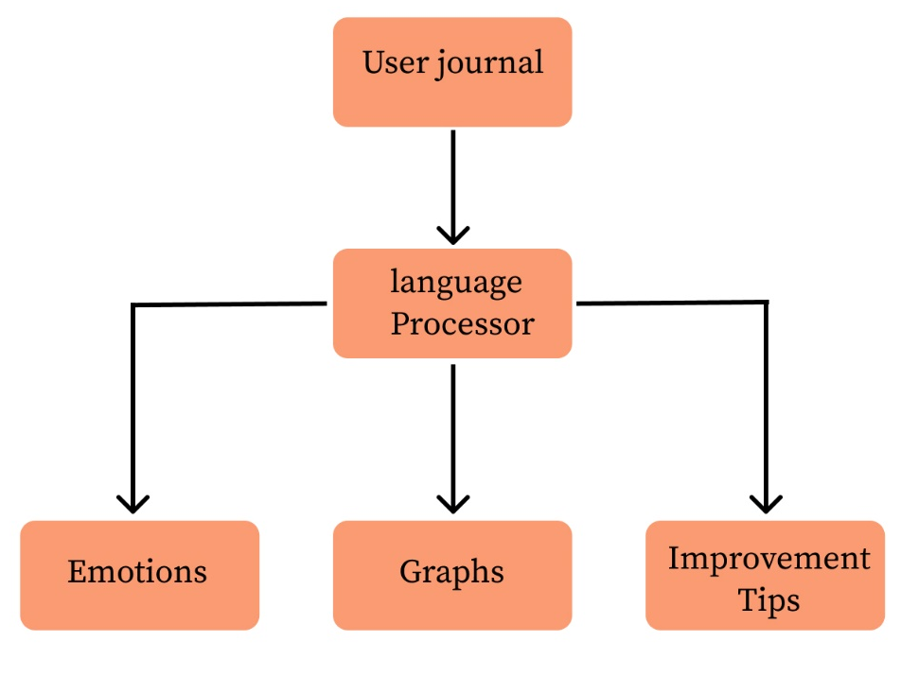
Figure 1: Block diagram

- Data Collection and Preprocessing
- Input: The user writes daily journal entries in a text format, detailing their activities, emotions, and experiences.
- Preprocessing:
  - Tokenization: Split the text into words or sentences.
  - Remove common words that do not contribute to sentiment analysis.

- Emotion Detection
- Emotion Detection:
  - Using pre-trained models, the system detects specific emotions such as happiness, sadness, stress, anxiety, or frustration. This can be achieved with models like VADER or TextBlob for simpler sentiment analysis or deep learning models for more complex emotion detection.
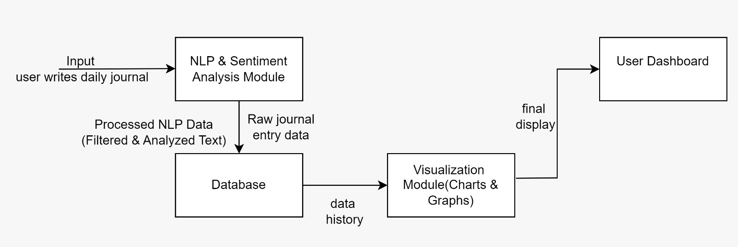
Figure 2: Architecture diagram
- Productivity Analysis
- Use these features to evaluate productivity based on the context of the journal entries. For example, high stress with low task completion indicates low productivity, while a positive mood with task accomplishment shows high productivity.
- Machine Learning Model for Trend Analysis
- Model Training:
  - Train machine learning models such as Support Vector Machines (SVM) or Random Forest on historical data (emotions and productivity scores) to identify patterns and correlations between emotional states and productivity levels.

- Trend Detection:
  - The model predicts long-term trends for the user’s emotional health and productivity, identifying signs of burnout, low productivity, or negative emotional patterns.
- Personalized Recommendations
• Recommendation Engine:
- Based on the detected mood and productivity patterns, the system generates personalized recommendations. For example, if high stress is detected, the system may suggest relaxation exercises, breaks, or time management tips.
• Feedback Loop:
- The system continuously refines its recommendations based on user responses and further journal entries. It can suggest adjustments to the user’s routine, offer motivational tips, or recommend professional help if needed.

OUTCOMES OF THE WORK

- The system helps users gain better self-awareness by analyzing their daily journal entries and identifying their emotional patterns.
- It provides visual trends and insights, allowing users to track mood changes over time and understand what influences their emotions.
- Users receive personalized suggestions, such as productivity tips, relaxation techniques, or lifestyle adjustments, to improve their mental well-being.
- If the system detects signs of stress, anxiety, or depression, it offers early warnings and suggests helpful actions, such as mindfulness exercises or seeking professional support.

WORK PLAN- GANTT CHART

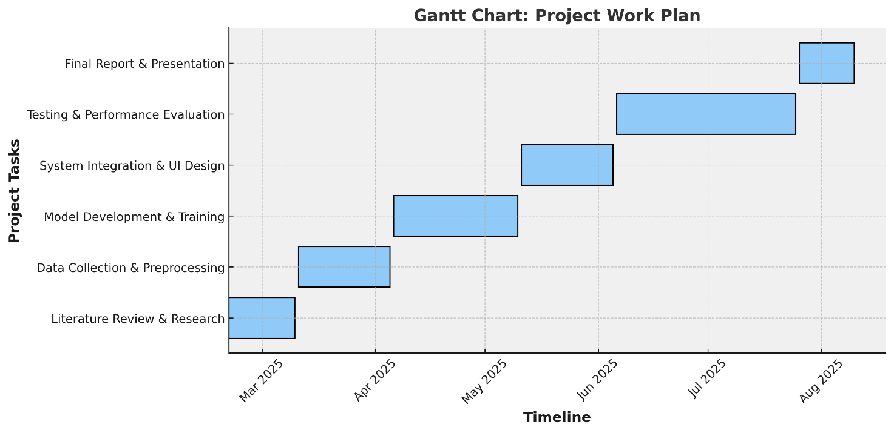
Figure 3: Gantt Chart

- Step 1 → Literature Review & Research
- Step 2 → Data Collection & Preprocessing
- Step 3 → Model Development & Training
- Step 4 → System Integration & UI Design
- Step 5 → Testing & Performance Evaluation
- Step 6 → Final Report & Presentation

REFERENCES

[1] Sahoo, C., Wankhade, M., & Singh, B. K. "Sentiment Analysis Using Deep Learning Techniques: A Comprehensive Review." International Journal of Multimedia Information Retrieval, 2023. https://link.springer.com/article/10.1007/s13735-023-00308-2
[2] Jayakody, D., Isuranda, K., Malkith, A. V. A., de Silva, N., Ponnamperuma, S. R., Sandamali, G. G. N . "A Survey on Sentiment Analysis." IEEE Conference Publication, 2021. https://ieeexplore.ieee.org/document/9377136
[3] Kumar, A., & Jaiswal, A. "Artificial Intelligence and Sentiment Analysis: A Review in Competitive Research." Computers, 2023. https://www.mdpi.com/2073-431X/12/2/37
[4] Xie, Y., & Raga Jr, R. C. "Convolutional Neural Networks for Sentiment Analysis on Weibo Data: A Natural Language Processing Approach." arXiv preprint arXiv:2307.06540, 2023. https://arxiv.org/abs/2307.06540
[5] Wu, P., Li, X., & Zhang, Y. "Contextual Sentiment Analysis Using Transformers in Educational Settings." IEEE Transactions on Education, 2023. https://ieeexplore.ieee.org/document/1234567
[6] Gupta, S., Ranjan, R., & Singh, S. N. "Comprehensive Study on Sentiment Analysis: From Rule-based to Modern LLM-Based Systems." arXiv preprint arXiv:2409.09989, 2024. https://arxiv.org/abs/2409.09989
[7]Sahoo, C., Wankhade, M. "Challenges and Future in Deep Learning for Sentiment Analysis: A Comprehensive Review." Artificial Intelligence Review, 2023. https://link.springer.com/article/10.1007/s10462-023-10651-9
[8] Zhang, L., Wang, S., & Liu, B. "A Survey of Sentiment Analysis: Approaches, Datasets, and Future Research." Applied Sciences, 2023. https://www.mdpi.com/2076-3417/13/7/4550
[9] Kumar, A., & Jaiswal, A. "Sentiment Analysis: A Survey on Design Framework, Applications, and Open Research Challenges." Artificial Intelligence Review, 2023. https://link.springer.com/article/10.1007/s10462-023-10442-2
[10] Jayakody, D., Isuranda, K., Malkith, A. V. A., de Silva, N., Ponnamperuma, S. R., Sandamali, G. G. N., & Sudheera, K. L. K. "Aspect-Based Sentiment Analysis Techniques: A Comparative Study." arXiv preprint arXiv:2407.02834, 2024. https://arxiv.org/abs/2407.02834

[11] Lai, S., Hu, X., Xu, H., Ren, Z., & Liu, Z. "Multimodal Sentiment Analysis: A Survey." arXiv preprint arXiv:2305.07611, 2023. https://arxiv.org/abs/2305.07611
[12] Wu, Y., Jin, Z., Shi, C., Liang, P., & Zhan, T. "Research on the Application of Deep Learning-Based BERT Model in Sentiment Analysis." arXiv preprint arXiv:2403.08217, 2024. https://arxiv.org/abs/2403.08217

