

19phy114-principles of measurement and sensors

**FIRE ALARM DETECTOR**



**ARUN PRAKASH(CB.EN.U4AIE19014)**

**C.R.ASSWIN (CB.EN.U4AIE19016)**

**P.S.SAI GANESH (CB.EN.U4AIE19044)**

**PRASHANTH V.R (CB.EN.U4AIE19047**)

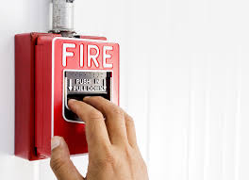TABLE OF CONTENTS

1. **Abstract.**
2. **Objective.**
3. **Methodology:**

* **Materials Used.**
* **Circuit Design.**
* **Working Principle.**

1. **Arduino Code.**
2. **Output.**
3. **Discussion.**
4. **Reference**

**Abstract:**

Fire accidents have increasingly become a common danger . Over the years ,occurrences of fire accidents have increased by many folds. This project deals with a Detection System for fire accidents. The alarm was not only designed considering the smoke but also including the increasing light intensity with raging fires and increase in temperature for the same. The primary sensors used here are temperature sensor,smoke sensor and photoresistor. A well commented code arduino code is also attached. Statistical operations has also been performed on the output obtained.

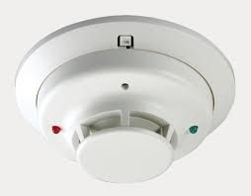

**Objective:**

To implement a Fire Detection System using temperature sensor,smoke sensor and photoresistor.

**Methodology:**

**Materials Used:**

* Temperature Sensor.
* Photoresistor.
* Smoke Sensor.
* Arduino.
* Breadboard.
* Potentiometer.
* Resistors.
* LED RGB.
* LCD.
* Slideswitch.
* Jumper wires.
* Piezo buzzer.

**Circuit Design:**

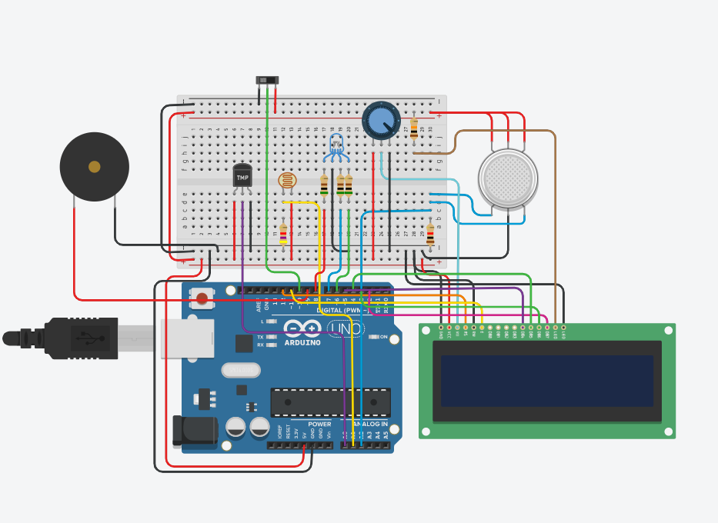

**Working Principle:**

The working of the sensor varies according to two cases.

**Case 1:**

When the fire has been spotted and someone trips on the alarm.The buzzer buzzes and the LCD screen shows. “ There is a fire!”.

**Case 2:**

When the sensor automatically picks up different reading from the three sensors- temperature sensor,smoke sensor and photoresistor. As the fire spreads , the luminescence , the amount of smoke produced and the temperature will also increase. When the reading s from the sensors cross a specific threshold, the rbg bulb will glow with different color intensity depending on the amount of fire. As the fire increases the bulb will turn from green to red. The threshold value for the photoresistor has been set in way that the alarm does not get activated by normal sunlight or light from a bulb.

**Arduino Code:**

#include <LiquidCrystal.h>

LiquidCrystallcd(12, 11, 5, 4, 3, 2);

int sen_val1 = 0;

int sen_val2 = 0;

int sen_val3 = 0;

int switch_state = LOW;

float voltage = 0.0;

float temp = 0.0;

void setup()

{

lcd.begin(16, 2);

pinMode(A0,INPUT); //Pin for Temperature Sensor

pinMode(A1,INPUT); //Pin for Photoresistor

pinMode(A2,INPUT); //Pin for Gas Sensor

pinMode(10,INPUT); //Pin for Switch

Serial.begin(9600);

for(int i = 6;i<=9;i++){

pinMode(i,OUTPUT); //Pin for LCD

}

}

void loop()

{

sen_val1 = analogRead(A0); // Temperature Sensor

sen_val2 = analogRead(A1); // Photoresistor

sen_val3 = analogRead(A2); // Gas Sensor

switch_state = digitalRead(10);// Manual Control

lcd.setCursor(0, 0); //Setting the 1st Line of LCD

voltage = 5.0*(sen_val1/1023.0);

temp = (voltage - 0.5)*100;

//Serial.println(sen_val2);

//Serial.println(temp);

//Serial.println(switch_state);

if(switch_state == HIGH){ //Manual control is turned on

tone(9, 300, 100);

digitalWrite(6,LOW);

digitalWrite(8,HIGH);

delay(500);

lcd.print("There is a fire");

}

else{ //Automatic control is turned on

if(temp > 75 && sen_val2 > 700 && sen_val3 > 200){

digitalWrite(6,LOW);

digitalWrite(8,HIGH);

tone(9, 300, 100);

delay(500);

lcd.print("There is a fire!");

}

else if((temp > 75 && sen_val3 > 200) || (temp > 75 && sen_val2 > 700)) {

tone(9, 300, 100);

digitalWrite(6,LOW);

digitalWrite(8,HIGH);

delay(500);

lcd.print("There is a fire!");

}

else if(temp > 75){

digitalWrite(6,LOW);

digitalWrite(8,HIGH);

lcd.print("The temp is too");

lcd.setCursor(0, 1);

lcd.print("high");

delay(1000);

lcd.clear(); //To clear the LCD

}

else{

digitalWrite(8,LOW);

digitalWrite(6,HIGH);

lcd.print("No fire , Safe! :)"); //Safe :)

}

}

}

**Output:**

**Smoke Sensor:**

Mode=85

Mean=204.2312

Median=194

Standard Deviation=94.3042

**Temperature Sensor:**

Mode=6.21

Mean=27.46121

Median=24.78

Standard Deviation=30.13452

**Photoresistor:**

Mode=887

Mean=862.9394

Median=884

Standard Deviation=34.81463

**Discussion:**

Statistical operations were completed which contains the mean, median and standard deviations for three types of sensor.

**Reference:**

1.<https://www.tinkercad.com/things/1R8Oy6QyhPp-copy-of-fire-detecting-alarm-working-100-haha/editel?tenant=circuits>

2. <https://www.arduino.cc/en/Tutorial/LiquidCrystalDisplay>