Using GRC, Illustrate some of the properties of complex (analytic) signals and show why we use them in communications systems. Demonstrate the reception of single side-band modulated signals using GRC

Done By -

K. Vinayak (CB.EN.U4AIE19032)

Manduva Gnanadeep (CB.EN.U4AIE19041)

Prashanth VR (CB.EN.U4AIE19047)

Vuyyuru Bindu Sri (CB.EN.U4AIE19069)



B.TECH CSE-AI, CEN DEPARTMENT, AMRITA SCHOOL OF ENGINEERING

**ACKNOWLEDGEMENT**

This project would not have been possible without the support and guidance of Dr. Neethu Mohan and Dr. Jyothish Lal G, who has provided us with sufficient knowledge and guidelines even during these unprecedented and trying times.

We would also like to thank our Computer Science and Engineering (Artificial Intelligence) department for giving us this opportunity to nurture and hone our skills.

Furthermore, we would like to thank the Amrita Vishwa Vidyapeetham management for providing ample resources to avail our project needs and a platform for online lectures during this lockdown.

**INTRODUCTION**

Single-sideband suppressed modulation (SSB) is a kind of modulation which is used to transmit information signals such as audio signals in radio communications. In the context of Amplitude modulation, this type of modulation uses bandwidth and transmitter power more efficiently. Generally amplitude modulation results in an output signal which is twice the maximum frequency of the information signal. SSB avoids this increase in bandwidth, power wasted on a carrier and at the cost of increased device complexity.

*Keywords* : Phase shift, frequency shift, hilbert transform, convolution

Properties of Complex signals used in SSB modulation and demodulation -

**Phase shift:**

The phasing method of SSB generation uses a phase shift technique that causes one of the side bands to be concealed out.

• It uses two balanced modulators instead of one. The balanced modulators effectively eliminate the carrier. The carrier oscillator is applied directly to the upper balanced modulator along with the audio modulating signal. Then both the carrier and modulating signal are shifted in phase by 90° and applied to the second,

lower, balanced modulator. The two balanced modulator outputs are then added together algebraically. The phase shifting action causes one side band to be cancelled out when the two balanced modulator outputs are combined.

• The carrier signal is VcSin2rrfct the modulating signal is VmSin2rrfmt.

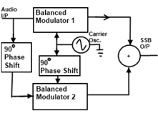

**Frequency shifting:**

In communications, the message x(t) (typically of lower frequency content than the frequency of the cosine) modulates the carrier cos(Ω0t) to obtain the modulated signal x(t) cos(Ω0t). Modulation is an important application of the Fourier transform, as it allows us to change the original frequencies of a message to much higher frequencies, making it possible to transmit the signal over the airwaves. amplitude modulation consists in multiplying an incoming signal x(t), or message, by a sinusoid of frequency higher than the maximum frequency of the incoming signal.

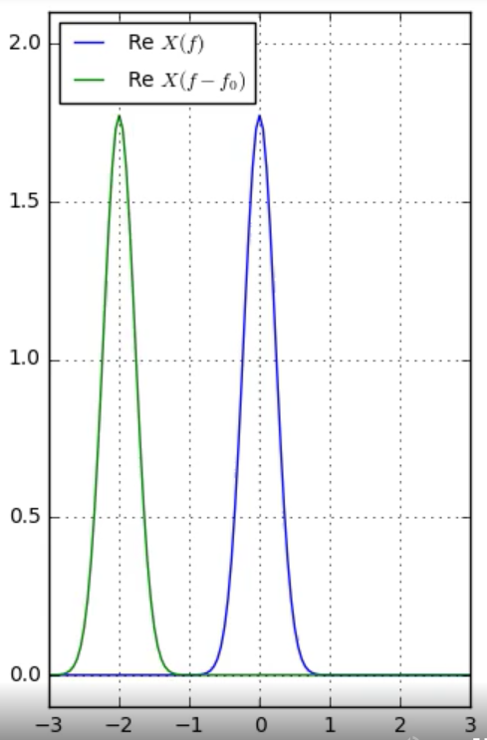



**Convolution**

Convolution is used to combine two signals to form a third signal. In Digital Signal Processing, convolution is the most important technique. The convolution of *f* and *g* is written *f*∗*g*, denoting the operator with the symbol * .It is defined as the integral of the product of the two functions after one is reversed and shifted. As such, it is a particular kind of integral transform –

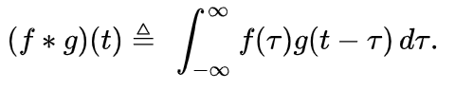

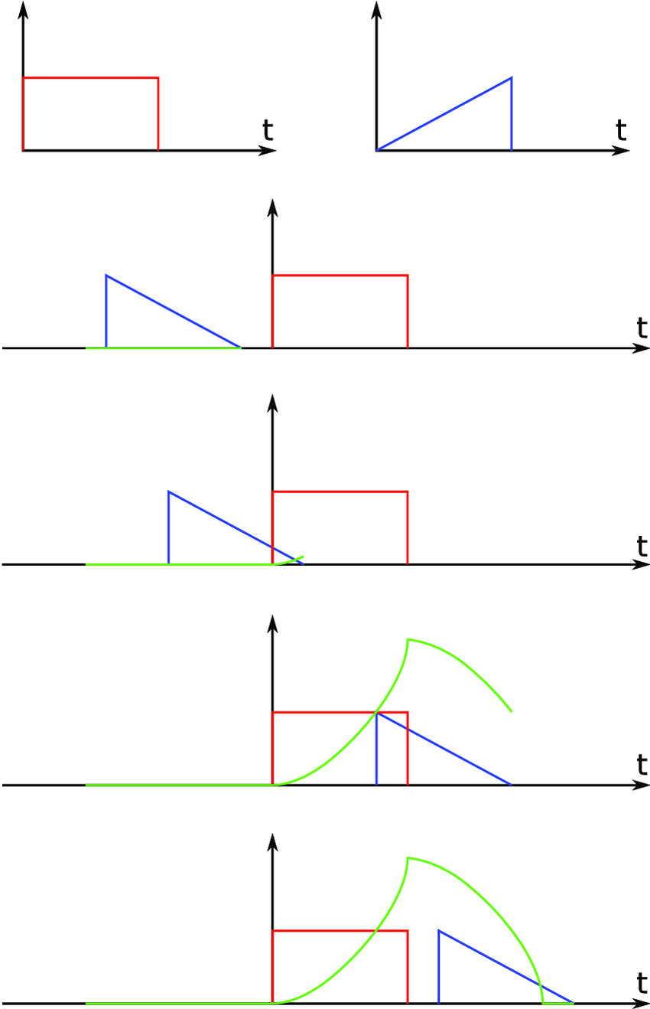

Convolution in simulink -

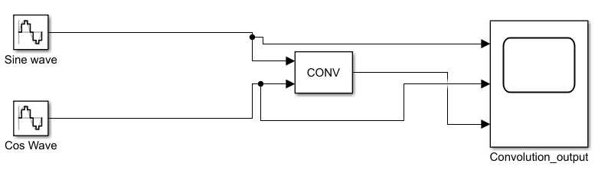

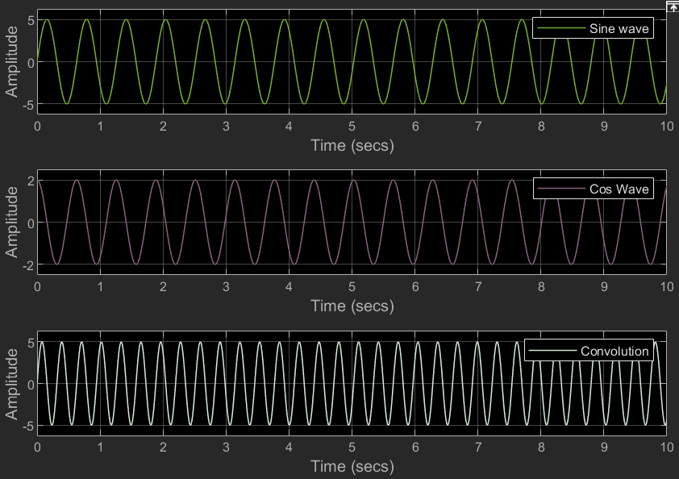

**Hilbert Transform**

A specific linear operator that takes a function, u(t) of a real variable, and produces another function of a real variable H(u)(t) is the Hilbert transform. The Hilbert transform on R, the real line, is defined by



The integral becomes well behaved for many common functions if an infinitesimally small section of the integration interval centred at the singularity y = x is deleted, as part of the definition of the integral. HT is popularly used in the signal demodulation. The collected vibration signals are generally modulated when the mechanical faults occur. Therefore, signal demodulation can separate the carrier and modulation components.

The fault features are hidden in the modulation component always. During signal pre-processing, it is necessary for us to implement the signal demodulation . The demodulation result for a given modulation signal is shown in Figure, where a modulation signal is given in Fig. A, the red dotted curve represents the corresponding envelope obtained by HT. The corresponding frequency spectra in

Fig. B illustrates that modulation frequency can be released from the carrier frequency and its sidebands. The obtained envelope contains a direct current component which has to be removed. The envelope is presented in Fig. C and the corresponding frequency spectrum is in Fig. D. HT is a very effective method for signal demodulation.

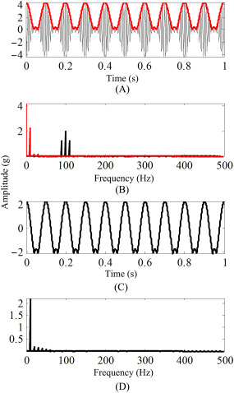

Hilbert Transform in Simulink

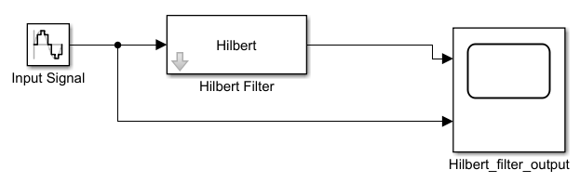

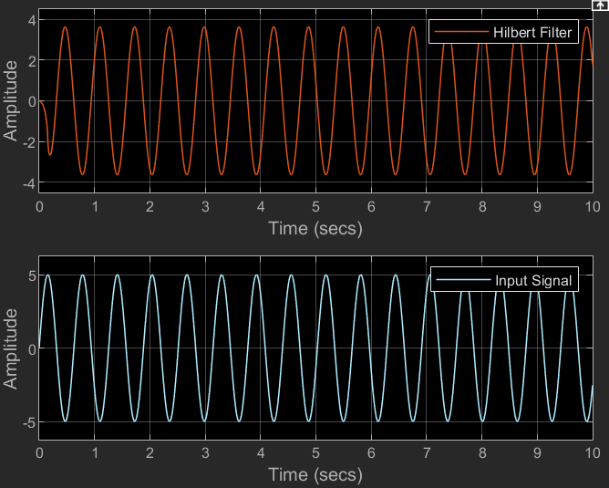

**Amplitude Scaling of Signals.**

A very basic operation performed on signals to vary its strength is the amplitude scaling. It is represented mathematically as Y(t) = α X(t).

Here, α is the scaling factor, where:-

α<1 → signal is attenuated.

α>1 → signal is amplified.

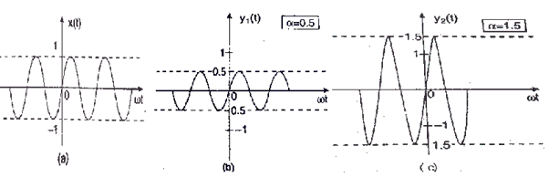

In the diagram, we have illustrated signals attenuated when α = 0.5 in fig (b) and amplified when α = 1.5 as in fig (c).

In other words, Consider a signal x(t) which is multiplied by a constant 'A' and indicated by a notation x(t) → Ax(t). For any arbitrary ’t’ the signal value x(t) is multiplied by a constant 'A'. Thus, x(t) tends to Ax(t) multiplies x(t) at every value of 't' by a constant 'A'. This is called amplitude-scaling. If the amplitude-scaling factor is negative, it flips the signal with the t-axis as the rotation axis of the flip. If the scaling factor is -1, only the signal will flip.

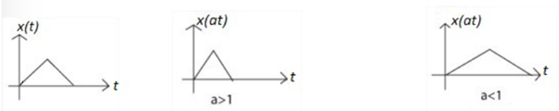

Amplitude Scaling in Simulink

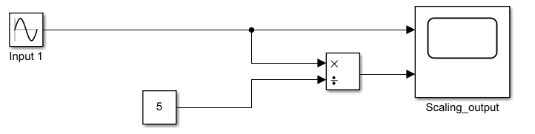

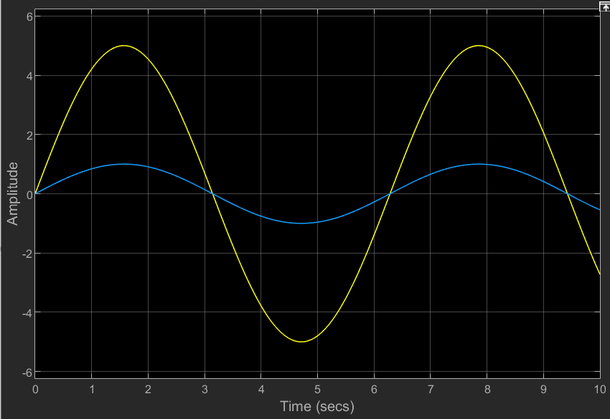

SSB Reception and Demodulation using GRC

1. The below flow graph is the implementation of the GRC model for reception and demodulation of SLSB (Single Lower Side Band) signal. The demodulation we are implementing here is known as Weaver’s method of demodulation. 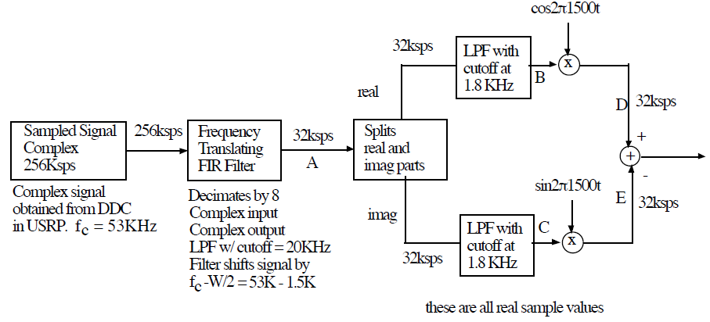

Fig.2.1 Flow graph for SSB Demodulation

1. In the flow graph, the sample rate should be fixed as 256000 as this received signal was sampled at this rate.
2. This signal was recorded in USRP at 50.3MHz, so the 0KHz point in the plot corresponds to 50.3MHz. And the original carrier frequency of this signal is known to be 53KHz.
3. For building a receiver, the first step is to build a channel filter, in order to filter the unnecessary frequencies and pass the signal of our interest. Before doing that we first shift our desired information signal by w/2 (where w is the frequency of our baseband signal i.e. 3KHz) as shown in Fig 2.2 a). This is done in order to convert our passband signal to baseband signal.

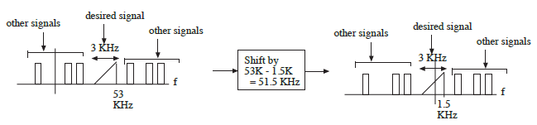

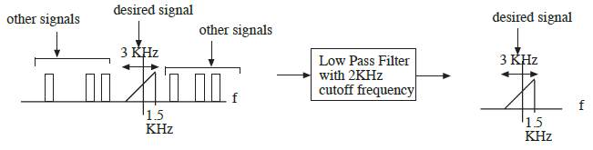

Fig 2.2 a) Shifting the baseband signal (top), b) Passing the shifted signal to a Low pass filter (bottom).

1. Now we pass this signal into a low pass filter, to filter out other signals than our baseband signal as shown in Fig 2.2 b).
2. These above mentioned operations are done by Frequency Xlating (translating) FIR Filter block in GRC. In the properties window of that block, the center frequency is given as -51500, which shifts the entire spectrum down to 51500 Hz. We enter the function firdes_low_pass in taps parameter, to generate a signal of gain 1, sample rate same as we defined earlier, cutoff frequency of 2KHz and a transition width of 100.
3. As the range of frequencies that are being processed are so high because of the present sample rate (256000), we can reduce it by changing the decimation parameter to 8, which changes the sample rate to 32000 (256000/8).
4. As the input signal is of complex type, we have to split it into real and imaginary parts in order to demodulate the SSB signal. So, the complex to float block in GRC takes care of it. Both the outputs of this block are real so the throttle block must be set to float type and set to the new sample rate of 32000. For observing these signals, we can connect them to frequency sinks which is also of float type. Here we can note that the signal cuts at 2000KHz, which is the cutoff frequency of the low pass filter.
5. Finally as we implement the weaver’s method, we take the real and imaginary parts of our signal. We then produce cosine and sine wave using signal source blocks and combine them with real and imaginary parts respectively and add those combined signals together.

GRC Model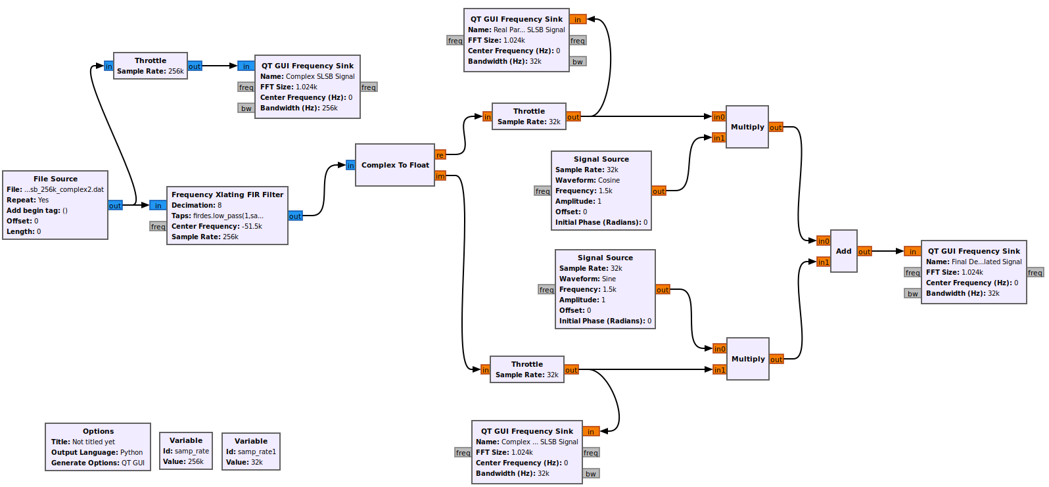

Fig. 3.0 GRC model for demodulation of SLSB Signal

Analyzing the output of the GRC model

Fig. 4.0 Given SLSB Complex signal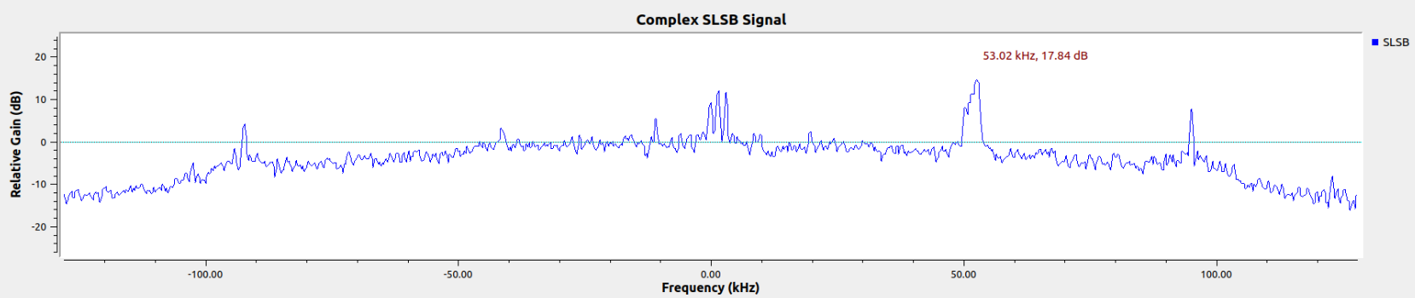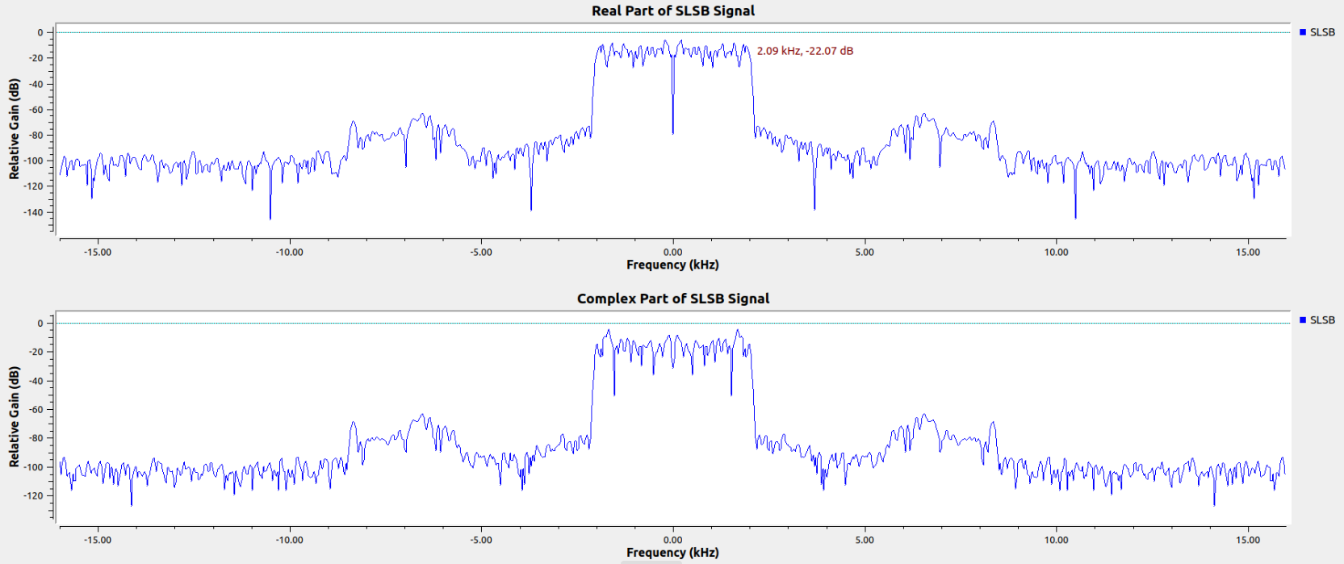

Fig 4.1 Real and Complex part of SLSB Signal

1. Figure 4.0 depicts the given complex Single lower sideband signal (SLSB). Here we can observe that the highest amplitude part has an approximate frequency of 53KHz from the 0 KHz point. So we can conclude that our signal of interest has a carrier frequency of 53KHz.
2. Also, we already know that this SSB signal was recorded when the USRP was set to 50.3MHz. Thus we can say that the modulated SSB signal has a frequency of 50.353MHz (50.3MHz + 0.053MHz).
3. Figure 4.1 shows the real and imaginary part of the SSB signal, which are produced inorder to get demodulated. We can also note that these signals extend out to 2KHz, which is the cutoff frequency of the low pass filter used.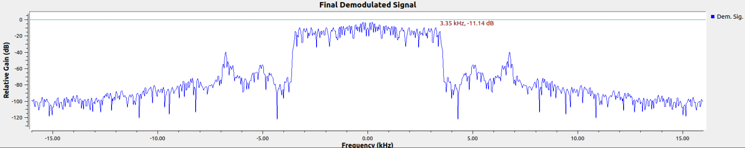

Fig. 4.2 SSB Signal after demodulation

1. The signal shown in Fig. 4.2 shows the final signal coming out of the adder block, which is the demodulated signal i.e, the baseband signal extracted out of the modulated SSB signal. Also we can note that this signal has a baseband frequency around 3KHz.

SSB Modulation and Demodulation of Real Signals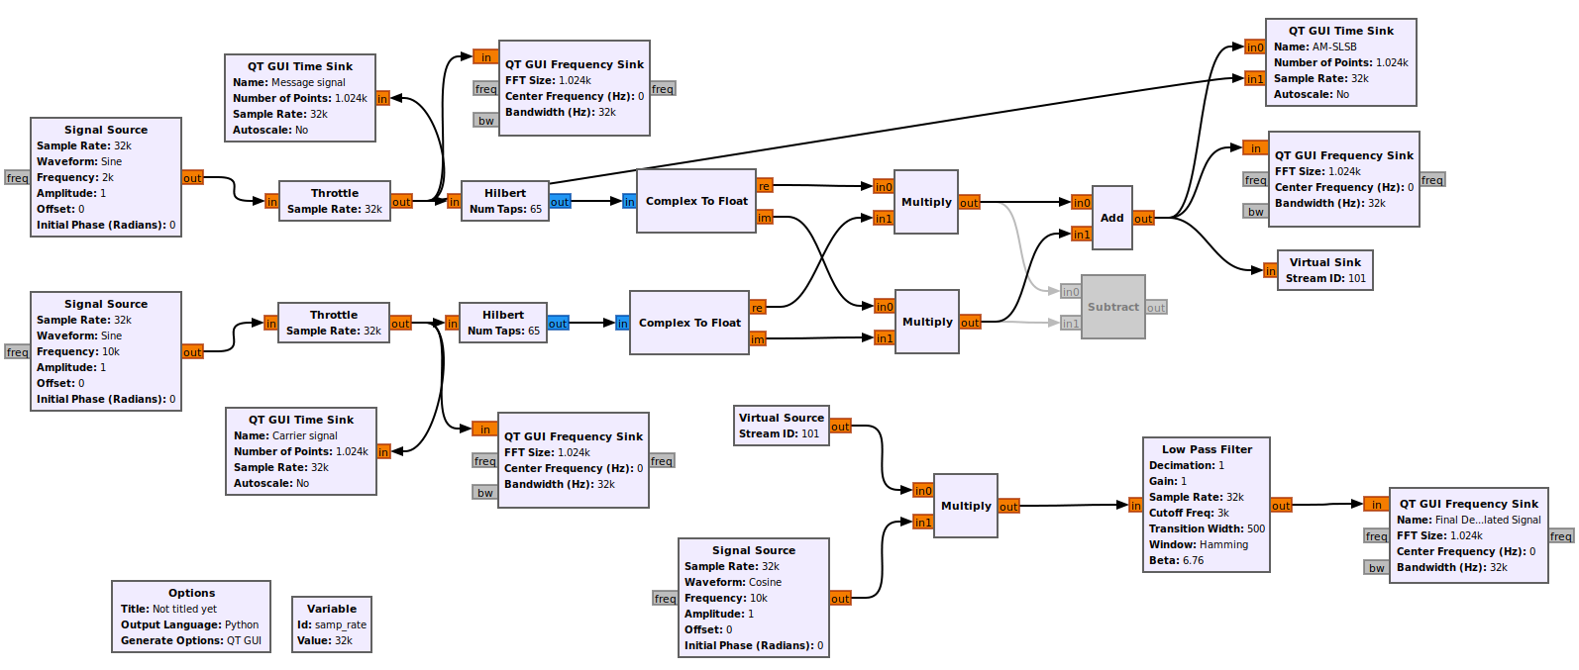

Fig. 5.0 GRC model for modulation and demodulation of SSB signals

1. The first half of the GRC model represents modulation of SSB signal. The output coming out of the add block depicts SLSB signal and the signal coming out of subtract block depicts SUSB signal.
2. Here we consider only the SLSB signal as our source. So, we give the SLSB signal to a virtual sink with an ID 101. We use the same ID for the virtual source in order to give the SLSB as the source signal for demodulation.
3. Here we perform a simple Coherent demodulation, where we combine the source (SLSB) signal with a signal, which has the same frequency as our initial carrier signal and remove the higher frequency parts in our output.

Analyzing the output of the GRC model

Fig. 5.2 a) Frequency spectrum of message signal b) Frequency spectrum of carrier signal c) Frequency spectrum of SLSB signal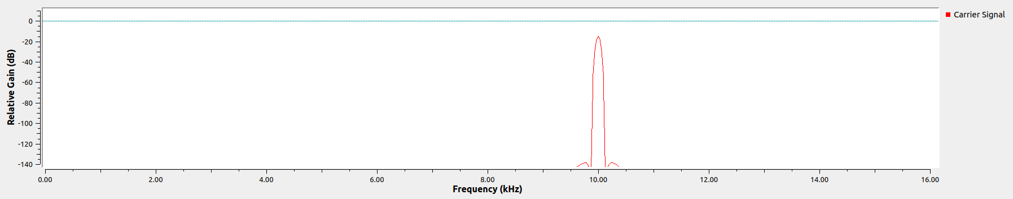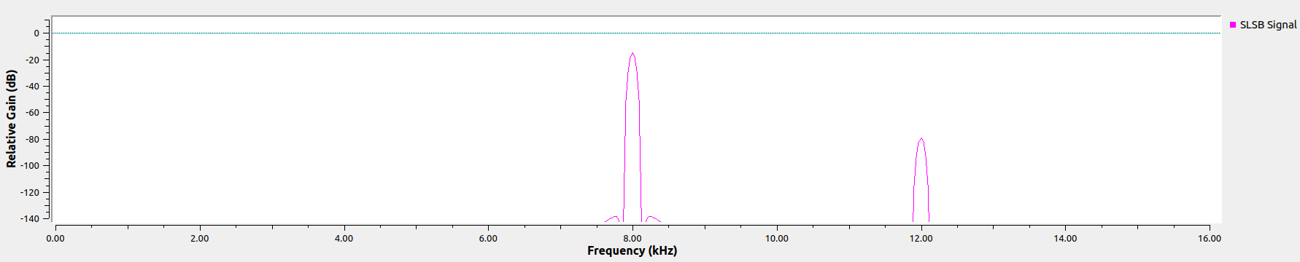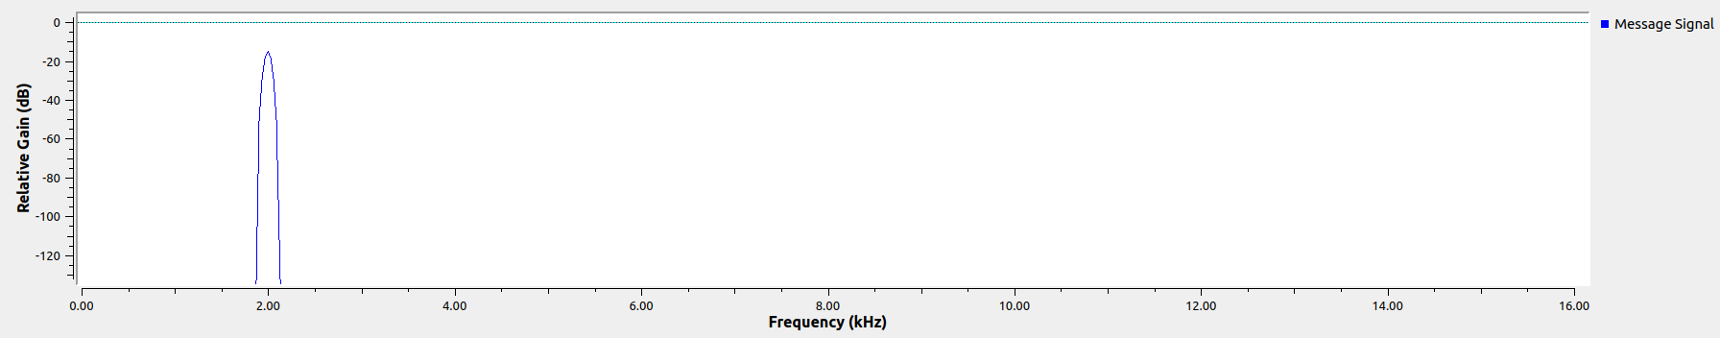

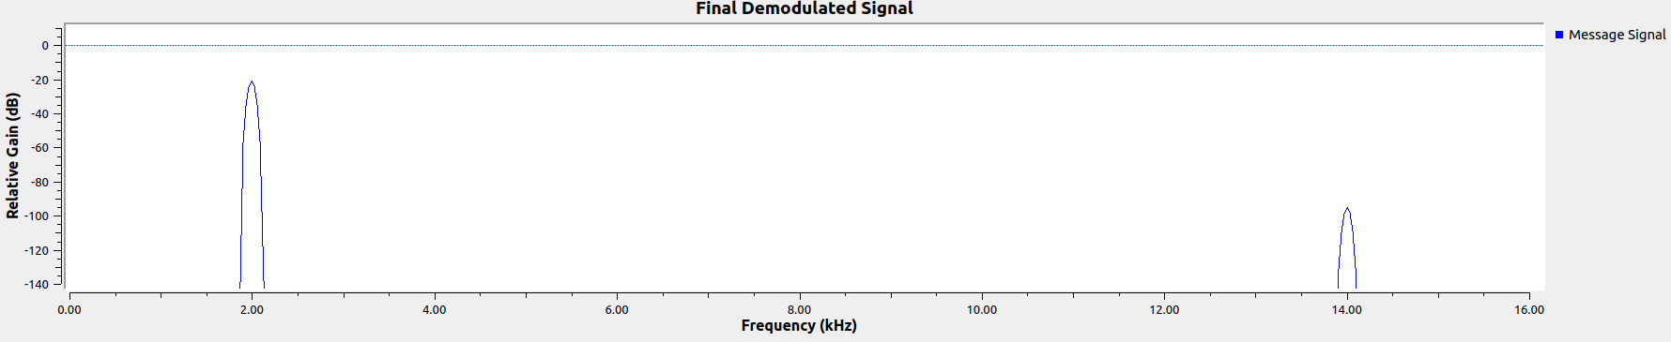

Fig 5.2 d) Frequency spectrum of Final demodulated signal

1. Here the frequency of message or source signal is taken as 2KHz (Fig. 5.2 a) ) and the frequency of the carrier signal is taken as 10 KHz (Fig 5.2 b) ).
2. So by performing SSB modulation, we get 2 components i.e, SUSB ((10 + 2) KHz = 12 KHz ) and SLSB ((10 - 2) KHz = 8 KHz).
3. After performing Coherent demodulation for our SLSB signal, the output is the same as it is shown in Fig. 5.2 d). Note that the final message signal frequency is the same as the frequency of the input signal, though some high frequency parts of very low power are displayed in the plot, which are removed by using a low pass filter.

SSB modulation and demodulation in matlab simulink

Message signal can be a single tone or multi tone for simplicity. Here we are considering a single tone message signal as a modulating signal.

Modulation -

Converting base band signal to pass band.

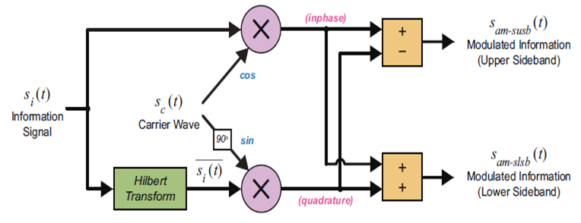

The above diagram shows the operations required to perform ssb modulation.

1.Firstly let’s consider an information signal and a carrier signal 

2.We then perform Hilbert transform on the information signal and phase shift the carrier signal by pi/2. and Phase shifted carrier wave 

3. And then multiply the resultant signals pair wise. Finally the AM-SSB modulated signal is as follows



4. From this we can split upper and lower sidebands as follows



5.These are modulated signals ready to be transmitted, at the other end we demodulate these signals and retrieve the information signal.

6.For this we convolve the modulated signal with carrier signal and pass it to Low Pass Filter (LPF).



Convolve AM-SSB signal with carrier wave



7.Output after passing through LPF -



AM SSB Modulation and Demodulation in Simulink

