Q4

Bastion host’s security group

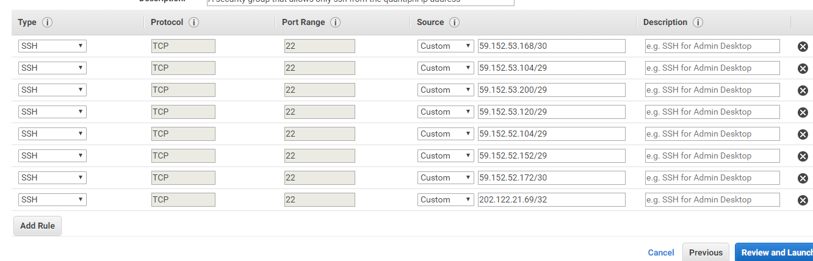

The three instances’in the private subnets security group inbound rules

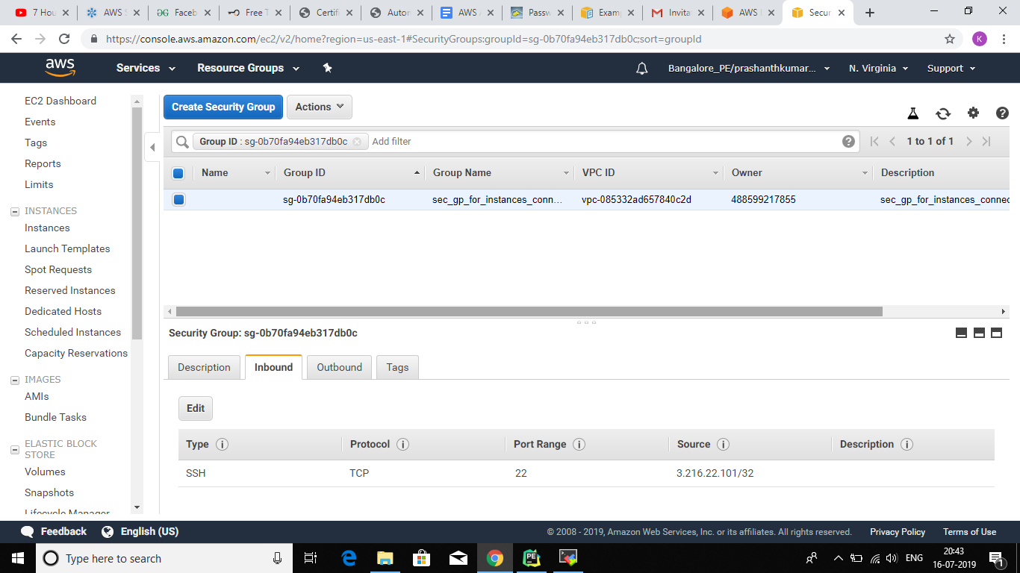

The three instances’in the private subnets security group outbound rules

