AI_ Assisted_Coding _Assignment_Week-6

Name : B.Prashanth

Roll No:2403A52197

**Assignment Number: 6.4**

**Task Description #1:**• Start a Python class named Student with attributes name, roll_number, and marks. Prompt  
GitHub Copilot to complete methods for displaying details and checking if marks are above  
average.  
**Expected Outcome #1:**  
• Completed class with Copilot-generated methods like display_details() and is_passed(),  
demonstrating use of if-else conditions.

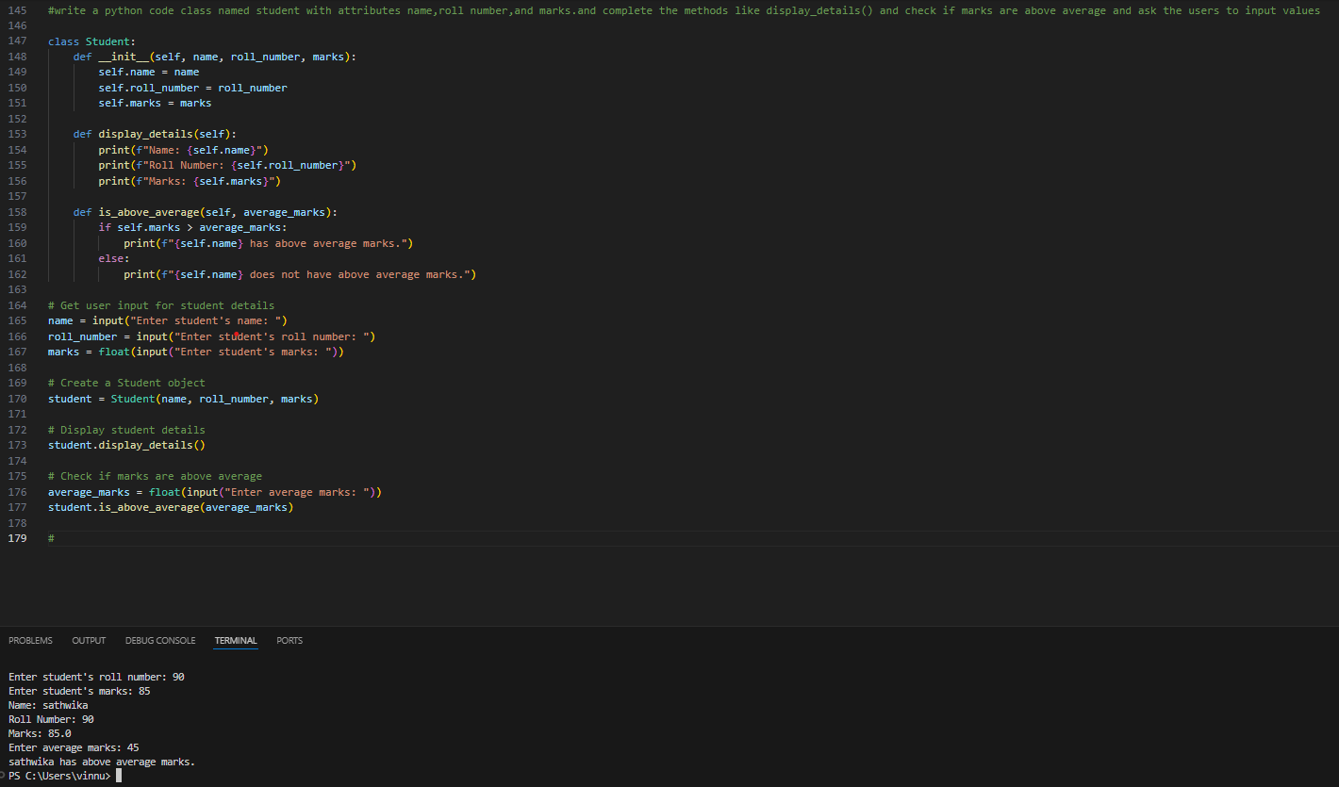

**Task Description #2:**  
• Write the first two lines of a for loop to iterate through a list of numbers. Use a comment  
prompt to let Copilot suggest how to calculate and print the square of even numbers only.  
**Expected Outcome #2:**

• A complete loop generated by Copilot with conditional logic (if number % 2 == 0) and  
appropriate output

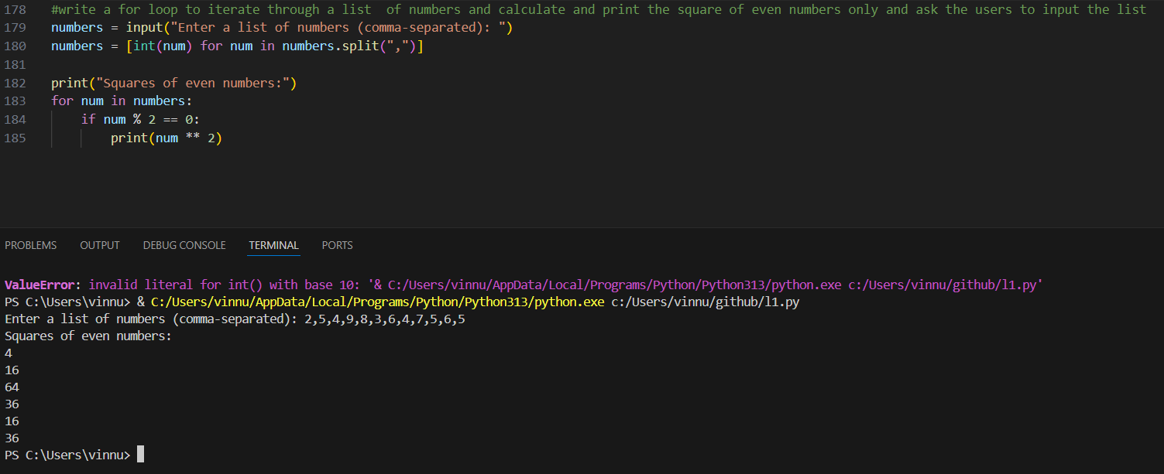

**Task Description #3:**  
• Create a class called BankAccount with attributes account_holder and balance. Use Copilot to  
complete methods for deposit(), withdraw(), and check for insufficient balance.  
**Expected Outcome #3:**  
• Functional class with complete method definitions using if conditions and self attributes. Code should prevent overdrawing

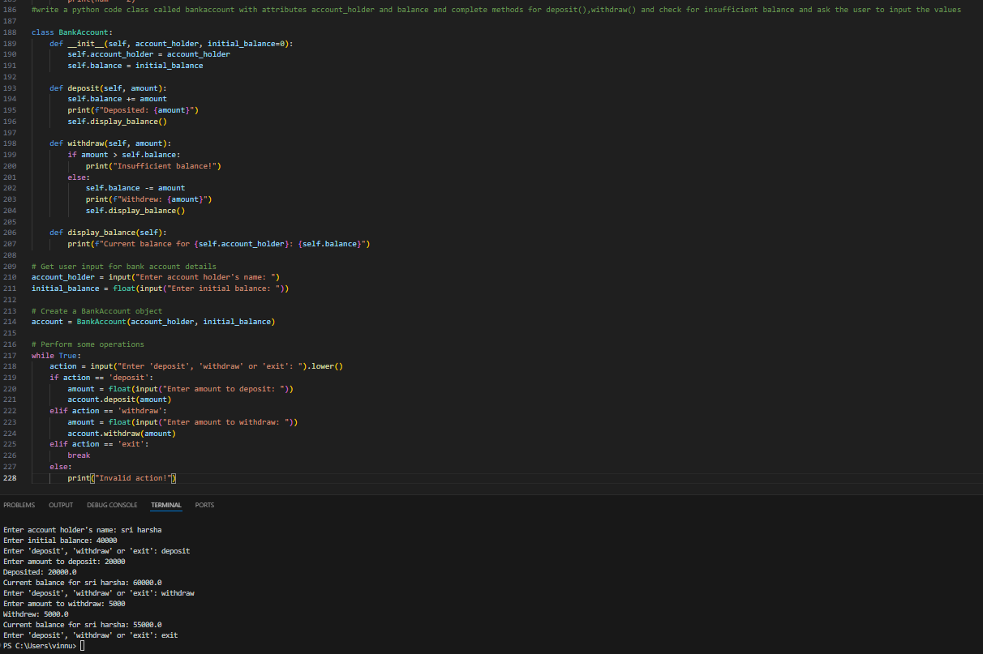

**Task Description #4:**• Define a list of student dictionaries with keys name and score. Ask Copilot to write a while  
loop to print the names of students who scored more than 75.  
**Expected Outcome #4:**  
• A complete while loop generated by Copilot with proper condition checks and formatted  
output.

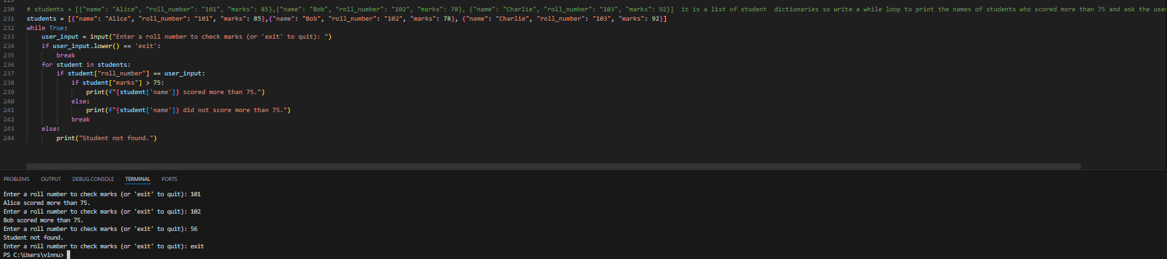

**Task Description #5:**  
• Begin writing a class ShoppingCart with an empty items list. Prompt Copilot to generate  
methods to add_item, remove_item, and use a loop to calculate the total bill using conditional  
discounts.  
**Expected Outcome #5:**  
• A fully implemented ShoppingCart class with Copilot-generated loops and if-else statements  
handling item management and discount logic.

