1. What is the exact output of the program below?

#include <iostream>

using namespace std;

int main()

{

int n = 4, k = 2;

cout << ++n << endl;

cout << n << endl;

cout << n++ << endl;

cout << n << endl;

cout << -n << endl;

cout << n << endl;

cout << --n << endl;

cout << n << endl;

cout << n-- << endl;

cout << n << endl;

cout << n + k << endl;

cout << n << endl;

cout << k << endl;

cout << n << k << endl;

cout << n << endl;

cout << " " << n << endl;cout << " n" << endl;

cout << "\n" << endl;

cout << " n * n = "; //CAREFUL!

cout << n * n << endl;

cout << 'n' << endl;

return 0;

}

**OUT PUT:**

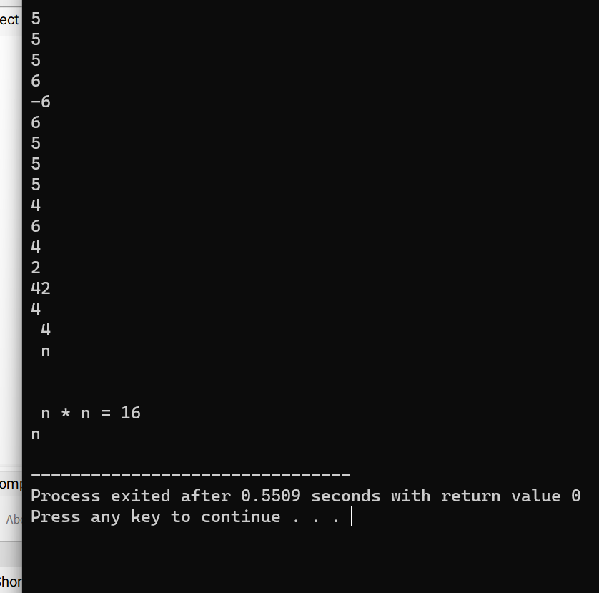

2. What is the output of the program below?

#include <iostream>

using namespace std;

int main()

{

int n = 3;

while (n >= 0)

{

cout << n * n << endl;

--n;

}

cout << n << endl;

while (n < 4)

cout << ++n << endl;

cout << n << endl;

while (n >= 0)

cout << (n /= 2) << endl;

return 0;

**OUT PUT:**

3. What is the output of the program below?

#include <iostream>

using namespace std;

int main()

{

int n;

cout << (n = 4) << endl;

cout << (n == 4) << endl;

cout << (n > 3) << endl;

cout << (n < 4) << endl;

cout << (n = 0) << endl;

cout << (n == 0) << endl;

cout << (n > 0) << endl;

cout << (n && 4) << endl;

cout << (n || 4) << endl;

cout << (!n) << endl;

return 0;

}

**OUT PUT:**

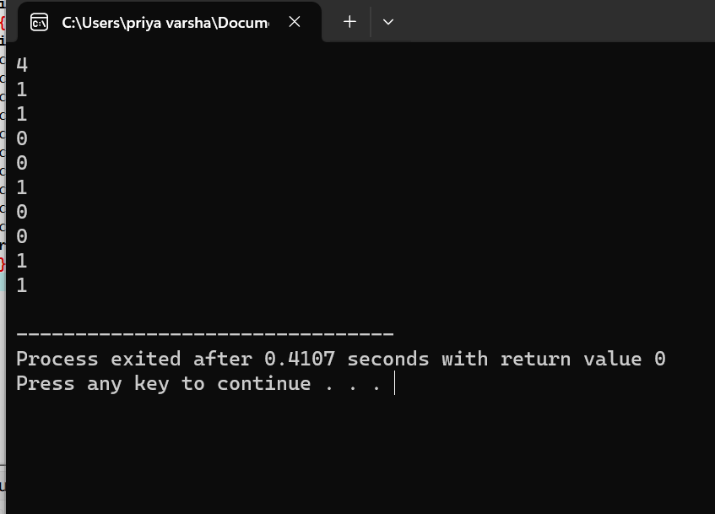

4. What is the output of the following program?

#include <iostream>

using namespace std;

int main(){

enum color_type {red, orange, yellow, green, blue, violet};

color_type shirt, pants;

shirt = red;

pants = blue;

cout << shirt << " " << pants << endl;

return 0;

}

**Out put:**

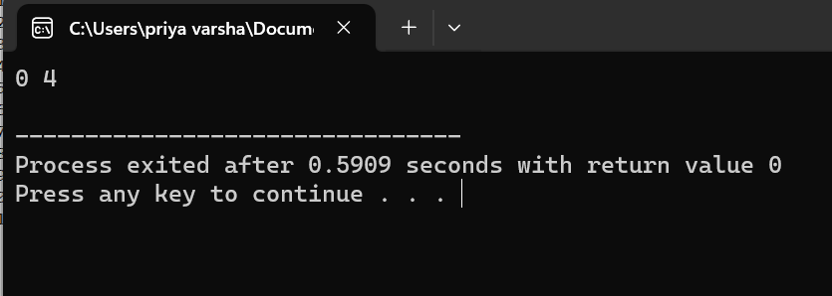

5. What is the output when the following code fragment is executed?

int i = 5, j = 6, k = 7, n = 3;

cout << i + j * k - k % n << endl;

cout << i / n << endl;

correct code:

#include <iostream>

using namespace std;

int main()

{

int i = 5, j = 6, k = 7, n = 3;

cout << i + j * k - k % n << endl;

cout << i / n << endl;

return 0;

}

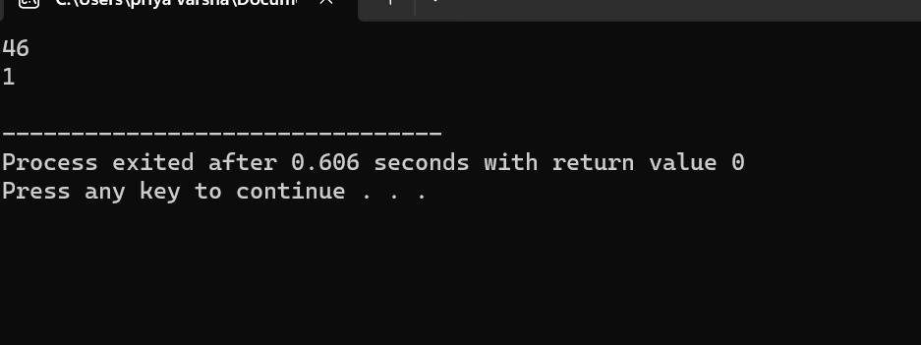

6. What is the output when the following code fragment is executed?

int found = 0, count = 5;

if (!found || --count == 0)

cout << "danger" << endl;

cout << "count = " << count << endl;

correct code:

#include <iostream>

using namespace std;

int main()

{

int found = 0, count = 5;

if (!found || --count == 0)

{

cout << "danger" << endl;

}

else

{

cout << "No danger" << endl;

}

cout << "count = " << count << endl;

return 0;

}

**Out put:**

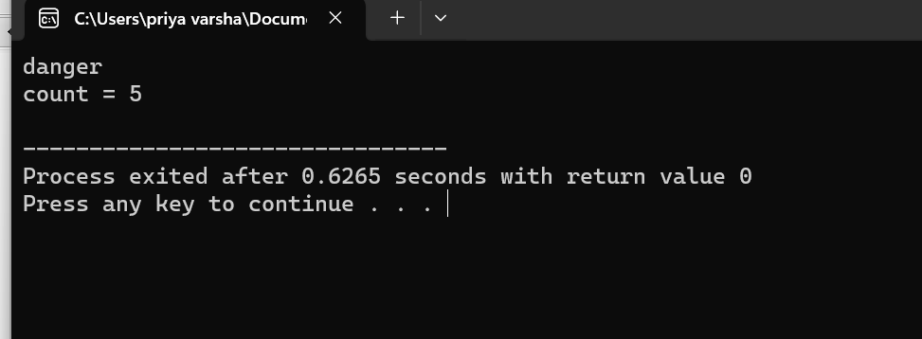

7. The loop shown below has been written by an inexperienced C++ programmer. The behavior of

the loop is not correctly represented by the formatting.

int n = 10;

while (n > 0)

n /= 2;

cout << n * n << endl;

**out put:**

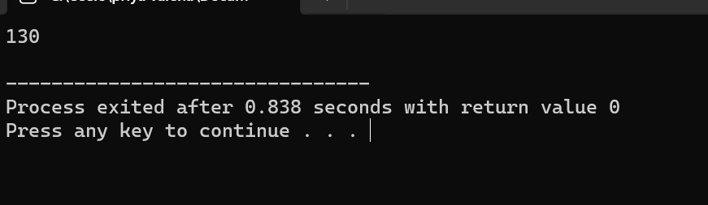

8. Remove all the unnecessary tests from the nested conditional statement below.

float income;

cout << "Enter your monthly income: ";

cin >> income;

if (income < 0.0)

cout << "You are going farther into debt every month." << endl;

else if (income >= 0.0 && income < 1200.00)

cout << "You are living below the poverty line." << endl;

else if (income >= 1200.00 && income < 2500.00)

cout << "You are living in moderate comfort." << endl;

else if (income >= 2500.00)

cout << "You are well off." << endl;

**#include <iostream>**

**using namespace std;**

**int main() {**

**float income;**

**cout << "Enter your monthly income: ";**

**if (!(cin >> income)) {**

**cout << "Invalid input. Please enter a numeric value for income." << endl;**

**return 1;**

**}**

**if (income < 0.0)**

**cout << "You are going farther into debt every month." << endl;**

**else if (income >= 0.0 && income < 1200.00)**

**cout << "You are living below the poverty line." << endl;**

**else if (income >= 1200.00 && income < 2500.00)**

**cout << "You are living in moderate comfort." << endl;**

**else if (income >= 2500.00)**

**cout << "You are well off." << endl;**

**return 0;**

**}**

**Out put:**

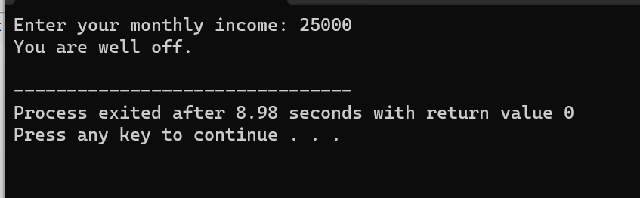

9. Answer the questions below concerning the following fragment of code.

int n;

cout << "Enter an integer: ";

cin >> n;

if (n < 10)

cout << "less than 10" << endl;

else if (n > 5)

cout << "greater than 5" << endl;

else

cout << "not interesting" << endl;

correct code:

**#include <iostream>**

**using namespace std;**

**int main() {**

**int n;**

**cout << "Enter an integer: ";**

**if (!(cin >> n)) {**

**cout << "Invalid input. Please enter an integer." << endl;**

**return 1;**

**}**

**if (n < 10)**

**cout << "less than 10" << endl;**

**else if (n > 5)**

**cout << "greater than 5" << endl;**

**else**

**cout << "not interesting" << endl;**

**return 0;**

**}**

**Out put:**

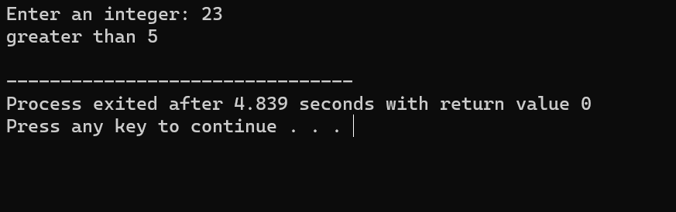

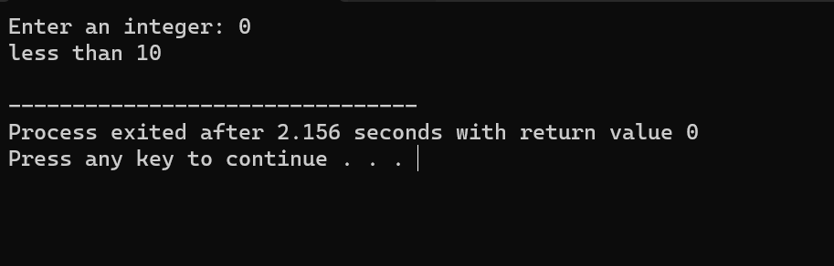

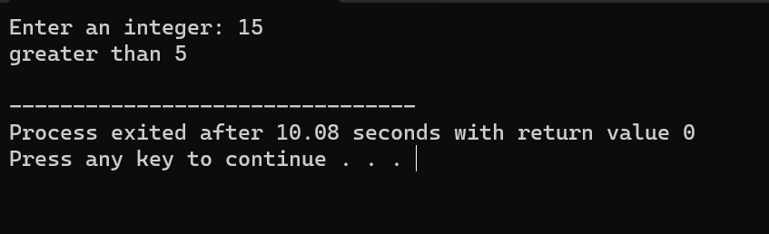

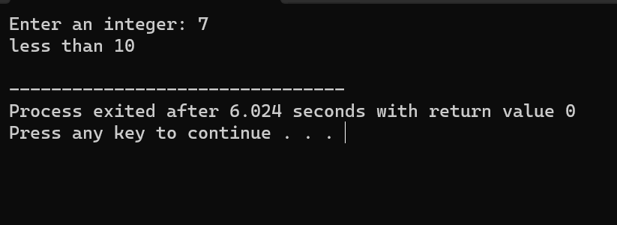

10. Rewrite the following code fragment so that it uses a "do...while..." loop to accomplish the same

task.

int n;

cout << "Enter a non-negative integer: ";

cin >> n;

while (n < 0)

{

cout << "The integer you entered is negative." << endl;

cout << "Enter a non-negative integer: ";

cin >> n;

}

**Out put:**

