BANL6625- Mid Exam

Prashanth

library(ggplot2)  
setwd("D:/Data Mining")  
my_data=read.csv("my_data.csv")  
my_data_df=my_data[,c(1,2,3,4,5,6)]  
summary(my_data_df)

## customer location soap_type quantity   
## Min. : 1 Length:5000 Length:5000 Min. : 1.000   
## 1st Qu.:1251 Class :character Class :character 1st Qu.: 3.000   
## Median :2500 Mode :character Mode :character Median : 6.000   
## Mean :2500 Mean : 5.524   
## 3rd Qu.:3750 3rd Qu.: 8.000   
## Max. :5000 Max. :10.000   
## NA's :500   
## age payment_type   
## Min. :18.00 Length:5000   
## 1st Qu.:38.00 Class :character   
## Median :58.00 Mode :character   
## Mean :58.56   
## 3rd Qu.:79.00   
## Max. :98.00   
## NA's :500

sum(is.na(my_data_df))

## [1] 1500

#removing NA's from the dataset  
  
clean_data=na.omit(my_data_df)  
sum(is.na(clean_data))

## [1] 0

#Binning the age into age_groups  
clean_data$age_group=cut(clean_data$age,breaks = c(0,10,30,50,100),labels = c("baby","young","Adult","Old"))  
summary(clean_data)

## customer location soap_type quantity   
## Min. : 1 Length:4500 Length:4500 Min. : 1.000   
## 1st Qu.:1261 Class :character Class :character 1st Qu.: 3.000   
## Median :2504 Mode :character Mode :character Median : 6.000   
## Mean :2499 Mean : 5.524   
## 3rd Qu.:3735 3rd Qu.: 8.000   
## Max. :5000 Max. :10.000   
## age payment_type age_group   
## Min. :18.00 Length:4500 baby : 0   
## 1st Qu.:38.00 Class :character young: 673   
## Median :58.00 Mode :character Adult:1131   
## Mean :58.56 Old :2696   
## 3rd Qu.:79.00   
## Max. :98.00

## Box plot and Scatter plot

clean_data$location=as.factor(clean_data$location)  
clean_data$soap_type=as.factor(clean_data$soap_type)  
clean_data$payment_type=as.factor(clean_data$payment_type)  
  
boxpl1=ggplot(data=clean_data,aes(x=soap_type,y=quantity))+geom_boxplot()  
boxpl2=ggplot(data=clean_data,aes(x=payment_type,y=quantity))+geom_boxplot()  
Scatter1=ggplot(data=clean_data,aes(x=age_group,y=quantity,col=soap_type))+geom_point()  
Scatter2=ggplot(data=clean_data,aes(x=age_group,y=quantity,col=location))+geom_point()  
boxpl1

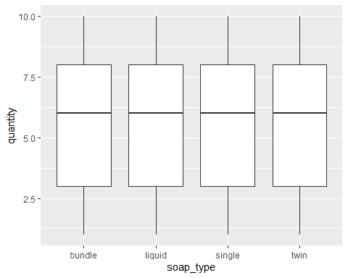

boxpl2

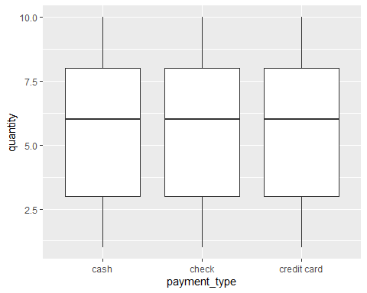

Scatter1

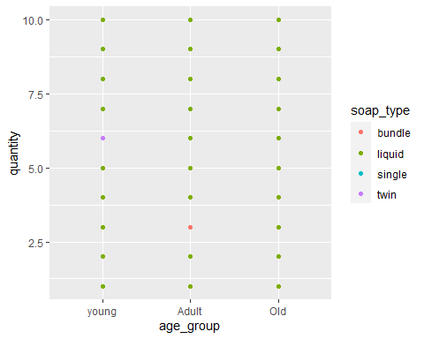

Scatter2

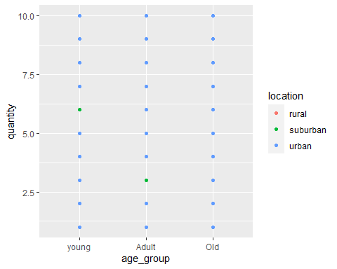

table(clean_data$soap_type)

##   
## bundle liquid single twin   
## 883 834 1668 1115

table(clean_data$location)

##   
## rural suburban urban   
## 2083 1381 1036

table(clean_data$payment_type)

##   
## cash check credit card   
## 1503 1475 1522

As we can see from the values in soap_type single,in location rural, and in payment_type credit card dominates the dataset.

ggplot(clean_data, aes(x=location, fill=soap_type)) +   
 geom_bar(position="stack") +   
 labs(title="Soap Types by Region", x="Region", y="Frequency") +   
 scale_fill_discrete(name="Soap Type")

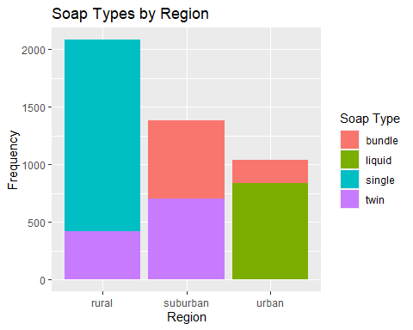

As we can see from the plot there are different type of soaps used in different locations.

In Rural Region - Single soap type is used

In Suburban Region - twin soap type is used

In Urban Region - Liquid soap type is used

ggplot(clean_data, aes(x=location, y=age, fill=payment_type)) +  
 geom_boxplot() +  
 ggtitle("Payment Type by Location and Age")

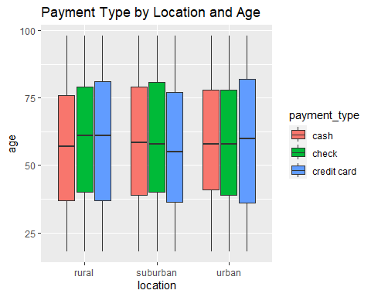

As we can see from the boxplot, different age people from different location choose different type of payment method

library(class)

## Warning: package 'class' was built under R version 4.2.2

library(caret)

## Warning: package 'caret' was built under R version 4.2.3

## Loading required package: lattice

clean_data$location=as.numeric(as.factor(clean_data$location))  
clean_data$payment_type=as.numeric(as.factor(clean_data$payment_type))  
  
#Removed customer column for prediction of data  
clean_data_sub=subset(clean_data,select=c("soap_type","location","quantity","age","payment_type"))  
  
#divided the data into 70:30 of train and test dataset  
train_index <- sample(row.names(clean_data_sub), 0.7*dim(clean_data_sub)[1])   
valid_index <- setdiff(row.names(clean_data_sub), train_index)   
train_df <- clean_data_sub[train_index, ]  
valid_df <- clean_data_sub[valid_index, ]  
train_norm_df=train_df  
valid_norm_df=valid_df  
#Standardizing the data  
norm_values <- preProcess(train_df[, c(2,3,4)], method=c("center", "scale"))  
train_norm_df[, c(2,3,4)] <- predict(norm_values, train_df[, c(2,3,4)])  
valid_norm_df[, c(2,3,4)] <- predict(norm_values, valid_df[, c(2,3,4)])  
  
new_data=data.frame(location="urban",quantity=3,age=55,payment_type="credit card")  
new_data$location=as.numeric(as.factor(new_data$location))  
new_data$payment_type=as.numeric(as.factor(new_data$payment_type))  
new_data_norm=predict(norm_values,new_data)  
  
predict_soap_type=knn(train=train_norm_df[,c(2,3,4,5)],test=new_data_norm,cl=train_norm_df$soap_type,k=67)  
predict_soap_type

## [1] single  
## Levels: bundle liquid single twin

The predicted soap_type for a person living in urban region, age of 55, quantity is 3 and payment type is credit card is “Single”