**GIthub Link**

|  |  |
| --- | --- |
| Github link for Jenkins Pipeline | https://github.com/Prashanth6782/Jenkins_HV_pk1 |
| Jenkins file | Please see the Jenkins file with this documentation |

**Creating a new pipeline project using Jenkins**

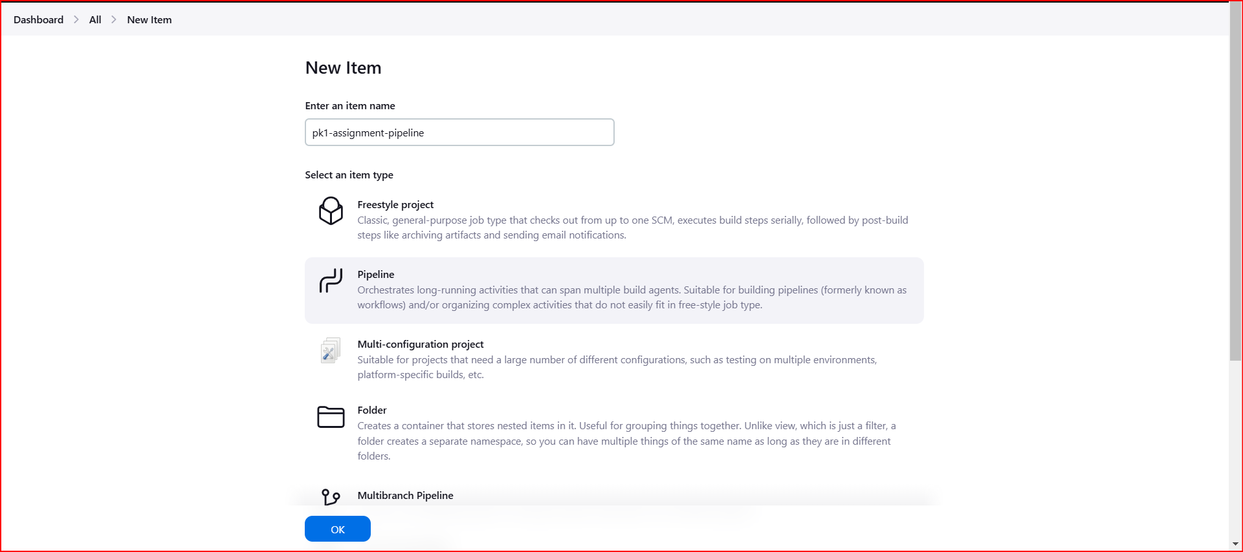

**Triggering the Poll SCM to run every minute**

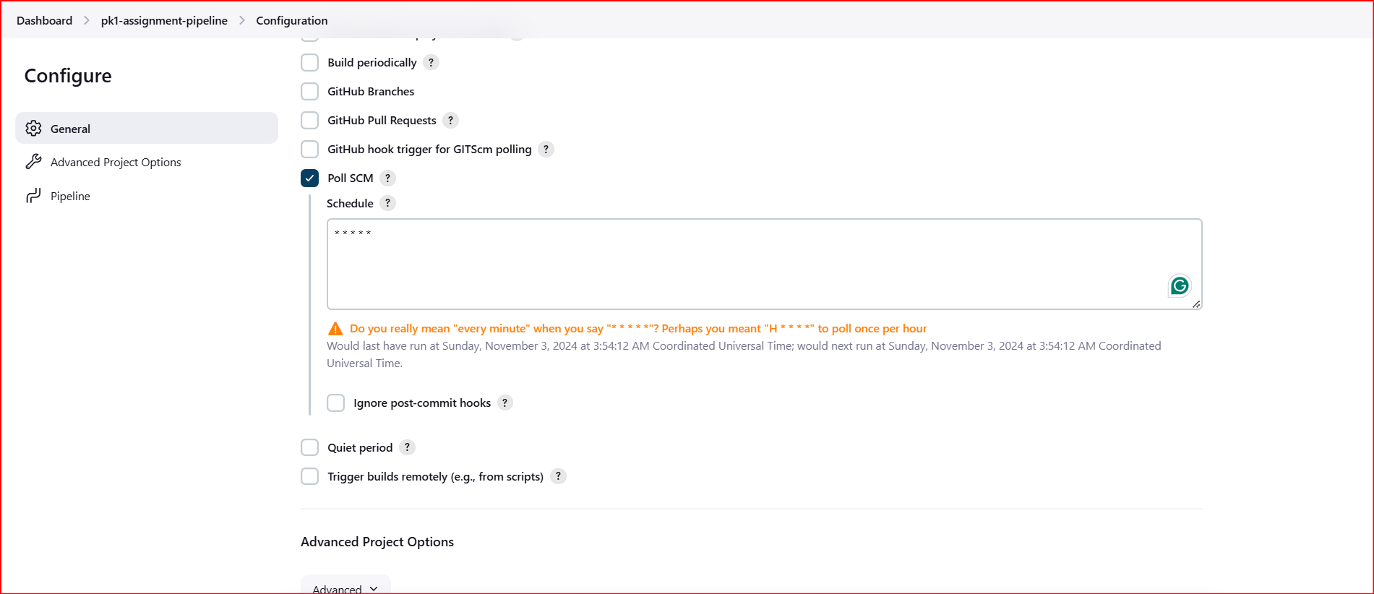

**After committing and pushing change to GitHub the pipeline automatically runs after configuration and till GIT step everything is successful**

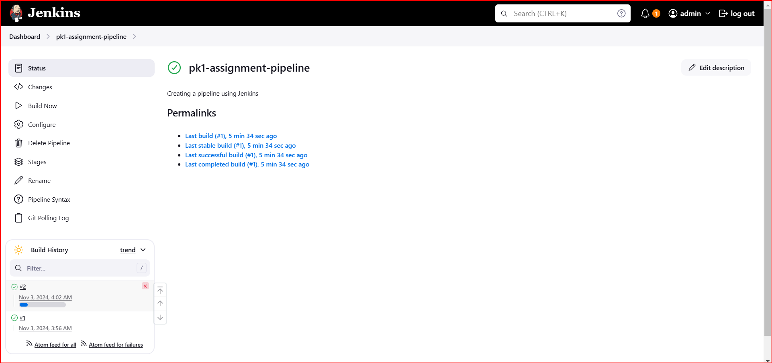

#2 is triggered – Please see the console output

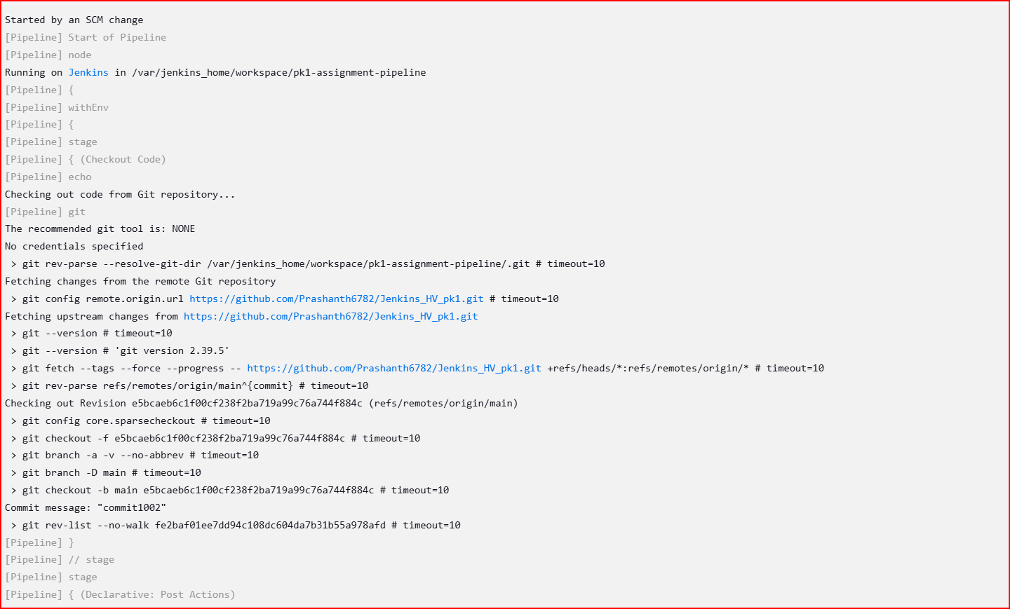

**Execution of the pipeline is shown as below**

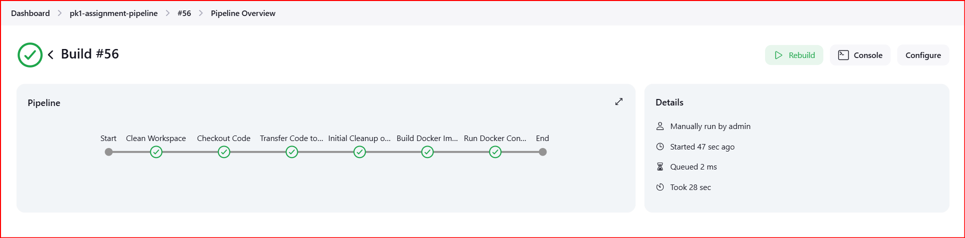

**Console output**

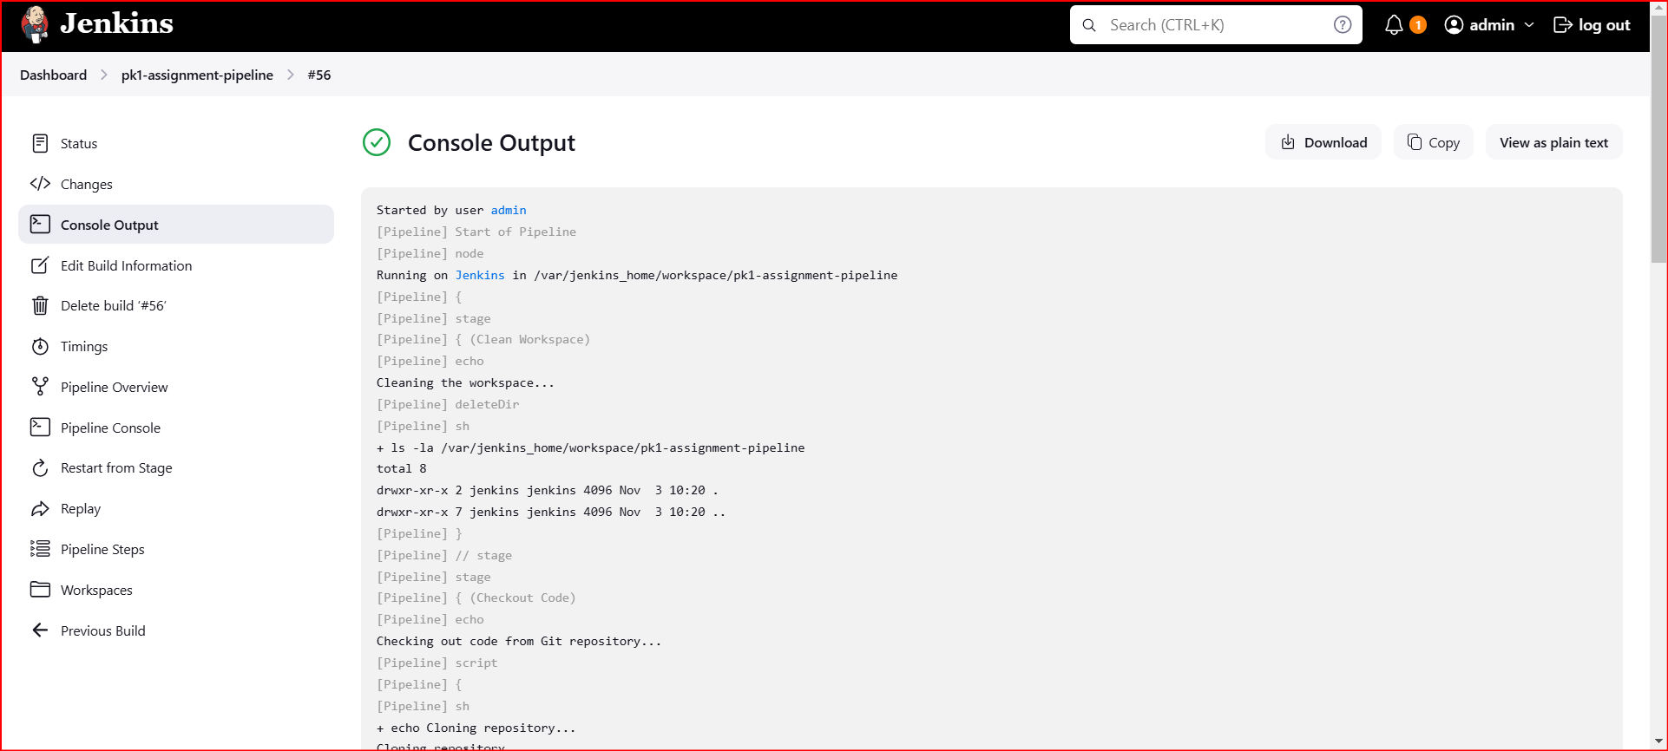

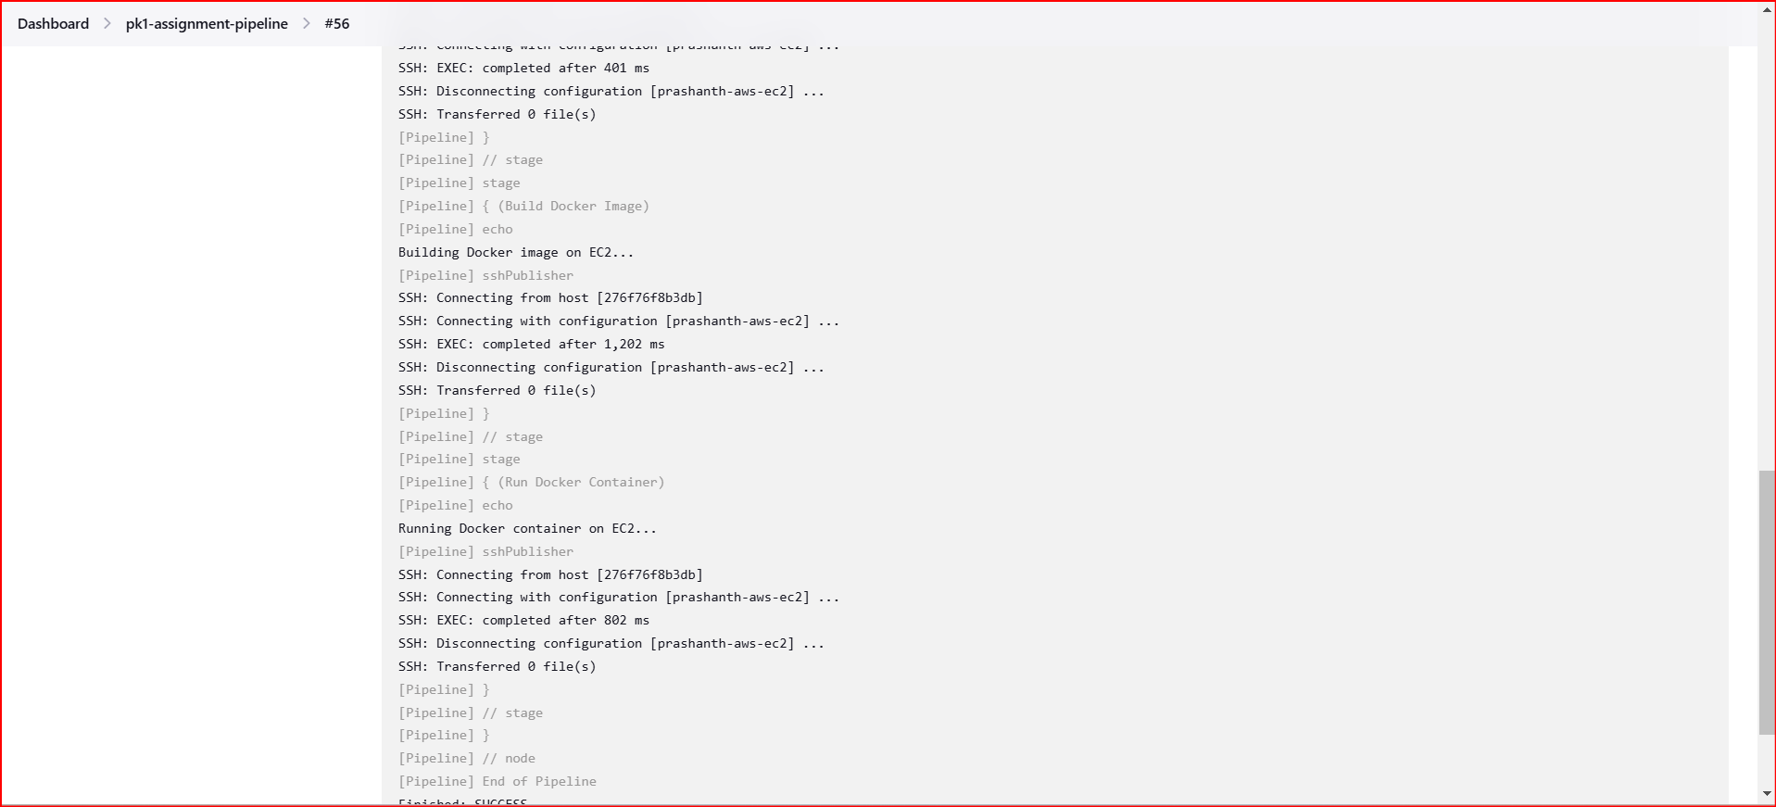

Another console showing the status

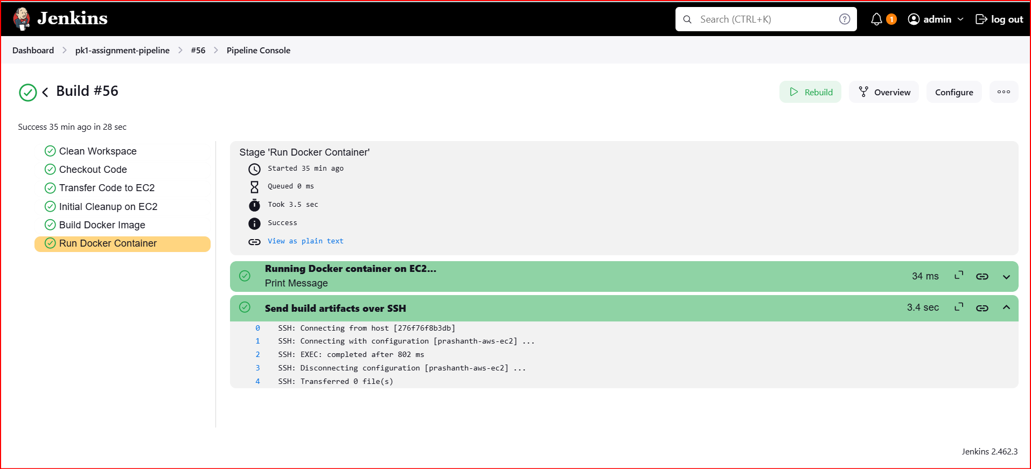

Docker image and container in aws ec2

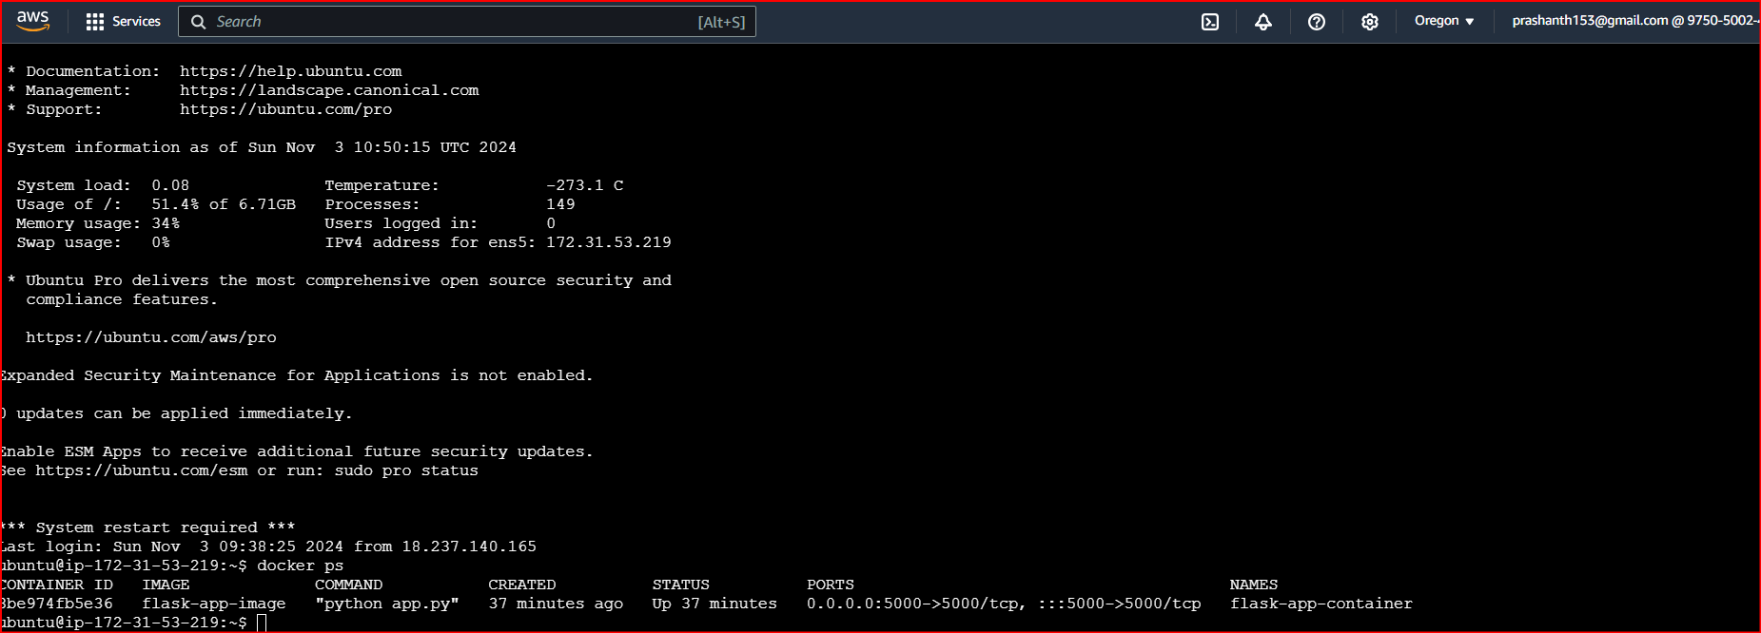

Output of the flask app after deploying in aws ec2

