|  |  |
| --- | --- |
| ***GIT HUB link*** |  |

***Docker compose once created was run with the below command***

***docker-compose up -d***

***Create the below steps and I have used docker compose as well.***

***Basic HTML Page:***

***The code is there in the git repository***

***2. Nginx Configuration:***

***- Create an Nginx configuration file named `nginx.conf` that serves the `index.html` page.***

***- Configure Nginx to listen on port 80.***

***3. Dockerfile:***

***- Create a `Dockerfile` to define the Docker image.***

***- Use an official Nginx base image.***

***- Copy the `index.html` and `nginx.conf` files into the appropriate location in the container.***

***- Ensure that the Nginx server is started when the container is run.***

***4. Building the Docker Image:***

***- Build the Docker image using the `Dockerfile`.***

***I created an ubuntu Ec2 instance with the ARM architecture and installed the AWS CLI for the same…***

***Did the “aws configure” then***

***Finally login succeeded as shown below***

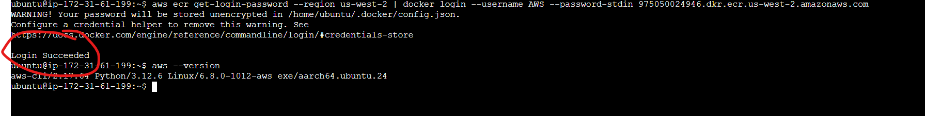

***After saving the docker image I transferred the saved docker image to Ec2 instance via winscp as shown below***

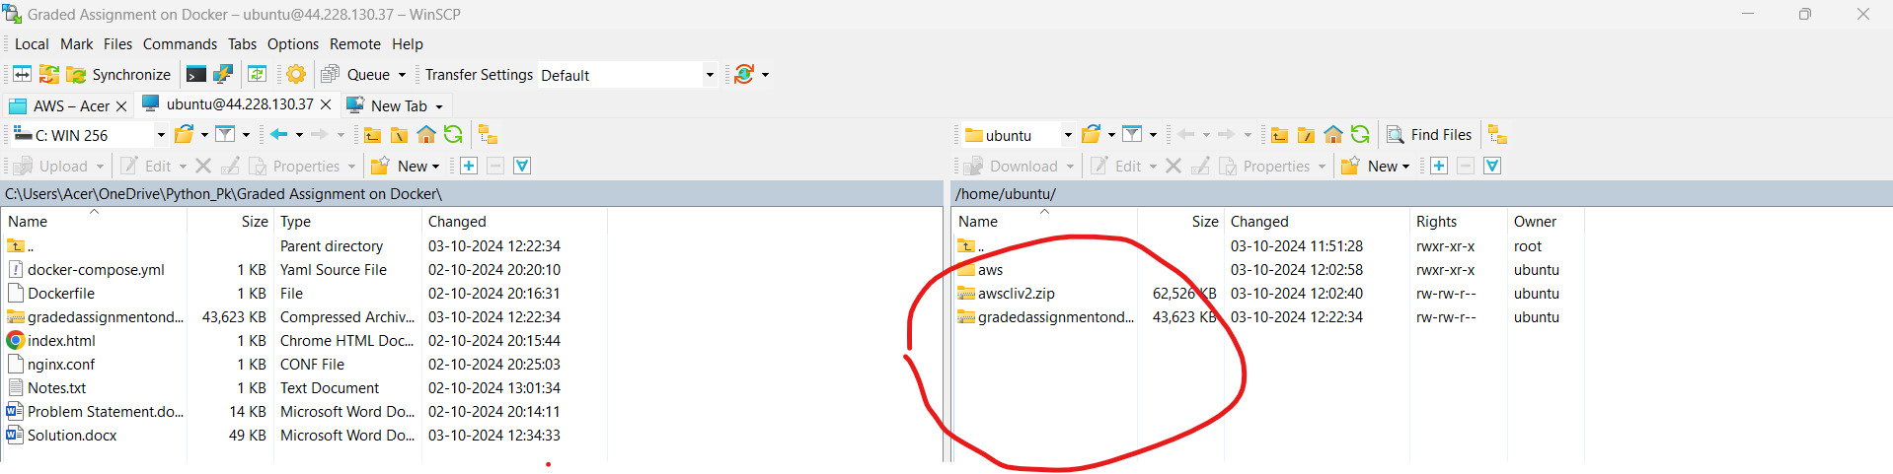

***Once connected to the EC2 instance, load the Docker image from the .tar file:***

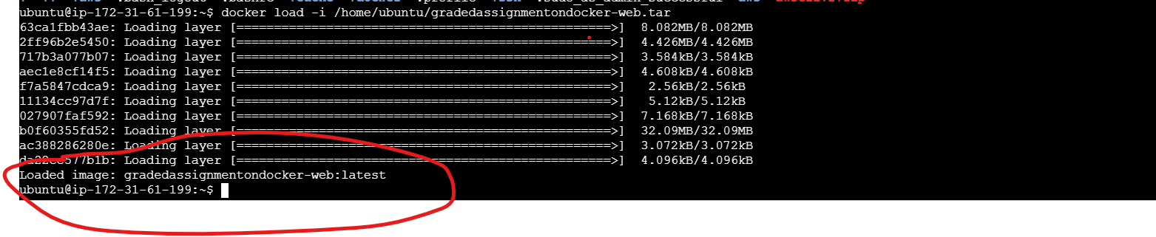

***You need to tag your local Docker image with the Amazon ECR repository URI. Assuming your local image is pk1-repo:latest, you would tag it like this:***

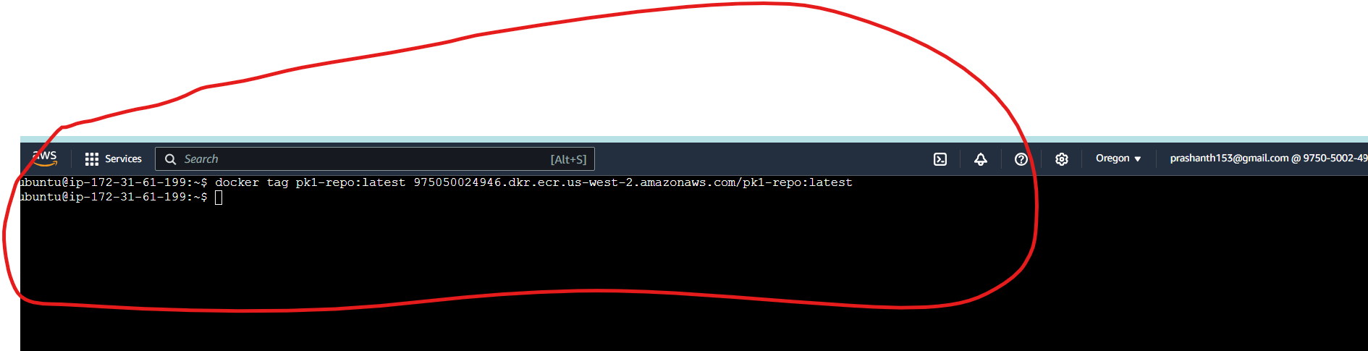

***Verify the tagging the images***

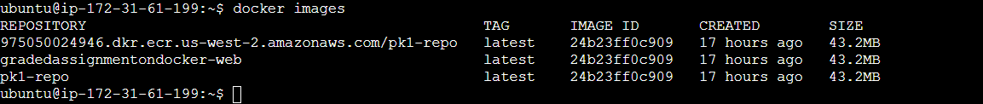

***Pushing the image to ECR finally***

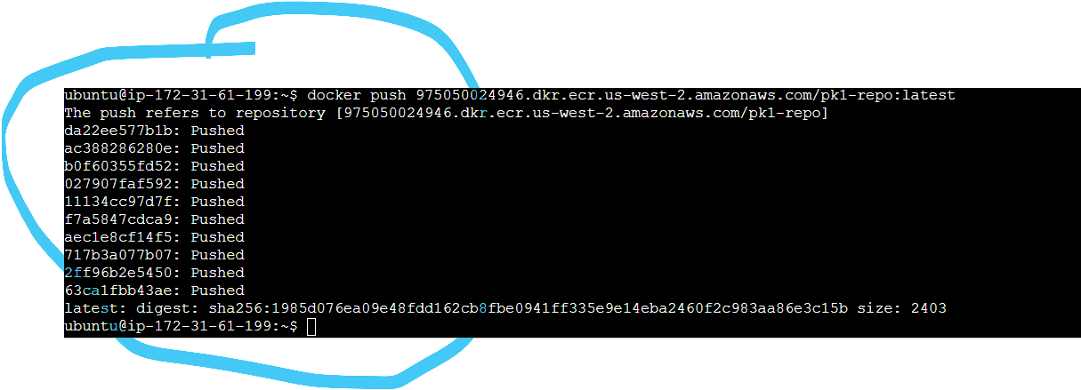

***Verifying the image in console (ECR)***

