# **All the scripts code are in:**

Shell-Scripting-Assignment-Hero-Vired-\scripts_herovired

**GITHUB repository:**

**https://github.com/Prashanth6782/Shell-Scripting-Assignment-Hero-Vired-.git**

# **Question 1**

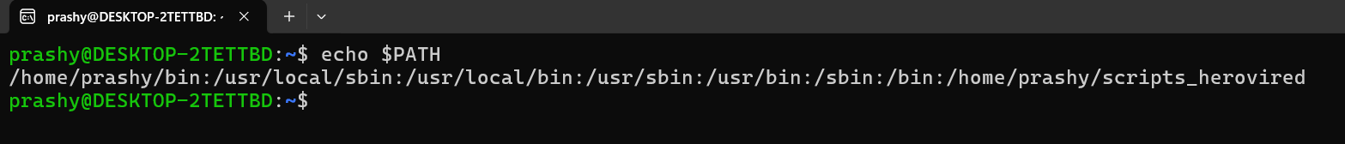

***Execute the script and show the output***

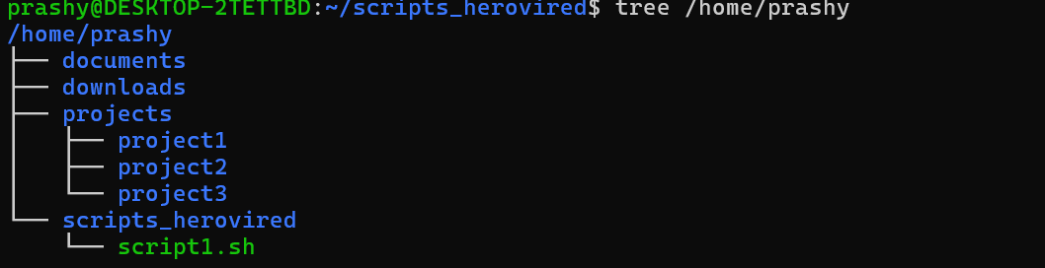

# **Question 2**

***Execute the script and show the output***

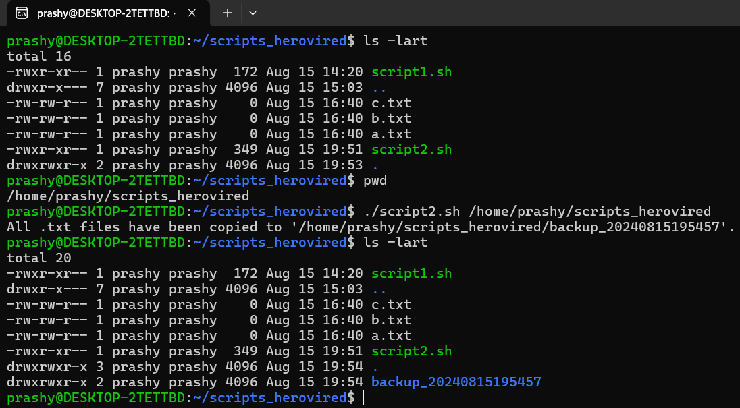

***Inside the backups we have only the text files***

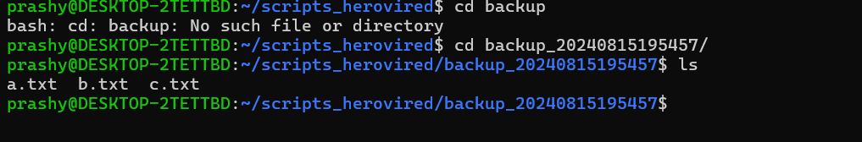

# **Question 3**

***Execute the script and show the output***

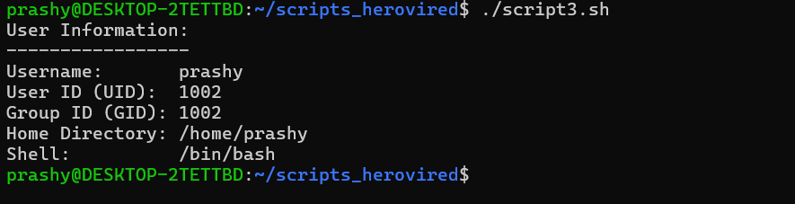

# **Question 4**

***Execute the script and show the output***

***Message is displayed that the cpu is within the limits***

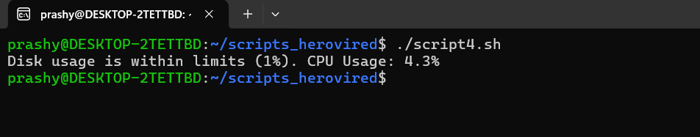

# **Question 5**

***Execute the script and show the output***

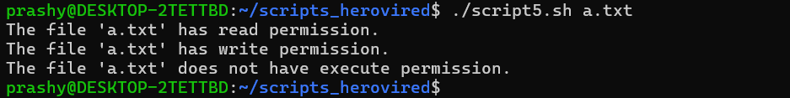

***LS command to verify the permissions once***

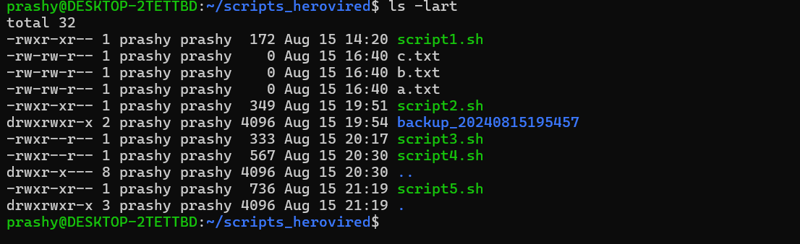

# **Question 6**

***Execute the script and show the output***

***Contents of the documents folder – 3 files***

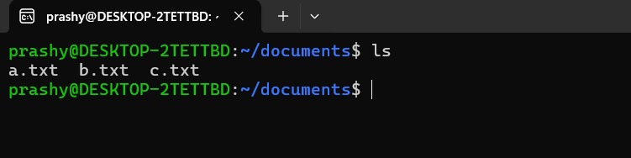

***Cron job settings for the daily execution***

***This will maje sure cron job will be executed once at 00:00 midnight***

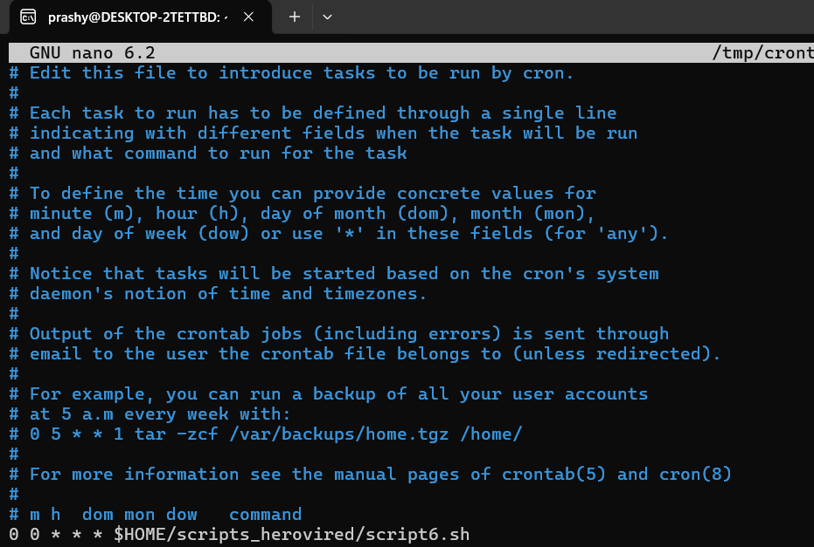

***Im just executing this script once manullay and captured the output***

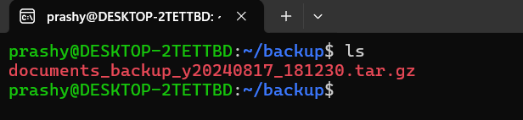

***Tar commands shows the list of files in the zipped file for validation***

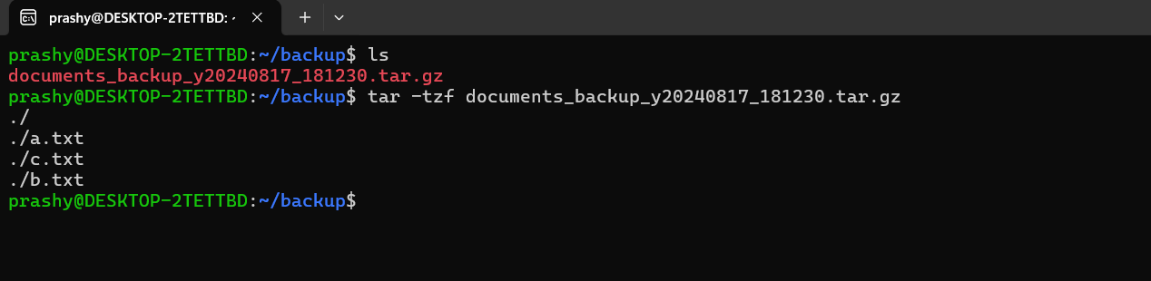

# **Question 7**

***Execute the script and show the output***

***When already apache is up and running***

***It reports that apache is already running as expected***

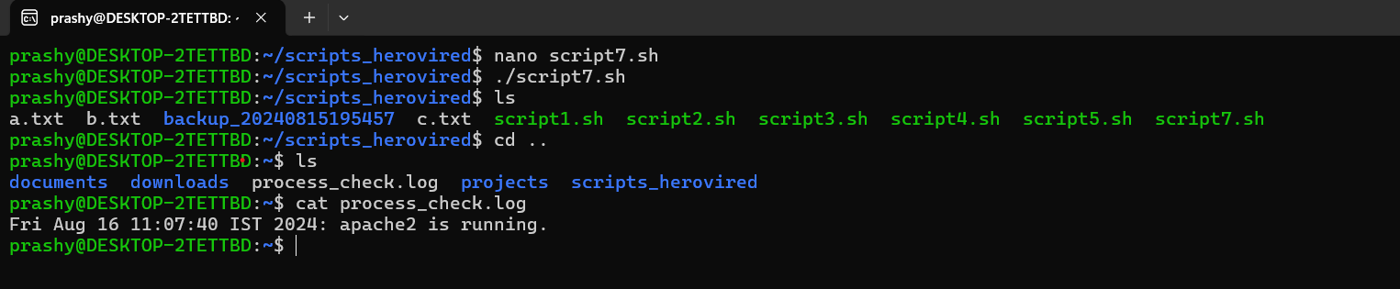

***When already apache is not up and running this tries to start apache I have checked manually the status***

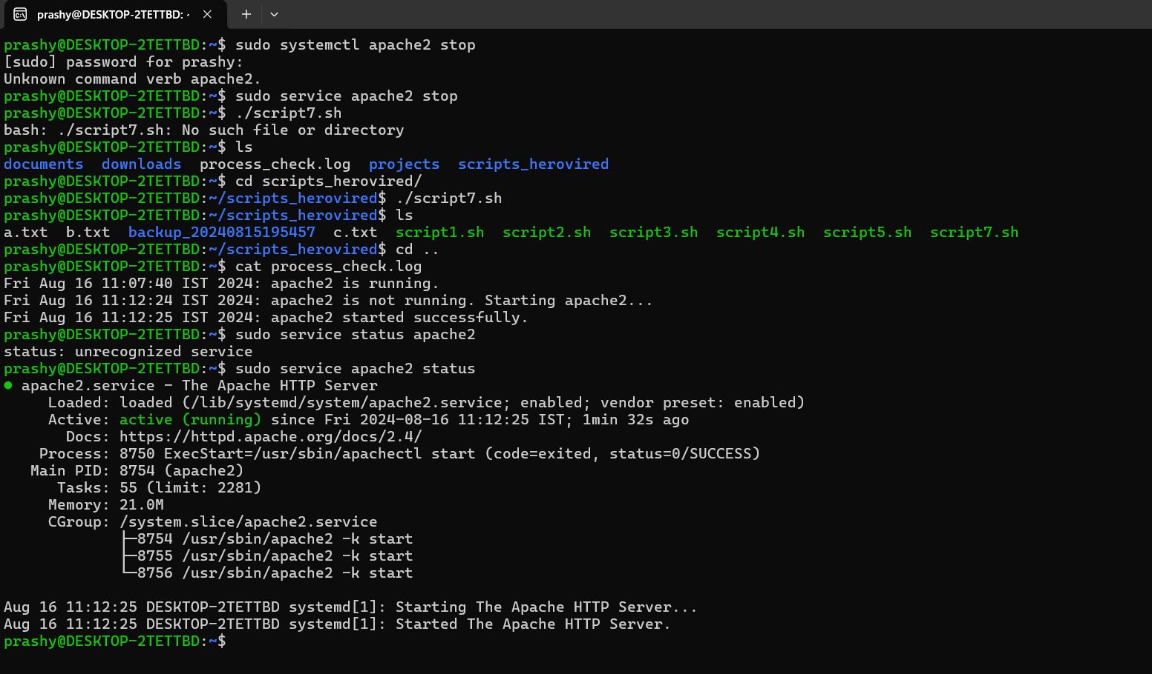

# **Question 8**

***Execute the script and show the output***

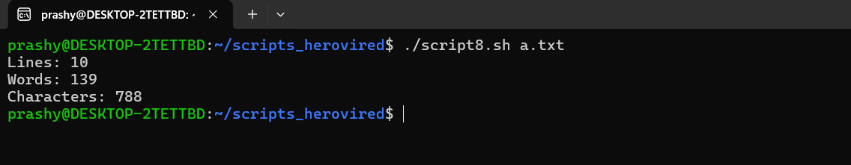

# **Question 9**

***Execute the script and show the output***

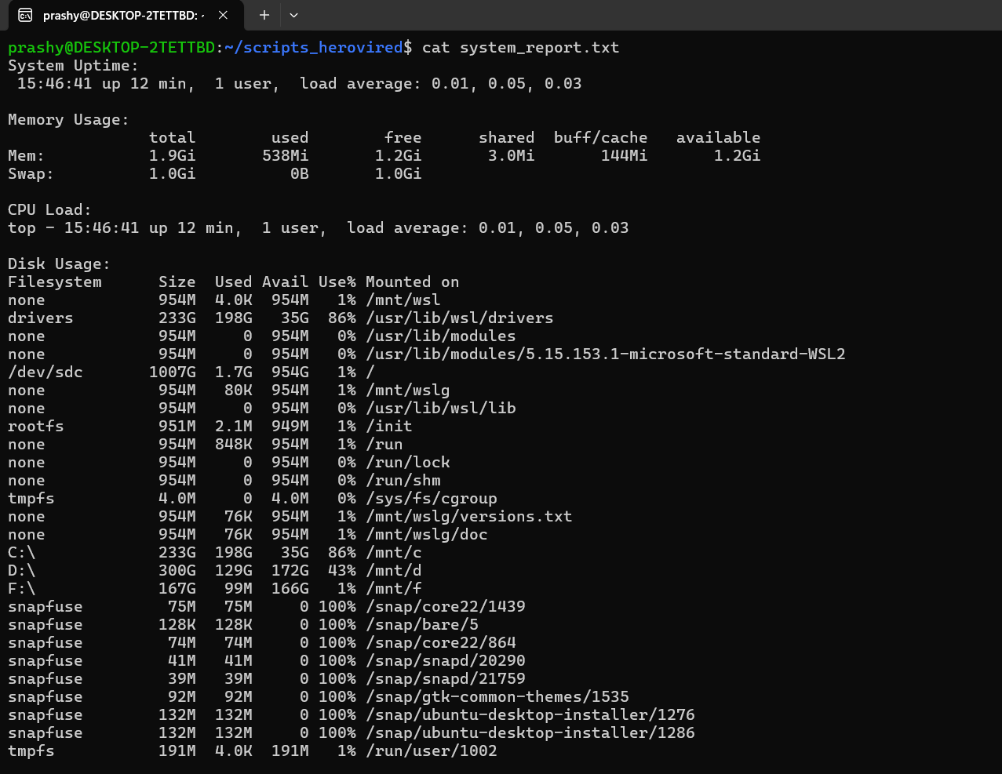

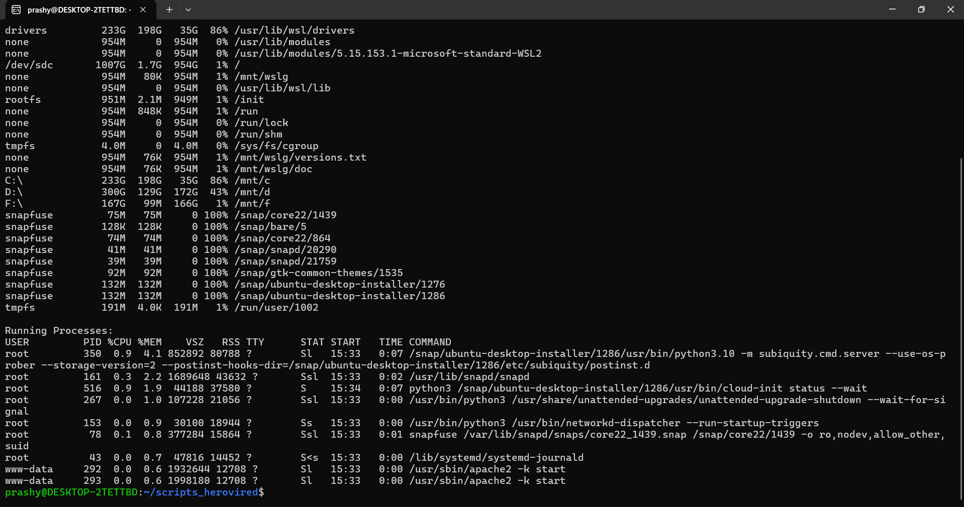

# **Question 10**

***Execute the script and show the output***

***Division with floating point since we are using bc***

***We have given only 2 decimal places in the script for decimal values as we have given***

***Scale =2 in the code***

