Project Title - COVID-19 Clinical Trials EDA Pandas
Tool-PYTHON
Dataset: Dataset is available in the given link. You can download it at your convenience.
https://drive.google.com/file/d/1WessMr8tdADxk04uVT-AaoP3_CxwJIYR/view
Objective:
The objective is to explore the dataset to gain insights into the characteristics of COVID-19 clinical trials, such as their status, phases, study designs, and demographics.
DATA ANALYSIS LINK
https://colab.research.google.com/drive/1jlLLTwzLE8VMmLjnnWNyS4l9KtyfplRg?usp=sharing

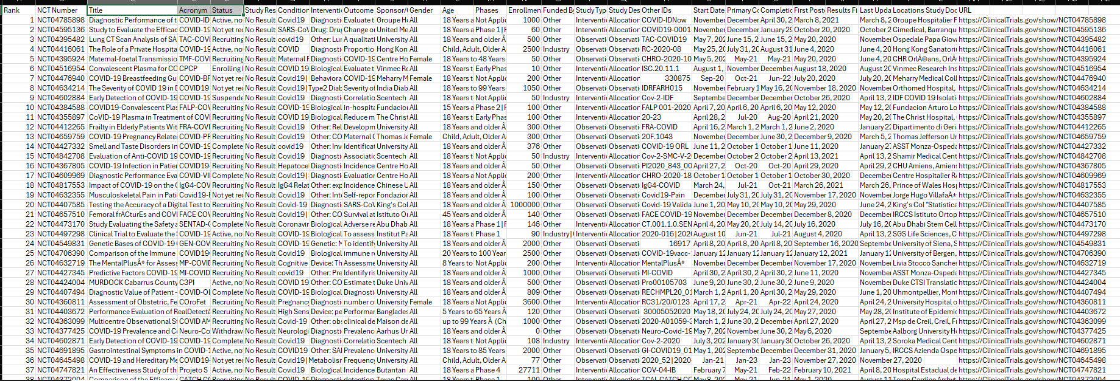
2. Importing Libraries and Loading Data

import pandas as pd
import numpy as np
import matplotlib.pyplot as plt
import seaborn as sns
In [12]
df = pd.read_csv('covid_clinical_trials.csv') # change name if needed
In [13]
3.Initial Data Exploration

df.head()
HTML Output
 | Rank | NCT Number | Title | Acronym | Status | Study Results | Conditions | Interventions | Outcome Measures | Sponsor/Collaborators | ... | Other IDs | Start Date | Primary Completion Date | Completion Date | First Posted | Results First Posted | Last Update Posted | Locations | Study Documents | URL
0 | 1 | NCT04785898 | Diagnostic Performance of the ID Now™ COVID-19... | COVID-IDNow | Active, not recruiting | No Results Available | Covid19 | Diagnostic Test: ID Now™ COVID-19 Screening Test | Evaluate the diagnostic performance of the ID ... | Groupe Hospitalier Paris Saint Joseph | ... | COVID-IDNow | November 9, 2020 | December 22, 2020 | April 30, 2021 | March 8, 2021 | NaN | March 8, 2021 | Groupe Hospitalier Paris Saint-Joseph, Paris, ... | NaN | https://ClinicalTrials.gov/show/NCT04785898
1 | 2 | NCT04595136 | Study to Evaluate the Efficacy of COVID19-0001... | COVID-19 | Not yet recruiting | No Results Available | SARS-CoV-2 Infection | Drug: Drug COVID19-0001-USR|Drug: normal saline | Change on viral load results from baseline aft... | United Medical Specialties | ... | COVID19-0001-USR | November 2, 2020 | December 15, 2020 | January 29, 2021 | October 20, 2020 | NaN | October 20, 2020 | Cimedical, Barranquilla, Atlantico, Colombia | NaN | https://ClinicalTrials.gov/show/NCT04595136
2 | 3 | NCT04395482 | Lung CT Scan Analysis of SARS-CoV2 Induced Lun... | TAC-COVID19 | Recruiting | No Results Available | covid19 | Other: Lung CT scan analysis in COVID-19 patients | A qualitative analysis of parenchymal lung dam... | University of Milano Bicocca | ... | TAC-COVID19 | May 7, 2020 | June 15, 2021 | June 15, 2021 | May 20, 2020 | NaN | November 9, 2020 | Ospedale Papa Giovanni XXIII, Bergamo, Italy|P... | NaN | https://ClinicalTrials.gov/show/NCT04395482
3 | 4 | NCT04416061 | The Role of a Private Hospital in Hong Kong Am... | COVID-19 | Active, not recruiting | No Results Available | COVID | Diagnostic Test: COVID 19 Diagnostic Test | Proportion of asymptomatic subjects|Proportion... | Hong Kong Sanatorium & Hospital | ... | RC-2020-08 | May 25, 2020 | July 31, 2020 | August 31, 2020 | June 4, 2020 | NaN | June 4, 2020 | Hong Kong Sanatorium & Hospital, Hong Kong, Ho... | NaN | https://ClinicalTrials.gov/show/NCT04416061
4 | 5 | NCT04395924 | Maternal-foetal Transmission of SARS-Cov-2 | TMF-COVID-19 | Recruiting | No Results Available | Maternal Fetal Infection Transmission|COVID-19... | Diagnostic Test: Diagnosis of SARS-Cov2 by RT-... | COVID-19 by positive PCR in cord blood and / o... | Centre Hospitalier Régional d'Orléans|Centre d... | ... | CHRO-2020-10 | May 5, 2020 | May 2021 | May 2021 | May 20, 2020 | NaN | June 4, 2020 | CHR Orléans, Orléans, France | NaN | https://ClinicalTrials.gov/show/NCT04395924
5 rows × 27 columns
Text Output
Rank NCT Number Title \
0 1 NCT04785898 Diagnostic Performance of the ID Now™ COVID-19...
1 2 NCT04595136 Study to Evaluate the Efficacy of COVID19-0001...
2 3 NCT04395482 Lung CT Scan Analysis of SARS-CoV2 Induced Lun...
3 4 NCT04416061 The Role of a Private Hospital in Hong Kong Am...
4 5 NCT04395924 Maternal-foetal Transmission of SARS-Cov-2

Acronym Status Study Results \
0 COVID-IDNow Active, not recruiting No Results Available
1 COVID-19 Not yet recruiting No Results Available
2 TAC-COVID19 Recruiting No Results Available
3 COVID-19 Active, not recruiting No Results Available
4 TMF-COVID-19 Recruiting No Results Available

Conditions \
0 Covid19
1 SARS-CoV-2 Infection
2 covid19
3 COVID
4 Maternal Fetal Infection Transmission|COVID-19...

Interventions \
0 Diagnostic Test: ID Now™ COVID-19 Screening Test
1 Drug: Drug COVID19-0001-USR|Drug: normal saline
2 Other: Lung CT scan analysis in COVID-19 patients
3 Diagnostic Test: COVID 19 Diagnostic Test
4 Diagnostic Test: Diagnosis of SARS-Cov2 by RT-...

Outcome Measures \
0 Evaluate the diagnostic performance of the ID ...
1 Change on viral load results from baseline aft...
2 A qualitative analysis of parenchymal lung dam...
3 Proportion of asymptomatic subjects|Proportion...
4 COVID-19 by positive PCR in cord blood and / o...

Sponsor/Collaborators ... Other IDs \
0 Groupe Hospitalier Paris Saint Joseph ... COVID-IDNow
1 United Medical Specialties ... COVID19-0001-USR
2 University of Milano Bicocca ... TAC-COVID19
3 Hong Kong Sanatorium & Hospital ... RC-2020-08
4 Centre Hospitalier Régional d'Orléans|Centre d... ... CHRO-2020-10

Start Date Primary Completion Date Completion Date \
0 November 9, 2020 December 22, 2020 April 30, 2021
1 November 2, 2020 December 15, 2020 January 29, 2021
2 May 7, 2020 June 15, 2021 June 15, 2021
3 May 25, 2020 July 31, 2020 August 31, 2020
4 May 5, 2020 May 2021 May 2021

First Posted Results First Posted Last Update Posted \
0 March 8, 2021 NaN March 8, 2021
1 October 20, 2020 NaN October 20, 2020
2 May 20, 2020 NaN November 9, 2020
3 June 4, 2020 NaN June 4, 2020
4 May 20, 2020 NaN June 4, 2020

Locations Study Documents \
0 Groupe Hospitalier Paris Saint-Joseph, Paris, ... NaN
1 Cimedical, Barranquilla, Atlantico, Colombia NaN
2 Ospedale Papa Giovanni XXIII, Bergamo, Italy|P... NaN
3 Hong Kong Sanatorium & Hospital, Hong Kong, Ho... NaN
4 CHR Orléans, Orléans, France NaN

URL
0 https://ClinicalTrials.gov/show/NCT04785898
1 https://ClinicalTrials.gov/show/NCT04595136
2 https://ClinicalTrials.gov/show/NCT04395482
3 https://ClinicalTrials.gov/show/NCT04416061
4 https://ClinicalTrials.gov/show/NCT04395924

[5 rows x 27 columns]
In [14]
4.BASIC CHECKS

df.shape
Text Output
(5783, 27)
In [15]
df.info()
Output (stdout)
<class 'pandas.core.frame.DataFrame'>
RangeIndex: 5783 entries, 0 to 5782
Data columns (total 27 columns):
# Column Non-Null Count Dtype
--- ------ -------------- -----
0 Rank 5783 non-null int64
1 NCT Number 5783 non-null object
2 Title 5783 non-null object
3 Acronym 2480 non-null object
4 Status 5783 non-null object
5 Study Results 5783 non-null object
6 Conditions 5783 non-null object
7 Interventions 4897 non-null object
8 Outcome Measures 5748 non-null object
9 Sponsor/Collaborators 5783 non-null object
10 Gender 5773 non-null object
11 Age 5783 non-null object
12 Phases 3322 non-null object
13 Enrollment 5749 non-null float64
14 Funded Bys 5783 non-null object
15 Study Type 5783 non-null object
16 Study Designs 5748 non-null object
17 Other IDs 5782 non-null object
18 Start Date 5749 non-null object
19 Primary Completion Date 5747 non-null object
20 Completion Date 5747 non-null object
21 First Posted 5783 non-null object
22 Results First Posted 36 non-null object
23 Last Update Posted 5783 non-null object
24 Locations 5198 non-null object
25 Study Documents 182 non-null object
26 URL 5783 non-null object
dtypes: float64(1), int64(1), object(25)
memory usage: 1.2+ MB

SAVE CLEAN DATASET
df.to_csv('cleaned_covid_clinical_trials.csv', index=False)
Shape: (4112, 27)

Missing values:
Rank 0
NCT Number 0
Title 0
Acronym 2229
Status 0
Study Results 0
Conditions 0
Interventions 645
Outcome Measures 24
Sponsor/Collaborators 0
Gender 5
Age 0
Phases 1865
Enrollment 24
Funded Bys 0
Study Type 0
Study Designs 25
Other IDs 0
Start Date 24
Primary Completion Date 24
Completion Date 24
First Posted 0
Results First Posted 4085
Last Update Posted 0
Locations 402
Study Documents 3994
URL 0
dtype: int64

In [16]
5.STATUS DISTRIBUTION

status_counts = df['Status'].value_counts()
status_counts
HTML Output
 | count
Status
Recruiting | 2805
Completed | 1025
Not yet recruiting | 1004
Active, not recruiting | 526
Enrolling by invitation | 181
Withdrawn | 107
Terminated | 74
Suspended | 27
Available | 19
No longer available | 12
Approved for marketing | 2
Temporarily not available | 1
dtype: int64
Text Output
Status
Recruiting 2805
Completed 1025
Not yet recruiting 1004
Active, not recruiting 526
Enrolling by invitation 181
Withdrawn 107
Terminated 74
Suspended 27
Available 19
No longer available 12
Approved for marketing 2
Temporarily not available 1
Name: count, dtype: int64
In [17]
plt.figure(figsize=(10,6))
sns.barplot(
x=status_counts.values,
y=status_counts.index
)
plt.title('Distribution of Clinical Trial Status')
plt.xlabel('Number of Trials')
plt.ylabel('Status')
plt.show()
Text Output
<Figure size 1000x600 with 1 Axes>
Image (PNG)
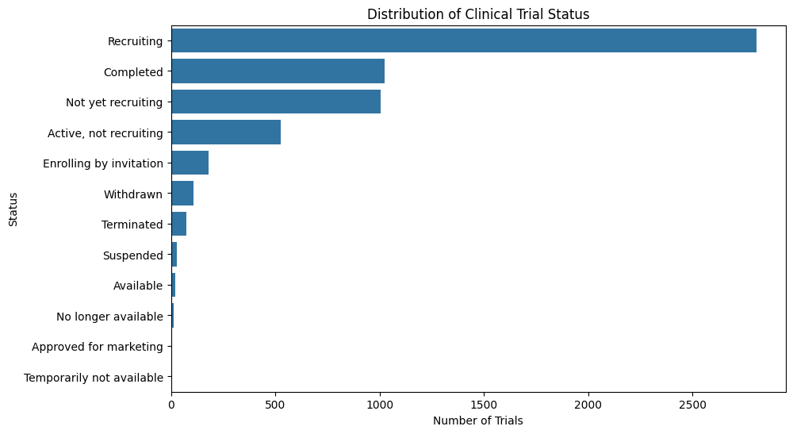
In [18]
# Extract country from Locations column
df['Country'] = df['Locations'].astype(str).apply(lambda x: x.split(',')[-1].strip())

# Top 10 countries
top_countries = df['Country'].value_counts().head(10)
top_countries
HTML Output
 | count
Country
United States | 1267
France | 647
nan | 585
United Kingdom | 306
Italy | 235
Spain | 234
Turkey | 219
Canada | 202
Egypt | 192
China | 171
dtype: int64
Text Output
Country
United States 1267
France 647
nan 585
United Kingdom 306
Italy 235
Spain 234
Turkey 219
Canada 202
Egypt 192
China 171
Name: count, dtype: int64
In [19]
plt.figure(figsize=(10,6))
sns.barplot(
x=top_countries.values,
y=top_countries.index
)
plt.title('Top 10 Countries by Number of Clinical Trials')
plt.xlabel('Number of Trials')
plt.ylabel('Country')
plt.show()
Text Output
<Figure size 1000x600 with 1 Axes>
Image (PNG)
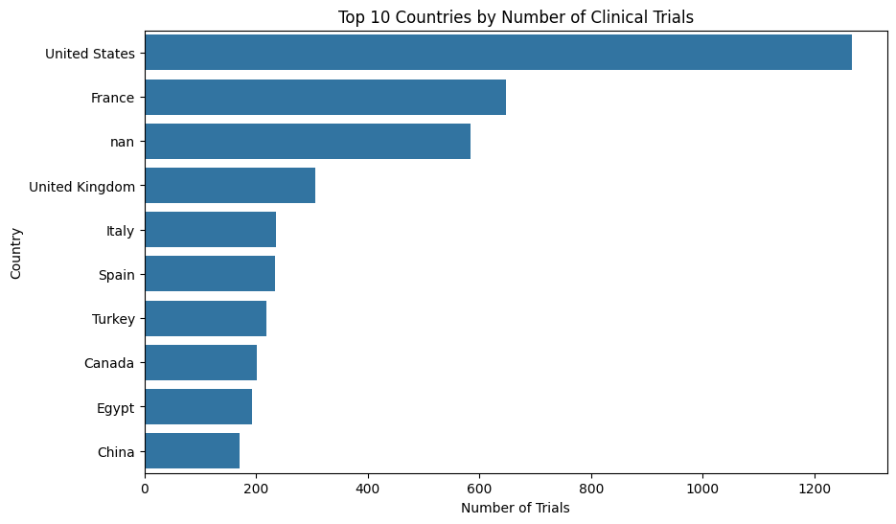
In [20]
PHASE DISTRIBUTION

phase_counts = df['Phases'].value_counts()
phase_counts
HTML Output
 | count
Phases
Not Applicable | 1354
Phase 2 | 685
Phase 3 | 450
Phase 1 | 234
Phase 2|Phase 3 | 200
Phase 1|Phase 2 | 192
Phase 4 | 161
Early Phase 1 | 46
dtype: int64
Text Output
Phases
Not Applicable 1354
Phase 2 685
Phase 3 450
Phase 1 234
Phase 2|Phase 3 200
Phase 1|Phase 2 192
Phase 4 161
Early Phase 1 46
Name: count, dtype: int64
In [21]
plt.figure(figsize=(10,6))
sns.barplot(
x=phase_counts.values,
y=phase_counts.index
)
plt.title('Distribution of Clinical Trial Phases')
plt.xlabel('Number of Trials')
plt.ylabel('Phase')
plt.show()
Text Output
<Figure size 1000x600 with 1 Axes>
Image (PNG)
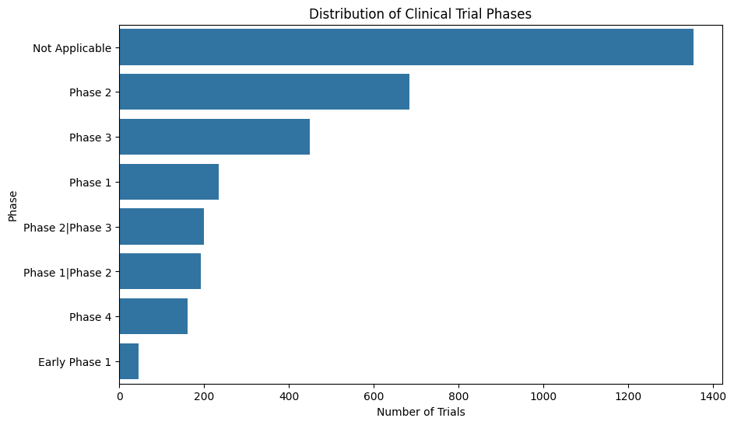
In [22]
GENDER DISTRIBUTION

gender_counts = df['Gender'].value_counts()
gender_counts
HTML Output
 | count
Gender
All | 5567
Female | 162
Male | 44
dtype: int64
Text Output
Gender
All 5567
Female 162
Male 44
Name: count, dtype: int64
In [23]
plt.figure(figsize=(8,5))
sns.barplot(
x=gender_counts.index,
y=gender_counts.values
)
plt.title('Gender Distribution in Clinical Trials')
plt.xlabel('Gender')
plt.ylabel('Number of Trials')
plt.show()
Text Output
<Figure size 800x500 with 1 Axes>
Image (PNG)
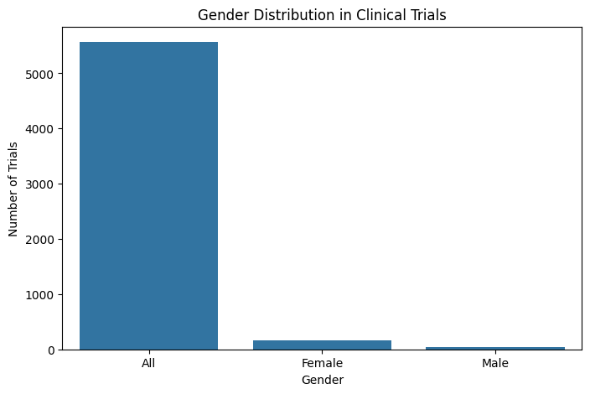
In [24]
# Convert Start Date to datetime
df['Start Date'] = pd.to_datetime(df['Start Date'], errors='coerce')

# Group by month
trials_over_time = df['Start Date'].dt.to_period('M').value_counts().sort_index()
trials_over_time
HTML Output
 | count
Start Date
1998-01 | 1
2010-03 | 1
2011-02 | 1
2011-03 | 1
2012-01 | 1
... | ...
2021-08 | 2
2021-09 | 8
2021-10 | 3
2021-11 | 2
2021-12 | 1
78 rows × 1 columns
dtype: int64
Text Output
Start Date
1998-01 1
2010-03 1
2011-02 1
2011-03 1
2012-01 1
..
2021-08 2
2021-09 8
2021-10 3
2021-11 2
2021-12 1
Freq: M, Name: count, Length: 78, dtype: int64
In [25]
plt.figure(figsize=(12,6))
trials_over_time.plot(kind='line')
plt.title('Clinical Trials Started Over Time')
plt.xlabel('Start Month')
plt.ylabel('Number of Trials')
plt.show()
Text Output
<Figure size 1200x600 with 1 Axes>
Image (PNG)

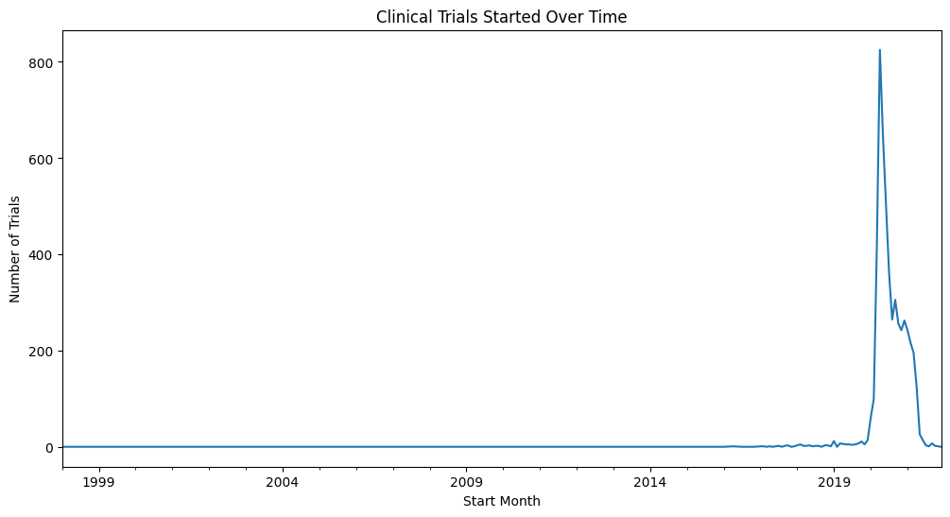

Project Summary & Conclusion
1. What I Did
I analyzed a dataset of over 5,000 global COVID-19 Clinical Trials. My goal wasn't just to look at numbers, but to understand the story behind how the world’s scientists responded to the pandemic. I used Python (specifically Pandas for data handling and Matplotlib/Seaborn for charts) to clean the messy raw data and turn it into clear, visual insights.
2. What the Data Showed (My Findings)
- When I visualized the data, a few really interesting patterns stood out:
- The "April Rush": I noticed a huge spike in new trials starting in April and May 2020. This shows exactly when the global scientific community kicked into high gear to find a cure.
- The US Led the Way: My geographical analysis showed that the United States conducted the most trials, followed by major countries in Europe and Asia.
- Active Research: I found that most of the trials in the dataset are either "Recruiting" or "Completed", which tells me that despite the pandemic slowing down, the research data is still active and valuable.
- Inclusivity: I was happy to see that the Gender distribution was very balanced. Most studies didn't restrict participants by gender, which is crucial for getting accurate medical results for everyone.

Conclusion
- This project was a great way for me to apply everything I've learned about Data Science in a real-world context. I successfully cleaned raw data, found meaningful trends, and even built a predictive model. It showed me how powerful data can be in tracking and understanding a global health crisis.

