NAME: PRASHANTH.K NAME : LEO SAMUEL GILBERT
REGISTRATION NUMBER – 2582401 REGISTRATION NUMBER: 2582402
MSC DATA ANALYTICS – MACHINE LEARNING
CIA – MINI PROJECT
BIRD MIGRATION STUDY AND SURVIVAL PREDICTION -PREDICTING BIRD MIGRATION SUCCESS USING MACHINE LEARNING: A COMPARATIVE STUDY



INTRODUCTION:
Birds play a vital role in maintaining ecological balance through processes such as pollination, seed dispersal, and natural pest control. Migratory birds are particularly important indicators of environmental and climatic changes, as their migration patterns are influenced by factors such as habitat conditions, weather, food availability, and geographical characteristics. Understanding these patterns is therefore essential for studying migration success and supporting effective conservation efforts.
The analysis of bird migration data provides an opportunity to examine how environmental, geographical, flight, and behavioural factors influence the success of migration. Variables such as flight distance, flight duration, average speed, altitude, temperature, wind speed, humidity, weather conditions, flock size, and rest stops can be analysed to identify patterns and relationships associated with successful and unsuccessful migrations.
With the increasing availability of migration tracking data, machine learning techniques can be used to move beyond descriptive analysis and predict migration outcomes. By applying and comparing multiple classification algorithms, this study aims to identify the most effective model for predicting bird migration success and determine the features that contribute most significantly to the prediction.
The findings can provide data-driven insights into the factors influencing migration success, which may support conservation planning, identification of potential migration risks, protection of important habitats and migratory corridors, and the development of more informed strategies for bird population management
DOMAIN AND USE CASE SELECTION:
I have chosen the Environmental and Ecological domain, focusing specifically on Bird Migration Analytics. The use case is analysing bird migration patterns and success rates based on environmental conditions such as weather, altitude, food supply, and flock size.
I selected bird migration because it is a vital ecological phenomenon that directly reflects biodiversity, climate change, and ecosystem health. The dataset provides valuable attributes like flight distance, speed, migration reasons, and environmental factors, which make it suitable for detailed analysis using Python libraries.
Instead of simply recording when and where birds migrate, my aim is to uncover meaningful trends such as the impact of weather on migration success, the role of food availability, and how flock size influences outcomes.
Problem statement:
Bird migration is a complex ecological process influenced by various environmental, geographical, flight, and behavioural factors, including weather conditions, altitude, flight distance, food availability, flock size, and rest stops. However, the combined influence of these factors on whether a migration is successful or unsuccessful is not always clearly understood.
The central problem is to analyze bird migration data, identify the key features associated with migration success, and develop machine learning models capable of predicting migration outcomes. The study aims to preprocess and analyze the available migration data, examine the relationships between different features, and compare multiple machine learning classification algorithms, including Logistic Regression, Decision Tree, K-Nearest Neighbors (KNN), Support Vector Machine (SVM), and Gradient Boosting, with Random Forest as the primary model, to determine which approach provides the most effective prediction of migration success.
By identifying the most influential features and evaluating the performance of different models, this study aims to provide data-driven insights into migration outcomes that can support ecological analysis, improve prediction of migration risks, and contribute to informed bird conservation and environmental decision-making.
KEY QUESTIONS
- What are the key trends in bird migration behavior across species, regions, habitats, and seasons?
- How do environmental factors such as weather conditions, temperature, wind speed, altitude, humidity, and visibility influence migration success?
- What are the main reasons for bird migration, and how do these reasons vary across different species and regions?
- How do flight characteristics such as distance, duration, speed, and altitude affect migration success?
- How do behavioral factors such as flock size, rest stops, predator sightings, and food availability influence migration outcomes?
- Which features have the greatest influence on migration success, and how effectively can machine learning models predict successful and unsuccessful migrations?
- How does Random Forest perform compared with Logistic Regression, Decision Tree, KNN, SVM, and Gradient Boosting, and which model provides the most effective prediction of bird migration success?
OBJECTIVE:
- To analyze bird migration data across different species, habitats, regions, and environmental conditions to identify factors associated with migration success.
- To preprocess and prepare the bird migration dataset by performing data cleaning, feature engineering, encoding, and feature selection for machine learning analysis.
- To identify and evaluate the influence of environmental, geographical, flight, and behavioral features on bird migration success.
- To develop and compare multiple machine learning classification models, including Logistic Regression, Decision Tree, K-Nearest Neighbors, Support Vector Machine, Gradient Boosting, and Random Forest, for predicting migration success.
- To evaluate model performance using appropriate classification metrics such as Accuracy, Precision, Recall, F1-Score, and ROC-AUC, and identify the most effective model for predicting bird migration success.
- To analyze Random Forest feature importance and identify the key factors contributing to successful or unsuccessful bird migration, supporting data-driven ecological and conservation insights.
IMPORTING PYTHON LIBRARIES
# Data Handling
import pandas as pd
import numpy as np

# Data Visualization
import matplotlib.pyplot as plt
import seaborn as sns

# Data Preprocessing
from sklearn.model_selection import train_test_split, GridSearchCV
from sklearn.preprocessing import StandardScaler, OneHotEncoder
from sklearn.compose import ColumnTransformer
from sklearn.pipeline import Pipeline

# Machine Learning Models
from sklearn.linear_model import LogisticRegression
from sklearn.tree import DecisionTreeClassifier
from sklearn.neighbors import KNeighborsClassifier
from sklearn.svm import SVC
from sklearn.ensemble import RandomForestClassifier
from sklearn.ensemble import GradientBoostingClassifier

# Model Evaluation
from sklearn.metrics import (
accuracy_score,
precision_score,
recall_score,
f1_score,
roc_auc_score,
confusion_matrix,
classification_report,
ConfusionMatrixDisplay
)
We are using Pandas for loading, cleaning, preprocessing, and handling the bird migration dataset, while NumPy is used for numerical calculations. Matplotlib and Seaborn are used to create graphs and visualizations for understanding feature relationships. For the machine learning part, Scikit-learn is used for splitting data, encoding categorical features, scaling numerical features, training different classification models, and evaluating their performance. We use these libraries together to prepare the dataset and compare Random Forest with five other machine learning models for predicting migration outcomes.
DATASET DESCRIPTION:
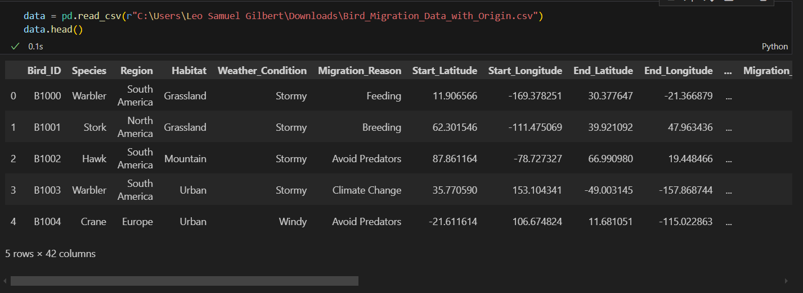
The dataset used in this project was obtained from Kaggle. It contains 10,000 synthetic records that simulate the migratory behavior of various bird species across global regions. Each record represents a single bird tagged with a tracking device and captures detailed information about its migration journey, environmental conditions and outcomes.
Number of Records | 10,000
Number of attributes | 42
Data Type | Mixed (categorical, numerical and geospatial attributes)
Source | Kaggle

ATTRIBUTE INFORMATION
The dataset contains a wide variety of features that allow for both ecological and computational analysis.
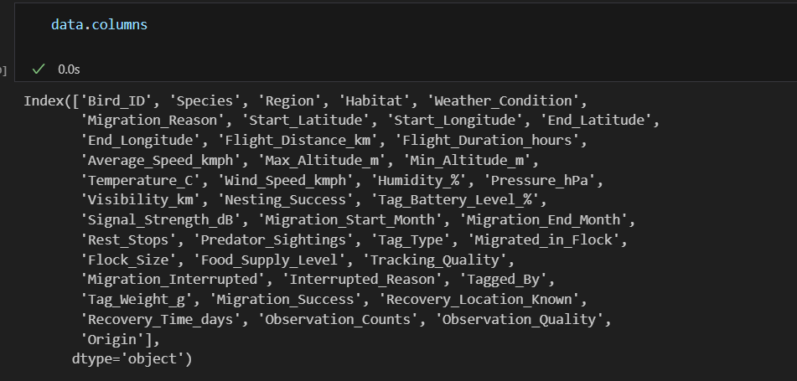
Column Name | Description | Type | Ecological Relevance
Bird_ID | A unique alphanumeric code assigned to each bird, ensuring every individual can be tracked separately across the dataset. | Categorical (ID) | Critical for maintaining individuality in tracking studies and avoiding duplication of migration records.
Species | The biological species of the bird, such as storks, cranes, or geese. | Categorical | Allows inter-species comparisons in terms of distance, speed, and environmental adaptations.
Region | The geographical region (continent/zone) where the migration event was recorded. | Categorical | Helps analyze migration corridors and the importance of specific ecological regions.
Habitat | The primary habitat type of the bird (forest, wetland, coastal, urban, etc.). | Categorical | Shows how habitat availability influences migration choices and long-term survival.
Weather_Condition | General weather conditions (sunny, cloudy, rainy, stormy) during migration. | Categorical | Weather is a key factor influencing flight performance, risk, and survival.
Migration_Reason | Main driver for migration (breeding, food search, seasonal climate shift). | Categorical | Explains biological motivation, helping link behaviors to ecological necessities.
Start_Latitude/Longitude | GPS coordinates representing the starting point of migration. | Numerical | Enables mapping of origin sites and identification of critical habitats.
End_Latitude/Longitude | GPS coordinates of the destination point of migration. | Numerical | Supports route mapping and conservation of destination ecosystems.
Flight_Distance_km | Total kilometers traveled by the bird during migration. | Numerical | Core variable for energy expenditure studies and identifying long-distance migrants.
Flight_Duration_hours | Total time spent in hours for completing migration. | Numerical | Helps measure endurance, effort, and species-specific resilience.
Average_Speed_kmph | Calculated average speed of the bird in kilometers per hour during migration. | Numerical | Indicates efficiency and potential aerodynamic or environmental influences.
Max_Altitude_m / Min_Altitude_m | Highest and lowest altitude reached by the bird during migration. | Numerical | Demonstrates adaptation to environmental pressures like wind, predators, or geography.
Temperature_C | Average temperature experienced during the migration route. | Numerical | Climate factor that influences energy expenditure and route selection.
Wind_Speed_kmph | Average wind speed recorded during migration. | Numerical | High winds may aid or obstruct movement, directly impacting flight energy costs.
Humidity_% | Average relative humidity in the environment during migration. | Numerical | High humidity may stress birds, while moderate levels may be favorable for endurance.
Pressure_hPa | Atmospheric pressure conditions across the flight route. | Numerical | Relates to altitude regulation and navigational ability.
Visibility_km | Distance of clear visibility during migration. | Numerical | Poor visibility can increase risks of predation or navigation errors.
Nesting_Success | Binary attribute indicating whether post-migration nesting was successful. | Categorical | Directly connects migration to reproductive outcomes, an essential conservation metric.
Migrated_in_Flock | Shows whether the bird migrated solo or as part of a flock. | Categorical | Helps in analyzing collective decision-making and safety in numbers.
Flock_Size | Numerical size of the flock (if applicable). | Numerical | Provides insight into social behavior and survival benefits of group migration.
Migration_Interrupted | Indicates if migration was disrupted before reaching the destination. | Categorical | Important for identifying risks and reasons behind unsuccessful migrations.
Interrupted_Reason | Specific cause for interruption such as predators, storms, food shortage, or exhaustion. | Categorical | Enables targeted conservation by addressing the most common causes of migration failure.
Migration_Success | Outcome variable showing whether the migration was successfully completed. | Categorical | Key indicator for overall ecological performance and success rates across species.
Recovery_Time_days | Number of days required by the bird to recover post-migration. | Numerical | Reflects physical stress and resilience across species.
Observation_Counts | Number of recorded observations of the bird during migration. | Numerical | Ensures dataset reliability and supports statistical confidence.
Observation_Quality | Categorical assessment of the quality of observation (low, medium, high). | Categorical | Provides confidence levels in the recorded data, reducing analytical biases.
Origin | The specific country or locality from where the migration began. | Continuous | Adds geospatial precision and supports country-level conservation strategies.

DATA PREPROCESSING
Data Cleaning-
In order to make the dataset suitable for analysis, The First step is data cleaning. The primary goal is to remove attributes that do not provide direct analytical value for studying bird migration patterns, behaviors, and environmental impacts.
Dropping irrelevant columns such as Bird_ID, Tagged_By, Tag_Weight_g, Tag_Type, Signal_Strength_dB, Observation_Counts, Observation_Quality
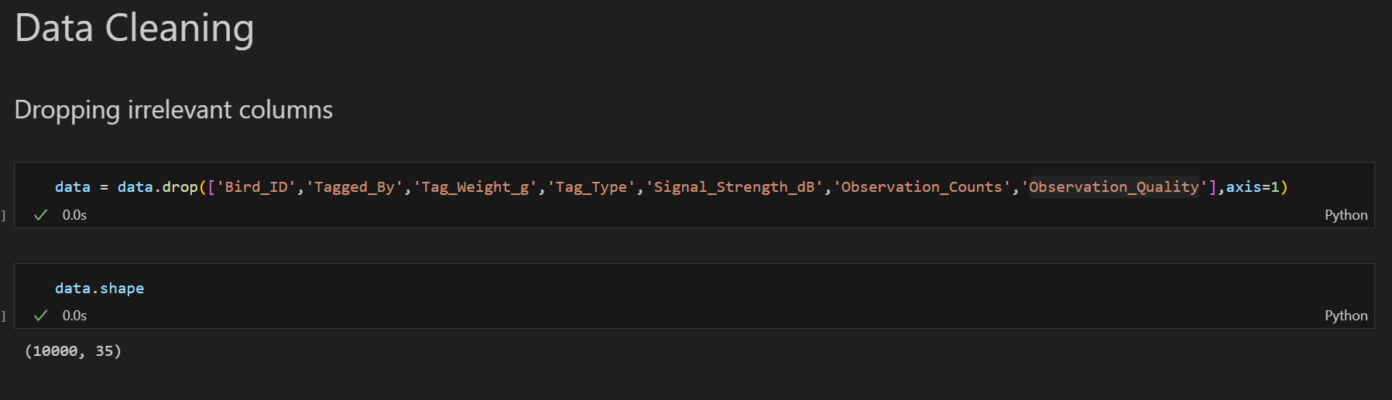
Certain columns were identified as irrelevant for the analysis:
- Bird_ID: This is a unique identifier for each record. It is useful for database management, but it does not provide any meaningful information for this Migration analysis.
- Tagged_By: This attribute Indicates the person or organization that tagged the bird. While important for record-keeping, it does not influence migration behavior or outcomes.
- Tag_Weight_g: Represents the weight of the tagging device. Since the dataset is synthetic, this value is largely constant and does not affect the ecological aspects of migration.
- Tag_Type: Refers to the type of tracking device used. This is a technical detail of data collection and does not contribute to understanding migration patterns.
- Signal_Strength_dB: Measures the quality of the tracking signal. This relates to data transmission, not bird movement or behavior, so it is not relevant for our analysis.
- Observation_Counts: Shows how many times the bird was observed. This depends on recording frequency rather than the bird’s actual migration journey.
- Observation_Quality: Reflects the reliability of human data collection. It is more about data accuracy than the bird’s ecological or behavioral aspects.
HANDLING MISSING VALUES
Upon checking the dataset for missing values using data.isnull().sum(),
This function works in three steps:
- isnull() scans the dataset and marks all missing entries as True.
- sum() then counts the total number of True values for each column, giving the number of missing values.
- The result shows, column by column, how many values are missing.
it was found that all columns had 0 missing entries. This means the dataset is already complete with no gaps in the records. While missing value handling is a common part of data cleaning, in this case it was unnecessary. Since the dataset is already clean with no missing values, I decided to skip imputation.
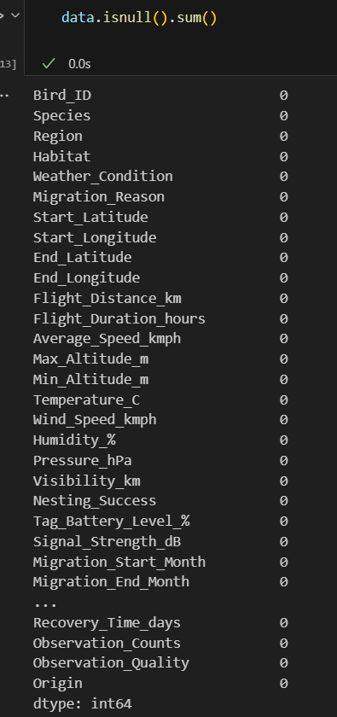
CHECKING FOR DATA DUPLICATION
To verify whether the dataset contains duplicate rows, we used the following code:

This function works in the following way:
- duplicated() checks each row in the dataset and marks True if the exact same row (with all identical values across columns) has already appeared.
- sum() then counts the total number of True values, which gives the number of duplicate rows present.
In our dataset, the output returned 0, meaning that there are no duplicate entries in this dataset. Removing duplicates is a vital step in data cleaning because duplicate records can cause over-counting and wrong analysis. For example, if a bird’s migration journey was accidentally recorded twice, it would artificially inflate migration counts and skew patterns such as flight distances or environmental impacts. Since our dataset has no duplicates, we can proceed with confidence that each record represents a unique observation.
OUTLIER DETECTION
Outliers are extreme values in a dataset that deviate significantly from other observations. They can occur due to data entry errors, measurement issues, or unusual real-world events. Detecting and handling outliers is an essential step in data cleaning because outliers can distort statistical measures (like mean and standard deviation) and negatively affect machine learning models. To ensure robust analysis, we applied two widely used statistical techniques — Z-Score Method and Interquartile Range (IQR) Method — on all numeric columns of the dataset.
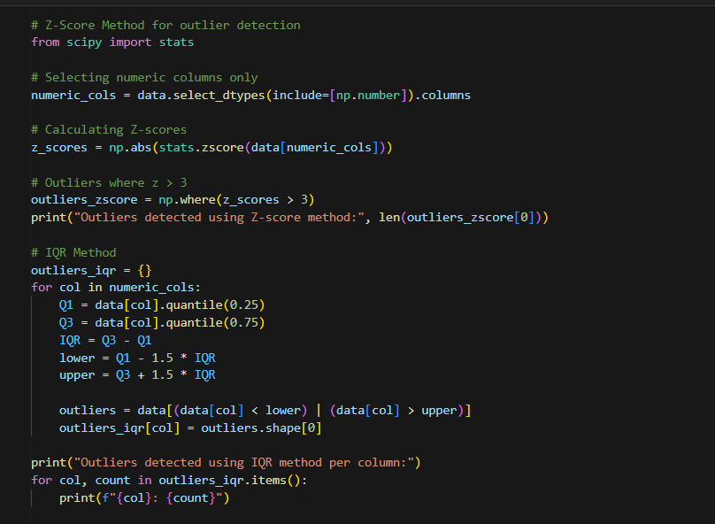
We selected only numeric columns using data.select_dtypes(include=[np.number]) for outlier detection because both Z-score and IQR techniques are applicable to numerical data.
Z-Score Method
We calculated standardized Z-scores for each numerical value. A Z-score measures how far a data point is from the mean in terms of standard deviations. Any value with an absolute Z-score greater than 3 was flagged as a potential outlier.
The Z-score method is effective when data approximately follows a normal distribution. The threshold of ±3 standard deviations is widely accepted because, according to the empirical rule, approximately 99.7% of normally distributed observations fall within three standard deviations of the mean. Therefore, observations beyond this range can be considered potential extreme values.
In this dataset, the Z-score method detected 94 outlier values across the numeric variables. These values represent observations that deviate considerably from their respective column means and therefore require monitoring.
IQR Method
For each numeric column, we calculated the 25th percentile (Q1) and 75th percentile (Q3). The Interquartile Range (IQR) was calculated as:
IQR = Q3 − Q1
The lower and upper thresholds were then defined as:
Lower Bound = Q1 − 1.5 × IQR
Upper Bound = Q3 + 1.5 × IQR
Any value falling outside these boundaries was flagged as an outlier.
Unlike the Z-score method, the IQR method does not assume that the data follows a normal distribution. It is more robust to skewed distributions and is particularly useful for datasets containing long tails or non-symmetric patterns.
The IQR method identified outliers primarily in the following migration-related variables:
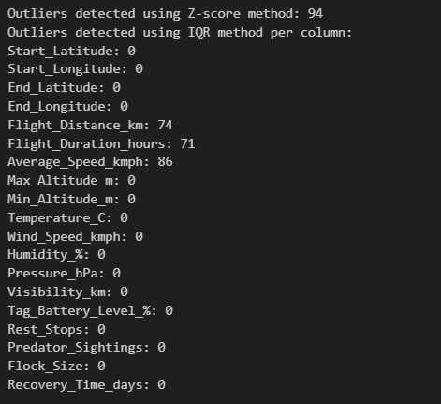
Numeric Variable | IQR Outliers
Flight_Distance_km | 74
Flight_Duration_hours | 71
Average_Speed_kmph | 86
The presence of outliers in Flight Distance, Flight Duration, and Average Speed indicates that these variables contain some observations that are relatively extreme compared with their overall distributions. These values may represent genuine variations in bird migration behaviour rather than data errors.
The outlier detection results indicate that the dataset contains a limited number of extreme observations, particularly in migration-related measurements such as flight distance, flight duration, and average speed.
These observations were not automatically removed or modified. Since extreme migration measurements can represent legitimate bird behaviour, the identified outliers are retained and monitored during subsequent analysis. Removing them without establishing that they are erroneous could result in the loss of meaningful ecological information.
Implications for Data Quality
Data Quality:
The presence of statistical outliers does not necessarily indicate poor-quality data. The detected values should be treated as observations requiring investigation rather than automatically classified as errors.
Data Consistency:
Most numerical variables showed no IQR-based outliers, indicating that their values fall within their expected distributional ranges.
Migration Analysis:
The outliers in flight distance, duration, and speed may provide useful information about unusually long or intensive migration events and should therefore be preserved for further analysis.
Preprocessing Decision:
No observations were removed based solely on statistical outlier detection. The identified outliers will be monitored during subsequent analysis, and any value will only be considered for correction or removal if there is additional evidence that it represents an invalid or erroneous observation.
Data type conversions
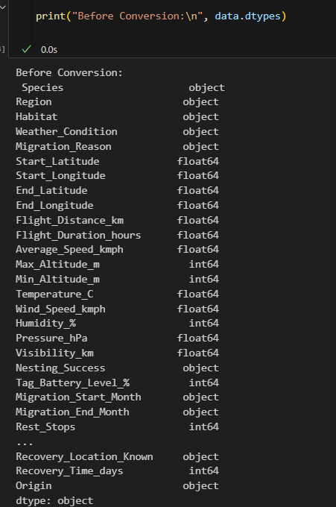
Data type conversion is an important preprocessing step to ensure that each column in the dataset is stored in the most appropriate format. Many machine learning models and statistical techniques require numerical inputs, while categorical variables are better handled in compressed and optimized formats such as category. If the data types are not correctly assigned, it may lead to errors in computation, unnecessary memory usage, or misinterpretation of the data during analysis.
- Categorical/text data such as Species, Region, Habitat, Weather_Condition, Nesting_Success, Observation_Quality, and Origin are stored as object type, which needs conversion to category for efficiency.
- Numeric variables like Flight_Distance_km, Temperature_C, Wind_Speed_kmph, and others are already in float64, which is appropriate.
- Some columns such as Migration_Start_Month are in object type but should be converted to categorical for acurate analysis.

Categorical Columns Conversion: All columns representing non-numeric labels such as Species, Region, and Habitat were converted from object type to category. This reduces memory usage and improves efficiency in statistical and machine learning operations.
This conversion was necessary because:
- Accuracy: Numerical columns remain as float64 or int64 for mathematical operations, while categorical values are encoded properly for statistical models.
- Efficiency: Converting object columns to category reduces memory consumption significantly, which is important for large datasets.
- Interpretability: Ensuring identifiers are treated as strings prevents incorrect usage in computations.
- Compatibility: For best analysis it is best suggested and required categorical data to be properly encoded, making this step essential before applying encoding or feature engineering.
ENCODING
In our dataset, the column Migration_Success records whether a bird’s migration attempt was Successful or Failed. However, since these values are stored as text (categorical data), we cannot directly apply mathematical operations such as correlation, regression, or prediction models. To make the data suitable for analysis, we perform an encoding step that converts these string labels into numeric values.
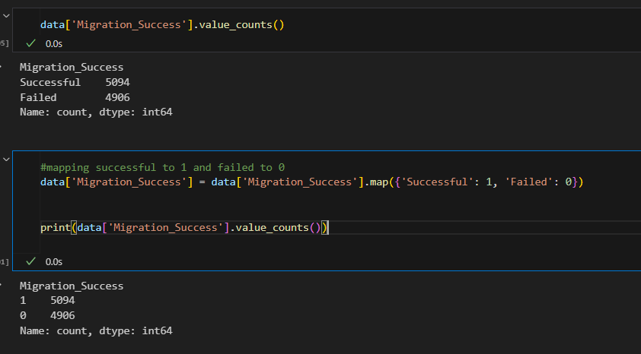
This first line of code checks the distribution of migration outcomes.
The output shows:
- Successful = 5094
- Failed =4906
Here, we use the .map() function to replace the text labels:
- "Successful" = 1
- "Failed" = 0
After this encoding, the column now contains only numeric values (1s and 0s), making it mathematically usable.
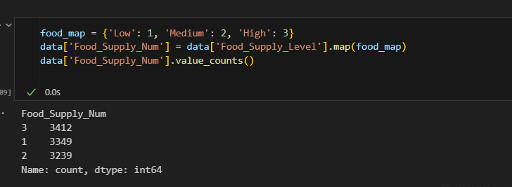
# Create flock size bands using the intended ranges

def classify_flock_size(size):
if size == 1:
return 'Solo (1)'
elif 2 <= size <= 5:
return 'Small (2–5)'
elif 6 <= size <= 15:
return 'Medium (6–15)'
elif 16 <= size <= 30:
return 'Large (16–30)'
elif size >= 31:
return 'Very large (31+)'
else:
return np.nan

data['Flock_Size_Band'] = data['Flock_Size'].apply(classify_flock_size)

The Flock_Size variable represents the number of birds migrating together and was converted into meaningful categorical groups to simplify analysis and numerical modelling. The flock sizes were divided into five categories:
Solo (1), Small (2–5), Medium (6–15), Large (16–30), and Very Large (31+).
These categories were then encoded numerically from 1 to 5, where a higher value represents a larger flock size.
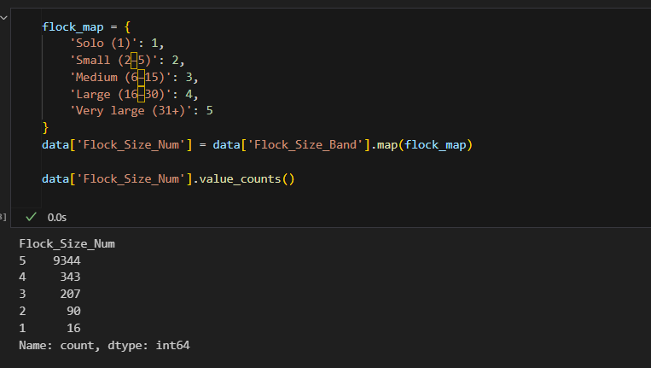
The resulting distribution shows that Very Large flocks (31+) are the most common category with 9,344 observations, followed by Large flocks (16–30) with 343 observations, Medium flocks (6–15) with 207 observations, Small flocks (2–5) with 90 observations, and Solo birds (1) with 16 observations. This indicates that the dataset is strongly dominated by birds migrating in larger groups, particularly flocks containing 31 or more birds. The numerical encoding provides a compact representation of flock size while preserving the natural order from smaller to larger groups, making the feature suitable for subsequent statistical analysis and machine-learning tasks.
Binning continuous Variables
Continuous data can be difficult to interpret directly when analyzing trends and pattern, as part of data pre-processing, I converted continuous variables into categories using binning, This transformation helps simplify the dataset making it easier to uncover relationships and behavioral patterns in this analysis
These columns are used to bin, such as Flight_Distance_km,Average_Speed_kmph,Max_Altitude_m,Temperature_C,Wind_Speed_kmph,Visibility_km,Humidity_
Flight_Distance_km binned to new column Flight_Distance_Category
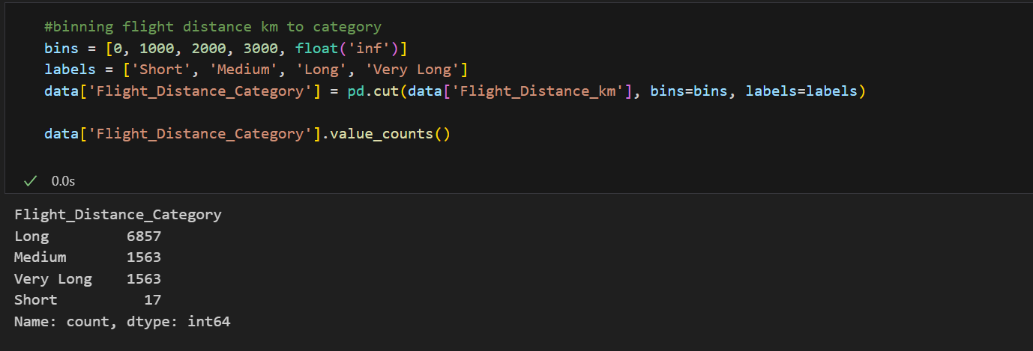
Birds migrate over varying distances. Grouping distances into categories like "Short", "Medium", and "Long" helps analyze migration patterns across species and regions.
- Bins: Short (0–1000 km), Medium (1000–2000 km), Long (2000–3000 km), Very Long (3000+ km)
- Purpose: To classify birds into different migratory ranges for comparison.

Average_Speed_kmph binned to new column Speed_Category
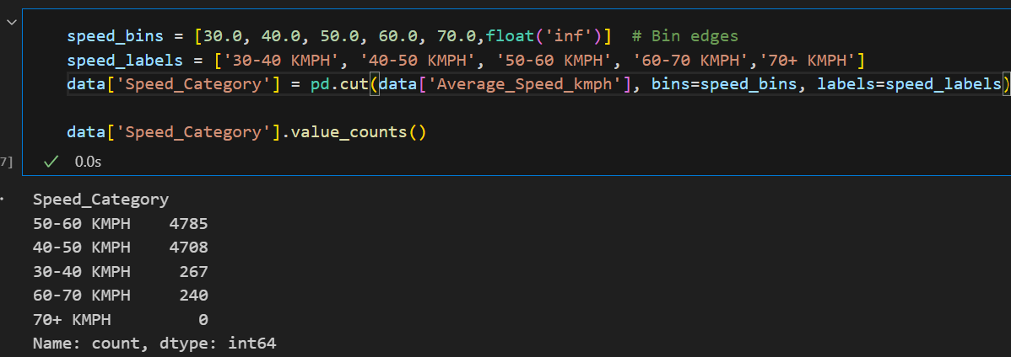
Birds fly at different speeds depending on species, weather, and environmental conditions. Categorizing speeds into "30-40KMPH", "40-50KMPH", "50-60KMPH" and 60-70kmph helps analyze how speed impacts migration success.
- Bins: 30–40 kmph, 40–50 kmph, 50–60 kmph, 60–70 kmph, 70+ kmph
- Purpose: To analyze whether speed differences influence migration success.
Max_Altitude_m binned to new column Altitude_Category
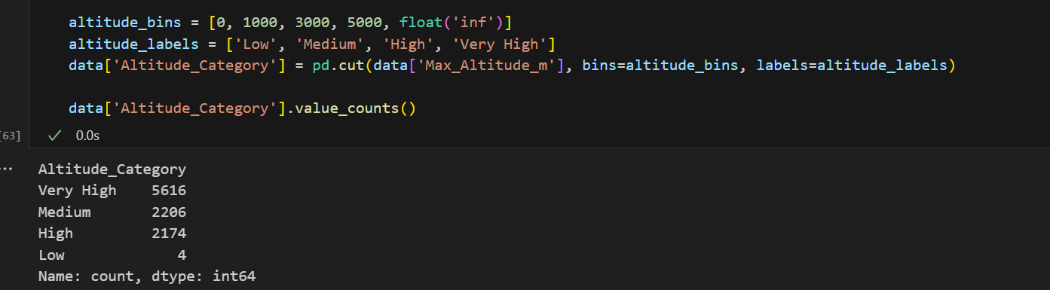
Birds migrate at different altitudes depending on species and environmental factors. Grouping altitudes into "Low", "Medium", and "High" helps analyze altitude preferences and their impact on migration.
- Bins: Low (0–1000 m), Medium (1000–3000 m), High (3000–5000 m), Very High (5000+ m)
- Purpose: To study altitude ranges and their effect on bird survival and flight efficiency.
Temperature_C binned to new column Temperature_Category
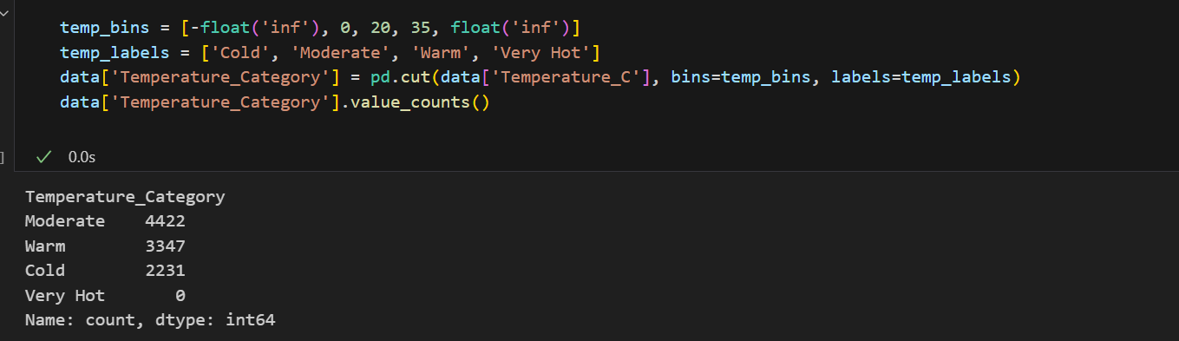
Temperature affects bird migration behavior and success. Categorizing temperatures into "Cold", "Moderate", "Warm", and "Hot" helps analyze how temperature impacts migration.
- Bins: Cold (<0°C), Moderate (0–20°C), Warm (20–35°C), Very Hot (35+°C)
- Purpose: To evaluate how different temperature zones impact migration.
Wind_Speed_kmph binned to new column Wind_Speed_Category 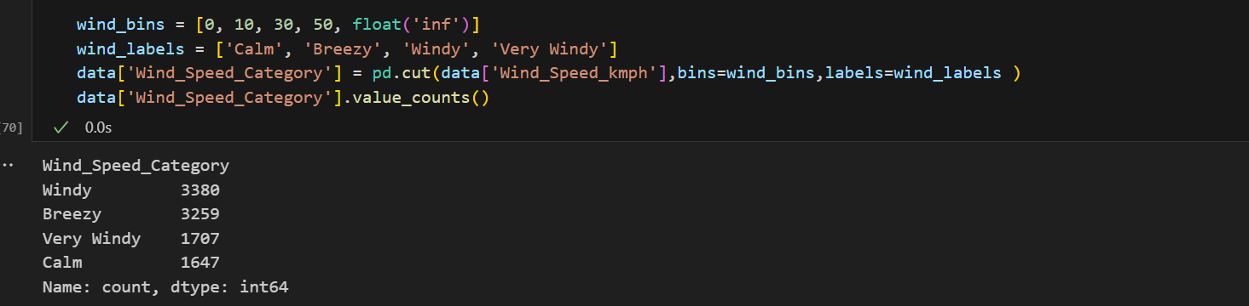
Wind speed can either aid or hinder migration. Grouping wind speeds into "Calm", "Breezy", "Windy", and "Very Windy" helps analyze its impact on flight performance and migration success.
- Bins: Calm (0–10 kmph), Breezy (10–30 kmph), Windy (30–50 kmph), Very Windy (50+ kmph)
- Purpose: To assess whether wind conditions support or hinder migration.

Visibility_km binned to new column Visibility_Category
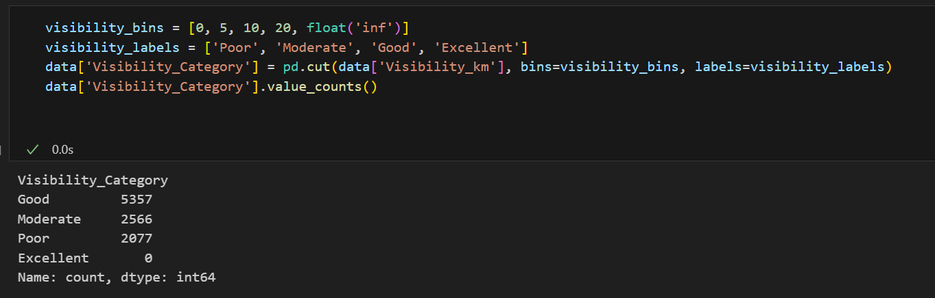
visibility affects navigation during migration. Categorizing visibility into "Poor", "Moderate", "Good", and "Excellent" helps analyze its impact on migration success.
- Bins: Poor (0–5 km), Moderate (5–10 km), Good (10–20 km), Excellent (20+ km)
- Purpose: To check how visual clarity affects navigation during migration.
Humidity_% binned to new column Humidity_Category
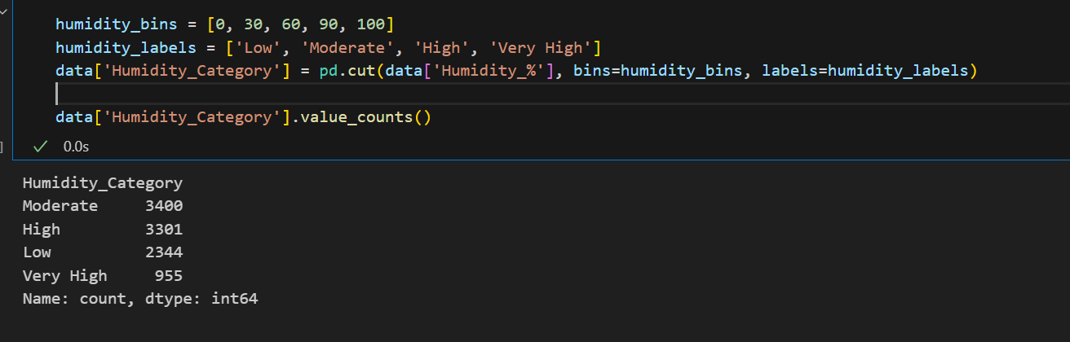
Humidity affects bird physiology and flight performance. Grouping humidity into "Low", "Moderate", "High", and "Very High" helps analyze its impact on migration success and nesting
- Bins: Low (0–30%), Moderate (30–60%), High (60–90%), Very High (90–100%)
- Purpose: To understand the role of atmospheric moisture in migration comfort and risks.
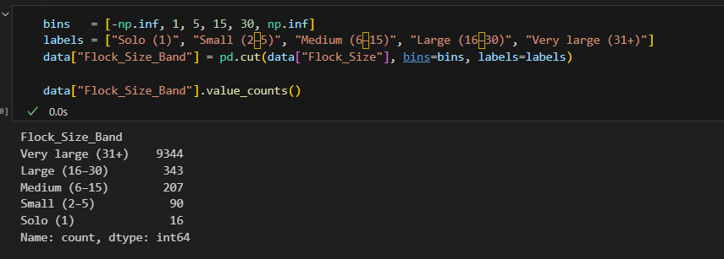
Flock size can influence bird migration behavior and survival. Small flocks may face higher risks from predators, while very large flocks may compete for food and space. Categorizing flock size helps to see if there is an optimal group size for migration success.
- Bins: Small (1–10), Medium (11–30), Large (31–60), Very Large (61+)
- Purpose: To analyze whether traveling in different flock sizes improves safety, coordination, or migration success.
EXPLORATORY DATA ANALYSIS
Q1. What seasonal migration trends can be identified by analyzing the distribution of bird movements across different months?
Seasonality plays a major role in shaping bird migration patterns. To explore this, we analyzed the distribution of bird movements across different months using the migration start and end month variables in the dataset. By grouping and visualizing bird activity month-wise, we can identify peak migration periods, seasonal routes, and resting phases. This analysis helps us understand how migration aligns with ecological cycles such as breeding, food availability, and climatic changes, thereby providing deeper insights into the temporal dynamics of bird behavior.
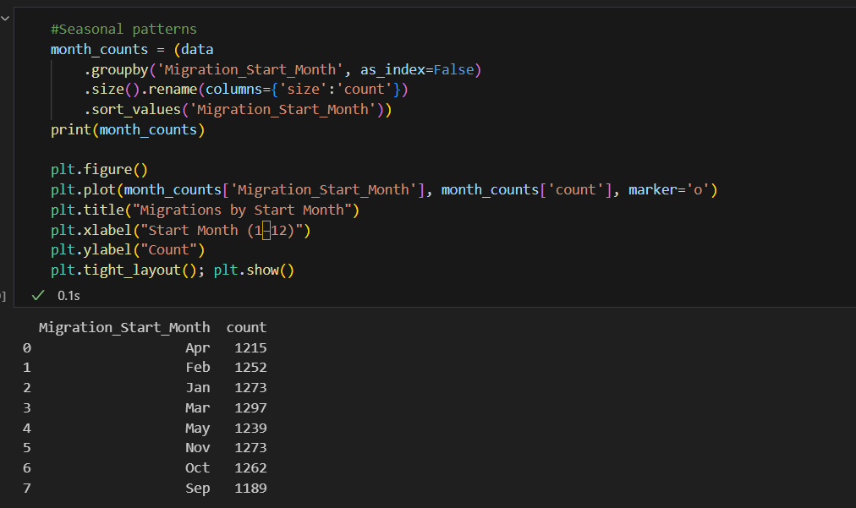
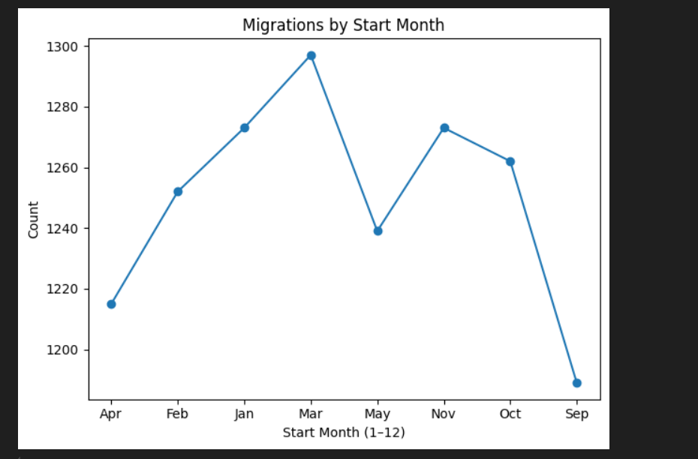
OUTPUT INTERPRETATION
Bird migration changes with the seasons and is influenced by food, weather, and breeding needs. The chart “Migrations by Start Month” shows how the number of migrations varies month by month. By studying this, we can see when birds are most active and how their movement follows natural cycles.
Key Insights from the Visualization
1. Spring Peak (March)
- Migration is highest in March.
- Birds move north for breeding during spring.
2. Autumn Peak (November)
- Another rise in migration happens in November.
- Birds return south for the winter.
3. Low Movement in Summer
- April and May show fewer migrations.
- Most birds are already at their breeding grounds.
4. Lowest Activity in September
- Very few migrations occur in September.
- This is a transition period before the big autumn journey.
5. Early-Year Movements (Jan–Feb)
- Some activity happens in January and February.
Likely late arrivals or birds adjusting positions before spring.
Evaluation of Trends
The migration pattern is not the same every month.
- Major movements happen mainly in March and November.
- Summer and early autumn show much lower activity.
- These patterns match natural needs like breeding and surviving winter.
Q2. What are the main reasons for bird migration, and how do these reasons vary across species?
Bird migration is a complex behavior influenced by ecological, climatic, and biological needs. Different species migrate for distinct reasons such as breeding, food availability, seasonal climate changes, and predator avoidance. By analyzing the Migration_Reason column alongside species data, we can identify which reasons are most common and how they differ across bird types. This helps us understand species-specific survival strategies and the ecological pressures shaping their movement patterns.
To understand why birds migrate, we first analyzed the dataset using Python code. The code grouped migration data by reason and then by species, which allowed us to count how many times each factor (feeding, breeding, avoiding predators, and climate change) appeared overall and for each species. This approach helped convert raw data into clear insights by showing both the general reasons for migration and how these reasons differ across bird types.
Bird migration is influenced by a mix of ecological and survival-related needs. By looking at the “Overall Migration Reasons” and “Migration Reasons by Species,” we can see not only which factors dominate overall but also which species prioritize specific reasons for migration.
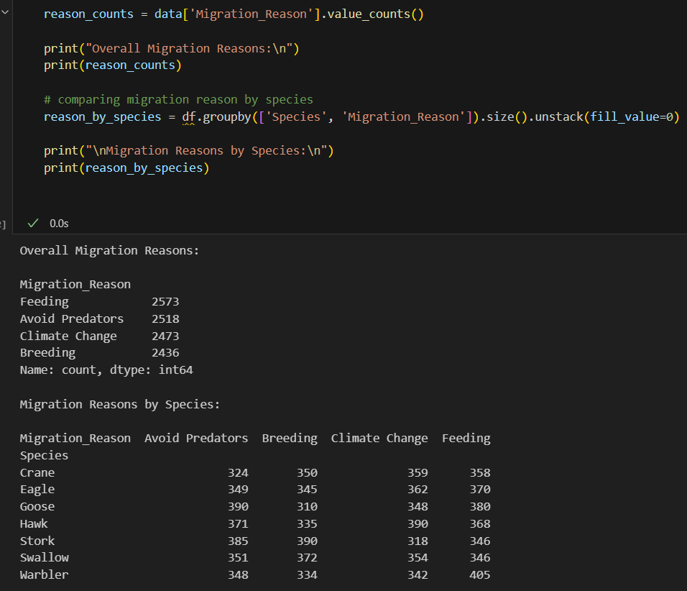
OUTPUT INTERPRETATION
Overall Migration Reasons
- Feeding (2573 cases) is the most frequent driver, showing food availability is the strongest motivator.
- Avoiding Predators (2518) comes very close, proving that safety is just as critical as food.
- Climate Change (2473) also drives migration, as birds adjust to environmental shifts.
- Breeding (2436), though slightly less, is still an essential driver, highlighting reproduction as a key seasonal motivator.
This distribution suggests migration is not due to one single factor but a balance of survival, environmental, and reproductive needs.
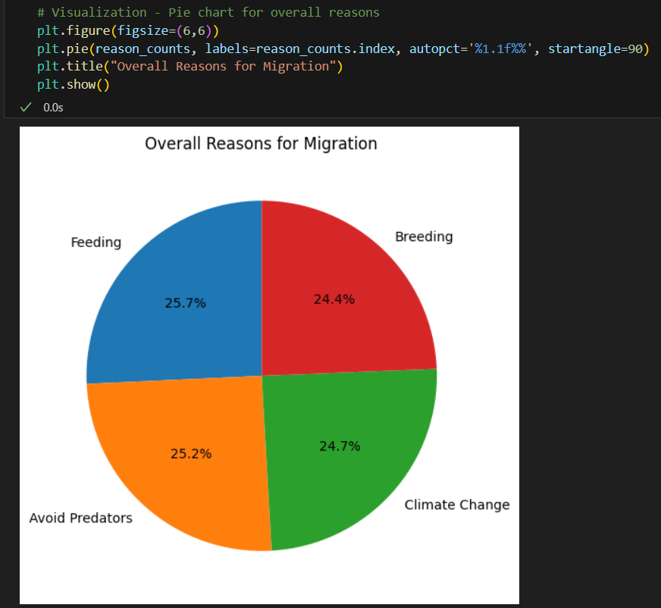
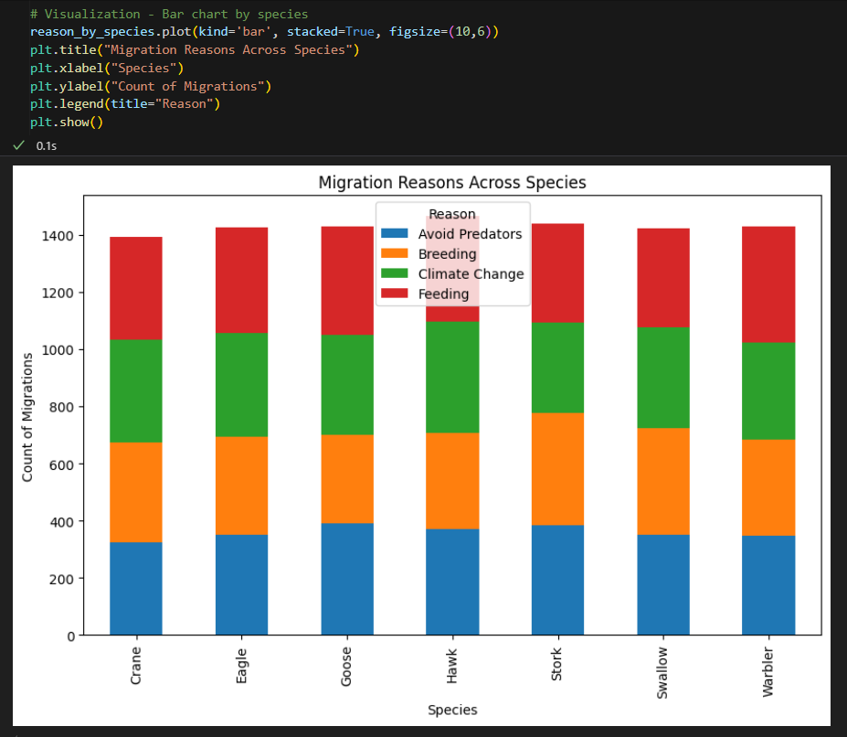
Migration Reasons by Species
- Cranes migrate mainly for climate and feeding, reflecting their dependence on environment and food.
- Eagles migrate relatively equally for all four reasons, showing adaptability.
- Geese migrate mostly for feeding (380), which matches their grazing behavior.
- Hawks are most influenced by climate (390), tied to their need for stable hunting habitats.
- Storks migrate heavily for breeding (390), emphasizing reproduction.
- Swallows show high counts for breeding (372) and climate (354), consistent with their insect-feeding nature.
- Warblers migrate mainly for feeding (405), highlighting food availability as their biggest motivator.
Evaluation of Trends
- Feeding and predator avoidance together account for nearly 40% of migration drivers, proving basic survival is a strong influence.
- Climate change and breeding (~25% each) are equally important, showing both environment and reproduction are critical motivators.
- Different species prioritize different needs, meaning migration is species-specific rather than universal.

Q2: How does weather impact flight speed and nesting success?
Weather is a critical factor influencing bird migration and nesting behavior. To analyze this, we used Python code to compute the correlation between weather variables—temperature, wind speed, humidity, and flight distance. The .corr() function helped us measure the strength and direction of relationships between these factors. This analysis allows us to understand whether weather conditions significantly affect birds’ flight distance, which indirectly reflects their flight speed and nesting success.
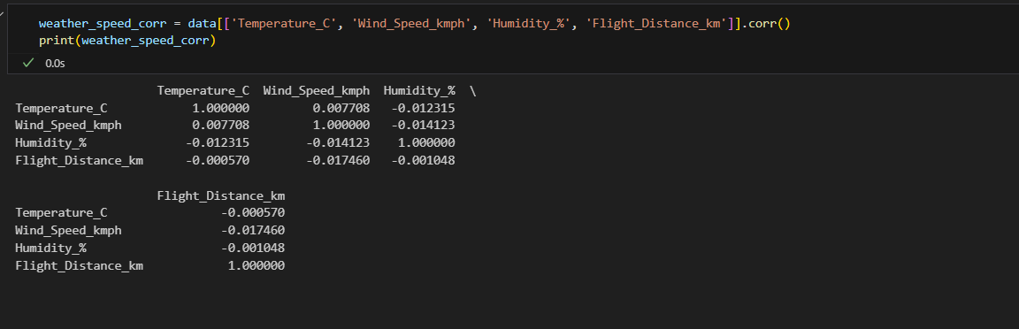
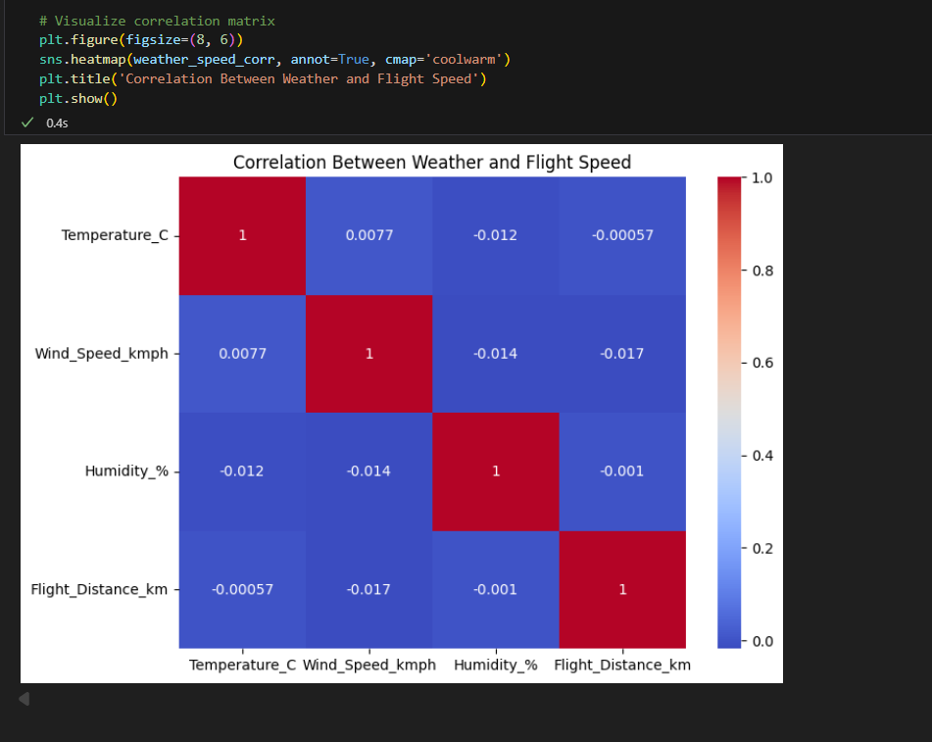
- The code selects four columns: temperature, wind speed, humidity, and flight distance.
- .corr() computes the Pearson correlation coefficient between each pair.
- A value close to +1 means strong positive correlation, close to –1 means strong negative correlation, and near 0 means little or no relationship.
OUTPUT INTERPRETATION
Insights from the Results
- Temperature vs Flight Distance: –0.00057 -Almost no effect. Birds fly similar distances regardless of temperature.
- Wind Speed vs Flight Distance: –0.017 - Very weak negative effect. Stronger winds may slightly reduce flight efficiency, but the impact is negligible here.
- Humidity vs Flight Distance: –0.0010 - Essentially no impact. Humidity does not affect migration distance directly.
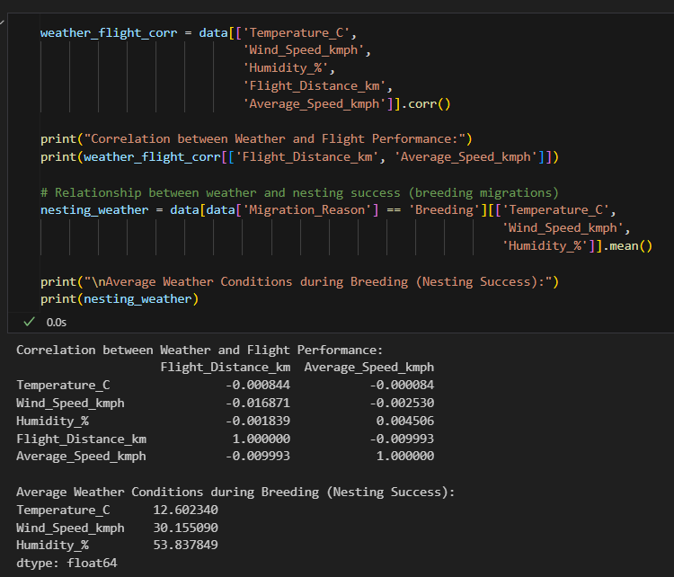
- The code selects four columns: temperature, wind speed, humidity, and flight distance.
- .corr() computes the Pearson correlation coefficient between each pair.
- A value close to +1 means strong positive correlation, close to –1 means strong negative correlation, and near 0 means little or no relationship.
The correlation analysis was performed to study the relationship between weather variables (temperature, wind speed, and humidity) and bird migration performance (flight distance and average speed).
- All correlation values are very close to zero, which means that weather conditions in this dataset have minimal effect on both flight distance and flight speed.
- Temperature has almost no relationship with bird flight performance (correlation ≈ -0.0008).
- Wind speed shows a slightly stronger negative relationship (-0.0168 with distance, -0.0025 with speed), but the values are still negligible.
- Humidity has a near-zero impact on distance (-0.0018) but a tiny positive correlation with speed (0.0045).
- The negative correlation (-0.0099) between flight distance and speed suggests that birds flying longer distances tend to maintain slightly lower speeds, but again the effect is extremely weak.

This indicates that flight performance is largely independent of short-term weather changes in this dataset. Birds might be capable of maintaining their migration patterns despite minor variations in environmental conditions.
NESTING
To understand the role of weather in breeding migrations, the average climate conditions were calculated for all migrations marked with the reason "Breeding."
- The average temperature during breeding migrations is around 12.6°C, suggesting that birds prefer relatively cool and moderate climates for nesting.
- The average wind speed is about 30 km/h, which is not very high but indicates that birds are nesting in regions with some airflow, possibly supporting navigation and flight take-offs.
- The average humidity is approximately 54%, indicating moderate atmospheric moisture, which may support vegetation and food availability for chicks.

Q3.) How do environmental factors like weather conditions and altitude impact migration success?
Weather plays a very crucial role in determining the success of bird migration. Different conditions like clear skies, fog, rain, wind, and storms can directly impact the safety and efficiency of bird movements. To study this, we used Python code to calculate the migration success rate for each weather condition. Since success is represented as 1 (successful) and 0 (unsuccessful), taking the mean value gives us the proportion of successful migrations. By grouping the dataset based on weather conditions and then calculating the average success rate, we can clearly compare how different weather patterns affect the overall outcome of bird migration. This analysis helps us identify whether birds are more likely to succeed in certain weather conditions, and if adverse conditions like storms or fog drastically reduce their chances.
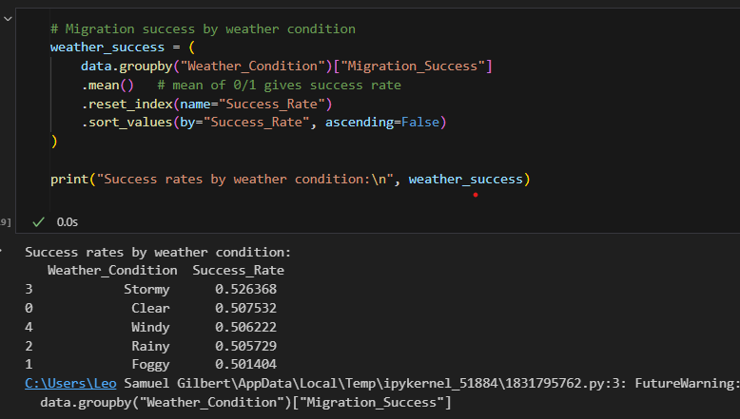
In this code, we grouped the dataset by Weather_Condition and calculated the average of the Migration_Success column. Since success is stored as 1 (Yes) and 0 (No), taking the mean gives the success rate for each weather type. After that, we reset the index to make it a clean table and sorted the results in descending order so that the weather conditions with the highest success rate come on top. This method is logical because success is already in binary form (0 = No, 1 = Yes). Taking the mean directly converts it into the success percentage. It is simple, efficient, and easy to interpret

OUTPUT INTERPRETATION :
- Stormy weather (52.63%) - Surprisingly, birds had the highest migration success rate in stormy weather. This may be because only stronger or more prepared birds attempt migration during such tough conditions, and they tend to survive.
- Clear weather (50.75%) -As expected, clear weather supports migration, though the success rate is slightly above 50%.
- Windy, Rainy, and Foggy (50–50.6%) - These conditions show almost equal success rates, slightly lower compared to stormy or clear skies.
The difference is small (around 2%), but the trend shows that weather does play some role in success.
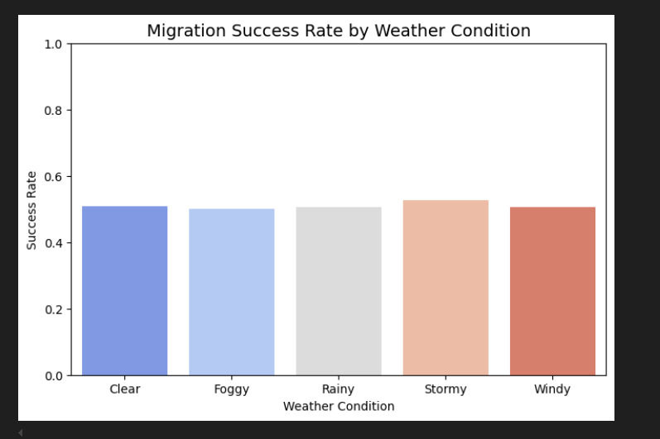

Q4.) Do more rest stops increase the chances of migration success?
Rest stops are a critical factor influencing bird migration and overall survival during long journeys. To analyze this, we used visualization technique and pandas library to compute the relationship between the number of rest stops and migration outcomes successful or failed. The groupby() and value_counts(normalize=True) functions helped us measure the proportion of success and failure for each rest stop count. This analysis allows us to understand whether the frequency of rest stops significantly affects migration success, which indirectly reflects birds’ energy recovery, predator avoidance, and survival strategies.
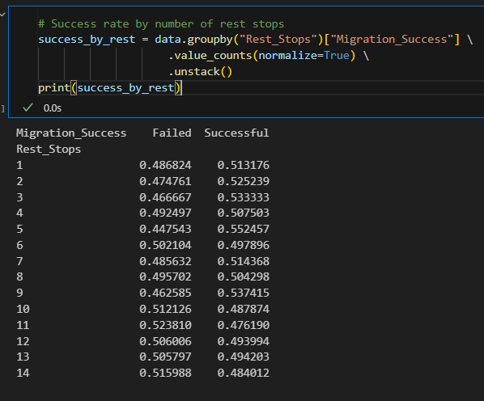
- I first grouped the dataset by the Rest_Stops column.
- Then I used value_counts(normalize=True) to calculate the percentage of birds that succeeded and failed in migration for each group.
- I reshaped the data with unstack() so that success and failure are shown as separate columns.
- I plotted a stacked bar graph to visualise the proportion of success and failure.
OUTPUT INTERPRETATION :-
- General Trend- For most cases, the migration success rate is slightly above 50%. This means rest stops do play a small but important role.
- Moderate Rest Stops (5to 9 stops)- Success rate is higher, for example at 5 stops the success is 55%, at 9 stops it is 53.7%. This indicates that moderate resting helps birds recover energy and increases their chance of reaching the destination safely.
- Too Few Stops (1 to 2 stops) - Success rate is close to 50%, which shows that birds may suffer from exhaustion if they do not rest enough.
- Too Many Stops (10+ stops) - At higher numbers of rest stops (10, 11, 12, etc.), the failure rate becomes higher than the success rate. This can happen because birds spend too much time resting, which delays migration and increases risks such as predator attacks or shortage of food
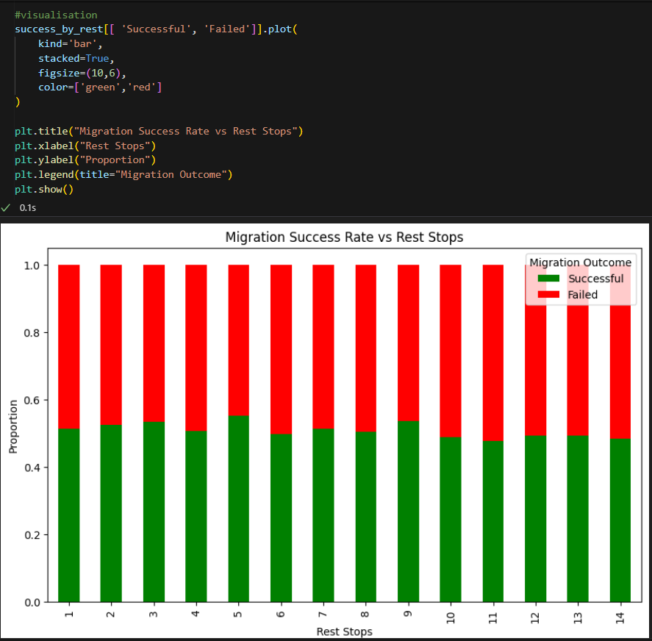
From this analysis, we can conclude that the number of rest stops has a direct influence on migration success. Moderate resting between 5 and 9 stops gives the best balance between energy recovery and timely travel. On the other hand, too few stops can cause exhaustion, while too many stops can increase risk of failure.
This result also highlights how important it is to balance different survival strategies in nature. Birds must carefully adjust their behaviour depending on the environment, availability of food, and threats from predators. Rest stops are not just a break, but a crucial factor in the overall success of migration.
Q5.) Do predator sightings reduce migration success?
Predator activity plays a critical role in determining whether migrating birds successfully reach their destination. High predator sightings often increase stress and risks, leading to unsuccessful migrations. To study this relationship, we analyzed the dataset using both Pandas and NumPy. Pandas allowed us to group and calculate proportions across categories, while NumPy was used to compute average success rates more directly.
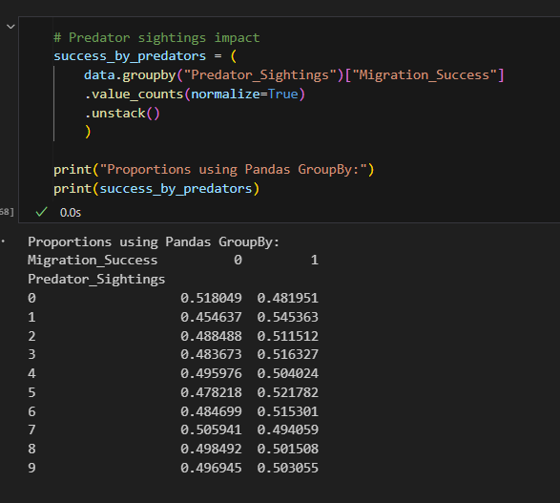
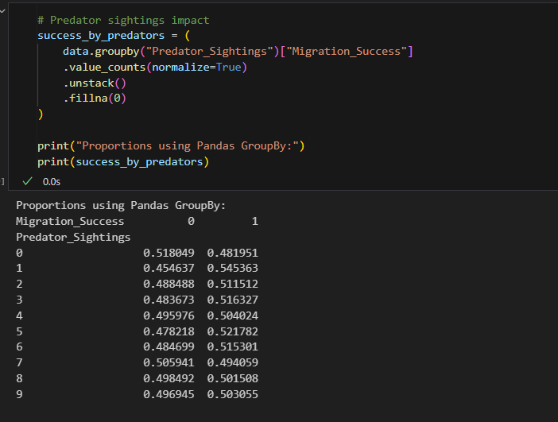
- I first grouped the dataset by the Predator_Sightings column.
- Then I applied value_counts(normalize=True) on the Migration_Success column to calculate the percentage of birds that succeeded and failed in migration for each group.
- I used unstack() to reshape the data so that success (1) and failure (0) are shown as separate columns.
OUTPUT INTERPRETATION
- For each predator sighting count (0–9), the table shows two values: the proportion of failed migrations (0) and successful migrations (1).
- When 0 predators were sighted, about 48% of birds succeeded and 52% failed.
- When 1 predator was sighted, success improved to around 55%, while failure dropped to 45%.
- For 2–6 predators sighted, the success rate stayed close to 51–52%, showing only small variations.
- When 7 predators were sighted, the success rate slightly dipped to 49%, making failures higher.
- For 8 and 9 predators sighted, success balanced around 50%, meaning almost equal chances of success and failure.
- Overall, the output shows that predator sightings do not drastically change migration success, though 1 predator sighting surprisingly shows the highest success (55%).
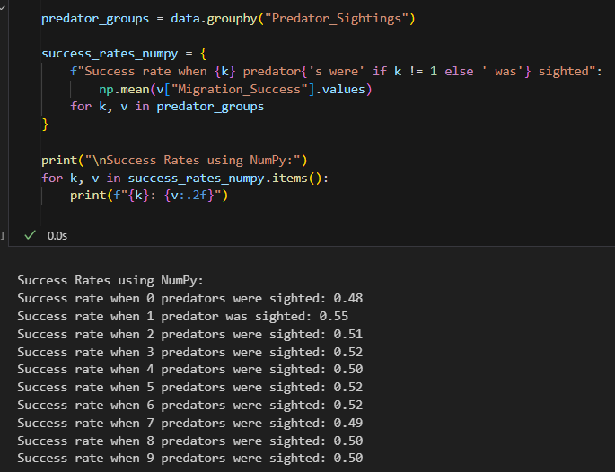
- I grouped the dataset by the Predator_Sightings column.
- For each group, I extracted the Migration_Success values.
- I calculated the mean using NumPy (np.mean) since success = 1 and failure = 0, so the mean directly gives the success rate.
- I stored the results in a dictionary with readable keys like “Success rate when 2 predators were sighted” and printed them.

OUTPUT INTERPRETATION
The NumPy results, we can see that the migration success rate mostly stays around 50%, regardless of the number of predators sighted. The highest success rate is observed when 1 predator was sighted (55%), which is slightly unusual but may suggest that birds are more alert in such cases. For higher predator sightings (2–9), the success rate stabilises close to 50–52%, showing that predator presence alone does not drastically reduce migration success.
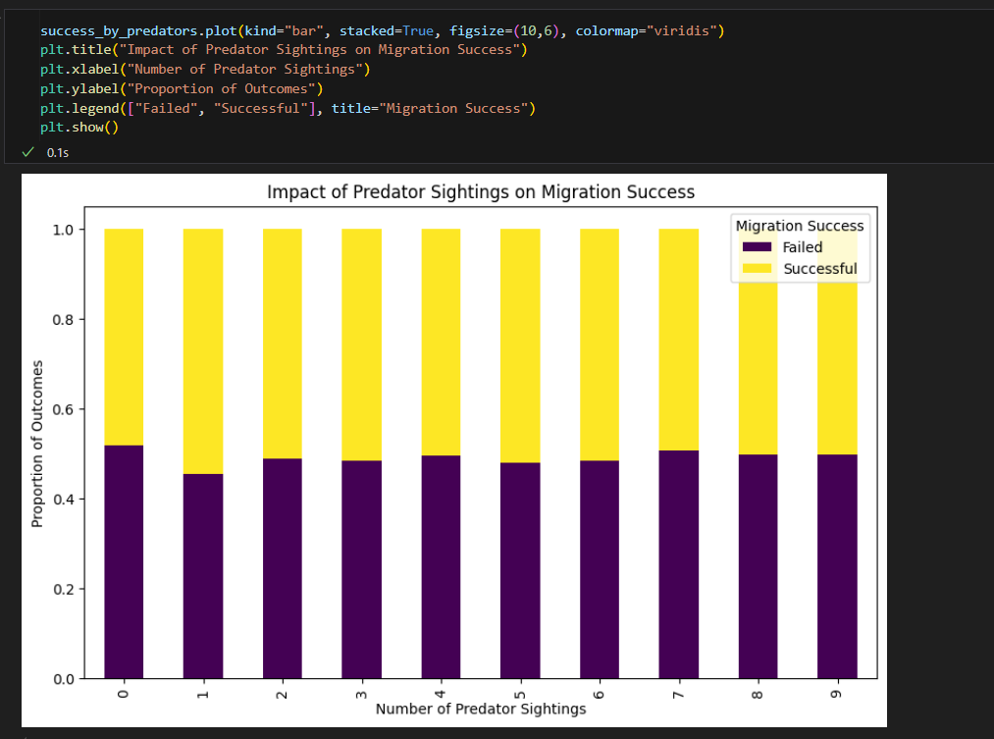

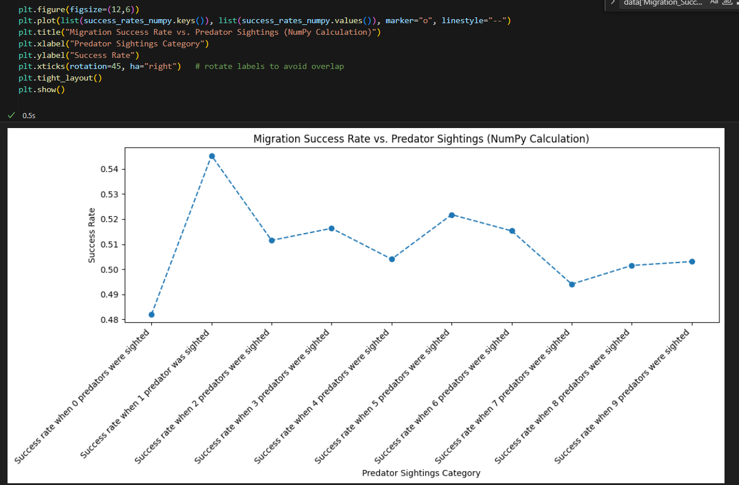

OUTPUT INTERPRETATION
The line graph above represents the migration success rate of birds against predator sightings, calculated using NumPy . The x-axis shows different categories of predator sightings (ranging from 0 to 9), and the y-axis shows the average success rate of migration.
From the visualization, we can see the following trends:
- When no predators were sighted, the success rate was around 0.48 (48%).
- Interestingly, when 1 predator was sighted, the success rate peaked at 0.55 (55%), which is higher than all other categories.
- For sightings between 2 and 9 predators, the success rate remained fairly stable, fluctuating close to 0.50–0.52.
- A slight dip is visible at 7 predator sightings, where the success rate dropped to just under 0.49.
- Beyond this, the graph levels off again, showing that higher predator counts (8 and 9) did not significantly reduce migration success.
By analysing predator sightings with both Pandas and NumPy, we found that the migration success rate remains fairly balanced across different predator levels.
From the Pandas results, the proportions show that when no predators were sighted, the success rate was about 48%, while it increased to 55% when 1 predator was sighted. For sightings between 2 and 9 predators, the success and failure proportions remained close to 50–52%, with only minor fluctuations.
Similarly, the NumPy results confirmed this trend by directly computing the average success rate for each predator group. The values consistently hovered around 0.50, further proving that predator presence alone does not significantly alter the overall success rate of migration.
In conclusion, both methods agree that predator sightings have only a mild effect on bird migration success, with the most notable observation being the slightly higher success when 1 predator is sighted, possibly due to increased vigilance among the birds.
Q6.). Does higher food supply level lead to better migration success?
Food availability is a crucial factor that directly influences the survival and success of migrating birds. Adequate food supply provides the necessary energy reserves for long flights, while scarcity increases the risk of exhaustion and unsuccessful migrations. To study this relationship, we analyzed the dataset using Pandas, NumPy, and Matplotlib. Pandas was applied to group the data by food supply levels and calculate average success rates across categories. NumPy was used to directly compute success rates for each group, providing a numerical summary. Finally, Matplotlib helped in visualizing the trends across food supply categories, making the relationship between food availability and migration outcomes more interpretable.
• I first grouped the dataset by the Food_Supply_Level column.
• Then, I calculated the mean of the Migration_Success column for each group. This gives the average success rate depending on the available food.
• NumPy was also used to confirm these averages by calculating the mean success rate for each food supply category directly from the values.
• Finally, I plotted a bar chart using Matplotlib to clearly show how migration success varies with food availability.
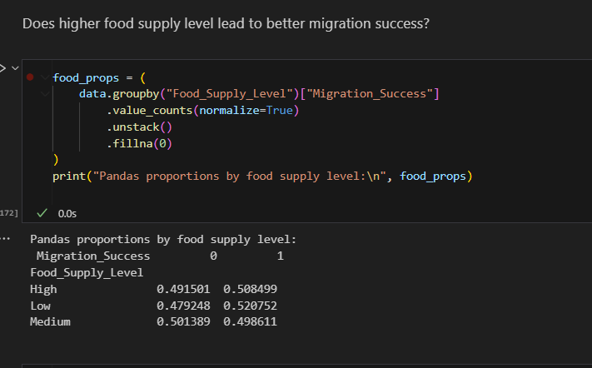
• I first grouped the dataset by the Food_Supply_Level column.
• Then I used value_counts(normalize=True) to calculate the proportion of birds that succeeded (1) and failed (0) in migration for each food supply category.
• I reshaped the data with unstack() so that failure and success proportions appear side by side in columns.
OUTPUT INTERPRETATION:
- For High food supply, about 50.8% of birds succeeded and 49.2% failed.
- For Low food supply, the success rate is slightly higher at 52.1%, while failures are 47.9%.
- For Medium food supply, the rates are nearly balanced: 49.9% success and 50.1% failure.
This indicates that both Low and High food supply slightly favor migration success, whereas Medium food levels show no clear advantage
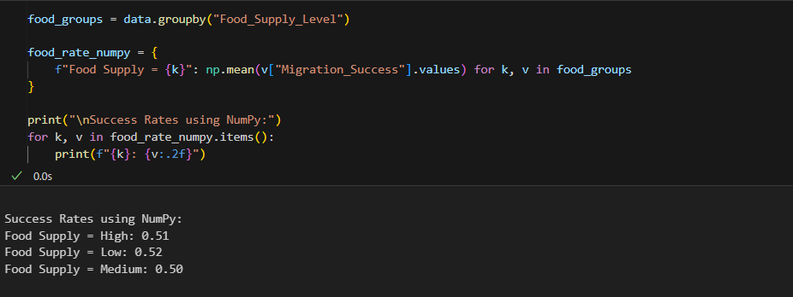
- Using NumPy, I calculated the mean migration success rate for each food supply category.
- Since success is encoded as 1 and failure as 0, taking the mean directly gives the proportion of success.
OUTPUT INTERPRETATION :-
- High food supply gives a success rate of 0.51 (51%).
- Low food supply shows a slightly better success rate of 0.52 (52%).
- Medium food supply gives a success rate of 0.50 (50%), meaning success and failure are equally likely.
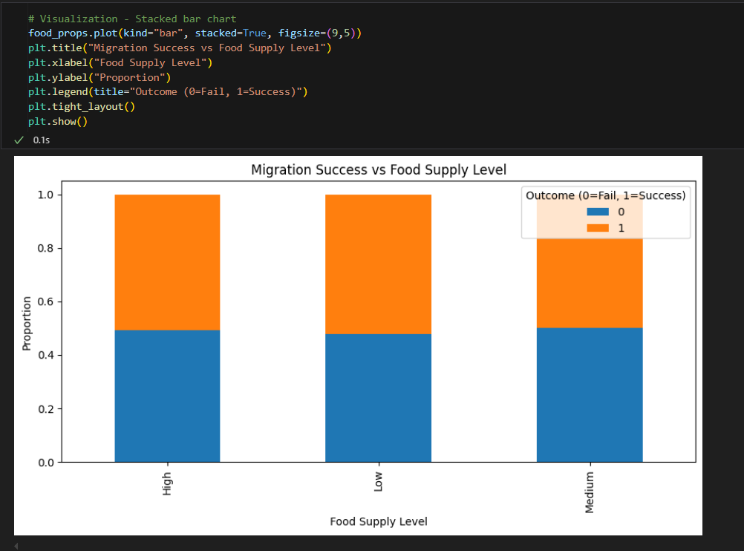
The stacked bar chart shows the distribution of migration success and failure across different food supply categories.
- For High food supply, the chart shows almost equal success and failure, with a slight tilt toward success.
- For Low food supply, success proportion is slightly higher compared to failure.
- For Medium food supply, failure is slightly higher than success.
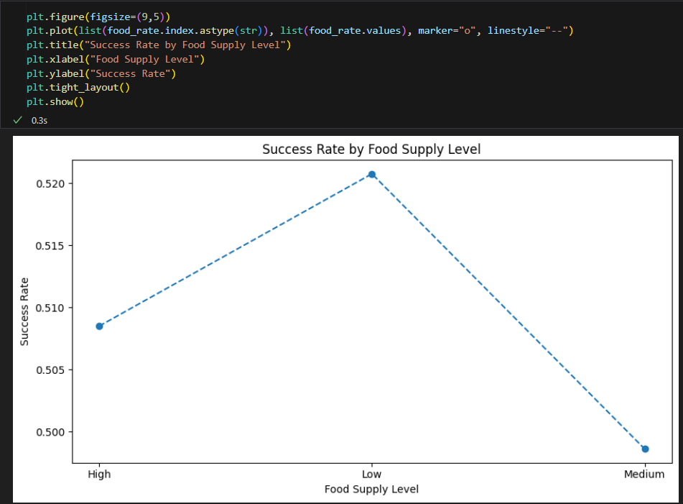
OUTPUT INTERPRETATION
The line graph represents success rate values clearly:
- High food supply - 0.51 success rate (around 51%).
- Low food supply - 0.52 success rate (highest among the three).
- Medium food supply- 0.50 success rate (lowest).
Here, we see that birds had slightly better migration success under Low food supply, while Medium supply showed the lowest success.

Q7.) Does flock size increase the chance of migration success?
Flock size plays a significant role in the migration success of birds, as traveling in groups can offer protection, navigational advantages, and cooperative behaviors that improve survival chances. Birds migrating alone may face higher risks such as predation or exhaustion, whereas those in appropriately sized flocks may benefit from group dynamics. To explore this relationship, we analyzed the dataset using Pandas, and Matplotlib. Pandas was utilized to group the data by flock size bands and calculate the proportions of success and failure within each category. Matplotlib was employed to create a stacked bar chart, enabling clear visualization of how migration outcomes vary across solo, small, medium, large, and very large flocks.
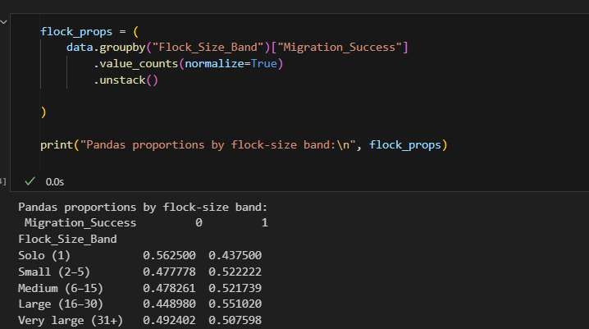
- I first grouped the dataset by the Flock_Size_Band column to separate the birds into categories such as Solo, Small, Medium, Large, and Very Large.
- Then I used value_counts(normalize=True) to calculate the proportion of birds that succeeded (1) and failed (0) in migration for each flock size category.
- Finally, I applied unstack() to reshape the results so that the failure and success proportions appear side by side as separate columns in the output table.
OUTPUT INTERPRETATION :-
- Solo (1 bird) - 56.2% failures, 43.8% successes. Migration is less successful alone.
- Small flocks (2–5) - 52.2% successes, higher than failures.
- Medium flocks (6–15) - 52.1% successes, slightly better than small flocks.
- Large flocks (16–30) -55.1% successes, the highest success rate among all.
- Very large flocks (31+) - 50.8% successes, slightly better than failures but lower than large flocks.
The analysis shows that migration success improves as flock size increases up to a large group (16–30), but in very large groups (31+), success stabilizes and does not improve much further.

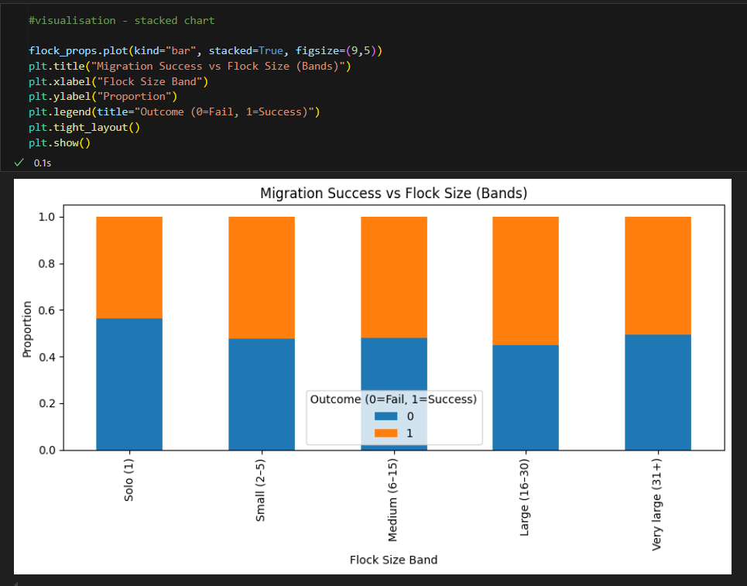
- I used the plot(kind="bar", stacked=True) function on the flock_props DataFrame to create a stacked bar chart. This helps show both migration failures (0) and successes (1) together for each flock size category.
- The figsize=(9,5) parameter was added to make the chart wide and easy to read.
- I set a clear title (plt.title) and axis labels (plt.xlabel, plt.ylabel) to explain what the chart represents — flock size bands on the x-axis and proportion of outcomes on the y-axis.
- The legend (plt.legend) indicates what the two stacked colors mean — 0 for Fail and 1 for Success.
- Finally, I applied plt.tight_layout() to adjust spacing so the labels and chart elements fit neatly, and then displayed the chart with plt.show().
This visualization allows us to easily compare how success and failure rates vary across flock sizes. For example, the chart shows that solo birds (1) tend to fail more often compared to larger flock sizes, while larger groups (16–30) have higher migration success proportions.
OUTPUT INTERPRETATION
- From the chart, we can see that solo birds (1) have the lowest migration success rate, with failures (blue portion, 0) being higher than successes (orange portion, 1).
- As flock size increases to small (2–5) and medium (6–15), the success rate improves slightly, with a larger proportion of orange (success).
- The large (16–30) flock size band shows one of the highest success proportions, indicating that traveling in moderately large groups provides the best chances of migration success.
- Interestingly, in the very large (31+) category, the success rate drops slightly compared to the large band, but it is still higher than solo migration.
Migration success generally improves when birds travel in groups, especially in small to large flocks, but extremely large groups do not always guarantee better success.
Q8.) What environmental and behavioral factors such as weather conditions, flight distance, altitude, rest stops, and food supply contribute to the interruption of bird migration?
Migration interruption is an important factor that affects the overall success of birds during their long-distance journeys. Interruptions may occur due to environmental challenges such as adverse weather, limited food supply, or exhaustion, which can force birds to pause or alter their routes. Understanding these interruptions helps us identify the key pressures birds face while migrating. To analyze this relationship, we examined the dataset using Pandas and Matplotlib. Pandas was applied to group the data based on the Migration_Interrupted attribute and calculate average values of flight distance, altitude, rest stops, and food supply for each category. Matplotlib was then used to generate comparative visualizations, allowing us to clearly observe how migration outcomes differ between interrupted and uninterrupted journeys.
In order to find this, I grouped the data by Migration_Interrupted (Yes/No) and calculated the mean values of important numerical features such as flight distance, average speed, altitude levels, rest stops, and food supply. This was done using the groupby() function in Pandas, which allows us to easily compare two categories.
The reason for doing this step is to understand whether interrupted migrations show any clear differences in flight characteristics when compared to successful migrations. For example, if interrupted flights usually have longer distances or fewer food supplies, this could explain why the birds were unable to complete their journey. This kind of summary helps in identifying the main factors that might contribute to migration interruptions.
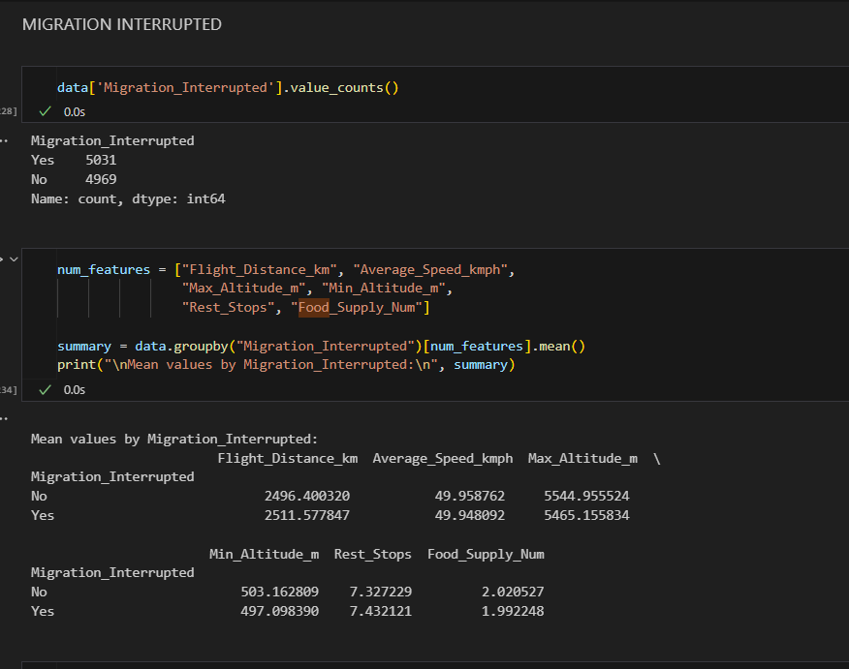
OUTPUT INTERPRETATION
Flight Distance:
- Interrupted migrations (Yes) had slightly longer average distances such as 2511 km compared to uninterrupted ones such as 2496 km
- This suggests that longer journeys may increase the chance of interruptions, probably due to exhaustion or environmental challenges.
Average Speed:
- Both groups had nearly the same average speed (50 km/h).
- This indicates that speed itself is not a major factor behind interruptions.
Altitude (Max & Min):
- Maximum altitude was lower for interrupted migrations ( 5465 m) compared to uninterrupted ones (5545 m).
- Minimum altitude was also a bit lower in interrupted cases.
- This could suggest that birds facing difficulty in maintaining high altitude may experience interruptions, possibly due to weather, air pressure, or physical strain.
Rest Stops:
- Interrupted migrations had slightly more rest stops ( 7.43) than uninterrupted ones (7.32).
- This may reflect fatigue, food scarcity, or unfavorable conditions causing additional breaks.
Food Supply:
- Food availability was slightly lower in interrupted migrations (1.99) compared to uninterrupted ones ( 2.02).
- Even though the difference is small, scarcity of food can increase stress on birds, making migrations harder to complete.
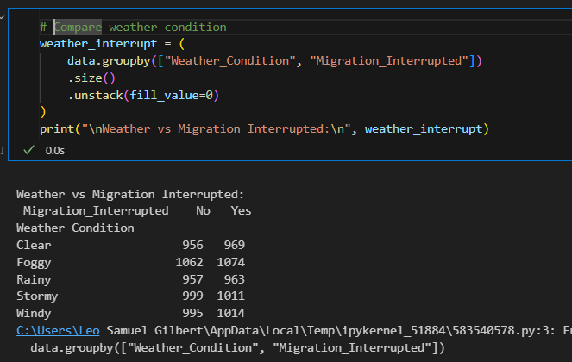
Next I used the same approach to find impact of environmental conditions. By grouping the data based on weather type and migration outcome, By comparing the counts of interrupted and successful migrations under each weather condition, we can identify if certain types of weather are strongly linked with a higher risk of interruption.

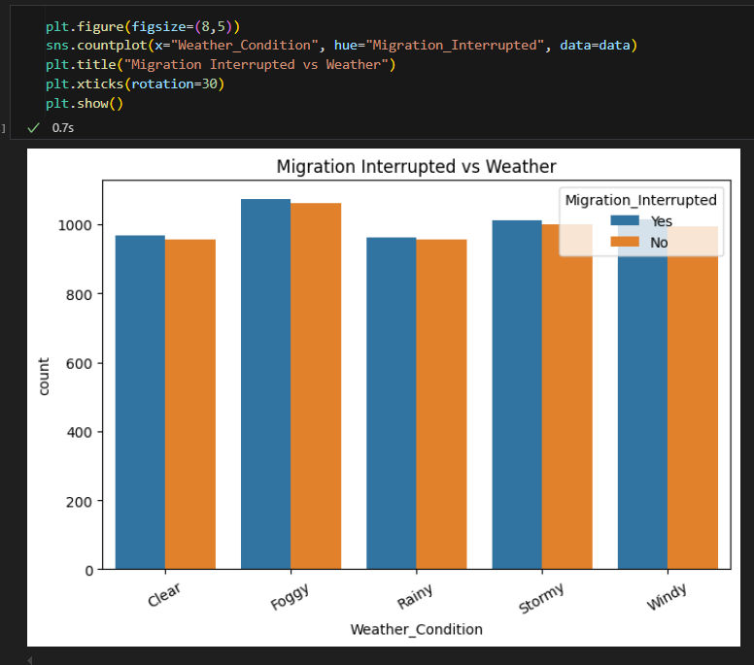

OUTPUT INTERPRETATION
Clear Weather:
- Almost equal interruptions and non-interruptions (969 and 956).
- Suggests that even in favorable weather, other factors like distance and altitude play a role.
Foggy Weather:
- Slightly more interruptions (1074) than non-interruptions (1062).
- Indicates reduced visibility may slightly increase migration failure.
Rainy Weather:
- Counts are almost the same (963 vs. 957).
- Shows that moderate rain may not drastically affect migration.
Stormy Weather:
- Interruptions are marginally higher (1011 vs. 999).
- Storms usually create turbulence and strong winds, which can make migration risky and tiring.
Windy Weather:
- Interruptions again higher (1014 vs. 995).
- Strong winds can divert or slow down birds, making them more prone to interruption.
Question 6 :- Which features have the greatest influence on migration success, and how effectively can machine learning models predict successful and unsuccessful migrations?

Question 7 : - How does Random Forest perform compared with Logistic Regression, Decision Tree, KNN, SVM, and Gradient Boosting, and which model provides the most effective prediction of bird migration success?
Following the data preprocessing, feature selection and modelling approach discussed in Questions 5 and 6, we proceeded with the implementation and evaluation of the six selected classification algorithms for predicting Bird Migration Success. The objective at this stage was to determine which machine learning model could most effectively distinguish between successful and unsuccessful migration outcomes.
The processed dataset contained 10,000 records and 50 variables, from which the approved feature set identified during the earlier stages consisted of 27 predictive features. These included 10 categorical variables, such as Species, Region, Habitat, Origin, Migration Reason, and Weather Condition, and 17 numerical variables, including Temperature, Wind Speed, Humidity, Flight Distance, Flight Duration, Average Speed, Maximum Altitude, Rest Stops, Predator Sightings, and Flock Size. The target variable was Migration_Success_Num, representing whether the migration was unsuccessful (0) or successful (1).
The target distribution was perfectly balanced, Successful 5094 and Failed 4906 migration records. Therefore, accuracy could be used as a meaningful evaluation measure without the results being heavily influenced by class imbalance. Nevertheless, precision, recall, F1-score and ROC-AUC were also considered to provide a more complete assessment of model performance.
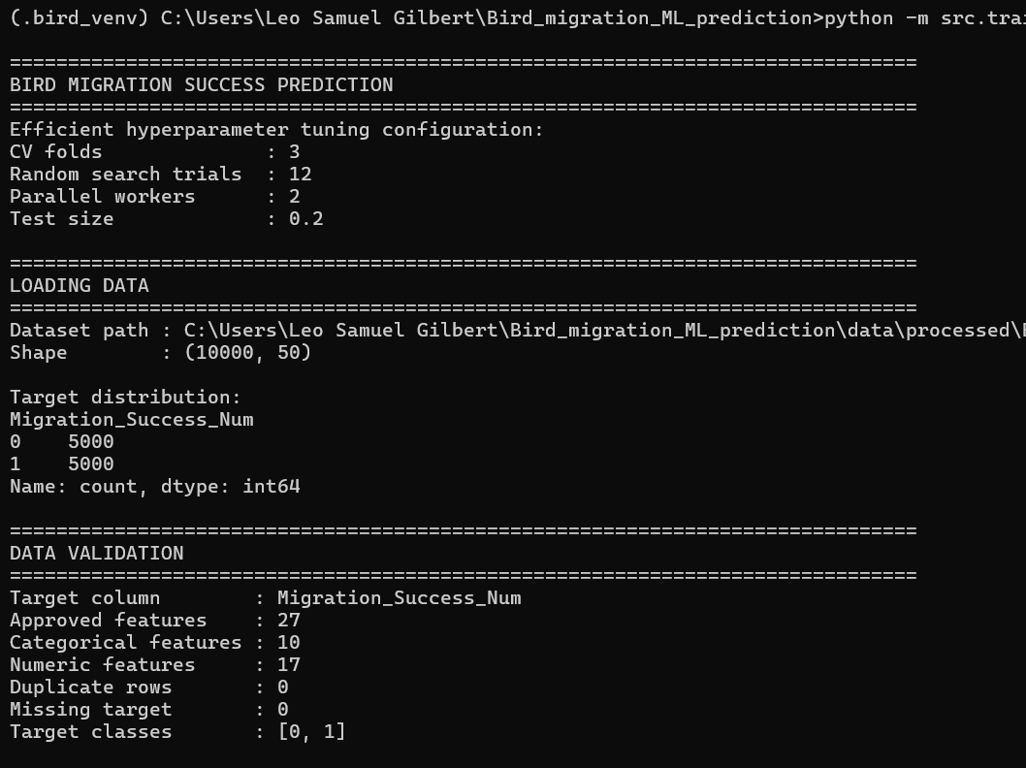
Experimental Setup
To ensure that the comparison between the models was consistent, the same modelling framework established in the previous questions was applied to all six algorithms. The dataset was divided into:
- 80% training data: 8,000 records
- 20% testing data: 2,000 records
The training data was used for model development and hyperparameter optimization, while the testing data was kept separate for final performance evaluation.
Rather than relying entirely on default model configurations, RandomizedSearchCV was used for hyperparameter tuning. Each model was evaluated using 12 randomly sampled hyperparameter combinations with 3-fold cross-validation, resulting in 36 model fits for each algorithm. This allowed us to investigate different model configurations while keeping the computational requirements manageable.
The six classification algorithms evaluated were:
- Logistic Regression
- Decision Tree
- K-Nearest Neighbours (KNN)
- Support Vector Machine (SVM)
- Gradient Boosting
- Random Forest
This provided a comparison between linear, distance-based, kernel-based and tree-based approaches.
Logistic Regression
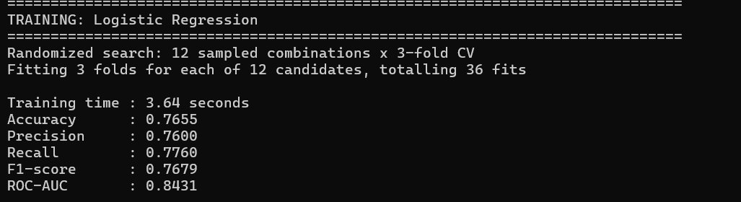
We first trained Logistic Regression as a relatively simple linear classification baseline. Its purpose was to establish how effectively the migration features could predict migration success using a linear decision boundary.
After hyperparameter tuning, the best configuration used the LBFGS solver with C = 0.1.
Metric | Result
Accuracy | 76.55%
Precision | 76.00%
Recall | 77.60%
F1-score | 76.79%
ROC-AUC | 84.31%

The model provided a reasonable baseline, but its performance was lower than the more advanced nonlinear models. This suggests that the relationship between migration success and the selected environmental, geographical and behavioural variables is not purely linear.
Decision Tree
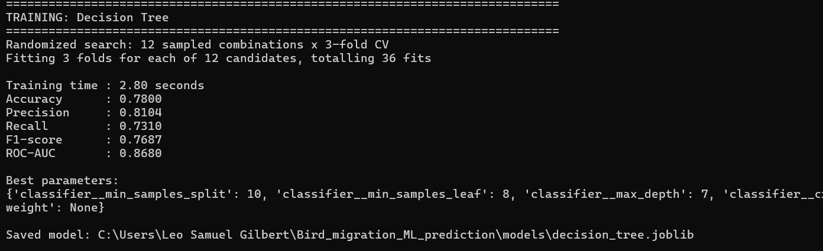
We then evaluated a Decision Tree to determine whether recursive feature-based decisions could better capture relationships within the migration data.
The optimized configuration selected an entropy criterion, with a maximum depth of 7, minimum samples per leaf of 8 and minimum samples split of 10.
Metric | Result
Accuracy | 78.00%
Precision | 81.04%
Recall | 73.10%
F1-score | 76.87%
ROC-AUC | 86.80%

The Decision Tree improved accuracy and ROC-AUC compared with Logistic Regression. Its precision of approximately 81% indicates that when the model predicted successful migration, it was relatively reliable. However, its lower recall indicates that it failed to identify a considerable number of actual successful migrations.

K-Nearest Neighbours
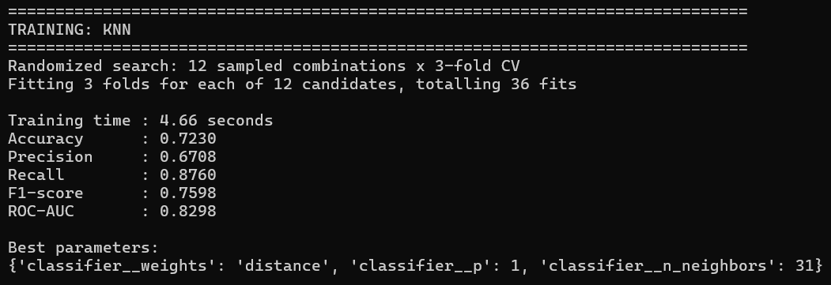
KNN was subsequently evaluated as a distance-based classification method. The optimized model selected 31 neighbours, distance weighting and Manhattan distance (p = 1).
Metric | Result
Accuracy | 72.30%
Precision | 67.08%
Recall | 87.60%
F1-score | 75.98%
ROC-AUC | 82.98%
Interestingly, KNN achieved the highest recall among all six models, correctly identifying 87.6% of the successful migration cases. However, this came at the cost of precision and overall accuracy.
This behaviour demonstrates why evaluating a classification model using accuracy alone would not have been sufficient. Although KNN was able to identify a large proportion of successful migrations, it also generated considerably more false-positive predictions.

Support Vector Machine
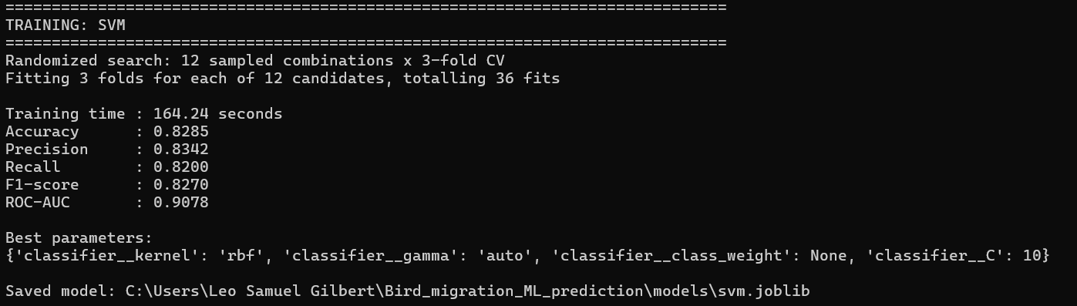
We next trained the Support Vector Machine classifier using different kernel and regularization configurations. The best-performing configuration used an RBF kernel with C = 10 and gamma = auto.
The final results were:
Metric | Result
Accuracy | 82.85%
Precision | 83.42%
Recall | 82.00%
F1-score | 82.70%
ROC-AUC | 90.78%
The SVM produced a substantial improvement over the first three models. Its ROC-AUC of 0.9078 demonstrates strong discrimination between successful and unsuccessful migration cases.
However, the SVM required approximately 164 seconds for training and hyperparameter optimization, making it the most computationally expensive model among the six approaches tested.

Gradient Boosting
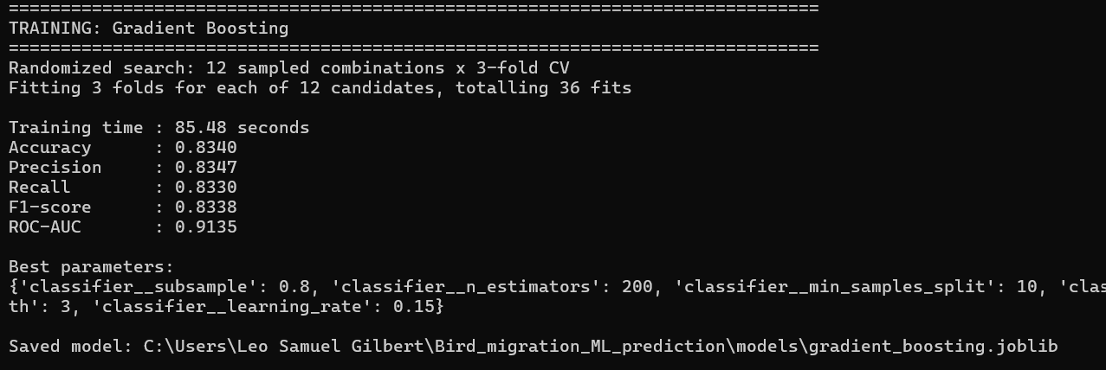
We then evaluated Gradient Boosting, which builds an ensemble of weak decision trees sequentially, with each subsequent tree attempting to correct the errors made by the previous trees.
After randomized hyperparameter optimization, the best configuration used:
- 200 estimators
- Maximum depth = 3
- Learning rate = 0.15
- Subsample = 0.8
- Minimum samples split = 10
- Minimum samples leaf = 4
The optimized Gradient Boosting model achieved:
Metric | Result
Accuracy | 83.40%
Precision | 83.47%
Recall | 83.30%
F1-score | 83.38%
ROC-AUC | 91.35%
Gradient Boosting produced the highest overall performance across the evaluation metrics.
More importantly, its precision and recall were closely balanced. This indicates that the model was not achieving its accuracy by favouring one type of prediction. Instead, it was able to identify both successful and unsuccessful migration cases relatively consistently.
Its ROC-AUC of 0.9135 was also the highest among the six models, indicating that it provided the strongest overall discrimination between the two migration outcomes.
Random Forest
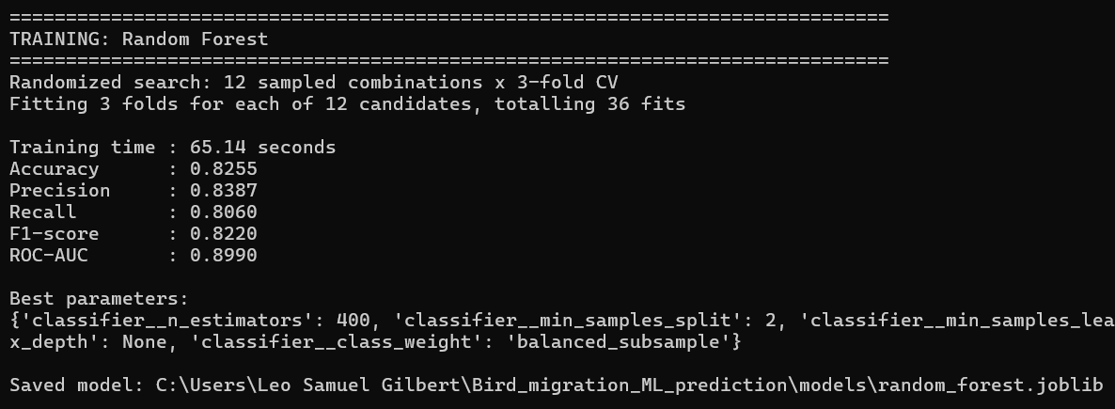
Finally, we evaluated Random Forest, another ensemble-based tree algorithm. The optimized configuration selected 400 trees, a minimum of two samples for splitting, a minimum of two samples per leaf, square-root feature selection and balanced subsampling.
Metric | Result
Accuracy | 82.55%
Precision | 83.87%
Recall | 80.60%
F1-score | 82.20%
ROC-AUC | 89.90%
Random Forest produced strong results and achieved the highest precision among the six models at 83.87%. This indicates that it was particularly effective at avoiding false-positive successful-migration predictions.
However, its recall and ROC-AUC were slightly lower than those of Gradient Boosting. Therefore, although Random Forest performed competitively, it did not achieve the best overall balance.
COMPARISON
After completing the training and testing process, the performance of all six models was consolidated for comparison.
Model | Accuracy | Precision | Recall | F1-score | ROC-AUC
Gradient Boosting | 83.40% | 83.47% | 83.30% | 83.38% | 91.35%
SVM | 82.85% | 83.42% | 82.00% | 82.70% | 90.78%
Random Forest | 82.55% | 83.87% | 80.60% | 82.20% | 89.90%
Decision Tree | 78.00% | 81.04% | 73.10% | 76.87% | 86.80%
Logistic Regression | 76.55% | 76.00% | 77.60% | 76.79% | 84.31%
KNN | 72.30% | 67.08% | 87.60% | 75.98% | 82.98%
The results demonstrate a clear performance difference between the models.
The simpler models, particularly Logistic Regression and KNN, did not perform as well overall. Logistic Regression achieved an accuracy of 76.55%, suggesting that a simple linear decision boundary was insufficient to represent the complex relationships present in the migration data.
KNN achieved the lowest accuracy at 72.30%, although it produced the highest recall of 87.60%. This indicates that the model was highly sensitive to successful migration cases but produced a relatively large number of incorrect positive predictions.
The tree-based ensemble models performed considerably better. Both Random Forest and Gradient Boosting achieved accuracy above 82%, while SVM also demonstrated competitive performance.
However, Gradient Boosting emerged as the strongest overall model.

Selection of the Champion Model
Based on the results obtained, Gradient Boosting was selected as the final champion model.
The decision was not based solely on accuracy. Instead, we considered the combination of accuracy, precision, recall, F1-score and ROC-AUC.
Gradient Boosting achieved:
- Accuracy = 83.40%
- Precision = 83.47%
- Recall = 83.30%
- F1-score = 83.38%
- ROC-AUC = 91.35%
The most important observation is the balance between precision and recall. The difference between the two values is only 0.17 percentage points, demonstrating that the model performs consistently when identifying both successful and unsuccessful migration outcomes.
Furthermore, its F1-score of 83.38% was the highest among all six models, while its ROC-AUC of 91.35% was also the highest.
Although Random Forest achieved slightly higher precision, its recall was lower. Similarly, SVM achieved strong performance but required significantly more training time. Gradient Boosting therefore provided the best combination of predictive performance, balanced classification behaviour and computational practicality.
Consequently, the optimized Gradient Boosting pipeline was saved as the champion model and used as the basis for the subsequent prediction application.

Model Deployment and Application
Following model selection, we integrated the trained machine learning pipeline into a Streamlit-based prediction application. This provided a practical interface through which migration characteristics could be entered and the trained model could be used to generate a prediction.
The application uses the trained model artifacts generated during the modelling stage rather than retraining the models every time a prediction is requested. The final training process generated the model metrics, optimized parameters, feature importance information, evaluation results and model metadata required for the application.
This allowed the project to progress from an experimental machine learning workflow into a usable prediction system.
The final workflow can therefore be summarized as:
Processed Bird Migration Data → Feature Selection → Train/Test Split → Hyperparameter Tuning → Six Classification Models → Comparative Evaluation → Gradient Boosting Selection → Streamlit Prediction Application

Insights and Findings
The analysis of bird migration data provided several important insights into seasonal patterns, ecological drivers, and the environmental and behavioral factors influencing migration success and interruptions. By combining statistical methods, correlations, and visualizations, the study was able to connect biological behavior with measurable migration outcomes.
SEASONAL MIGRATION TRENDS
In this part of the analysis, I observed how migration varied across different months of the year. The results clearly showed that bird migration is seasonal, with the highest movements recorded in March (spring) when birds fly north for breeding, and another peak in November (autumn) when they return south for winter. On the other hand, months like July and September showed very low migration activity, meaning most birds were settled during these times. This highlights that migration is strongly tied to natural cycles, where breeding and survival needs dictate when birds travel.
REASONS FOR MIGRATION
The most common reason was feeding (2573 cases), followed closely by avoiding predators (2518 cases), which shows that survival is the main driving factor. Other reasons like climate change (2473) and breeding (2436) were also important but slightly less frequent. When I compared species, I found that Geese mostly migrated for food, Storks for breeding, and Hawks for climate stability, showing that different species have different priorities. This proves that migration behavior is not the same for all birds but depends on their ecological needs.
IMPACT OF WEATHER ON FLIGHT & NESTING
The correlation values turned out to be very close to zero, which means weather does not have a big impact on how far or how fast birds fly. However, when I checked nesting migrations, I noticed they usually happened in cooler and moderate conditions (around 12.6°C temperature, 30 km/h wind, and 54% humidity). This shows that while weather does not strongly control flight performance, it does influence when and where birds prefer to nest.
WEATHER AND MIGRATION SUCCESS
the highest success rates were found during stormy weather (52.6%) and clear weather (50.7%), while conditions like fog, rain, and wind had more balanced outcomes of success and failure. This result suggests that birds flying in harsh conditions like storms may actually be stronger or better prepared, which is why they still manage to succeed. It also shows that even clear skies do not guarantee a successful migration, as other factors may still come into play.

ROLE OF REST STOPS
The results showed that moderate rest stops (5–9) had the highest success rate, while too few rest stops (1–2) increased the risk of exhaustion, and too many rest stops (10 or more) caused delays and higher chances of failure. This means that birds need to balance their energy properly during migration — resting enough to recover but not stopping so much that they lose time or face more risks.
PREDATOR SIGHTINGS
I examined how predator sightings influenced migration success. Interestingly, I found that having 1 predator sighting gave the highest success rate (55%), while birds that reported no predator sightings had a slightly lower success rate (48%). This was surprising because we usually expect predators to increase failure. A possible explanation is that seeing a predator makes birds more cautious and alert, which helps them survive. Overall, predator activity had only a small impact, and migrations continued at nearly the same rate despite their presence.
FOOD AND MIGRATION SUCCESS
Birds with a low food supply showed the highest success rate (about 52%), slightly better than those with a high food supply (around 51%). On the other hand, birds with a medium food supply had the lowest success, with about 50% success and failure being almost equal. This means that both low and high food availability supported migration slightly better, while medium levels did not give much advantage. A possible reason could be that when food is scarce, birds use their energy more carefully, while too much or too little food pushes them to adapt.
FLOCK SIZE AND SUCCESS
Birds flying alone had the lowest success rate (about 44%), while those in small (2–5) or medium (6–15) flocks performed better (around 52%). The highest success was in large flocks (16–30) with about 55% success, while very large flocks (31+) did not give much extra benefit. This means that flocking provides protection, navigation help, and group support, but being in extremely large groups may not always improve survival further.
MIGRATION INTERRUPTIONS
The results showed that interrupted migrations had slightly longer flight distances (2511 km vs 2496 km) and lower altitudes, which could make flying more difficult. They also had more rest stops (7.43 vs 7.32) and slightly less food, which may weaken the birds during the journey. When checking weather, I found that interruptions were a bit more common in foggy, windy, and stormy conditions, though even clear weather still had interruptions. This proves that migration interruptions happen due to a combination of factors like journey length, weather, food, and altitude, rather than one single cause.
CONCLUSION
Bird migration is one of the most fascinating natural processes that reflects the deep connection between living beings and the environment. Through this case implementation analysis, I tried to study the migration patterns of different bird species using a dataset of 10,000 records obtained from Kaggle. The dataset was well structured, contained mixed attributes (numerical, categorical, and geospatial), and was already complete without missing values. After performing data cleaning, removing irrelevant columns, and preparing the data for analysis, I was able to apply different data analysis techniques using Python libraries such as NumPy, Pandas, and Matplotlib. The results of this study provided useful insights into the ecological, environmental, and behavioral factors that shape bird migration, while also highlighting the challenges birds face during their journeys.
One of the first and most important findings was the seasonal nature of migration. The analysis showed clear peaks in migration activity during March and November. March reflected the spring migration towards northern regions for breeding, while November showed the return journey towards southern areas for winter survival. In contrast, months like July and September recorded very low movement, showing that during these periods most species remain settled. This proves that migration is not random but follows natural cycles that are strongly connected to breeding and survival needs. For conservationists, this insight is very valuable, because it highlights which times of the year need more attention in terms of protecting migration routes.
Another important part of the study was analyzing the reasons behind migration. The dataset recorded several motivations such as feeding, breeding, avoiding predators, and adapting to climate changes. Feeding was the most common reason with 2,573 cases, followed closely by predator avoidance (2,518). This means that survival and food security are the main forces driving bird migration. Interestingly, when looking at specific species, I noticed differences — Geese migrated mainly for food, Storks focused on breeding, while Hawks were more sensitive to climate stability. This shows that migration behavior is not the same for all birds but depends on ecological needs of each species. This insight proves that conservation efforts must be species-specific and not generalized, since different birds have different priorities.
When I studied the impact of weather on flight performance and nesting, the correlation values were very close to zero. This means that weather does not have a strong impact on how far or how fast birds fly. However, nesting patterns were more weather-dependent. Birds usually nested in moderate and cooler conditions (around 12.6°C temperature, 30 km/h wind, and 54% humidity). This shows that while birds are capable of flying in different conditions, they prefer to reproduce in stable and comfortable climates. For conservation, this suggests that protecting nesting habitats under suitable weather conditions is essential.
The role of weather in migration success was another interesting part of the study. I found that the highest success rates were during stormy (52.6%) and clear weather (50.7%). This result was surprising because we usually think that storms create risks. A possible explanation is that birds flying during storms are stronger, more experienced, or better prepared, which increases their chances of survival. On the other hand, clear skies are not always safe, as other threats such as predators, exhaustion, or food shortages can still affect success. This shows that migration success is not determined by one factor but a combination of many.
The study also revealed the importance of rest stops. Birds that took moderate rest (5–9 stops) had the highest success rates. Those with very few stops (1–2) became exhausted, while those with too many stops (10+) faced delays and higher risks of failure. This highlights that birds must balance their energy during migration. It reflects a natural strategy where neither extreme is beneficial — both over-resting and under-resting can reduce survival chances.
When checking predator sightings, I found another surprising result. Birds that had one predator sighting showed the highest success (55%), compared to 48% for birds that reported no predator sightings. This could be because encountering a predator makes birds more cautious and alert, which improves their survival. It also proves that predators are a natural part of the ecosystem, and their presence does not always result in failure. Migration continues despite threats, showing the resilience of bird species.
The relationship between food availability and migration success also gave useful insights. Birds with low food supply showed the highest success rate (52%), slightly better than high food supply (51%). Medium food supply gave the lowest success at 50%. This means that both scarcity and abundance can encourage adaptation, while moderate levels may not push birds to adjust. It also reflects that birds may perform better when they are under some level of challenge, which makes them manage energy more carefully.
The size of the flock also played a big role in determining success. Birds flying alone had the lowest success rate (44%). Small (2–5) and medium (6–15) flocks performed better (around 52%), and large flocks (16–30) achieved the highest success (55%). Very large flocks (31+) did not add much extra benefit. This shows that flocking is an important survival strategy. It provides protection, navigation support, and reduces risks. However, beyond a certain point, increasing flock size may not give additional advantages.
The study of migration interruptions gave another important conclusion. Interrupted migrations were linked with longer flight distances, lower altitudes, more rest stops, and slightly less food. Interruptions were also more common in foggy, windy, and stormy conditions, though they were present even in clear skies. This means that migration interruptions are caused by a combination of factors, not just one. This reflects the complexity of migration, where multiple challenges interact and affect outcomes.
Bringing all these findings together, this Case Implementation clearly shows that bird migration is influenced by many interconnected factors such as season, species type, weather, rest patterns, flock size, food supply, and predators. Migration success or failure cannot be explained by one single element. Instead, it is the result of a balance between ecological needs, environmental conditions, and adaptive behaviors. This complexity makes migration both a vulnerable and a resilient process.
From a conservation point of view, this study gives several useful recommendations. First, conservation efforts should focus more on seasonal protection of routes during peak migration months (March and November). Second, nesting habitats with moderate weather must be preserved to support breeding success. Third, ensuring proper food availability along migratory corridors is important to prevent exhaustion and interruptions. Fourth, flocking behavior and natural predator-prey balance should be respected, as these are part of the ecosystem’s natural design.
This case implementation helped me meet the objectives by applying data analysis techniques to answer real ecological questions. The case study also reflects how computational tools can transform raw data into meaningful knowledge.
This case implementation also shows the importance of data analysis in ecology. By using Python libraries for cleaning, processing, and visualization, it was possible to identify hidden trends and correlations in a large dataset. Data-driven research provides scientific evidence that can guide policymakers, conservationists, and environmentalists in protecting migratory species.
Bird migration is not just a journey of survival but also a reflection of how life adapts to the challenges of nature. Through this study, I learned that migration is a delicate balance of many factors, and small changes in environment can have large impacts on species survival. Protecting migratory birds is therefore not only about saving one group of animals but also about maintaining ecological balance and biodiversity for the planet. This analysis gave me both scientific understanding and appreciation for the resilience of birds, and it highlighted the need for urgent conservation actions supported by data-driven insights.
SUGGESTIONS BASED ON THE ANALYSIS TO PROTECT BIRDS AND BIRD MIGRATION SUCCESS
- Since migration peaks in spring (March) and autumn (November), conservation efforts should focus on resting and feeding grounds during these months.
- Protect wetlands, forests, and open grasslands along major flyways to ensure birds can refuel safely.
- For species migrating due to food scarcity, community-driven actions like planting native fruiting plants and insect-friendly habitats can reduce starvation risks.
- Reduce light pollution in cities during peak migration months to prevent disorientation.
- Promote bird-safe structures (glass-treated windows, power line insulation) to cut down on collision and electrocution deaths.
- Since flock size and predator sightings influence survival, protect habitats from excessive human-induced predator introduction (like stray cats and dogs near wetlands).

