**1) Doctor Sequence Diagram**

**“https://creately.com/app?diagid=jaj29q561”**

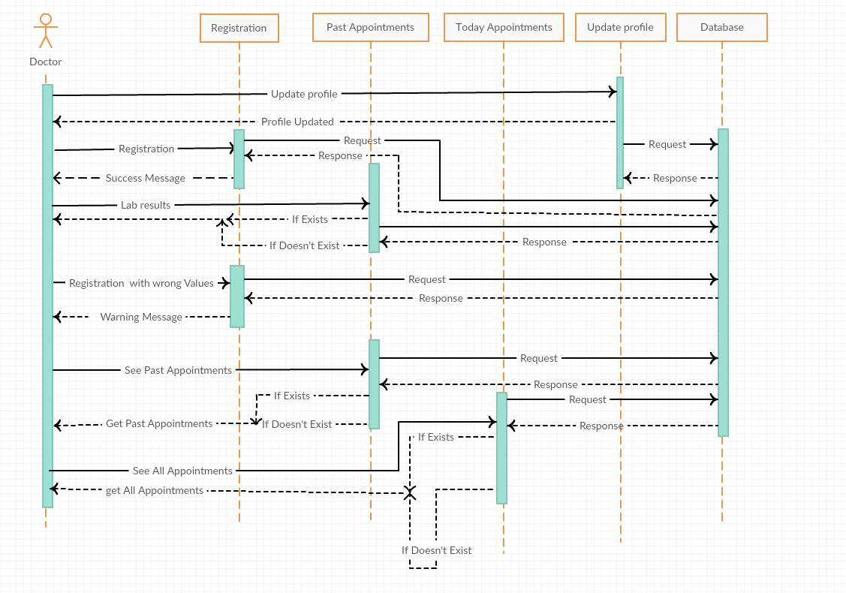

**1) Patient Sequence Diagram:**

**“https://creately.com/app?diagid=jaj8h1zh”**

