**Department of Computer Science**

**SRI MAHAVEERA FIRST GRADE COLLEGE**

**KODANGALLU, MOODBIDRI – 574197**

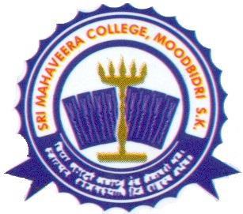

### CERTIFICATE

This is to certify that the project work titled

“Electronic Bid”

**Submitted by**

**Ms. Suneha Muskan (Reg.no: 155770402)**

In partial of the requirement for the award of degree of Bachelor of Computer Application of Mangalore University, is a bonafide record of the work

Carried out at

SRI MAHAVEERA COLLEGE

MOODBIDRI

During December to April 2017-18

**Mr. Harish Shetty Mrs. Parnashree**

**Internal guide and lecturer Head of the Department**

**Department Of Computer Science Department Of Computer Science**

###### Prof. H. Chandrashekar Dixit

**Principal**

**Examiners:**

**1) __________________ 2) __________________**

**External Examiner Internal Examiner**

**“ELECTRONIC BID”**



SUBMITTED IN PARTIAL FULFILMENT OF THE REQUIREMENTS FOR THE AWARD OF DEGREE

OF

**BACHELOR OF COMPUTER APPLICATION**

BY

**Ms. SUNEHA MUSKAN (Reg.no: 155770402)**

WORK CARRIED OUT AT

**SRI MAHAVEERA COLLEGE**

**MOODBIDRI**

DEC-2017 TO APRIL-2018

**Mr. HARISH Shetty**

INTERNAL GUIDE

DEPARTMENT OF COMPUTER SCIENCE

SRI MAHAVEERA COLLEGE

MOODBIDRI – 574197

**SRI MAHAVEERA COLLEGE**

**MOODBIDRI - 574197**